Supplementary Information for
Electronic structure, cationic and excited states of nitrogen-containing spiroborates

Andrey E. Sidorin^{a*}, Sergey A. Tikhonov^{a,b}, Ilya S. Samoilov^{c}, Ivan S. Osmushko^{a,d}, Irina V. Svistunovaª, Galina O. Tretyakova^{a,d}, Zahar N. Puzyr'kovª, Vitaliy I. Vovnaª

ªFar Eastern Federal University, School of Natural Sciences, Vladivostok 690950, Russian Federation
^{b} Kamchatka Branch of the Geophysical Survey of the Russian Academy of Sciences, Petropavlovsk-Kamchatsky 683023, Russian Federation
^{c}Saint Petersburg State University, Department of Photonics, St. Petersburg 199034, Russian Federation
^{d} Institute of Chemistry, Far Eastern Branch of Russian Academy of Sciences, Vladivostok, 690022, Russian Federation
*e-mail: sae94@mail.ru

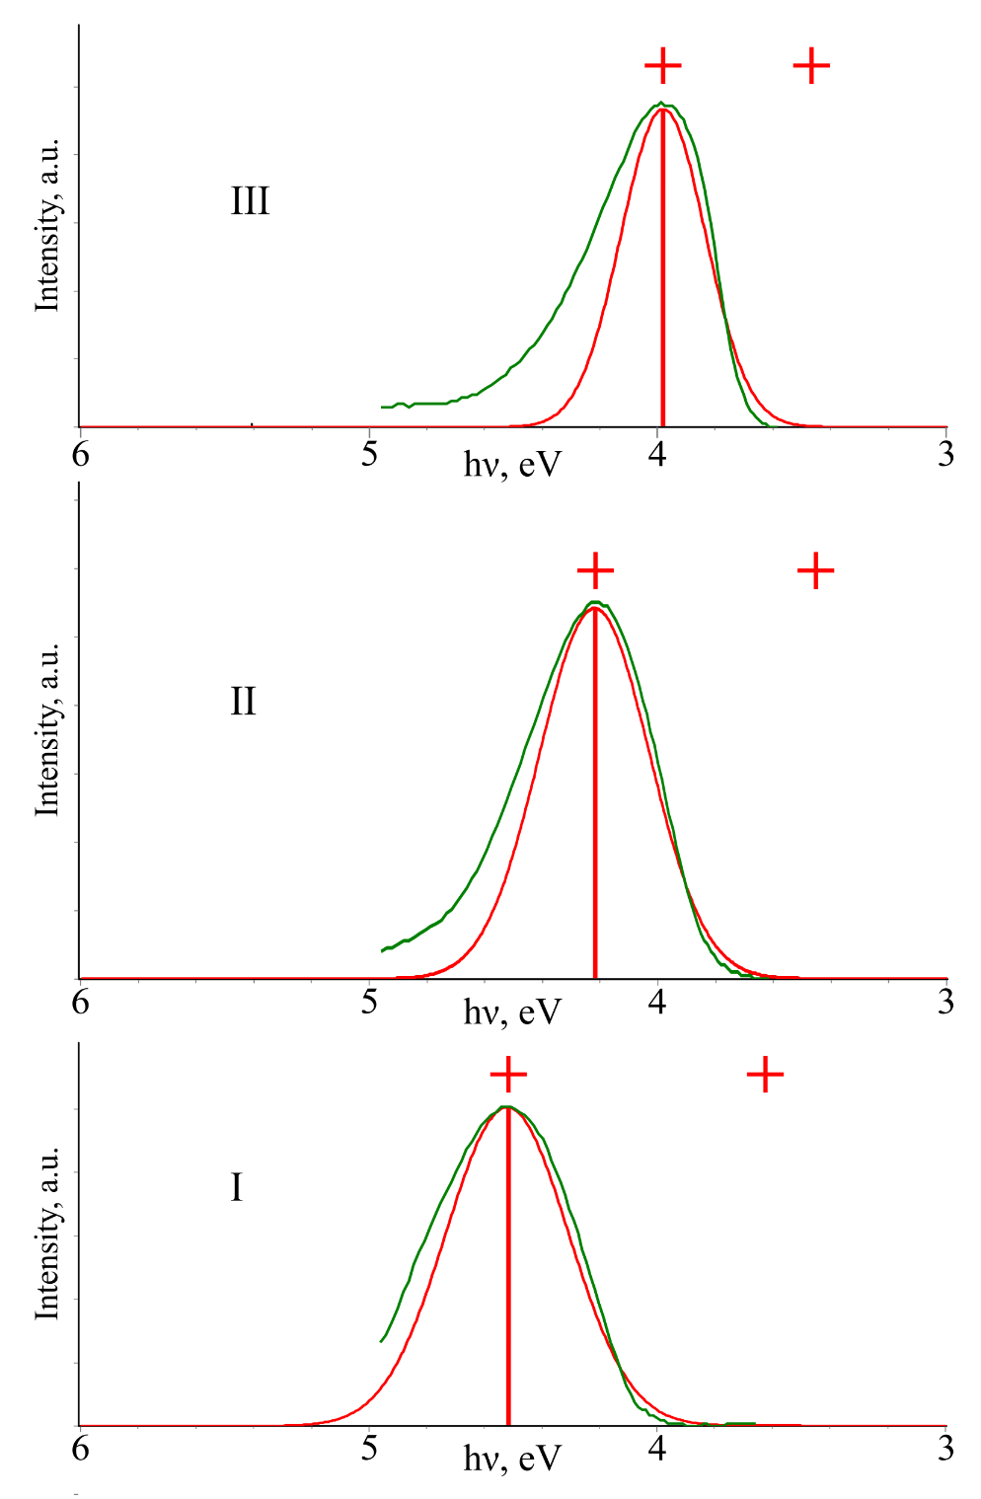
Fig. S1. Optical spectra of compounds I−III. The experimental absorption spectra (green line) and theoretical absorption spectra (ADC(2)/cc-pVDZ) (red line).

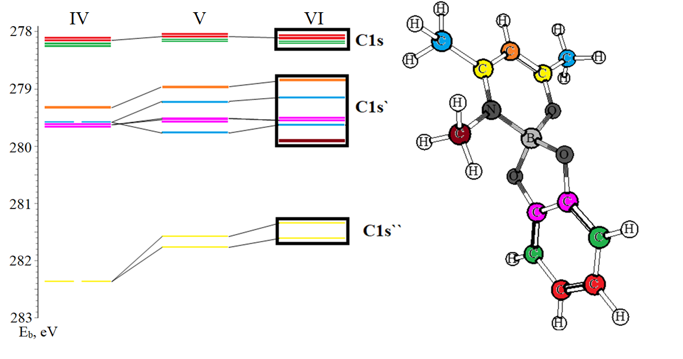
Fig. S2. Correlation diagram of C1s levels, based on DFT/CAMB3LYP/cc-PVDZ calculation.

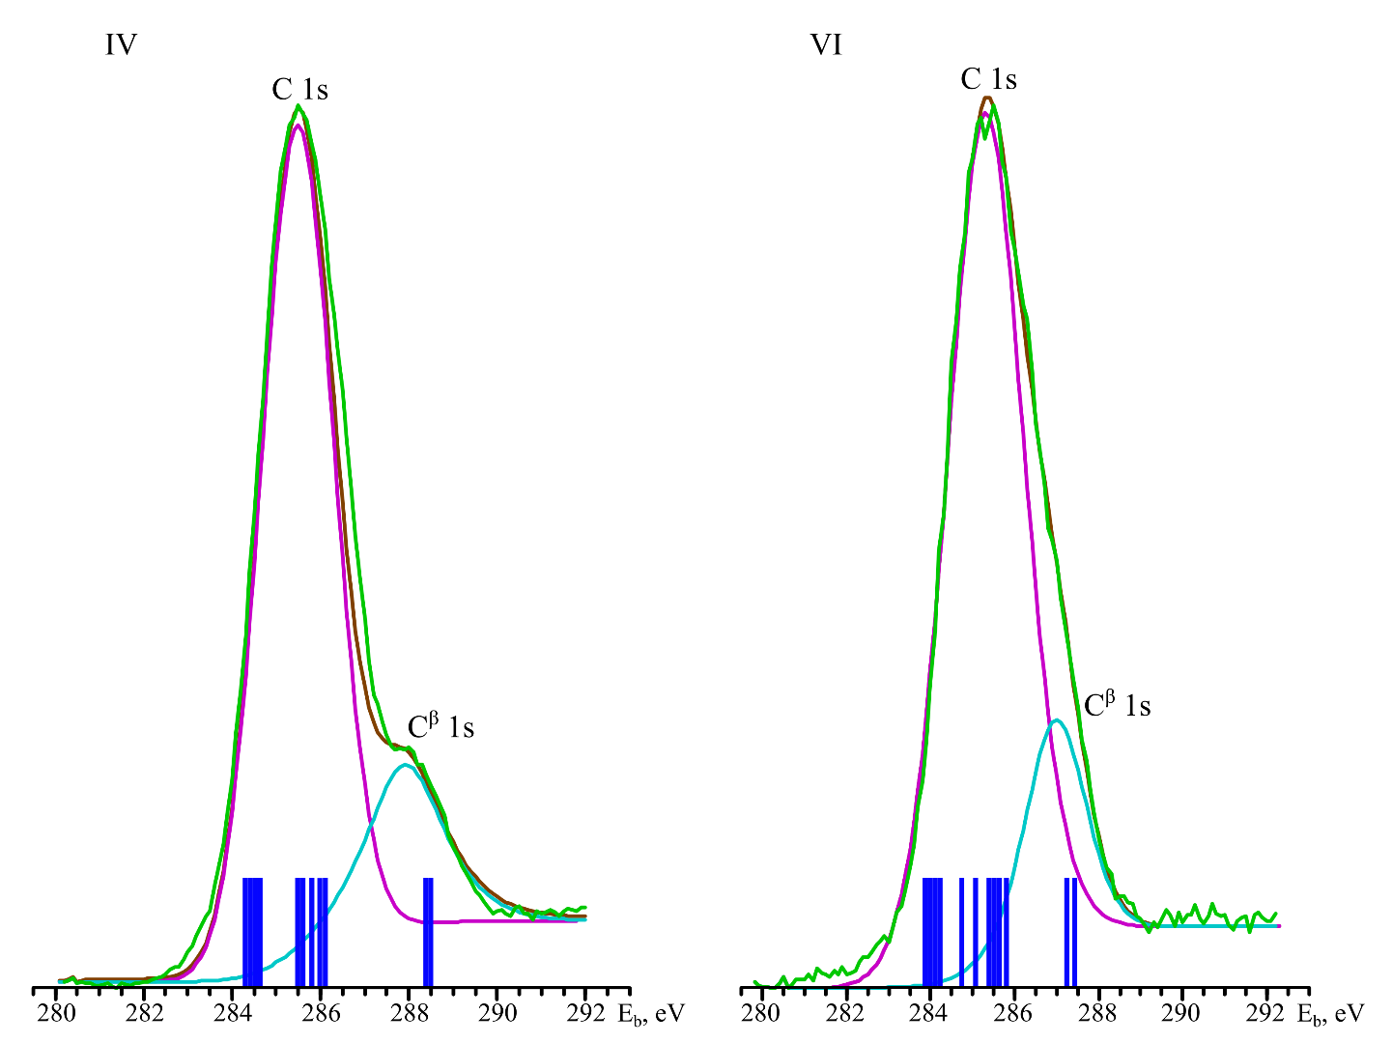
Fig. S3. X–ray photoelectron spectra of C1s–levels of compounds IV and VI.

Table S1. Energies and half–widths of bands in X–ray photoelectron spectra of 1s–electrons of complexes IV and VI.
Electron levels | IV |  |  |  | VI
Electron levels | E_{b} | half–width | К(s, l), % | К(mol. formula), % | E_{b} | half–width | К(s, l), % | К(mol. formula), %
O 1s | 533.9 | 2.2 | 25.00 | 22.94 | 533.3 | 1.9 | 18.43 | 17.65
C 1s | 285.5 | 2.3 | 70.89 | 68.75 | 285.5 | 2.6 | 71.53 | 70.59
N 1s | none | none | none | none | 400.5 | 1.7 | 4.46 | 5.88
B 1s | 193.1 | 1.7 | 6.17 | 6.25 | 193.4 | 1.5 | 5.58 | 5.88

