Appendix A – Additional analysis
Country Scientific Production
According to Fig A1, the distribution of scientific production by various countries in the subject of sentimental analysis and social media is the largest scientific production is INDIA with 224 documents.

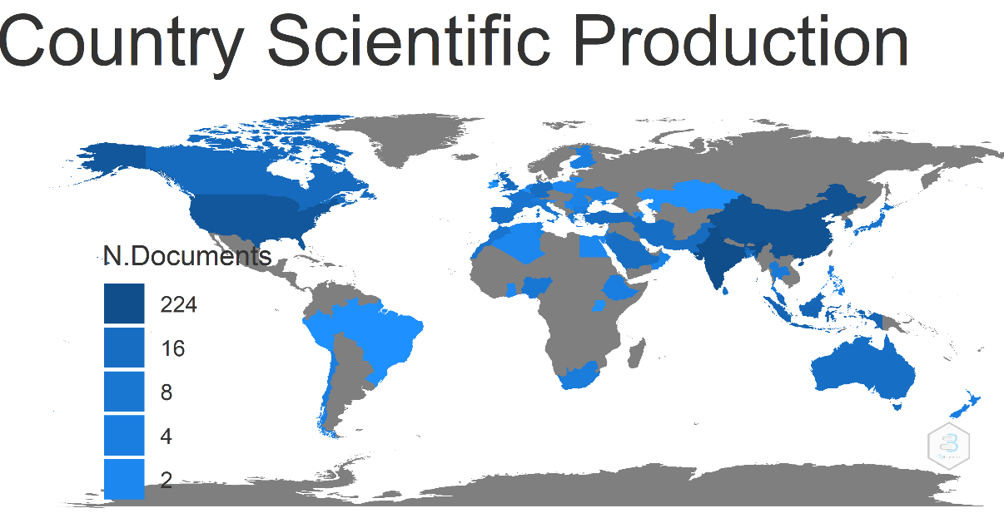
Figure A1: Country Scientific Production
Corresponding author's country
Fig A2 shows the number of articles produced by the authors of different countries (SCP) and the rate of cooperation of each country’s authors with other countries' authors (MCP). For instance, authors of the China have produced 18 articles, and China author’s co-authorship with other countries with 42 articles. Subsequently, the authors of India ranked second with 2 articles, and author’s co-authorship with other countries are with 30 articles.
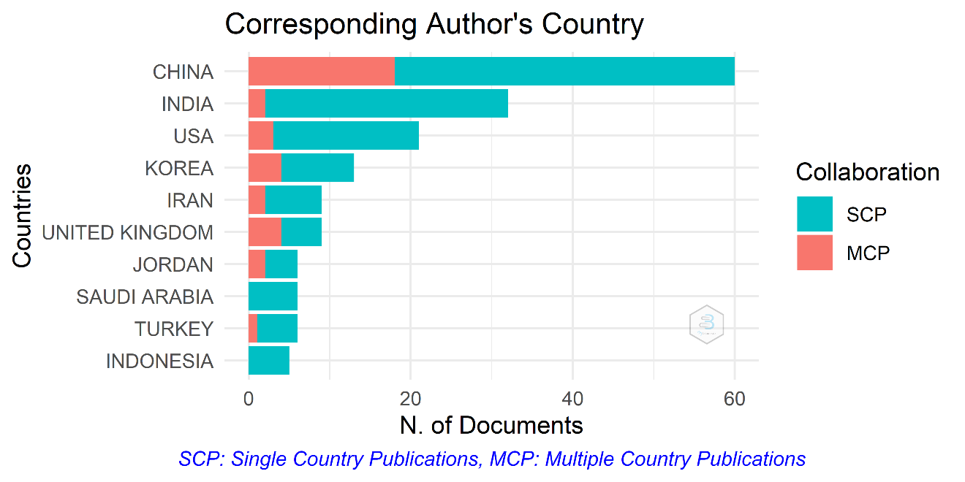
Figure A2: Corresponding author's country
Collaboration network
Fig A3 shows the Author’s Collaboration Network.
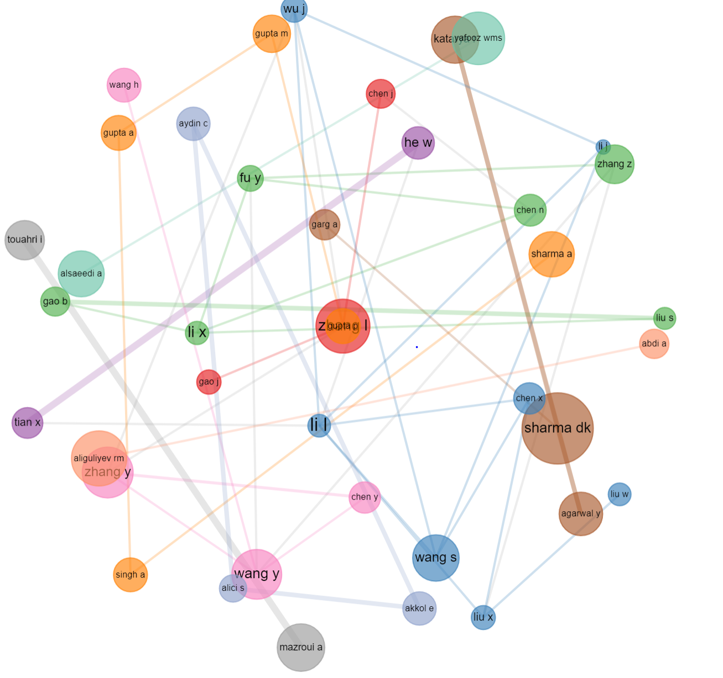
Figure A3: Author’s Collaboration Network

Authors and Co-authorship
In total, 523 articles were written by 1550 authors. figure showed the top five most productive authors contributing to the research field of sentiment analysis in social media research. These five most productive authors have published 24 articles.
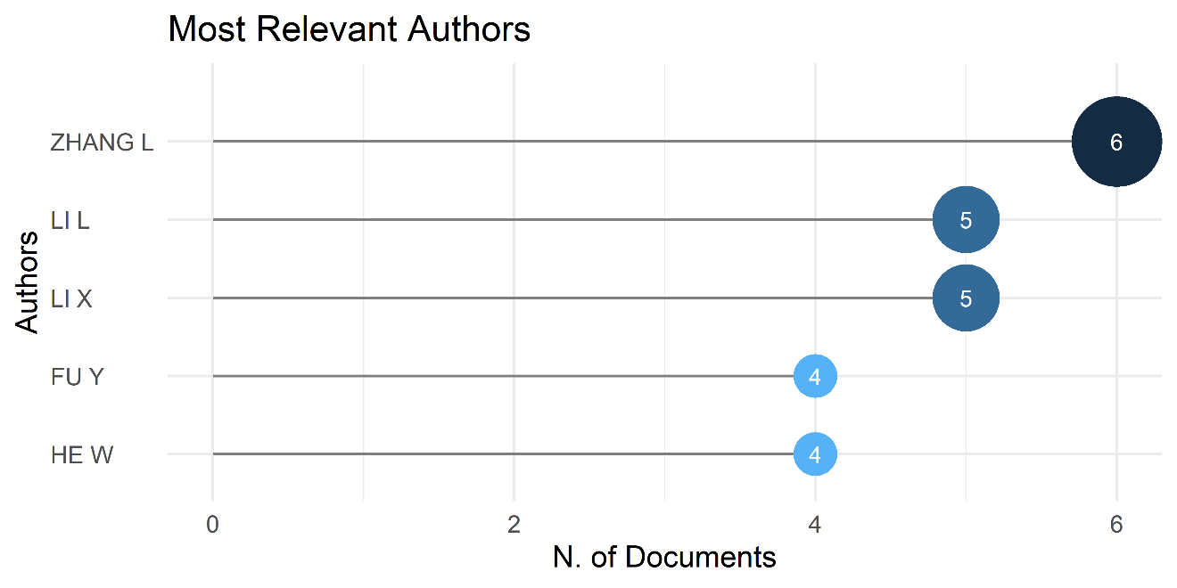
Figure A4: The Top Most Productive Authors
Country Collaboration map
In terms of the average citation, papers published by researchers in China, USA, India and Canada have maintained the highest citations. Fig. A5 shows the results of the collaborations among various countries. As we can observe from the results of Fig. A5, there was strong collaboration from the researchers in the United States from one side and other countries which was the highest to China, India and Canada, respectively.
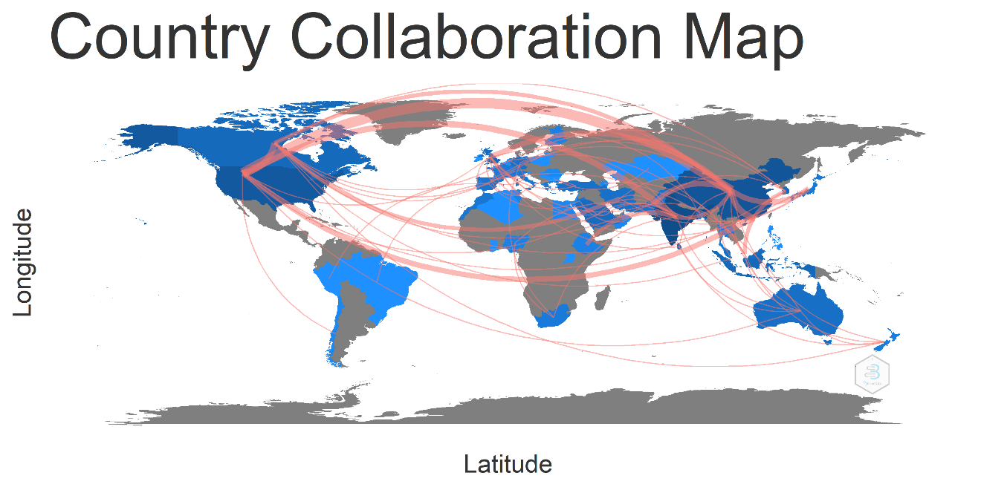
Figure A5: Country Collaboration map
The most common keywords
Fig A6 demonstrates some of the most cited references associated with sentimental analysis and social media. As we can observe from the results of Fig A6, sentiment analysis, machine learning and Social media are the three well recognized keywords used in the target literature.
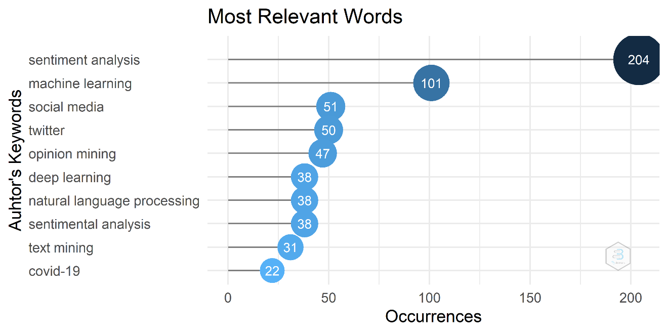
Figure A6: The most popular10 keywords used in studies

Document analysis
To identify the emerging trends, we conducted the document analysis. The trend topics of abstracts are as shown in Figure A7. To reveal the conceptual structure of the documents, we present the thematic map of author keywords as shown in Figure A7. In Figure, the research themes obtained from the conceptual structure of documents are characterized by two parameters as ‘density’ and ‘centrality’. The clusters represent the themes of research, and the size of the clusters is proportional to the number of keywords. The factorial analysis of the documents using correspondence analysis as topic dendrogram is shown in fig A8 below. The topic dendrogram shows the clustering of documents.
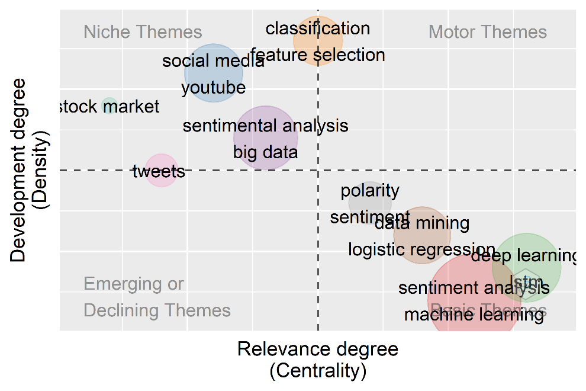
Figure A7: The thematic map of author keywords
Following figure A8 demonestrates a topic dendrogram on the topic area.
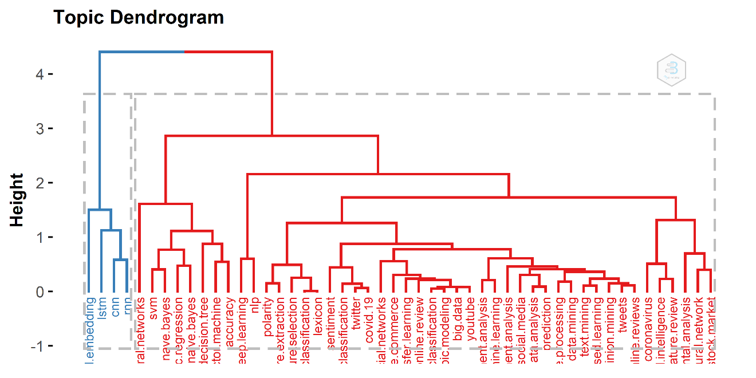
Figure A8: The topic Dendrogram

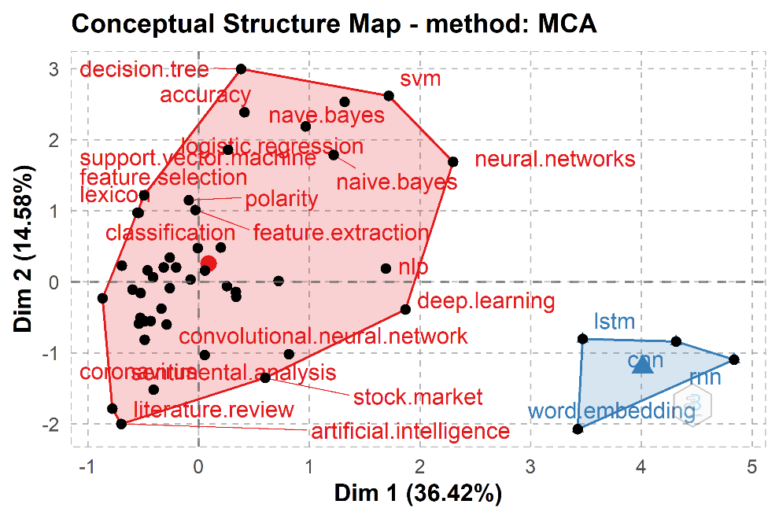
Figure A9: Factorial Map
The TreeMap (in figure A10) highlights the available keyword combinations. Using this, we can identify them and use the word cloud to indicate what they stand for: with” sentimental analysis and social media” are areas of study, in order of magnitude.

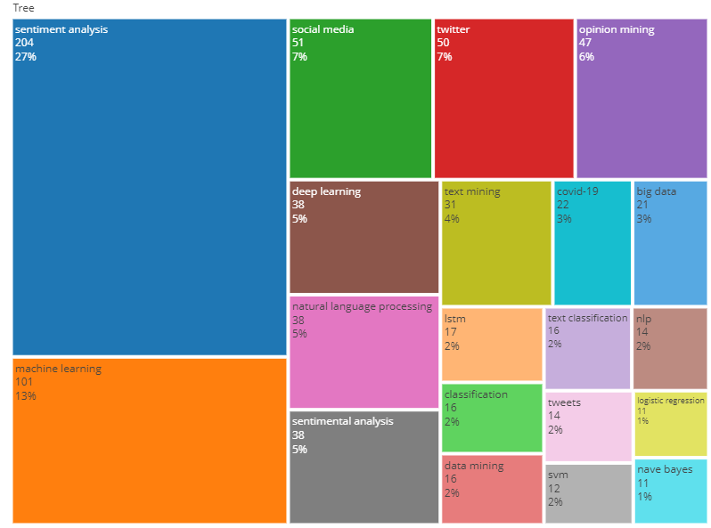
Figure A10: Word TreeMap.

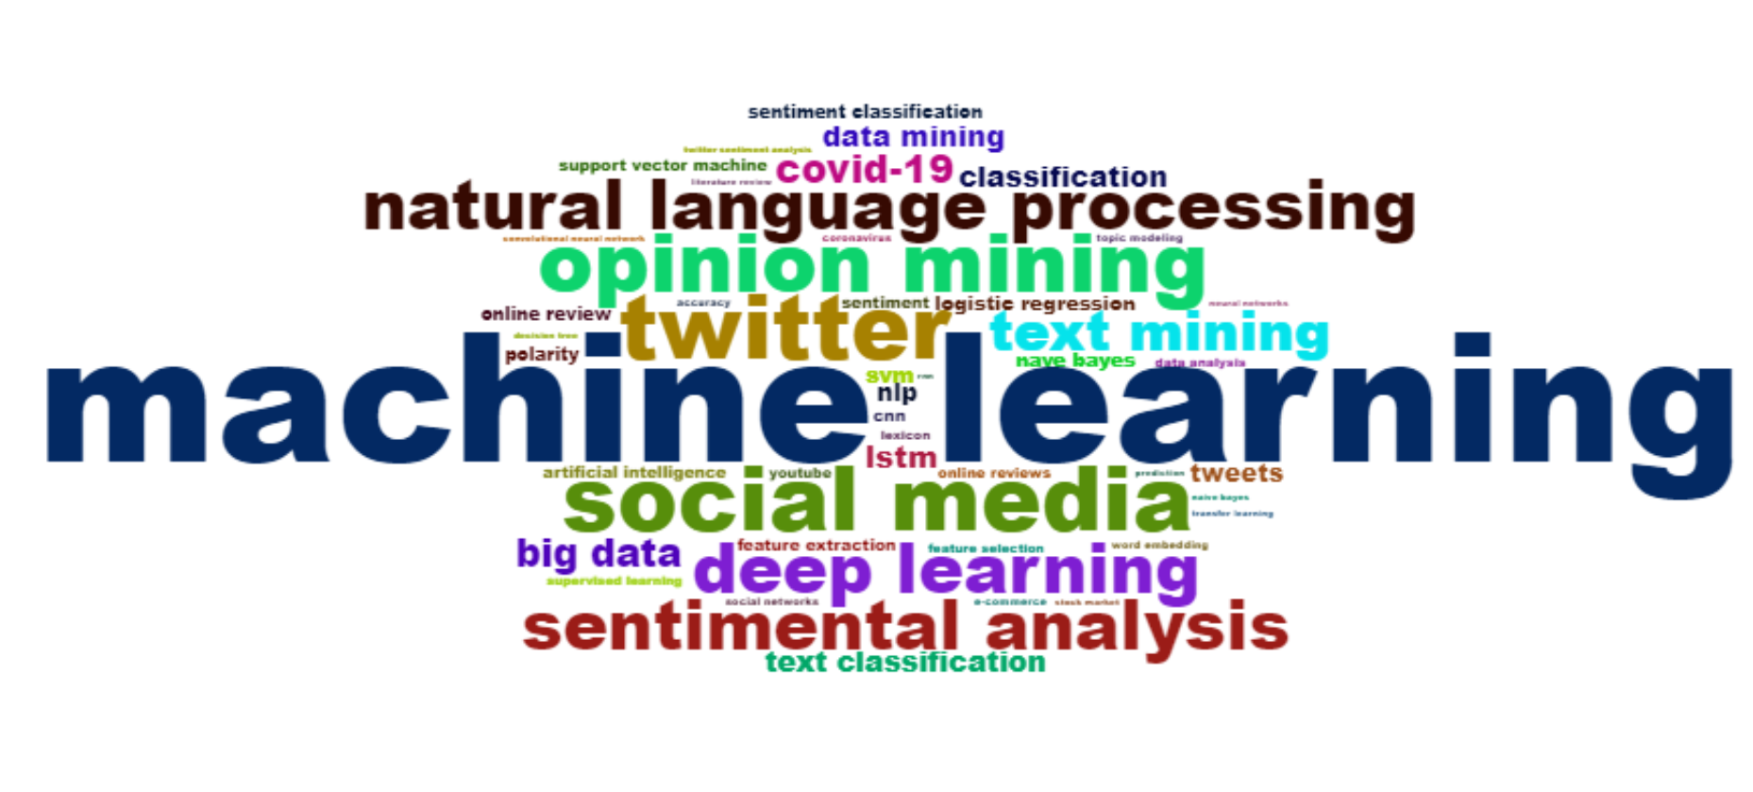
Figure A11: Word Cloud Author's keywords

Source Local Impact
Fig A12 shows the number of citations that were published in the top ten outlets. It shows that some articles were cited exclusively in certain years. The results show that the citations are from different journals, with the Journal of Information Processing and Management being the most cited journal TC (381).
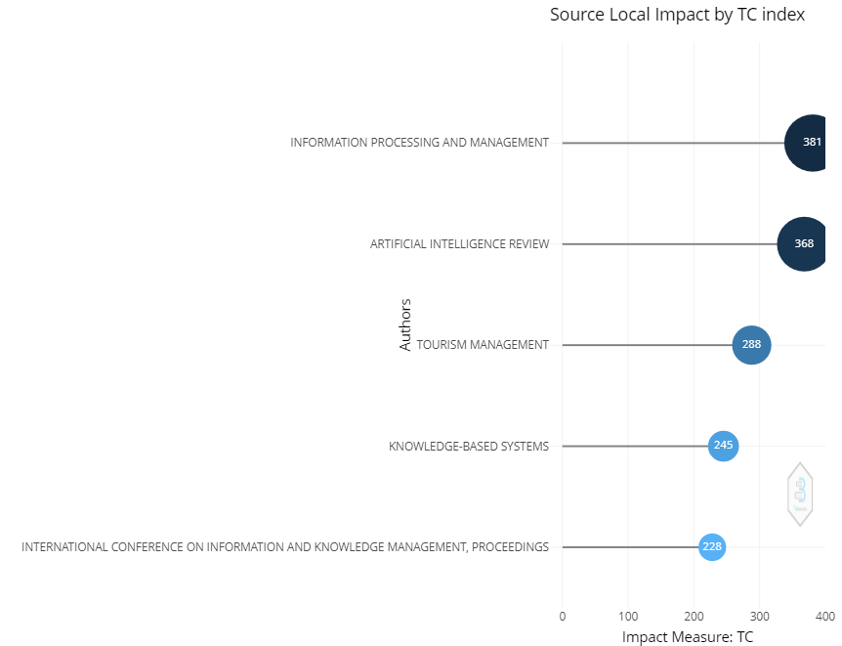
Figure A12: Top 10 most cited Journals
Figure A13 shows the increase in publications, visualizes Journals that have done exceptionally well with the subject and related topics. Between 2018 and 2022, there are huge increase in the number of articles published on this topic.

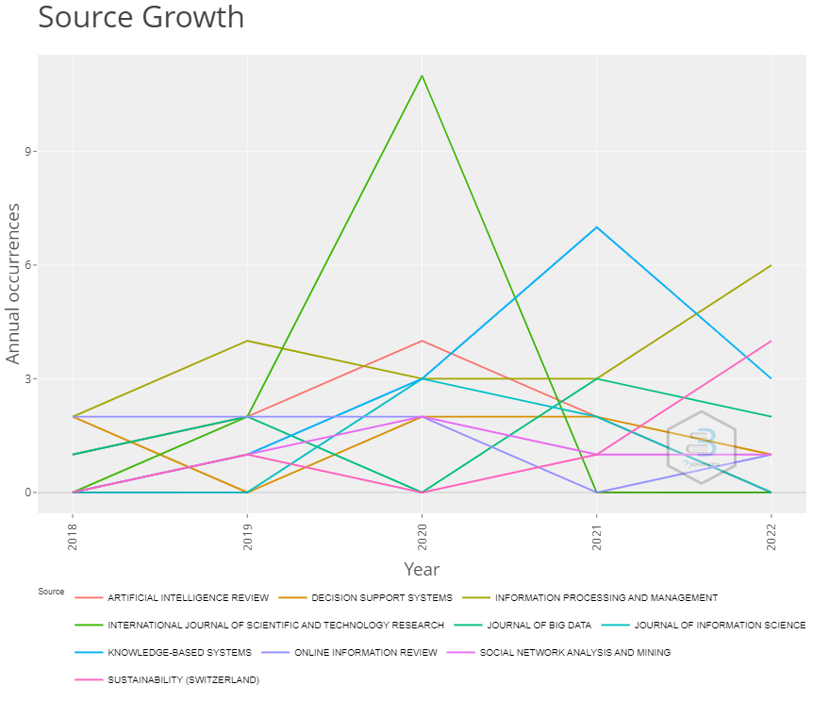
Figure A13: Source Growth

