Supplementary Information

Prediction of stable radon fluoride molecules and geometry optimization using first-principle calculations
Jaeeun Kang¹, Ina Park², Ji Hoon Shim², Duck Young Kim^{2, 3, ∗}, and Wooyong Um^{1, 4, 5, ∗}
¹Division of Advanced Nuclear Engineering (DANE), Pohang University of Science and Technology (POSTECH), 77 Cheongam–ro, Nam–Gu, Pohang, Gyeongbuk, 790–784, Republic of Korea
²Department of Chemistry, Pohang University of Science and Technology (POSTECH), 77 Cheongam–ro, Nam–Gu, Pohang, Gyeongbuk, 790–784, Republic of Korea
³Center for High Pressure Science & Technology Advanced Research, Shanghai, Republic of China
⁴Division of Environmental Sciences and Engineering (DESE), Pohang University of Science and Technology (POSTECH), 77 Chongam–ro, Nam–Gu, Pohang 790–784, Republic of Korea
⁵Nuclear Environmental Technology Institute (NETI), Pohang University of Science and Technolo-gy (POSTECH), Pohang, Gyeongbuk 790–784, Republic of Korea
*Correspondence: duckyoung.kim@hpstar.ac.cn, wooyongum@postech.ac.kr

Supplementary Table S1. Geometric parameters determined by DFT for C_{2v}, C_{3v}, and O_{h} structures of XeF₆.
Basis set | Initial  symmetry | Bond length (Å) | Bond angle (º) | Energy (Hartree) | ΔE  (kcal/mol)
LANL2DZ | C_{2v} | a = 1.99  b =1.94  c =1.90 | α =110.17  β = 81.23 | – 613.91 | – 1.19
LANL2DZ | C_{3v} | a = 1.98  b =1.89 | α = 109.02  β = 81.12 | – 613.91
LANL2DZ | O_{h} | r = 1.95 | θ = 90 | – 613.91 | – 2.07
def2-SVP | *C_{2v} | a, b, c = 1.95 | α, β = 90 | – 928.13 | – 0.19
def2-SVP | *C_{3v} | a, b = 1.95 | α, β = 90 | – 928.13
def2-SVP | O_{h} | r = 1.95 | θ = 90 | – 928.13 | 0.00
CEP-31G | C_{2v} | a = 1.99  b =1.94  c =1.90 | α = 103.92  β = 83.18 | – 613.97 | – 0.56
CEP-31G | C_{3v} | a = 2.00  b =1.92 | α = 107.91  β = 81.68 | – 613.97
CEP-31G | O_{h} | r = 1.98 | θ = 90 | – 613.97 | – 0.75
**Experiment¹⁸ |  | a = 1.94  b =1.85 | α = 114.90  β = 81.0
* Initial symmetry converged to numerical O_{h}. ** The bond angles are the results of all-electron calculation at SCF level.

Supplementary Table S2. Geometric parameters determined by MP2 for C_{2v}, C_{3v}, and O_{h} structures of XeF₆.
Basis set | Initial  symmetry | Bond length (Å) | Bond angle (º) | Energy (Hartree) | ΔE  (kcal/mol)
LANL2DZ | *C_{2v} | a, b, c = 1.94 | α, β = 90 | – 611.05 | – 30.48
LANL2DZ | C_{3v} | a = 1.95  b =1.85 | α = 111.61  β = 80.96 | – 611.10
LANL2DZ | O_{h} | r = 1.94 | θ = 90 | – 611.05 | – 30.60
def2-SVP | *C_{2v} | a, b, c = 1.95 | α, β = 90 | – 924.30 | 0.06
def2-SVP | *C_{3v} | a, b = 1.95 | α, β = 90 | – 924.30
def2-SVP | O_{h} | r = 1.95 | θ = 90 | – 924.30 | 0.06
CEP-31G | *C_{2v} | a = 1.99  b =1.94  c =1.91 | α, β = 90 | – 611.09 | – 26.78
CEP-31G | C_{3v} | a = 2.00  b =1.92 | α = 109.79  β = 80.71 | – 611.13
CEP-31G | O_{h} | r = 1.98 | θ = 90 | – 611.09 | – 26.84
**Experiment¹⁸ |  | a = 1.94  b =1.85 | α = 114.90  β = 81.0
* Initial symmetry converged to numerical O_{h}. ** The bond angles are the results of all-electron calculation at SCF level.

Supplementary Table S3. Geometric parameters determined by CCSD for C_{2v}, C_{3v}, and O_{h} structures of XeF₆.
Basis set | Initial  symmetry | Bond length (Å) | Bond angle (º) | Energy (Hartree) | ΔE  (kcal/mol)
LANL2DZ | C_{2v} | a = 1.96  b =1.88  c =1.85 | α = 128.25  β = 80.06 | – 611.10 | – 6.59
LANL2DZ | C_{3v} | a = 1.94  b =1.83 | α = 113.11  β = 80.178 | – 611.11
LANL2DZ | O_{h} | r = 1.94 | θ = 90 | – 611.06 | – 30.54
def2-SVP | C_{2v} | a = 1.99  b =1.90  c = 1.86 | α = 121.64  β = 84.32 | – 924.33 | – 2.57
def2-SVP | C_{3v} | a = 1.97  b =1.86 | α = 108.63  β = 82.40 | – 924.34
def2-SVP | O_{h} | r = 1.95 | θ = 90 | – 924.31 | – 17.62
CEP-31G | C_{2v} | a = 1.98  b =1.90  c =1.86 | α = 129.08  β = 82.21 | – 611.13 | – 6.27
CEP-31G | C_{3v} | a = 1.96  b =1.86 | α = 113.15  β = 80.30 | – 611.14
CEP-31G | O_{h} | r = 1.96 | θ = 90 | – 611.09 | – 29.85
**Experiment¹⁸ |  | a = 1.94  b =1.85 | α = 114.90  β = 81.0
** The bond angles are the results of all-electron calculation at SCF level.

Supplementary Table S4. Geometric parameters determined with relativistic effect (DK calculation) by CCSD for C_{2v}, C_{3v}, and O_{h} structures of XeF₆.
Basis set | Initial  symmetry | Bond length (Å) | Bond angle (º) | Energy  (Hartree) | ΔE  (kcal/mol)
aug-cc-pVTZ-DK3 | C_{2v} | a = 1.98  b =1.90  c =1.87 | α = 124.76  β = 83.94 | – 7547.27 | – 10.41
aug-cc-pVTZ-DK3 | C_{3v} | a = 1.97  b = 1.87 | α = 109.62  β = 81.87 | – 7547.28
aug-cc-pVTZ-DK3 | O_{h} | r = 1.98 | θ = 90 | – 7547.18 | – 66.98
cc-pVTZ-DK3 | C_{2v} | a = 1.97  b =1.90  c =1.87 | α = 124.19  β = 84.08 | – 7547.18 | – 8.28
cc-pVTZ-DK3 | C_{3v} | a = 1.96  b = 1.86 | α = 109.46  β = 81.97 | – 7547.19
cc-pVTZ-DK3 | O_{h} | r = 1.93 | θ = 90º | – 7547.16 | – 18.88
**Experiment¹⁸ |  | a = 1.94  b =1.85 | α = 114.90  β = 81.0
** The bond angles are the results of all-electron calculation at SCF level.

Supplementary Table S5. Geometric parameters determined by DFT for C_{2v}, C_{3v}, and O_{h} structures of RnF₆. All basis sets were converged to numerical O_{h}.
Basis set | Initial  symmetry | Bond length (Å) | Energy (Hartree) | Converged  symmetry
aug-cc-pVDZ | C_{2v} | a, b, c = 2.03 | – 887.44 | Numerical  O_{h}
aug-cc-pVDZ | C_{3v} | a, b = 2.03 | – 887.44 | Numerical  O_{h}
aug-cc-pVDZ | O_{h} | r = 2.03 | – 887.44 | Numerical  O_{h}
def2-SVP | C_{2v} | a, b, c = 1.99 | – 887.49 | Numerical  O_{h}
def2-SVP | C_{3v} | a, b = 1.99 | – 887.49 | Numerical  O_{h}
def2-SVP | O_{h} | r = 1.99 | – 887.49 | Numerical  O_{h}
CEP-31G | C_{2v} | a = 2.01  b, c =2.00 | – 613.51 | Numerical  O_{h}
CEP-31G | C_{3v} | a, b = 2.01 | – 613.51 | Numerical  O_{h}
CEP-31G | O_{h} | r = 2.01 | – 613.51 | Numerical  O_{h}

Supplementary Table S6. Geometric parameters determined by MP2 for C_{2v}, C_{3v} and O_{h} structures of RnF₆. All basis sets were converged to numerical O_{h}.
Basis set | Initial  symmetry | Bond length (Å) | Energy (Hartree) | Converged  symmetry
aug-cc-pVDZ | C_{2v} | a, b, c = 2.03 | – 883.58 | Numerical  O_{h}
aug-cc-pVDZ | C_{3v} | a, b = 2.03 | – 883.58 | Numerical  O_{h}
aug-cc-pVDZ | O_{h} | r = 2.03 | – 883.58 | Numerical  O_{h}
def2–SVP | C_{2v} | a, b, c = 1.98 | – 883.65 | Numerical  O_{h}
def2–SVP | C_{3v} | a, b = 1.98 | – 883.65 | Numerical  O_{h}
def2–SVP | O_{h} | r = 1.98 | – 883.65 | Numerical  O_{h}
CEP–31G | C_{2v} | a, b, c = 1.99 | – 610.67 | Numerical  O_{h}
CEP–31G | C_{3v} | a, b = 1.99 | – 610.67 | Numerical  O_{h}
CEP–31G | O_{h} | r = 1.99 | – 610.67 | Numerical  O_{h}
Supplementary Table S7. The dissociation energy determined with relativistic effect by CCSD of RnF₂, RnF_{4,} and RnF₆.
Molecules | Reaction | Basis set | Energy (kcal/mol)
RnF₂ | RnF₂ → Rn + F₂ | aug-cc-pVTZ-DK3A | 39.09
RnF₂ | RnF₂ → Rn + F₂ | cc-pVTZ-DK3A | 29.87
RnF₄ | RnF₄ → Rn + 2F₂ | aug-cc-pVTZ-DK3A | 86.62
RnF₄ | RnF₄ → Rn + 2F₂ | cc-pVTZ-DK3A | 71.70
RnF₄ | RnF₄ → RnF₂ + F₂ | aug-cc-pVTZ-DK3A | 47.53
RnF₄ | RnF₄ → RnF₂ + F₂ | cc-pVTZ-DK3A | 41.84
RnF₆ | RnF₆ → Rn + 3F₂ | aug-cc-pVTZ-DK3A | 139.62
RnF₆ | RnF₆ → Rn + 3F₂ | cc-pVTZ-DK3A | 122.85
RnF₆ | RnF₆ → RnF₄ + F₂ | aug-cc-pVTZ-DK3A | 53.01
RnF₆ | RnF₆ → RnF₄ + F₂ | cc-pVTZ-DK3A | 51.15
RnF₆ | RnF₆ → RnF₂ + 2F₂ | aug-cc-pVTZ-DK3A | 100.54
RnF₆ | RnF₆ → RnF₂ + 2F₂ | cc-pVTZ-DK3A | 92.99

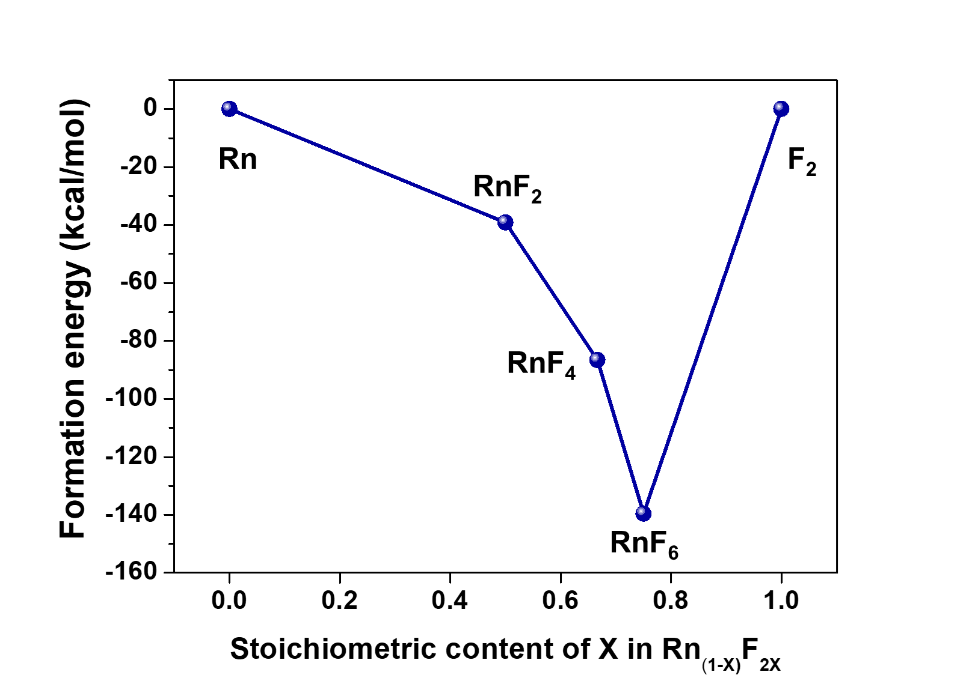
Supplementary Figure S1. Convex hull diagram of radon fluorides as well as Rn and F₂ with formation energy (kcal/mol).

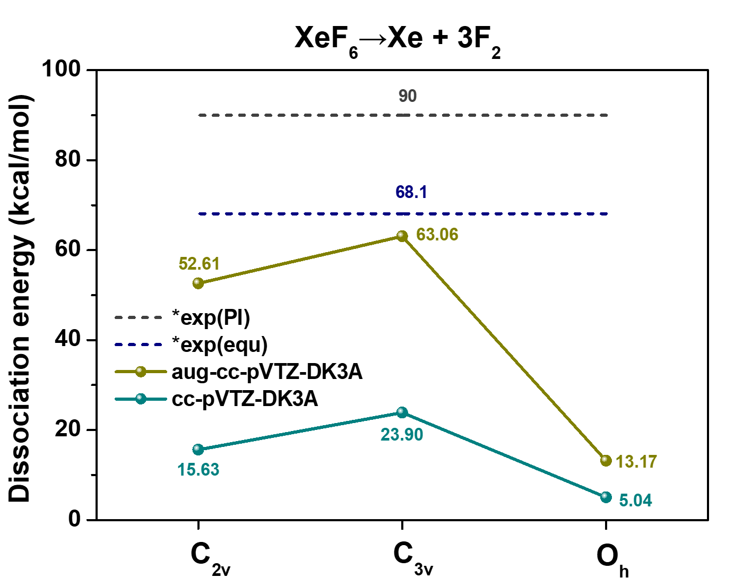
* The values obtained from the equilibrium³¹ (equ) and photoionization³² (PI) experiments.
Supplementary Figure S2. The dissociation energy of XeF6 → Xe +3F₂ with DK calculation by CCSD method.

