Supplementary Materials for

USP18 is an essential regulator of muscle cell differentiation and maturation

Cyriel Sebastiaan Olie¹, Adán Pinto-Fernández^{2,3}, Andreas Damianou^{2,3}, , Iolanda Vendrell^{2,3}, Hailiang Mei⁴, Bianca den Hamer¹, Erik van der Wal¹, Jessica C. de Greef¹, , Vered Raz^{1*} and Benedikt M. Kessler^{2,3}

* Corresponding author. Email: v.raz@lumc.nl; benedikt.kessler@ndm.ox.ac.uk

This PDF file includes:

Supplementary Text
Figs. S1 to S5
Tables S1 to S4
Fig. S1

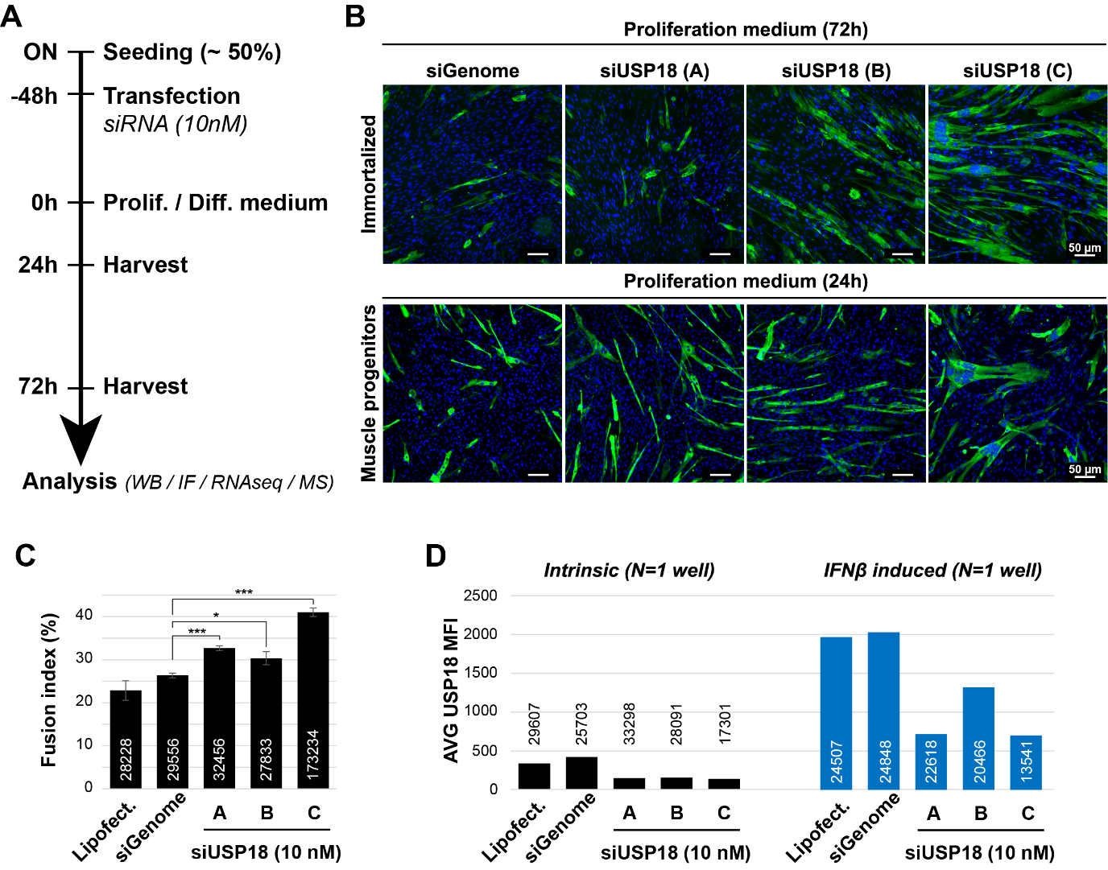
Figure S1. USP18 siRNAs reduce USP18 expression and induce premature differentiation. (A) A schematic overview of USP18 KD experimental setup. ON = overnight. All experiments were performed in at least three biological replicates. (B) Representative immunofluorescence images show MyHC staining after transfection of three USP18 siRNAs. Upper panel shows the effect after 72 hours in proliferation medium in immortalized muscle cells. Lower panel after 24 hours in proliferation for myogenic progenitor cells. Nuclei are counterstained with DAPI (blue). Scale bar is 50 μm. (C-D) Bar charts show the fusion index (C) and the respective USP18 mean fluorescence intensity (MFI) (D) of muscle progenitors. USP18 MFI was measured from untreated or IFNβ-treated cell cultures (D). Number of cells is above/inside the bars. In panel C, average and error bars (SD) are from N=3. Statistical significance is depicted by asterisks. (*: 0.05-0.005, or *** <0.0005). Panel D was average MFI over the indicated number of cells of one well.

Fig. S2

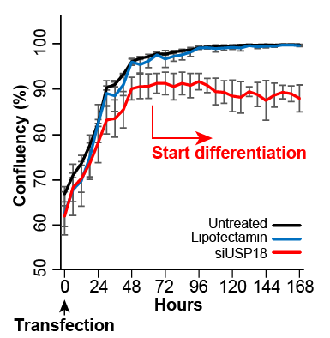

Figure S2. USP18 depletion stops cell growth. Graph shows a change in cellular confluency (%) in USP18 KD cells cultured in proliferation medium. Untreated, treated with transfection reagent only or transfected with siUSP18 are depicted with black, blue or red lines, respectively. Cell confluency was measured at 6h intervals. Averages and error bars are from N=3 biological replicates. Based on Fig. 2E, showing differentiation of USP18 KD at 24h timepoint (That is: 48h transfection + 24h new medium), ‘Start differentiation’ for USP18 KD is indicated at the 72h timepoint. Results were obtained in immortalized cell cultures.

Fig. S3

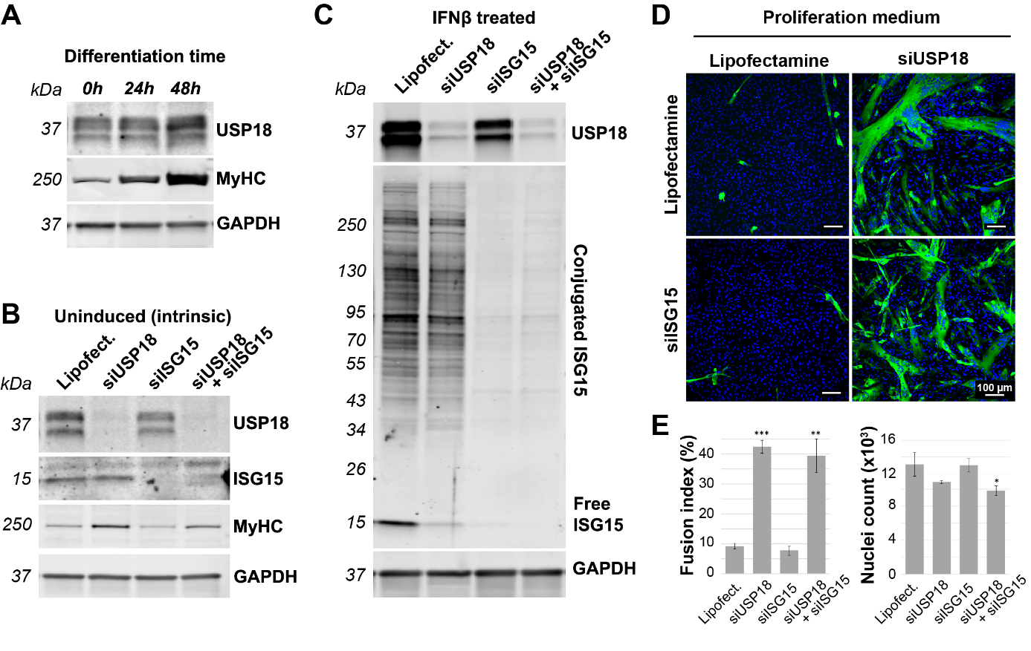
Figure S3. USP18 KD induces differentiation reprograming in myogenic progenitors. (A) Representative western blot shows USP18 and MyHC expression during differentiation. GAPDH indicates equal loading. (B-C) Representative western blots show USP18 and ISG15 expression. MyHC marks differentiation and GAPDH is a loading control. Panel B shows intrinsic (uninduced) protein expression and panel C shows expression after IFN-1 induction. (D) Representative immunofluorescence images show differentiating cells in siUSP18 cultures and co-transfection with siISG15 in proliferation medium. Scale bar is 100 μm. (E) Bar charts show fusion index and the respective cell count. Average and error bars (SD) are from N=3 biological replicates. Statistical significance is depicted by asterisks. (*: 0.05-0.005, **: 0.005-0.0005, *** <0.0005).

Fig. S4

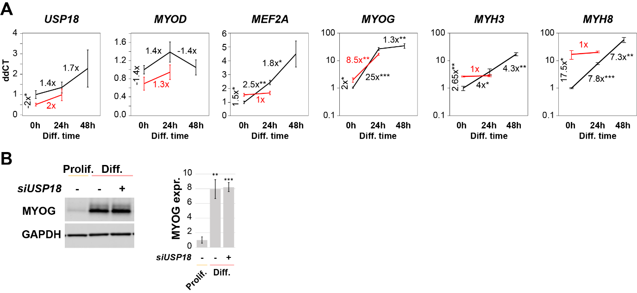
Figure S4. USP18 KD re-programs the myogenic regulatory factors profile, RT-qPCR validation. (A) Graphs show the average ddCT values for differentiation in control (black) and USP18 KD (red) cell cultures and the respective fold changes. (B) Representative western blot shows the MYOG expression. Bar chart shows the quantifications for which GAPDH was used as loading control. Expression levels were normalised to control samples in proliferation medium (Prolif.). Average and error bars (SD) are from N=3. Statistical significance is depicted by asterisks. (*: 0.05-0.005, **: 0.005-0.0005, *** <0.0005). Results were obtained in immortalized cell cultures.

Fig. S5

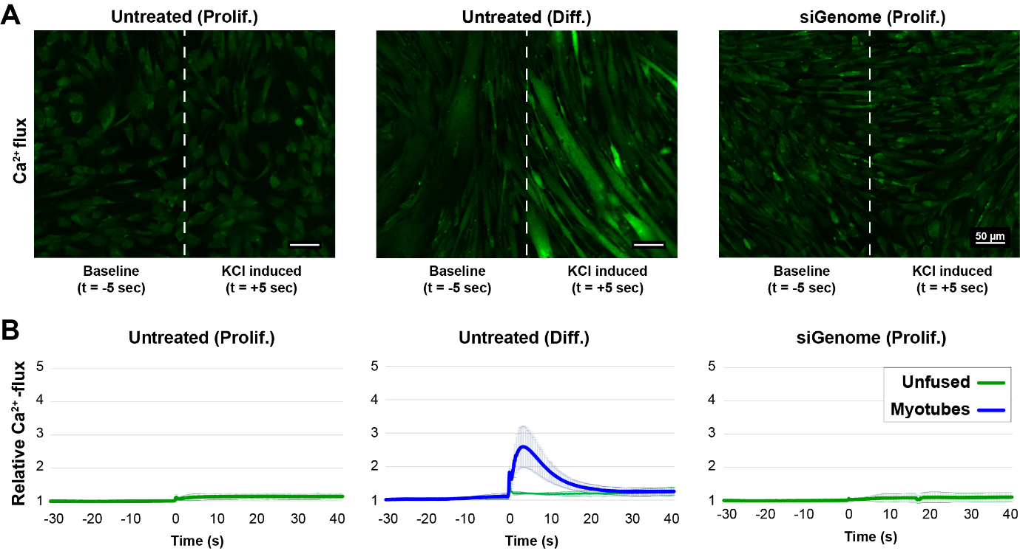Figure S5. Calcium flux for proliferating and differentiating immortalized muscle cells. (A) Representative images show the calcium flux (green signal) 5 seconds before or after KCl (10 mM) administration in untreated or siGenome transfected cells cultured in proliferation or differentiation medium. The respective images are separated by a white dashed line. Scale bar is 50 μm. (B) Graphs show the change in calcium flux over time. Calcium flux in uni-nucleated (unfused) or multi-nucleated (myotubes) cells is depicted by green or blue lines. Average and error bars (SD) are from N=3 biological replicates.

Table S1.

 | Protein | Dilution |  | Host | Supplier | Cat. number
 | Protein | IF | WB | Host | Supplier | Cat. number
Primary antibodies | USP18 | 1:100 | 1:1000 | anti-Rabbit | Cell signaling | #4813
Primary antibodies | ISG15 | 1:100 | 1:1000 | anti-Rabbit | Cell signaling | #2743
Primary antibodies | pSTAT1 | - | 1:1000 | anti-Rabbit | Cell signaling | #9167
Primary antibodies | GAPDH | - | 1:5000 | anti-Mouse | Invitrogen | MA5-15738
Primary antibodies | USP16 | - | 1:1000 | Anti-Rabbit | ProteinTech | 14055-1-AP
Primary antibodies | KLHL31 | - | 1:1000 | anti-Rabbit | ProteinTech | 24781-1-AP
Primary antibodies | TNNI1 | - | 1:1000 | anti-Rabbit | Novus Biologicals | NBP1-56641
Primary antibodies | MyHC | 1:250 | 1:250 | anti-Mouse | DSHB | MF20
Primary antibodies | TNNT3 | - | 1:1000 | anti-Mouse | DSHB | JLT12
Primary antibodies | TTN | 1:50 | - | anti-Mouse | DSHB | 9D10
 | Target | Fluorophore | Dil. | Supplier
2nd antibodies | Anti-Rabbit | Cy5 | 1:5000 | Thermo Fisher Scientific
2nd antibodies | Anti-Mouse  (IgG or IgM) | 488 | 1:5000 | Thermo Fisher Scientific
2nd antibodies | WB anti-Rb/M | 800/680 | 1:10000 | IRDye 800CW or IRDye 680RD (LI-COR)

Table S1. List of used antibodies for immunofluorescence and western blotting.
Table S2.

siRNA | Supplier | Cat. number / sequence
siGenome | Dharmacon | #D-001206-13
USP18 (A) | Eurofins | CUGCAUAUCUUCUGGUUUA
USP18 (B) | Eurofins | GGAAGAAGACAGCAACAUG
USP18 (C) | Thermo Fisher | AM16708, ID: 105194
ISG15 | Dharmacon | #L-004235-03-0005

Table S2. List of used siRNAs

Table S3. The USP18-dependent Transcriptome. Related to Fig. 3A-B and Fig. 4
Table S4. The USP18-dependent Proteome. Related to Fig. 5

