Supplemental Table 1: Summary of mutations based on the location of the primary tumor
Supplemental Table 1: Summary of Mutations based on the location of primary tumor
 | Location of primary tumor
Variable | Right  (N=68) | Left/Sigmoid (N=69) | Rectum  (N= 103) | p-value
Liver Tumor histology
Desmoplastic | 31 (46%) | 28 (41%) | 46 (44%) | 0.8261
Non-desmoplastic | 37 ( 54%) | 41 (59%) | 58 (56%) | 0.8261
KRAS mutation in primary tumor
Yes | 10 (56%) | 4 (24%) | 11 (34%) | 0.1313
No | 8 (44%) | 13 (76%) | 21 (66%) | 0.1313
KRAS mutation in liver tumor
Yes | 19 (56%) | 7 (23%) | 17 (35%) | 0.0241
No | 15 (44%) | 23 (77%) | 31 (65%) | 0.0241
KRAS mutation in Liver or primary tumor
Yes | 24 (56%) | 9 (25%) | 26 (39%) | 0.0197
No | 19 (44%) | 27 (75%) | 41 (61%) | 0.0197
NRAS mutation in primary tumor
Yes | 1 (6.0%) | 2 (12.0%) | 0 (0%) | 0.1605
No | 17 (94.0%) | 15 (88.0%) | 32 (100%) | 0.1605
NRAS mutation in Liver tumor
Yes | 0 (0%) | 1 (3.0%) | 1 (2.0%) | 0.5999
No | 33 (100%) | 29 (97%) | 46 (98%) | 0.5999
NRAS mutation in Liver or primary tumor
Yes | 1 (2.0%) | 2 (6.0%) | 1 (2.0%) | 0.4861
No | 41 (98%) | 34 (94%) | 65 (98%) | 0.4861
BRAF mutation in primary tumor
Yes | 2 (11%) | 1 (6.0%) | 1 (3.0%) | 0.5197
No | 16 (89%) | 16 (94%) | 31 (97%) | 0.5197
BRAF mutation in Liver tumor
Yes | 4 (12%) | 1 (3.0%) | 2 (3.0%) | 0.2581
No | 29 (88%) | 29 (97%) | 46 (96%) | 0.2581
BRAF mutation in Liver or primary tumor
Yes | 5 (12%) | 1 (3.0%) | 2 (3.0%) | 0.0988
No | 37 (88%) | 35 (97%) | 65 (97%) | 0.0988
TP53 Mutation in the primary tumor
Yes | 1 (3.0%) | 1 (3.0%) | 2 (4%) | 0.9601
No | 32 (97%) | 29 (97%) | 44 (96%) | 0.9601
APC Mutation in the primary tumor
Yes | 3 (9.0%) | 3 (10%) | 4 (8.0%) | 0.9690
No | 30 (91%) | 27 (90%) | 44 (92%) | 0.9690
PIK3CA Mutation in the primary tumor
Yes | 7 (21%) | 1 (03%) | 2 (04%) | 0.0139
No | 26 (79%) | 29 (97%) | 46 (96%) | 0.0139
CTNNB2 Mutation in the primary tumor
Yes | 1 (03%) | 0 (00%) | 0 (00%) | 0.3034
No | 32 (97%) | 30 (100%) | 48 (100%) | 0.3034
MAP2K1 Mutation in the primary tumor
Yes | 1 (03%) | 0 (00%) | 0 (00%) | 0.3034
No | 32 (97%) | 30 (100%) | 48 (100%) | 0.3034
AKT1 Mutation in Liver or primary tumor
Yes | 1 (03%) | 0 (00%) | 0 (00%) | 0.3034
No | 32 (97%) | 30 (100%) | 48 (100%) | 0.3034
ERBB2 Mutation in Liver or primary tumor
Yes | 0 (00%) | 0 (00%) | 1 (03%) | 0.5740
No | 18 (100%) | 17 (100%) | 31 (97%) | 0.5740
Number of Mutation in liver
0 | 9 (26%) | 19 (63%) | 23 (49%) | 0.0042
1 | 12 (35%) | 9 (30%) | 20 (43%) | 0.0042
2 | 12 (35%) | 2 (07%) | 4 (09%) | 0.0042
3 | 1 (03%) | 0 (00%) | 0 (00%) | 0.0042
Number of Mutations in primary tumor
0 | 5 (28%) | 10 (59%) | 17 (53%) | 0.4026
1 | 9 (50%) | 5 (29%) | 11 (34%) | 0.4026
2 | 3 (17%) | 2 (12%) | 4 (13%) | 0.4026
3 | 1 (06%) | 0 (00%) | 0 (00%) | 0.4026

Supplemental Figure 1: Survival of Right-sided Primary tumors by Histopathologic Growth Pattern
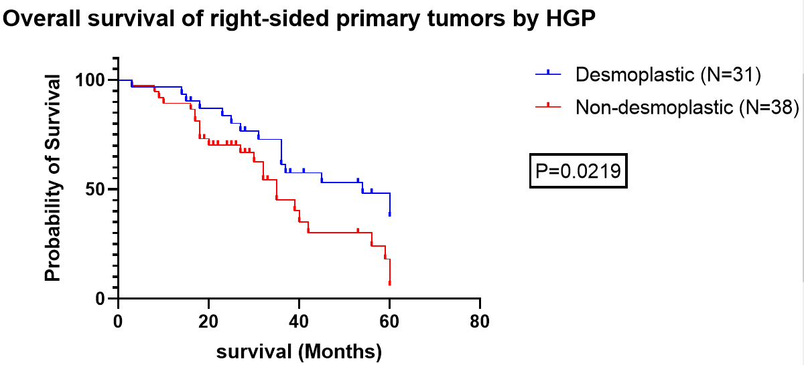

Supplemental Figure 2: Overall survival of entire cohort from diagnosis of liver metastasis
