Field trial of an automated batch chlorinator system at two shared shallow tubewells among camps for forcibly displaced Myanmar nationals (FDMN) in Cox's Bazar, Bangladesh

Nuhu Amin^{1*}, Mahbubur Rahman¹, Mahbub-Ul Alam¹, Abul Kasham Shoab¹, Md. Kawsar Alome², Maksudul Amin², Tarique Mohammad Nurul Huda¹, Leanne Unicomb¹

¹Enviromental Interventions Unit, Infectious Diseases Division, icddr,b, Dhaka, Bangladesh
²Action Against Hunger, Bangladesh
*Correspondence to: Nuhu Amin, email: nuhu.amin@icddrb.org

Table S1: Free residual chlorine concentration level with different iron concentrations in 4 tubewells in FDMN-camp, Cox’s Bazar, 2018
Sampling Dates | Tubewell ID | Concentration of iron (mg/L) | ~5.25% NaOCL: Water (mL) | Concentration of chlorine used for treatment |  | Concentration of Free Chlorine (mg/L)
8/28/2018 | 17* | <0.2 | 1500:750 |  | 3.5% | 9.1
8/28/2018 | 17 | <0.2 | 1500:750 |  | 3.5% | 8.6
8/28/2018 | 17 | <0.2 | 1500:750 |  | 3.5% | 9.3
8/28/2018 | 17 | <0.2 | 1500:750 |  | 3.5% | 10.3
Mean free chlorine concentration (SD) |  |  |  |  |  | 9.3 (0.7)
8/29/2018 | 13 | 6.5 | 1500:750 |  | 3.5% | 3.5
8/29/2018 | 13 | 6.5 | 1500:750 |  | 3.5% | 0.02
8/31/2018 | 13 | 6.5 | 1500:500 |  | 3.9% | 0.4
8/31/2018 | 13 | 6.5 | 1500:500 |  | 3.9% | 0.4
Mean free chlorine concentration (SD) |  |  |  |  |  | 1.11 (1.6)
8/29/2018 | 2** | 7 | 1000:500 |  | 3.5% | 0.04
Mean free chlorine concentration (SD) |  |  |  |  |  | 0.04
8/31/2018 | 5 | 1.5 | 1500:750 |  | 3.5% | 4.2
8/31/2018 | 5 | 1.5 | 1500:750 |  | 3.5% | 2.6
8/31/2018 | 5 | 1.5 | 1500:750 |  | 3.5% | 4.4
8/31/2018 | 5 | 1.5 | 1500:750 |  | 3.5% | 3.7
Mean free chlorine concentration (SD) |  |  |  |  |  | 3.73 (0.83)
*At the beginning of the field trial, we had installed Zimba at deep tubewell ID-17, but we received complaints from the household users that the handle had become too tight to pump water. Hence, we removed the Zimba from tubewell ID-17.
**Tubewell 2 had a very high (7 mg/L) concentration of iron and it was not providing sufficient residual chlorine immediately after treatment. Additionally, the color of the water became red due to chemical reaction between iron and residual chlorine immediately after mixing resulting in the removal the Zimba from tubewell ID-2.
Figure S1: Zimba automated chlorine dispenser. Figure provided by inventor Suprio Das.
Figure showing (a) Outer box: upper part of outer box holds dosing chamber and lower part acts as secondary tank which water flushes into after chlorination. (b) Dosing chamber: this chamber holds an automatic siphon and the chlorine dispenser. As untreated water from the handpump starts filling up this chamber, 3 mL of sodium hypochlorite solution is ejected from the chlorine dispenser into this water. When the water level reaches the high-water level (10 L) the automatic siphon is triggered and this 10 L of treated water is flushed into the secondary tank. (c) Siphon: Water from the dosing chamber flushes into the secondary tank through the siphon. (d) Chlorine dispenser: This consists of a chlorine reservoir and a combination of interconnected pipes and tubes. Dimensions of the Zimba are 76 cm x 45 cm x 25 cm; the outer casing, dosing chamber and the siphon are made of fiberglass and the dispensers are made of acrylic.

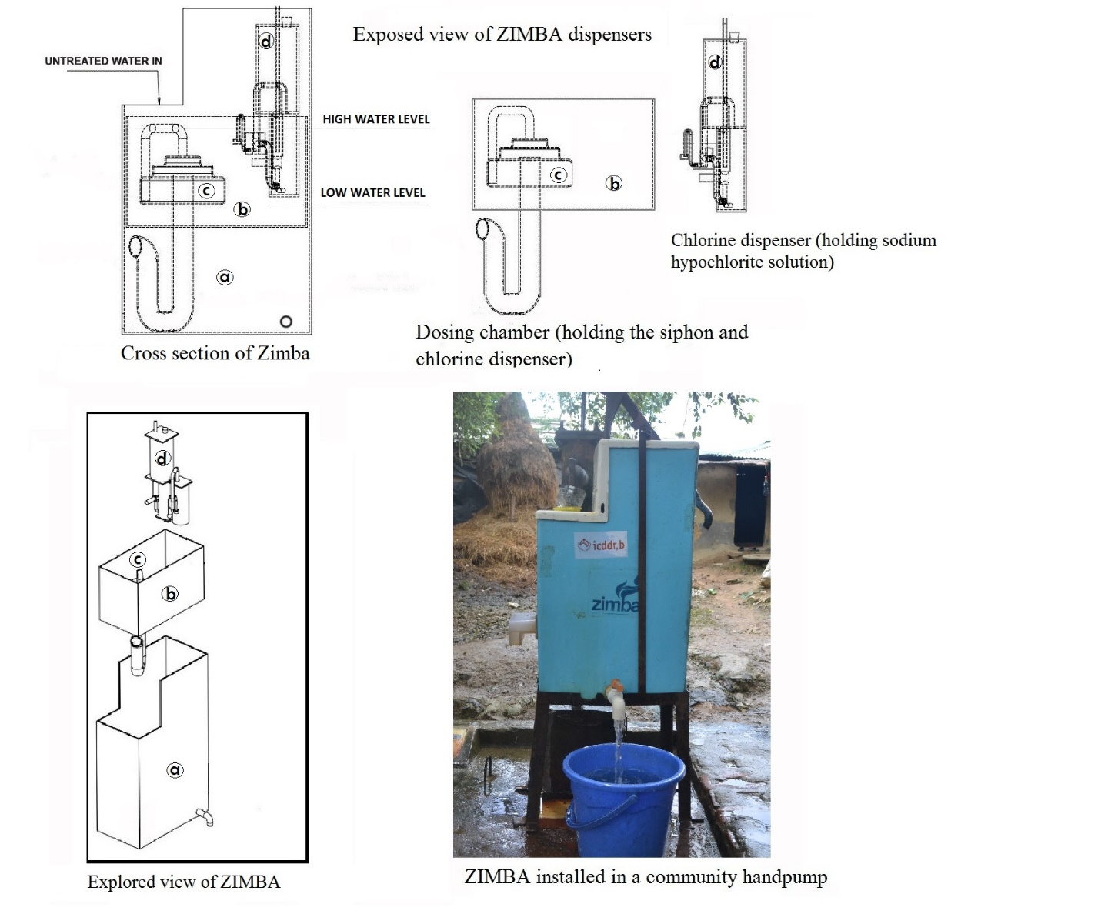
Figure S2: Study site map
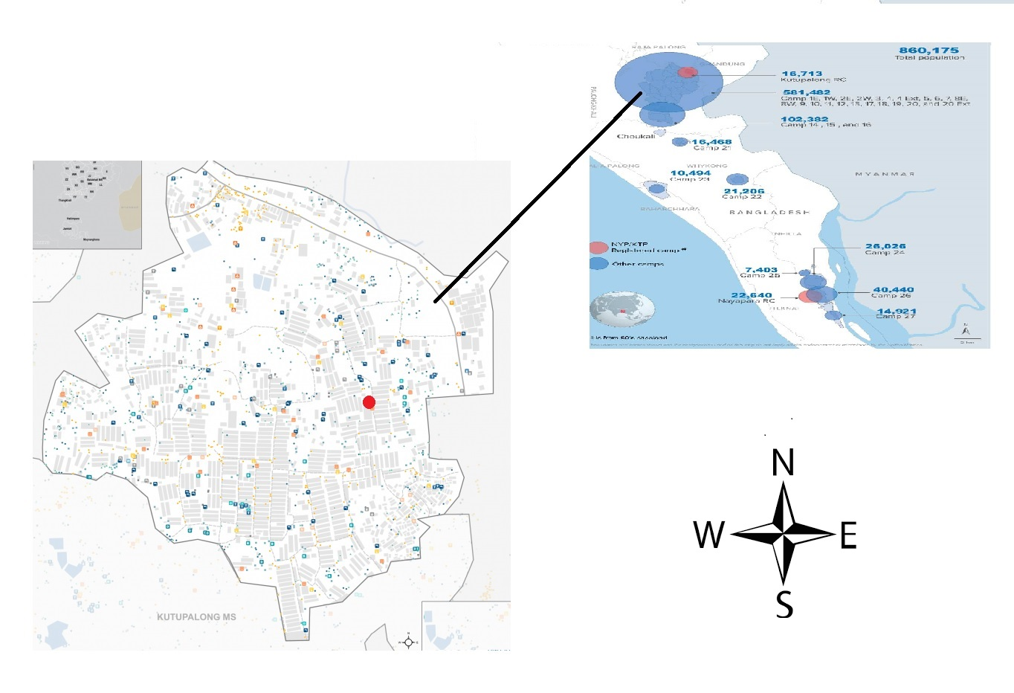
Figure S3: Study flow chart
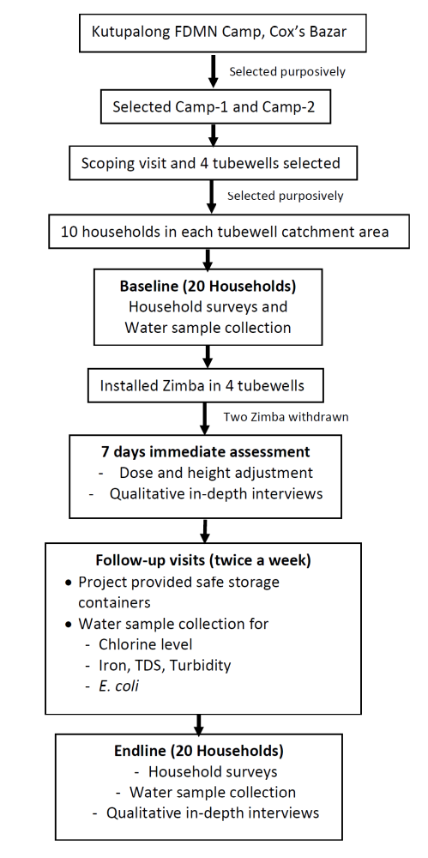
Figure S3: Raised foot step to resolve the increased height of tubewell after Zimba installation, Rohingya camp, Cox’s Bazar-2017
