Supplementary. Table 2. List of genes included in the SYSUCC Personalized Diagnostics Pane (Tumor tissues)
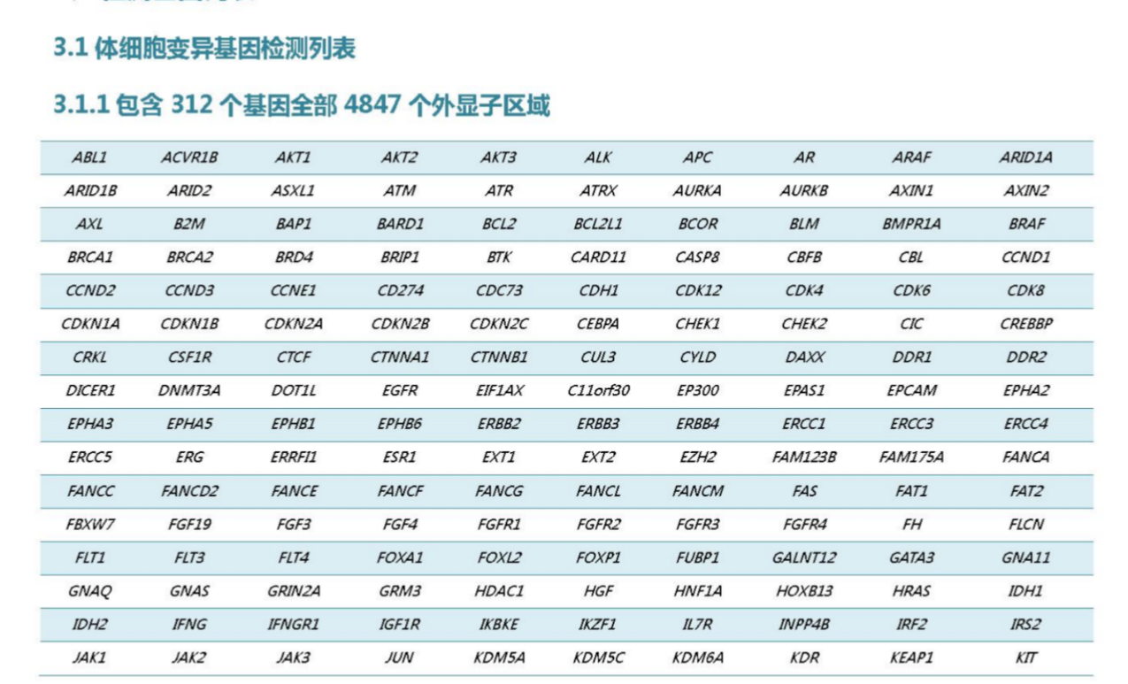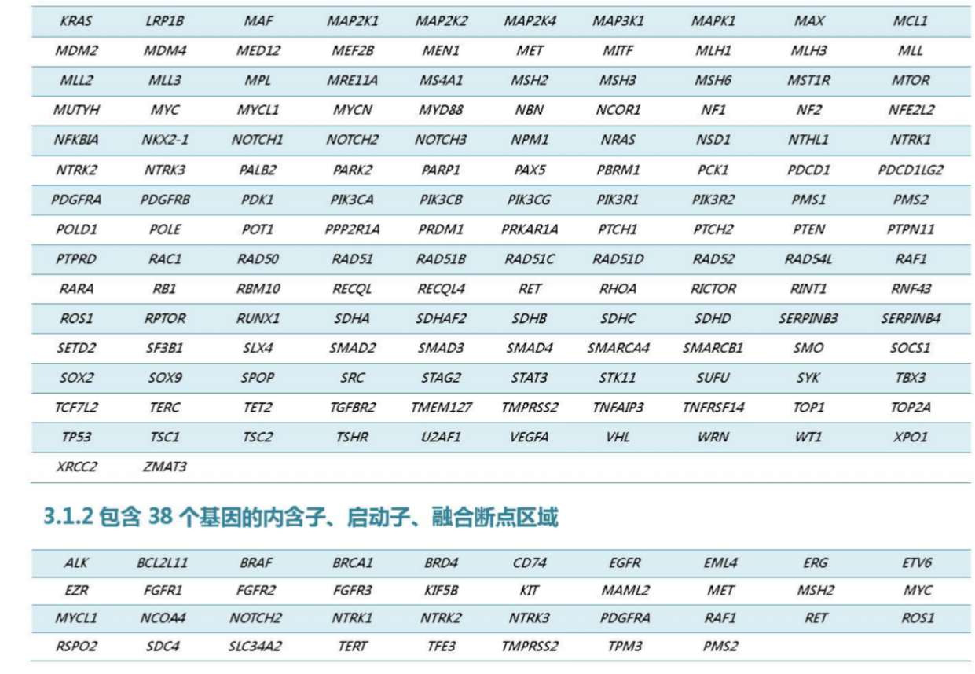
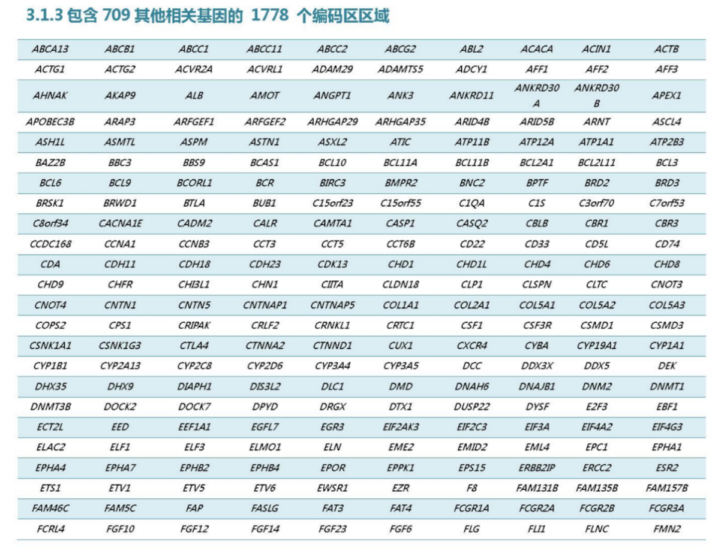
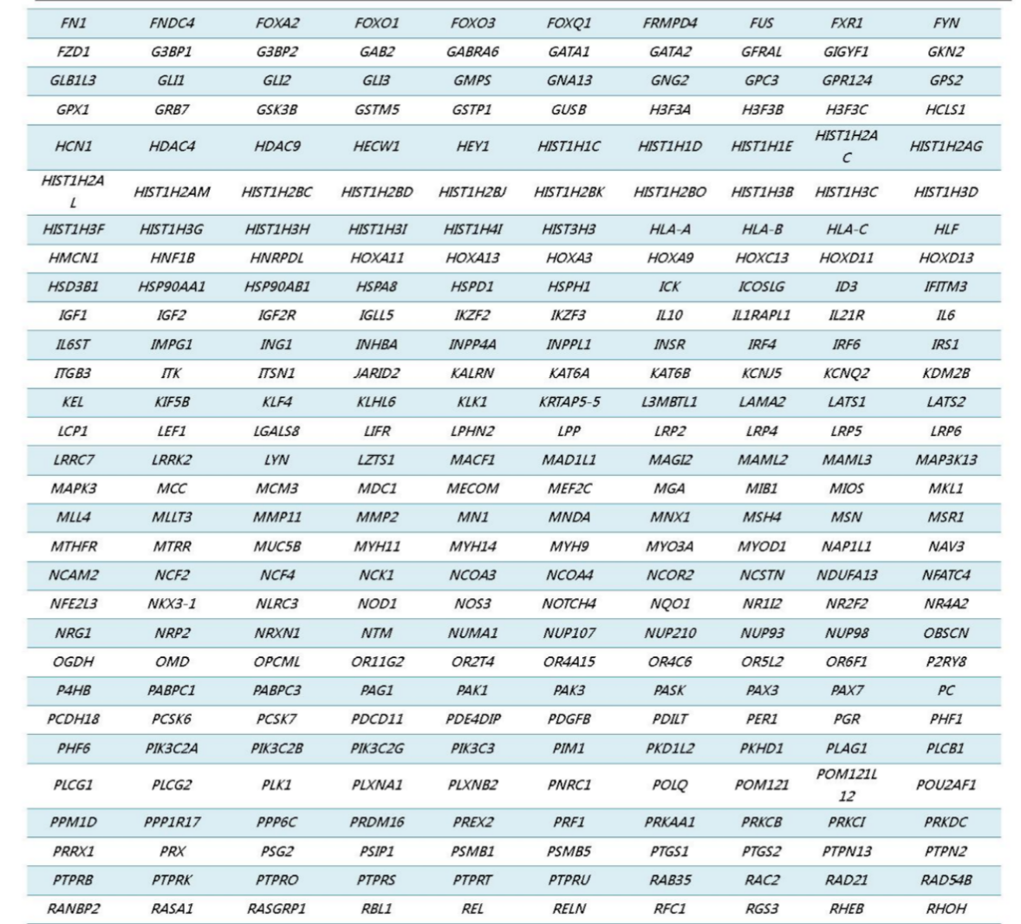
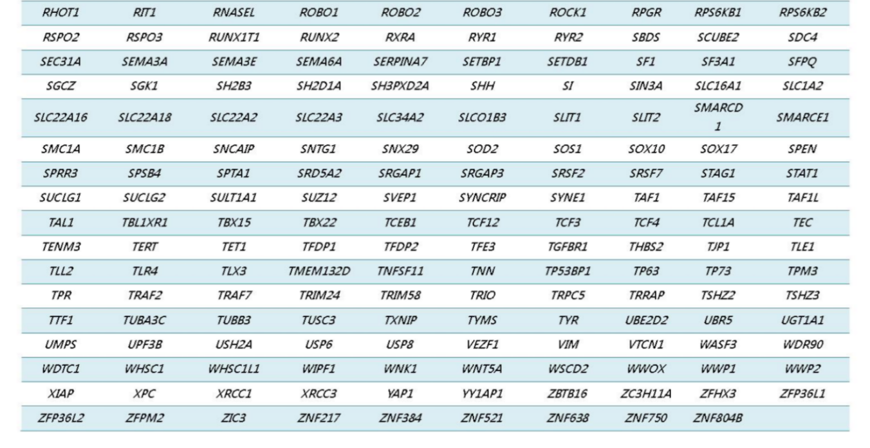

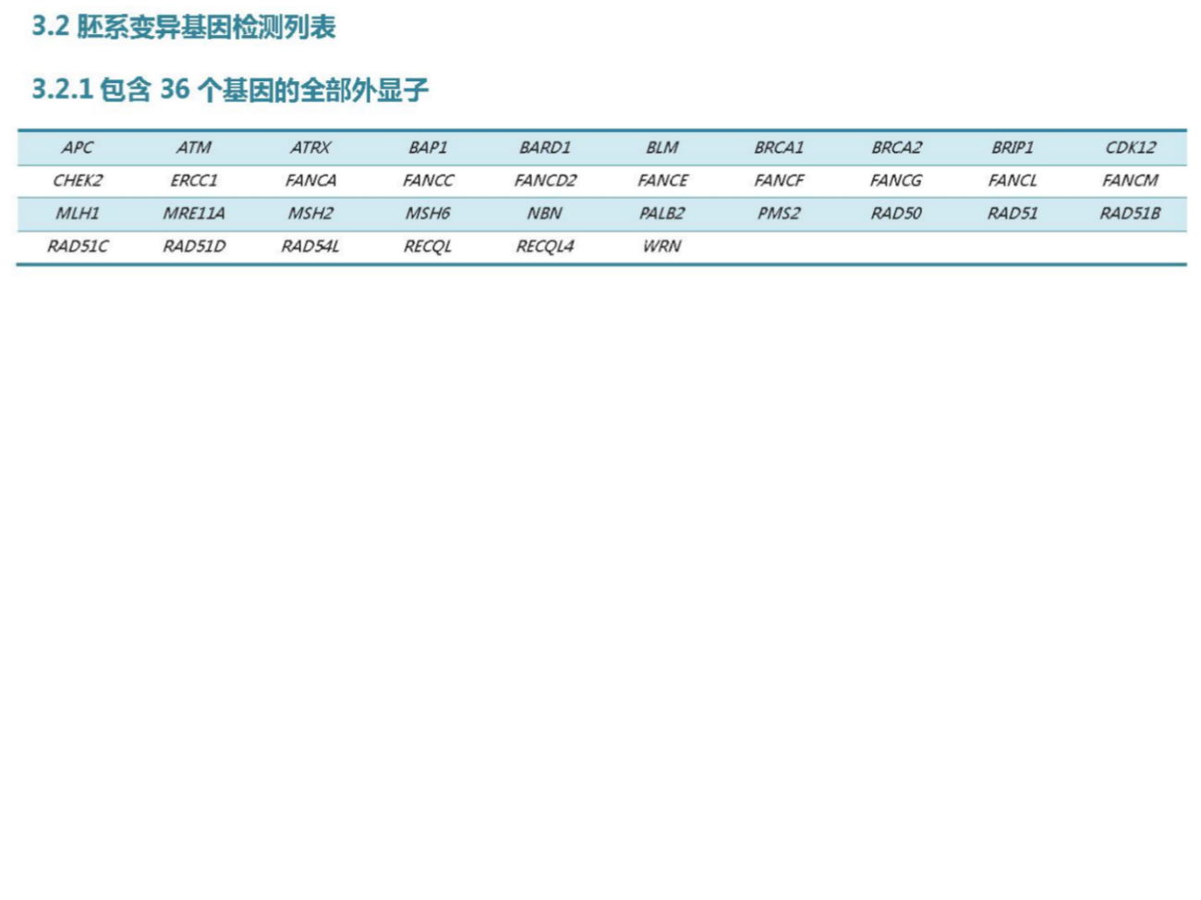

Supplementary. Table 4. Demographic and clinical characteristics of SWI/SNF mutant patients with advanced NSCLC who received Docetaxel or Atezolizumab in the POPLAR/AOK Cohort.

Clinical Characteristic | Docetaxel  N= 116 | Atezolizumab  N=118 | P value
Age, n(%)  >65 years  ≤65 years | 44(37.93%)  72(62.07%) | 40(33.90%)  78(66.10%) | 0.6124
Sex, n(%)  Male  Female | 76(65.52%)  40(34.48%) | 77(65.25%)  41(34.75%) | 0.9999
Race, n(%)  White  Asian  Other | 96(82.76%)  13(11.21%)  7(6.03%) | 87(73.73%)  17(14.41%)  14(11.86%) | 0.1928
ECOG PS score, n(%)  0  1 | 33(28.45%)  83(71.55%) | 41(34.75%)  77(65.25%) | 0.3707
Smoking status, n(%)  Never  Current  Previous | 8(6.90%)  22(18.96%)  86(74.14%) | 10(8.47%)  24(20.34%)  84(71.19%) | 0.8540
Histology, n(%)  Nonsquamous  Squamous | 76(65.52%)  40(34.48%) | 80(67.80%)  38(32.20%) | 0.8172
No.of prior therapies, n(%)  1  2 | 108(63.91%)  61(73.85%) | 48(36.09%)  17(26.15%) | 0.1970

Supplementary. Table 5. Co-occurring mutations affect the responses to ICIs for SWI/SNF mutant advanced NSCLC.

 | HR (95%CI) | P Value | Beta | Wald test
TP53 Mutant VS. Wild type | 0.319(0.131- 0.775) | 0.012* | -1.143 | 6.37
LRP1B Mutant VS. Wild type | 0.533(0.228-1.243) | 0.145 | -0.630 | 2.12
EPH Family Mutant VS. Wild type | 1.074(0.473-2.441) | 0.865 | 0.071 | 0.03
KRAS Mutant VS. Wild type | 0.561(0.210-1.501) | 0.25 | -0.578 | 1.32
STK11/KEAP1 Mutant VS. Wild type | 3.378(1.323-8.627) | 0.011* | 1.217 | 6.48
CDKN2A Mutant VS. Wild type | 0.775(0.181-3.321) | 0.732 | -0.255 | 0.12
MET Mutant VS. Wild type | 0.972(0.128-7.351) | 0.978 | -0.029 | 0.01
ERBB2 Mutant VS. Wild type | 4.232(1.159-15.450) | 0.029* | 1.443 | 4.77

