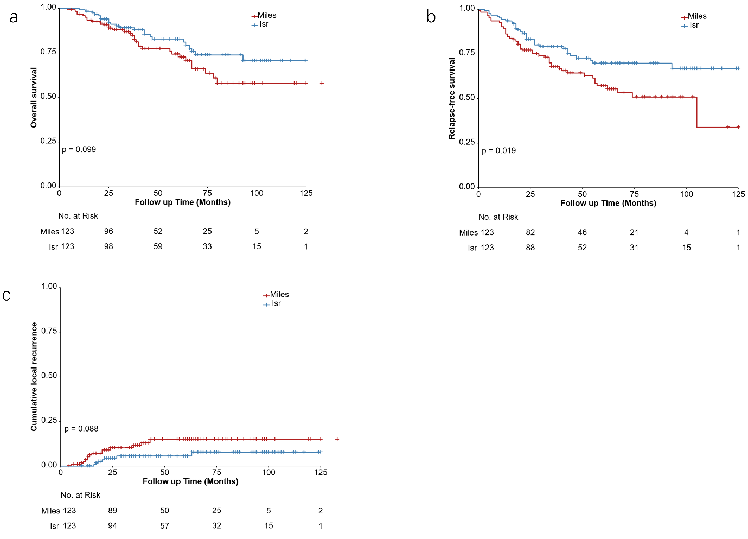
Supplementary Fig. 1 Five-year disease-free survival curves for the ISR and APR groups before PSM. (a) Overall survival, (b) Relapse-free survival, (c) Cumulative local recurrence
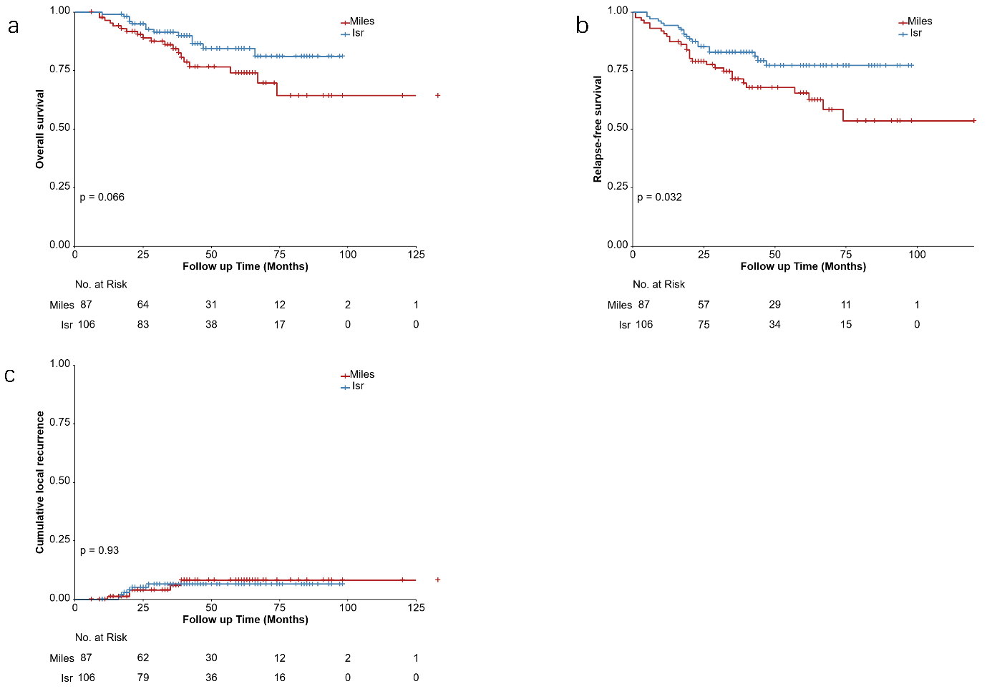
Supplementary Fig. 2 Five-year survival rates of patients who received laparoscopic surgery before PSM. (a) Overall survival, (b) Relapse-free survival, (c) Cumulative local recurrence

