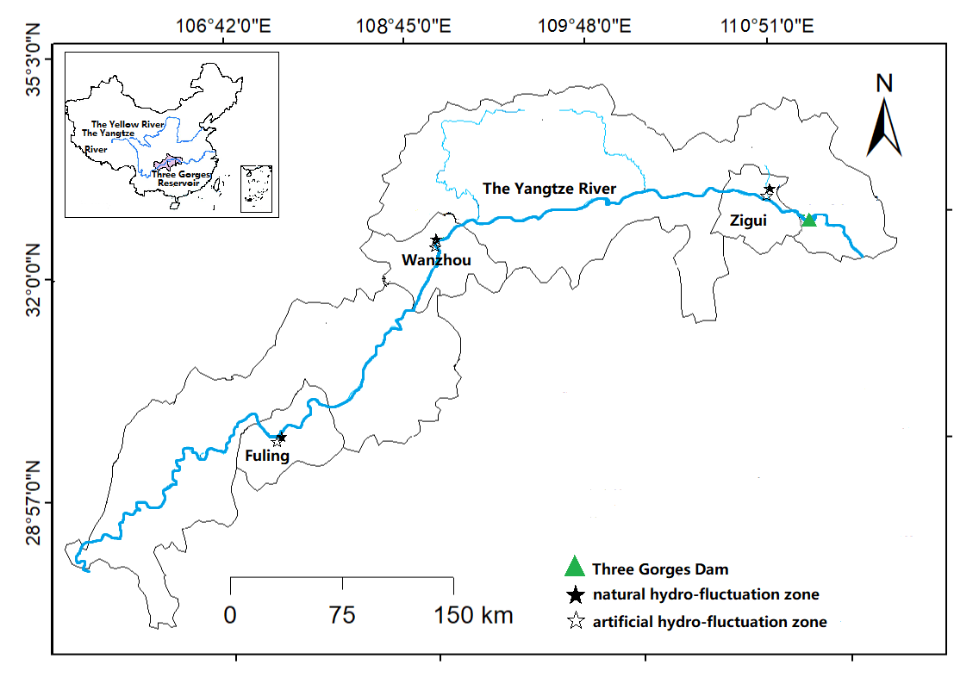
Fig. S1 Soil sample sampling sites
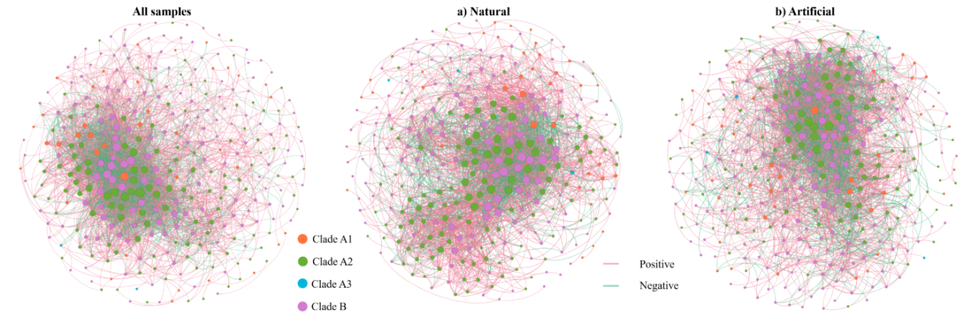
Fig. S2 Co-occurrence network analysis of all CMX NB clades in natural and artificial hydro-fluctuation zones

