Supplementary information for:

Quantifying the processes of accelerated wintertime Tibetan Plateau warming: External forcing versus local feedbacks

Mengchu Zhaoª, Xiu-Qun Yang^{a, b}, Lingfeng Taoª
ª CMA-NJU Joint Laboratory for Climate Prediction Studies, School of Atmospheric Sciences, Nanjing University, Nanjing 210023, China
^{b} Southern Marine Science and Engineering Guangdong Laboratory (Zhuhai), Zhuhai 519082, China

Contents of this files:
Figs. S1-S7

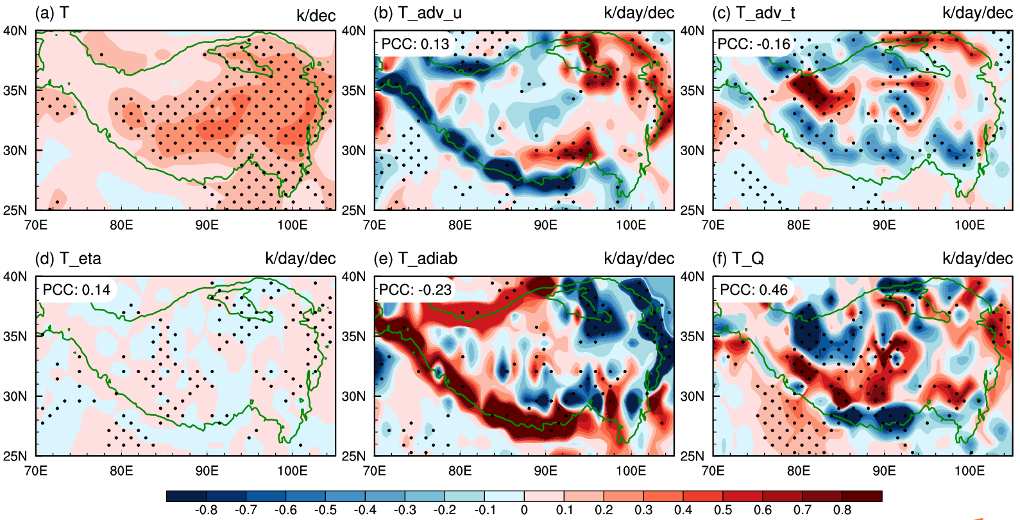
Figure S1. Horizontal distributions of linear trends of (a) the temperature (K/dec) and its budget anomalies (K/day/dec) for (b) horizontal advection of climatological temperature by anomalous wind, (c) horizontal advection of climatological wind by anomalous temperature, (d) vertical temperature advection, (e) adiabatic heating, and (f) diabatic heating on the lowest model level for JRA-55. The black dots denote the trends with the confidence level exceeding 95%. The green curve outlines the TP areas with an averaged altitude higher than 3000m.

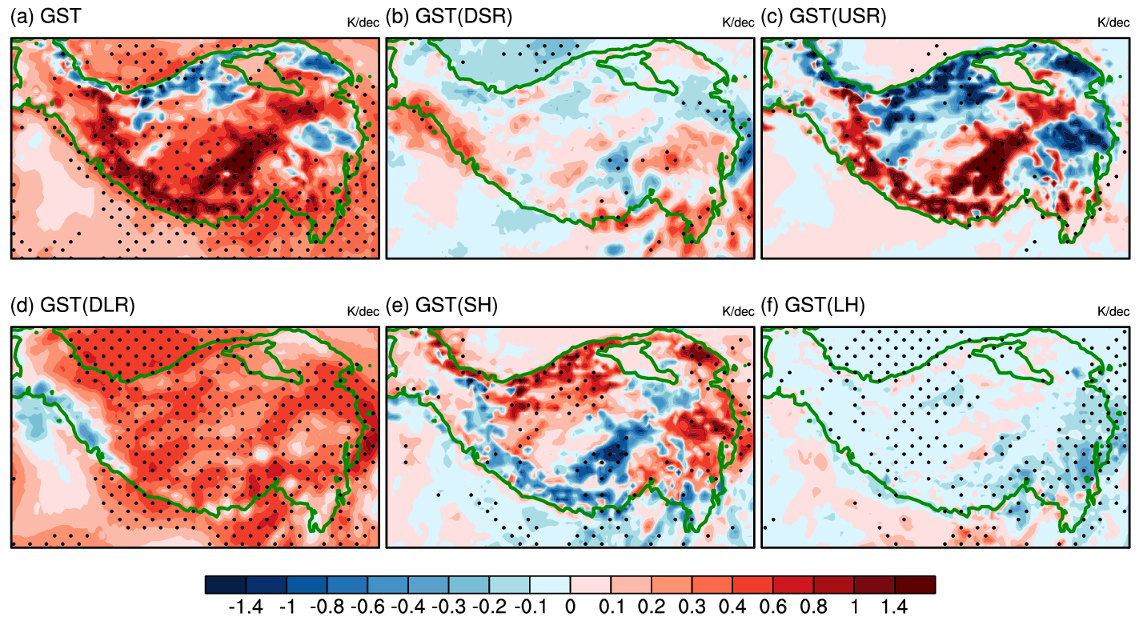
Figure S2. Horizontal distributions of linear trends of (a) the GST anomalies (K/dec) and its components constrained by the surface energy balance due to changes in (b) downward shortwave radiation (DSR), (c) upward shortwave radiation (USR), (d) downward longwave radiation (DLR), (e) surface sensible heat flux (SH), and (f) surface latent heat flux (LH) for CRA-40. The black dots denote the anomalies with the confidence level exceeding 95%. The green curve outlines the TP areas with an averaged altitude higher than 3000m.

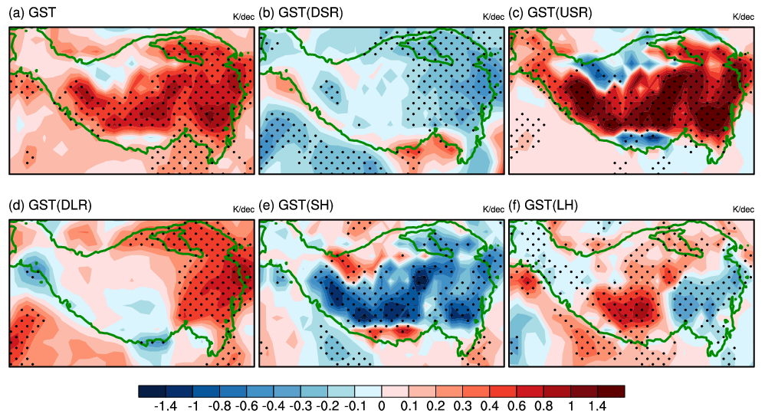
Figure S3. As in Fig. S2, but for JRA-55.

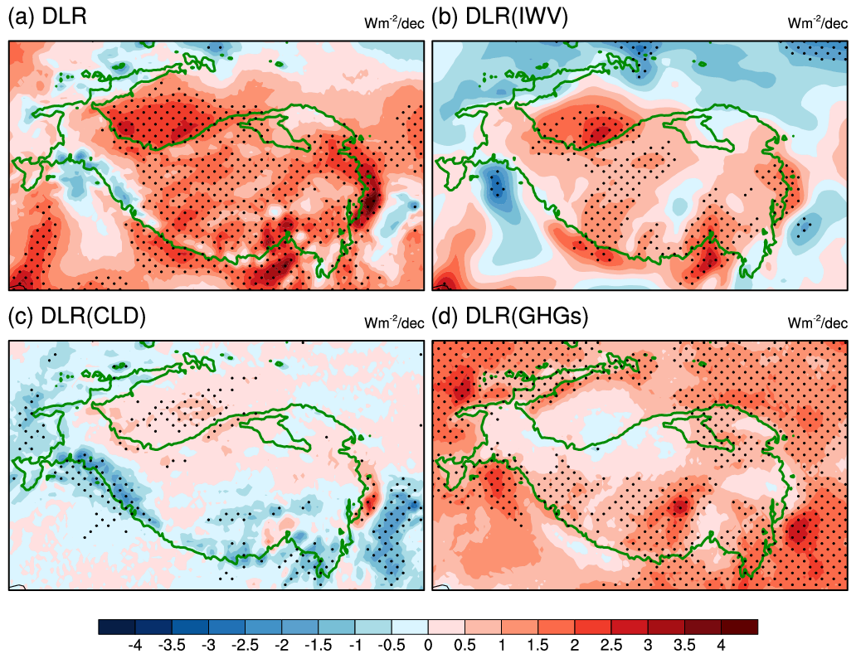
Figure S4. Horizontal distributions of linear trends of (a) the downward longwave radiation (DLR) flux anomalies (Wm⁻²/dec) and their components due to changes in (b) atmospheric water vapor, (c) cloud, and (d) anthropogenic greenhouse gases for CRA-40. The black dots denote the anomalies with the confidence level exceeding 95%. The green curve outlines the TP areas with an averaged altitude higher than 3000m.

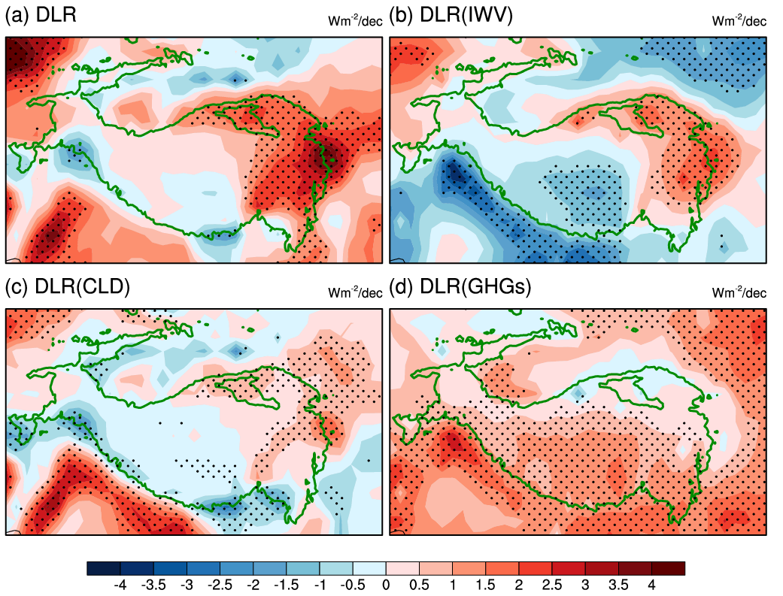
Figure S5. As in Fig. S4, but for JRA-55.

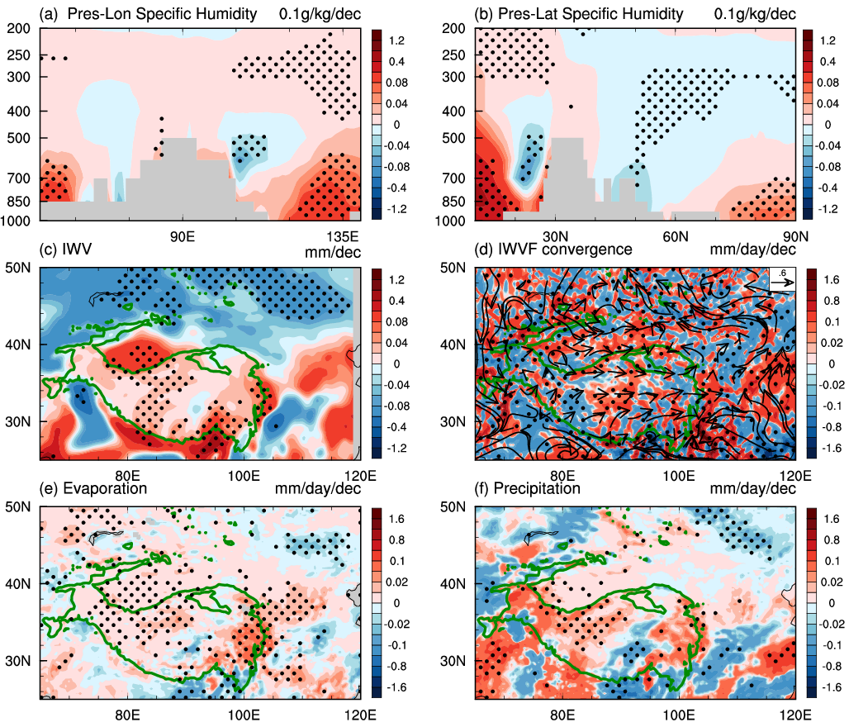
Figure S6. (a) Longitude-altitude and (b) latitude-altitude sections of linear trends of the specific humidity anomalies (0.1g/kg/dec) over TP for CRA-40. Horizontal distributions of linear trends of (c) the vertically integrated water vapor anomalies (mm/dec), (d) vertically integrated water vapor flux anomalies (vectors; kg/m/s/dec) and their convergences (shading; mm/day/dec), (e) the surface evaporation anomalies (mm/day/dec), and (f) the precipitation anomalies (mm/day/dec) for CRA-40. The black rectangle areas in (a) and (b) represent the TP region. The black dots denote the anomalies in shaded fields with the confidence level exceeding 95%. The green curve outlines the TP areas with an averaged altitude higher than 3000m.

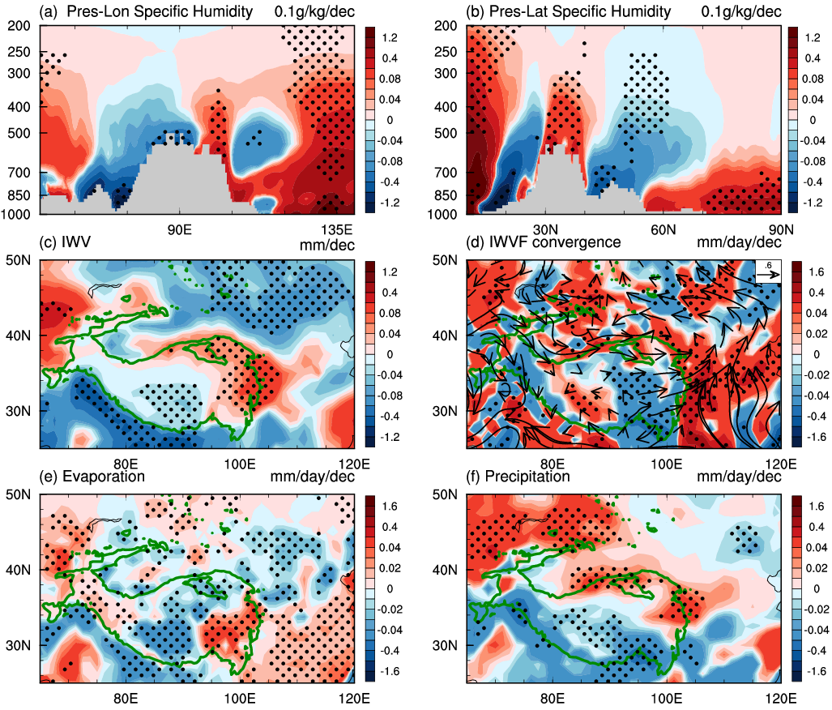
Figure S7. As in Fig. S6, but for JRA-55.

