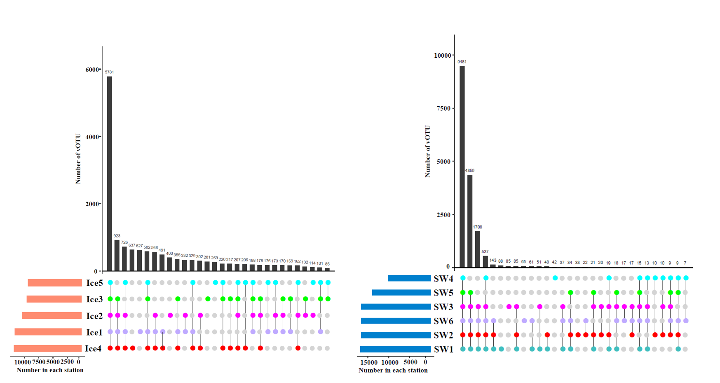
Fig. S1 UpSet plot visualizing the intersecting sets of viral operational taxonomic units (vOTUs) at different samples.
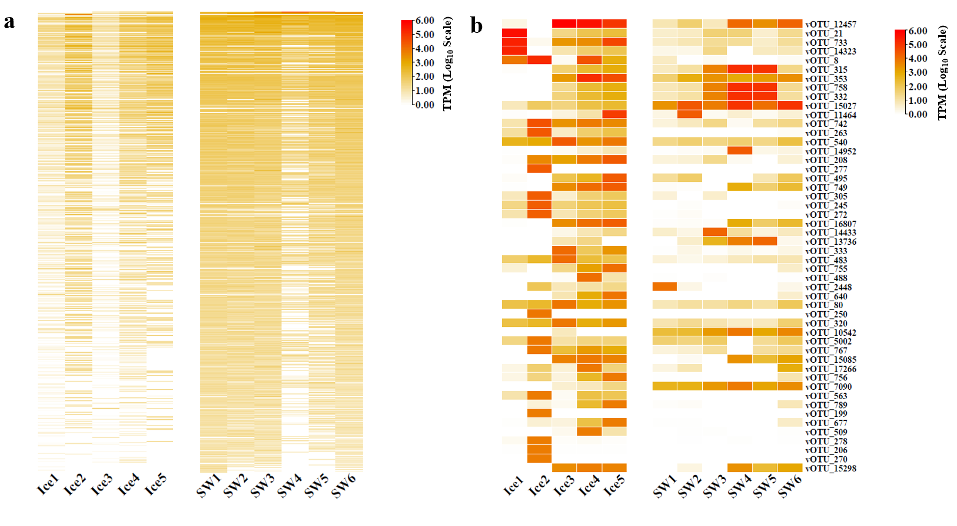Fig. S2 Heatmap showing the relative abundance of vOTUs in eleven viromes. a) All vOTUs with their relative abundance of ASIWV. b) The 50 most abundant vOTUs in all viromes.
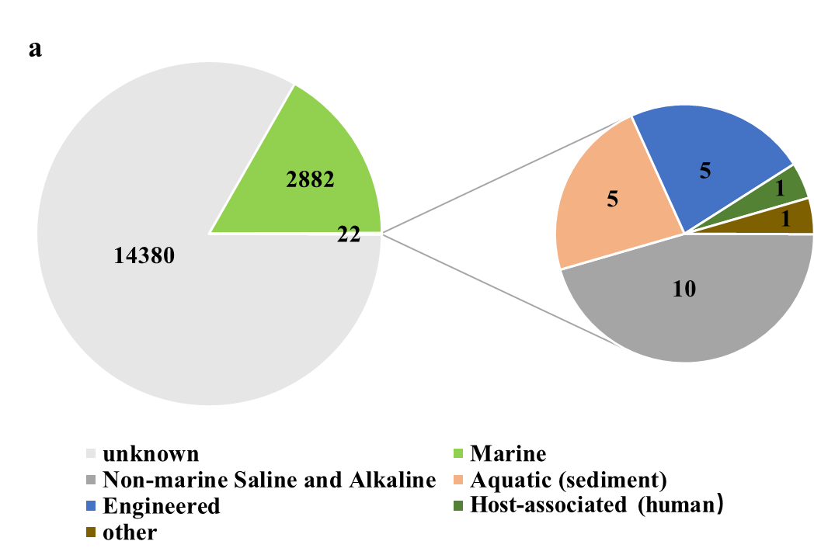
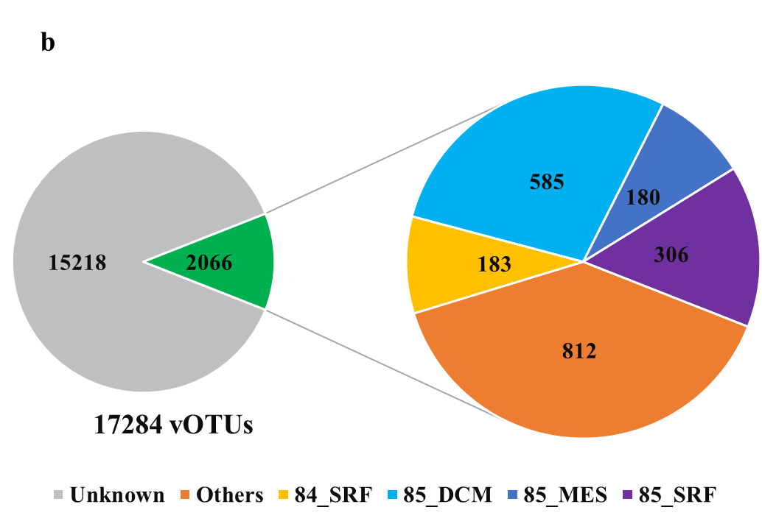
Fig. S3 The comparison results between ASIWV and known datasets. a) The comparison result between ASIWV and IMG/VR v3 dataset. b) The comparison result between ASIWV and GOV2.0. The large circle indicates the number of vOTUs that are aligned to GOV2.0, and the four samples 84_SRF, 85_DCM, 85_MES and 85_SRF were from the Antarctic region.

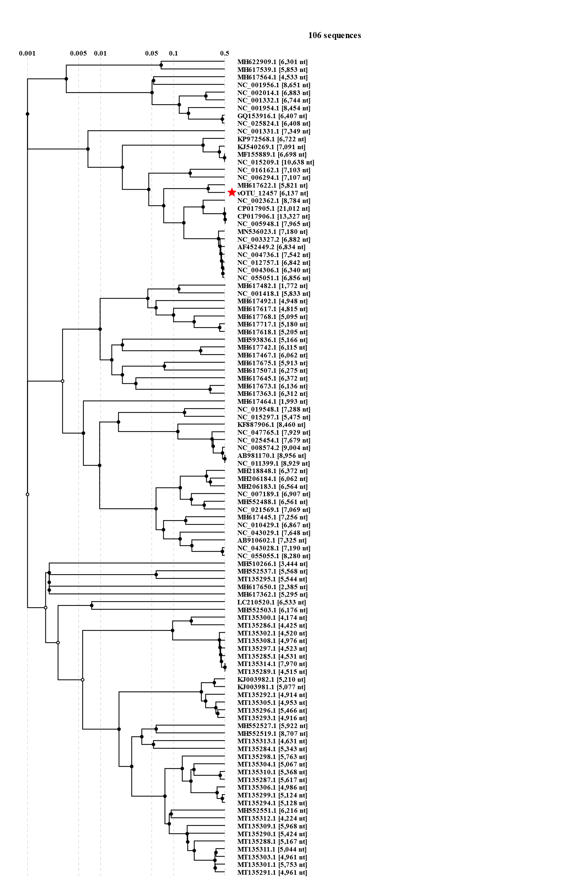
Fig. S4 The phylogenetic analysis of the vOTU_12,457 with the highest relative abundance in ASIWV, and 105 reference sequences belong to Inoviridae from NCBI.

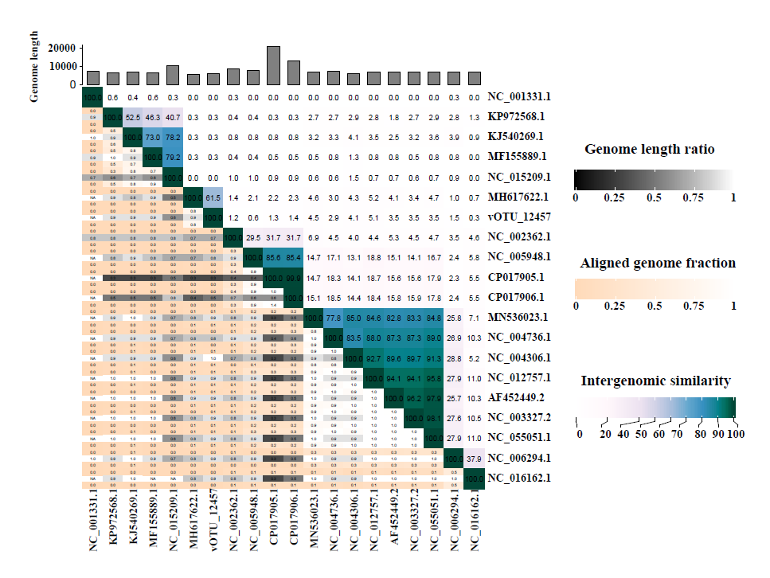
Fig. S5 The heatmap ANI values of viruses on the same evolutionary tree branch which includes the vOTU_12,457.

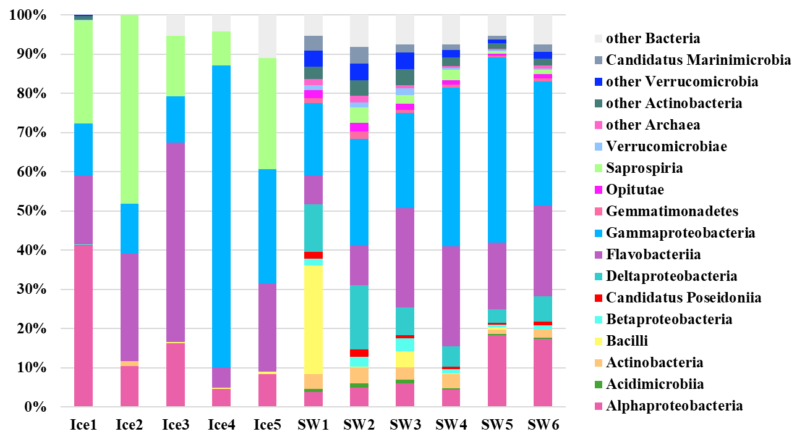
Fig. S6 The community structure of metagenome-assembled genomes (MAGs) at the class level.

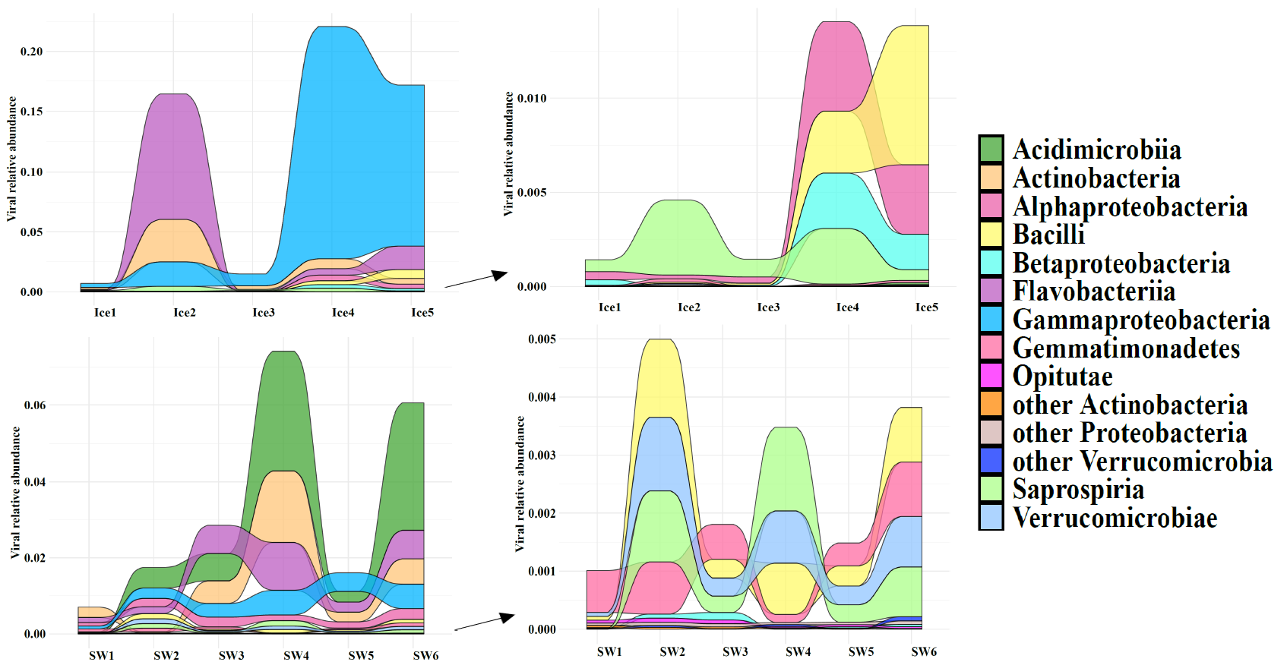
Fig.S7 The relative abundance patterns of viruses which were predicted to have the host.
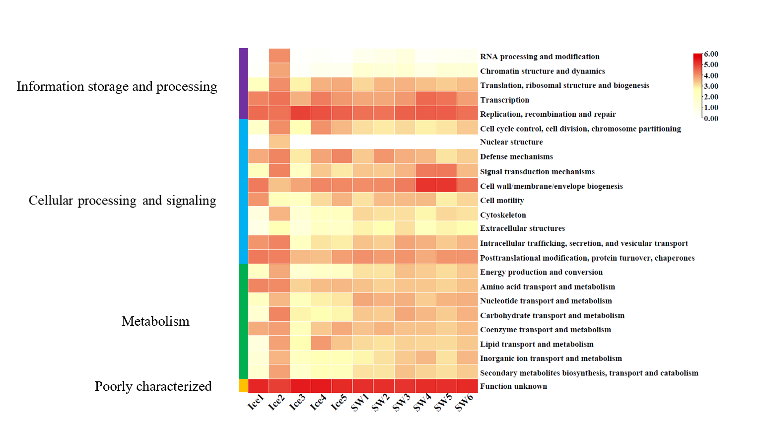Fig. S8 The COG functional analysis of viral contigs of the eleven viromes.

