Additional File
Trends in Polysubstance Mortality in White and Black Americans during the Opioid Epidemic, 1999-2018

Additional File Table 1. Classification and definition of ICD-10 cause-of-death codes involving opioids, benzodiazepines, and stimulants
Additional File Table 2. Sensitivity analysis of mortality trends due to synthetic opioids overall and in combination with other psychoactive drugs by race, 1999-2018 (excluding 2006)
Additional File Figure 1. Mortality trends from cocaine, benzodiazepines, and psychostimulants overall and in combination with opioids by race and sex, 1999–2018
Additional File Table 3. Mortality trends due to combinations of opioids and other psychoactive drugs by race in men, 2013-2018
Additional File Table 4. Mortality trends due to combinations of opioids and other psychoactive drugs by race in women, 2013-2018
Additional File Figure 2. Percent of co-involvement of psychoactive drugs in deaths due to opioid subtypes by race, 1999-2018

Additional File Table 1. Classification and definition of ICD-10 cause-of-death codes involving opioids, benzodiazepines, and stimulantsª
Step 1: Death due to drug overdose |  | Underlying cause of death^{b}
 |  | ICD-10 code | Definition
 |  | X40–X44 | Accidental poisoning by drugs (unintentional)
 |  | X60–X64 | Intentional self-poisoning by drugs (Suicide)
 |  | X85 | Assault by drug poisoning (homicide)
 |  | Y10–Y14 | Drug poisoning of undetermined intent
Step 2: Specific drug involved in overdose death |  | Multiple cause of death
 |  | ICD-10 code | Definition
Opioids
Any Opioid |  | T40.0 | Poisoning by opium
 |  | T40.1 | Poisoning by heroin
 |  | T40.2 | Poisoning by other opioids (includes natural opioids like morphine and semisynthetic opioids like oxycodone and hydrocodone)
 |  | T40.3 | Poisoning by methadone
 |  | T40.4 | Poisoning by synthetic opioids other than methadone (e.g., fentanyl, fentanyl analogs, and tramadol)
 |  | T40.6 | Poisoning by other and unspecified narcotics
Commonly prescribed opioids |  | T40.2 | Poisoning by other opioids (includes natural opioids like morphine and semisynthetic opioids like oxycodone and hydrocodone)
Heroin |  | T40.1 | Poisoning by heroin
Synthetic opioids |  | T40.4 | Poisoning by synthetic opioids other than methadone (e.g., fentanyl, fentanyl analogs, and tramadol)
Benzodiazepines
Benzodiazepines |  | T42.4 | Poisoning by benzodiazepines
Stimulants
Cocaine |  | T40.5 | Poisoning by cocaine
Psychostimulants with abuse potential |  | T43.6 | Poisoning by psychostimulants with abuse potential excluding cocaine (includes methamphetamine, MDMA, methylphenidate, amphetamine salts)
Abbreviations: ICD-10: International Classification of Diseases, Tenth Revision; MDMA: 3,4-methylenedioxy-methamphetamine
ª First, a drug overdose death was identified using any underlying cause-of-death code among those listed. Multiple cause-of-death codes were then used to indicate the specific drug causing overdose death. For the purpose of this study, a polysubstance death is a drug-related death record that includes multiple cause-of-death codes from at least 2 of the investigated drugs.
^{b}Underlying cause of death is a disease or injury which initiated the train of events leading directly to death, or the circumstances of the accident or violence which produced the fatal injury [1].

Additional File Table 2. Sensitivity analysis of mortality trends due to synthetic opioids overall and in combination with other psychoactive drugs by race, 1999-2018 (excluding 2006)
Drug/drug combination | White |  |  |  |  | Black/African American |  |  |  |  | AAPC  Black-White diff | p-value
Drug/drug combination | Age-adjusted death rateª |  |  |  | AAPC (95%CI)  (2013-2018) | Age-adjusted death rateª |  |  |  | AAPC (95%CI)  (2013-2018) | AAPC  Black-White diff | p-value
Drug/drug combination | 1999 | 2010 | 2013 | 2018 | AAPC (95%CI)  (2013-2018) | 1999 | 2010 | 2013 | 2018 | AAPC (95%CI)  (2013-2018) | AAPC  Black-White diff | p-value
Synthetic opioids
Overall^{b} | 0.29 | 1.14 | 1.13 | 10.89 | 61.73* (50.23,74.12) | 0.11 | 0.35 | 0.47 | 10.68 | 93.93* (77.51,111.88) | -32.20* | 0.00
+ Heroin | 0.01 | 0.02 | 0.08 | 3.10 | 89.98* (75.48,105.68) | 0.00 | 0.00 | 0.06 | 3.48 | 115.07* (92.08,140.81) | -25.08 | 0.09
+ Prescription  opioids | 0.05 | 0.31 | 0.33 | 1.65 | 43.04* (33.86,52.85) | 0.02 | 0.09 | 0.13 | 1.36 | 66.59* (40.45,97.59) | -23.55 | 0.12
+ Benzodiazepines | 0.05 | 0.29 | 0.30 | 1.90 | 49.34* (39.85, 59.49) | 0.02 | 0.05 | 0.08 | 0.87 | 72.69* (49.86, 99.01) | -23.35 | 0.08
+ Cocaine | 0.02 | 0.06 | 0.08 | 2.79 | 103.29* (65.48,149.74) | 0.01 | 0.04 | 0.10 | 4.39 | 128.55* (91.65, 172.55) | -25.26 | 0.39
+ Psychostimulants | 0.00 | 0.03 | 0.06 | 1.41 | 87.42* (74.38, 101.43) | 0.00 | 0.00 | 0.01 | 0.55 | 122.99* (101.05,147.33) | -35.57* | 0.00
Data source: Centers for Disease Control and Prevention [2,3].
Abbreviation: AAPC, average annual percent change; AAPC Black-White diff, average annual percent change difference between Black and White
*AAPC is statistically significant from zero (2-sided P<0.05). Mortality trends were evaluated using the Joinpoint Regression Program (Version 4.8.0.1).
ª Death rates were calculated per 100,000 population and adjusted to the 2000 US standard population.
^{b} Overall mortality refers to all deaths involving synthetic opioids whether alone or in combination with any other drug.

Additional File Figure 1. Mortality trends from cocaine, benzodiazepines, and psychostimulants overall and in combination with opioids by race and sex, 1999–2018
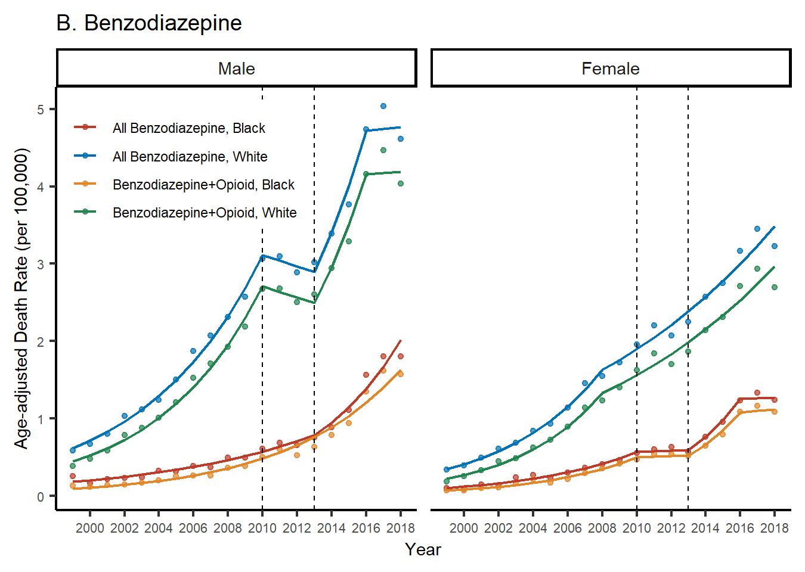
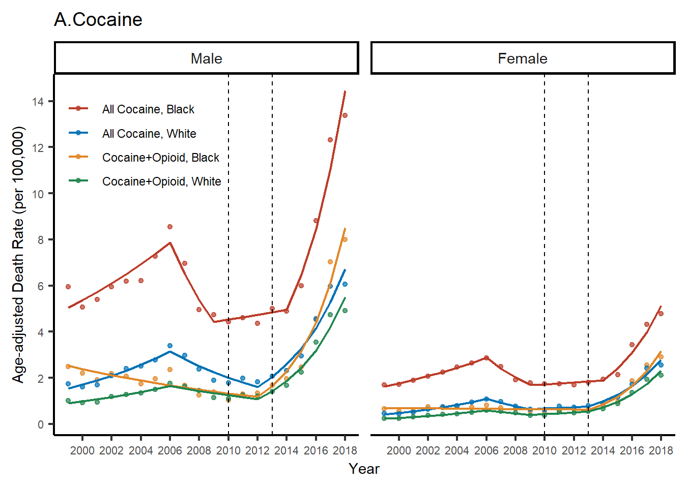

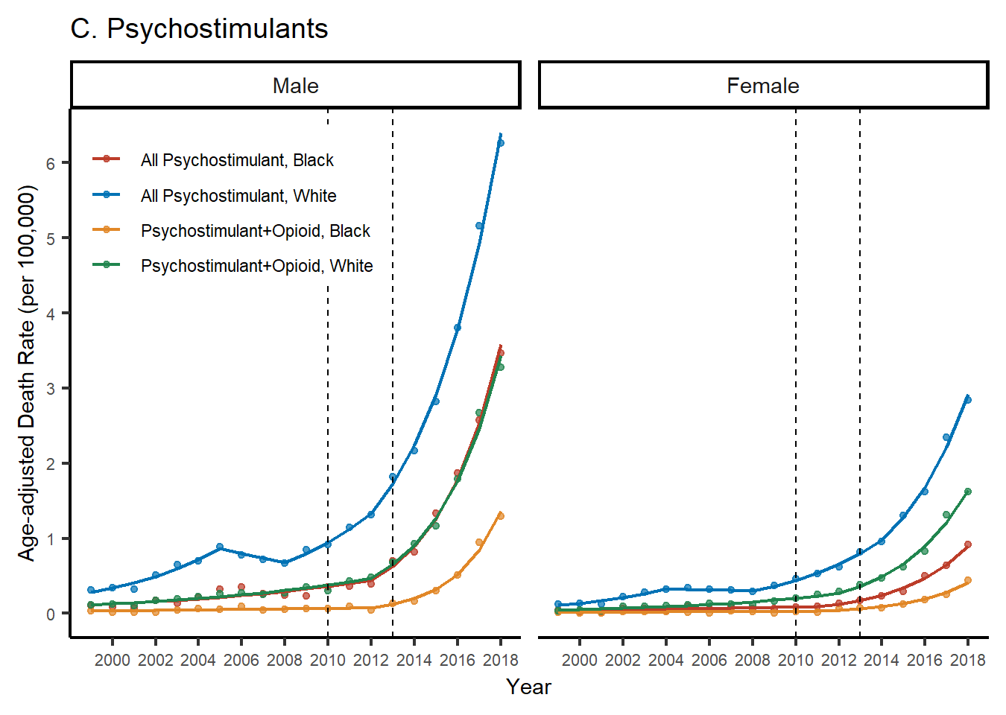

Data source: Centers for Disease Control and Prevention; Abbreviation: AAPC, average annual percent change
^{ⴕ} AAPC is not statistically significant from zero (2-sided P<0.05). Mortality trends were evaluated using the Joinpoint Regression Program (Version 4.8.0.1).
Note: Overall mortality from a specific drug is all deaths involving this drug whether alone or when combined with any other drug.
Additional File Table 3. Mortality trends due to combinations of opioids and other psychoactive drugs by race in men, 2013-2018
Cause of drug-related death | White Men |  |  |  | Black Men
Cause of drug-related death | Age-adjusted Death Rate Per 100,000 Population |  | AAPC | AAPC 95% | Age-adjusted Death Rate Per 100,000 Population |  | AAPC | AAPC 95%
Cause of drug-related death | 2013 | 2018 | AAPC | AAPC 95% | 2013 | 2018 | AAPC | AAPC 95%
All Opioids | 11.70 | 22.15 | 15.00 | 9.30 - 21.00 | 6.33 | 20.64 | 30.01 | 25.00 - 35.23
Synthetic Opioids | 1.24 | 15.43 | 68.54 | 56.19 - 81.87 | 0.48 | 16.83 | 103.8 | 91.42 - 116.97
Heroin | 4.73 | 7.80 | 12.04 | 9.29 - 14.86 | 3.45 | 7.64 | 20.86 | 13.05 - 29.2
Psychostimulants | 1.82 | 6.26 | 29.88 | 26.87 - 32.97 | 0.70 | 3.47 | 41.55 | 34.68 - 48.76
Cocaine | 2.06 | 6.05 | 26.85 | 20.36 - 33.69 | 4.99 | 13.37 | 24.46 | 17.79 - 31.51
Prescription Opioids | 4.75 | 5.09 | 2.75^{ⴕ} | -4.21 - 10.21 | 1.77 | 3.35 | 14.92 | 11.42 - 18.54
Cocaine + All Opioids | 1.40 | 4.91 | 31.06 | 24.63 - 37.82 | 1.67 | 7.99 | 38.95 | 30.51 - 47.94
Synthetic Opioids + Heroin | 0.11 | 4.61 | 88.85 | 65.55 - 115.44 | 0.07 | 5.54 | 112.6 | 91.66 - 135.83
Benzodiazepines | 3.02 | 4.61 | 10.48 | 4.09 - 17.27 | 0.75 | 1.80 | 20.87 | 14.79 - 27.27
Benzodiazepines + All Opioids | 2.60 | 4.04 | 10.90 | 3.58 - 18.73 | 0.63 | 1.57 | 16.46 | 15.01 - 17.94
Cocaine + Synthetic Opioids | 0.11 | 3.91 | 114.08 | 93.91 - 136.34 | 0.13 | 6.66 | 132.86 | 103.7 - 166.18
Psychostimulants + All Opioids | 0.68 | 3.28 | 39.34 | 35.01 - 43.81 | 0.13 | 1.29 | 61.25 | 50.83 - 72.39
Benzodiazepines + Synthetic Opioids | 0.31 | 2.42 | 50.87 | 33.41 - 70.61 | 0.09 | 1.16 | 85.57 | 59.39 - 116.05
Prescription Opioids + Synthetic Opioids | 0.33 | 2.11 | 50.30 | 40.35 - 60.95 | 0.13 | 2.04 | 71.45 | 45.24 - 102.37
Synthetic Opioids + Psychostimulants | 0.06 | 1.88 | 91.09 | 75.91 - 107.59 | 0.00 | 0.86 | 190.63 | 143.53 - 246.84
Cocaine + Heroin | 0.80 | 1.86 | 19.43 | 14.84 - 24.2 | 0.96 | 2.73 | 28.70 | 23.55 - 34.07
Benzodiazepines + Prescription Opioids | 1.55 | 1.51 | 0.69 ^{ⴕ} | -5.88 - 7.71 | 0.34 | 0.53 | 14.25 | 11.97 - 16.58
Heroin + Psychostimulants | 0.30 | 1.41 | 37.28 | 32.52 - 42.21 | 0.07 | 0.55 | 50.08 | 42.71 - 57.83
Benzodiazepines + Heroin | 0.61 | 1.25 | 17.71 | 11.9 - 23.82 | 0.17 | 0.53 | 22.27 | 12.42 - 32.99
Cocaine + Benzodiazepines | 0.33 | 0.98 | 29.24 | 20.01 - 39.17 | 0.17 | 0.62 | 29.89 | 17.15 - 44.02
Prescription Opioids + Heroin | 0.58 | 0.89 | 11.26 | 2.53 - 20.73 | 0.30 | 0.66 | 22.88 | 17.64 - 28.35
Cocaine + Prescription Opioids | 0.41 | 0.80 | 18.24 | 9.29 - 27.92 | 0.44 | 1.08 | 22.33 | 15.74 - 29.29
Prescription Opioids + Psychostimulants | 0.28 | 0.73 | 22.49 | 17.73 - 27.44 | 0.05 | 0.18 | 33.90 | 19.99 - 49.42
Cocaine + Psychostimulants | 0.11 | 0.68 | 47.58 | 38.61 - 57.13 | 0.13 | 0.71 | 49.35 | 38.29 - 61.29
Benzodiazepines + Psychostimulants | 0.19 | 0.68 | 30.44 | 25.68 - 35.39 | 0.03 | 0.10 | 40.63 | 21.95 - 62.17
Data source: Centers for Disease Control and Prevention [2,3]; Abbreviation: AAPC, average annual percent change
^{ⴕ} AAPC is not statistically significant from zero (2-sided P<0.05). Mortality trends were evaluated using the Joinpoint Regression Program (Version 4.8.0.1).
Note: Overall mortality from a specific drug is all deaths involving this drug whether alone or when combined with any other drug.

Additional File Table 4. Mortality trends due to combinations of opioids and other psychoactive drugs by race in women, 2013-2018
Cause of drug-related death | White Women |  |  |  | Black Women
Cause of drug-related death | Age-adjusted Death Rate Per 100,000 Population |  | AAPC  (2013-2018) | AAPC 95% | Age-adjusted Death Rate Per 100,000 Population |  | AAPC  (2013-2018) | AAPC 95%
Cause of drug-related death | 2013 | 2018 | AAPC  (2013-2018) | AAPC 95% | 2013 | 2018 | AAPC  (2013-2018) | AAPC 95%
All Opioids | 6.54 | 10.29 | 10.32 | 3.26 - 17.85 | 2.97 | 7.37 | 21.27 | 16.8 - 25.92
Synthetic Opioids | 1.01 | 6.23 | 48.59 | 36.05 - 62.28 | 0.46 | 5.29 | 68.81 | 31.55 - 116.62
Prescription Opioids | 3.50 | 3.55 | 0.15 ^{ⴕ} | -3.87 - 4.33 | 1.47 | 2.00 | 5.28 | 1.33 - 9.38
Benzodiazepines | 2.25 | 3.23 | 7.90 | 6.71 - 9.1 | 0.57 | 1.24 | 16.4 | 3.05 - 31.48
Psychostimulants | 0.82 | 2.84 | 29.52 | 25.38 - 33.8 | 0.17 | 0.92 | 38.73 | 32.25 - 45.53
Benzodiazepines + All Opioids | 1.86 | 2.70 | 8.35 | 6.93 - 9.79 | 0.52 | 1.08 | 16.62 | 3.92 - 30.88
Heroin | 1.32 | 2.60 | 16.73 | 12.21 - 21.44 | 0.70 | 2.27 | 25.53 | 19.93 - 31.39
Cocaine | 0.79 | 2.56 | 29.55 | 22.23 - 37.31 | 1.80 | 4.77 | 22.71 | 16.97 - 28.72
Cocaine + All Opioids | 0.55 | 2.11 | 33.75 | 25.8 - 42.2 | 0.63 | 2.90 | 38.58 | 28.96 - 48.91
Cocaine + Synthetic Opioids | 0.06 | 1.65 | 105.57 | 75.05 - 141.41 | 0.08 | 2.40 | 105.60 | 83.07 - 130.89
Psychostimulants + All Opioids | 0.38 | 1.62 | 35.23 | 30.09 - 40.57 | 0.07 | 0.44 | 46.07 | 37.48 - 55.19
Synthetic Opioids + Heroin | 0.04 | 1.56 | 86.74 | 68.64 - 106.78 | 0.04 | 1.69 | 116.43 | 97.36 - 137.35
Benzodiazepines + Synthetic Opioids | 0.29 | 1.36 | 40.25 | 31.09 - 50.05 | 0.07 | 0.61 | 55.05 | 39.11 - 72.81
Benzodiazepines + Prescription Opioids | 1.18 | 1.29 | 3.15 | 0.68 - 5.68 | 0.38 | 0.55 | 9.10 | 5.53 - 12.79
Prescription Opioids + Synthetic Opioids | 0.32 | 1.17 | 32.84 | 22.19 - 44.42 | 0.12 | 0.78 | 48.25 | 7.44 - 104.58
Synthetic Opioids + Psychostimulants | 0.05 | 0.93 | 86.46 | 75.12 - 98.52 | 0.01 | 0.27 | 82.94 | 65.64 - 102.06
Cocaine + Heroin | 0.26 | 0.69 | 23.18 | 16.14 - 30.64 | 0.23 | 0.98 | 31.59 | 26.21 - 37.2
Heroin + Psychostimulants | 0.12 | 0.55 | 34.91 | 28.92 - 41.18 | 0.01 | 0.16 | 54.23 | 46.44 - 62.44
Benzodiazepines + Heroin | 0.23 | 0.53 | 21.74 | 13.64 - 30.42 | 0.07 | 0.28 | 33.34 | 26.82 - 40.19
Cocaine + Benzodiazepines | 0.16 | 0.50 | 28.7 | 20.96 - 36.93 | 0.10 | 0.32 | 14.84 | 11.71 - 18.06
Prescription Opioids + Psychostimulants | 0.17 | 0.43 | 18.33 | 16.78 - 19.89 | 0.04 | 0.13 | 18.87 | 13.07 - 24.96
Cocaine + Prescription Opioids | 0.18 | 0.43 | 21.00 | 11.68 - 31.09 | 0.20 | 0.46 | 19.65 | 7.02 - 33.77
Benzodiazepines + Psychostimulants | 0.12 | 0.43 | 29.61 | 23.77 - 35.73 | 0.02 | 0.10 | 44.74 | 32.56 - 58.05
Cocaine + Psychostimulants | 0.05 | 0.35 | 54.72 | 41.86 - 68.74 | 0.04 | 0.24 | 40.76 | 27.01 - 55.99
Prescription Opioids + Heroin | 0.17 | 0.32 | 15.37 | 8.47 - 22.71 | 0.08 | 0.27 | 31.71 | 24.69 - 39.13
Data source: Centers for Disease Control and Prevention [2,3]; Abbreviation: AAPC, average annual percent change
^{ⴕ} AAPC is not statistically significant from zero (2-sided P<0.05). Mortality trends were evaluated using the Joinpoint Regression Program (Version 4.8.0.1).
Note: Overall mortality from a specific drug is all deaths involving this drug whether alone or when combined with any other drug.

Additional File Figure 2. Percent of co-involvement of psychoactive drugs in deaths due to opioid subtypes by race, 1999-2018
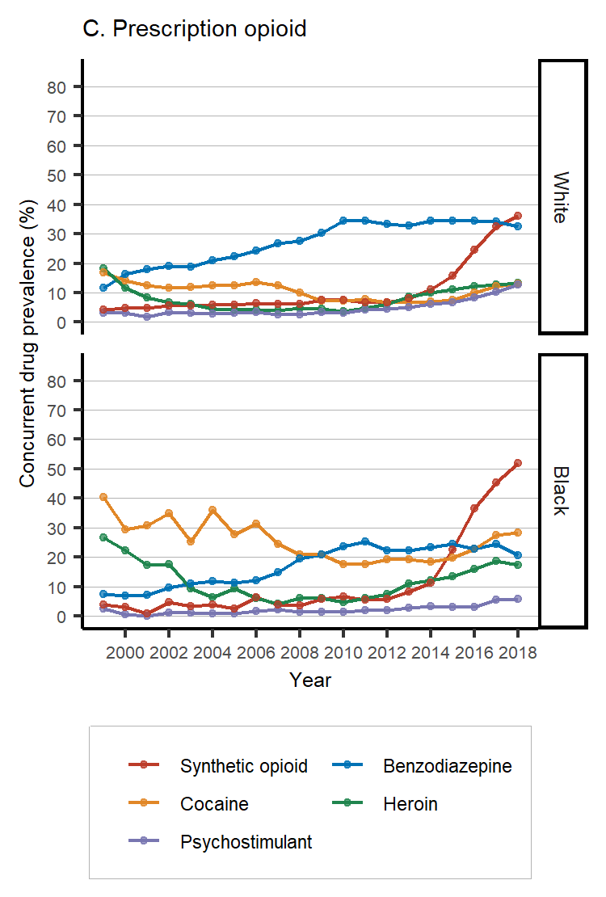
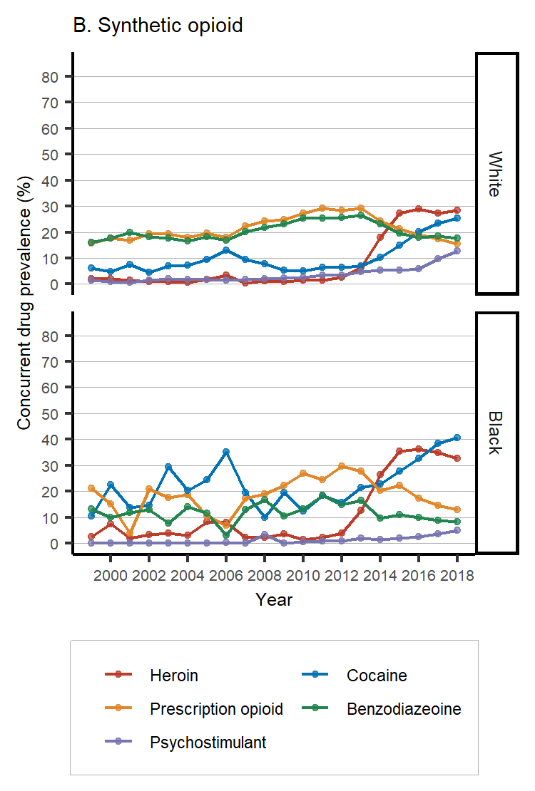
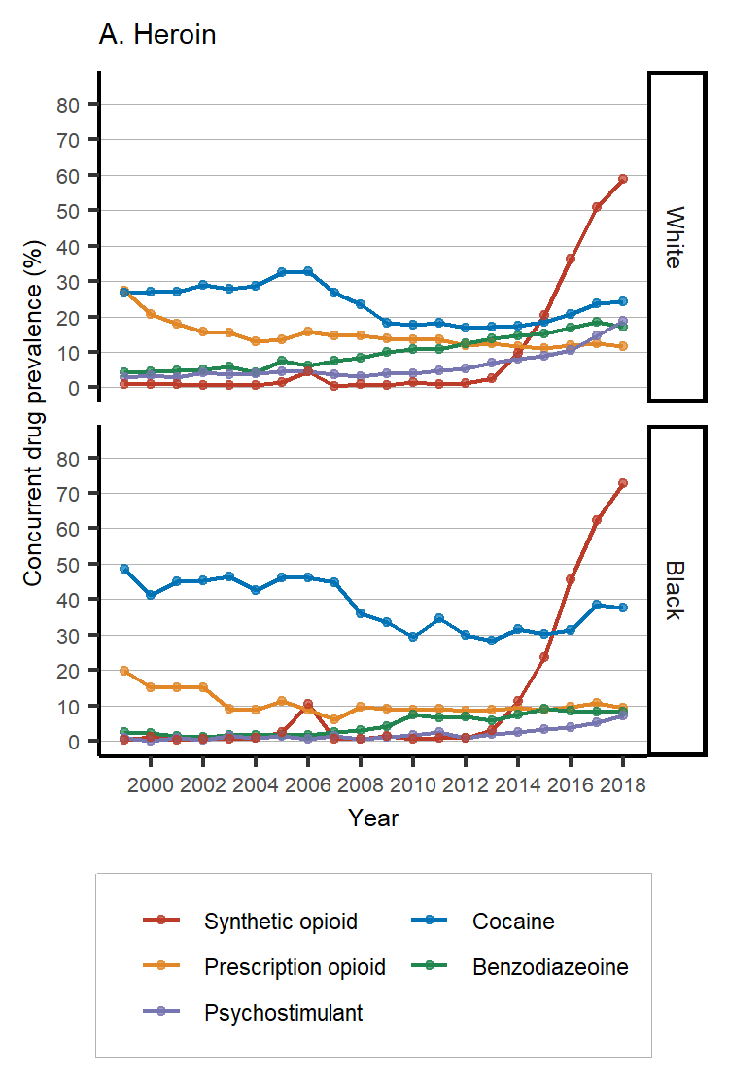

References
- World Health Organization. International Statistical Classification of Diseases and Related Health Problems-10th Revision (5 ed.).2016. Geneva, Switzerland: WHO Press.
- Centers for Disease Control and Prevention. Mortality multiple cause files. Accessed March 10, 2020. https://www.cdc.gov/nchs/data_access/vitalstatsonline.htm#Mortality
- Centers for Disease Control and Prevention. U.S. Census populations with bridged race categories 1999 to 2018 request. Accessed March 13, 2020. https://www.cdc.gov/nchs/nvss/bridged_race.htm

