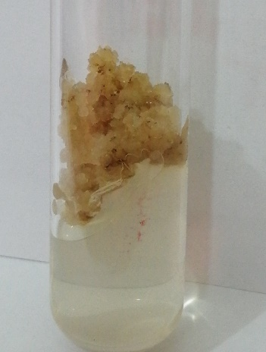
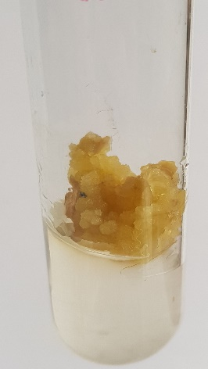
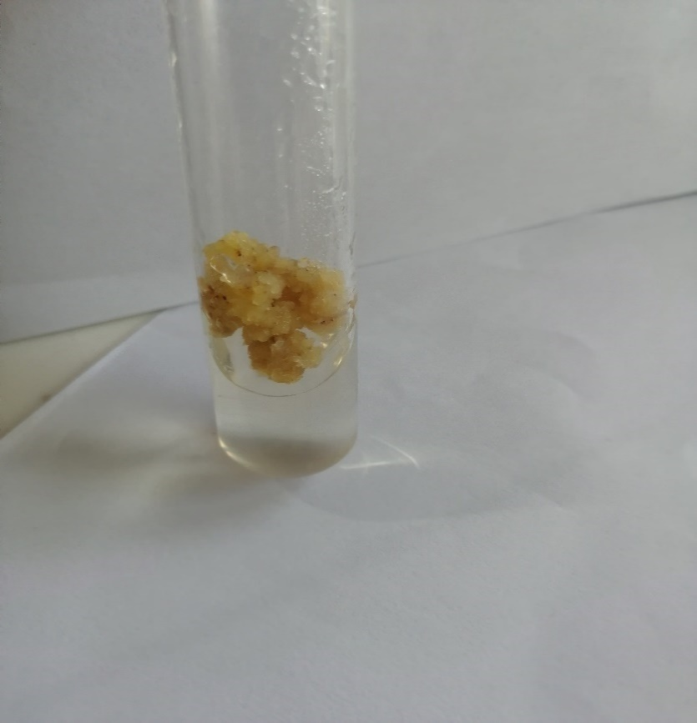
Fig. 1 (a) Control callus culture of YT-53 (0mM Pb(NO₃)₂ +3.5mg/l 2,4-D at day 90(2x)
Fig. 1(b) Control callus culture of YT-53(0mM Pb(NO₃) +3.5mg/l 2,4-D at day 120 (2x)
Fig. 1 (c) Control callus culture of YT-53 treated with 0mM Pb(NO₃) +3.5mg/l 2,4-D at day150 (2x)

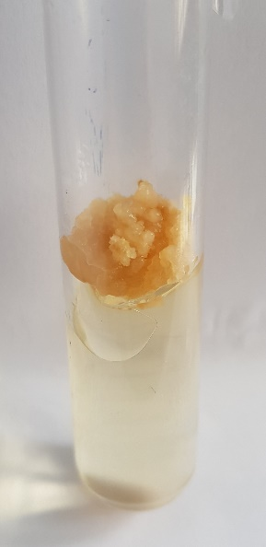
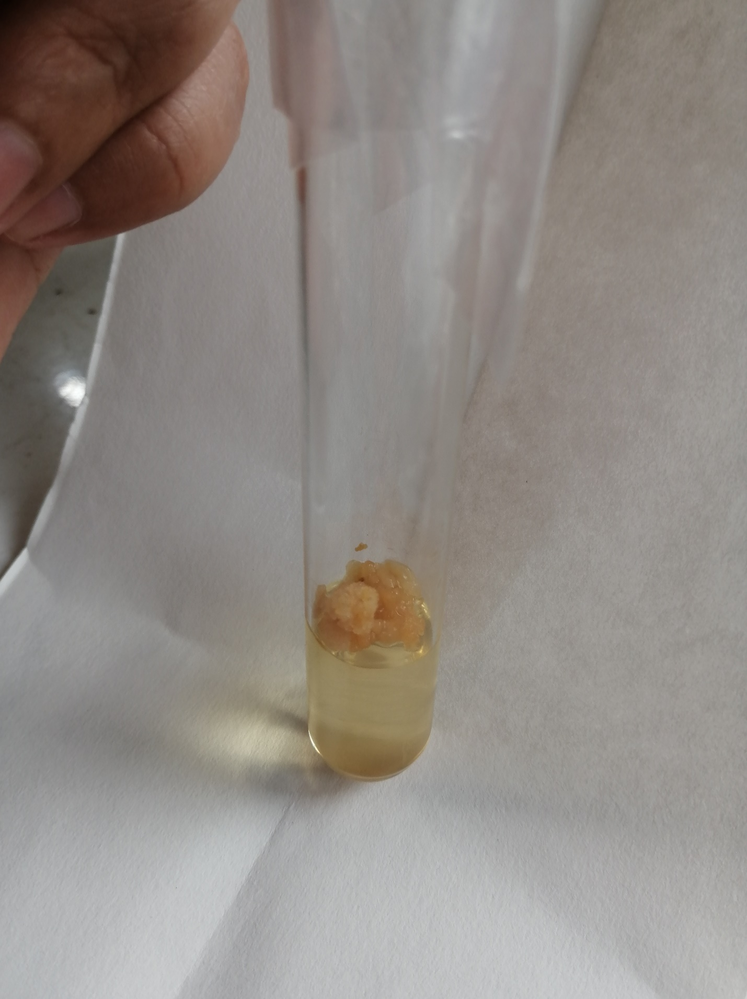
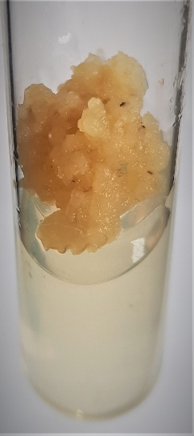
Fig. 2 Callus culture of YT-53 treated with 0.1mM Pb(NO₃)₂ +3.5mg/l 2,4-D at day 150 (2x)
Fig. 2 (a) Callus culture of YT-53 treated with 0.1mM Pb(NO₃)₂ +3.5mg/l 2,4-D after 90 days (2x)
Fig. 2 (b) Callus culture of YT-53 treated with 0.1mM Pb(NO₃)₂ +3.5mg/l 2,4-D at day 120 (2x)

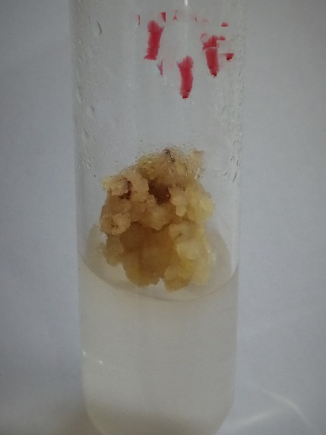
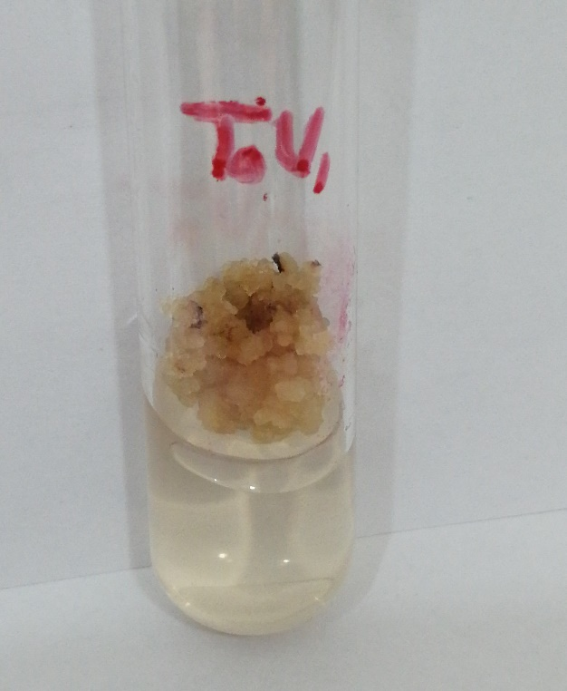
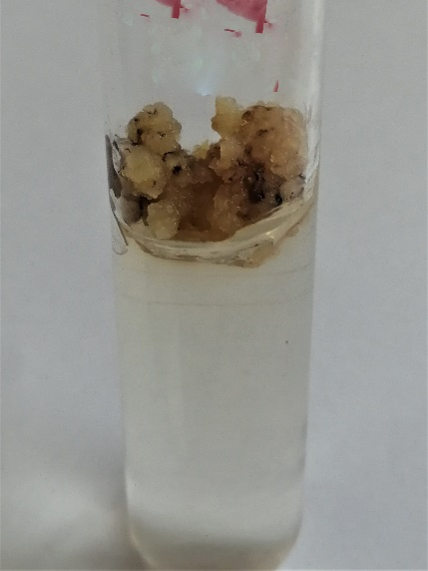
Fig. 3(b) Callus culture of YT-53 treated with 0.2mM Pb(NO₃)₂ +3.5mg/l 2,4-D at day 120 (2x)

Fig. 3 (c) Callus culture of YT-53 treated with 0.2mM Pb(NO₃)₂ +3.5mg/l 2,4-D at day 150 (2x)

Fig. 3(a) Callus culture of YT-53 treated with 0.2mM Pb(NO₃)₂ +3.5mg/l 2,4-D after 90 days (2x)

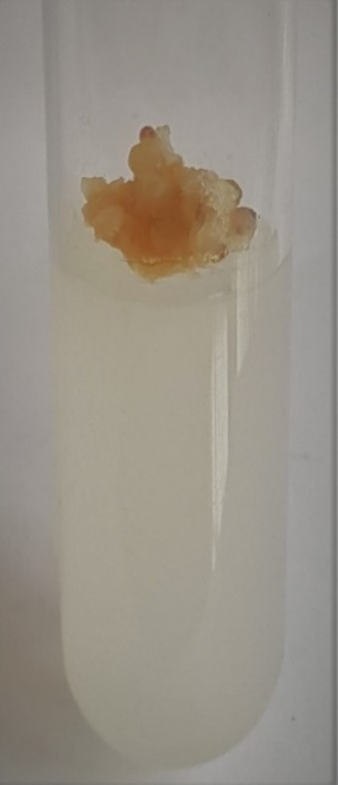
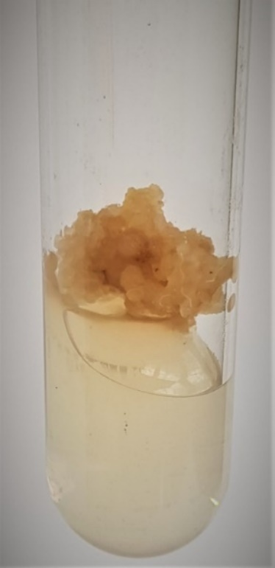
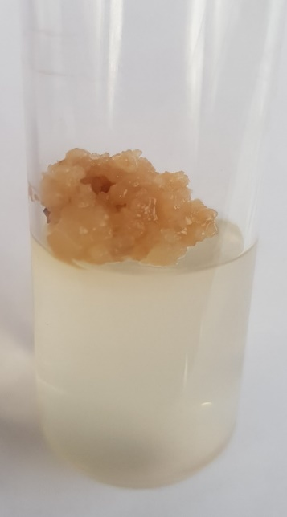
Fig. 4(a) Callus culture of YT-53 treated with 0.3mM Pb(NO₃)₂ +3.5mg/l 2,4-Dafter 90 days (2x)

Fig. 4(b) Callus culture of YT-53 treated with 0.3mM Pb(NO₃)₂ +3.5mg/l 2,4-D at day 120 (2x)
Fig. 4(c) Callus culture of YT-53 treated with 0.3mM Pb(NO₃)₂+3.5mg/l 2,4-D at day 150 (2x)
c)

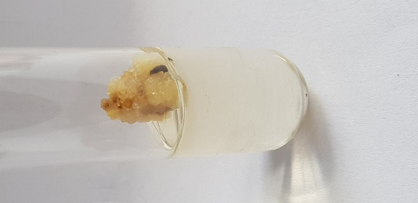
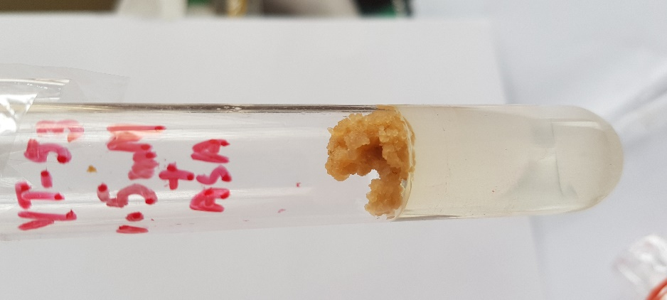
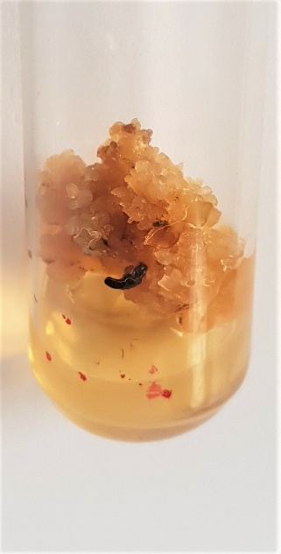
Fig. 5(a) Callus culture of YT-53 treated with 0.4mM Pb(NO₃)₂ +3.5mg/l 2,4-D at day 90 (2x)
Fig.5(b) Callus culture of YT-53
treated with 0.4mM Pb(NO₃)₂ +3.5mg/l 2,4-D at day 120 (2x)
Fig. 5(c) Callus culture of YT-53 treated with 0.4mM Pb(NO₃)₂ +3.5mg/l 2,4-D at day 150 (2x)

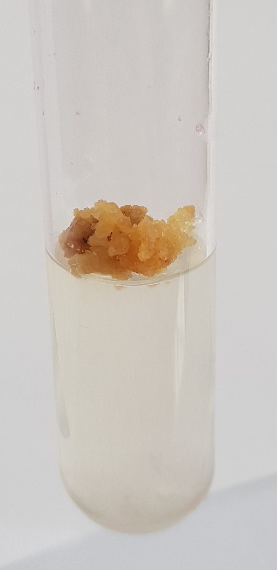
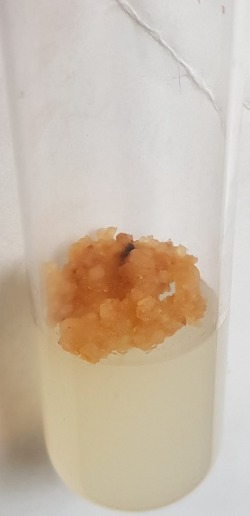
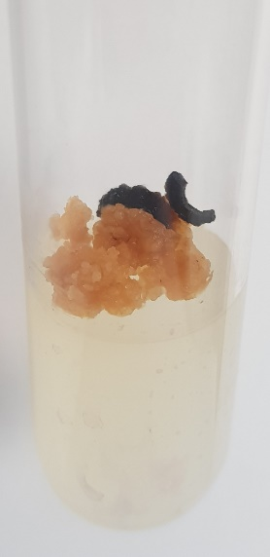
Fig. 6(a) Callus culture of YT-53 treated with 0.5mM Pb(NO₃)₂ +3.5mg/l 2,4-D at day 90 (2x)

Fig. 6(b) Callus culture of YT-53 treated with 0.5mM Pb(NO₃)₂ +3.5mg/l 2,4-D at day 120 (2x)

Fig. 6(c) Callus culture of YT-53 treated with 0.5mM Pb(NO₃)₂ +3.5mg/l 2,4-D at day 150 (2x)

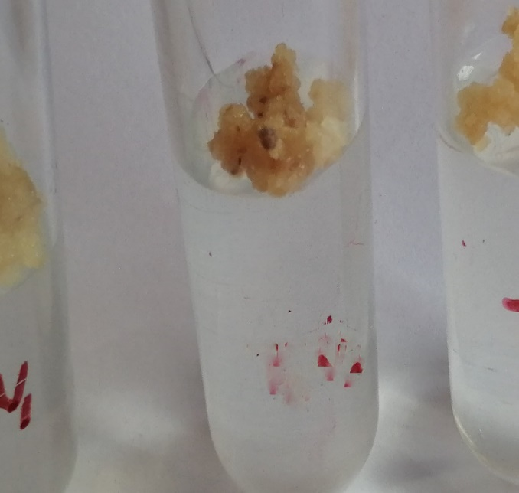
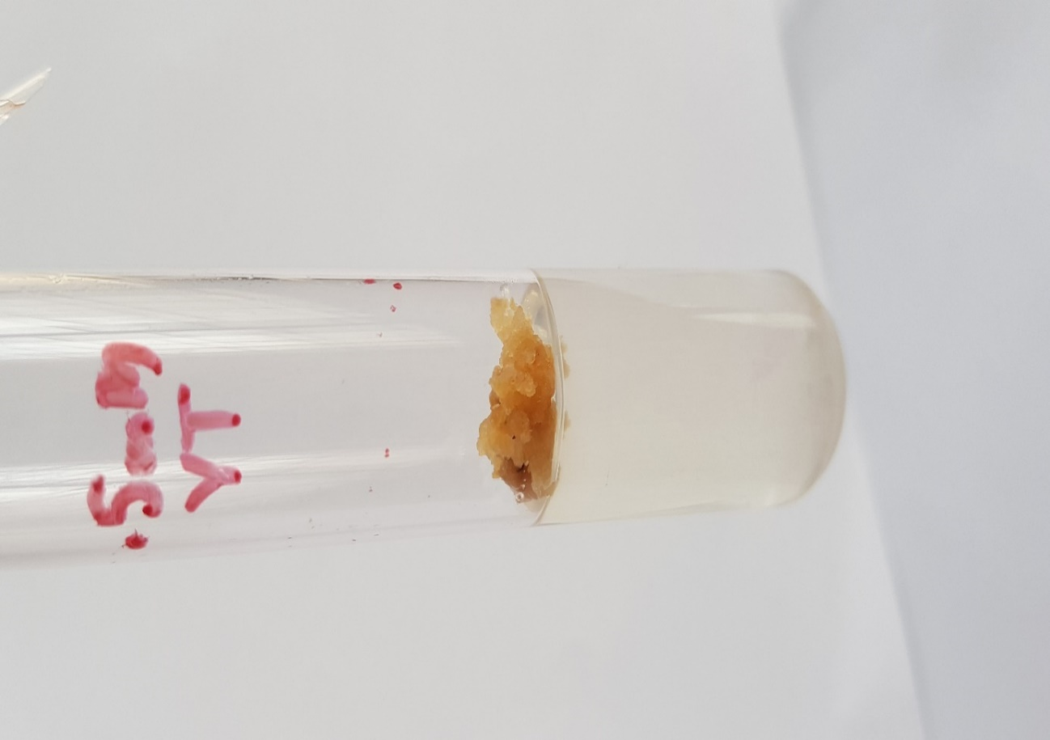
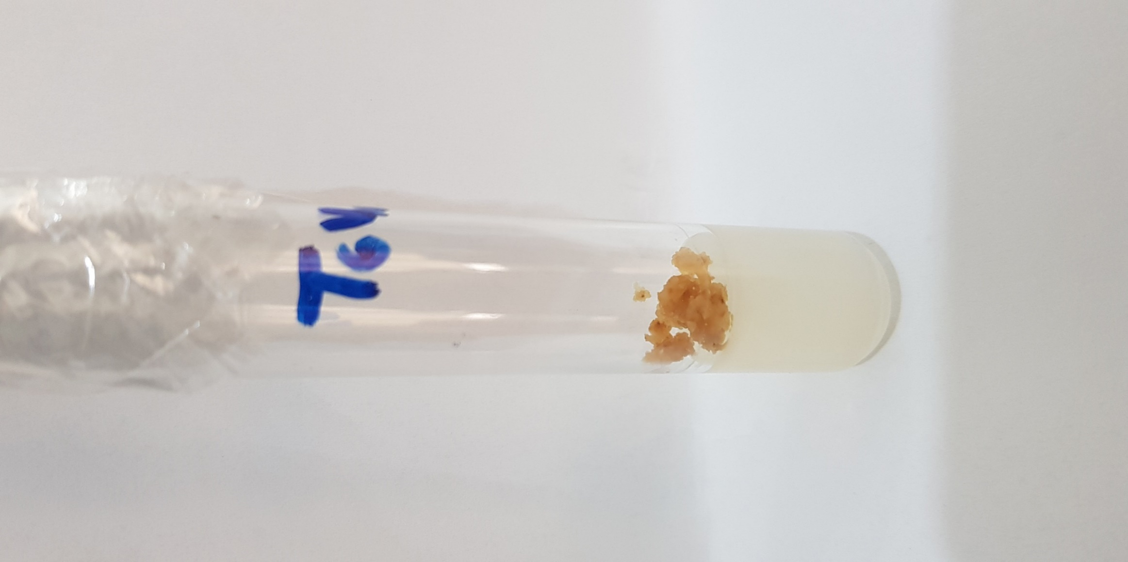
Fig. 7(a) Callus culture of YT-53 treated with 1mM Pb(NO₃)₂+3.5mg/l 2,4-D at day 90 (2x)

Fig. 7(b) Callus culture of YT-53 treated with 1mM Pb(NO₃)₂ +3.5mg/l 2,4-D at day 120 (2x)

Fig. 7(c) Callus culture of YT-53 treated with 1mM Pb(NO₃)₂ +3.5mg/l 2,4-D at day 150 (2x)

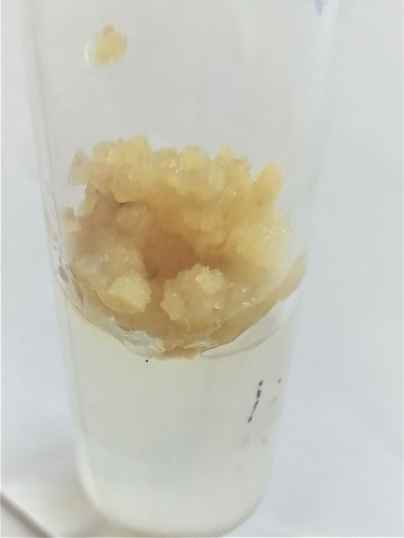
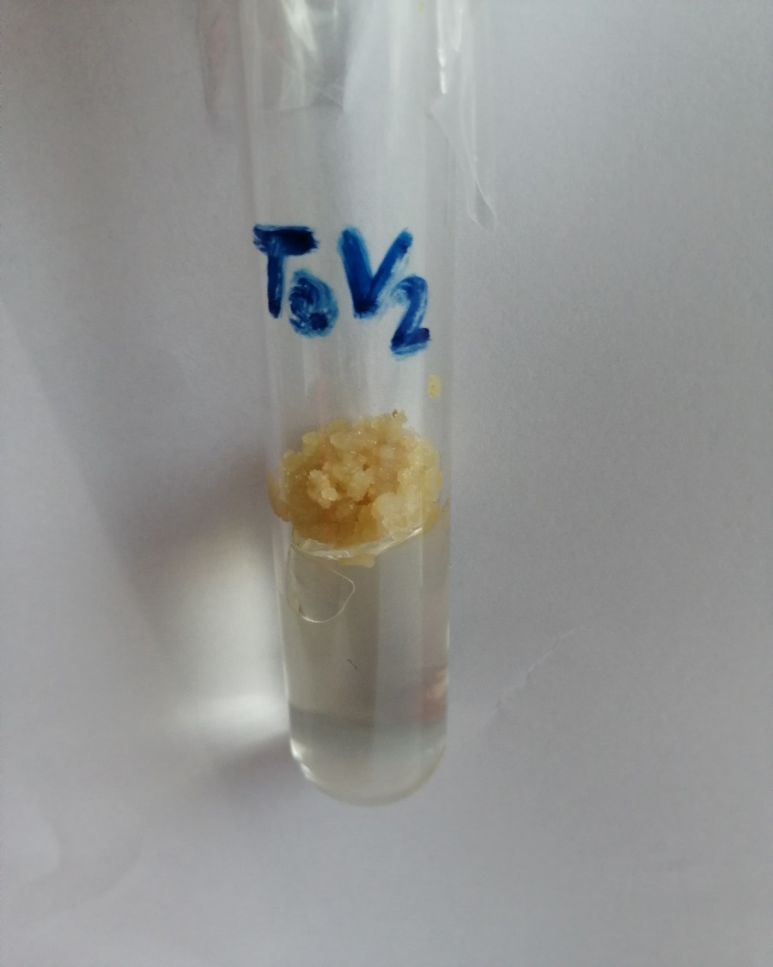
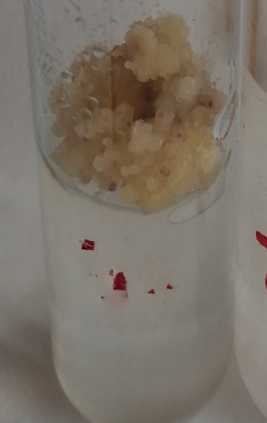
Fig. 8 (b)Control Callus culture of CP-77-400(0mM Pb(NO₃)₂ +5mg/l 2,4-D)at day 120 (2x)
Fig. 8 (a) Control callus culture of CP-77-400(0mM Pb(NO₃)₂ +5mg/l 2,4-D) at day 90 (2x)

Fig. 8 (c) Control callus culture of CP-77-400(0mM Pb(NO₃)₂ +5mg/l 2,4-D) at day 150 (2x)

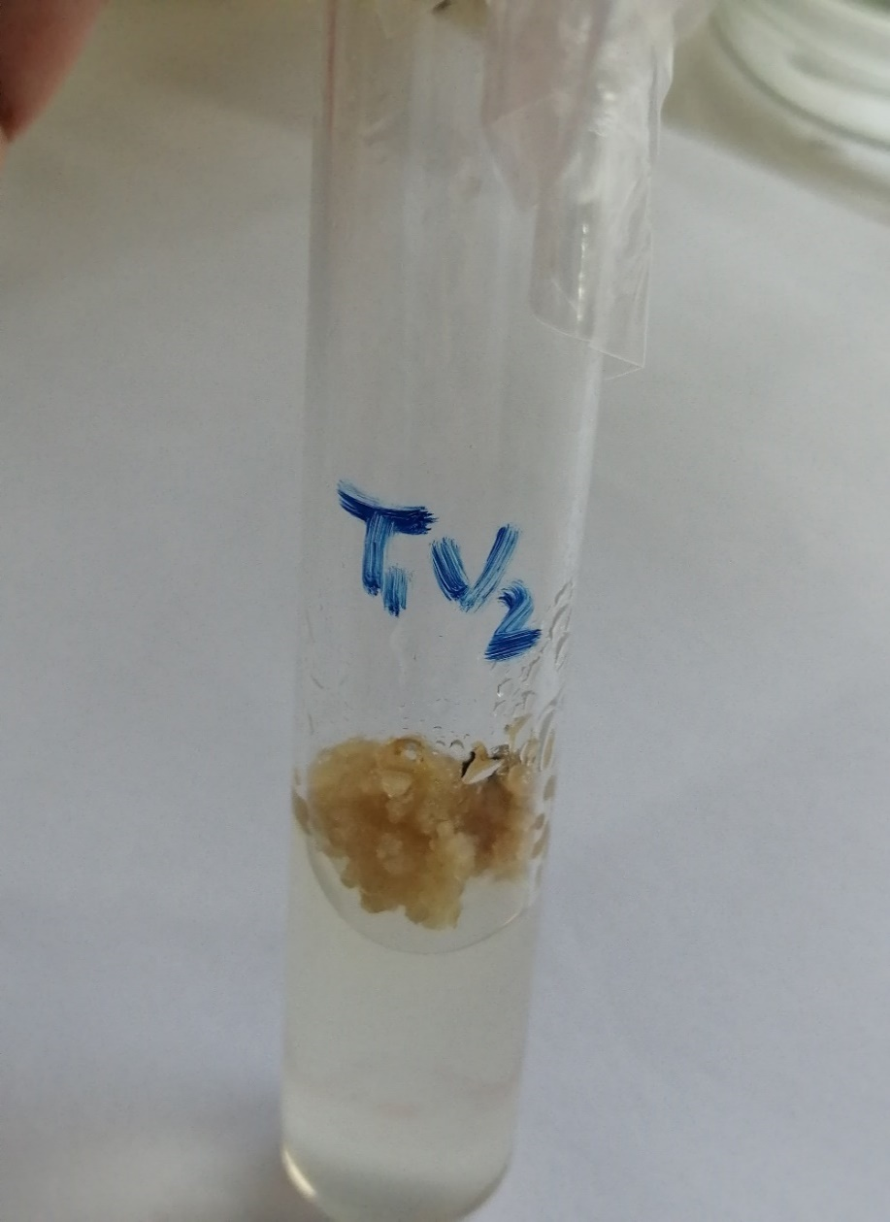
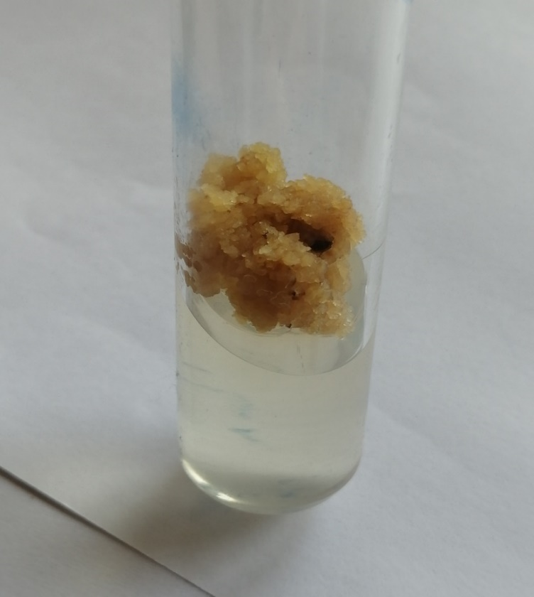
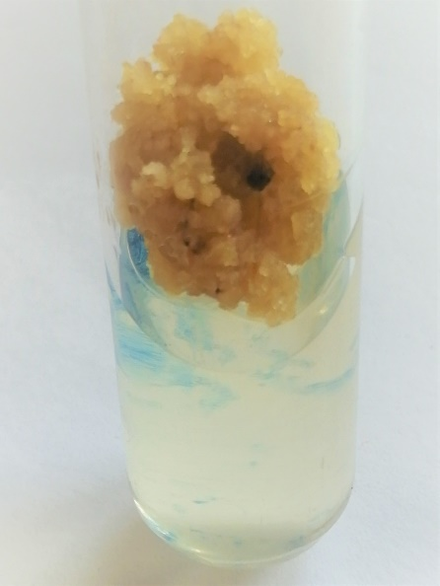
Fig. 9 (b) Callus culture of CP-77-400 treated with 0.1mM Pb(NO₃)₂ +5mg/l 2,4-D at day 120 (2x)

Fig. 9(a) Callus culture of CP-77-400 treated with 0.1mM Pb(NO₃)₂ +5mg/l 2,4-D at day 90 (2x)

Fig. 9 (c) Callus culture of CP-77-400 treated with 0.1mM Pb(NO₃)₂ at day 150 (2x)

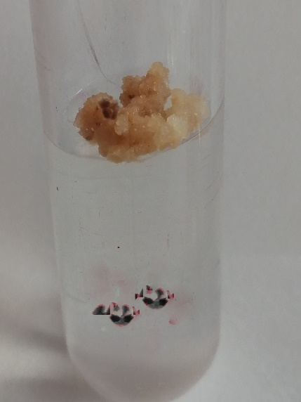
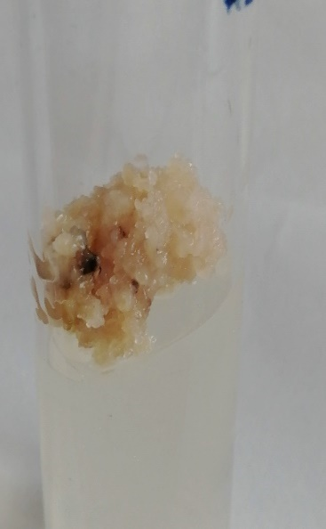
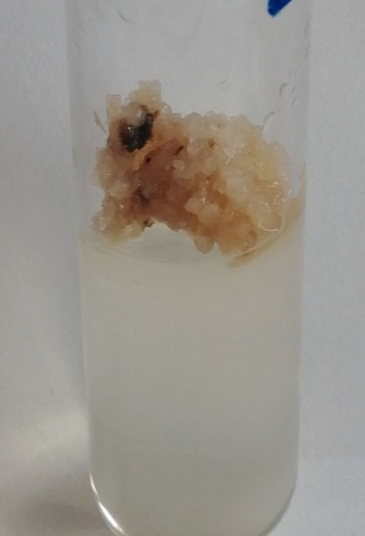
Fig. 10 (a) Callus culture of CP-77-400 treated with 0.2mM Pb(NO₃)₂ +5mg/l 2,4-D at day 90 (2x)

Fig. 10 (b) Callus culture of CP-77-400 treated with 0.2mM Pb(NO₃)₂ +5mg/l 2,4-D at day 120 (2x)
Fig. 10(c) Callus culture of CP-77-400 treated with 0.2mM Pb(NO₃)₂ +5mg/l 2,4-D at day 150 (2x)

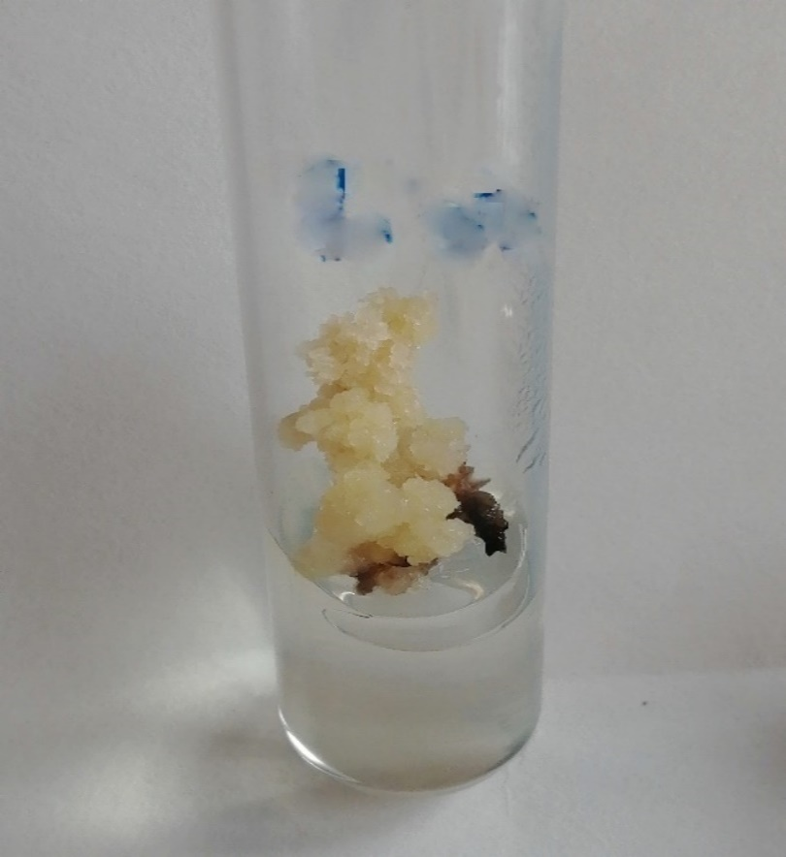
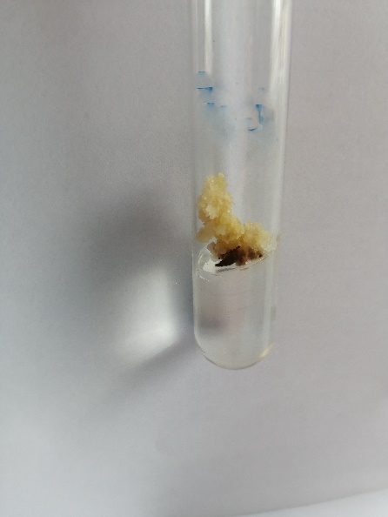
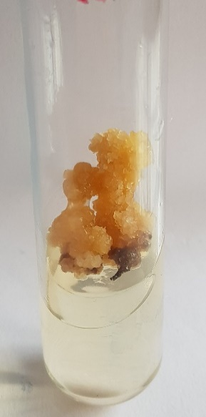
Fig. 11(a) Callus culture of CP-77-400 treated with 0.3mM Pb(NO₃)₂ +5mg/l 2,4-D at day 90 (2x)

Fig. 11 (b) Callus culture of CP-77-400 treated with 0.3mM Pb(NO₃)₂ +5mg/l 2,4-D at day 120 (2x)
Fig. 11 (c) Callus culture of CP-77-400 treated with 0.3mM Pb(NO₃)₂ +5mg/l 2,4-D at day 150 (2x)

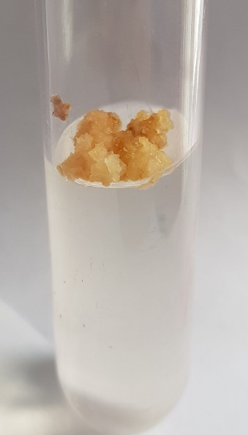
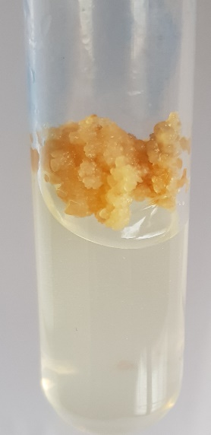
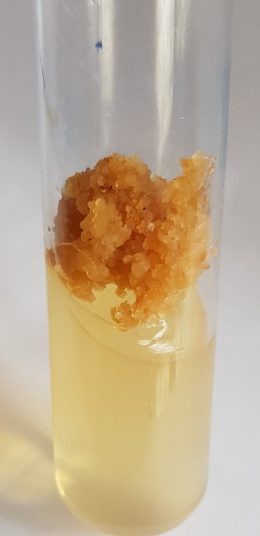
Fig. 12 (a) Callus culture of CP-77-400 treated with 0.4mM Pb(NO₃)₂ +5mg/l 2,4-D at day 90 (2x)

Fig. 12(b) Callus culture of CP-77-400 treated with 0.4mM Pb(NO₃)₂ +5mg/l 2,4-D at day 120 (2x)

Fig. 12 (c) Callus culture of CP-77-400 treated with 0.4mM Pb(NO₃)₂+5mg/l 2,4-D at day 150 (2x)

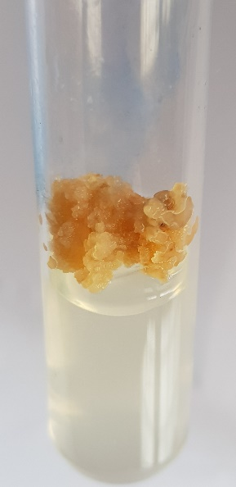
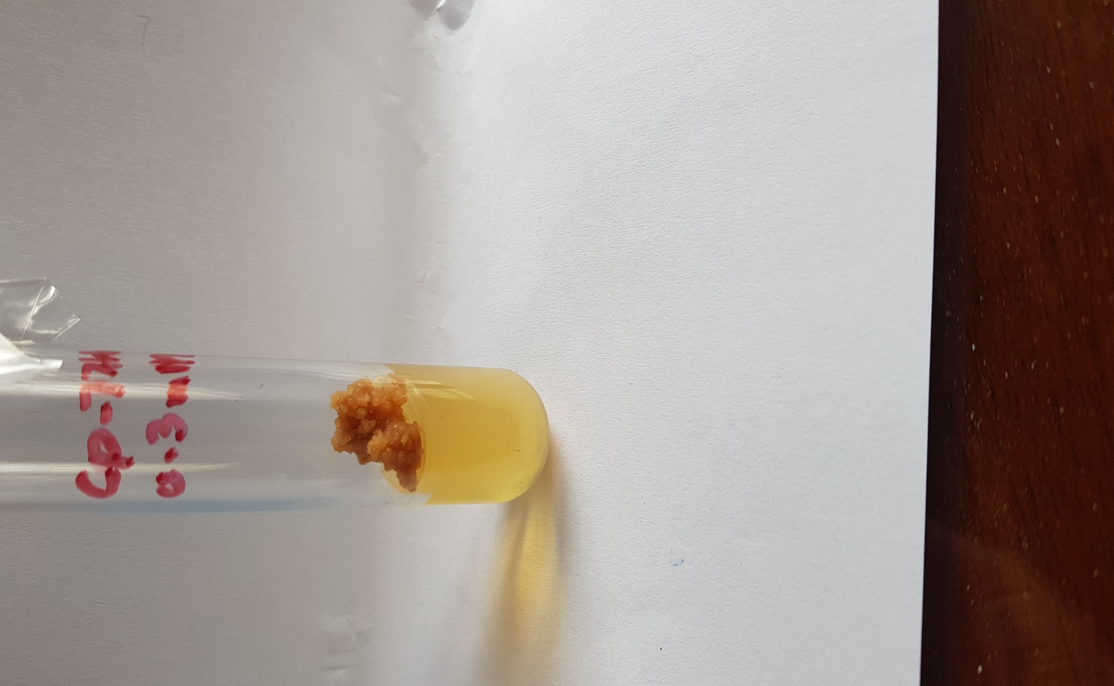
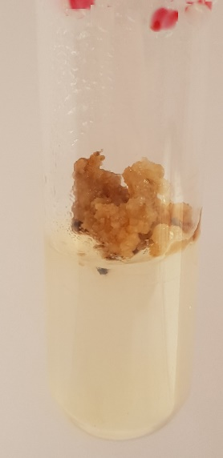
Fig. 13(a) Callus culture of CP-77-400 treated with 0.5mM Pb(NO₃)₂+5mg/l 2,4-D at day 90 (2x)
Fig. 13 (b) Callus culture of CP-77-400 treated with 0.5mM Pb(NO₃)₂ +5mg/l 2,4-D at day 120 (2x)
Fig. 13 (c) Callus culture of CP-77-400 treated with 0.5mM Pb(NO₃)₂ +5mg/l 2,4-D at day 150 (2x)

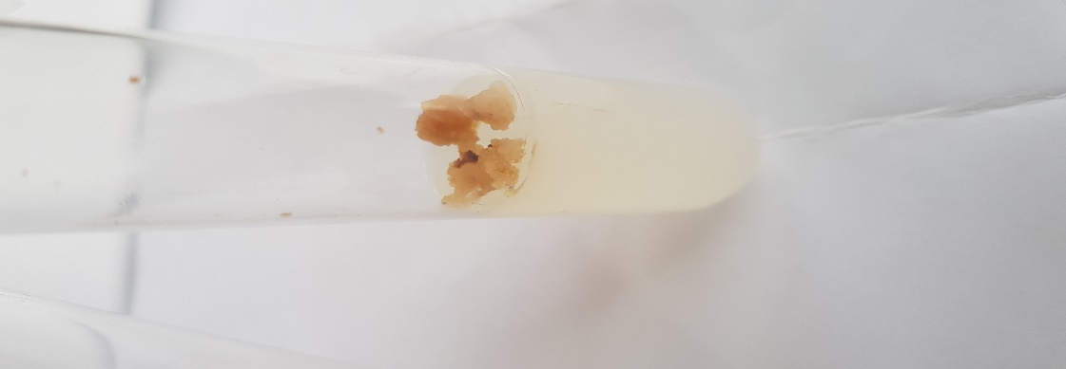
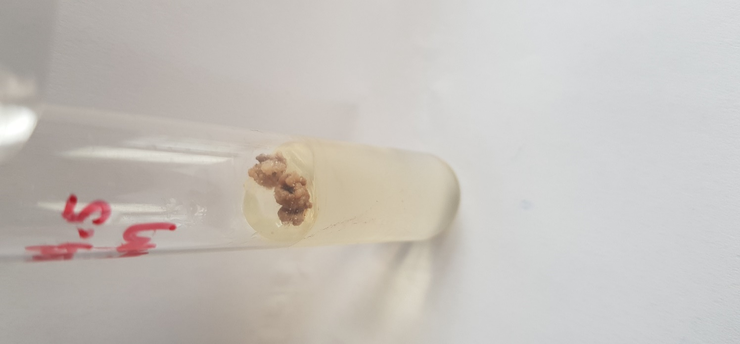
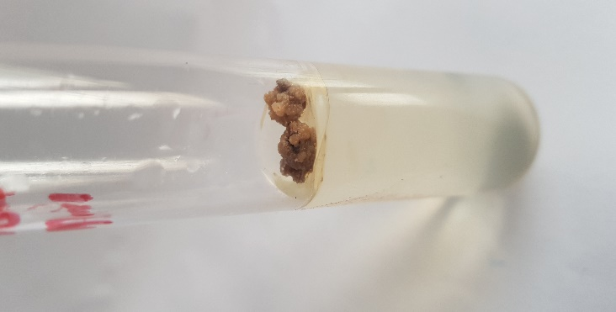
Fig. 14 (c) Callus culture of CP-77-400 treated with 1mM Pb(NO₃)₂ +5mg/l 2,4-D at day 150 (2x)
Fig. 14 (a) Callus culture of CP-77-400 treated with 1mM Pb(NO₃)₂ +5mg/l 2,4-D at day 90 (2x)
Fig. 14 (b) Callus culture of CP-77-400 treated with 1mM Pb(NO₃)₂ +5mg/l 2,4-D at day 120 (2x)

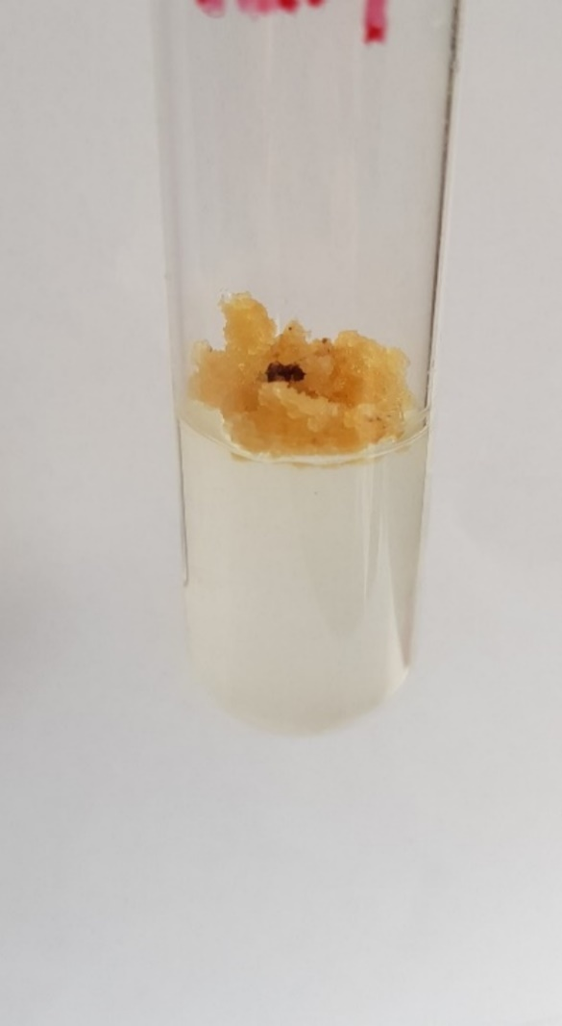
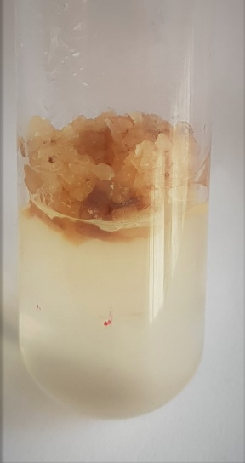
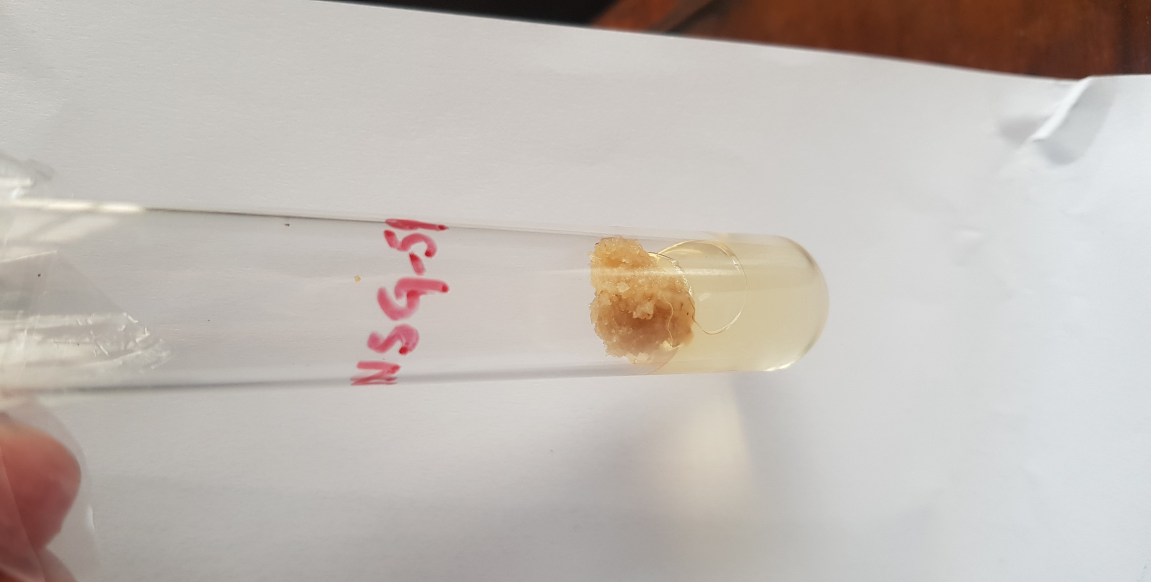
Fig. 15 (a) Control callus culture of NSG-59(0mM Pb(NO₃)₂ +3.5mg/l 2,4-D )at day 90 (2x)
Fig. 15 (b) Control callus culture of NSG-59 control(0mM Pb(NO₃)₂ +3.5mg/l 2,4-D) at day 120 (2x)
Fig. 15 (c) Control callus culture of NSG-59 (0mM Pb(NO₃)₂ +3.5mg/l 2,4-D)at day 150 (2x)

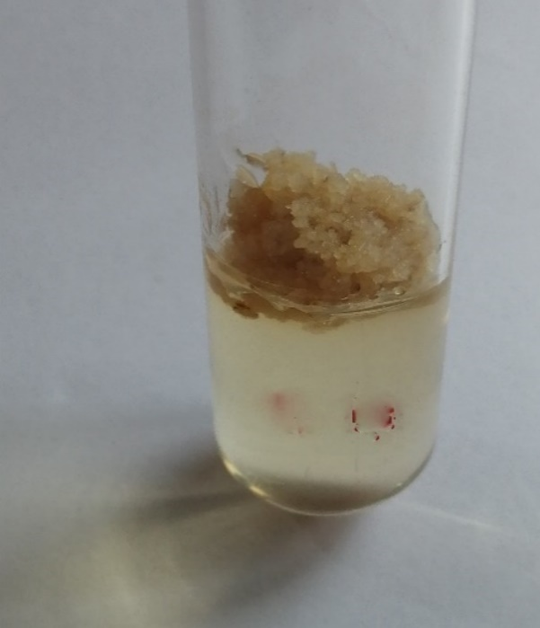
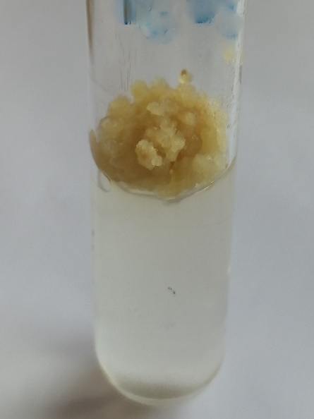
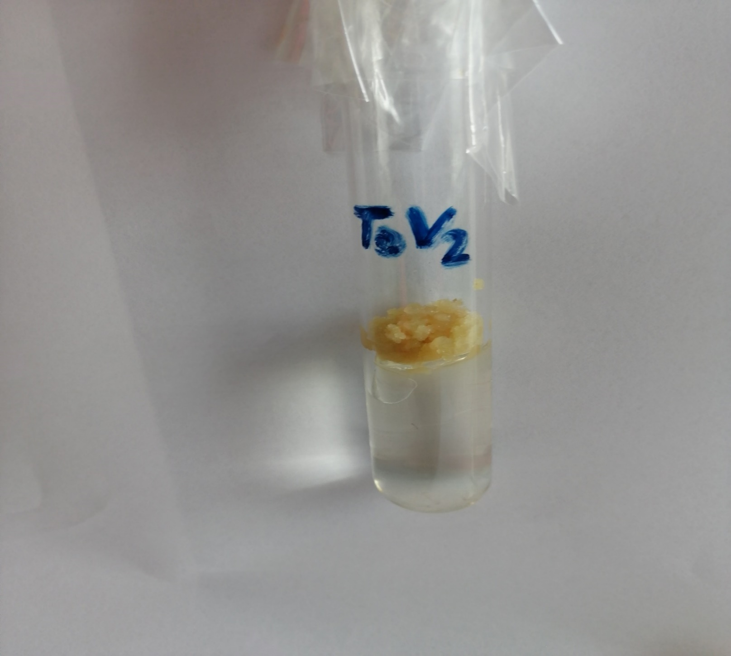
Fig. 16(c) Callus culture of NSG-59 treated with 0.1mM Pb(NO₃)₂ +3.5mg/l 2,4-D at day 150 (2x)
Fig. 16 (b) Callus culture of NSG-59 treated with 0.1mM Pb(NO₃)₂ +3.5mg/l 2,4-D at day 120 (2x)
Fig. 16 (a) Callus culture of NSG-59 treated with 0.1mM Pb(NO₃)₂ +3.5mg/l 2,4-D at day 90 (2x)

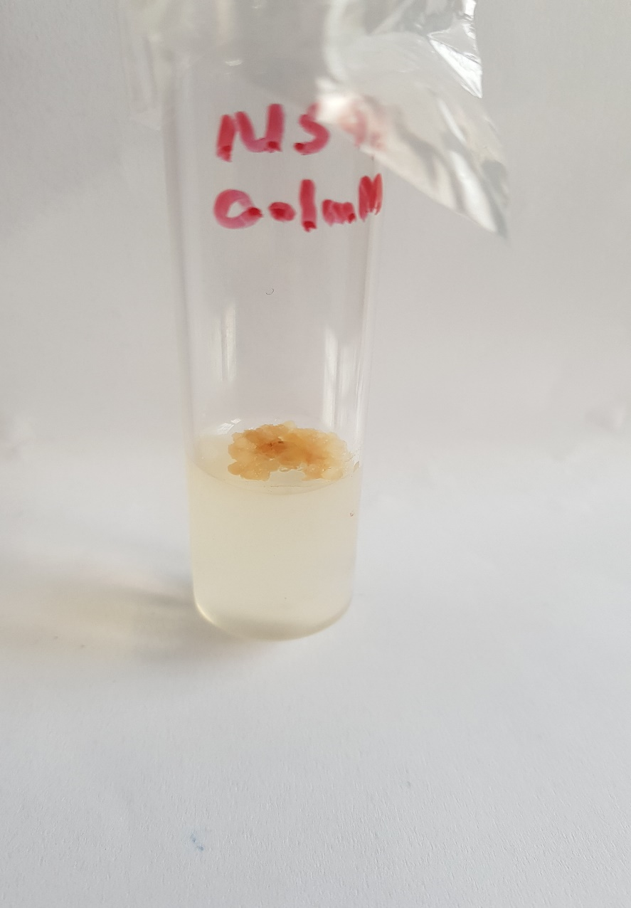
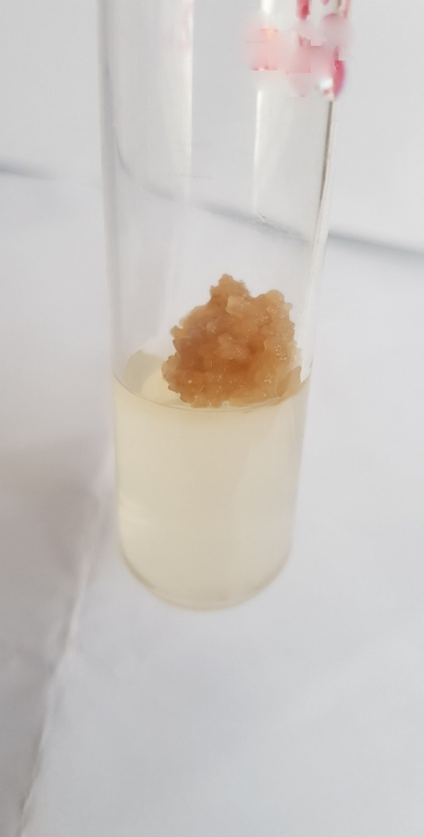
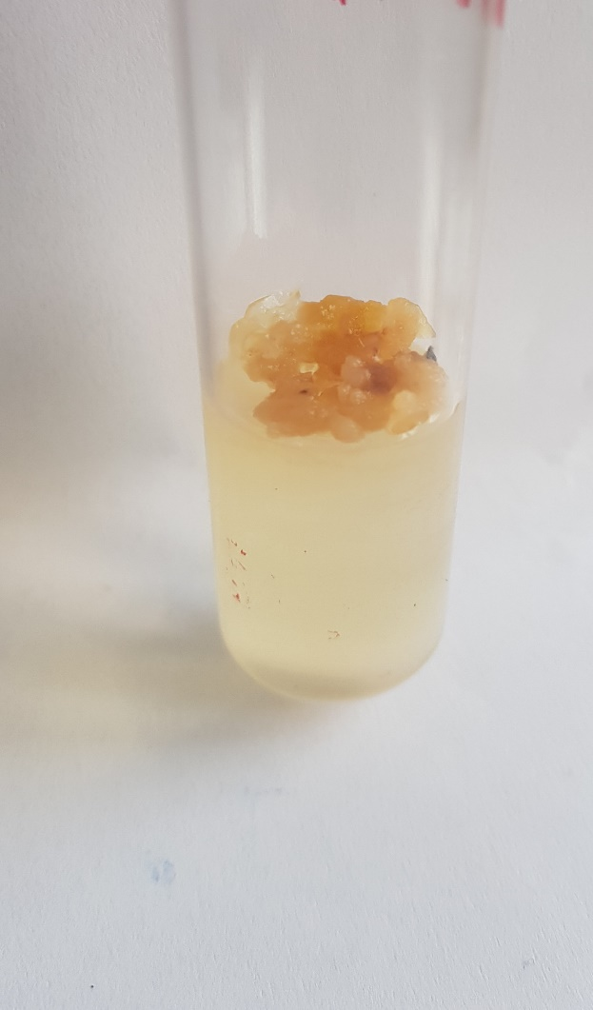
Fig. 17 (a) Callus culture of NSG-59 treated with 0.2mM Pb(NO₃)₂ +3.5mg/l 2,4-D at day 90 (2x)
Fig. 17 (c) Callus culture of NSG-59 treated with 0.2mM Pb(NO₃)₂ +3.5mg/l 2,4-D at day 150 (2x)
Fig. 17(b) Callus culture of NSG-59 treated with 0.2mM Pb(NO₃)₂ +3.5mg/l 2,4-D at day 120 (2x)

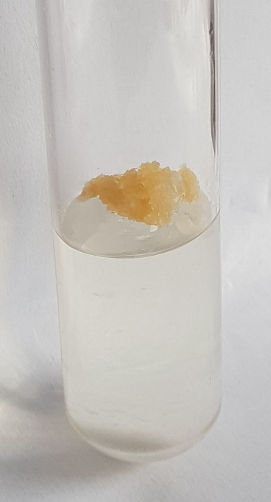
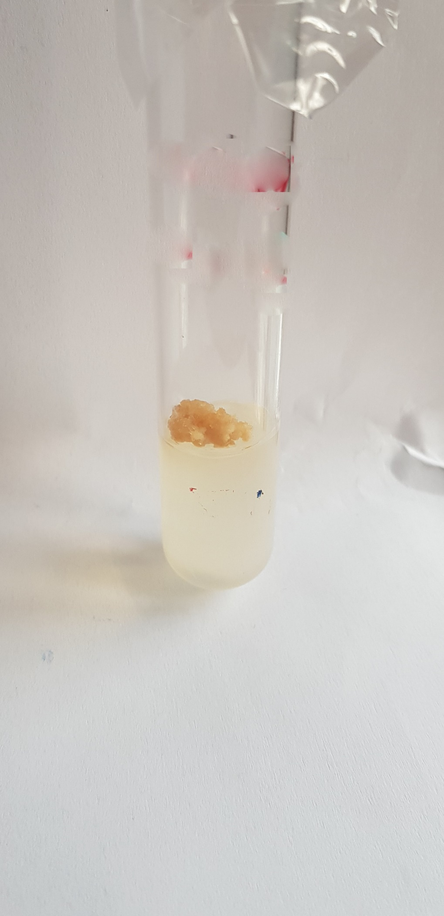
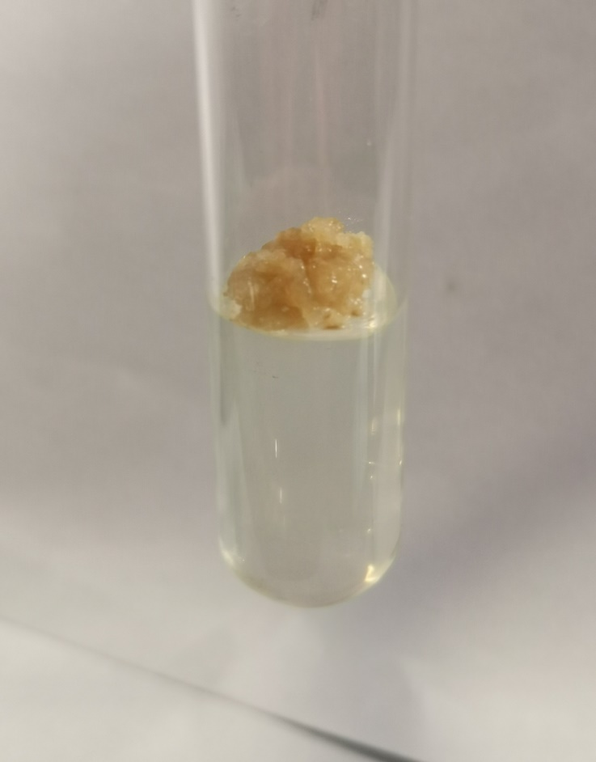
Fig. 18(a) Callus culture of NSG-59 treated with 0.3mM Pb(NO₃)₂+3.5mg/l 2,4-D at day 90 (2x)
Fig. 18 (b) Callus culture of NSG-59 treated with 0.3mM Pb(NO₃)₂ +3.5mg/l 2,4-D at day 120 (2x)
Fig. 18 (c) Callus culture of NSG-59 treated with 0.3mM Pb(NO₃)₂ +3.5mg/l 2,4-D at day 150 (2x)

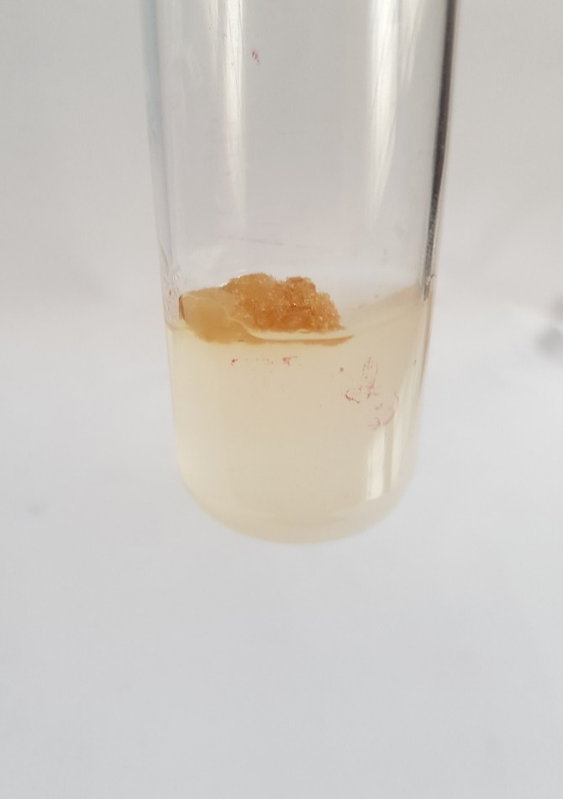
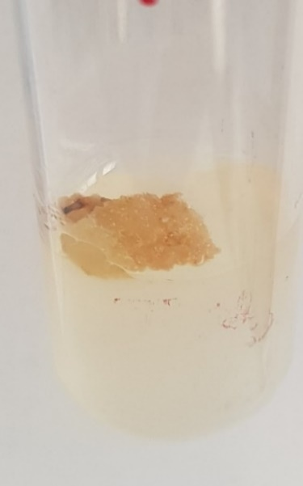
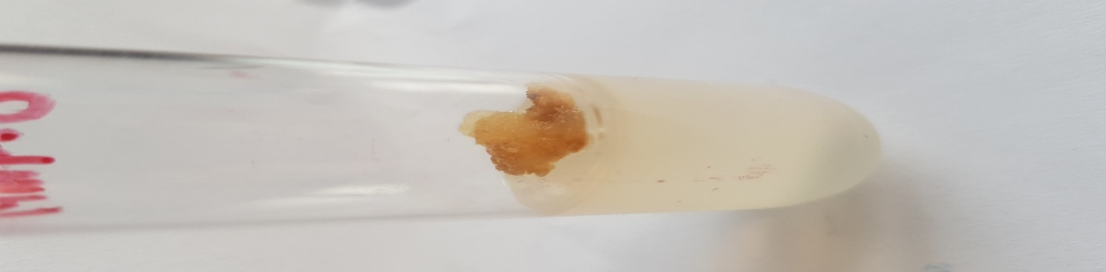
Fig. 19 (a) Callus culture of NSG-59 treated with 0.4mM Pb(NO₃)₂ +3.5mg/l 2,4-D at day 90 (2x)
Fig. 19 (b) Callus culture of NSG-59 treated with 0.4mM Pb(NO₃)₂ +3.5mg/l 2,4-D at day 120 (2x)
Fig. 19 (c) Callus culture of NSG-59 treated with 0.4mM Pb(NO₃)₂ +3.5mg/l 2,4-D at day 150 (2x)

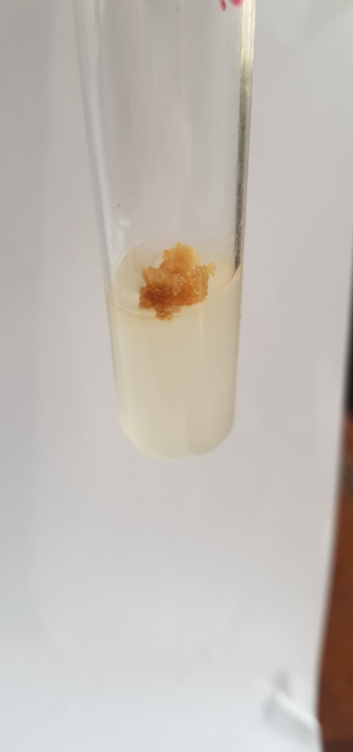
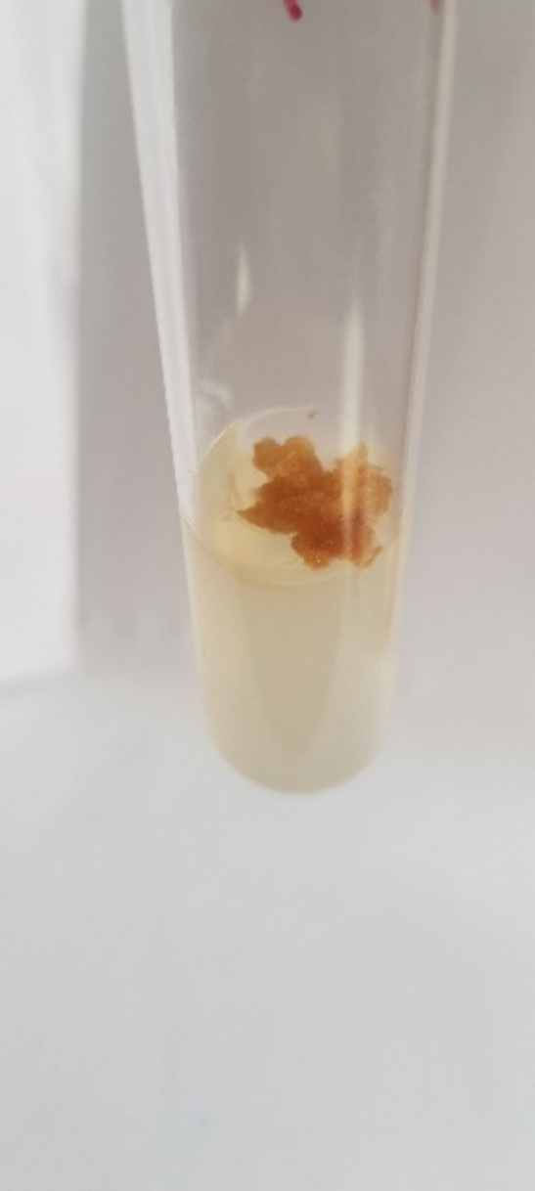
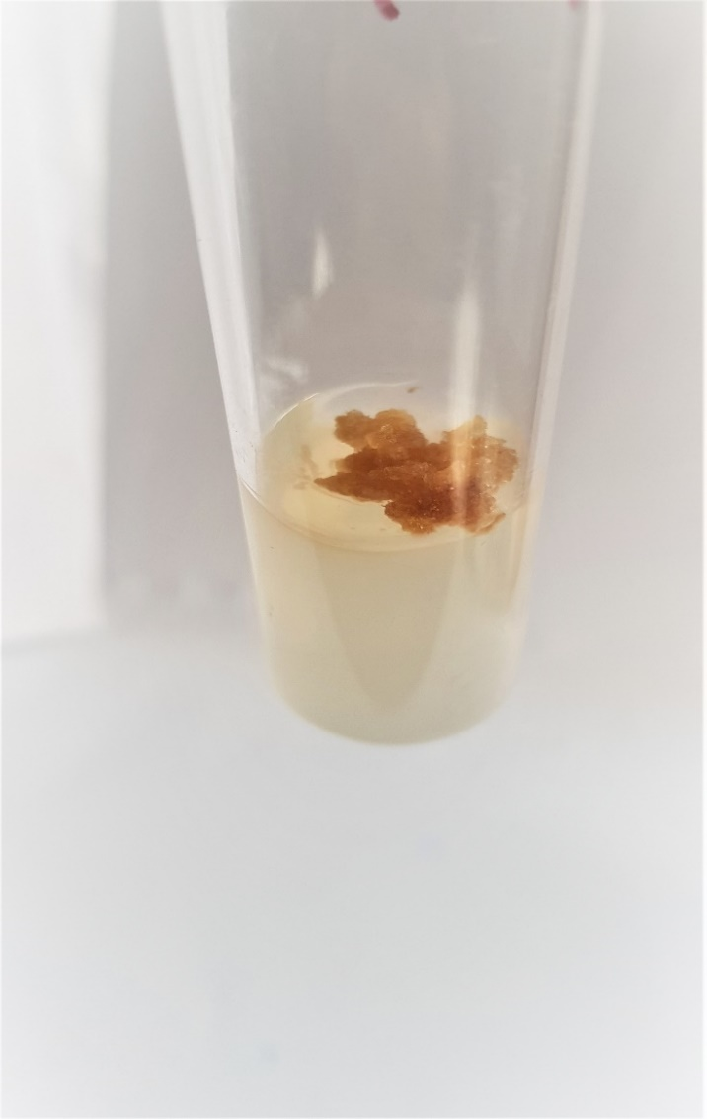
Fig. 20 (a) Callus culture of NSG-59 treated with 0.5mM Pb(NO₃)₂ +3.5mg/l 2,4-D at day 90 (2x)
Fig. 20 (b) Callus culture of NSG-59 treated with 0.5mM Pb(NO₃)₂ +3.5mg/l 2,4-D at day 120 (2x)
Fig. 20 (c) Callus culture of NSG-59 treated with 0.5mM Pb(NO₃)₂ +3.5mg/l 2,4-D at day 150 (2x)

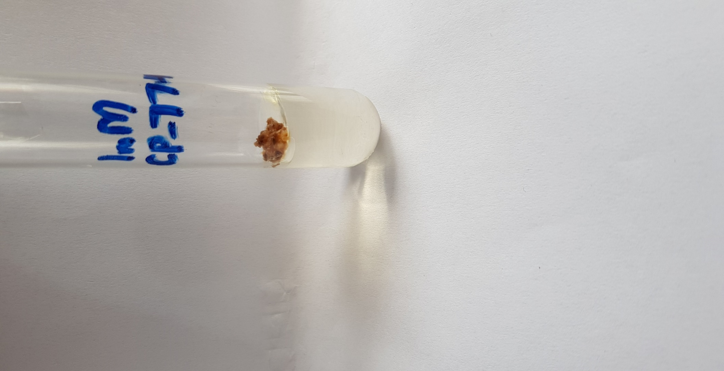
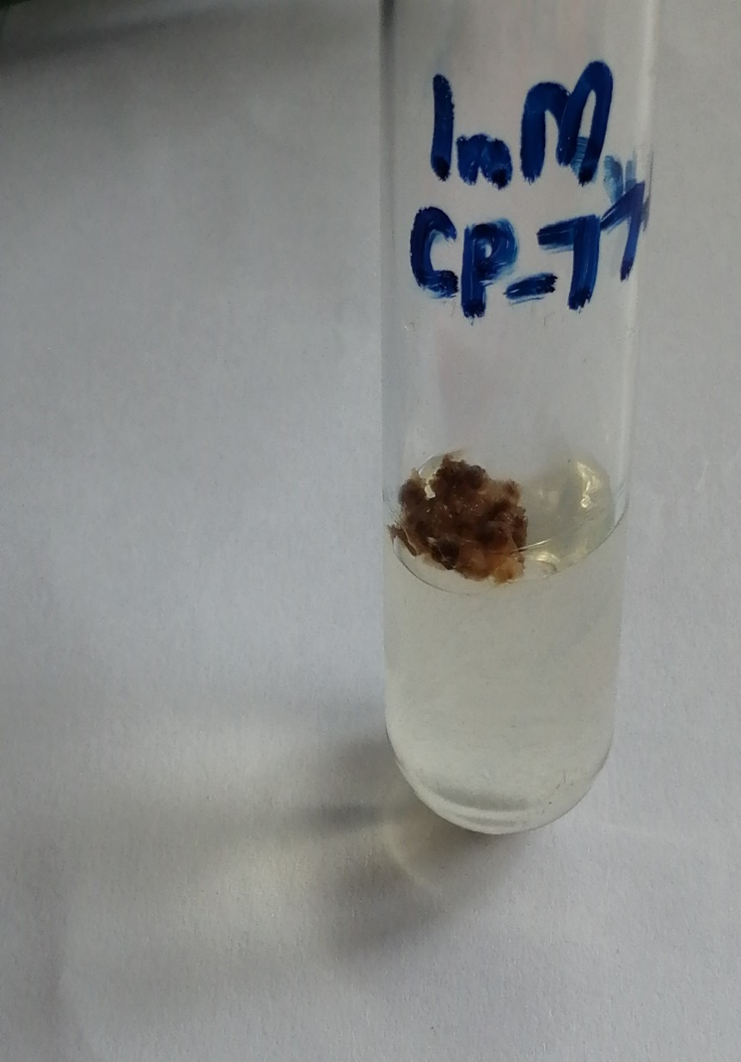
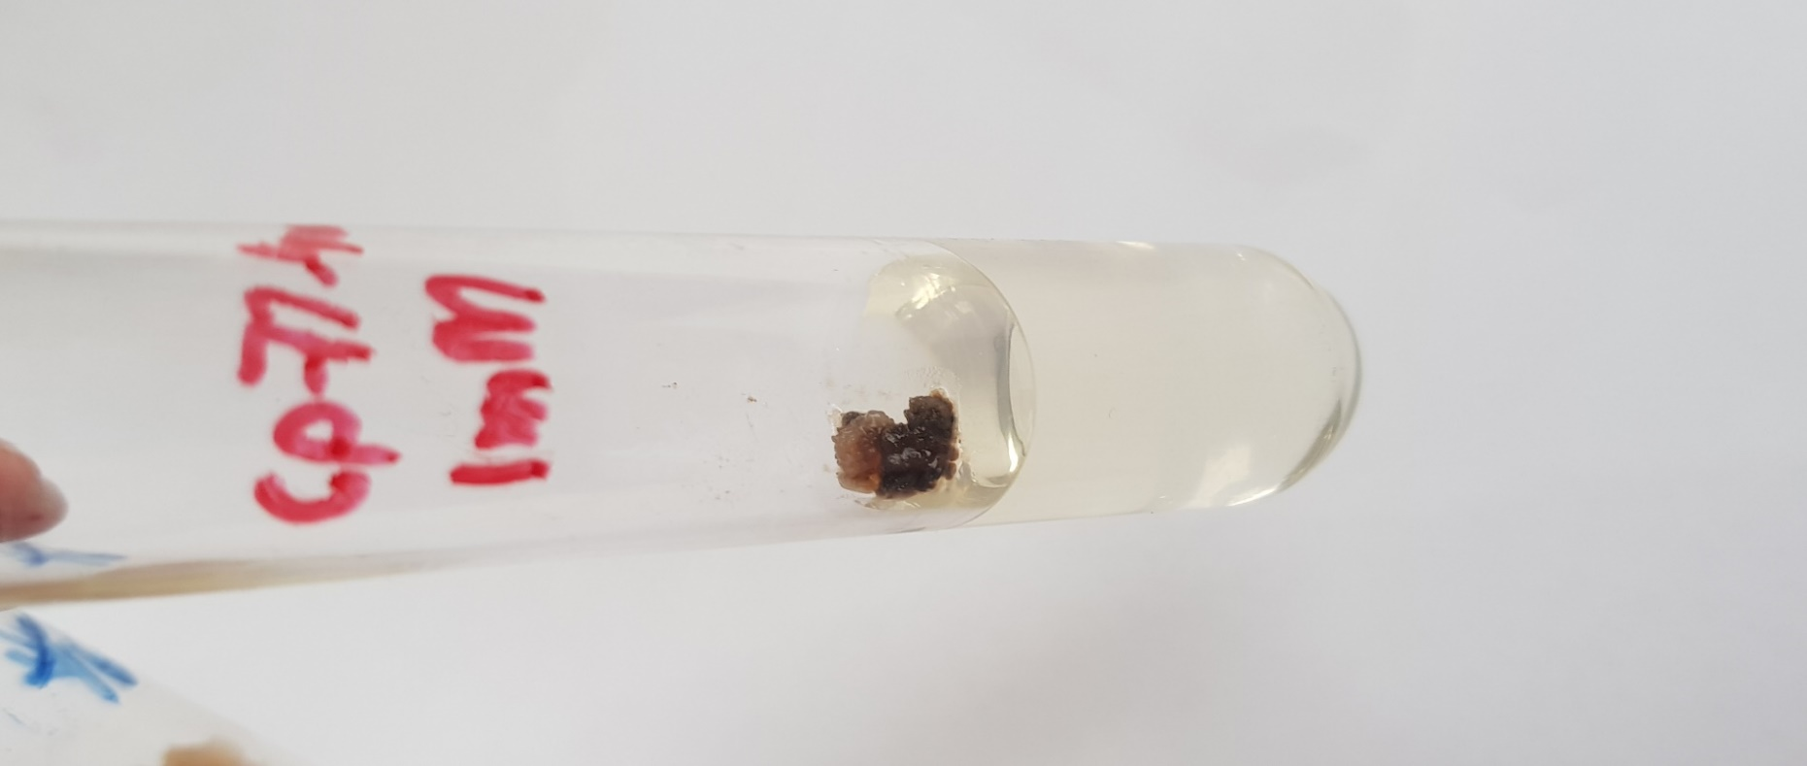
Fig. 21(a) Callus culture of NSG-59 treated with 1mM Pb(NO₃)₂ +3.5mg/l 2,4-D at day 90 (2x)
Fig. 21(b) Callus culture of NSG-59 treated with 1mM Pb(NO₃)₂ +3.5mg/l 2,4-D at day 120 (2x)
Fig. 21 (c) Callus culture of NSG-59 treated with 1mM Pb(NO₃)₂ +3.5mg/l 2,4-D at day 150 (2x)

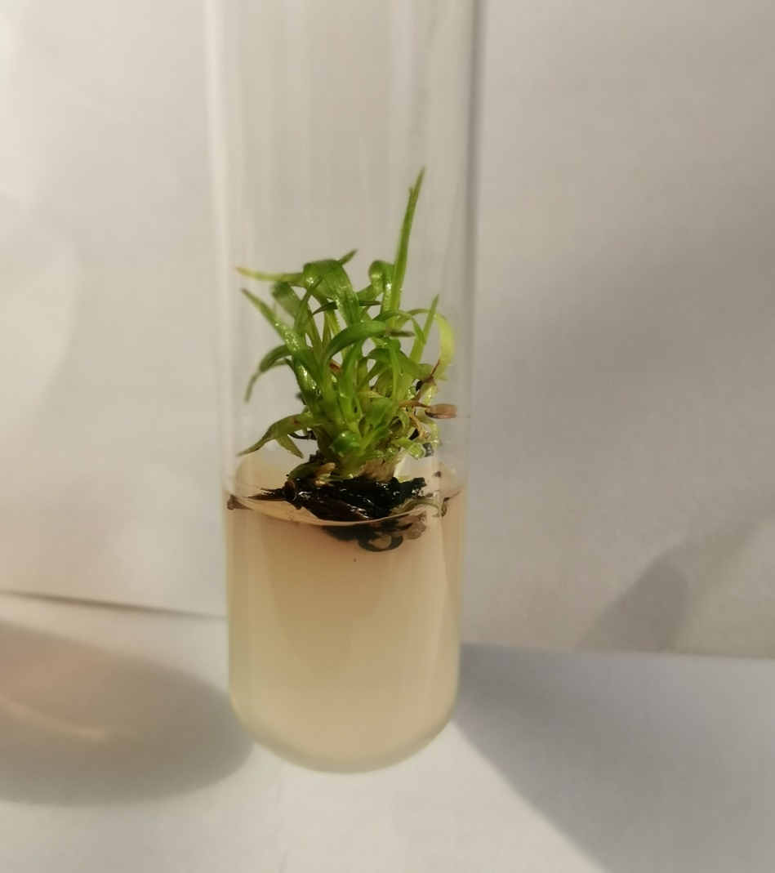
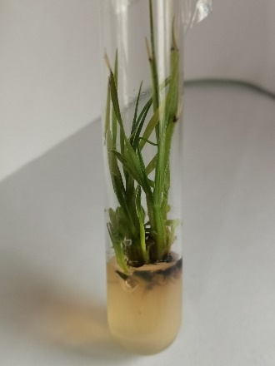
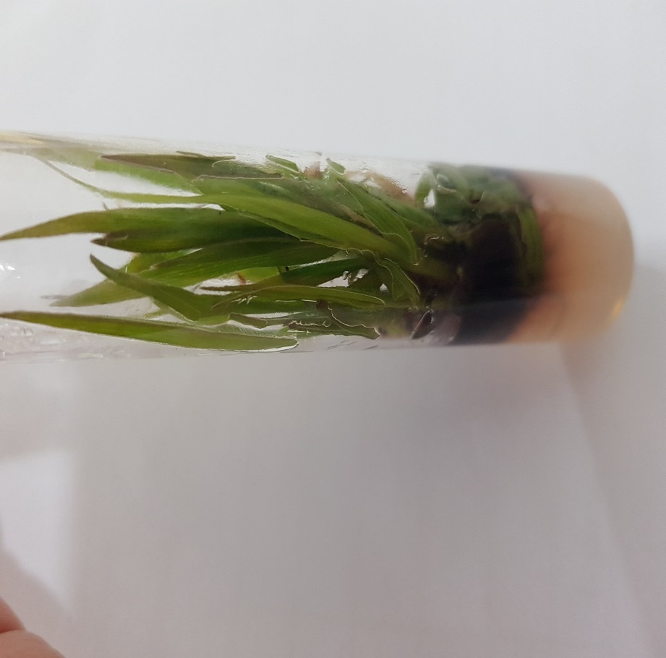
Fig. 22 (a)Shoots of YT-53 regenerated from 0mM Pb(NO₃)₂ treated callus on MS+2mg/l Kin. at day 30 (1x)

Fig. 22 (b) Shoots of YT-53 regenerated from 0mM Pb(NO₃)₂ treated callus on MS+2mg/l Kin at day 60 (1x)
Fig. 22(c) Shoots of YT-53 regenerated from 0mM Pb(NO₃)₂ treated callus on MS+2mg/l Kin at day 90 (1x)

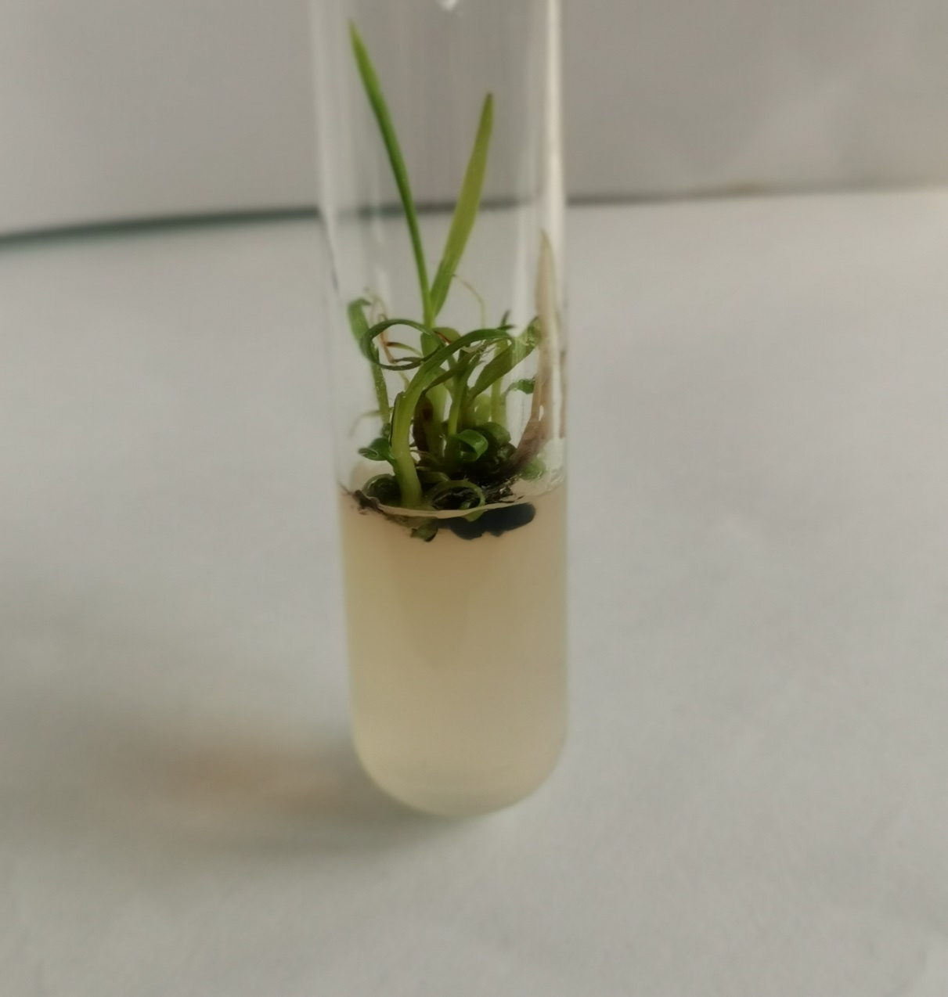
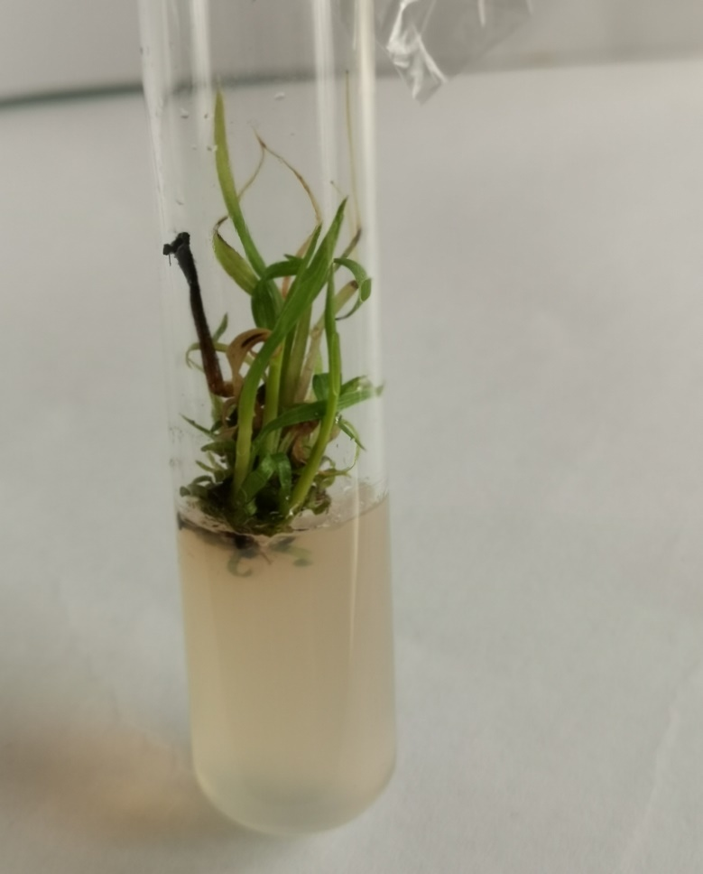
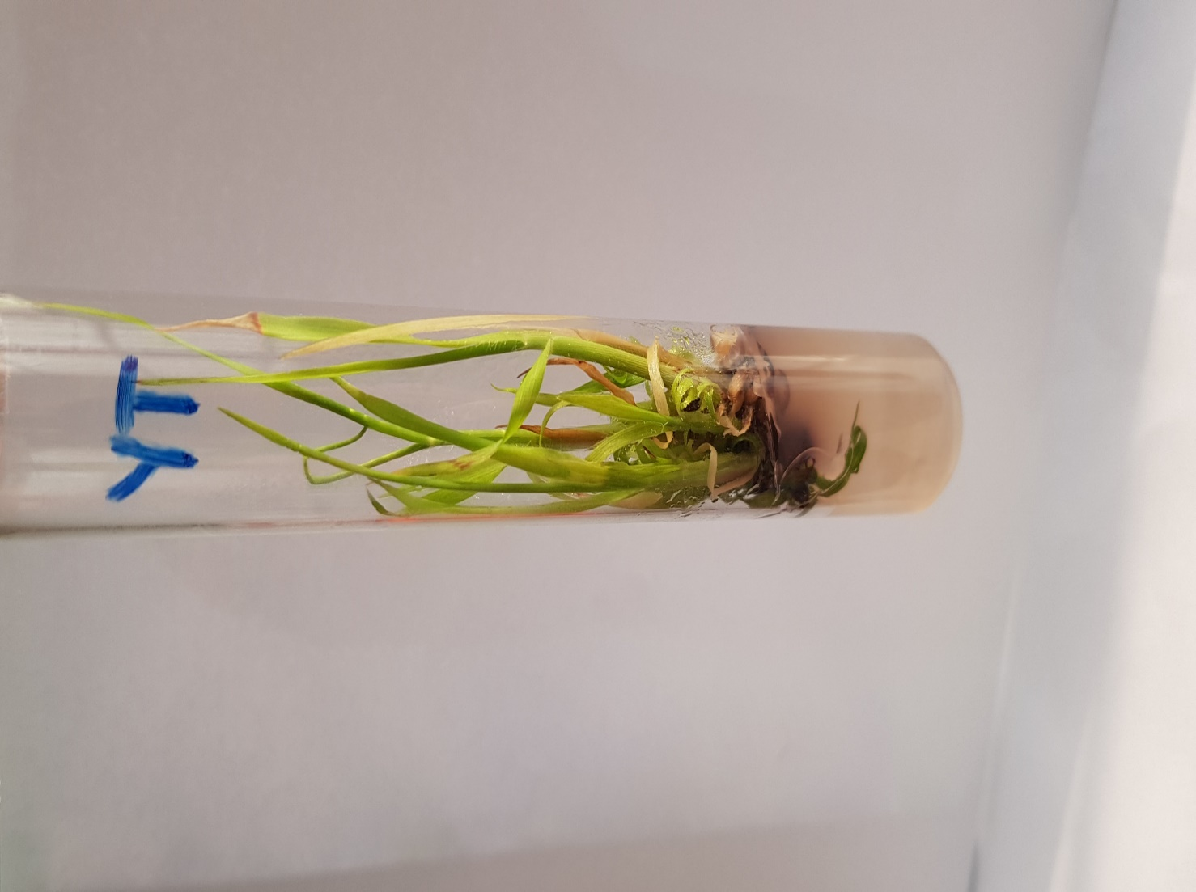
Fig. 23 (a) Shoots of YT-53 regenerated from 0.1mM Pb(NO₃)₂ treated callus on MS+2mg/l Kin at day 30 (1x)
Fig. 23 (b) Shoots of YT-53 regenerated from 0.1mM Pb(NO₃)₂ treated callus on MS+2mg/l Kin at day 60 (1x)
Fig. 23(c) Shoots of YT-53 regenerated from 0.1mM Pb(NO₃)₂ treated callus on MS+2mg/l Kin at day 90 (1x)

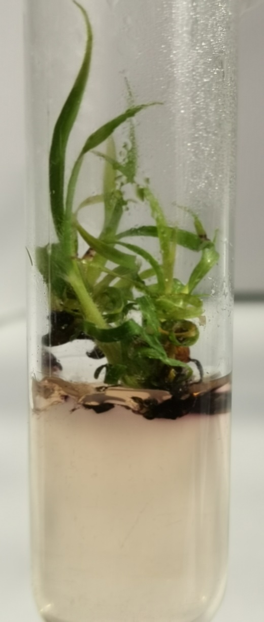
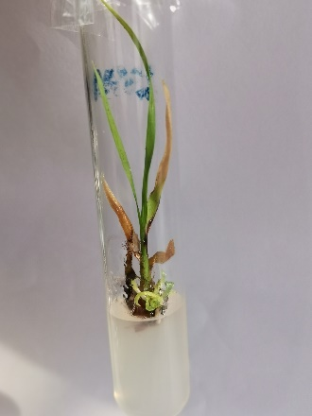
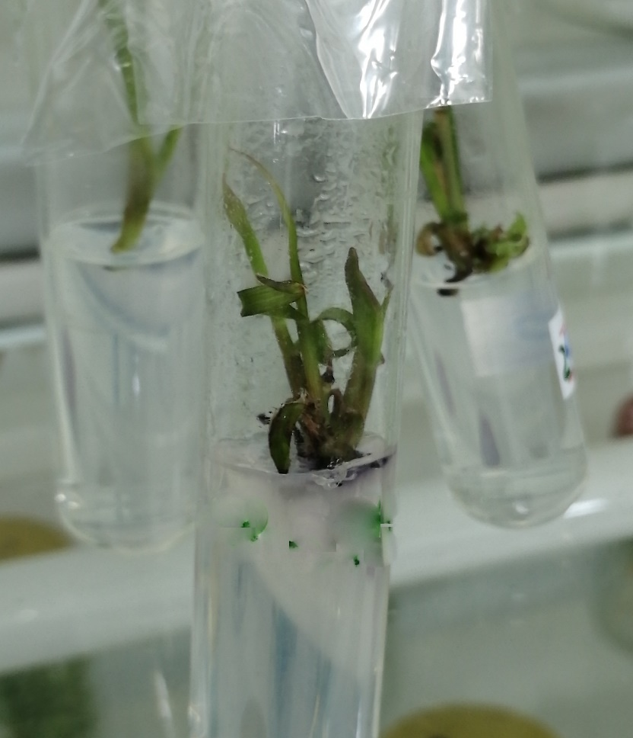
Fig. 24 (b) Shoots of YT-53 regenerated from 0.2mM Pb(NO₃)₂ treated callus on MS+2mg/l Kin at day 60 (1x)

Fig. 24(a) Shoots of YT-53 regenerated from 0.2mM Pb(NO₃)₂ treated callus on MS+2mg/l Kin at day 30 (1x)

Fig. 24(c) Shoots of YT-53 regenerated from 0.2mM Pb(NO₃)₂ treated callus on MS+2mg/l Kin at day 90 (1x)

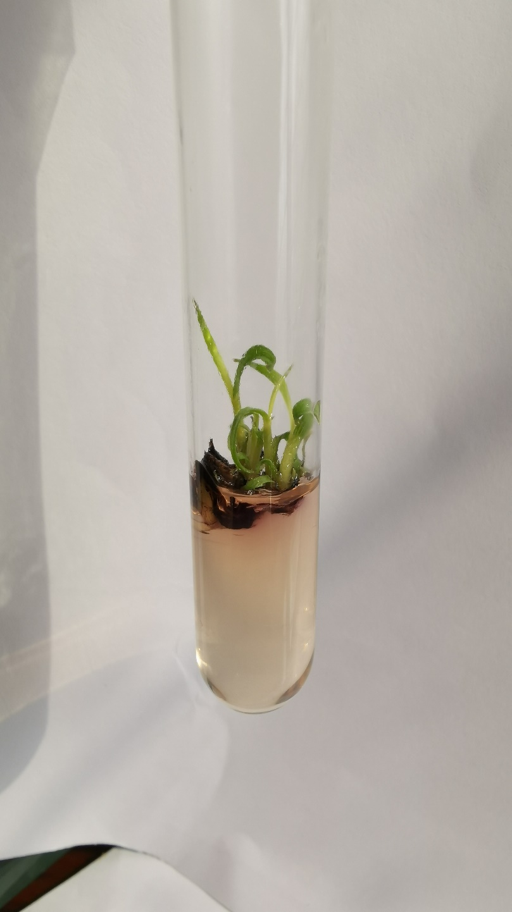
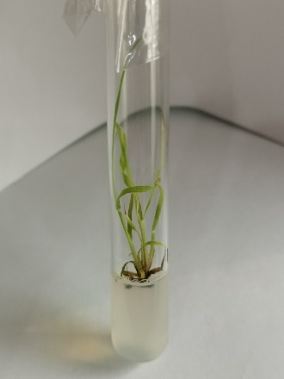
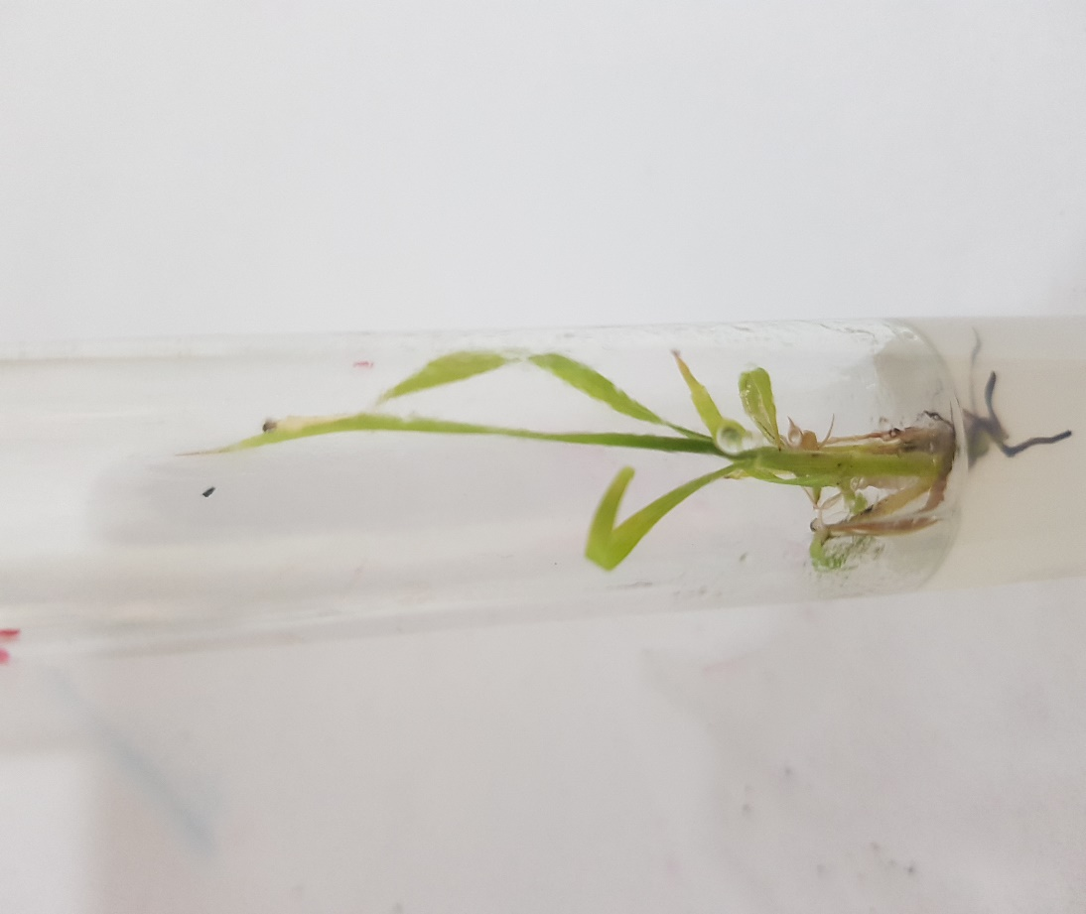
Fig. 25(c) Shoots of YT-53 regenerated from 0.3mM Pb(NO₃)₂ treated callus at day 90 (1x)

Fig. 25(b) Shoots of YT-53 regenerated from 0.3mM Pb(NO₃)₂ treated callus at day 60 (1x)

Fig. 25 (a) Shoots of YT-53 regenerated from 0.3mM Pb(NO₃)₂ treated callus at day 30 (1x)

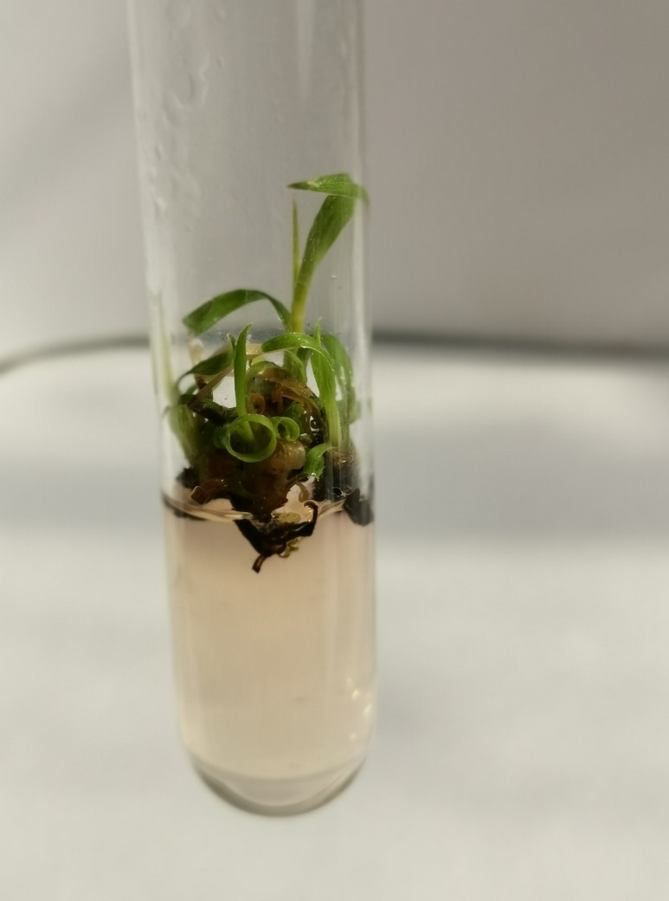
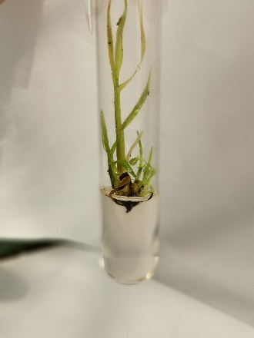
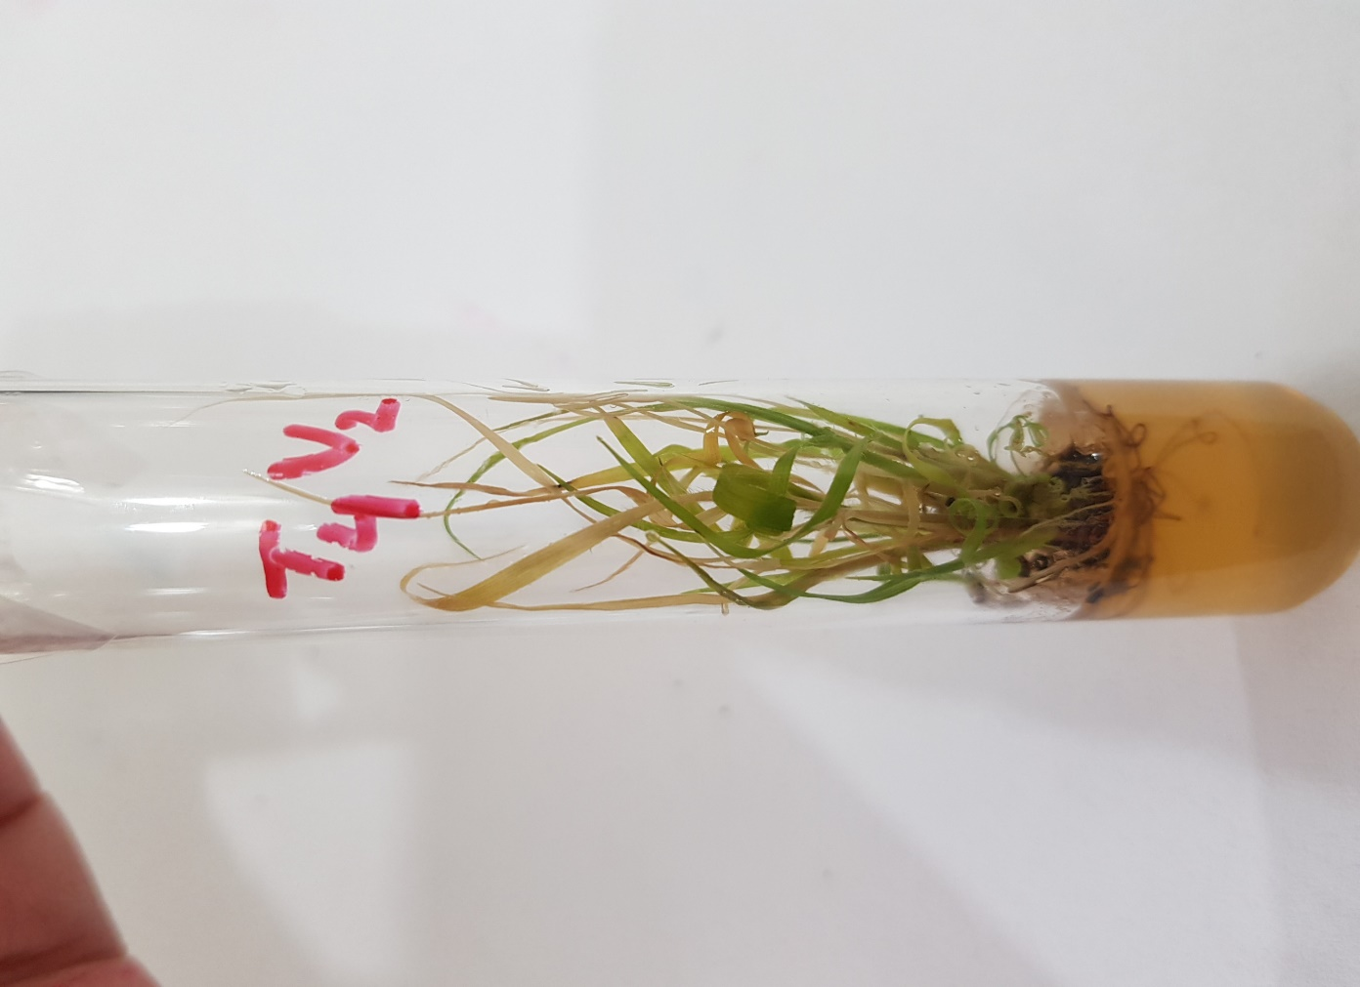
Fig. 26 (a) Shoots of YT-53 regenerated from 0.4mM Pb(NO₃)₂ treated callus on MS+2mg/l Kin at day 30 (1x)

Fig. 26(b) Shoots of YT-53 regenerated from 0.4mM Pb(NO₃)₂ treated callus on MS+2mg/l Kin at day 60 (1x)

Fig. 26(c) Shoots of YT-53 regenerated from 0.4mM Pb(NO₃)₂ treated callus on MS+2mg/l Kin at day 90 (1x)

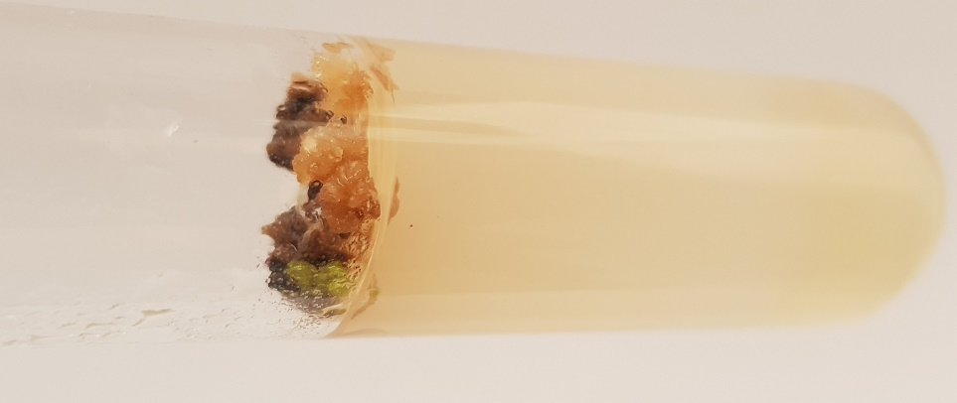
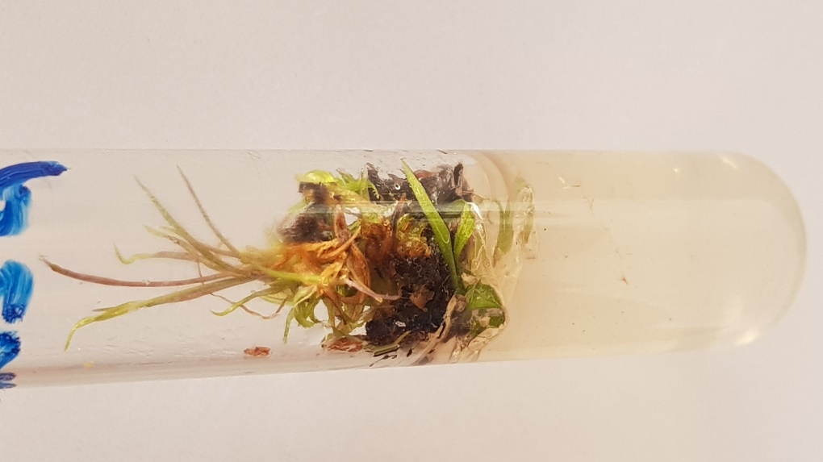
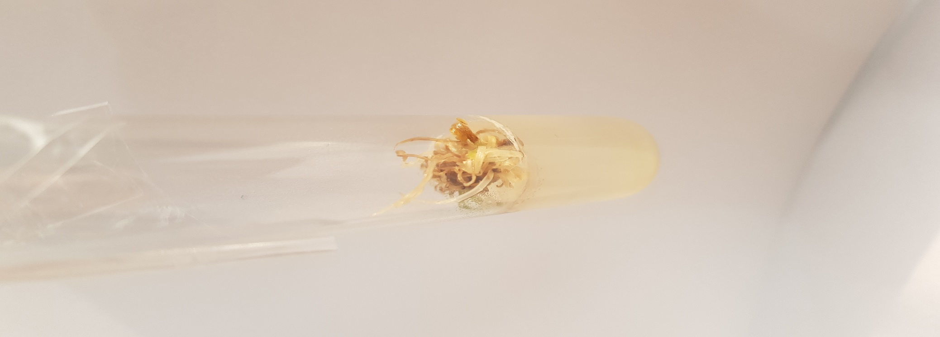
Fig. 27 (a) Shoots of YT-53 regenerated from 0.5mM Pb(NO₃)₂ treated callus on MS+2mg/l Kin at day 30 (1x)

Fig. 27 (b) Shoots of YT-53 regenerated from 0.5mM Pb(NO₃)₂ treated callus at day 60 (1x)

Fig. 27 (c) Shoots of YT-53 regenerated from 0.5mM Pb(NO₃)₂ treated callus on MS+2mg/l Kin at day 90 (1x)

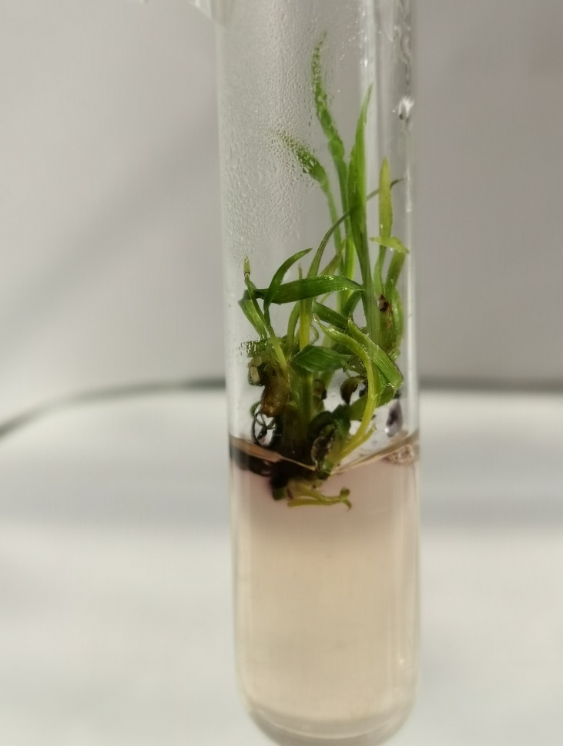
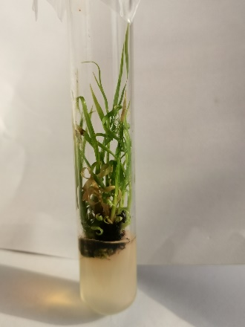
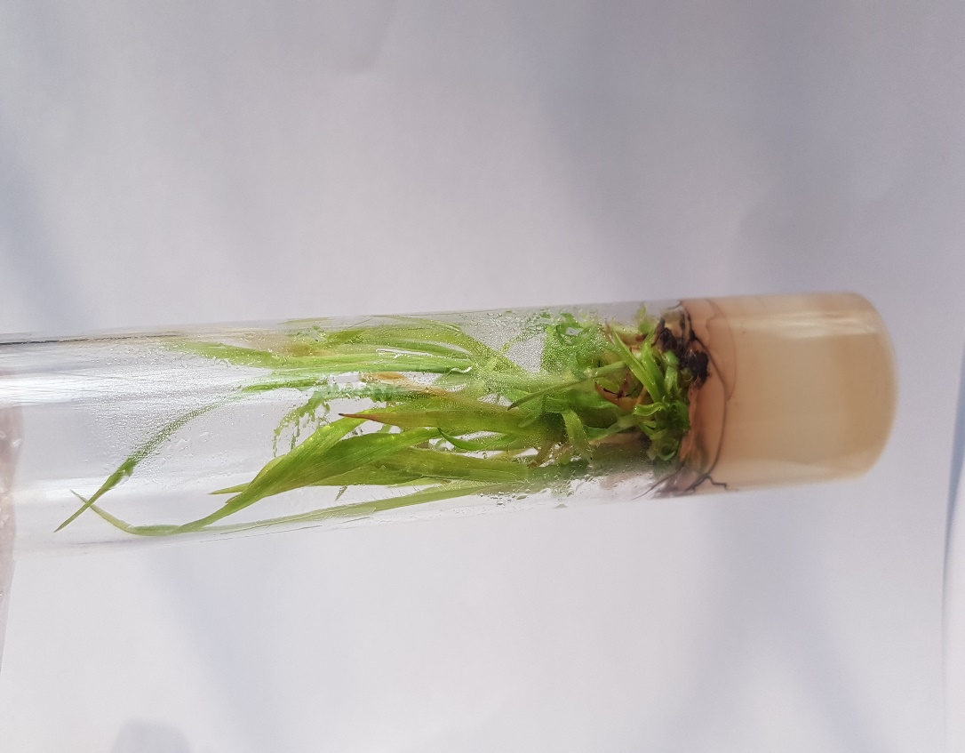
Fig. 28(a) Shootst of CP-77-400 regenerated from 0mM Pb(NO₃)₂ treated callus on MS+1mg/l BAP at day 30 (1x)

Fig. 28 (b) Shoots of CP-77-400 regenerated from 0mM Pb(NO₃)₂ treated callus on MS+1mg/l BAP at day 60 (1x)

Fig. 28(c) Shoots of CP-77-400 regenerated from 0mM Pb(NO₃)₂ treated callus at day 90 (1x)

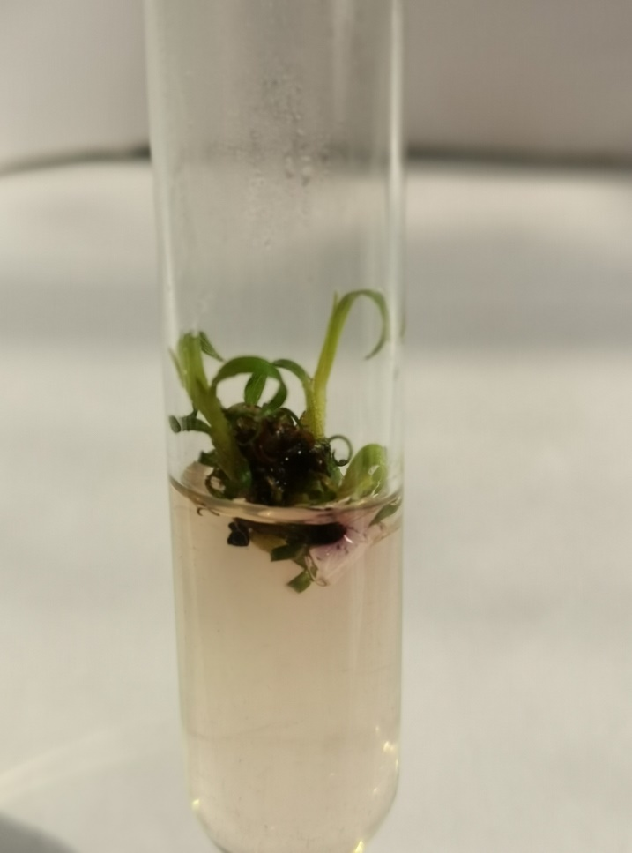
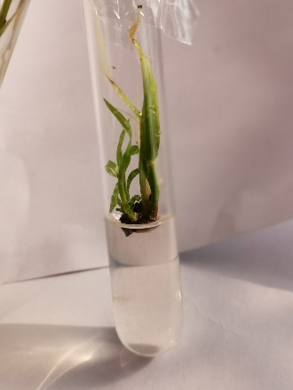
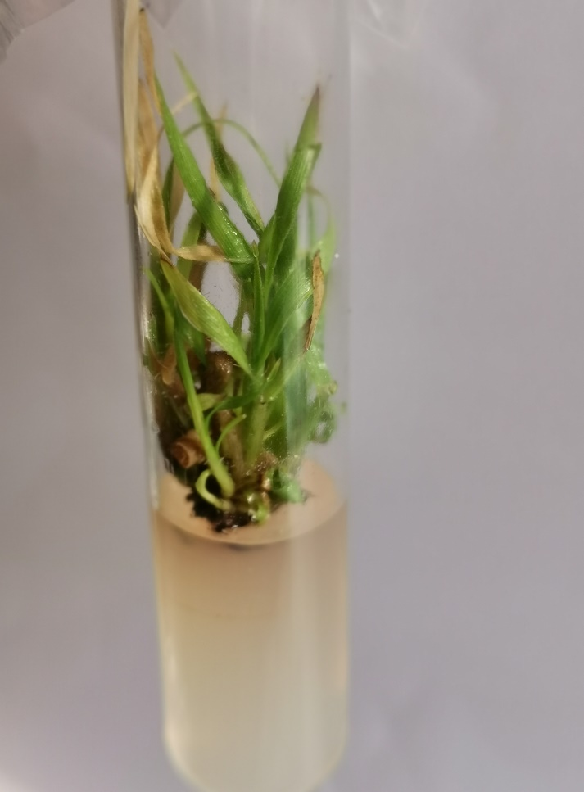
Fig. 29(c) Shoots of CP-77-400 regenerated from 0.1mM Pb(NO₃)₂ treated callus on MS+1mg/l BAP at day 90 (1x)

Fig. 29(b) Shoots of CP-77-400 regenerated from 0.1mM Pb(NO₃)₂ treated callus on MS+1mg/l BAP at day 60 (1x)

Fig. 29(a) Shoots of CP-77-400 regenerated from 0.1mM Pb(NO₃)₂ treated callus on MS+1mg/l BAP at day 30 (1x)

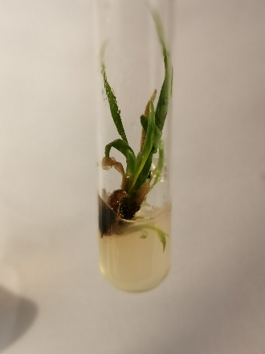
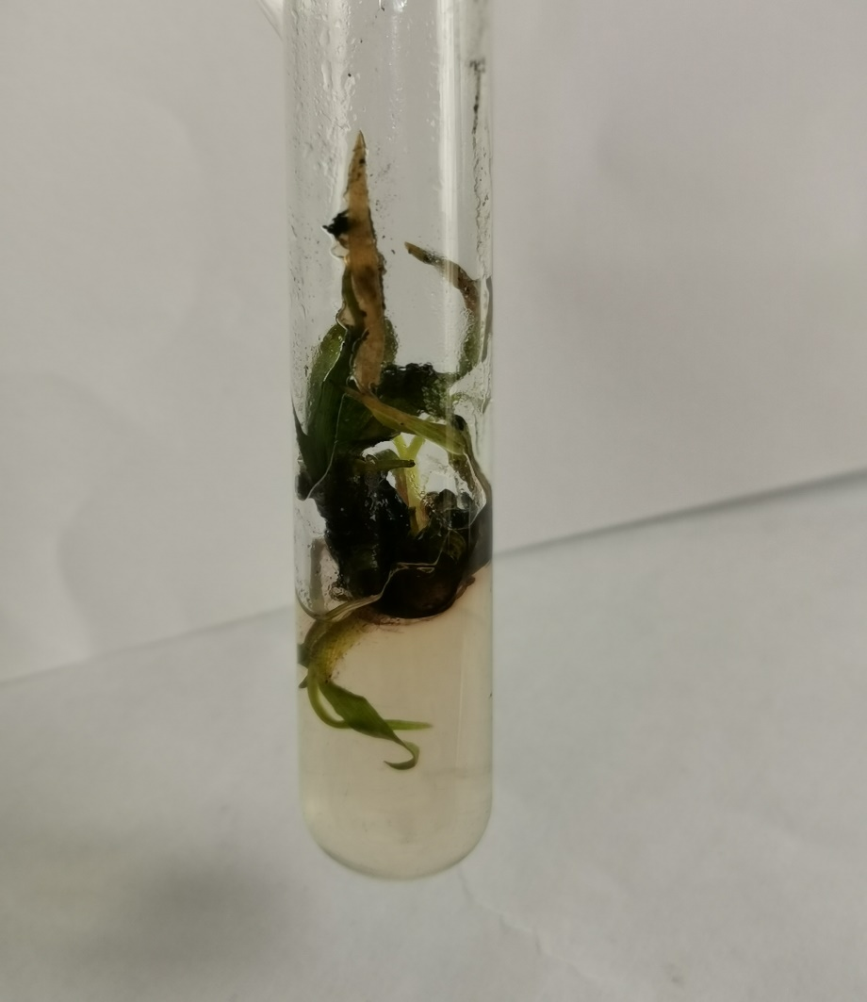
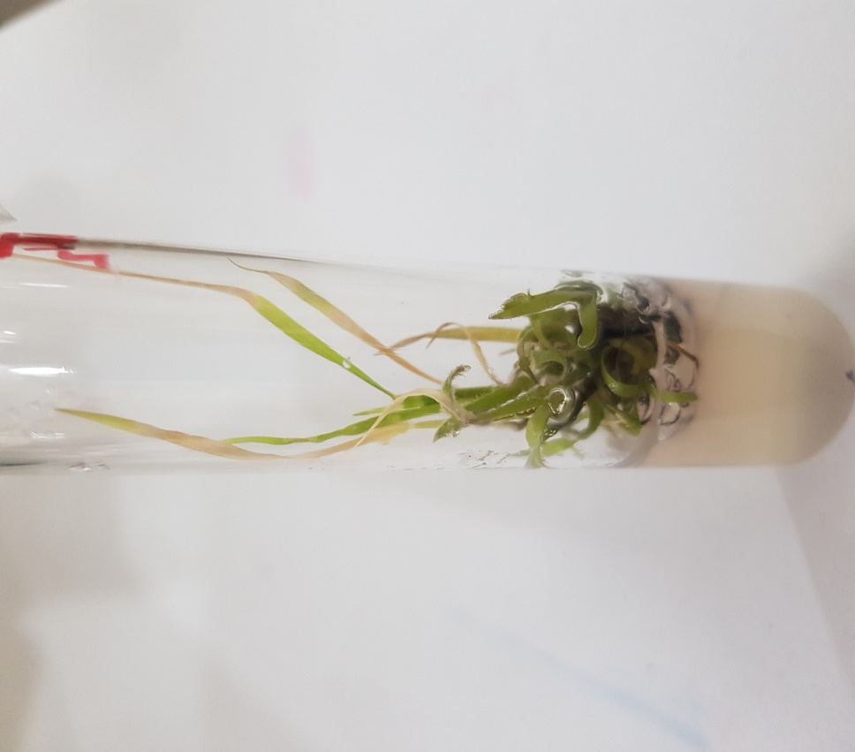
Fig. 30 (a) Shoots of CP-77-400 regenerated from 0.2mM Pb(NO₃)₂ treated callus on MS+1mg/l BAP at day 30 (1x)

Fig. 30(b) Shoots of CP-77-400 regenerated from 0.2mM Pb(NO₃)₂ treated callus on MS+1mg/l BAP at day 60 (1x)

Fig. 30 (c) Shoots of CP-77-400 regenerated from 0.2mM Pb(NO₃)₂ treated callus on MS+1mg/l BAP at day 90 (1x)

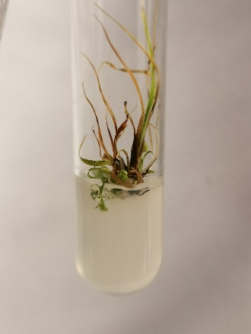
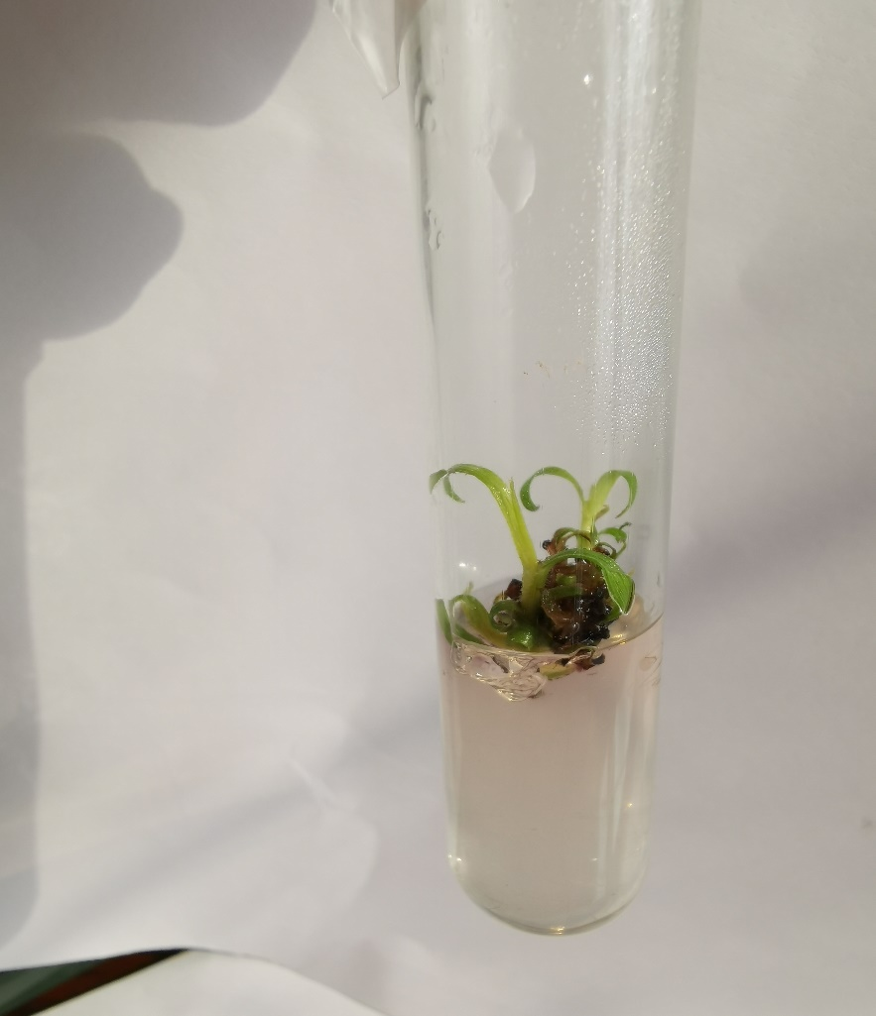
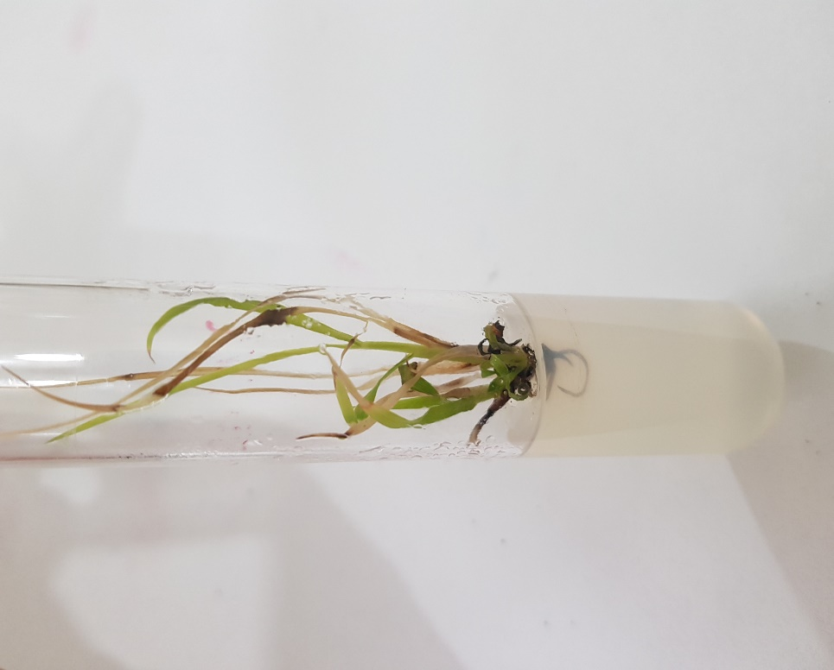
Fig. 31 (c) Shoots of CP-77-400 regenerated from 0.3mM Pb(NO₃)₂ treated callus on MS+1mg/l BAP at day 90 (1x)

Fig. 31(b) Shoots of CP-77-400 regenerated from 0.3mM Pb(NO₃)₂ treated callus on MS+1mg/l BAP at day 60 (1x)

Fig. 31(a) Shoots of CP-77-400 regenerated from 0.3mM Pb(NO₃)₂ treated callus on MS+1mg/l BAP at day 30 (1x)

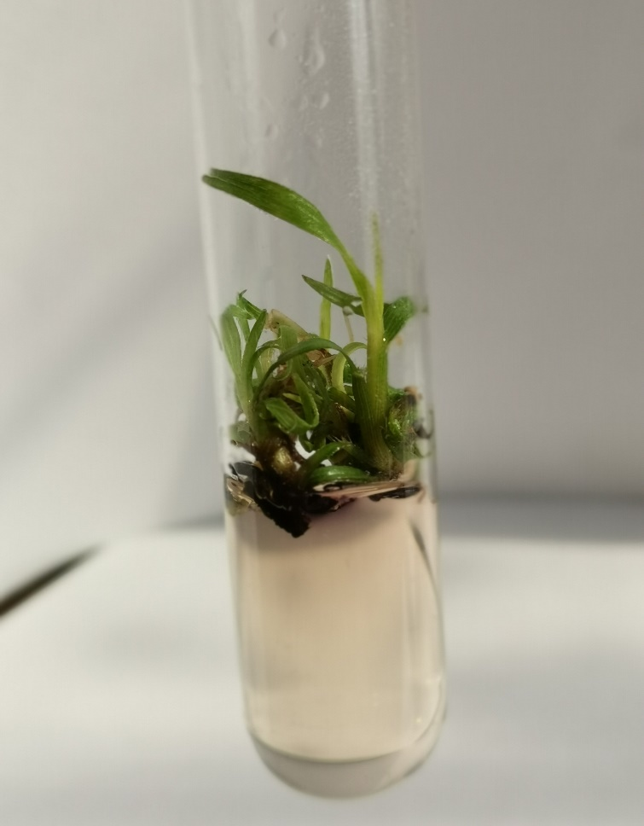
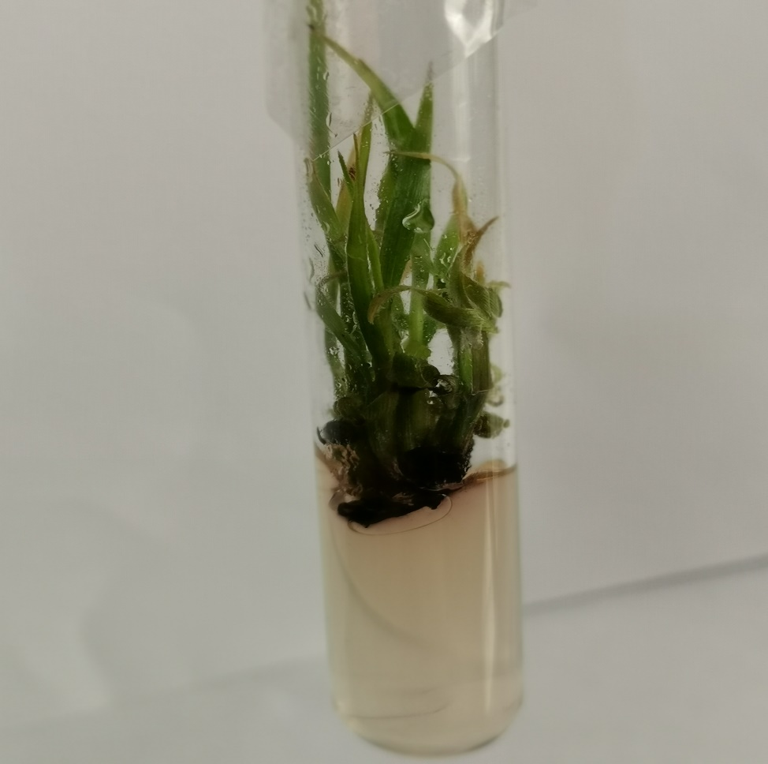
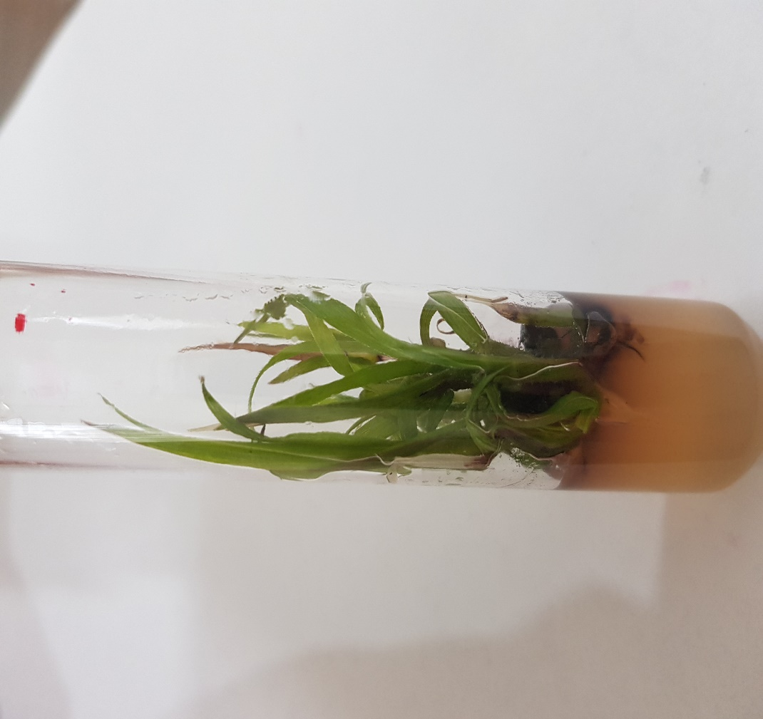
Fig. 32 (a) Shoots of NSG-59 regenerated from 0mM Pb(NO₃)₂ treated callus on MS+2mg/l Kin. at day 30 (1x)

Fig. 32 (b) Shoots of NSG-59 regenerated from 0mM Pb(NO₃)₂ treated callus on MS+2mg/l Kin. at day 60 (1x)

Fig. 32 (c) Shoots of NSG-59 regenerated from 0mM Pb(NO₃)₂ treated callus on MS+2mg/l Kin. at day 90 (1x)

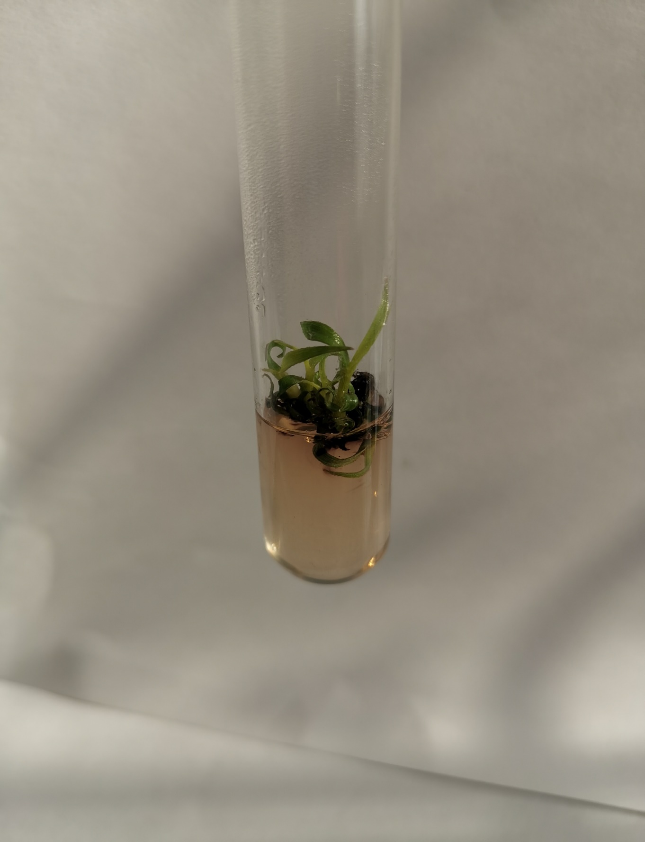
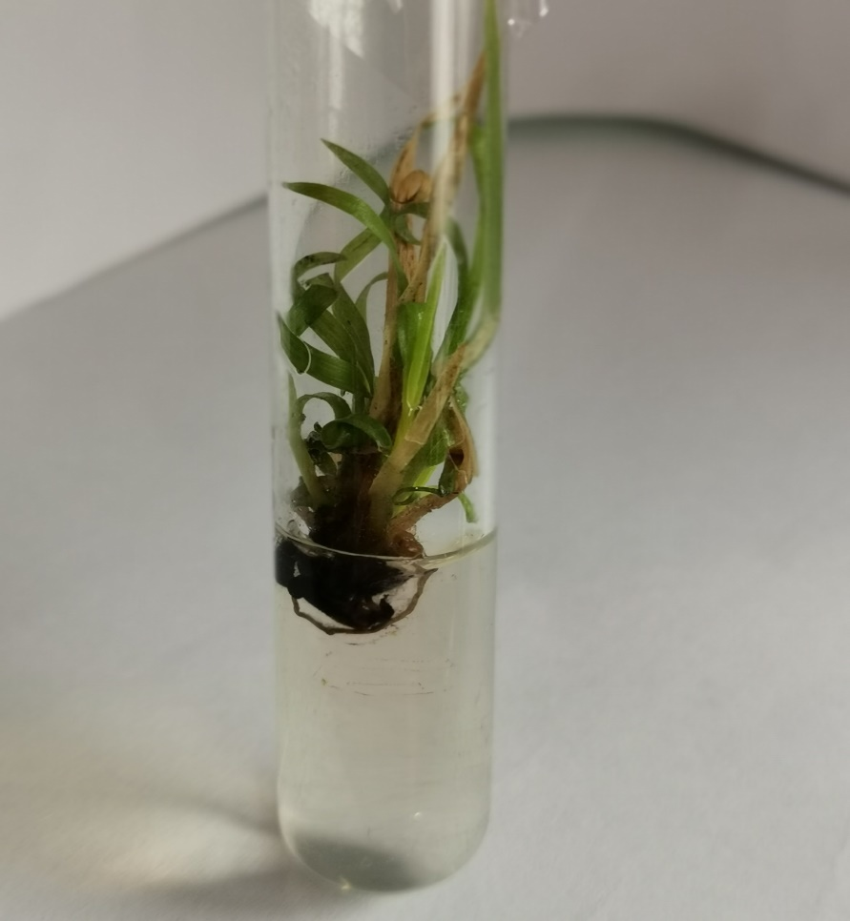
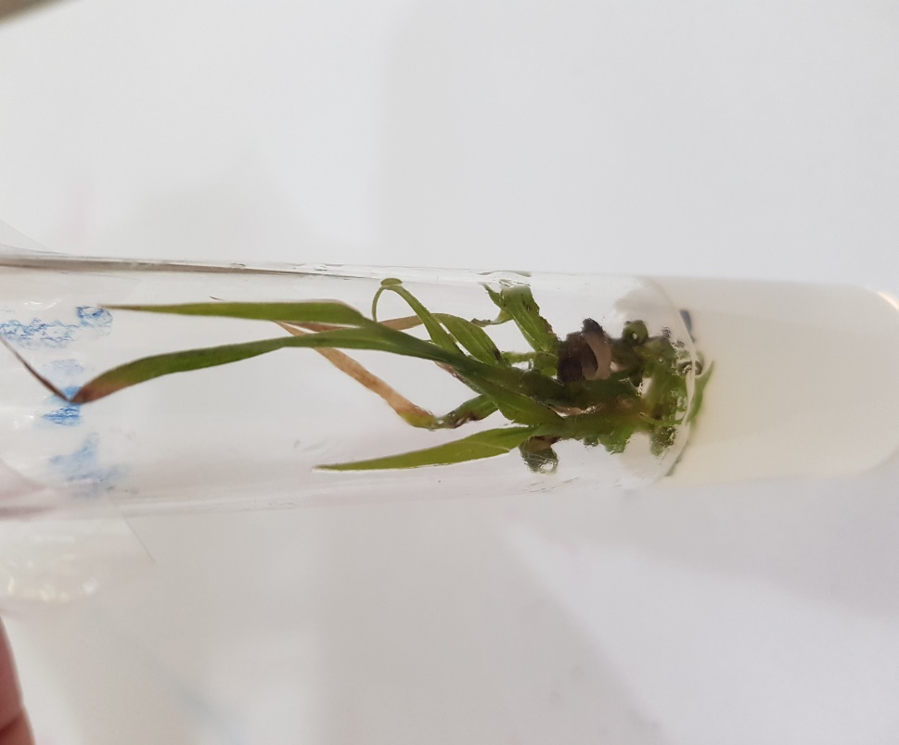
Fig. 33 (c) Shoots of NS[G-59 regenerated from 0.1mM Pb(NO₃)₂ treated callus +2mg/l Kin. at day 90 (1x)

Fig. 33(b) Shoots of NSG-59 regenerated from 0.1mM Pb(NO₃)₂ treated callus +2mg/l Kin. at day 60 (1x)

Fig. 33 (a) Shoots of NSG-59 regenerated from 0.1mM Pb(NO₃)₂ +2mg/l Kin. treated callus at day 30 (1x)

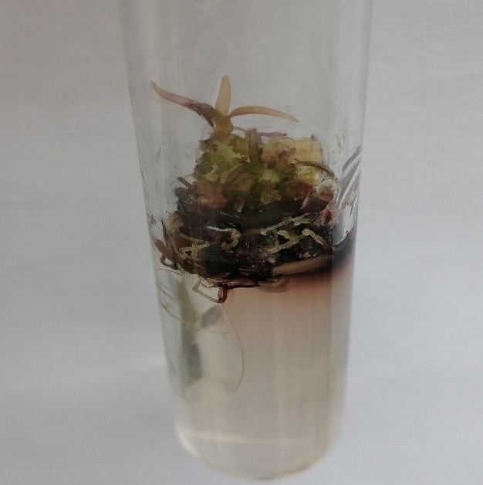
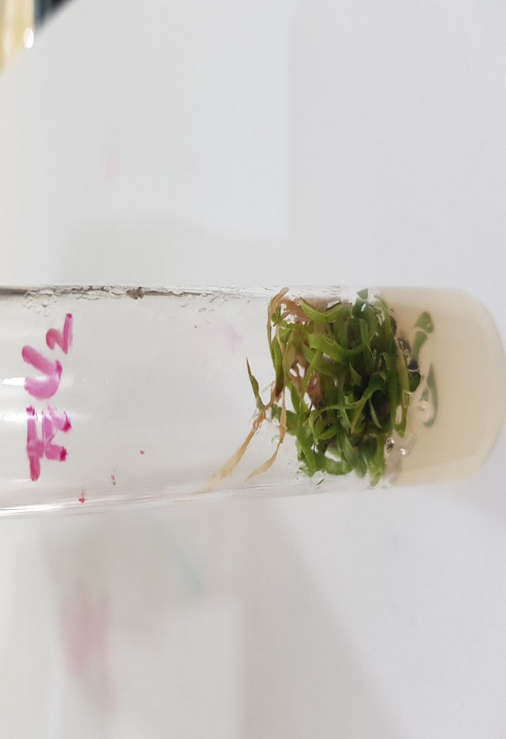
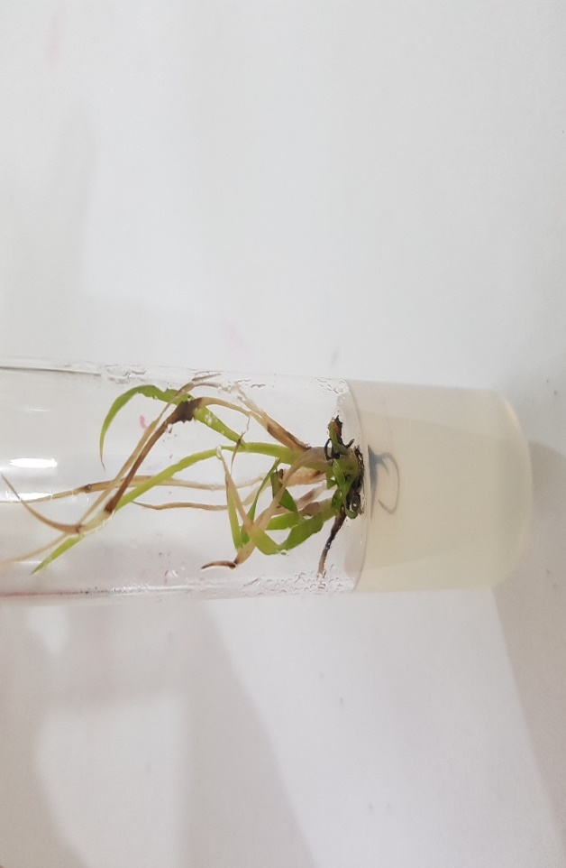
Fig. 34 (a)Shoots of NSG-59 regenerated from 0.2mM Pb(NO₃)₂ treated callus +2mg/l Kin. at day 30 (1x)

Fig. 34 (b) Shoots of NSG-59 regenerated from 0.2mM Pb(NO₃)₂ treated callus +2mg/l Kin. at day 60 (1x)

Fig. 34 (c) Shoots of NSG-59 regenerated from 0.2mM Pb(NO₃)₂ treated callus +2mg/l Kin. at day 90 (1x)

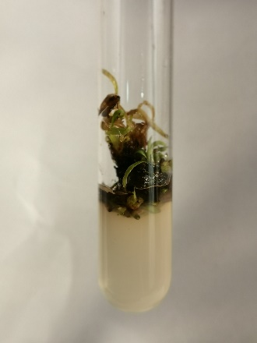
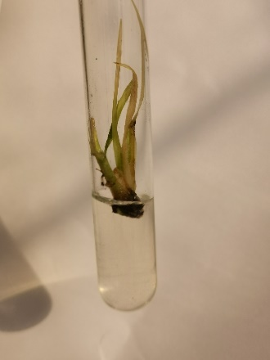
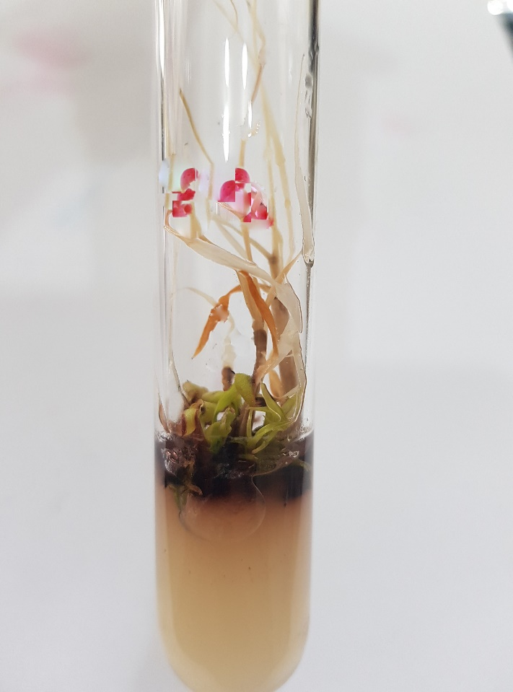
Fig. 35 (a) Shoots of NSG-59 regenerated from 0.3mM Pb(NO₃)₂ treated callu+2mg/l Kin. s at day 30 (1x)

Fig. 35 (b) Shooots of NSG-59 regenerated from 0.3mM Pb(NO₃)₂ treated callus+2mg/l Kin. at day 60 (1x)

Fig. 35(c) Shoots of NSG-59 regenerated from 0.3mM Pb(NO₃)₂ treated callus+2mg/l Kin. at day 90 (1x)

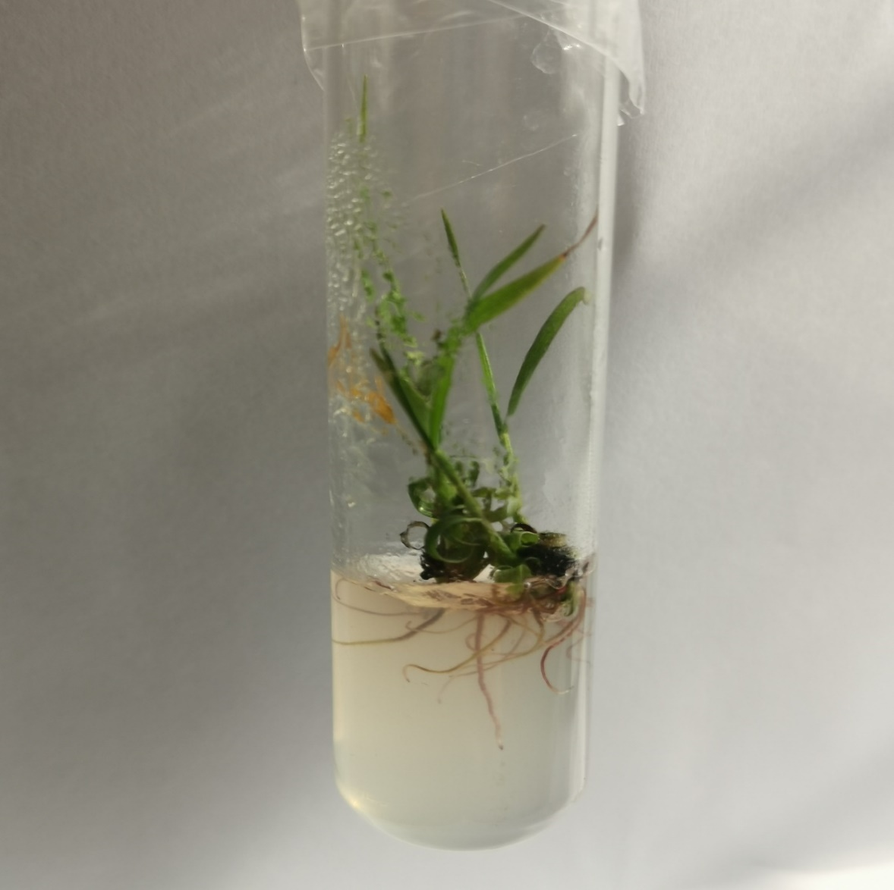
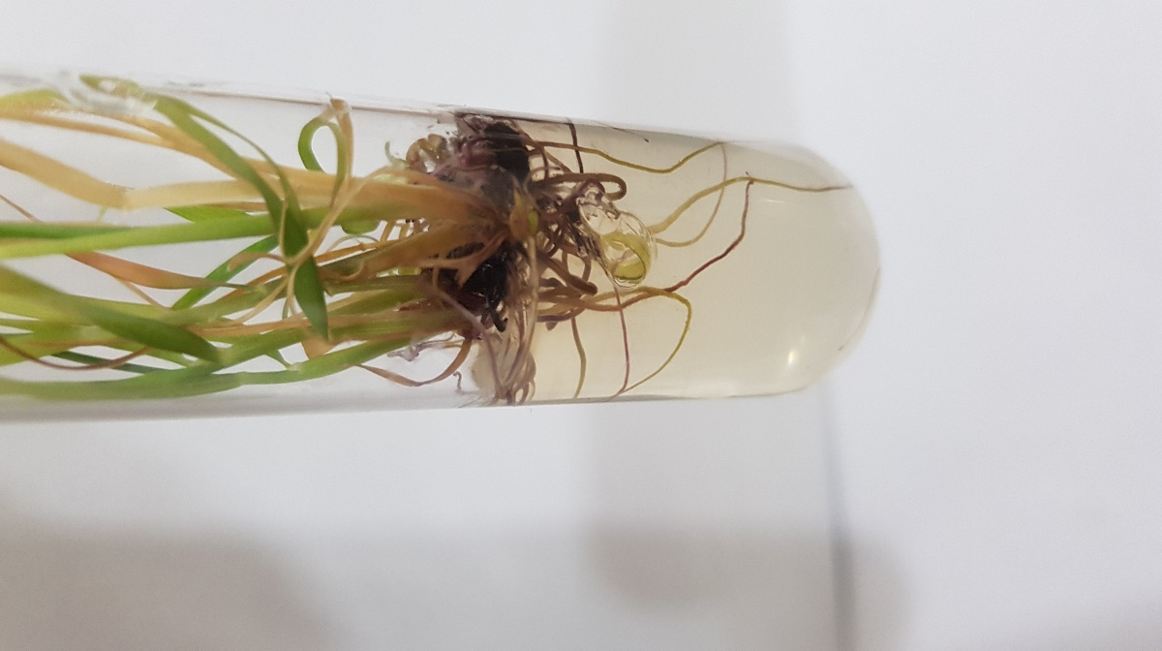
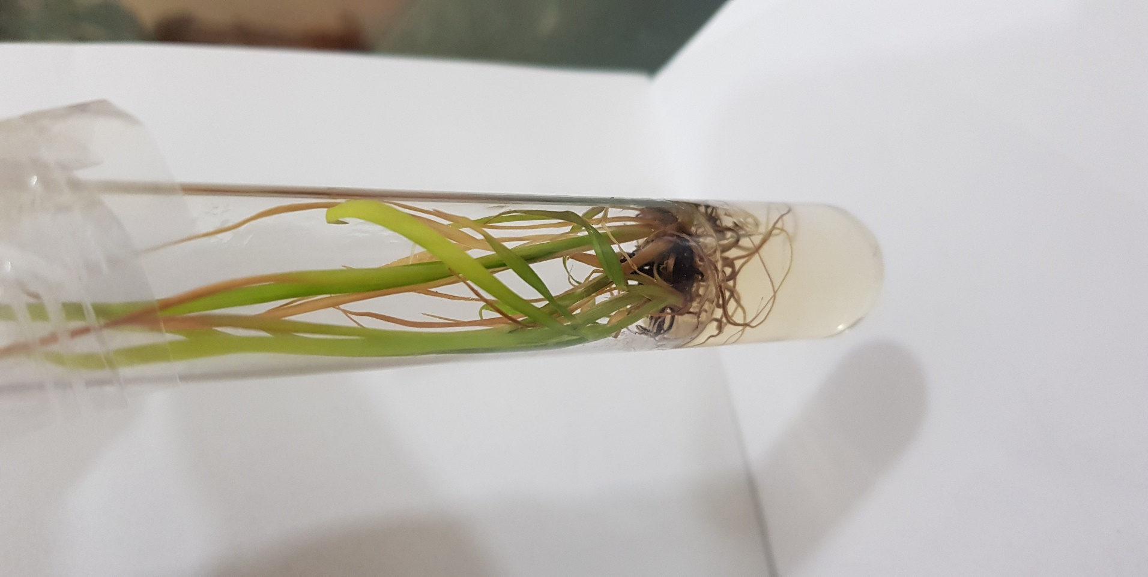
Fig. 36 (a)Well developed roots of YT-53 from plant regenerated from 0mM Pb(NO₃)₂ treated callus on MS+1mg/l NAA+1mg/l IBA at day 60 (2x)

Fig. 36 (b)Well developed roots in YT-53 from plant regenerated from 0.1mM Pb(NO₃)₂ treated callus on MS+1mg/l NAA+1mg/l IBA at day 60 (2x)

Fig. 36 (c)Well developed roots in YT-53 from plant regenerated from 0.2mM Pb(NO₃)₂ treated callus on MS+1mg/l NAA+1mg/l IBA at day 60 (2x)

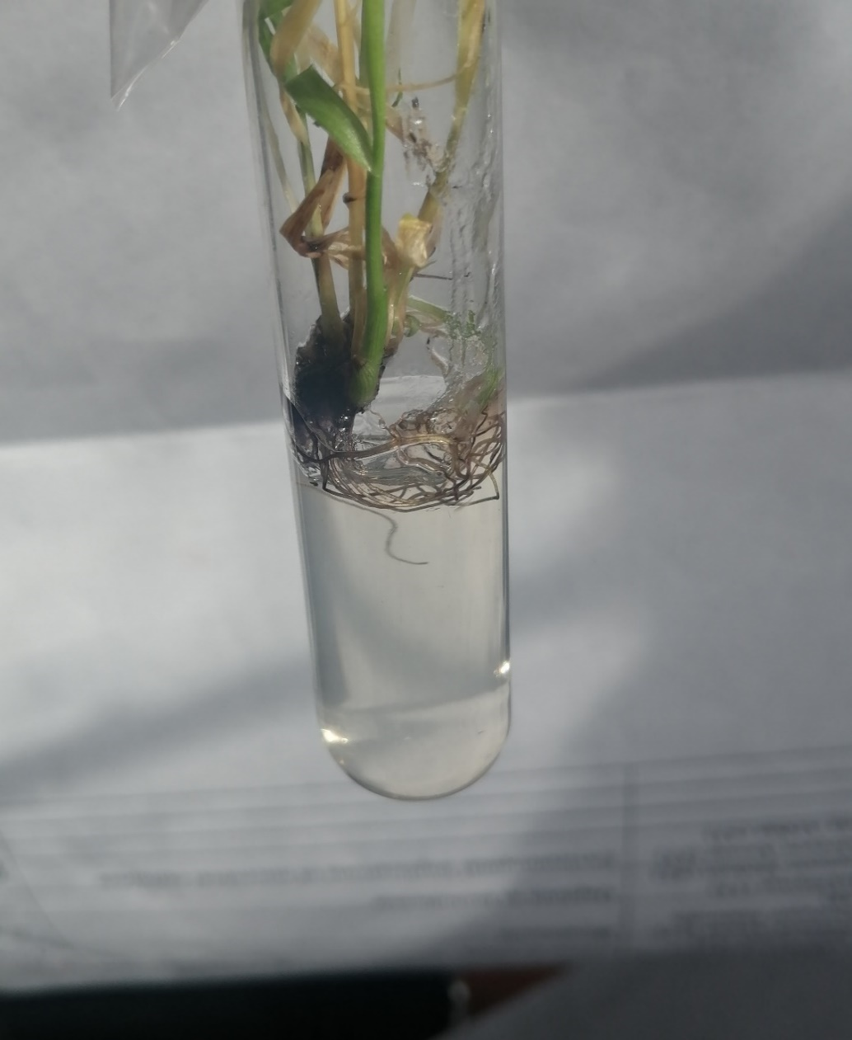
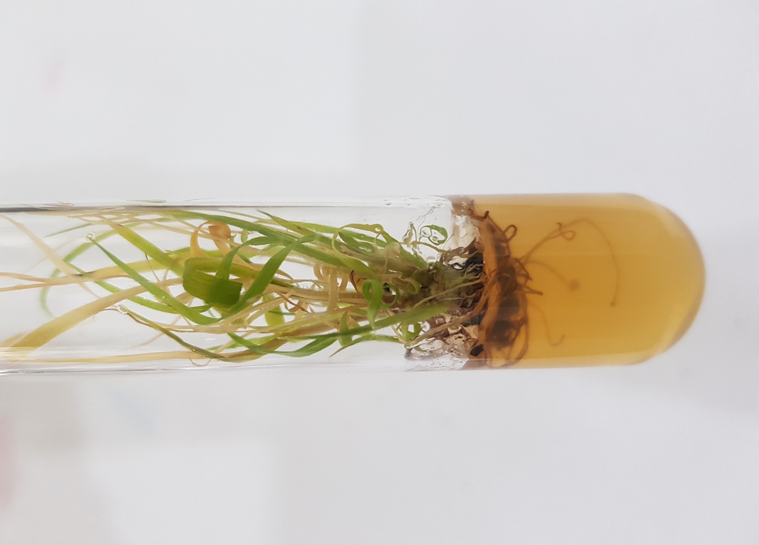
Fig. 36(d)Well developed roots in YT-53 from plant regenerated from 0.3mM Pb(NO₃)₂ treated callus on MS+1mg/l NAA+1mg/l IBA at day 60 (2x)

Fig. 36 (e)Well developed roots in YT-53 from plant regenerated from 0.4mM Pb(NO₃)₂ treated callus on MS+1mg/l NAA+1mg/l IBA at day 60 (2x)

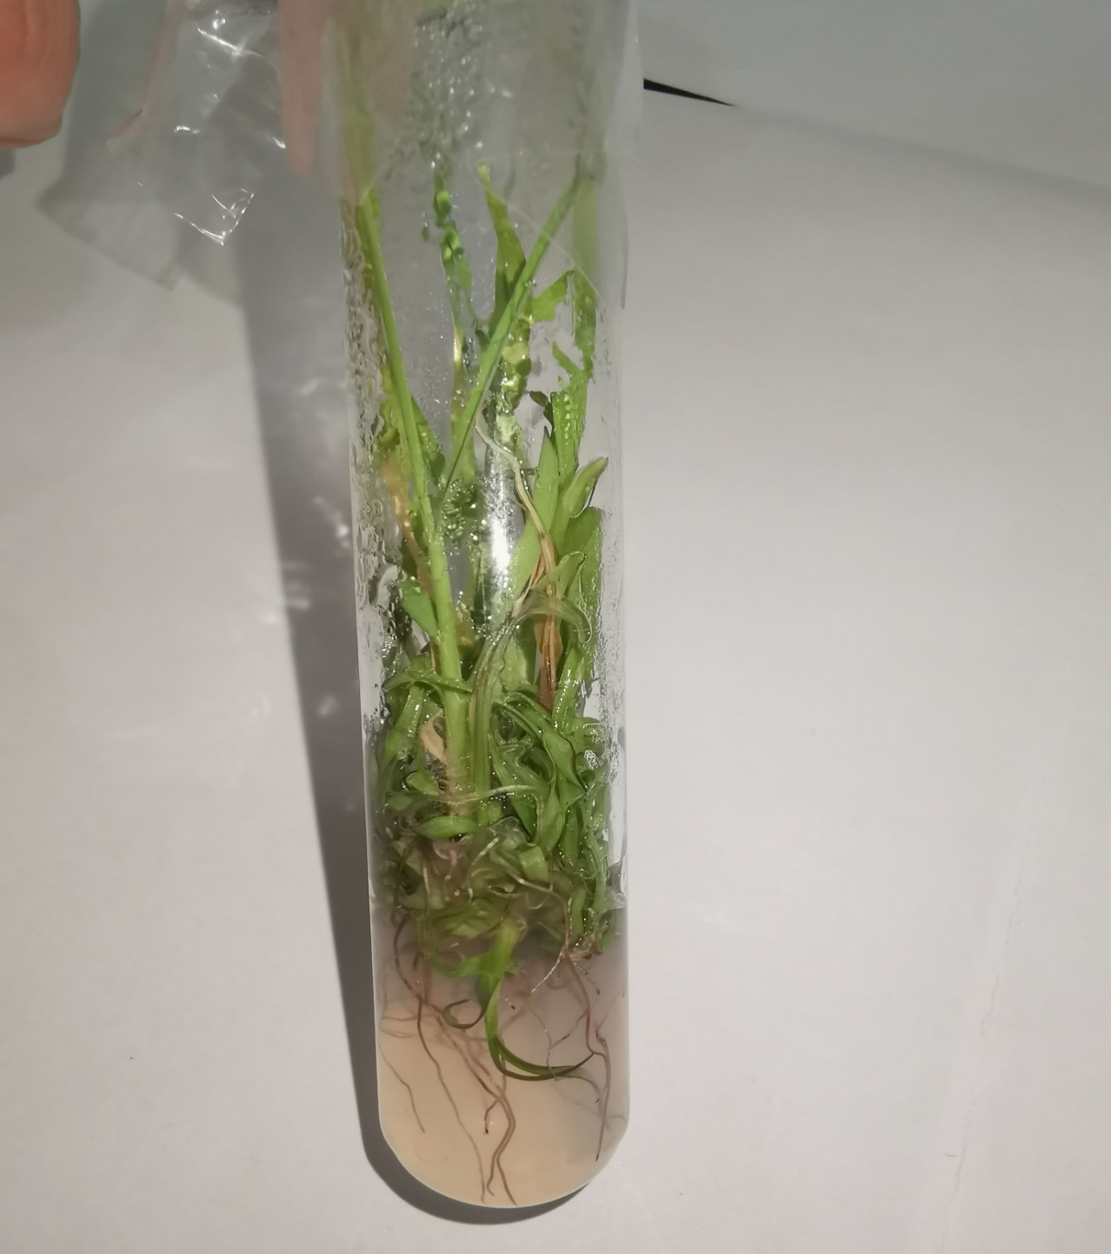
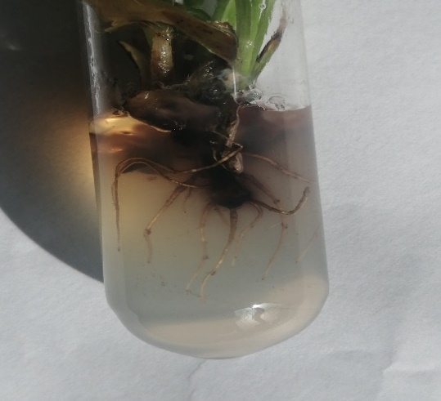
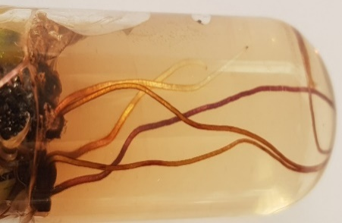
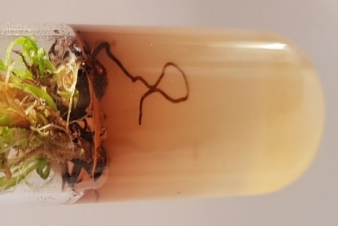
Fig. 37 (a)Well developed roots in CP-77400 from plant regenerated from 0mM Pb(NO₃)₂ treated callus on ½ MS+3mg/l NAA at day 60 (2x)

Fig. 37 (b)Welll developed roots in CP-77-400 from plant regenerated from 0.1mM Pb(NO₃)₂ treated callus ½ MS+3mg/l NAA at day 60 (2x)

Fig. 37(c)Well developed roots in CP-77-400 from plant regenerated from 0.2mM Pb(NO₃)₂ treated callus on ½ MS+3mg/l NAA at day 60 (2x)

Fig. 37 (d)Well developed roots in CP-77-400 from plant regenerated from 0.3mM Pb(NO₃)₂ treated callus on ½ MS+3mg/l NAA at day 60 (2x)

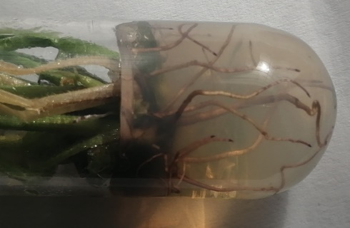
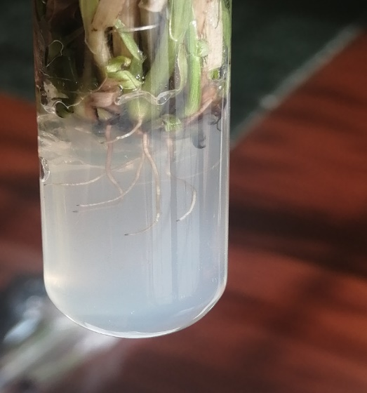
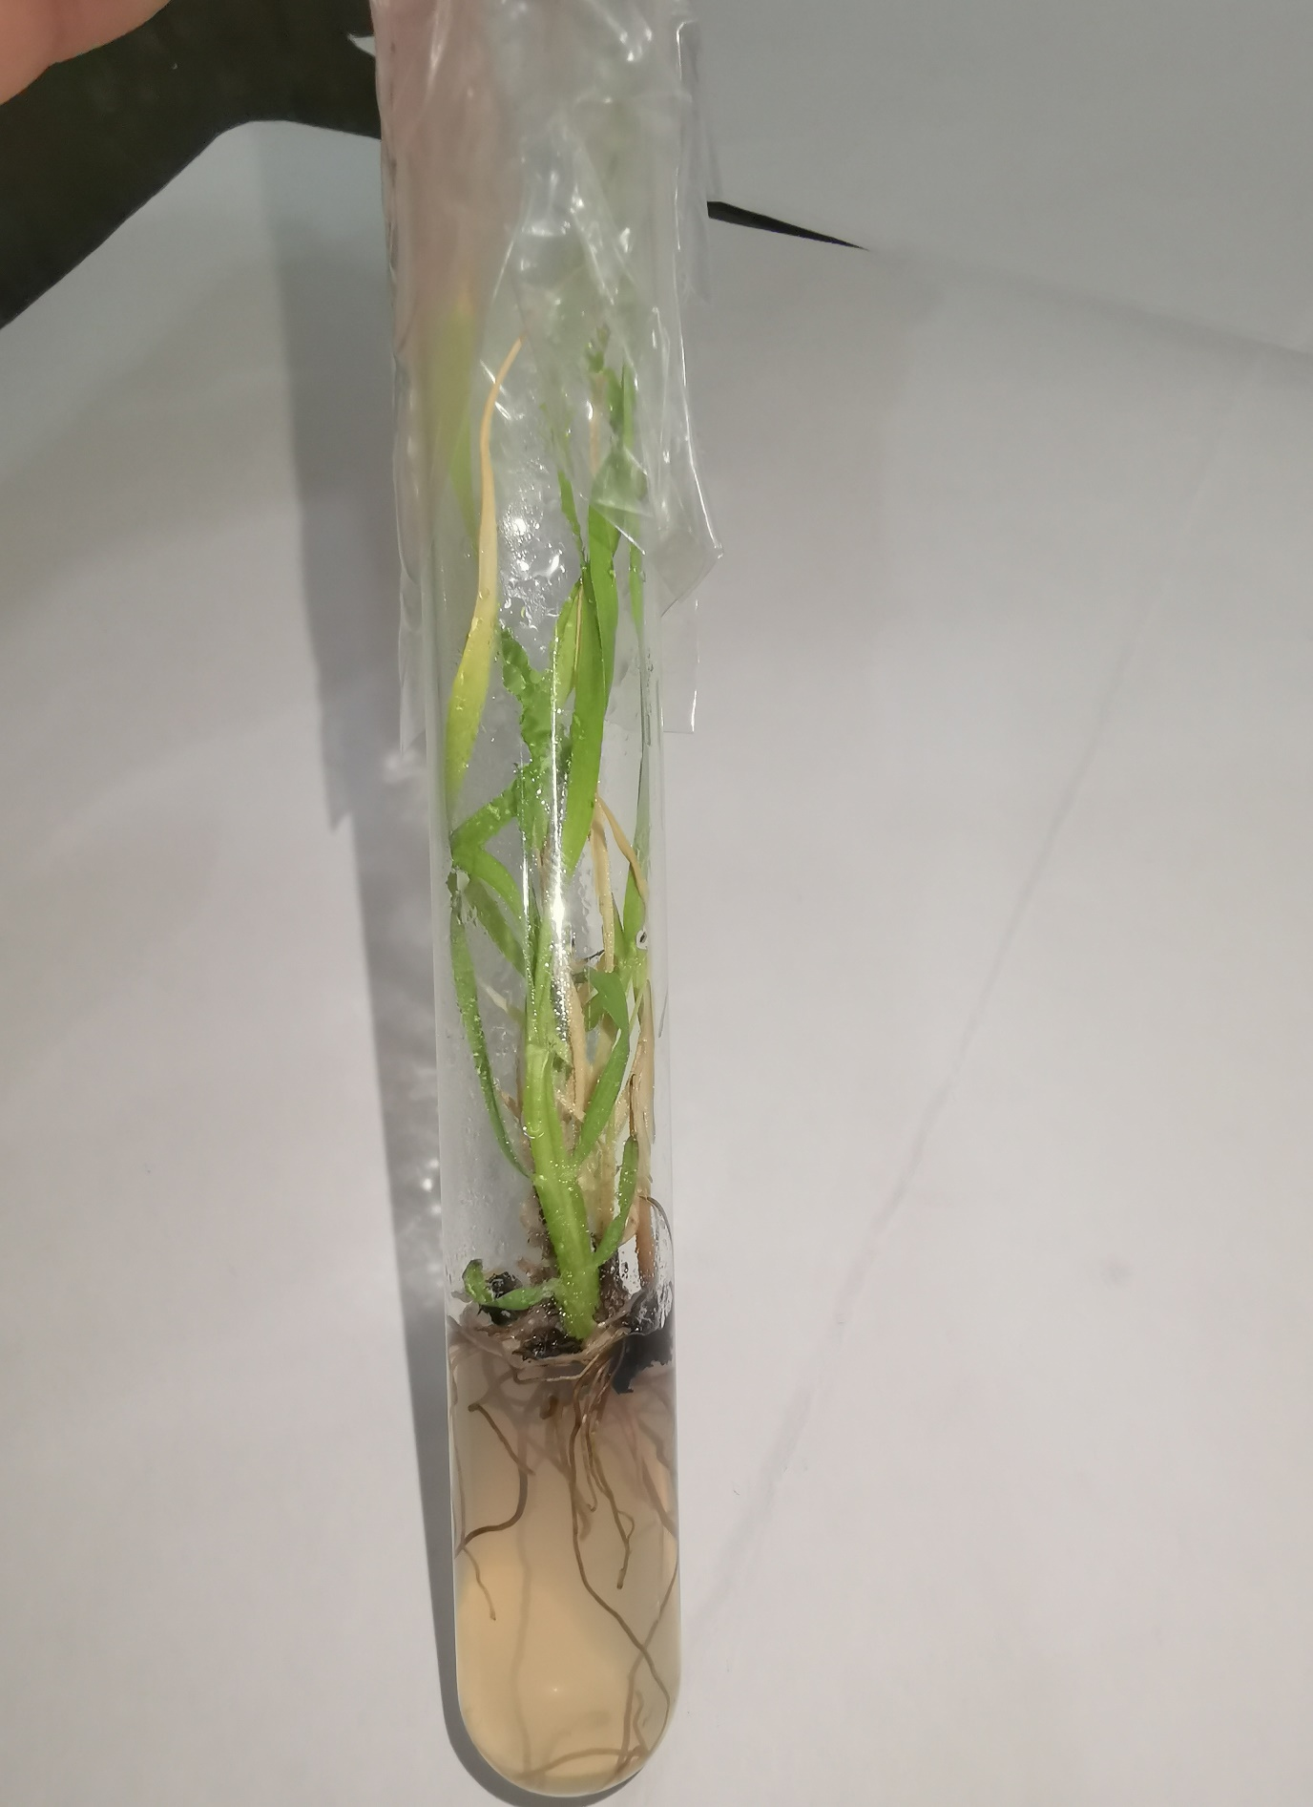
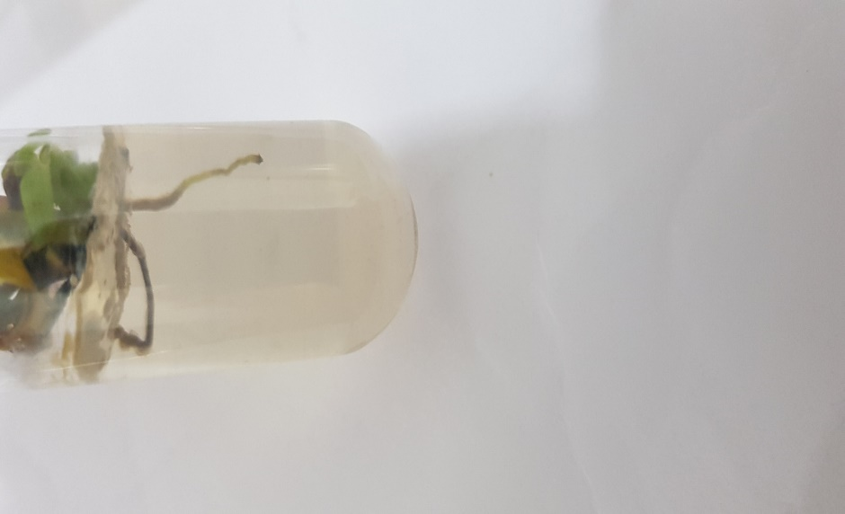
Fig. 38 (c)Well developed roots in NSG-59 from plant regenerated from 0.2mM Pb(NO₃)₂ treated callus on ½ MS+3mg/l NAA at day 60 (2x)

Fig. 38 (d)Well developed roots in NSG-59 from plant regenerated from 0.3mM Pb(NO₃)₂ treated callus on ½ MS+3mg/l NAA at day 60 (2x)

Fig. 38 (a)Well developed roots in NSG-59 from plant regenerated from 0mM Pb(NO₃)₂ treated callus on ½ MS+3mg/l NAA at day 60 (2x)

Fig.38 (b)Well developed roots in NSG-59 from plant regenerated from 0.1mM Pb(NO₃)₂ treated callus on ½ MS+3mg/l NAA at day 60 (2x)

