Supplementary Information

Electrically reconfigurable optical color filters using heterogeneous chiral liquid crystals

Dahee Wang, Seungmin Nam, Wontae Jung, and Su Seok Choi*
Department of Electrical Engineering, Pohang University of Science and Technology (POSTECH), Pohang 37673, Republic of Korea

* E-mail address
Su Seok Choi: choiss@postech.ac.kr

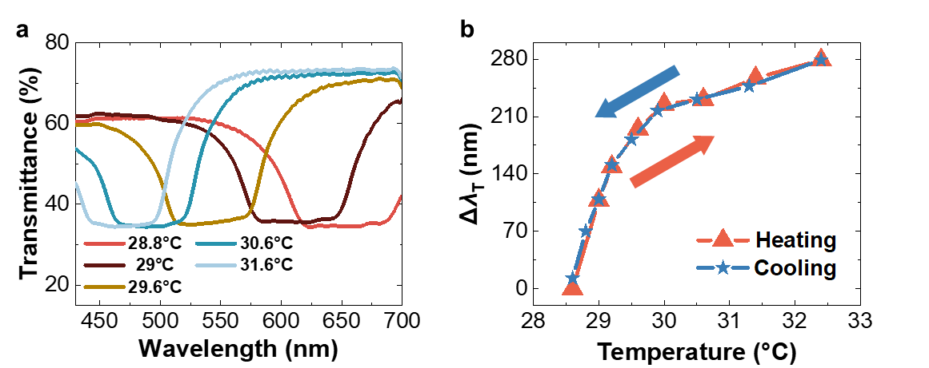

Figure S1. a Transmission spectra of the T-CLC when heated to a certain temperature. b Change in minimum transmission wavelength upon heating and cooling of T-CLC mixture.

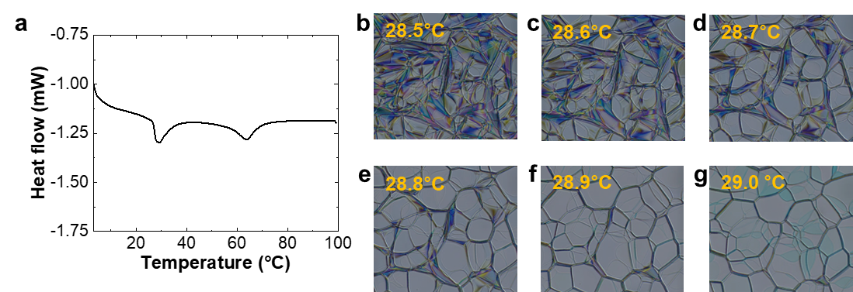
Figure S2. a Differential scanning calorimetry of the T-CLC mixture. b-g Polarized optical microscopy of the T-CLC under cross-polarization when heated with fine steps of 0.1°C/min.

Figure S3. Experimentally measured (black squares) and theoretically calculated (red solid line) pitches following Keating’s theory, which are temperature dependent. The fitting values selected for the optimized fitting were T₀ = 27.5 °C, β = 0.3168 and γ = 244.3702.

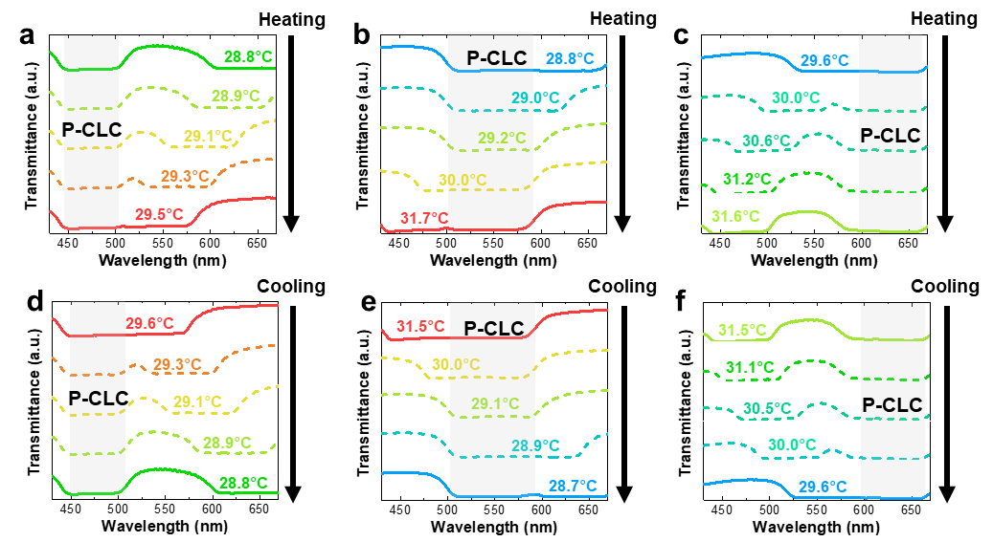
Figure S4. Transmission spectra upon heating and cooling of a, d green/red, b, e blue/red, and c, f blue/green filters, respectively.

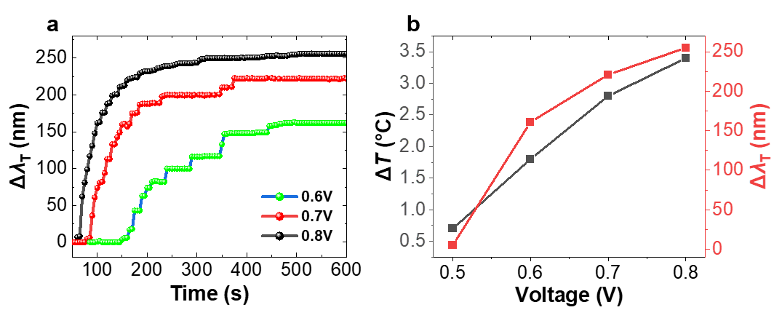
Figure S5. a Change in minimum transmission wavelength of T-CLC in time domain when voltage is applied. b Change in the temperature and minimum transmission wavelength of the T-CLC in terms of different voltages measured after 10 min of stabilization.

Supplementary Table 1. Mass ratios of RM257 and LC 756 used to fabricate red, green, and blue reflecting P-CLC.
 | M_{red,1} | M_{red,2} | M_{green, 1} | M_{green, 2} | M_{blue, 1} | M_{blue, 2}
RM257 [wt%] | 95.40 | 95.88 | 94.81 | 95.34 | 93.97 | 94.58
LC756 [wt%] | 4.60 | 4.12 | 5.19 | 4.66 | 6.03 | 5.42

Supplementary Videos

Supplementary Video 1
Electrothermal response video of each heterogeneous CLC color filter device.

Supplementary Video 2
Pixel binning operation for 2 × 2 array of heterogeneous CLC color filters.

