Appendix 3– Structural model of predictive relationship between motivational regulation strategies and motivational components (The numbers inside ellipses are the R² values)

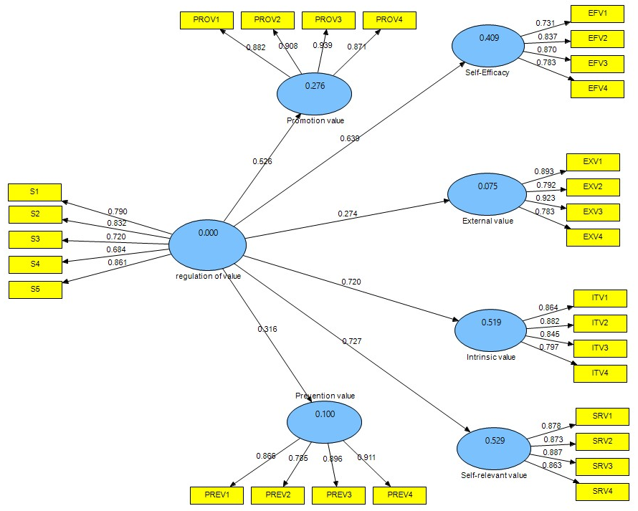

Figure 1: Structural model and predictive relationship between regulation of value strategy and motivational components

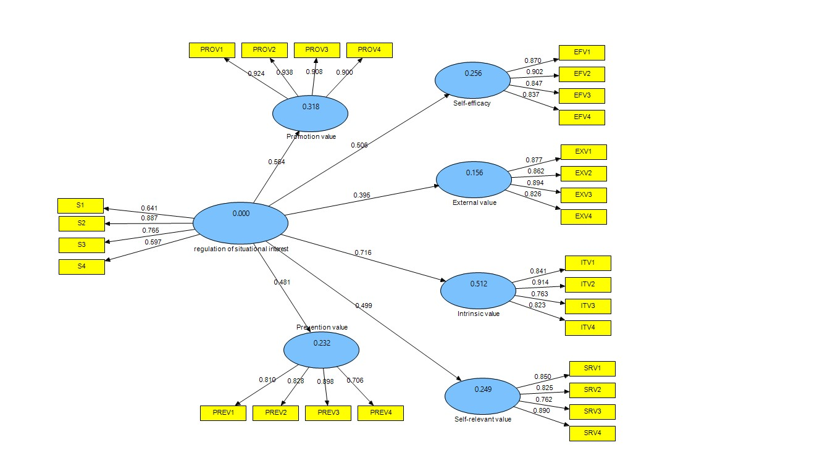
Figure 2: Structural model and predictive relationship between regulation of situational interest strategy and motivational components

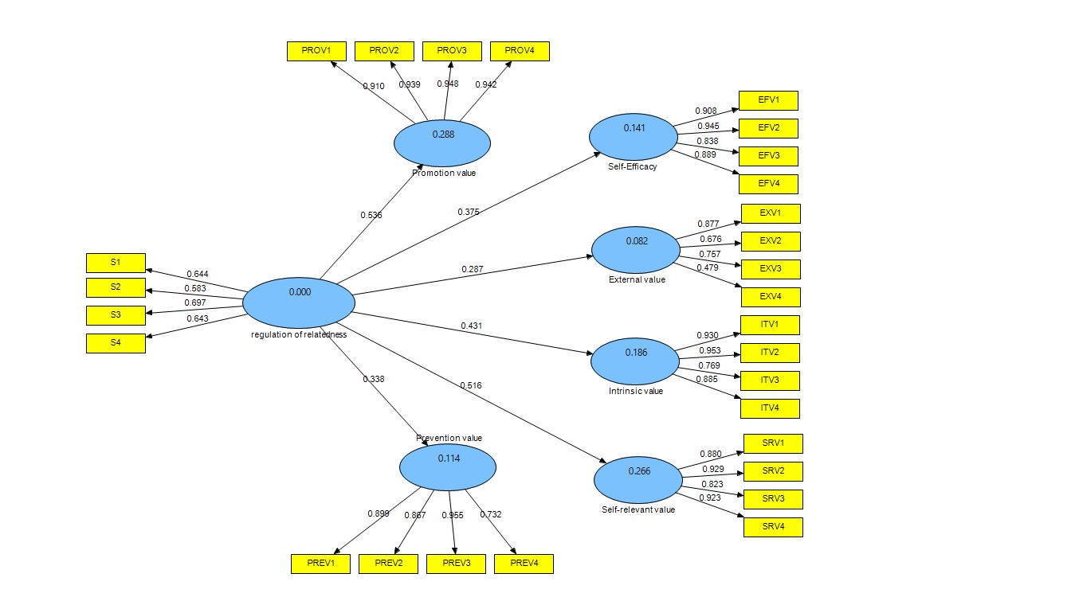

Figure 3: Structural model and predictive relationship between regulation of relatedness strategy and motivational components

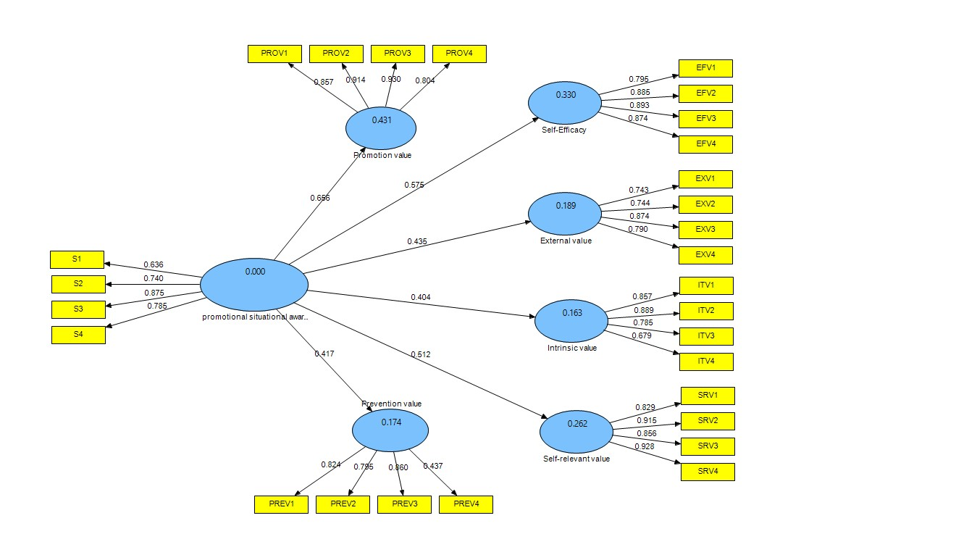
Figure 4: Structural model and predictive relationship between promotional situational awareness strategy and motivational components

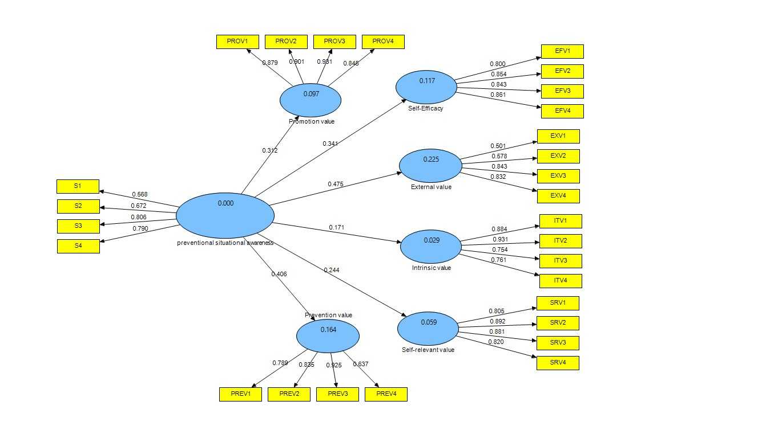
Figure 5: Structural model and predictive relationship between preventional situational awareness strategy and motivational components

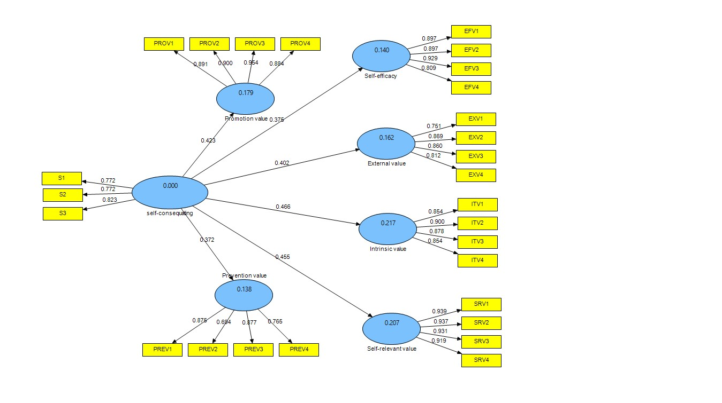
Figure 6: Structural model and predictive relationship between self-consequating strategy and motivational components

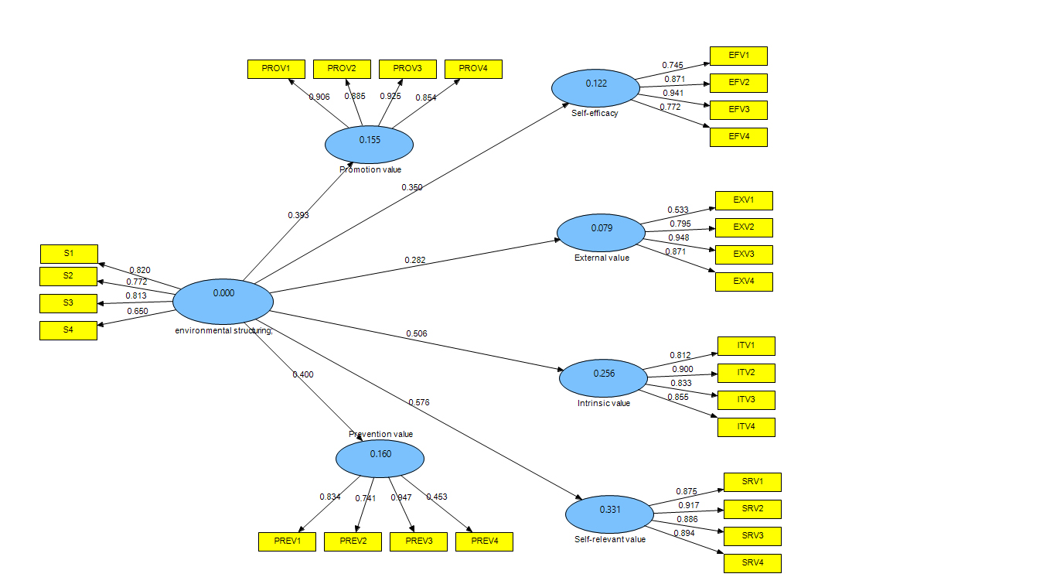
Figure 7: Structural model and predictive relationship between environmental structuring strategy and motivational components (Before deleting item PREV4)

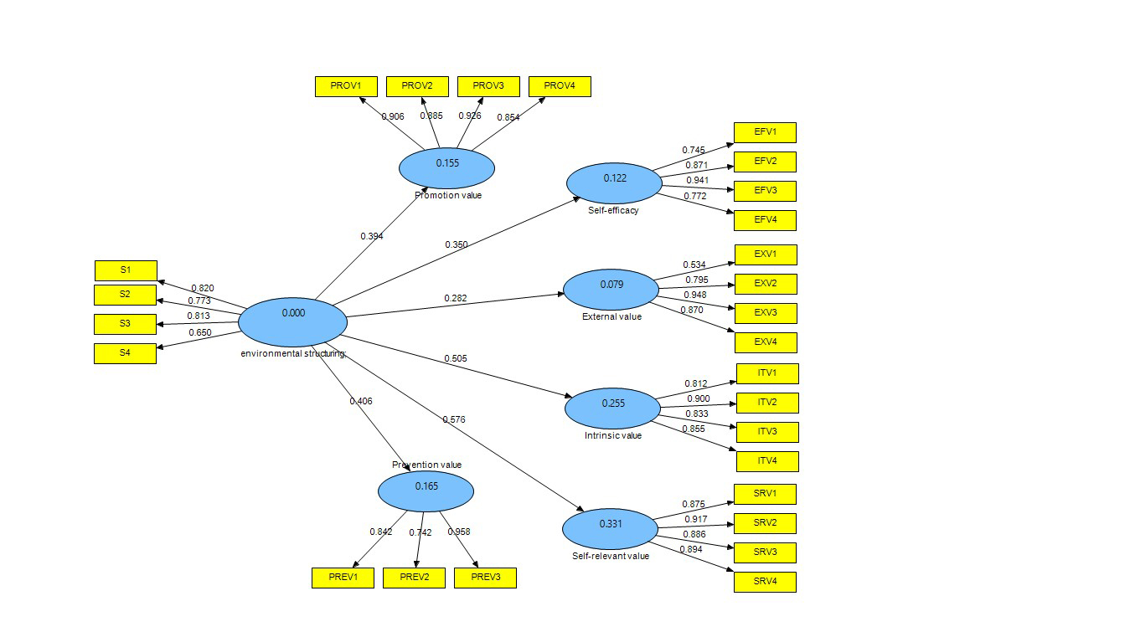
Figure 8: Structural model and predictive relationship between environmental structuring strategy and motivational components (After deleting item PREV4)

