Graphene Family in the Acute Treatment of Migraine: Molecular Docking and Dynamics Simulation
Sima Rezvantalab¹*, Aylar Imanpour²
¹Renewable Energies Department, Faculty of Chemical Engineering, Urmia University of Technology, Urmia 57166‑419, Iran.
²Regenerative Medicine group (REMED), Universal Scientific Education and Research Network (USERN), Tehran, Iran
*Corresponding author email: s.rezvantalab@uut.ac.ir

Supporting Information
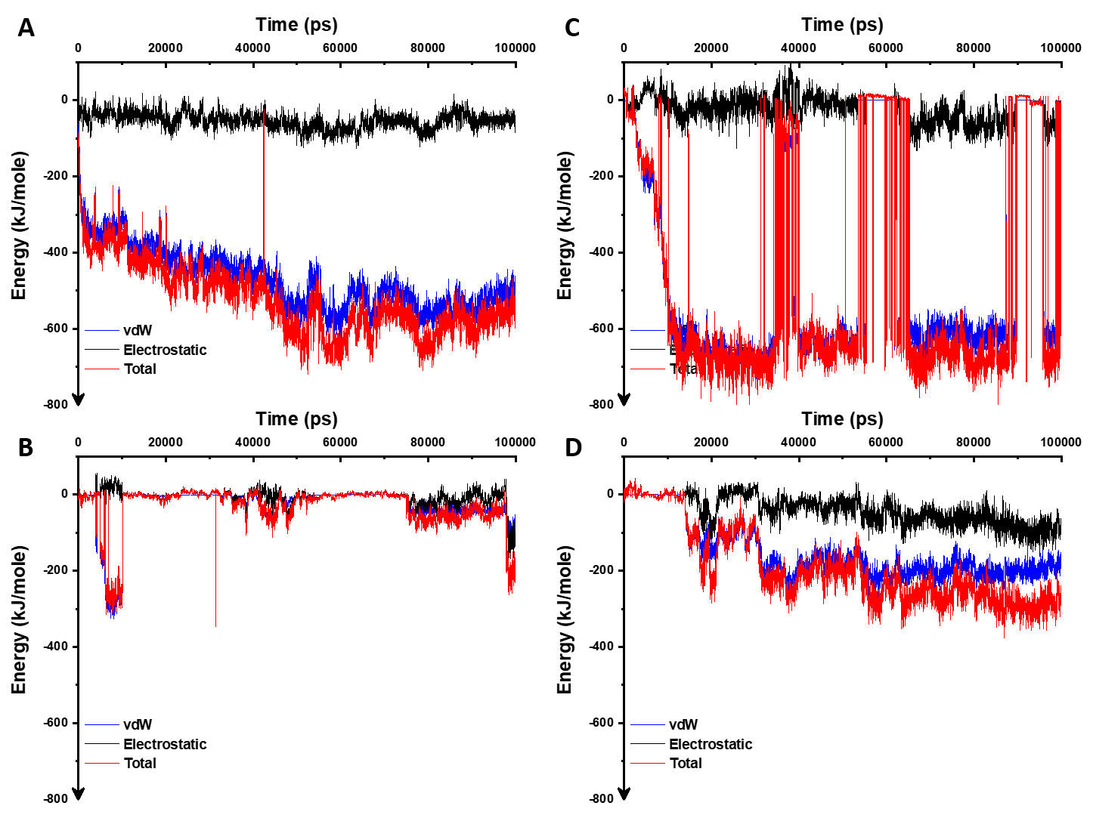
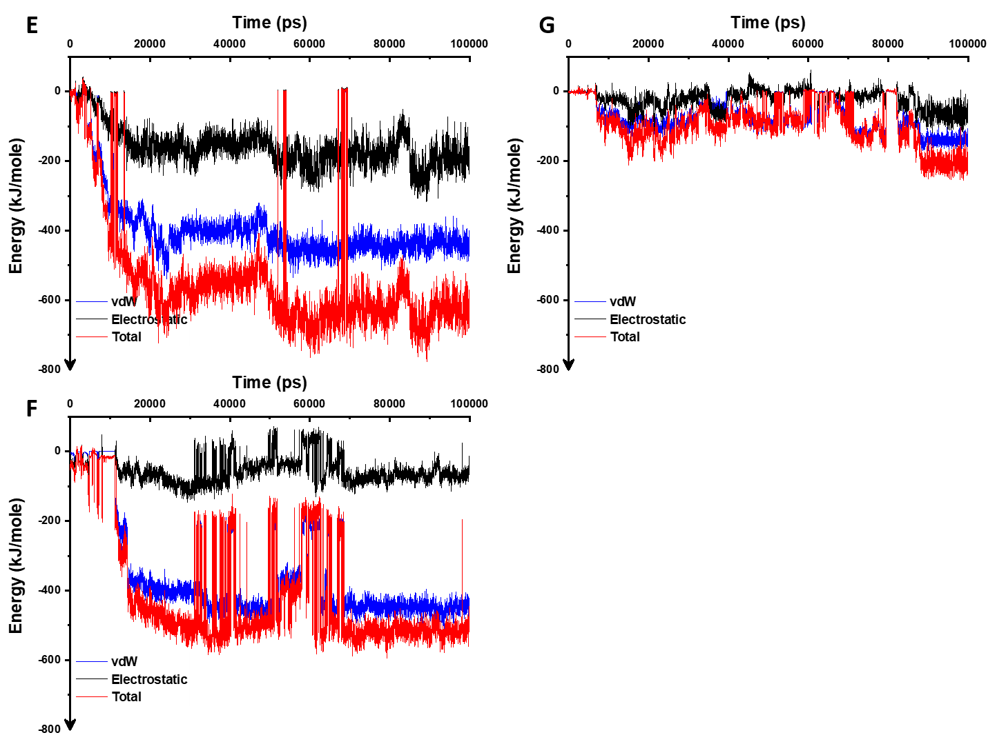
Figure S1. (A-G) Interaction energies during the simulation for Gr, Gr-COOH, Gr-NH₂, Gr-COOH&NH₂, Gr-OH, Gr-O, and Ubrogepant, respectively.

Table S1. Salt bridge pairs in the protein structure
Gr-O |  |  | Gr-NH2 |  |  | Gr-COOH & NH2
1 | ASP47 | ARG61 | 1 | ASP47 | ARG61 | 1 | ASP47 | ARG61
2 | ASP47 | ARG64 | 2 | ASP58 | ARG61 | 2 | ASP47 | ARG64
3 | ASP58 | ARG64 | 3 | ASP70 | LYS103 | 3 | ASP55 | ARG102
4 | ASP70 | LYS103 | 4 | ASP77 | ARG67 | 4 | ASP58 | ARG61
5 | ASP71 | ARG38 | 5 | ASP90 | LYS40 | 5 | ASP70 | LYS103
6 | ASP77 | ARG67 | 6 | GLU29 | ARG91 | 6 | ASP77 | ARG67
7 | ASP90 | ARG91 | 7 | GLU38 | ARG119 | 7 | ASP106 | ARG113
8 | GLU29 | ARG91 | 8 | GLU68 | ARG67 | 8 | ASP108 | ARG113
9 | GLU68 | ARG64 | 9 | GLU88 | ARG37 | 9 | GLU47 | LYS51
10 | GLU68 | ARG67 | 10 | GLU88 | ARG91 | 10 | GLU53 | ARG102
11 | GLU88 | ARG37 |  |  |  | 11 | GLU68 | ARG64
12 | GLU88 | ARG91 |  |  |  | 12 | GLU68 | ARG67
 |  |  |  |  |  | 13 | GLU78 | LYS79
 |  |  |  |  |  | 14 | GLU88 | ARG37
 |  |  |  |  |  | 15 | GLU88 | ARG91
 |  |  |  |  |  | 16 | GLU99 | LYS100

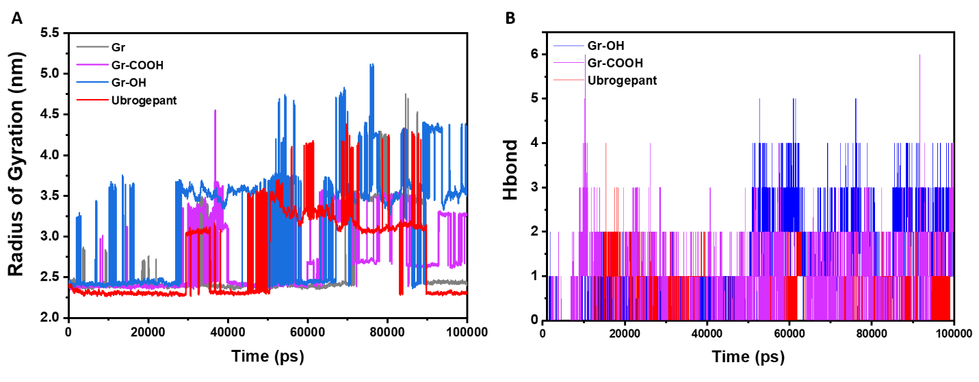
Figure S2. A, B) Variation of Rg and Hbond number during the simulation for Gr, Gr-COOH, Gr-OH, and Ubrogepant, respectively.

