Figure S1
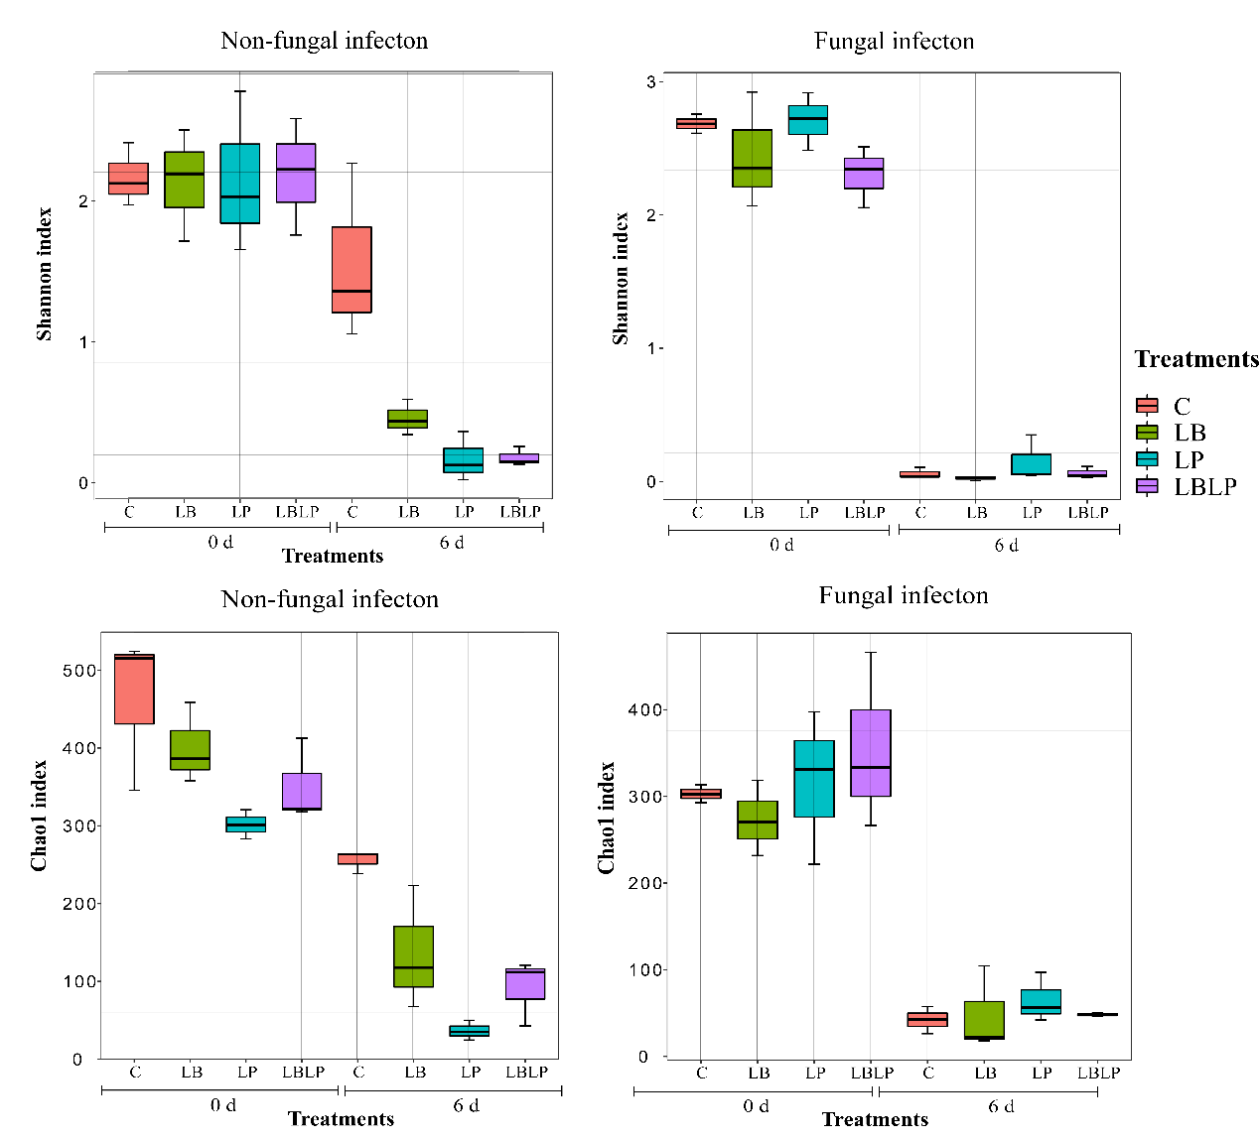
Fig. S1. The bacterial diversity indexes in non-fungal infection (left) and fungal infection (right) of corn silage during aerobic exposure. C, control; LB, L. buchneri applied at 1 × 10⁶ cfu g⁻¹ FW; LP, L. plantarum applied at 1 × 10⁶ cfu g⁻¹ FW; LBLP, L. buchneri and L. plantarum applied at 0.5 × 10⁶ cfu g⁻¹ FW. 0 d, after silo opening; 6 d, after 6 days of aerobic exposure; FW, fresh weight.

Figure S2
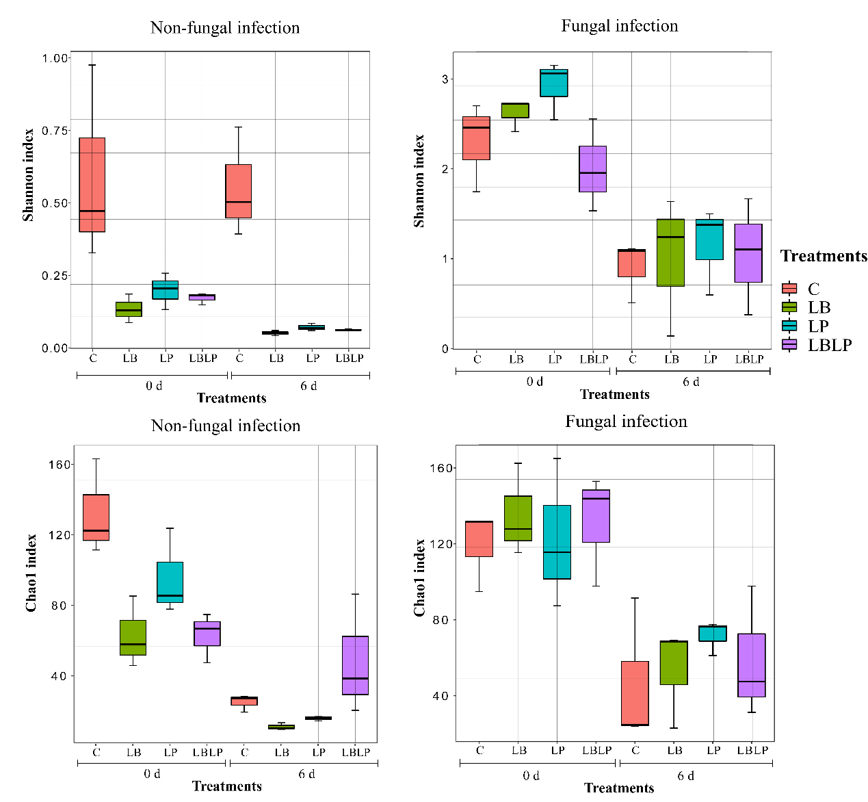
Fig. S2. The fungal diversity indexes in non-fungal infection (left) and fungal infection (right) of corn silage during aerobic exposure. C, control; LB, L. buchneri applied at 1 × 10⁶ cfu g⁻¹ FW; LP, L. plantarum applied at 1 × 10⁶ cfu g⁻¹ FW; LBLP, L. buchneri and L. plantarum applied at 0.5 × 10⁶ cfu g⁻¹ FW. 0 d, after silo opening; 6 d, after 6 days of aerobic exposure; FW, fresh weight.

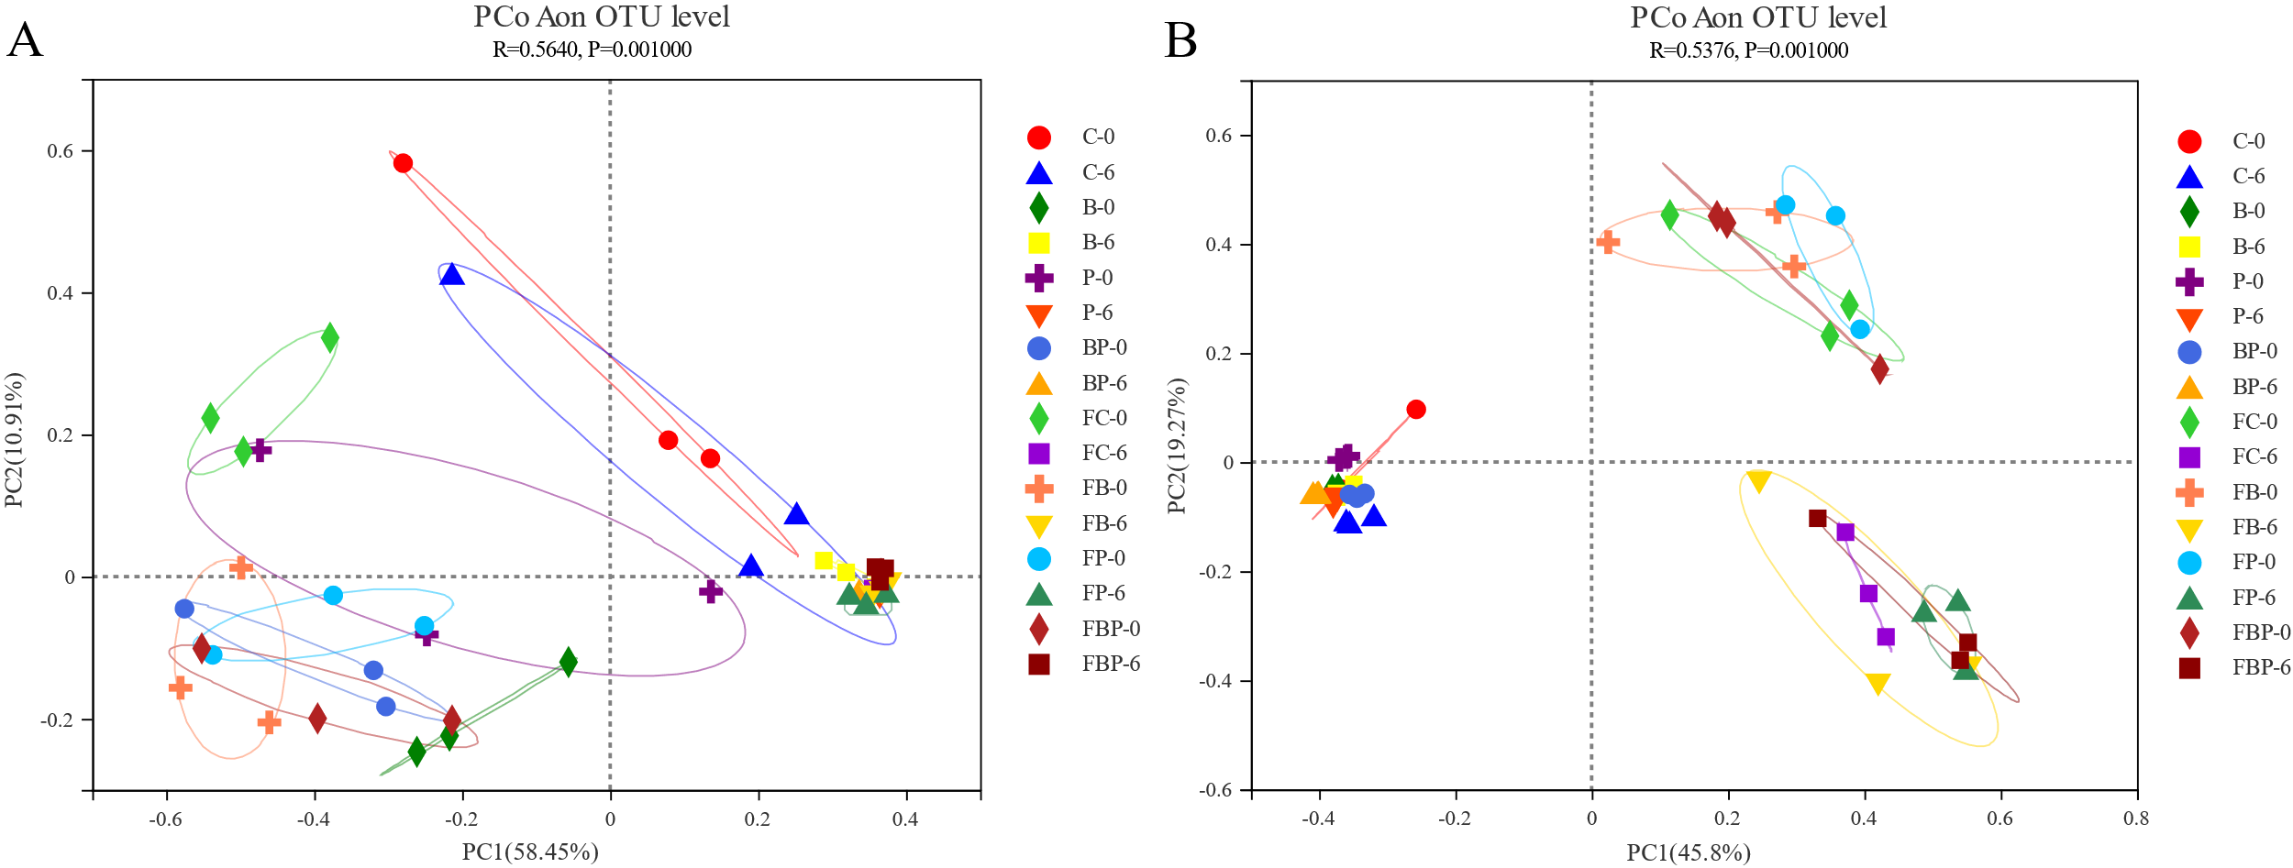
Fig. S3. Principal coordinate analysis (PCoA) plot based on Unweighted-UniFrac dissimilarity distance of the bacterial (A, R = 0.5640, P = 0.001) and fungal (B, R = 0.5376, P = 0.001) community between samples. C, Control of non-fungal infestation silages; B, L. buchneri treatment of non-fungal infestation silages; P, L. plantarum treatment of non-fungal infestation silages; BP, L. buchneri and L. plantarum treatment of non-fungal infestation silages; FC, Control of fungal infestation silages; FB, L. buchneri treatment of fungal infestation silages; FP, L. plantarum treatment of fungal infestation silages; FBP, L. buchneri and L. plantarum treatment of fungal infestation silages; Arabic number indicating days of aerobic exposure.

