Supplementary Figures

Doublecortin-expressing neurons in human cerebral cortex layer II and amygdala from infancy to 100 year-old

Ya-Nan Li^{1#}, Dan-Dan Hu^{1#}, Xiao-Lu Cai¹, Yan Wang¹, Chen Yang¹, Juan Jiang¹, Qi-Lei Zhang¹, Tian Tu^{1,2}, Xiao-Sheng Wang¹, Hui Wang¹, Ewen Tu³, Xiao-Ping Wang⁴, Aihua Pan^{1*}, Xiao-Xin Yan¹ and Lily Wan^{1,2*}

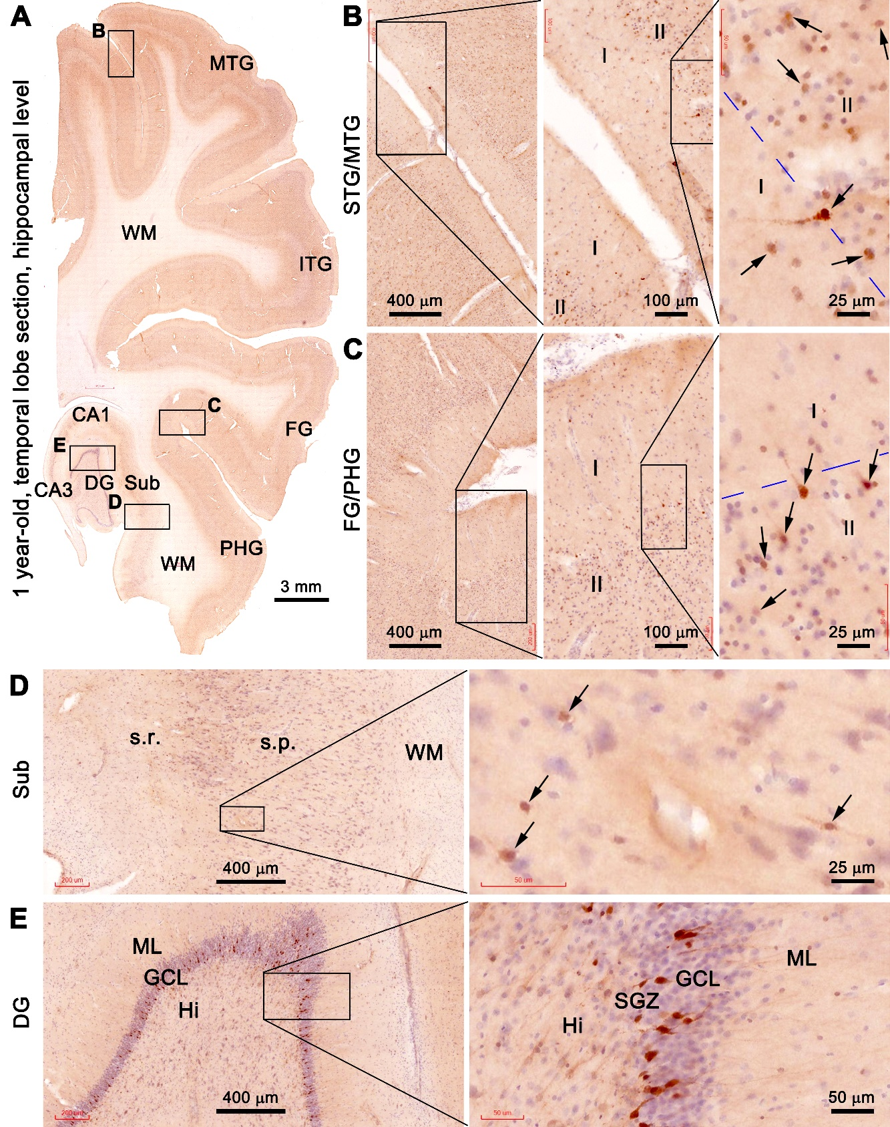
Supplemental Fig. 1. Doublecortin immunoreactive (DCX+) neurons in a temporal section from the 1 year-old case. Panel (A) is the Motic-scanned low magnification image of DCX labeling with hematoxylin counterstain, with the boxed areas enlarged as other panels. DCX+ neurons (examples are pointed by arrows) are present around layer II in all temporal cortical gyri (A-C), the subiculum (A, D) and the dentate gyrus (A, E). Notably, the DCX+ immature granule cells in the subgranular zone (SGZ) and granular cell layer (GCL) are distinctly labeled, including their dendritic processes extending across the GCL. Additional abbreviations are as defined in the main Figure 1 of the paper. Scale bars are as indicated.

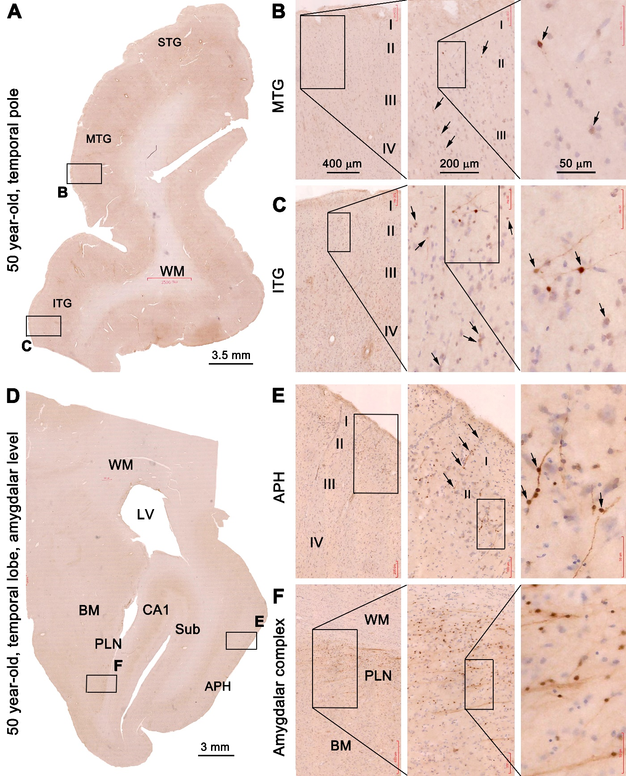
Supplemental Fig. 2. DCX+ neurons in coronal sections passing the temporal pole and amygdala in the 50 year-old case. (A) and (D) show the low magnification views of the sections, with the boxed areas enlarged as indicated. DCX+ neurons are present in layers I-III across various cortical areas (B-E), with the strongly labeled ones occurred in clusters, as well as chains sometimes extending inwardly from layer I to II/III (C, D). In the amygdala, DCX+ neurons are mostly localized to the paralaminar nucleus (PLN), which also often arrange in migratory chains (F). Additional abbreviations are as defined in the main Figures 1 and 2. Scale bars are included in the panels.

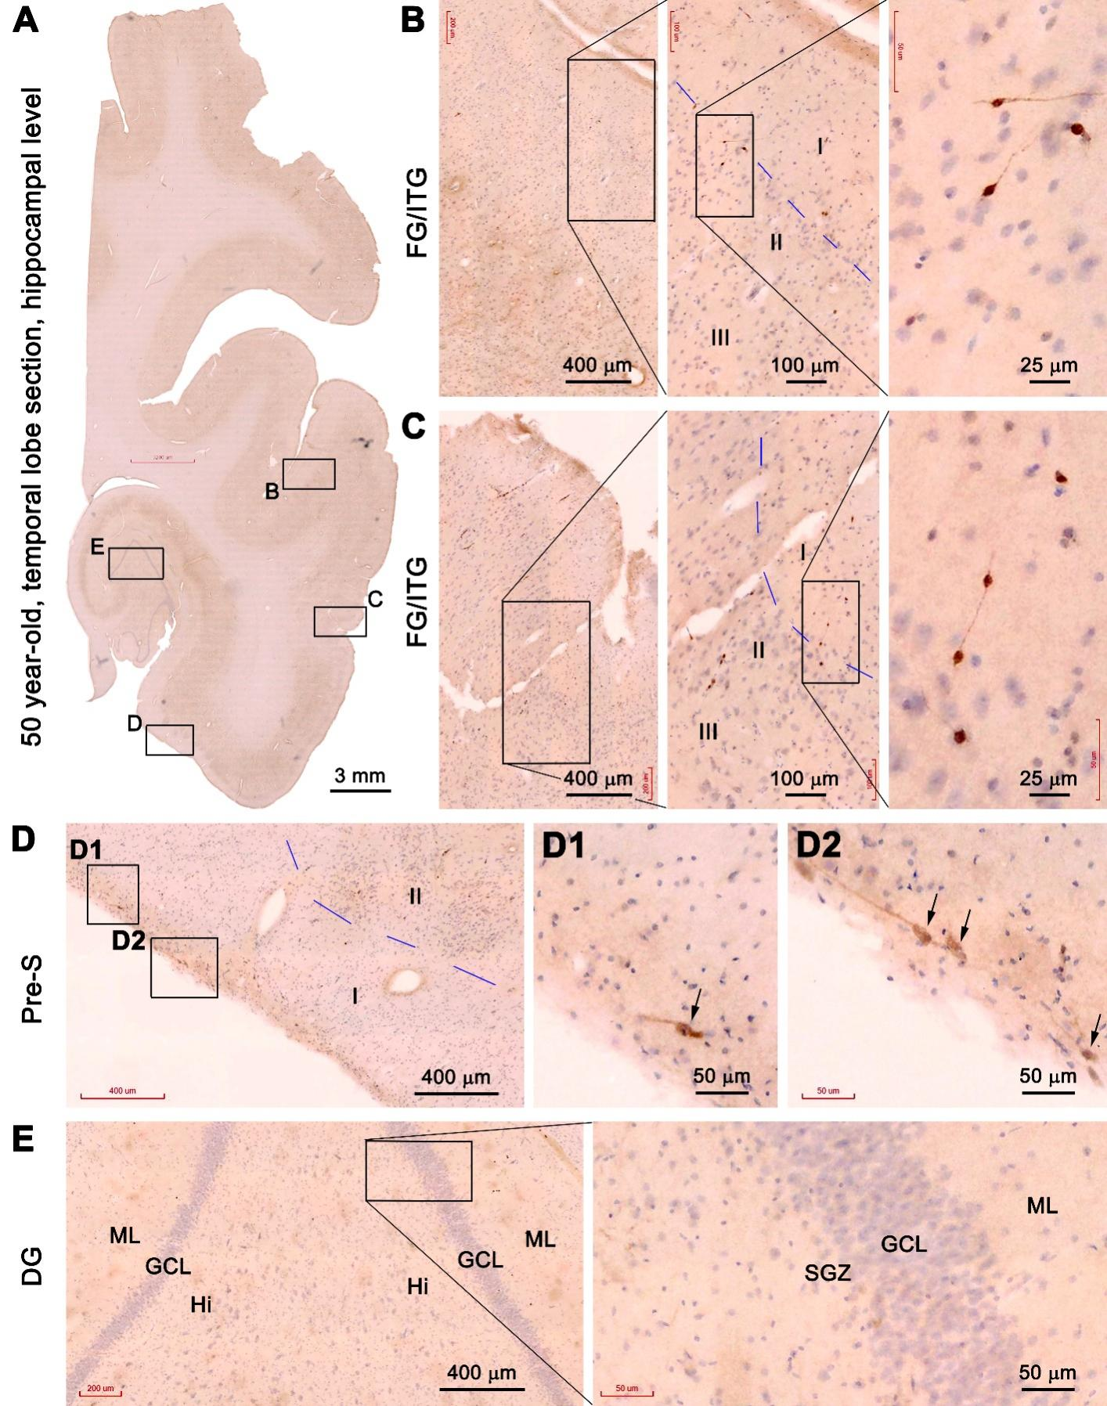
Supplemental Fig. 3. DCX+ neurons in a temporal lobe section passing the mid-hippocampus from the 50 year-old case. Labeled neuronal profiles at different cortical and amygdalar locations in the boxed areas in the low magnification image (A) are shown as panels (B-E). A small number of labeled cells are seen in the temporal neocortex largely around layer II (B, C). Moving into the hippocampal formation in this same section, no DCX+ neurons could be clearly observed in the dentate gyrus. Abbreviations are as defined in main figure 1 in the paper. Scale bars are marked.
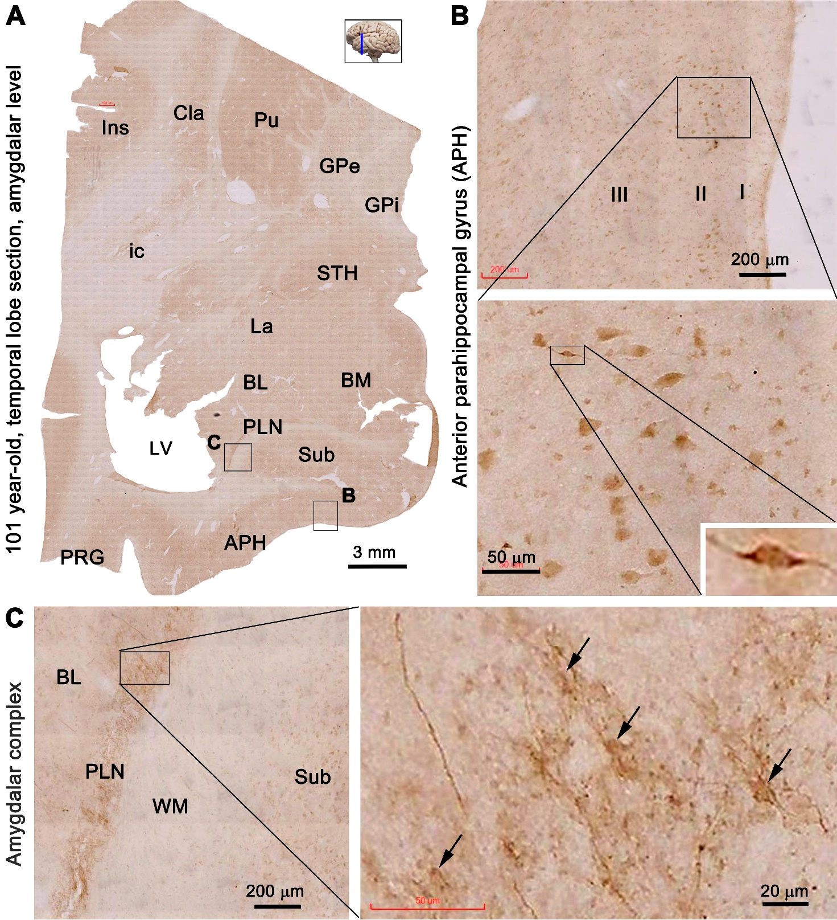
Supplemental Fig. 4. DCX+ neuronal profiles in a temporal lobe section at the level of the amygdala in the 101 year-old case. Panel arrangements, anatomical structures and scale bars are as indicated. Labeled neurons can be found in the anterior parahippocampal gyrus (B), most of which are relatively large in size, while a few of them appear bipolar in shape and exhibit fairly strong immunolabeling (insert). In the amygdala, there are a lot of labeled cells in the paralaminar nucleus. Some lightly stained somata (pointed by arrows) are seen among labeled neuronal processes (C). Ins: insular cortex; Cla: claustrum; Pu: putamen; GPe and GPi: external and internal parts of the globus pallium; ic: internal capsule; STH: subthalamus; LA, BL, BM and PL: lateral, basolateral, basomedial and paralaminar nuclei of the amygdala; Sub: subiculum; APH: anterior parahippocampal gyrus; PRG: perirhinal gyrus; LV: lateral ventricle; WM: white matter.

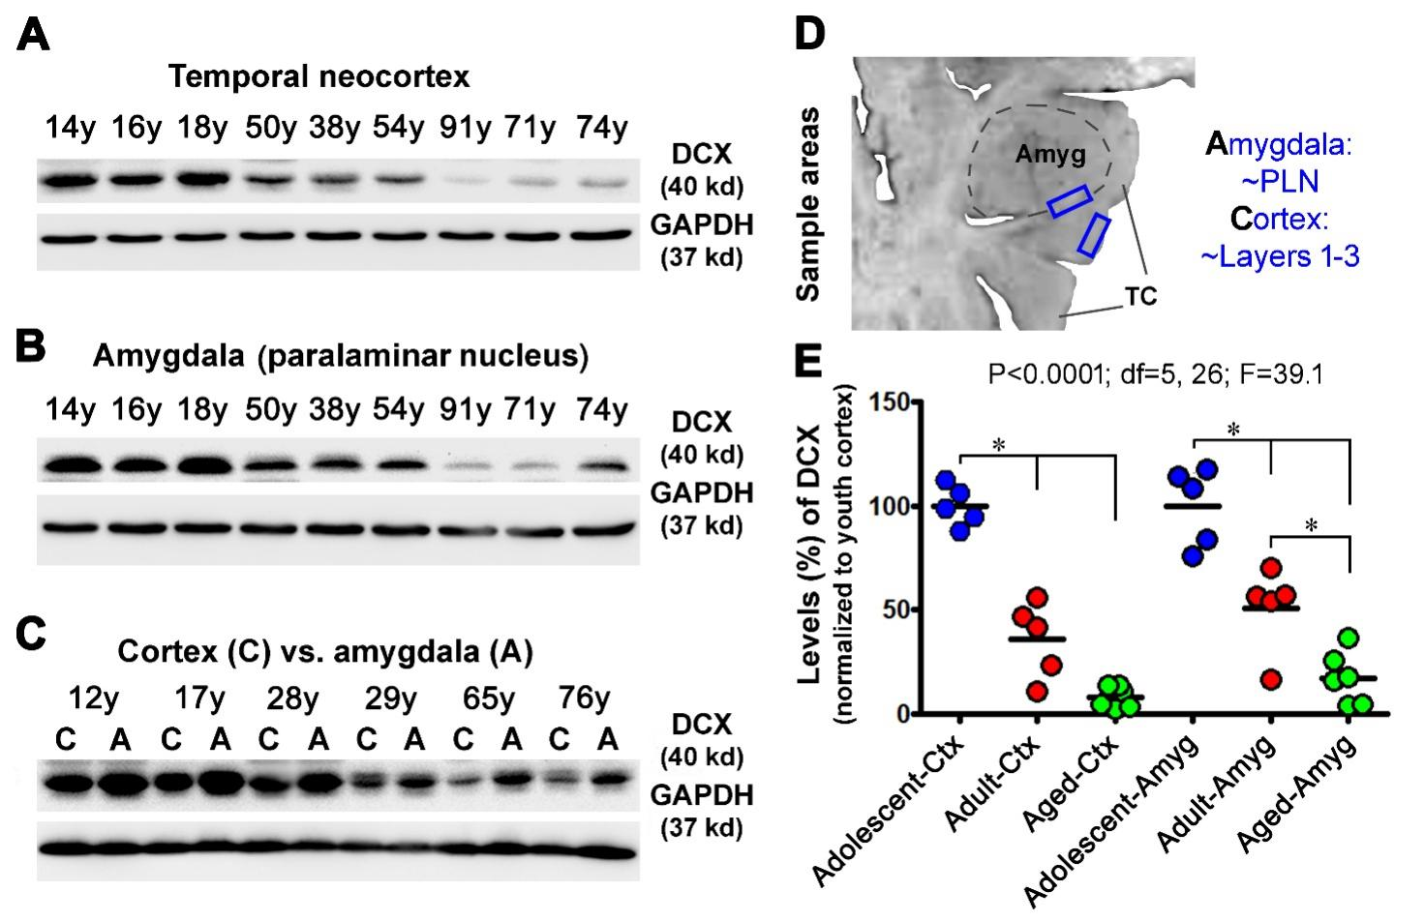

Supplemental Fig. 5. Western blot assessment of the age-related decline in DCX protein levels in temporal neocortical and amygdalar lysates. Panels (A, B) are representative images of immunoblotted DCX and the internal loading control, glyceraldehyde-3-phosphate dehydrogenase (GAPDH), in lysates from the cases at different ages in years (y) as indicated. Panel (C) shows a simultaneous assessment of the protein levels in the amygdala and cortex other individual cases. In each experiment, DCX proteins were blotted first, followed by stripping of the DCX antibody binding, and reblotting of GAPDH. Panel (D) illustrates the method for dissecting the cortical (C) and amygdalar (A) blocks from the frozen temporal lobe slice. Panel (E) summarize the levels of DCX protein in the cortical and amygdalar lysates from cases in the adolescent (n=5), adult (n=5) and aged (n=6) groups. The levels are normalized to the mean (defined as 100%) of the adolescent group. Results of statistical analyses (one-way ANOVA with posthoc test) are included in the graph, with *indicating significant intergroup difference in the mean levels.

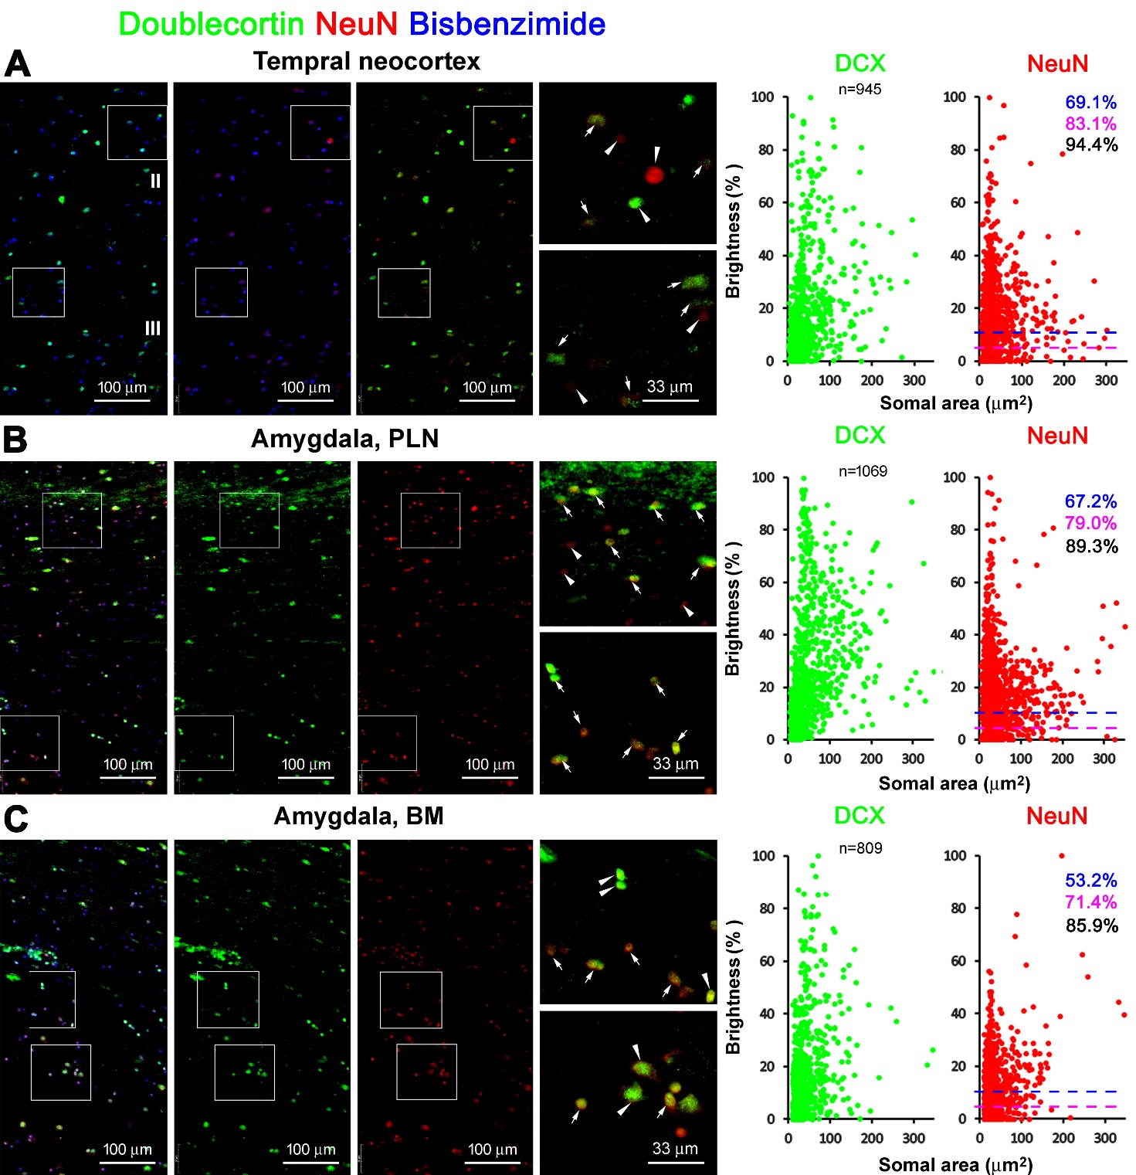Supplemental Fig. 6. Double immunofluorescent characterization of the colocalization of neuron-specific nuclear antigen (NeuN) in DCX+ neurons and correlated single-cell densitometric analysis. (A-C) show low and high power views of single-channel and merged images of DCX and NeuN double immunofluorescence with bisbenzimide counterstain in the temporal neocortex and amygdalar nuclei. The double-labeled cells are pointed by arrows, and the single-labeled by arrowheads. The NeuN labeling intensity is weaker in the DCX+ neurons than in nearby mature neurons not expressing DCX (DCX-/NeuN+ neurons). The dot graphs show the relative densities of DCX and NeuN labeling among DCX+ neurons around layer II, the PLN and BM, which are normalized to the level (defined as 100%) measured in mature neurons. The total number of cells measured and the rates of NeuN colocalization in the DCX+ neurons calculated using 0% (black), 5% (purple) and 10% (blue) of the normalized densities as cutoffs are indicated in the graphs. Note that the somal size is less than 200 µm² for the majority of the DCX+/NeuN+ neurons.

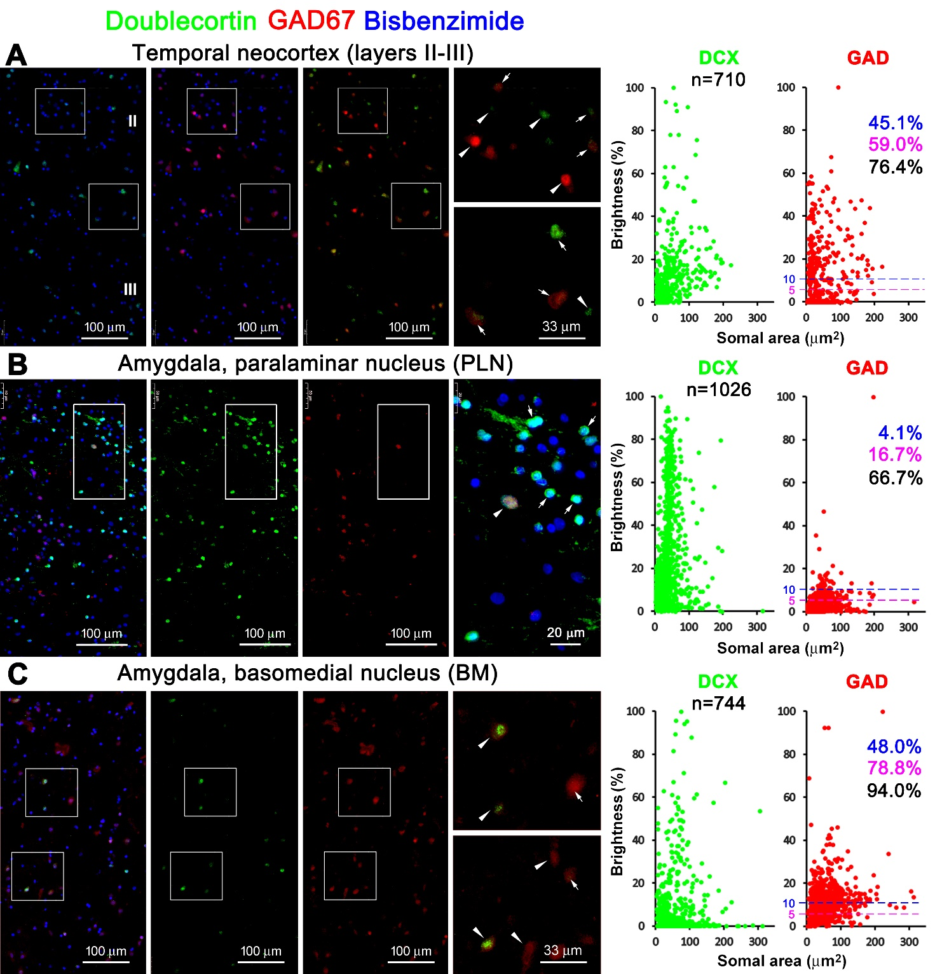Supplemental Fig. 7. Double immunofluorescent characterization of the colocalization of glutamate decarboxylase 67 (GAD67) in DCX+ neurons and correlated single-cell densitometric analysis. Image panels show low and high power views of DCX and GAD67 double immunofluorescence with bisbenzimide counterstain in the indicated areas. Double-labeled cells are pointed by arrowheads, and the single-labeled by arrows. The GAD67 labeling intensity is weaker in the DCX+ neurons than in mature interneurons. The dot graphs show the relative densities of DCX and GAD67 labeling among the DCX+ neurons, with GAD67 densities normalized to the level (100%) measured in mature interneurons (DCX-/GAD67+). The relative densities vary among the population of analyzed neurons. The total number of cells analyzed and the rates of GAD67 colocalization in the DCX+ neurons calculated using 0% (black), 5% (purple) and 10% (blue) of the relative densities as cutoffs are indicated in the graphs. The majority of the DCX+/GAD67+ neurons have a somal size ≤200 µm².
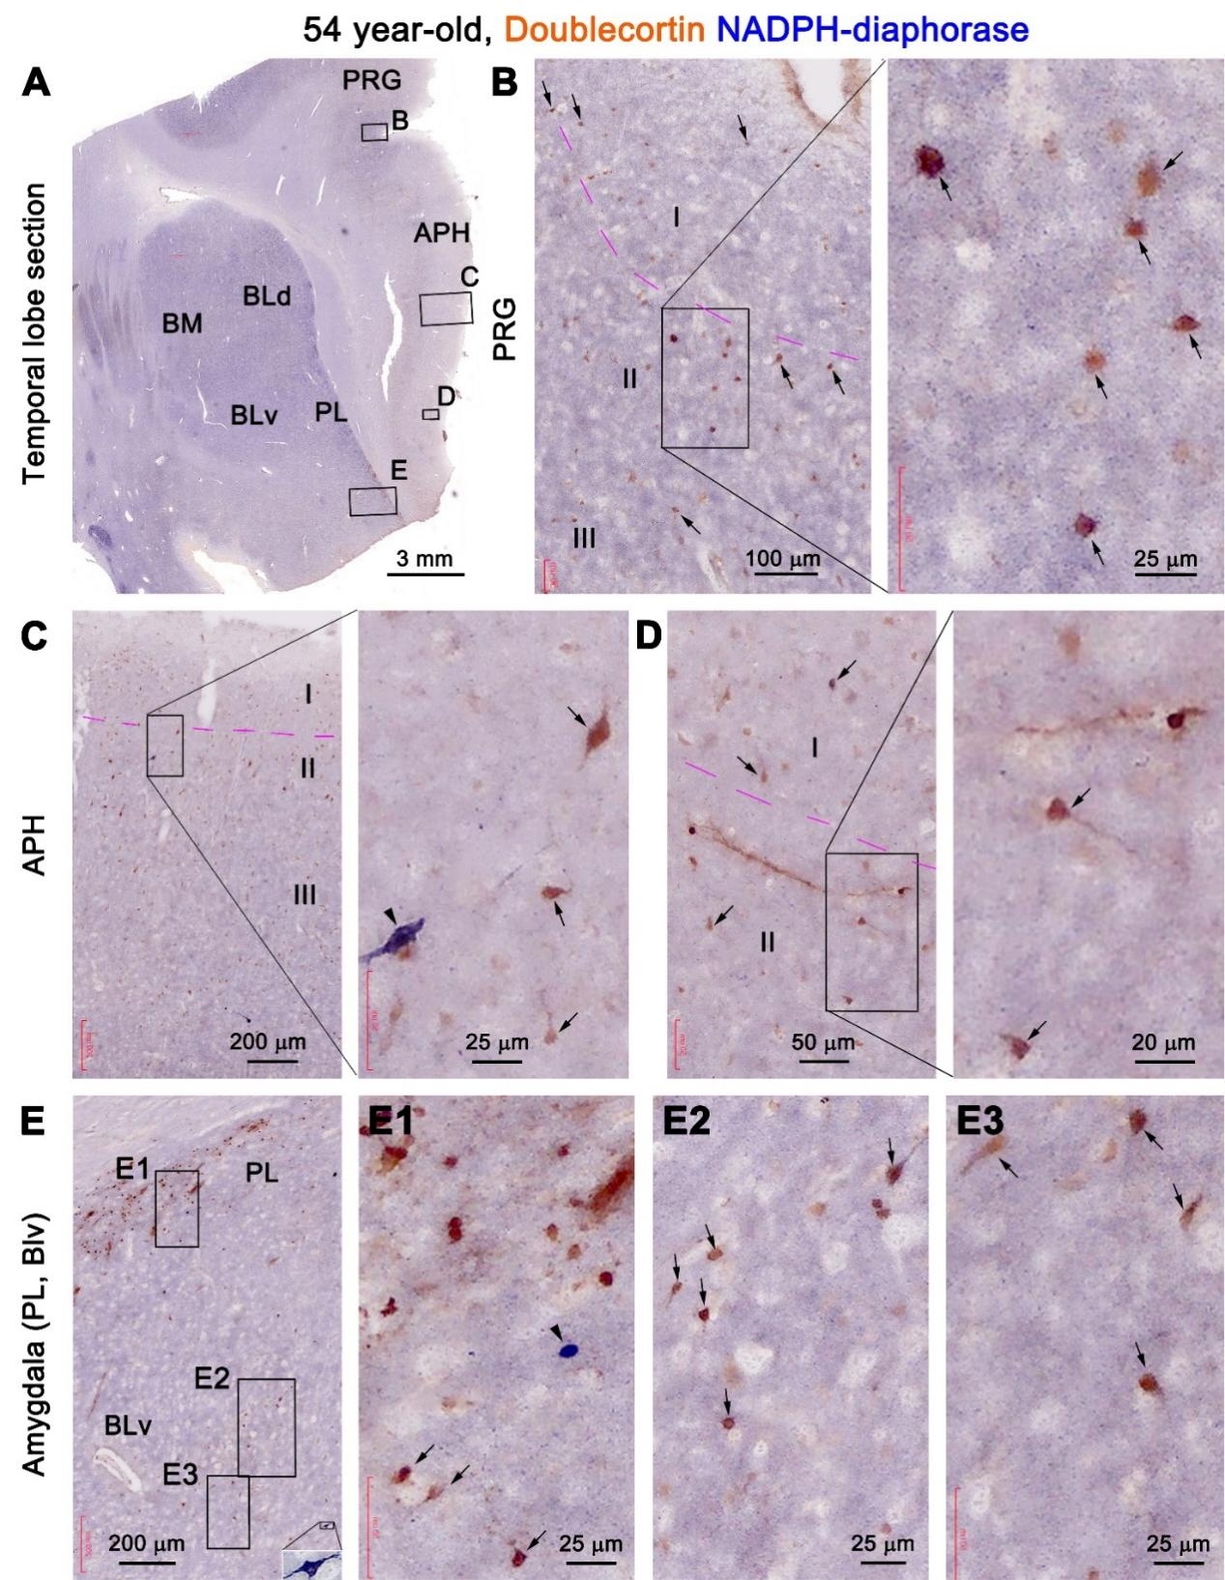
Supplemental Fig. 8. Colocalization of nicotinamide adenine dinucleotide phosphate-diaphorase (NADPH-d) reactivity in DCX+ neurons in a section from the 54 year-old case. Panel (A) is a low magnification image of a temporal lobe section passing the amygdala, with framed areas in the cortical areas and amygdala enlarged sequentially as indicated. Many relatively large-sized DCX+ neurons (pointed by arrows) in the cortical areas exhibit light NADPH-d histochemical reactivity, including some in layer I (B-D). In the amygdala, double-labeled neurons are seen largely in the basolateral (BL) nucleus, whereas the small-sized DCX+ neurons in the paralaminar nucleus do not co-express NADPH-d (E-E3). DCX+ migratory chains are present in the cortex and amygdala (D, E, E1). Non-colocalized type I (C, E) and type II (E1) NADPH-d interneurons (pointed by arrowheads) exhibit bright blue histochemical reactivity. Abbreviations are as defined in main Figures 1 and 2. Scale bars are provided.
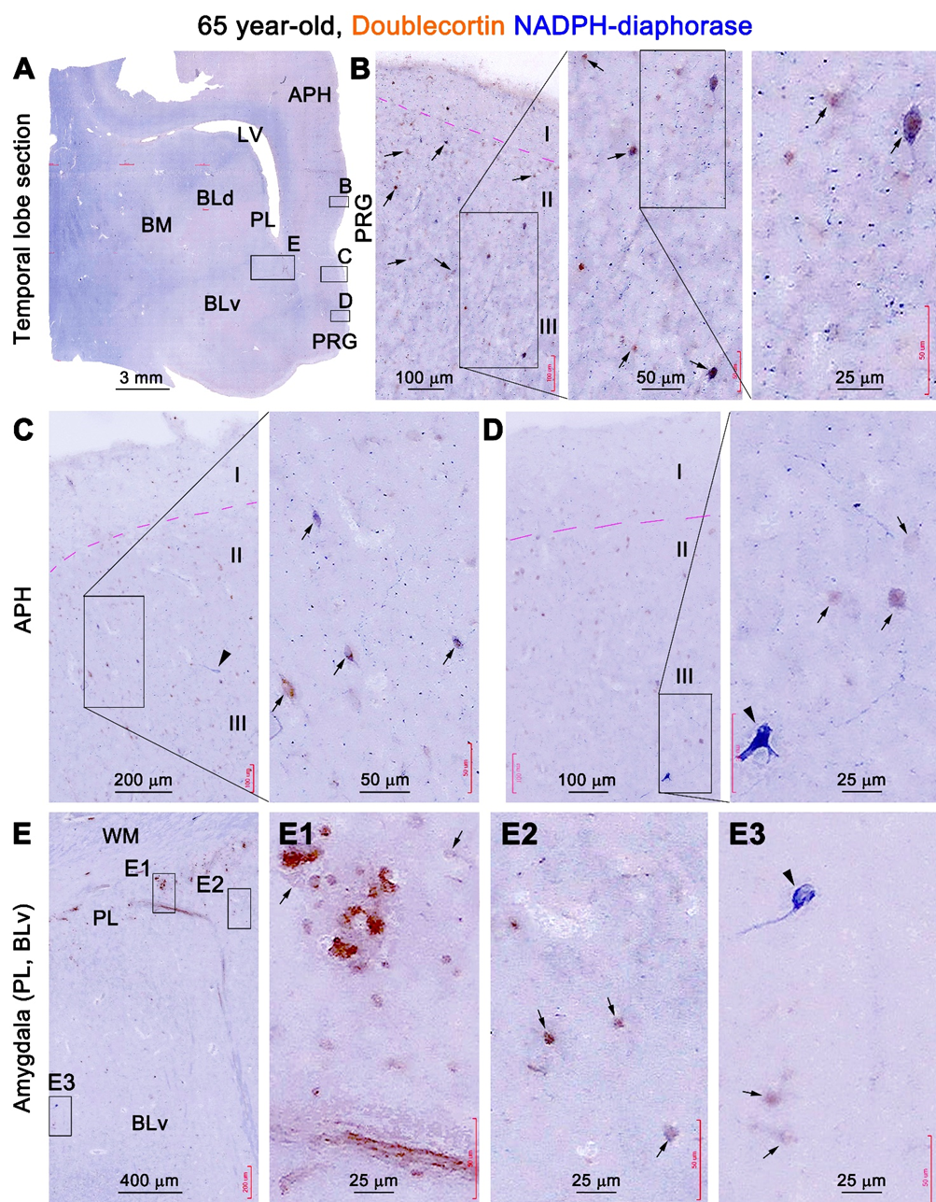
Supplemental Fig. 9. Additional assessment of colocalization of NADPH-d reactivity in DCX+ neurons. Panel (A) is a low power view of a temporal lobe section at the level of the amygdala from the 65 year-old case, with framed areas enlarged as indicated. Double labeled neurons (pointed by arrows) are present in the cortical areas (B-D) and the amygdala (E, E1-3). A long DCX+ migratory chain extends from the paralaminar (PL) nucleus to the ventral subdivision of the basolateral nucleus (BLv). Two type II neurons exhibit bright blue NADPH-d reactivity without DCX immunolabeling. Abbreviations are as defined in main Figures 1 and 2. Scale bars are provided.

