Supplementary Data

Genetic Risk Factors for ME/CFS Identified using Combinatorial Analysis
Author(s): Sayoni Das, Krystyna Taylor, James Kozubek, Jason Sardell, Steve Gardner
Date: 22 September 2022
Status: v17.0

Supplementary Data

Pain Questionnaire Study Design
UK Biobank participants included in the Pain Questionnaire case cohort answered positively to the question:
Data Type | ICD-10 / Data Field ID | Description
Self-reported | 120010 | Ever had Chronic Fatigue Syndrome or Myalgic Encephalitis (M.E.)
UK Biobank participants excluded from the Pain Questionnaire control cohort met one or more of the following criteria:
Table 8: Control selection criteria for the ME/CFS Pain Questionnaire cohort
Data Type | ICD-10 / Data Field ID | Description
HES | G93.3 | Postviral fatigue syndrome
HES | R53.x | Malaise and fatigue
HES | G47.x | Sleep disorders
HES | M79.7 | Fibromyalgia
Self-reported | 120009 | Ever had fibromyalgia syndrome?
Self-reported | 120010 | Ever had Chronic Fatigue Syndrome or Myalgic Encephalitis?
Self-reported | 120120 | Exercise brings on fatigue
Self-reported | 120122 | Fatigue interferes with physical functioning
Self-reported | 120123 | Fatigue causes frequent problems
Self-reported | 120124 | Fatigue prevents sustained physical functioning
Self-reported | 120125 | Fatigue interferes with carrying out certain duties or responsibilities
Self-reported | 120126 | Fatigue is among three most disabling symptoms
Self-reported | 120127 | Fatigue interferes with work, family or social life

Genotype Quality Control
Appropriate quality control of genotype data was performed using PLINK³³ and GRAF (Genetic Relationship and Fingerprinting) based on standard quality control procedures to ensure thorough cleaning of the data before it is used for genomic analyses.
This included the following steps:
- Batch effect correction: Batch-level quality control procedures was performed based on recommendations by UK Biobank²⁶ and only SNPs that pass all batch-level QC were used for further analysis.
- Sample and SNP filtering based on missingness: The filtering for SNPs with missing data (<5%) was followed by filtering of individuals with missing data (<5%) using PLINK.
- Minor Allele Frequency (MAF) filtering of SNPs: The genotype data would be filtered to exclude SNPs with MAF <0.0001 using PLINK.
- Hardy-Weinberg Equilibrium (HWE) filtering: HWE filtering was performed on controls with p<10⁻¹⁰ using PLINK.
- Heterozygosity filtering: Samples with extreme (very high or very low) heterozygosity were removed.
- Sample filtering based on relatedness: GRAF-rel was used to identify duplicates and closely related subjects in the dataset. After identification of close relatives, only one representative of each closely related family pairs was retained.
- Ancestry analysis: GRAF-pop was used for ancestry inference and limit samples for the dataset to European ancestry.
- Sex discrepancy of individuals: Samples that have discrepancies between the sex recorded in the dataset and their sex based on absence/presence of a Y chromosome were removed.

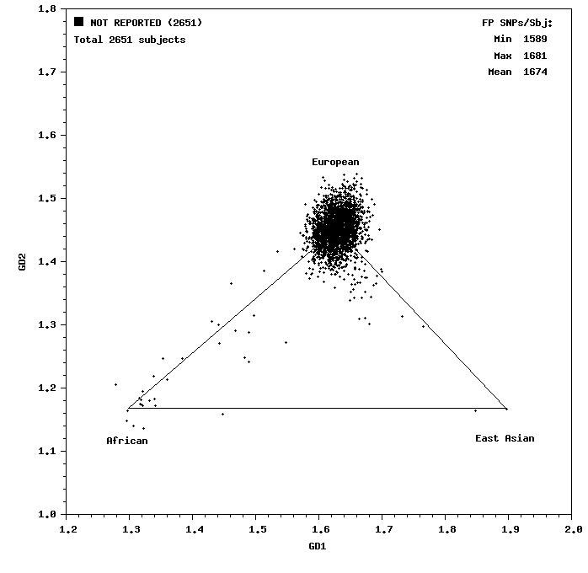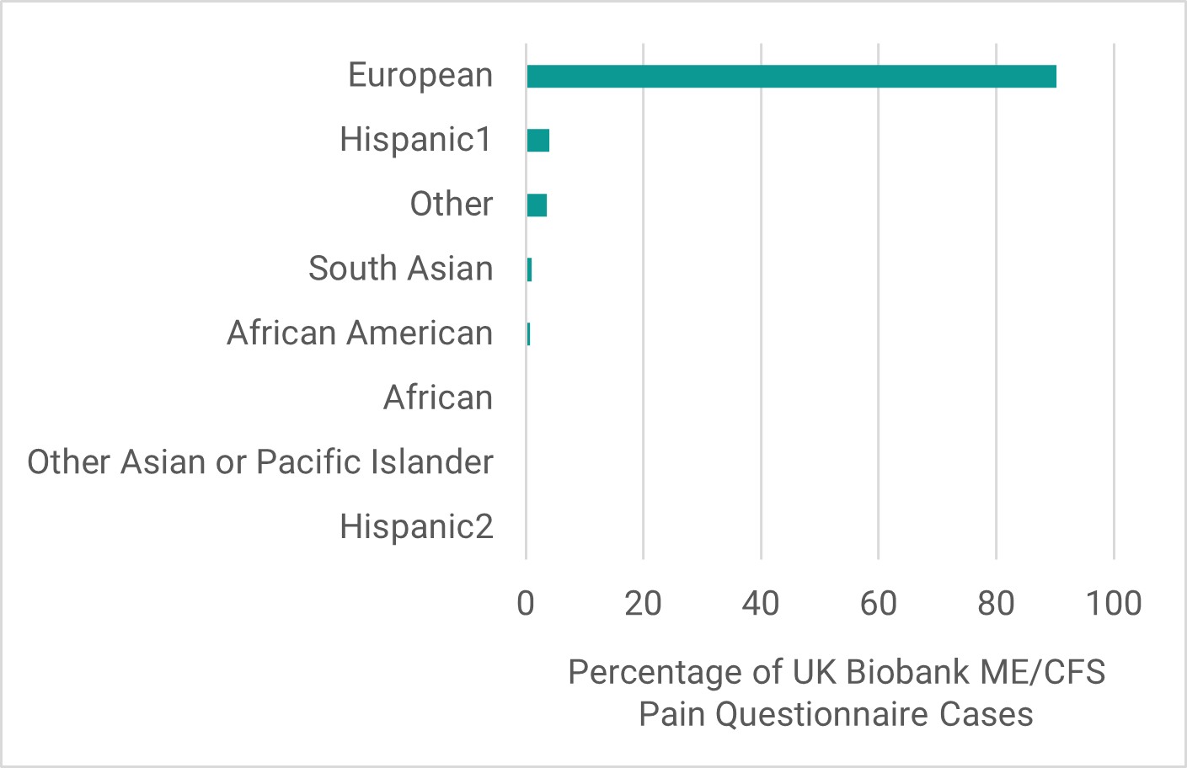
(a) (b)
Figure 10: (a) Ancestry inference plot generated by GRAF-pop and (b) the ancestry distribution of ME/CFS case population (n=2,651 cases) generated from UK-Biobank using self-reported diagnosis in Pain Questionnaire before quality control shows very strong bias for European ancestry (>90%).

Cohort Analysis

Data used for Cohort Analysis
Data used for cohort analysis in Figure 2:

Exposure to infectious agents:
Data Type | ICD-10/ Data Field /Category ID | Description
Blood assays | 23053 | EBV seropositivity for Epstein-Barr Virus
Blood assays | 1307 | Infectious disease antigens
HES | A00.x-B99.x | Chapter I Certain infectious and parasitic diseases

Diagnosis with any of the most common autoimmune diseases:
Data Type | ICD-10 / Data Field / Category ID | Description
HES | M05.x or M06.x | Rheumatoid arthritis
HES | L40.x or M07.x | Psoriasis / psoriatic arthritis
HES | G35.x | Multiple sclerosis
HES | M32.x | Systemic lupus erythematosus
HES | K50.x or K51.x | Inflammatory bowel disease (Crohn’s and ulcerative colitis)
HES | K90.0 | Celiac disease
HES | M45.x | Ankylosing spondylitis
HES | M35.0 | Sjogren’s syndrome
HES | M35.3 | Polymyalgia rheumatica
HES | M34.x | Systemic sclerosis
HES | M79.7 | Fibromyalgia
HES | E10.x | Type 1 diabetes
HES | E06.x | Thyroiditis

Evidence of significant stressful events:
Data Type | ICD-10 / Data Field /Category ID | Description
Self-reported | 6145 | Illness, injury, bereavement, stress in last two years (any but ‘none of the above’)
Self-reported | 20499 | Ever sought or received professional help for mental distress
Self-reported | 20500 | Ever suffered mental distress preventing usual activities
HES | Chapter XX | External causes of morbidity and mortality

Sex
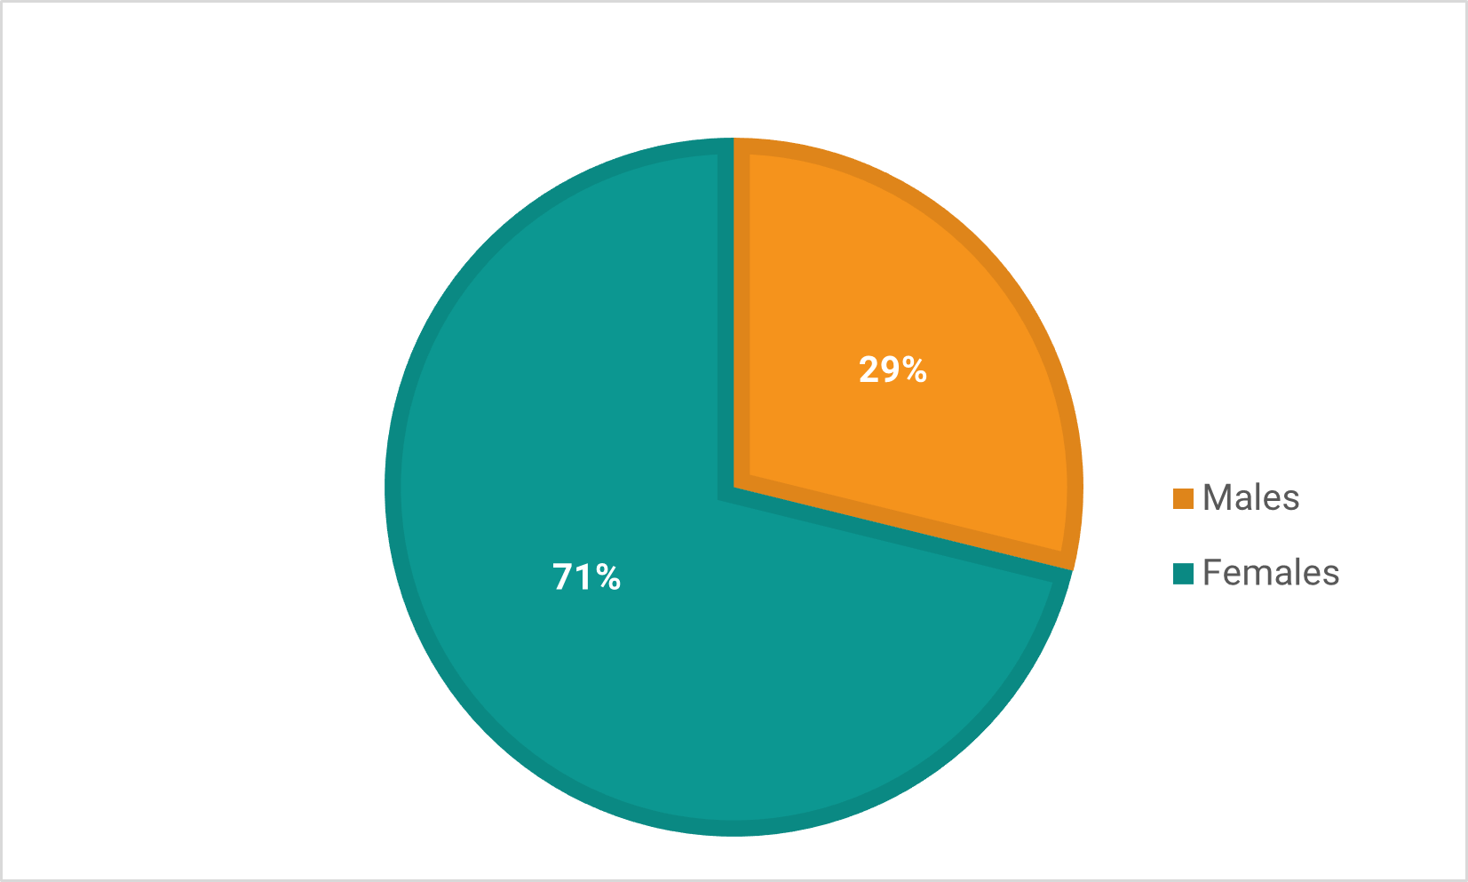
Figure 11: The proportion of females in the Pain Questionnaire case population was substantially higher (~71%) than males (29%).

Age & BMI
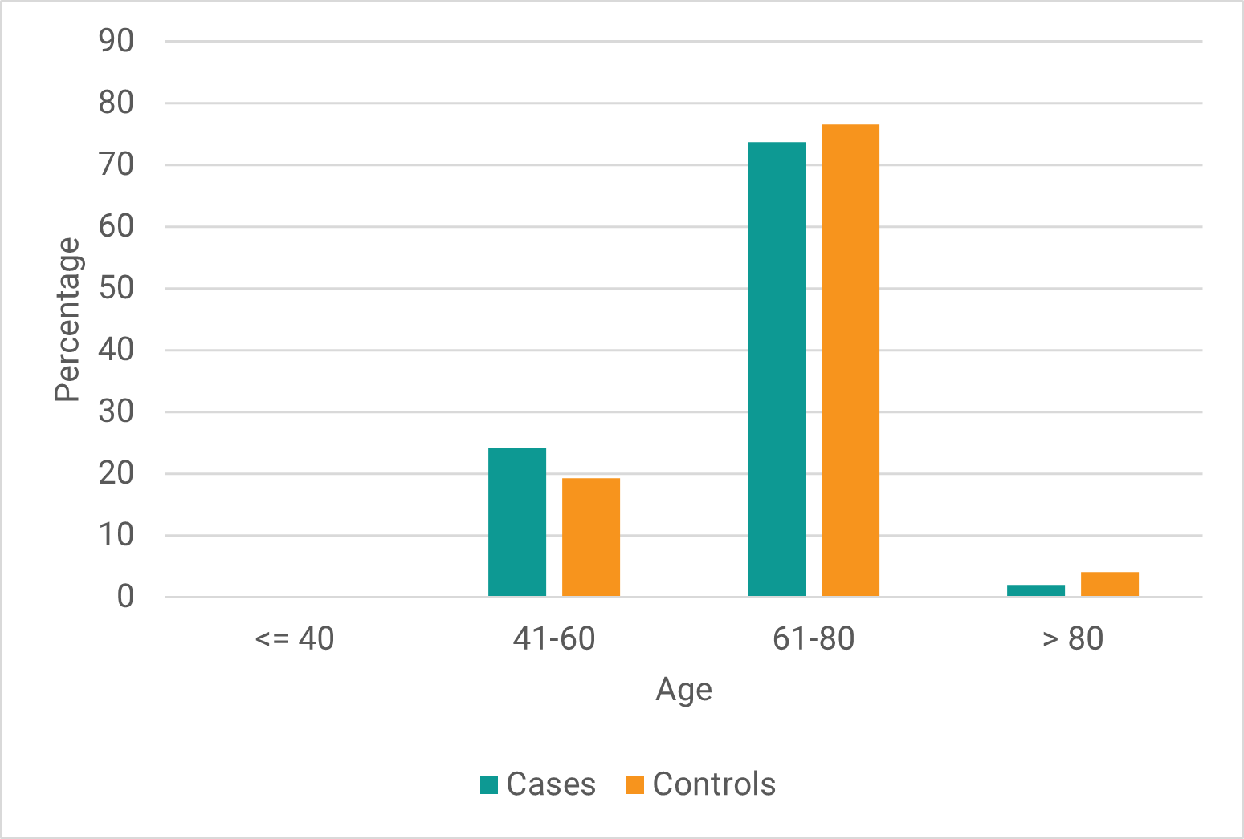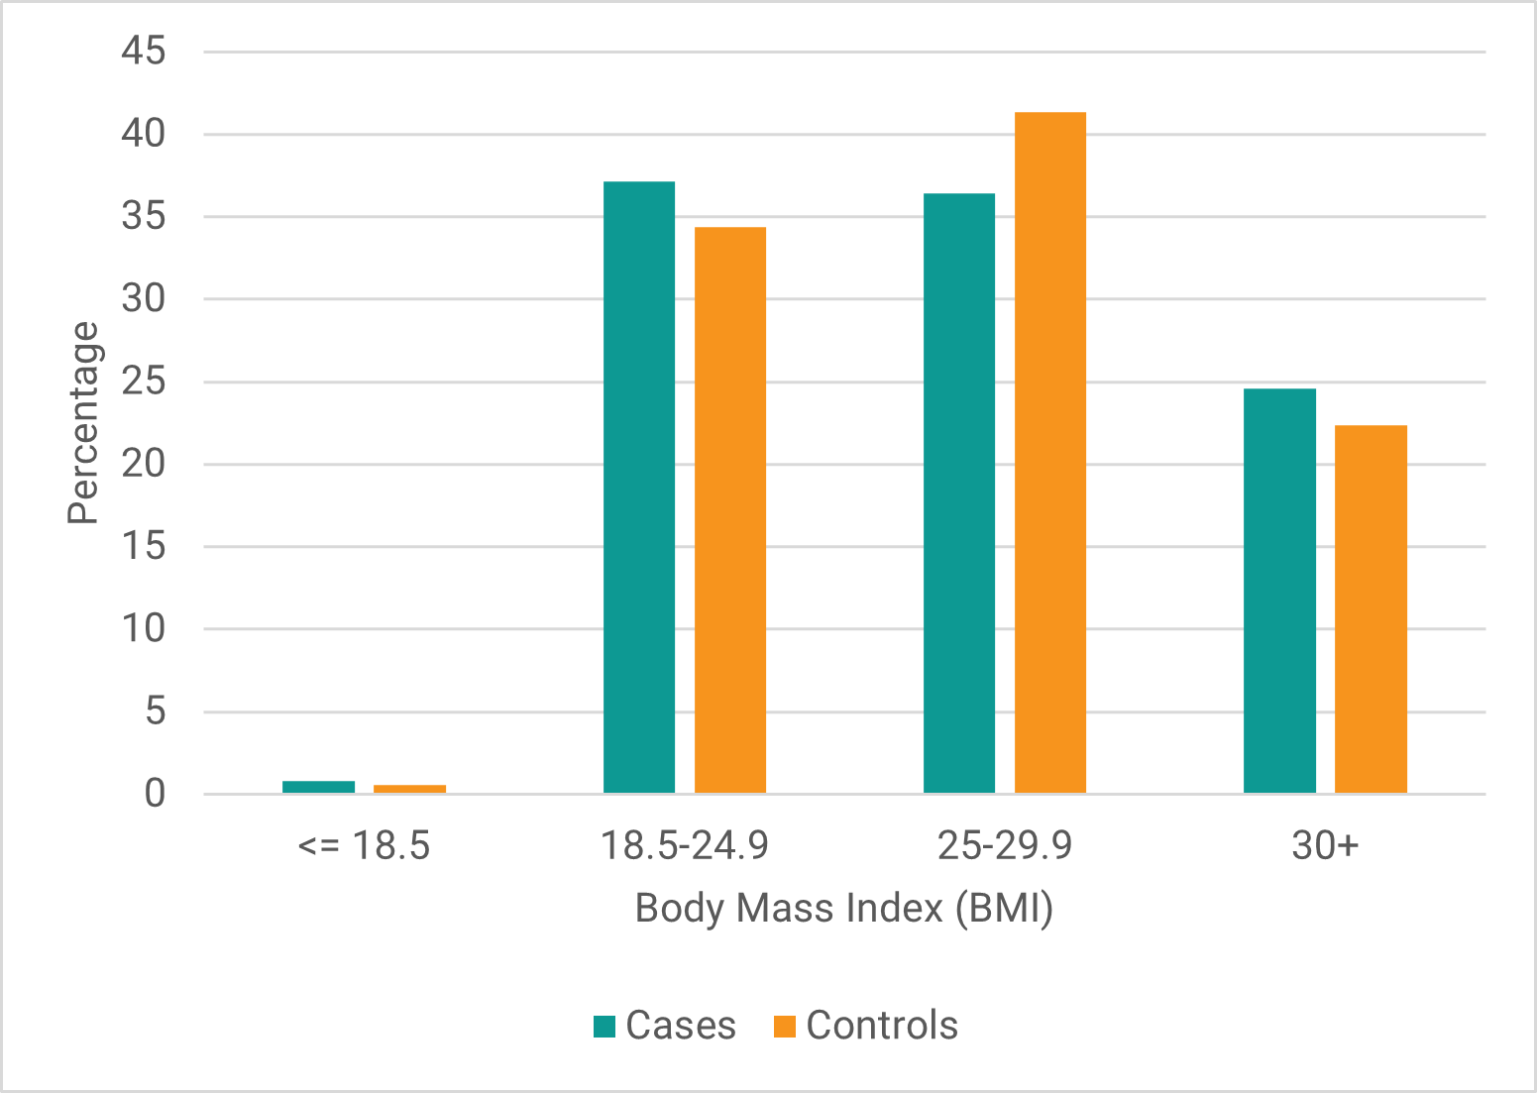
(a) (b)
Figure 12: Distribution of (a) age and (b) BMI of cases vs controls in the Pain Questionnaire cohort.

Combinatorial Disease Signatures
Table 9: List of 84 disease signatures with its constituent SNPs and mapped genes identified in the ME/CFS Pain Questionnaire study.
Disease signature | SNPs | Genes
Disease signature 1 | rs7731560, rs237475, rs2904106 | AL035685.1, KCNB1, ATP9A
Disease signature 2 | rs11695478, rs7837321, rs62112949 | TRAPPC9, LINC00683
Disease signature 3 | rs11695478, rs7837321, rs66754206 | TRAPPC9, LINC00683
Disease signature 4 | rs11695478, rs7837321, rs13047599 | TRAPPC9, SON
Disease signature 5 | rs11695478, rs10784508, rs4984526 | NR2F2-AS1, AC012409.2
Disease signature 6 | rs10488419, rs2471534, rs2398428 | EXOC4, CEP290, SLC15A4
Disease signature 7 | rs42756, rs77677798, rs2398428 | MCTP1, GTF3AP6, SLC15A4
Disease signature 8 | rs7376617, rs4377693, rs60619978 | LINC02495, SCAMP1-AS1, KCTD1
Disease signature 9 | rs76621327, rs7376617, Affx-34417209 | LINC02495, FBP1
Disease signature 10 | rs7376617, rs28715644, rs5747306 | LINC02495, RAP1GAP2, BCL2L13
Disease signature 11 | rs35537747, rs10177290, rs7376617 | LINC01789, AC005540.1, LINC02495
Disease signature 12 | rs62401163, rs12530627, rs72732818 | CYP39A1, RPL36AP45
Disease signature 13 | rs12530627, rs72732818, rs2309099 | RPL36AP45
Disease signature 14 | rs11695478, rs58264436, rs7837321 | TMEM232, TRAPPC9
Disease signature 15 | rs58264436, rs7007248, rs9646604 | TMEM232, ODF1, SOCS6
Disease signature 16 | rs58264436, rs12309571, rs9646604 | TMEM232, SOCS6
Disease signature 17 | rs2592394, rs58264436, rs7926655 | HOXD-AS2, TMEM232, SLC5A12
Disease signature 18 | rs58264436, rs994779, rs7159803 | TMEM232, TTC6
Disease signature 19 | rs72711020, rs58264436, rs9646604 | S100A2, TMEM232, SOCS6
Disease signature 20 | rs58264436, rs4526126, rs10500403 | TMEM232, FAM153C, AC027130.1, IQCK
Disease signature 21 | rs58264436, rs4524616, rs7101688 | TMEM232, AL589740.1, OR52M1
Disease signature 22 | rs7731560, rs62521813, rs237475, rs2904106 | C8orf34, AL035685.1, KCNB1, ATP9A
Disease signature 23 | rs7731560, rs11221492, rs237475, rs2904106 | AP000920.1, AL035685.1, KCNB1, ATP9A
Disease signature 24 | rs58634322, rs7731560, rs237475, rs2904106 | AC009486.1, AL035685.1, KCNB1, ATP9A
Disease signature 25 | rs57169846, rs11030639, rs16947237, rs4777865 | AC009468.1, STIM1, GPC5, AC091078.1
Disease signature 26 | rs4738034, rs16947237, rs61744697, rs9979510 | AC079089.1, GPC5, DNAH9, AF212831.1
Disease signature 27 | rs4738034, rs16947237, rs79935615, rs9979510 | AC079089.1, GPC5, DNAH9, AF212831.1
Disease signature 28 | rs11030639, rs16947237, rs1956944, rs4777865 | STIM1, GPC5, OR7K1P, AC091078.1
Disease signature 29 | rs11780906, rs7913215, rs16947237, rs6062914 | ADCY8, GDI2, GPC5, CHRNA4
Disease signature 30 | rs13414838, rs17779800, rs16947237, rs351224 | NMS, GPC5, STRA6
Disease signature 31 | rs13414838, rs9869834, rs16947237, rs351224 | NMS, SYNPR, SYNPR-AS1, GPC5, STRA6
Disease signature 32 | rs12712033, rs9403525, rs12950480, rs3556 | KIAA1211L, PHACTR2, STX8, PEPD
Disease signature 33 | rs9403525, rs2028009, rs35463808, rs2244010 | PHACTR2, LINC02577, DPF3, AP000561.1
Disease signature 34 | rs9403525, rs2028009, rs649372, rs35463808 | PHACTR2, LINC02577, SERTM1, DPF3
Disease signature 35 | rs13138313, rs9403525, rs9299270, rs35774571 | AC108206.1, PHACTR2, AL441989.1, CBLN2
Disease signature 36 | rs74135796, rs12332121, rs13285566, rs3785477 | AL450244.1, LINC02214, ZNF618, AKAP1
Disease signature 37 | rs4844861, rs11135368, rs3785477, rs206604 | LAMB3, AC008415.1, AKAP1, AP005209.1
Disease signature 38 | rs817095, rs1566129, rs3785477, rs10470164 | AC009975.2, AC009975.1, NID2, AKAP1, HUNK
Disease signature 39 | rs35388418, rs4601136, rs1445326, rs3785477 | AC097491.1, AL589740.1, AKAP1
Disease signature 40 | rs2029952, rs3779859, rs7952262, rs35868427 | AC122138.1, MYOM2, NELL1, ETV6
Disease signature 41 | rs1020411, rs2029952, rs3798276, rs7027070 | AC122138.1, TINAG, PAX5
Disease signature 42 | rs2029952, rs17009338, rs72708234, rs684232 | AC122138.1, CCDC59, VPS53
Disease signature 43 | rs2029952, rs17009338, rs684232, rs2190805 | AC122138.1, CCDC59, VPS53, AC006504.7, AC005357.2
Disease signature 44 | rs2029952, rs17773312, rs684232, rs2190805 | AC122138.1, CCDC59, VPS53, AC006504.7, AC005357.2
Disease signature 45 | rs60600282, rs2029952, rs12515588, rs12422918 | IGKV1OR2-108, AC122138.1, AC008581.2, ZBED3-AS1, AC022414.1, SRGAP1
Disease signature 46 | rs7624046, rs6842554, rs2029952, rs11839732 | KCNMB2-AS1, KCNMB2, AC117457.1, AC097110.1, AC122138.1
Disease signature 47 | rs41306603, rs58634322, rs7731560, rs237475, rs2904106 | S100PBP, AC009486.1, AL035685.1, KCNB1, ATP9A
Disease signature 48 | rs58634322, rs7731560, rs77821266, rs237475, rs2904106 | AC009486.1, AP001978.1, AL035685.1, KCNB1, ATP9A
Disease signature 49 | rs1986655, rs34694271, rs2499908, rs73021223, rs1644757 | FAT4, USP6NL, CDON, CAMSAP3
Disease signature 50 | rs17571877, rs56309153, rs6912599, rs2499908, rs2378865 | LINC02238, ATOH8, OFCC1, USP6NL, AL139353.1, HEATR5A
Disease signature 51 | rs56309153, rs35396333, rs6912599, rs2499908, rs2378865 | ATOH8, YTHDC2, OFCC1, USP6NL, AL139353.1, HEATR5A
Disease signature 52 | rs56309153, rs35396333, rs6912599, rs2499908, rs7157977 | ATOH8, YTHDC2, OFCC1, USP6NL, AL139353.1, HEATR5A
Disease signature 53 | rs946448, rs7605428, Affx-33425392, rs73021223, rs6561713 | CYB5RL, AL357673.1, MRPL37, AC007402.1, FREM1, CDON, AL450423.1
Disease signature 54 | rs12562306, rs7605428, Affx-33425392, rs73021223, rs6561713 | CYB5RL, AL357673.1, MRPL37, AC007402.1, FREM1, CDON, AL450423.1
Disease signature 55 | rs72864990, rs9876108, rs6835113, rs209165, rs73021223 | FMNL2, LINC00882, ELOVL6, RPL13P, LINC01623, CDON
Disease signature 56 | rs946448, rs7605428, rs116395696, Affx-33425392, rs73021223 | CYB5RL, AL357673.1, MRPL37, AC007402.1, FREM1, CDON
Disease signature 57 | rs12562306, rs7605428, rs116395696, Affx-33425392, rs73021223 | CYB5RL, AL357673.1, MRPL37, AC007402.1, FREM1, CDON
Disease signature 58 | rs1267267, rs7930105, rs73021223, rs9304634, rs2042286 | MPLKIP, FBXO3, CDON, LINC00906
Disease signature 59 | rs6861966, rs10884539, rs954090, rs4932370, rs59165976 | LINC01435, PTPRR, RN7SL363P, INSR
Disease signature 60 | rs10501233, rs7122851, rs2269787, rs4788817, rs59165976 | LRRC4C, AC090720.1, AP000446.1, SYT17, AC009097.2, INSR
Disease signature 61 | rs12044097, rs570817, rs10501233, rs6491316, rs59165976 | SPTA1, CFAP77, LRRC4C, AC090720.1, INSR
Disease signature 62 | rs61825301, rs35186300, rs570817, rs10501233, rs59165976 | OBSCN, CFAP77, LRRC4C, AC090720.1, INSR
Disease signature 63 | rs2304725, rs1395905, rs949730, rs10420798, Affx-16805420 | SLC6A11, AC027804.1, SYT1, AC090709.1, AC008738.6, SULF2
Disease signature 64 | rs12490191, rs2304725, rs1395905, rs10420798, Affx-16805420 | SSUH2, SLC6A11, AC027804.1, AC008738.6, SULF2
Disease signature 65 | rs12464809, rs62254551, rs6832769, rs9444564, rs4313118 | RN7SKP93, AC134729.1, CLOCK, TMEM165, AL590392.1, AC104370.1
Disease signature 66 | rs2985754, rs726471, rs1327804, rs11839732, rs10403668 | NRCAM, TPT1P9, AP1M2
Disease signature 67 | rs13015713, rs1917097, rs4745697, rs11839732, rs4813374 | SUCLA2P2, AC108752.1, RIN2
Disease signature 68 | rs879665, rs1917097, rs10503277, rs519138, rs11839732 | MROH2A, AC108752.1, CSMD1, AC091096.1
Disease signature 69 | rs4144251, rs56045138, rs17052708, rs11839732, rs11696277 | AC012368.1, LINC00445, PCSK2
Disease signature 70 | rs73797049, rs11769606, rs28846183, rs12812478, rs11839732 | ABLIM2, ZNF767P, CASC8
Disease signature 71 | rs2985754, rs726471, rs1327804, rs917602, rs11839732 | NRCAM, TPT1P9, PRMT8
Disease signature 72 | rs817095, rs62452969, rs1566129, rs3785477, rs75827101 | AC009975.2, AC009975.1, AC007001.1, AC005062.1, NID2, AKAP1, LDLRAD4
Disease signature 73 | rs74135796, rs2611215, rs758682, rs4501964, rs3785477 | AL450244.1, AC093655.1, TEAD1, AKAP1
Disease signature 74 | rs12550751, rs4760980, rs12930636, rs3785477, rs11910362 | GPIHBP1, AC025252.1, AC093515.1, AKAP1
Disease signature 75 | rs2236212, rs10764325, rs7953236, rs17136255, rs3785477 | ELOVL2, CACNB2, AXIN1, AKAP1
Disease signature 76 | rs2236212, rs10764325, rs17136255, rs3785477, rs2243408 | ELOVL2, CACNB2, AXIN1, AKAP1
Disease signature 77 | rs10018406, rs75548762, rs4601136, rs1445326, rs3785477 | AC097491.1, HMGN3, AL589740.1, AKAP1
Disease signature 78 | rs10018406, rs4601136, rs116842259, rs1445326, rs3785477 | AC097491.1, AL589740.1, INSC, AKAP1
Disease signature 79 | rs10011047, rs4601136, rs116842259, rs1445326, rs3785477 | AC097491.1, AL589740.1, INSC, AKAP1
Disease signature 80 | rs2236212, rs55652946, rs10764325, rs17136255, rs3785477 | ELOVL2, CACNB2, AXIN1, AKAP1
Disease signature 81 | rs17812116, rs10011047, rs4601136, rs1445326, rs3785477 | SUCLG2-AS1, AC097491.1, AL589740.1, AKAP1
Disease signature 82 | rs4920832, rs62584791, rs7134469, rs3785477, rs8107775 | RPS2P25, AKAP1, R3HDM4
Disease signature 83 | rs35388418, rs4601136, rs116842259, rs1445326, rs3785477 | AC097491.1, AL589740.1, INSC, AKAP1
Disease signature 84 | rs62388082, rs2236212, rs10764325, rs17136255, rs3785477 | ELOVL2, CACNB2, AXIN1, AKAP1

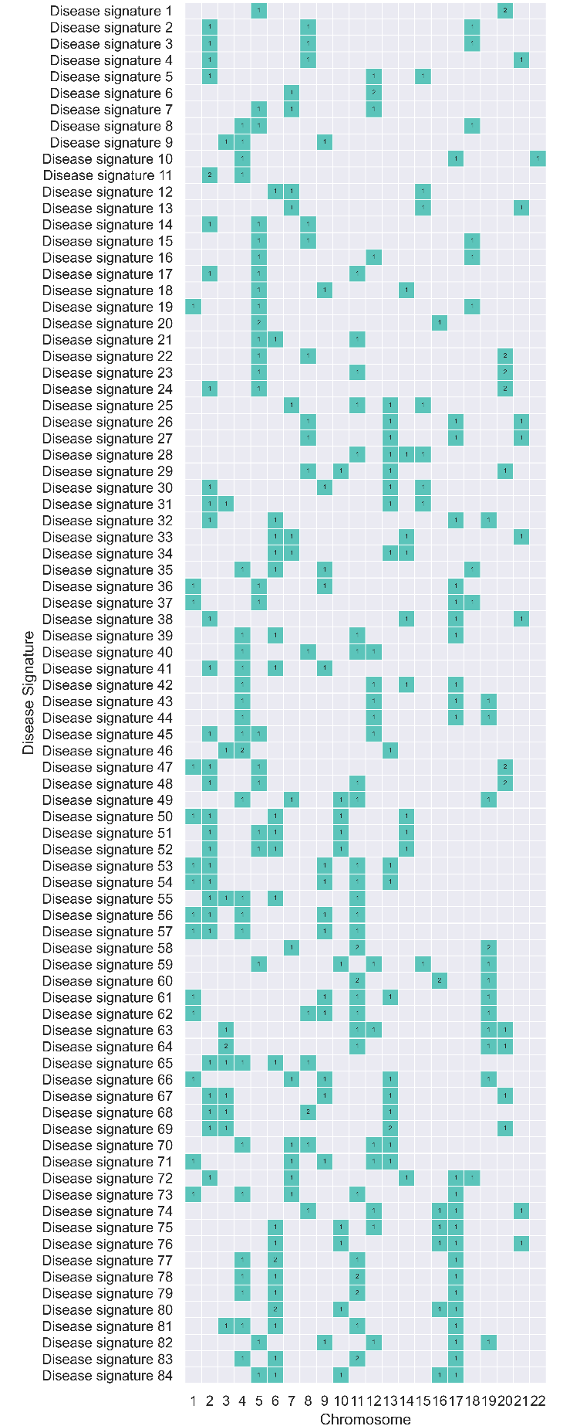
Figure 13: Distribution of chromosomal location of SNPs associated with 84 disease signatures identified in the Pain Questionnaire study. None of the SNPs identified in the disease signatures were observed to be in linkage disequilibrium (LD).
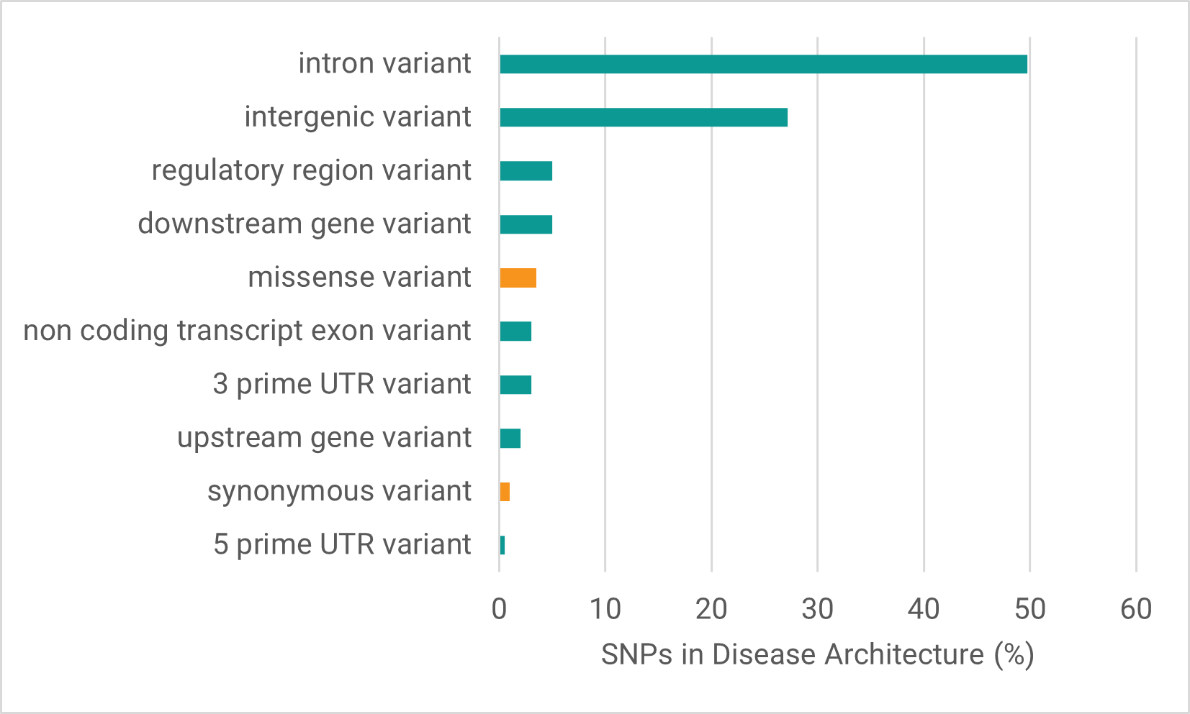
Figure 14: Distribution of variant consequences (most severe predicted by Ensembl VEP) of critical SNPs identified in the Pain Questionnaire study. More than 95% of SNPs were non-coding variants (shown in green) and <5% were coding variants (shown in orange).
As an internal validation we generated five smaller subsets of the Pain Questionnaire cohort each excluding a different 10% of the cases. These cross-validation runs therefore comprised 90% of the case population compared against the same set of controls as the Pain Questionnaire cohort. We compared the odds ratios and Z-scores of the disease signatures identified in the full cohort to those identified in each of the subset analyses. The odds ratios and Z-scores of the SNP combinations remain largely consistent irrespective of small changes to the case population (Figure 15).
This technical (internal cross-validation) replicate study provided an internal parameter check, but it has insufficient independence between both the case and control sets used in the runs for reliable use as formal replication.
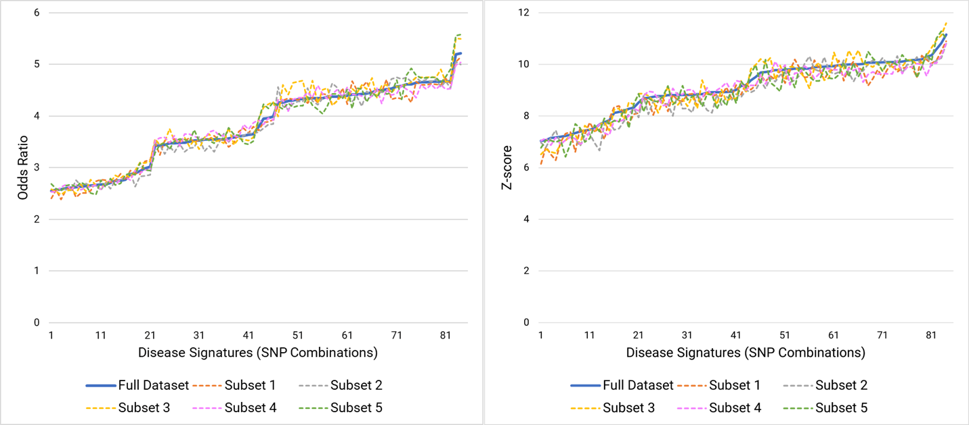
(a) (b)
Figure 15: Comparison of (a) odds ratios and (b) Z-scores of the full Pain Questionnaire dataset with five sub-cohort splits containing 90% of the same cases as the full cohort and the same set of controls.

Genes Associated with Phenotypes
Table 10: Frequency distribution of categorical phenotypic features in cases associated with gene(s) compared to all cases and controls in the cohort. p-values were calculated to assess the association of each feature using two-sided Fisher’s exact tests.
Phenotypic Feature | Gene(s) | Gene case count with feature | Gene Case count | All case count with feature | Total case count | All controls count with feature | Total control count | p-value (compared to cases) before multiple testing | Adjusted p-value (compared to cases) | p-value (compared to controls) before multiple testing | Adjusted p-value (compared to controls)
Illness injury bereavement stress in last 2 years (2019+) | SLC6A11  SULF2 | 4 | 170 | 12 | 2,382 | 1 | 4,764 | 0.003 | 0.177 | 6.00 X 10⁻²¹ | 7.61 X 10⁻²¹
Illness injury bereavement stress in last 2 years (2014+) | CDON | 48 | 328 | 249 | 2,382 | 3 | 4,764 | 0.023 | 0.861 | 6.36 X 10⁻¹⁴⁵ | 1.19 X 10⁻¹⁴⁴
Fibromyalgia (ICD-10: M79.7) | CLOCK | 13 | 153 | 108 | 2,382 | 0 | 4,764 | 0.026 | 0.969 | 2.92 X 10⁻⁹⁰ | 1.87 X 10⁻⁸⁹
Other soft tissue disorders (ICD-10: M79) | CLOCK | 22 | 153 | 224 | 2,382 | 0 | 4,764 | 0.044 | 0.969 | 1.15 X 10⁻¹⁵¹ | 1.04 X 10⁻¹⁴⁹
Thyroiditis (ICD10-10: E06) | PHACTR2 | 3 | 343 | 5 | 2,382 | 0 | 4,764 | 0.033 | 0.969 | 1.07 X 10⁻¹⁰ | 1.92 X 10⁻¹⁰
Males (Genetic sex) | S100PBP | 48 | 125 | 687 | 2,382 | 11 | 4,764 | 0.022 | 0.078 | 0 | 0
Males (Genetic sex) | ATP9A  KCNB1 | 55 | 144 | 687 | 2,382 | 31 | 4,764 | 0.016 | 0.078 | 7.29 X 10⁻²⁵¹ | 3.28 X 10⁻²⁵⁰

Table 11: Frequency distribution of quantitative phenotypic features in cases associated with gene(s) compared to all cases and controls in the cohort. p-values were calculated to assess the association of each feature using two-sided Mann-Whitney U tests.
Phenotypic Feature | Gene(s) | Gene case count with feature data | Max, Mean & Min value of feature for cases with gene assoc. | All case count with feature data | Max, Mean & Min value of feature for all cases | Control count with gene assoc. and feature data | Max, Mean & Min value of feature for controls | p-value (compared to cases) before multiple testing | Adjusted p-value (compared to cases) after multiple testing
Phenylalanine levels in plasma | SLC6A11  SULF2 | 41 | 0.07  0.047  0.032 | 595 | 0.08  0.044  0.017 | 0 | N/A | 0.022 | 0.988

Table 12: Frequency distribution of quantitative phenotypic features in cases associated with communities compared to all cases and controls in the cohort. p-values were calculated to assess the association of each feature using two-sided Mann-Whitney U tests.
Phenotypic Feature | Community | Gene case count with feature data | Max, Mean & Min value of feature for cases with gene assoc. | All case count with feature data | Max, Mean & Min value of feature for all cases | Control count with gene assoc. and feature data | Max, Mean & Min value of feature for controls | p-value (compared to cases) before multiple testing | Adjusted p-value (compared to cases) after multiple testing
Lactate levels in plasma | 3 | 61 | 1.81  3.41  6.81 | 595 | 1.41  3.69  9.64 | 0 | N/A | 0.028 | 0.992
Lactate levels in plasma | 14 | 100 | 1.66  3.92  7.13 | 595 | 1.41  3.69  9.64 | 0 | N/A | 0.017 | 0.992
Genes Associated with SNPs using eQTL and Chromatin Interaction Data
Table 13: Gene assignments for SNPs using publicly available eQTL and chromatin-interaction data.
SNP | Genes assigned using eQTL/chromatin data | Gene assignment approach | Tissue(s) of Interest | Genes assigned from genome assembly
rs2904106 | SALL4 | eqtl | Brain_Cerebellum | ATP9A
rs3785477 | RP11-166P13.3 | eqtl | Whole_Blood,  Brain_Hypothalamus,  Brain_Frontal_Cortex_BA9,  Brain_Putamen_basal_ganglia,  Brain_Nucleus_accumbens_basal_ganglia | AKAP1
rs41306603 | FNDC5 | eqtl | Brain_Frontal_Cortex_BA9 | S100PBP
rs6832769 | SRD5A3 | eqtl | Whole_Blood,  Brain_Cerebellum | CLOCK
rs11839732 | LINC00346, TEX29 | promoter | Dorsolateral_Prefrontal_Cortex | -
Tissue Expression of Genes
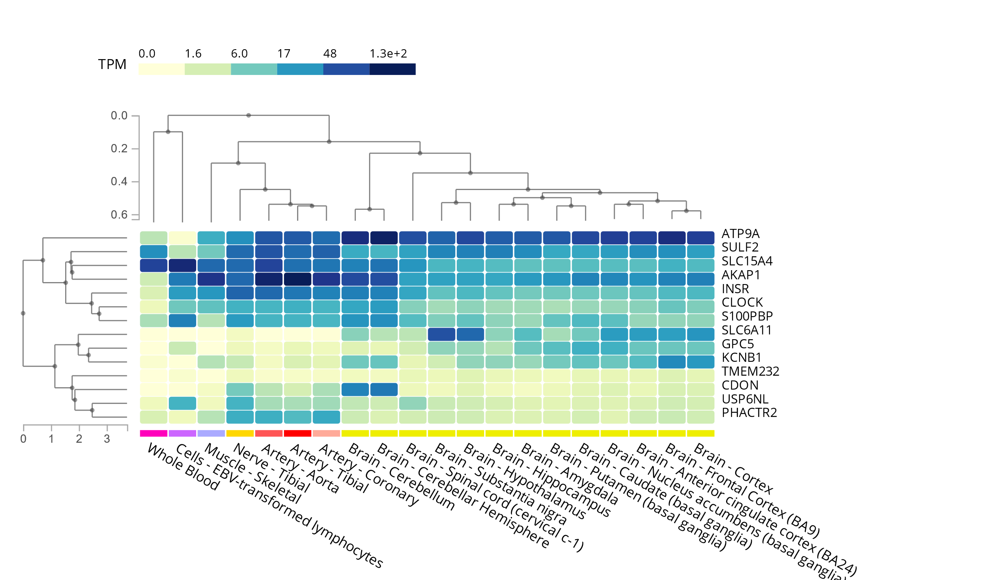
Figure 16: Clustered heatmap showing tissue expression profiles (GTEx) for 14 genes identified in the Pain Questionnaire study.

Comparison with UK Biobank CFS Verbal Interview Study
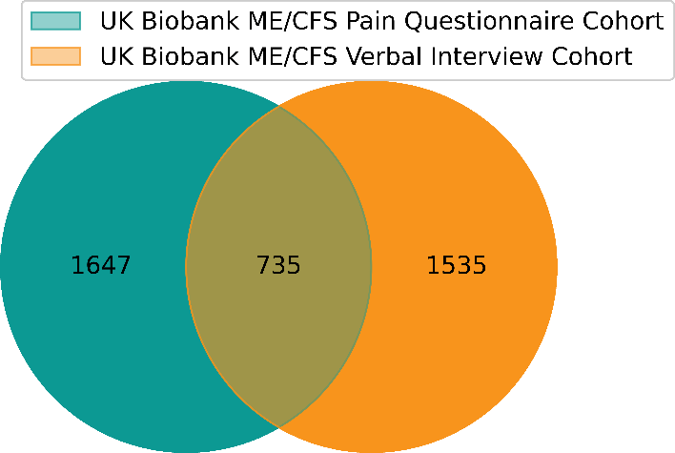
Figure 17: Case overlap between two UK Biobank ME/CFS cohorts (Pain Questionnaire and Verbal Interview)

Gene Annotation Data Sources
Table 14: Example public annotation sources for various types of study results
Annotation Type | Data Source(s)
Encoded Protein Structure and Function | Uniprot, InterPro, PDBe-KB
SNP-Disease Association | GWAS Catalog, PharmGKB, OpenTargets
Gene-Disease Association | PubMed, PubChem NCBI, OpenTargets
Gene Tissue/Cell Expression | Human Protein Atlas, GTEx, Promoter Capture HiC, Expression Atlas
Pathways, Interactions or MoA | Reactome, KEGG, Gene Ontology, PANTHER, WikiPathways, STRING, PubMed, IntAct
Safety / Toxicology | International Mouse Phenotyping Consortium, Tox21, eTox, HeCaToS, Open Targets
Drugs and chemical compounds | ChEMBL, DrugBank, PubChem NCBI, ProbeMiner, PDBe-KB

Table 15: Biological pathway enrichment results for genes associated with disease signatures identified in the ME/CFS Pain Questionnaire study using g:Profiler. Only significant results are reported from the enrichment analysis that used only non-electronic gene annotations, Bonferroni multiple testing correction and considered genes with at least one annotation as background genes.
Disease Signature No. | Annotation source | Annotation name | Annotation ID | p value | Genes in Disease Signatures (query genes) | Genes with Annotation
1 | GO:BP | negative regulation of secretion by cell | GO:1903531 | 0.007028 | AL035685.1, KCNB1, ATP9A | KCNB1, ATP9A
1 | GO:BP | negative regulation of secretion | GO:0051048 | 0.009192 | AL035685.1, KCNB1, ATP9A | KCNB1, ATP9A
1 | GO:BP | regulation of exocytosis | GO:0017157 | 0.018417 | AL035685.1, KCNB1, ATP9A | KCNB1, ATP9A
6 | WP | Ciliary landscape | WP:WP4352 | 0.003524 | EXOC4, CEP290, SLC15A4 | EXOC4, CEP290, SLC15A4
6 | REAC | Cilium Assembly | REAC:R-HSA-5617833 | 0.032864 | EXOC4, CEP290, SLC15A4 | EXOC4, CEP290, SLC15A4
22 | GO:BP | negative regulation of secretion by cell | GO:1903531 | 0.007028 | C8orf34, AL035685.1, KCNB1, ATP9A | C8orf34, KCNB1, ATP9A
22 | GO:BP | negative regulation of secretion | GO:0051048 | 0.009192 | C8orf34, AL035685.1, KCNB1, ATP9A | C8orf34, KCNB1, ATP9A
22 | GO:BP | regulation of exocytosis | GO:0017157 | 0.018417 | C8orf34, AL035685.1, KCNB1, ATP9A | C8orf34, KCNB1, ATP9A
23 | GO:BP | negative regulation of secretion by cell | GO:1903531 | 0.007028 | AP000920.1, AL035685.1, KCNB1, ATP9A | KCNB1, ATP9A
23 | GO:BP | negative regulation of secretion | GO:0051048 | 0.009192 | AP000920.1, AL035685.1, KCNB1, ATP9A | KCNB1, ATP9A
23 | GO:BP | regulation of exocytosis | GO:0017157 | 0.018417 | AP000920.1, AL035685.1, KCNB1, ATP9A | KCNB1, ATP9A
24 | GO:BP | negative regulation of secretion by cell | GO:1903531 | 0.007028 | AC009486.1, AL035685.1, KCNB1, ATP9A | KCNB1, ATP9A
24 | GO:BP | negative regulation of secretion | GO:0051048 | 0.009192 | AC009486.1, AL035685.1, KCNB1, ATP9A | KCNB1, ATP9A
24 | GO:BP | regulation of exocytosis | GO:0017157 | 0.018417 | AC009486.1, AL035685.1, KCNB1, ATP9A | KCNB1, ATP9A
30 | REAC | Visual phototransduction | REAC:R-HSA-2187338 | 0.009099 | NMS, GPC5, STRA6 | NMS, GPC5, STRA6
31 | REAC | Visual phototransduction | REAC:R-HSA-2187338 | 0.009099 | NMS, SYNPR, SYNPR-AS1, GPC5, STRA6 | NMS, SYNPR, SYNPR-AS1, GPC5, STRA6
47 | GO:BP | negative regulation of secretion by cell | GO:1903531 | 0.007028 | S100PBP, AC009486.1, AL035685.1, KCNB1, ATP9A | S100PBP, KCNB1, ATP9A
47 | GO:BP | negative regulation of secretion | GO:0051048 | 0.009192 | S100PBP, AC009486.1, AL035685.1, KCNB1, ATP9A | S100PBP, KCNB1, ATP9A
47 | GO:BP | regulation of exocytosis | GO:0017157 | 0.018417 | S100PBP, AC009486.1, AL035685.1, KCNB1, ATP9A | S100PBP, KCNB1, ATP9A
48 | GO:BP | negative regulation of secretion by cell | GO:1903531 | 0.007028 | AC009486.1, AP001978.1, AL035685.1, KCNB1, ATP9A | KCNB1, ATP9A
48 | GO:BP | negative regulation of secretion | GO:0051048 | 0.009192 | AC009486.1, AP001978.1, AL035685.1, KCNB1, ATP9A | KCNB1, ATP9A
48 | GO:BP | regulation of exocytosis | GO:0017157 | 0.018417 | AC009486.1, AP001978.1, AL035685.1, KCNB1, ATP9A | KCNB1, ATP9A
49 | GO:BP | regulation of Golgi organization | GO:1903358 | 0.000946 | FAT4, USP6NL, CDON, CAMSAP3 | FAT4, USP6NL, CDON, CAMSAP3
59 | KEGG | MAPK signaling pathway | KEGG:04010 | 0.032815 | LINC01435, PTPRR, RN7SL363P, INSR | LINC01435, PTPRR, RN7SL363P, INSR
60 | GO:BP | positive regulation of developmental growth | GO:0048639 | 0.035473 | LRRC4C, AC090720.1, AP000446.1, SYT17, AC009097.2, INSR | LRRC4C, SYT17, INSR
63 | REAC | GABA synthesis, release, reuptake and degradation | REAC:R-HSA-888590 | 7.92E-05 | SLC6A11, AC027804.1, SYT1, AC090709.1, AC008738.6, SULF2 | SLC6A11, SYT1, SULF2
63 | KEGG | Synaptic vesicle cycle | KEGG:04721 | 0.000276 | SLC6A11, AC027804.1, SYT1, AC090709.1, AC008738.6, SULF2 | SLC6A11, SYT1, SULF2
63 | REAC | Neurotransmitter release cycle | REAC:R-HSA-112310 | 0.000634 | SLC6A11, AC027804.1, SYT1, AC090709.1, AC008738.6, SULF2 | SLC6A11, SYT1, SULF2
63 | REAC | Transmission across Chemical Synapses | REAC:R-HSA-112315 | 0.017284 | SLC6A11, AC027804.1, SYT1, AC090709.1, AC008738.6, SULF2 | SLC6A11, SYT1, SULF2
63 | REAC | Neuronal System | REAC:R-HSA-112316 | 0.041282 | SLC6A11, AC027804.1, SYT1, AC090709.1, AC008738.6, SULF2 | SLC6A11, SYT1, SULF2

