Supplemental Information
An ER–Horse Detonating Stress Cascade for Hepatocellular Carcinoma Nanotherapy

Xintong Bian^{a,b,d,#}, Ningke Fan^{b,#}, Meng Li^{e,#}, Daobin Han^{b}, Jia Li^{b}, Lu Fan^{b}, Xinyu Li^{b}, Liangsheng Kong^{b}, Hua Tang^{f}, Shijia Ding^{b}, Fangzhou Song^{d,***}, Siqiao Li^{c,**} and Wei Cheng^{a,*}

ªThe Center for Clinical Molecular Medical Detection, The First Affiliated Hospital of Chongqing Medical University, Chongqing 400042, China.
^{b}Key Laboratory of Clinical Laboratory Diagnostics (Ministry of Education), College of Laboratory Medicine, Chongqing Medical University, Chongqing 400016, China.
^{c}Department of Forensic Medicine, Faculty of Basic Medical Sciences, Chongqing Medical University, Chongqing 400016, China.
^{d}Molecular Medicine and Cancer Research Center, Faculty of Basic Medical Sciences, Chongqing Medical University, Chongqing 400016, China.
^{e}The Second Affliated Hospital of Chongqing Medical University, Chongqing 400010, China.
^{f}Key Laboratory of Molecular Biology for Infectious Diseases (Ministry of Education), Institute for Viral Hepatitis, Department of Infectious Diseases, The Second Affiliated Hospital of Chongqing Medical University, Chongqing 400016, China.

#These authors contributed equally to the work and are thus co-first authors
*Corresponding authors
Wei Cheng; E-mail: chengwei@hospital.cqmu.edu.cn
**Corresponding authors
Siqiao Li; E-mail: lsqzzw@cqmu.edu.cn
***Corresponding authors
Fangzhou Song; E-mail:fzsongcq@163.com
This file includes:
Materials and Fig.S1 to S11

Materials and Supplementary Figures

Materials
REAGENT or RESOURCE | SOURCE | IDENTIFIER
Primary Antibodies (Westerns/Confocal)
Anti-STIM1 | Proteintech® | 11565-1-AP
Anti-ORAI1 | Proteintech® | 66223-1-lg
Anti-EEA1 | Proteintech® | 66218-1-lg
CD206 | Proteintech® | 18704-1-AP
Anti-Calnexin (CNX) | Proteintech® | 10427-2-AP
Anti-Calreticulin (CRT) | Proteintech® | 27298-1-AP
Anti-GRP94 | Affinity® | AF0735
Anti-GRP78 | Affinity® | AF5366
Anti-Casepase-12 | Bimake® | A5690
Anti-CHOP | Bimake® | A5383
Anti-TRAF2 | Bimake® | A5445
Anti-Cl-casepase3 | Abclon® | A0214
Bcl-2 Rabbit Recombinant mAb | Bimake | A5010
Bax Rabbit Recombinant mAb | Bimake | A5131
GAPDH Rabbit Recombinant mAb | Bimake | A5028
Secondary Antibodies
(Westerns/Confocal)
Anti-Rabbit IgG(H+L) Dylight 549 | EarthOx® | E032320-01
Anti-Mouse IgG(H+L) FITC | EarthOx® | E031210-01
Anti-Mouse IgG Dylight 649 | EarthOx® | E032610-01
Anti-Mouse IgG(H+L) Dylight 594 | EarthOx® | E032410-01
Anti-Rabbit IgG(H+L) Dylight 594 | EarthOx® | E032420-01
Chemicals and Dyes
Endoplasmic Reticulum Isolation Kit | Sigma-Aldrich | ER0100
Fluo-4 AM | Beyotime Biotechnology | S1060
Dihydroethidium | Beyotime Biotechnology | S0063
Conanavalin A-FITC (Con A–FITC) | Sigma-Aldrich | C7642
Conanavalin A (Con A) | Sigma-Aldrich | C2272
Mannose-Cy5 | Sigma-Aldrich | 3458-28-4
Dextran-Cy5 | LookChem | R-CD5-002
DAPI | Salarbio | C0060
Mito-Tracker Red CMXRos | Beyotime Biotechnology | C1049B
1,1'-dioctadecyl-3,3,3',3'-tetramethylindocarbocyanine perchlorate (DIL) | Beyotime Biotechnology | C1036
3,3′-dioctadecyloxacarbocyanine perchlorate (DIO) | Beyotime Biotechnology | C1038
DiR | PerkinElmer | 125964
Lyso-Tracker Red | Beyotime Biotechnology | C1046
Cocktail | Bimake | B14002
Tetrasodium 1,2-Bis(2-aminophenoxy)ethane-N,N,N',N'-tetraacetate (BAPTA) | Macklin | 126824-24-6
Disodium 4,4'-Diisothiocyanato -2,2'-stilbenedisulfonate Hydrate (DIDS) | Aladdin | 67483-13-0
2-Aminoethoxydiphenyl borate (2-APB) | Macklin | 126824-24-6
Paraformaldehyde | Chem-supply suppyline | FA010-P
DMEM | Life Technologies | 11965-092
CCK8 Kits | Biosharp | BS350A
Annexin V-FITC Kit | Beyotime Biotechnology | C1062M
Cell Lines
HepG2 cell | Obtained from the Chinese Academy of Sciences Cell Bank | N/A
L02 cell | Obtained from the Chinese Academy of Sciences Cell Bank | N/A
SMMC-7721 cell | Obtained from the Chinese Academy of Sciences Cell Bank | N/A
MCF 10A cell | Obtained from the Chinese Academy of Sciences Cell Bank | N/A
RBC | Gifted by Chongqing Traditional Chinese Medicine Hospital
Organisms/Strains
BALB/c | Animal Resources Centre, Chongqing Medical University | N/A
Software and Algorithms
ImageJ | Open source
Adobe Illustrator | Adobe Illustrator
Origin9 | GraphPad Software
LAS X | CLSM images analysis
Indigo | Animals images analysis
CytExpert | Flow cytometry analysis
Primer name | Sequence (5’ – 3’) | Melting temperature
siGRP94 | GAAGGAUCAAGGACGGAUGTT | 54
antisense | CAUCCGUCCUUGAUCCUUCTT | 54

Supplementary Figure Legends

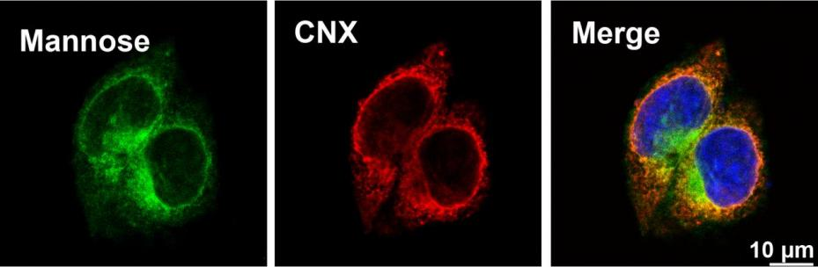

Fig. S1. CLSM images of mannose (green, marked by Con A–FITC) and ER (red, marked by anti–CNX) of HepG2 cells. Scale bar = 10 µm.

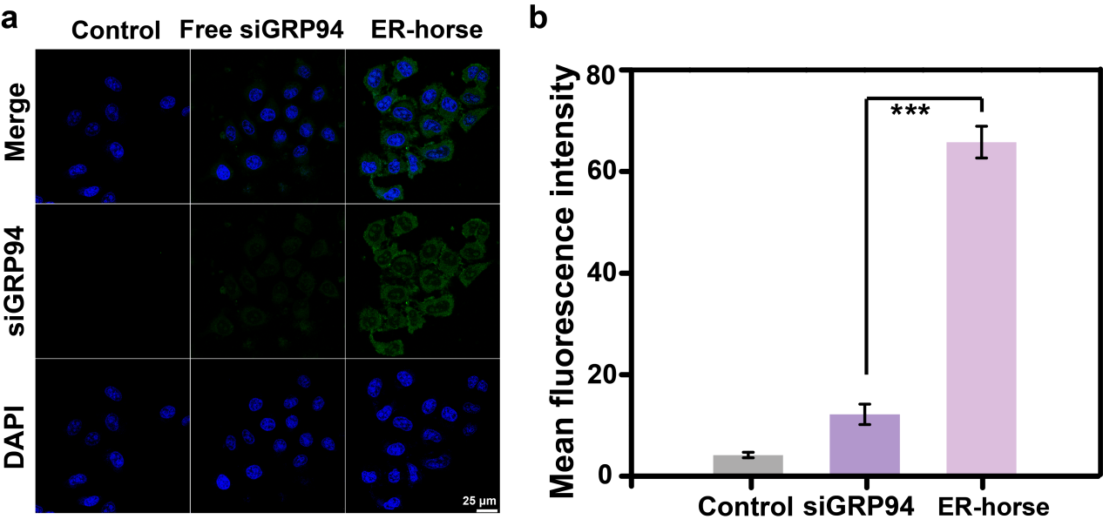
Fig. S2. Protective effect of ER–horse on siGRP94 (green, marked by FITC) in serum-containing medium. (a) Fluorescence intensity of siGRP94-FITC in HepG2 cells detected by CLSM after incubation with different treatments (PBS, siGRP94, ER–horse). (b) Quantitative comparison of the CLSM images.

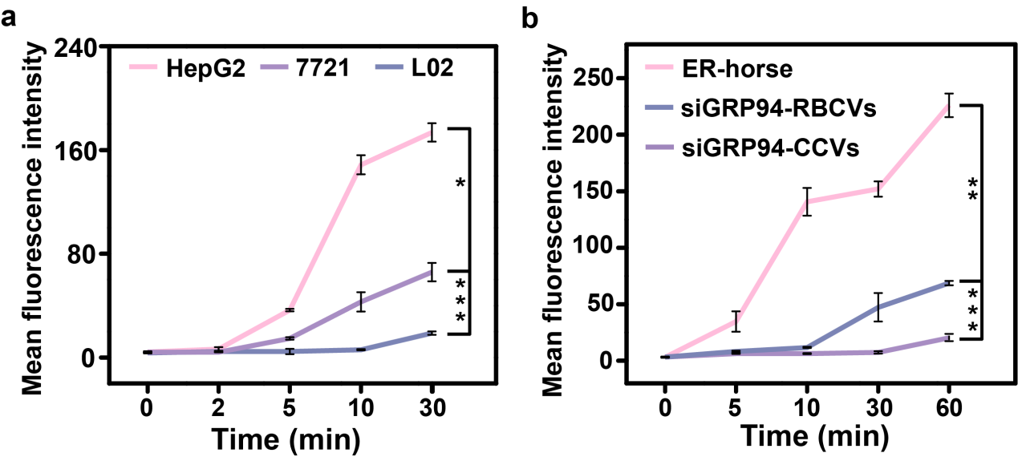
Fig. S3. Selectivity of ER-horse. (a) Quantitative comparison of the homologous targeting of ER–horse to different cells within 0–30 min. (b) Quantitative comparison of the homologous targeting of different vesicles with siGRP94 (ER–horse, siGRP94–RBCVs, and siGRP94–CCVs, marked by siRNA–FITC) to HepG2 cells within 0–60 min.

Fig. S4. Representative co-localization images of ERVs fused with the PM, ER, mitochondria and lysosomes at different times as detected by CLSM. The yellow area represents the co-localization of fluorescence-labeled organelles (red, marked by the corresponding tracker dyes) and FITC-ERVs (green, marked by Con A-FITC).

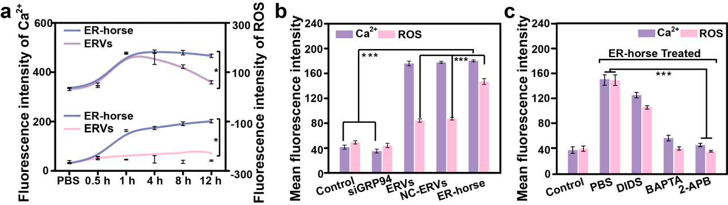
Fig. S5. (a) Quantitative comparison of intracellular Ca²⁺ concentrations (upper curves) and ROS production (lower curves) in HepG2 cells after incubation with ERVs and ER–horse for 0, 0.5, 1, 4, 8 and 12 h. (b) Quantitative comparison of intracellular Ca²⁺ concentration and ROS production in HepG2 cells after incubation with different treatments (PBS, free–siGRP94, ERVs, NC–ERVs, ER–horse). (c) Quantitative comparison of intracellular Ca²⁺ concentration and ROS production in HepG2 cells after incubation with ER–horse after pretreatment with different drugs (DIDS, BAPTA, 2–APB). The data are expressed as the mean ± SD (n = 3); a single asterisk indicates p < 0.05, double asterisks indicate p < 0.01, and triple asterisks indicate p < 0.001.

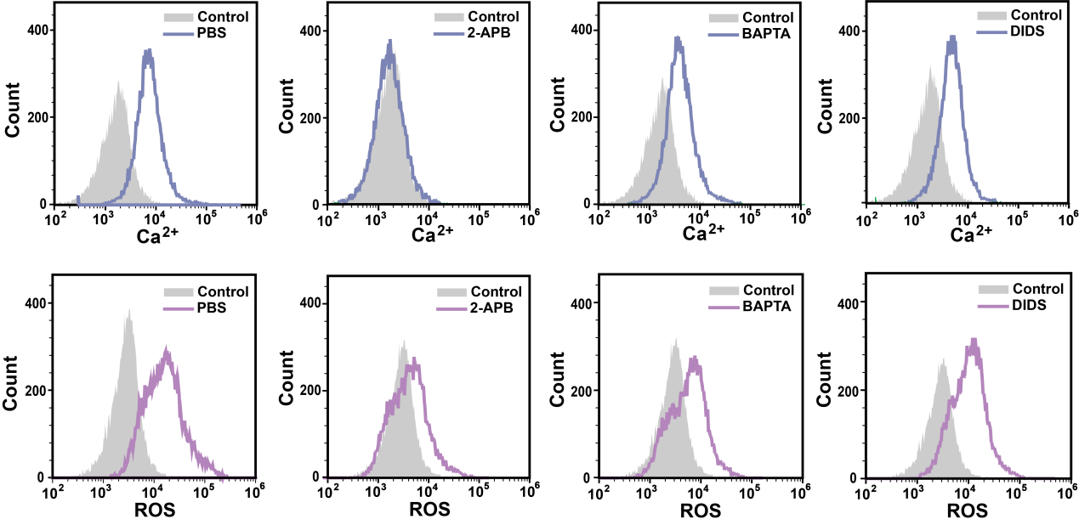
Fig. S6. Determination of the intracellular Ca²⁺ concentration (marked by Fluo-4 AM) and the production of ROS (marked by DHE) in HepG2 cells incubated with ER–horse (10 μM) for 1 h after pretreatment with different drugs (2-APB, BAPTA, DIDS) as monitored by flow cytometry.

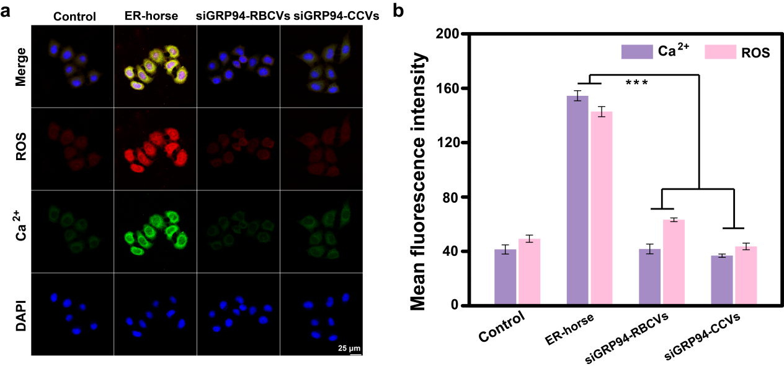
Fig. S7. Specificity of siGRP94 in different biocarriers. (a) Determination of the intracellular Ca²⁺ concentration and the production of ROS in HepG2 cells after incubation with siGRP94 ER–horse, siGRP94–RBCVs, siGRP94–CCVs) for 1 h as detected by CLSM. (b) Quantitative comparison of the above CLSM images.

Fig. S8. Selectivity of ER–horse in different cell lines. Determination of the intracellular Ca²⁺ concentration and the production of ROS in 7721 cells after incubation with ER–horse for 0, 1 h, and 12 h.

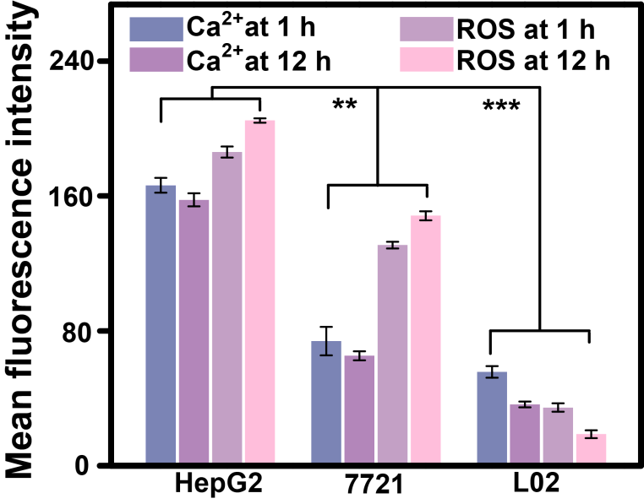
Fig. S9. Selectivity of ER–horse in inducing the influx of Ca²⁺ and the production of ROS. Quantitative comparison of the intracellular Ca²⁺ concentration and ROS production in HepG2 cells, 7721 cells and L02 cells after incubation with ER–horse for 1 h and 12 h. The data are expressed as the mean ± SD (n = 3); a single asterisk indicates p < 0.05, double asterisks indicate p < 0.01, and triple asterisks indicate p < 0.001.

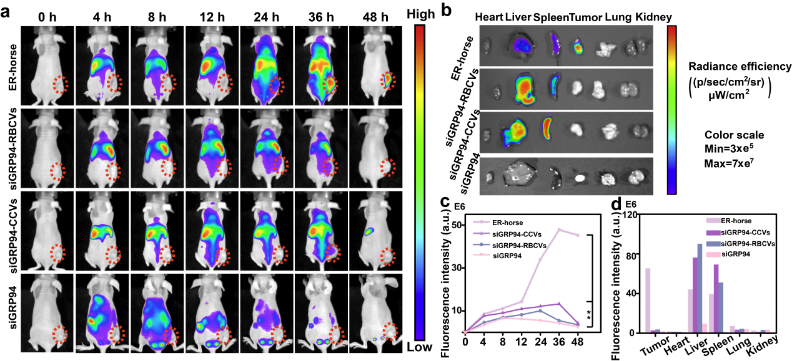
Fig. S10. Antitumor effect of ER–horse in vivo. (a) Time–lapse NIR fluorescence images of HepG2 tumor–bearing BALB/c mice in vivo. ER–horse exhibited an obvious tumor–targeting effect (the red circles indicate tumor sites). (b) Ex vivo NIR fluorescence images of the major organs (heart, liver, spleen, lungs, and kidneys) and tumors 48 h after the injection of ER–horse, siGRP94–RBCVs and siGRP94–CCVs and siGRP94. ER–horse demonstrated excellent tumor accumulation. (c) NIR fluorescence intensities around the tumors quantified at the indicated time points. The data are expressed as the mean ± SD (n = 3); a single asterisk indicates p < 0.05, and double asterisks indicate p < 0.01. (d) Semiquantitative biodistribution of ER–horse, siGRP94–RBCVs and siGRP94–CCVs and siGRP94. ER–horse in HepG2 tumor–bearing BALB/c mice as determined by the averaged fluorescence intensity in the organs and tumors.
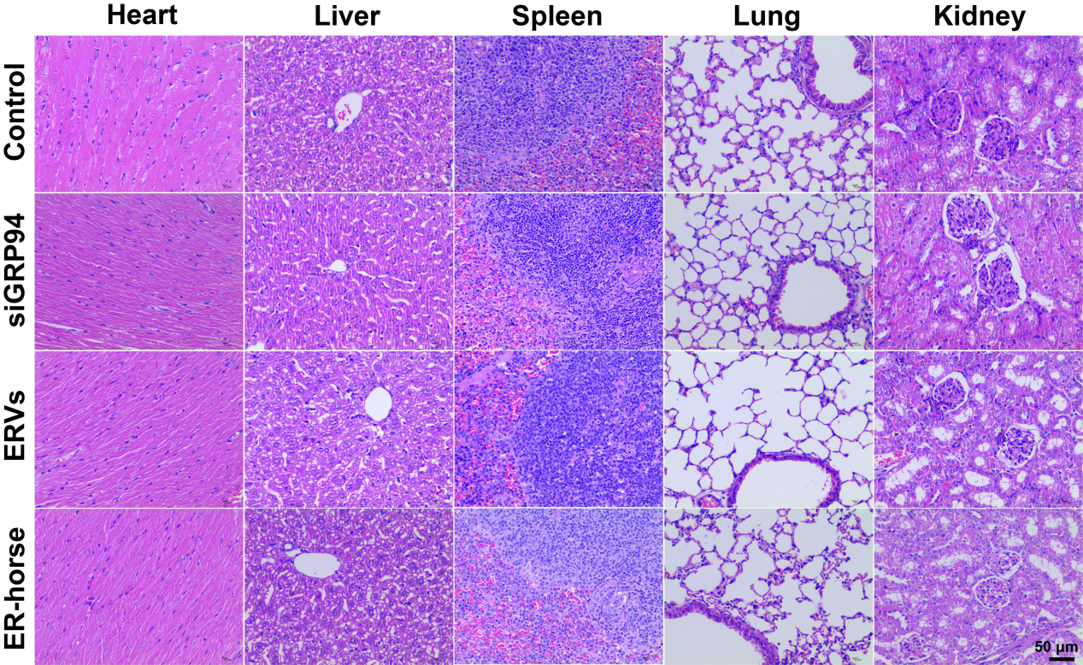

Fig. S11. Pharmacological evaluation of main organs. H&E-stained tissue sections of heart, liver, spleen, lung, and kidney tissues from untreated mice (top row) and from mice injected with ER–horse (bottom row). Scale bar = 50 μm.

