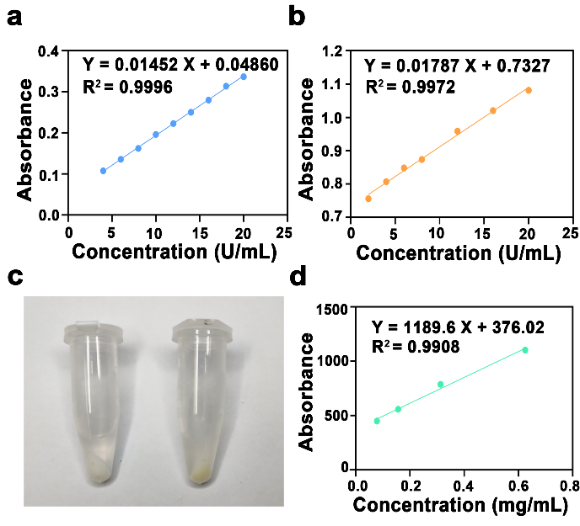
Fig. S1 Characterization of nanocomposites. a The standard curve of DC. b The standard curve of LOD. c Digital photos of HMOP-DC and DC-HMOP-LOD in dd H₂O. d The standard curve of DC-HMOP-LOD-FITC
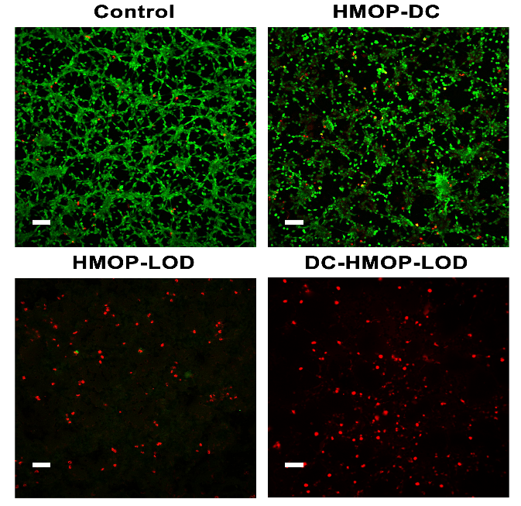
Fig. S2 The therapeutic effect of various nanocomposite treatments was detected by CLSM images (scale bar = 100 μm)
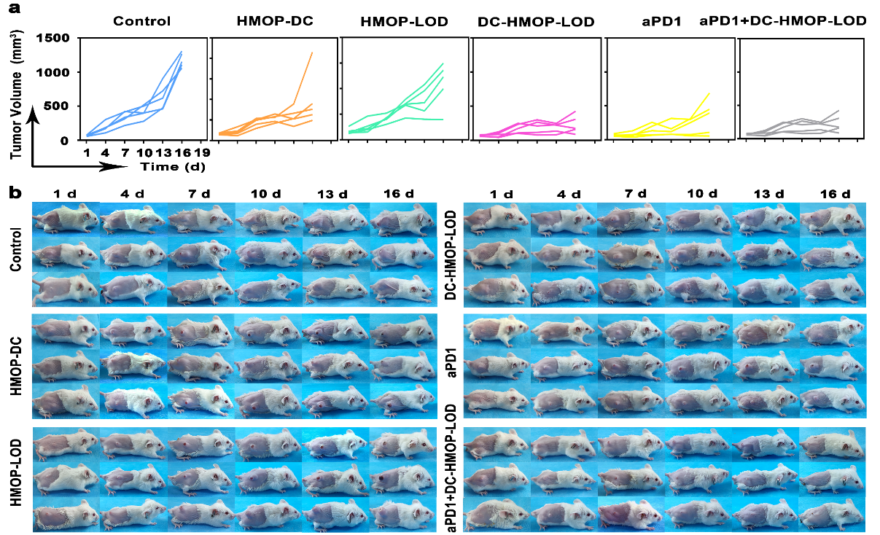
Fig. S3 Antitumor efficiency in vivo. a Tumor growth curves of mice with different nanocomposite treatments. b Images of CT26 tumor-bearing Balb/c mice

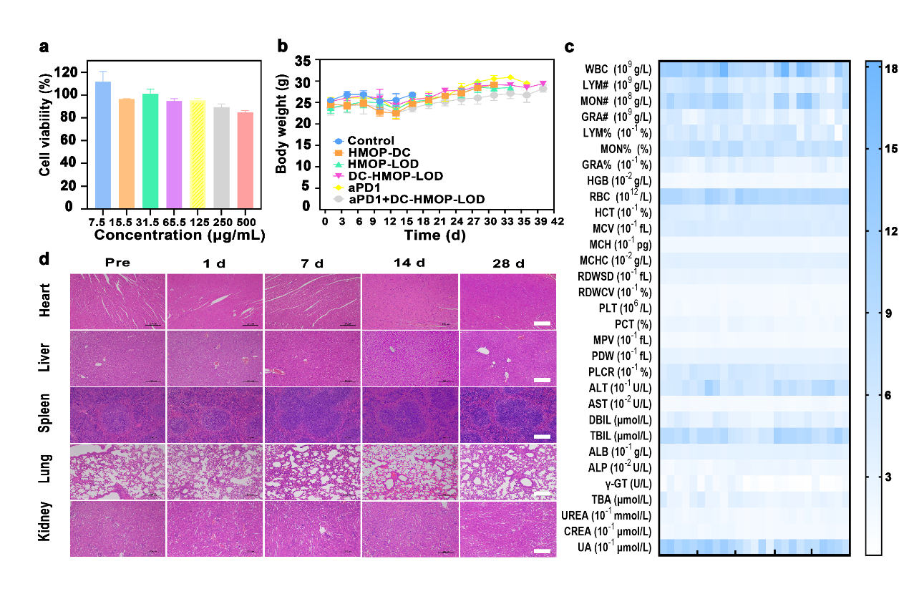
Fig. S4 Safety and pharmacokinetic study of DC-HMOP-LOD. a Viabilities of CT26 cells after 24 h of incubation with different concentrations of HMOP. b Time-dependent body weight curves of CT26-bearing mice in five groups after various nanocomposite treatments. c Hematological and blood biochemical tests of mice and (d) images of H&E-stained slices of major organs (heart, liver, spleen, lung, and kidney) after intravenous injection of DC-HMOP-LOD (scale bar = 200 μm)

