Supplemental Information:
GHG Emissions Affected by Agricultural Drainage Ditch Dredging and Vegetation Brushing

Andrew Schietzsch¹, Emilia Craiovan², Mark Sunohara², Oliver Blume³, Richard Amos³, Anne-Martine Doucet⁴, Ian Clark⁴, David R. Lapen², David Blowes¹, Carol Ptacek¹*

¹Dept. Earth and Environmental Sciences, University of Waterloo, 200 University Ave W, Waterloo, Canada, N2L 3G1
²Ottawa Research Development Centre, Agriculture and Agri-Food Canada, 960 Carling Ave., Ottawa, Canada, K1A 0C6
³Dept. Earth Sciences, Carleton University, 1125 Colonel By Dr., Ottawa, Canada, K1S 5B6
⁴Dept. Earth and Environmental Sciences, University of Ottawa, 75 Laurier Ave. E., Ottawa, Canada, K1N 6N5
*corresponding author
GHG data cleaning
GHG concentration time series data typically will form a linear trend. Occasionally one data point was quite divergent from the trend indicated by the other four data points in the time series. This could be due to a contaminated Exetainer vial that was not evacuated properly prior to sampling, poor fastening of a GHG chamber lid on the GHG collar, technician error when inserting the gas sample syringe into the Exetainer vial septa cap, or a leaking seal on the septa cap. Technician error can be significant due to the challenge of sampling with sharp syringe needles at specific time intervals while standing in a drainage ditch with sloped uneven and slippery terrain and flowing water. Another issue is that the first sample (0 min) can sometimes be off the trend of the other samples. The first sample is a measure of ambient GHG concentrations and sampled near the soil at the GHG collars before the GHG chamber lids were placed on top of the collars. The deviance from the other samples can be due to this sample being obtained in an ambient environment which may have effects from wind mixing or possibly the technician exhaling near the sample. To ensure slopes are real trends in GHG concentration, all time series trends were manually inspected with slope and R² calculation. If four out of five data points showed a strong trend but one data point was subjectively off the trend line, that a single data point was removed to clean the dataset (Supplementary Figure S3).

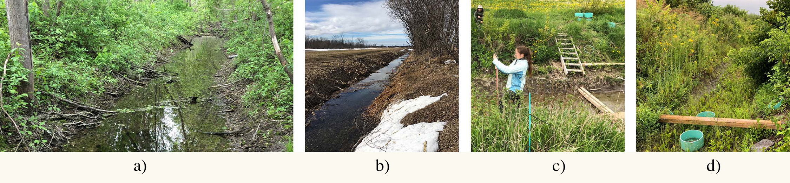
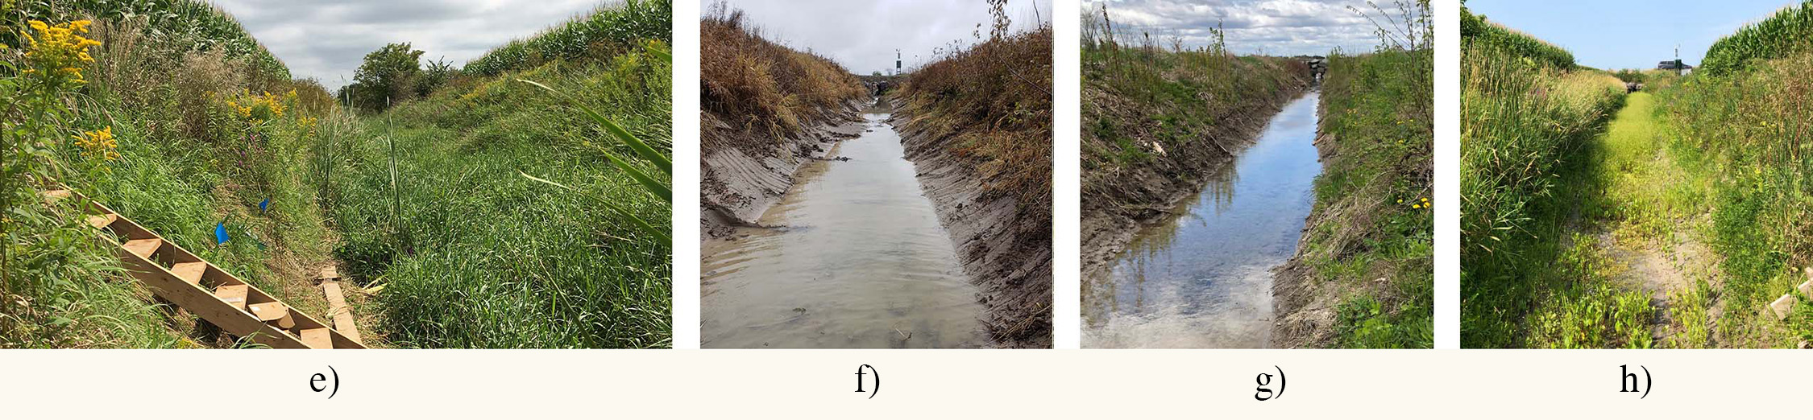
Supplementary Figure S1 Photographs of ditch and bank brush cutting and ditch dredging.
Top row: a) Control Tree May 2019, b) Brush cutting trees (February 2018), c) Brush Cut Tree (May 2019), d) Brush Cut Tree (Aug 2019).
Bottom row: e) Control Shrub (May 2019), f) ditch dredging (November 2018), g) Brush Cut Shrub (May 2019), h) Brush Cut Shrub (August 2019).
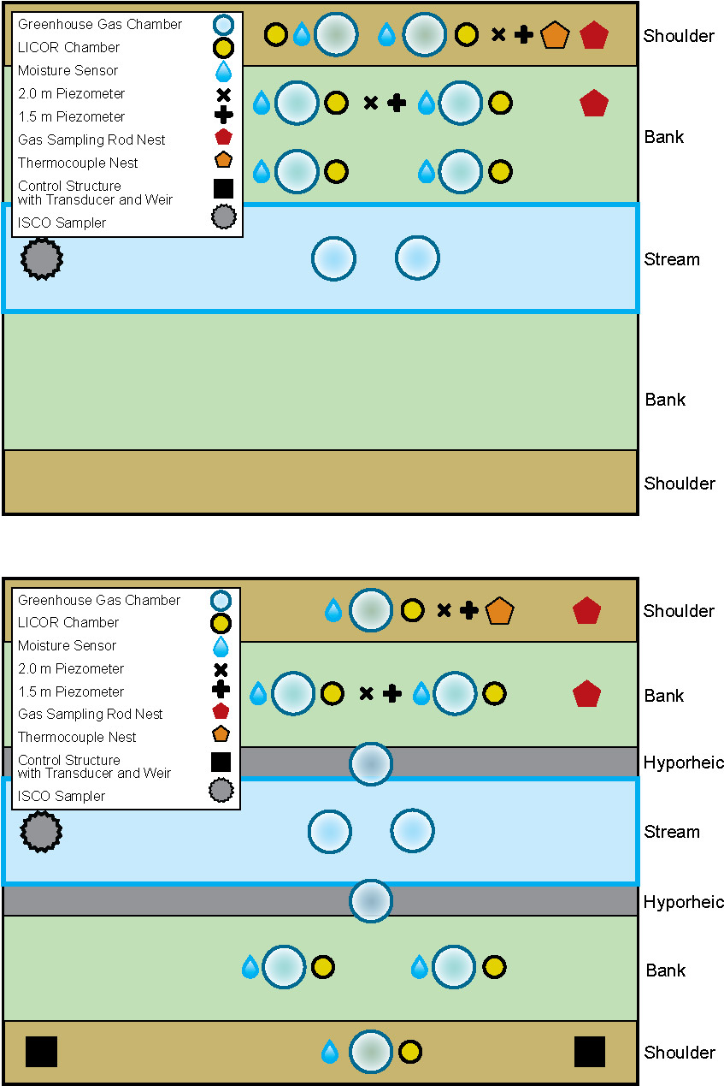
Supplementary Figure S2 Overhead view of microplot site showing layout of instrumentation. Deployed in 2018 above 2019 and 2020 on bottom. Instrumentation type in legend. Ditch zone on right.
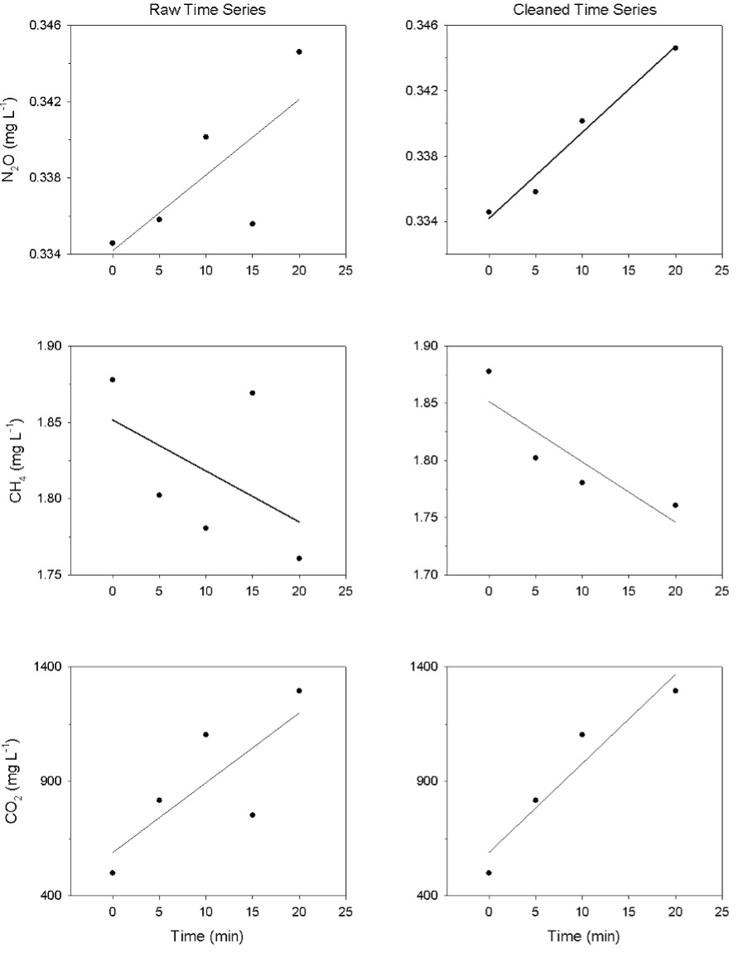
Supplementary Figure S3 Comparison of GHG concentration time series data before and after manual data cleaning. Data is for single GHG chamber location on southwest bank collected on July 9, 2019. Line is linear fit where slope is used in subsequent GHG chamber flux data. From top to bottom: N₂O, CH₄, CO₂. From left to right: raw data, manually cleaned data.
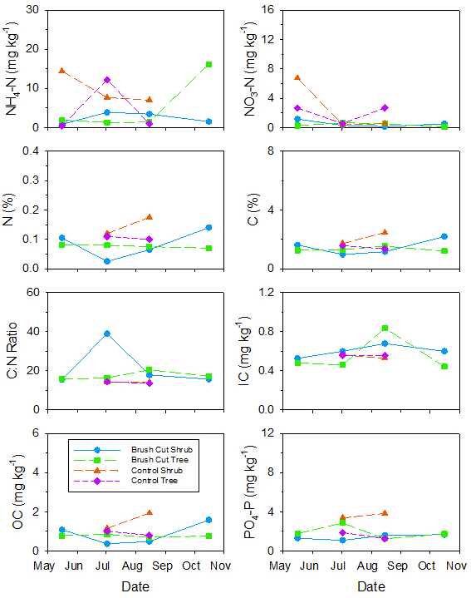
Supplementary Figure S4 Temporal changes in Hyporheic zone soil chemical composition for 2019 at 0-15 cm depth for Brush Cut Shrub •, Brush Cut Tree ■, Control Shrub ▲, Control Tree ♦. From top to bottom: NH₄-N, NO₃-N, N, C, C:N ratio, inorganic carbon, organic carbon, plant available phosphorus.
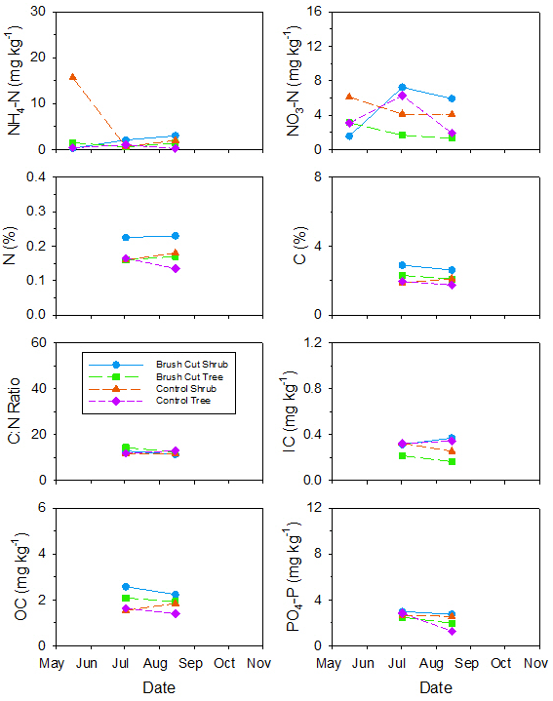
Supplementary Figure S5 Temporal changes in Bank zone soil chemical composition for 2019 at 0-15 cm depth for Brush Cut Shrub •, Brush Cut Tree ■, Control Shrub ▲, Control Tree ♦. From top to bottom: NH₄-N, NO₃-N, N, C, C:N ratio, inorganic carbon, organic carbon, plant available phosphorus.
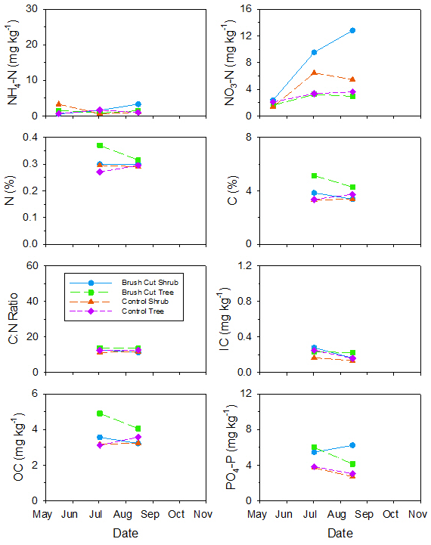
Supplementary Figure S6 Temporal changes in Shoulder zone soil chemical composition for 2019 at 0-15 cm depth for Brush Cut Shrub •, Brush Cut Tree ■, Control Shrub ▲, Control Tree ♦. From top to bottom: NH₄-N, NO₃-N, N, C, C:N ratio, inorganic carbon, organic carbon, plant available phosphorus.
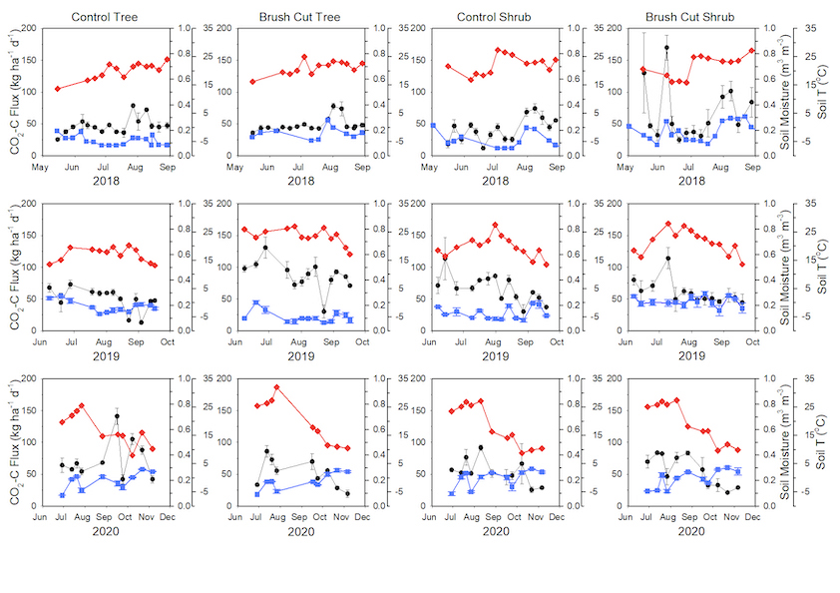 Supplementary Figure S7 CO₂ Flux •, Soil Moisture ■, and Soil T ♦ time series with calculated standard error bars from LI-COR measurements in agricultural drainage ditch Shoulder zone. From top to bottom 2018, 2019, and 2020 sampling seasons. From left to right Control Tree, Brush Cut Tree, Control Shrub, Brush Cut Shrub sites.
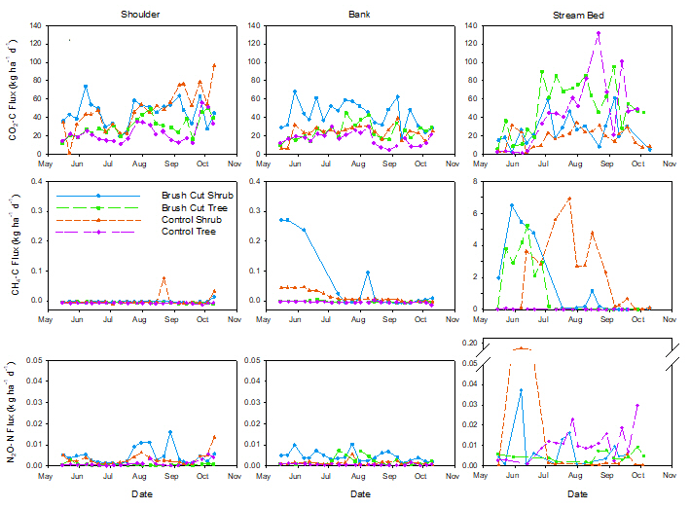
Supplementary Figure S8 Time Series of CO₂, CH₄, N₂O Fluxes from May until November 2018 for Brush Cut Shrub •, Brush Cut Tree ■, Control Shrub ▲, Control Tree ♦. Only flux with R²>0.8 included. Note different scale for CH₄ flux from Stream Bed. From top to bottom: CO₂-C, CH₄-C, N₂O-N fluxes. From left to right Shoulder, Bank, Instream zones. 2018 data used different chamber layout than 2019 and 2020. Bank includes Bank and Hyporheic zones.
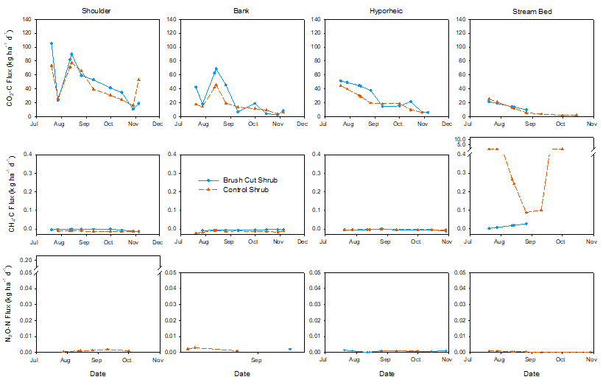
Supplementary Figure S9 Time Series of CO₂, CH₄, N₂O Fluxes from July until November 2020 for Brush Cut Shrub •, Brush Cut Tree ■, Control Shrub ▲, Control Tree ♦. Only flux with R² >0.8 included. From top to bottom: CO₂-C, CH₄-C, N₂O-N fluxes. From left to right Shoulder, Bank, Hyporheic, Instream zones.
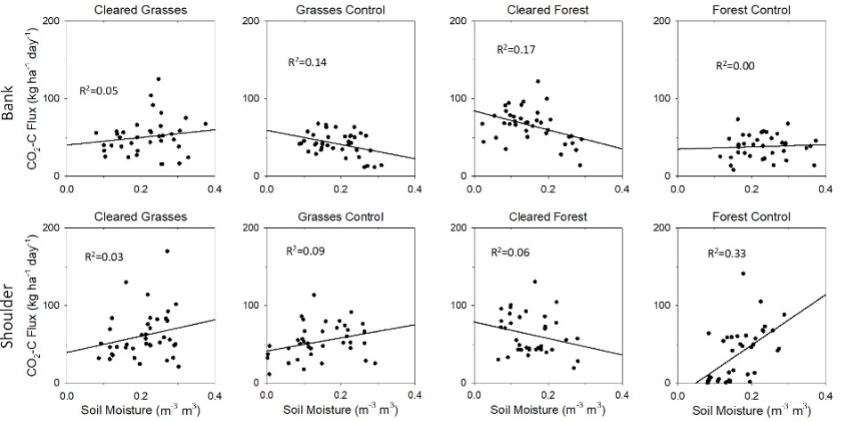
Supplementary Figure S10 LI-COR CO₂ flux versus soil moisture content with calculated R² correlation coefficients. Line is a linear regression to visually indicate correlation. Drainage ditch regions: top row Bank, bottom row Shoulder. Ditch sites from left to right: Brush Cut Shrub, Control Shrub, Brush Cut Tree, Control Tree.
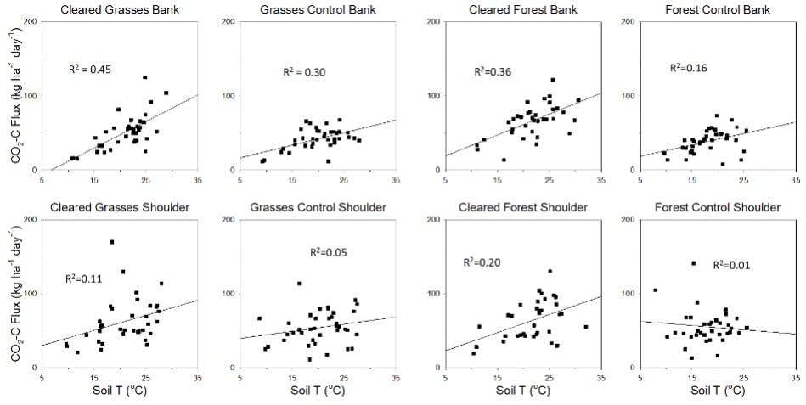
Supplementary Figure S11 LI-COR CO₂ flux versus soil T with calculated R² correlation coefficients. Line is a linear regression to visually indicate correlation. Drainage ditch regions: top row Bank, bottom row Shoulder. Ditch sites from left to right: Brush Cut Shrub, Control Shrub, Brush Cut Tree, Control Tree.
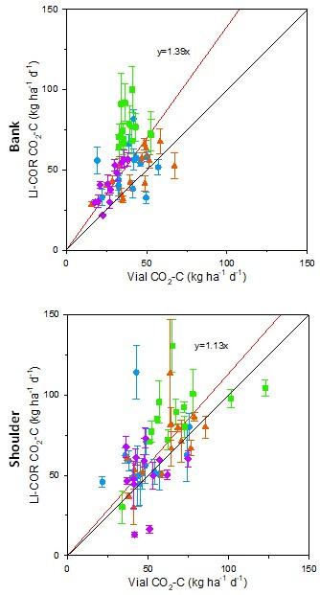
Supplementary Figure S12 LI-COR CO₂ flux with calculated standard error versus Vial method CO₂ flux during 2019 sampling season for Brush Cut Shrub •, Brush Cut Tree ■, Control Shrub ▲, Control Tree ♦. Black line represents theoretical LI-COR=Vial method. Red line represents linear fit with no intercept given by equation above it.
Supplementary Table S1 Multiple Linear Regressions LI-COR Data, CO₂ dependent variable, Soil Moisture and Soil T independent variables
 |  | Soil M |  | Soil T
Region Name | N | P Value | Significant | P Value | Significant
All sites bank and shoulder | 243 | 0.825 | No | <0.001 | Yes
Brush Cut Shrub Bank | 33 | 0.060 | No | <0.001 | Yes
Brush Cut Shrub Shoulder | 33 | 0.466 | No | 0.062 | No
Brush Cut Tree Bank | 28 | 0.690 | No | <0.001 | Yes
Brush Cut Tree Shoulder | 28 | 0.731 | No | 0.029 | Yes
Control Shrub Bank | 32 | 0.238 | No | 0.016 | Yes
Control Shrub Shoulder | 32 | 0.545 | No | 0.137 | No
Control Tree Bank | 28 | 0.114 | No | <0.001 | Yes
Control Tree Shoulder | 28 | 0.581 | No | 0.745 | No

Supplementary Table S2 Mean and standard error measurements over three years for parameters at different microplot sites
 | Brush Cut Shrub  (Site 1) |  | Brush Cut Tree  (Site 5) |  | Control Shrub  (Site 10) |  | Control Tree  (Site 11)
Data Set | Mean | SEM | Mean | SEM | Mean | SEM | Mean | SEM
LI-COR Bank CO₂ | 52 | 4 | 66 | 3 | 42 | 2 | 39 | 2
Bank Soil M | 0.23 | 0.01 | 0.15 | 0.01 | 0.19 | 0.01 | 0.23 | 0.01
Bank Soil T | 21 | 1 | 22 | 1 | 20 | 1 | 18 | 1
Vial Shoulder CO₂ | 47 | 3 | 45 | 4 | 52 | 3 | 33 | 3
Vial Bank CO2 | 38 | 2 | 31 | 2 | 29 | 2 | 22 | 2
Vial Hyporheic CO₂ | 19 | 4 | 8 | 2 | 24 | 5 | 8 | 2
Vial Instream CO₂ | 26 | 3 | 41 | 5 | 20 | 2 | 37 | 6

Supplementary Table S3 One way ANOVA analysis over three years for parameters
Data Set | N | Normality | P | Equal Variance | P | ANOVA significant  (Y/N) | P | Holm Sidak Paired T-Test Results
LI-COR Bank CO₂ | 41 | Failed | < 0.050 | Passed | 0.078 | Y | <0.001 | 5 significantly higher than 10, 11
Bank Soil M | 41 | Passed | 0.093 | Passed | 0.656 | Y | <0.001 | 5 significantly lower than 1, 11. 10 significantly lower than 11
Bank Soil T | 41 | Failed | <0.050 | Passed | 0.797 | Y | 0.005 | 11 significantly lower than 1, 5
Vial Shoulder CO₂ | 37 | Failed | <0.050 | Passed | 0.165 | Y | <0.001 | 11 significantly lower than 1, 10
Vial Bank CO₂ | 37 | Passed | 0.884 | Failed | <0.050 | Y | <0.001 | 11 significantly lower than 1, 5. 10 significantly lower than 1
Vial Hyporheic CO₂ | 22 | Passed | 0.577 | Failed | <0.050 | Y | 0.041 | 11 significantly lower than 10
Vial Instream CO₂ | 30 | Failed | <0.050 | Failed | <0.050 | Y | 0.002 | 10 significantly lower than 5, 11

