Table 1 ACCROS-I Study Schema

Activity | Treatment |  |  |  |  |  |  |  |  |  |  |  |  |  | Follow-up
Schedule (day) | 1 | 2 | 3 | 4 | 5 | 6 | 7 | 8 |  | 9 |  | 10 |  | 14 |  | 28
Study visits | 1 |  |  |  |  |  | 2 |  |  |  |  | 3 |  | 4 |  | 5
Contact Study Center | X
Randomization | X
Informed Consent | X
Inclusion & Exclusion Criteria | X
Demographic Data | X
Temperature Measurement | X |  |  |  |  |  | x |  |  |  |  | x |  | x
Urine Pregnancy test | X
Pulse Oximetry | X |  | x |  | x |  | x |  |  |  |  |  |  | x
Sampling nasopharyngeal swabs | X |  |  |  |  |  | x |  |  |  |  |  |  | x
Quantitative PCR measurement¹ | X |  |  |  |  |  | x |  |  |  |  |  |  | x
Laboratory Test² | X |  | x |  | x |  | x |  |  |  |  | x |  | x |  | x
Assessment of Subject Status³ | X | x | x | x | x | x | x |  |  |  |  |  |  | x |  | x
Safety assessment | X | x | x | x | x |  | x |  |  |  |  | x |  | x |  | x
Documentation of symptoms (Subject)⁴ |  |  |  |  |  |  |  |  |  |  |  |  |  |  | x |  | x
Study Drug Administration
Review Subject Compliance |  | x | x | x | x |  | x |  |  |  |  | x |  | x
Final Assessment |  |  |  |  |  |  |  |  |  |  |  |  |  | x |  | x

Table 2 Subject’s Characteristics ACCROS-I
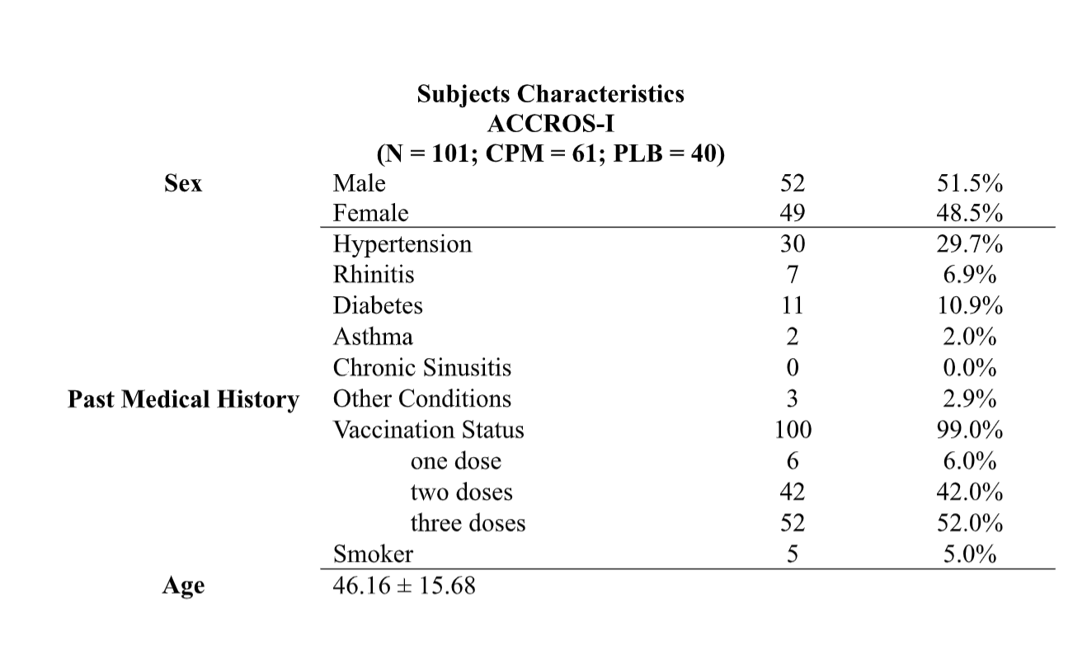

Table 3 COVID-19 associated symptoms as reported by patients on day1 and after 7 days of the treatment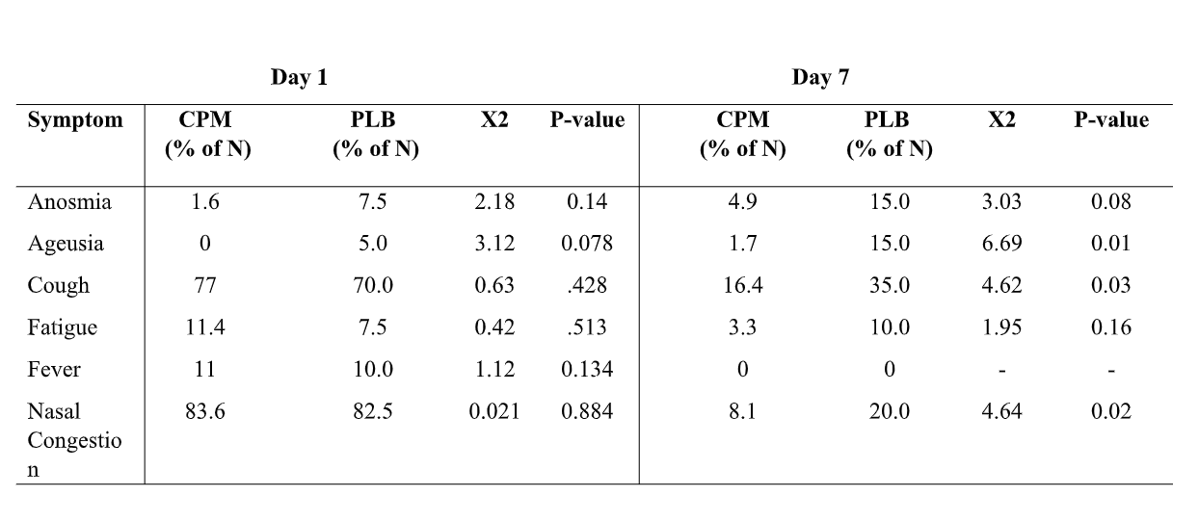
CPM: Chlopheniramine Maleate; Placebo: PLB.

Table 4 Subject’s Characteristics ACCROS-II
