Extended Data
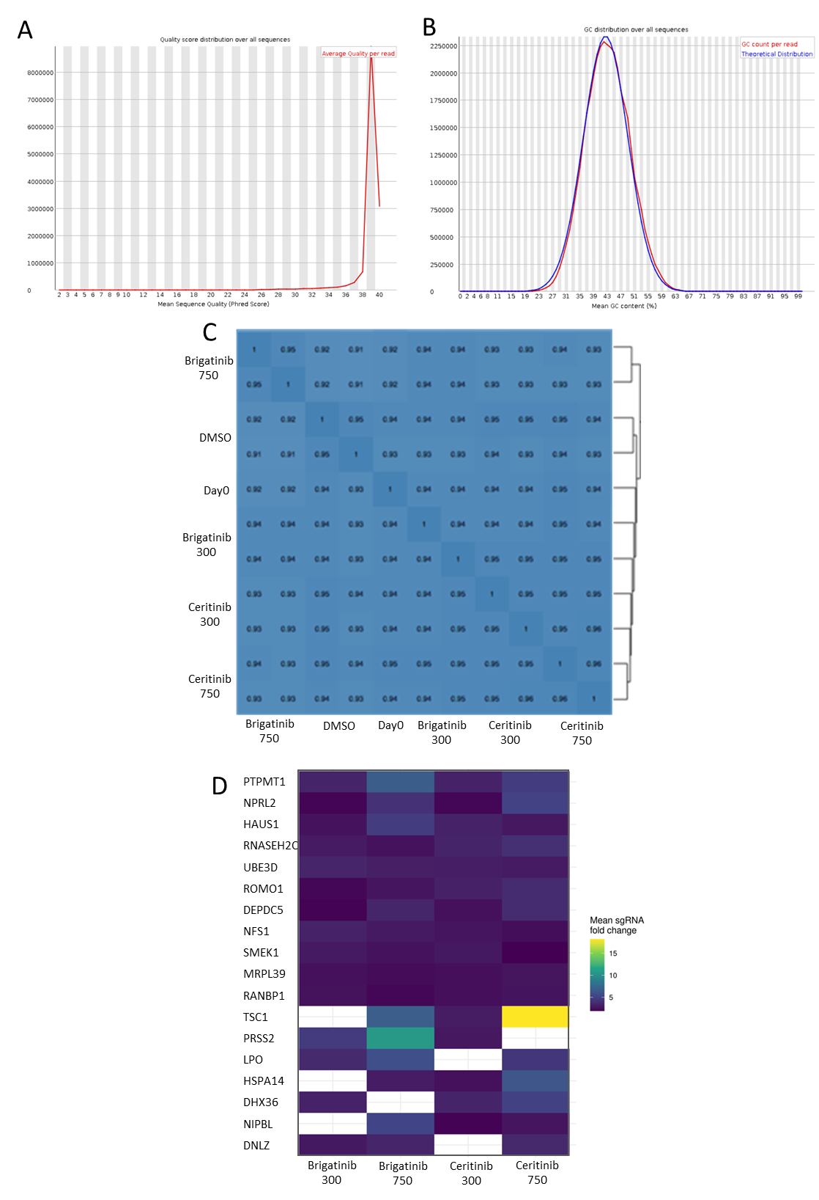
Extended Data Figure 1. Quality control and analysis of GECKO screen data
(A) The distribution of per-read ‘mean base quality’ for each sample (upper plot). All samples from the GeCKO screen overlap with a peak at ~38, which is well beyond the generally acceptable threshold value of 30. (B) The lower plot shows the distribution of the mean GC content of reads per sample. An acceptable mean should be ~40-50% and samples from the same screen should have a similar GC content; the GeCKO samples satisfy those criteria. (C) Pairwise Pearson correlation analysis of all samples from the GeCKO screen. The analysis was performed based on the log-transformed read counts of sgRNAs in each sample. (D) Heatmap of protein-coding gene hits identified in both brigatinib and ceritinib screens (at 300 nM and/or 750 nM of each drug). Coloured squares represent the mean values of fold changes (ALKI TKI versus DMSO treated) of the selected sgRNAs, from lower (blue) to higher (yellow) fold changes.

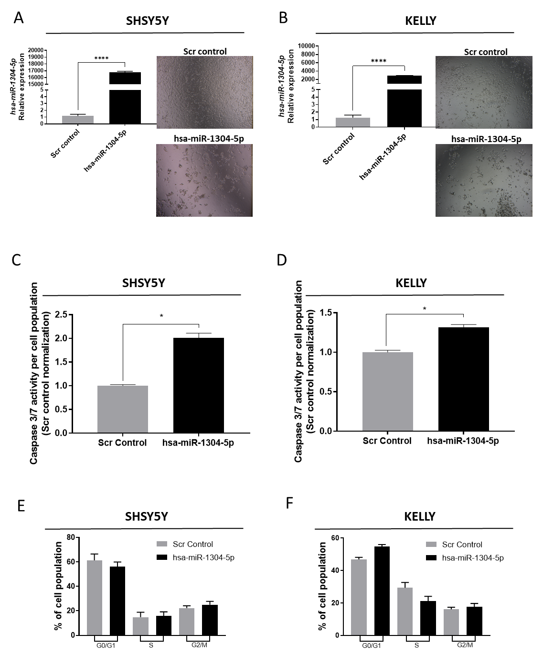
Extended Data Figure 2. miR-1304-5p inhibits NB cell viability inducing apoptosis but not affecting cell cycle progression
(A, B) Confirmation of miR-1304-5p upregulation by RT-qPCR upon transfection of the mimic (hsa-miR-1304-5p) relative to the mimic-scrambled control (Scr control) with image inserts showing their effects on cell confluency for the indicated cell lines. (C, D) Caspase 3/7 activity was measured by luminescence normalized for the Scr control transfected cells in the indicated cell lines 72 h post-transfection. (E, F) Cell cycle analysis 72 h post-transfection of the indicated cell lines, shown as the percentage of cells in each phase of the cell cycle. Data shown represent the means ± SEM of three independent experiments. Statistical comparison was conducted using a one-way Anova with Tukey`s post-test in E and F and a Student`s t-test in A-D. *p<0.05.

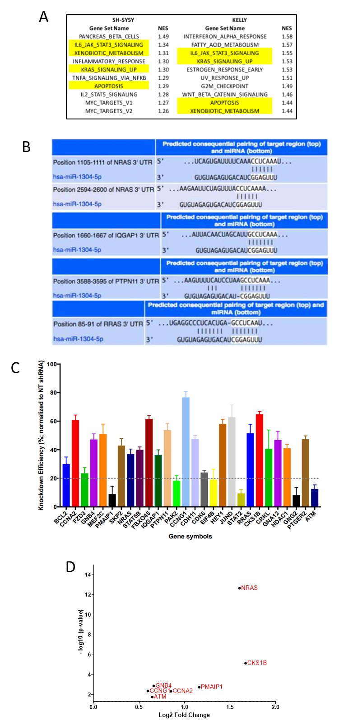
Extended Data Figure 3. Identification and validation of miR-1304-5p target genes
(A) The top-10 MSigDB’s hallmark enriched gene sets altered following miR-1304-5p transfection, detected by genome-wide expression microarray (HT-12 v4), ranked by normalized enrichment score (NES) index for KELLY and SH-SY5Y cell lines, with common pathways highlighted in yellow. (B) TargetScan-predicted binding sites of miR-1304-5p to NRAS, RRAS, PTPN11 and IQGAP1 mRNAs. (C) RT-qPCR validation of the 28 target genes associated with cancer pathways predicted to be dysregulated by miR-1304-5p from expression microarray results and predicted to be direct targets of miR-1304-5p by TargetScan 7.1. Gene expression is represented as the knockdown efficiency compared to a scrambled negative control (Scr control). The dotted line reflects the 20% knockdown level threshold applied. (D) Microarray expression of the 28 genes identified as potential targets of miR-1304-5p in ceritinib resistant (n=2) versus sensitive (n=2) orthotopic NB xenograft models ³⁴. Hits shown have a fold change> 1 (log₂=0) and p<0.05 (-log₁₀=1.3).

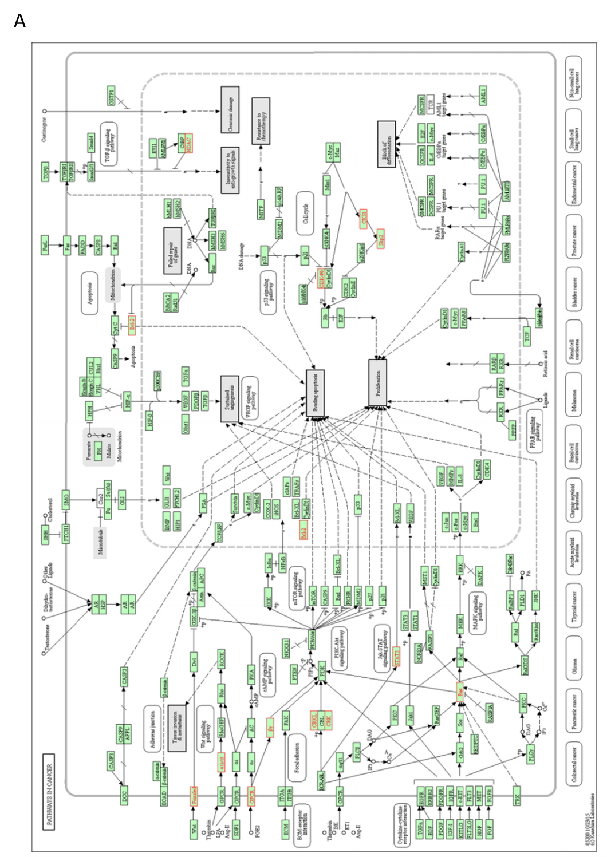

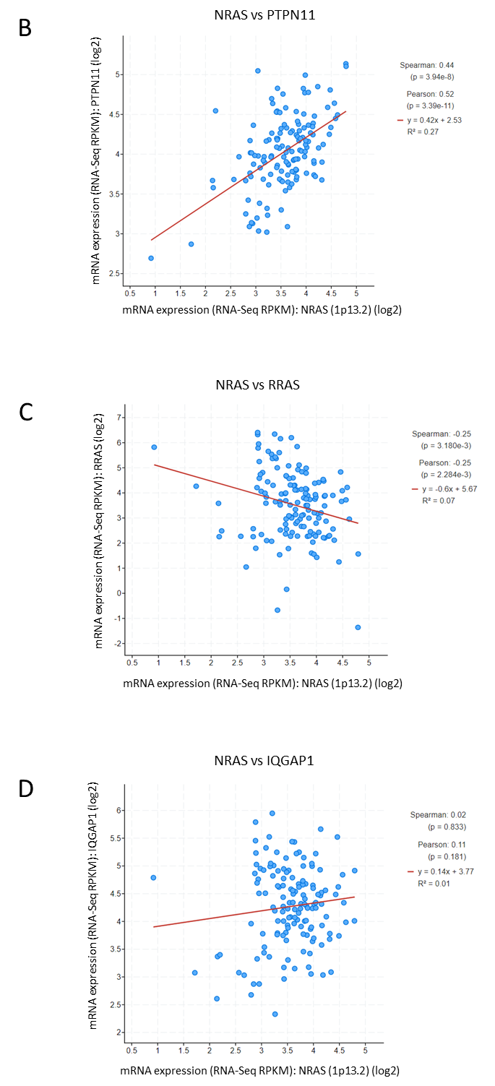
Extended Data Figure 4. KEGG pathway analysis and correlation of expression of the top miR-1304-5p target genes in clinical samples
(A) KEGG pathways associated with cancer as determined by the 276 genes selected from microarray and binding prediction analyses. (B-D) Correlation of bulk RNA sequencing expression levels of NRAS with PTPN11, RRAS or IQGAP1 in 143 NB patient tumours ³³, shown as a log₂ scale.

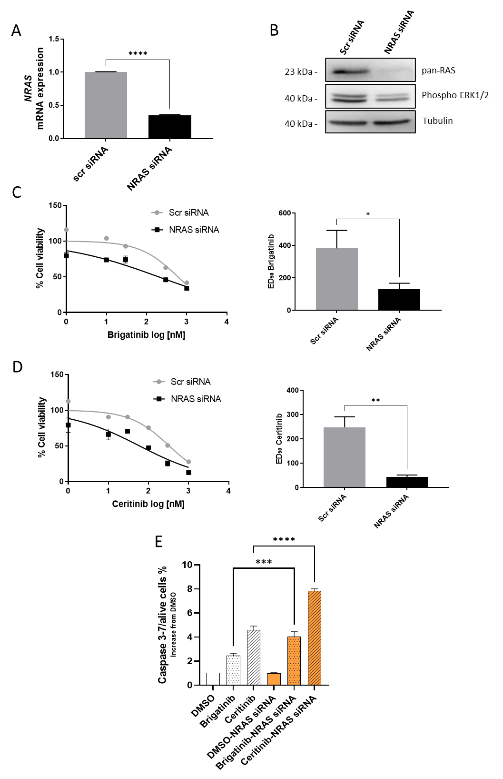

Extended Data Figure 5. NRAS knockdown increases NB sensitivity to ALK TKIs.
(A) Transcript levels of NRAS following siRNA-mediated knockdown in SHSY-5Y cells detected by RT-qPCR relative to the siRNA-scrambled control (Scr siRNA). (B) Western blot of the indicated proteins in SHSY5Y cells upon NRAS knockdown. (C-D) SH-SY5Y cell viability (measured via CTG) and ED₅₀ on a combination of NRAS siRNA transfection and brigatinib (C) or ceritinib (D) treatment for 72 h at the indicated doses. ED₅₀ values shown in the graphs on the right were calculated from the non-linear fit curves shown on the left. Data shown are representative of three independent experiments. Statistical comparisons were conducted with a two-way ANOVA with Sidak`s post-test and Student`s t-test of means ± SEM. *p<0.05, **p<0.01. (E) Apoptosis determined by caspase 3/7 activity in SH-SY5Y cells treated with a combination of a NRAS siRNA and brigatinib (1000nM) or ceritinib (1000nM). Results shown are representative of three independent experiments. Significance was determined using a one-way ANOVA with Tukey`s post-test of the means ± SEM. ***p<0.001, ****p<0.0001.

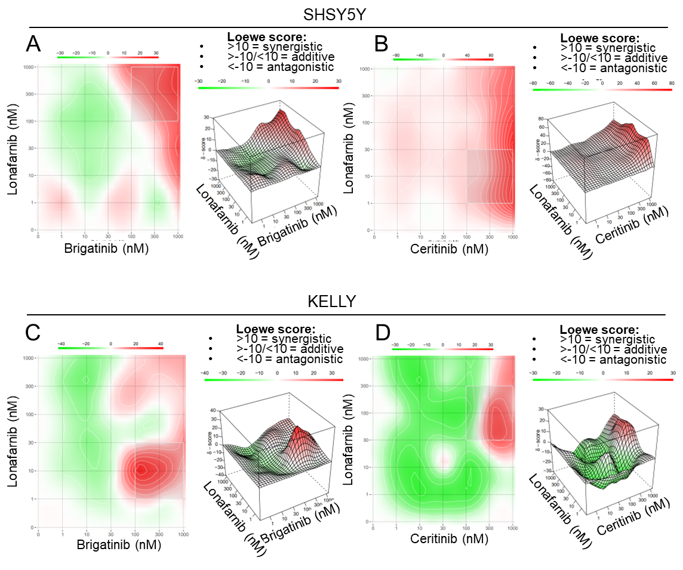
Extended Data Figure 6. Two-dimensional and three-dimensional representation of ALK TKI and lonafarnib synergism NB cells
Loewe synergy scores calculated with the Synergy Finder tool ⁸⁴ for SH-SY5Y cells treated with a combination of lonafarnib and brigatinib (A) or lonafarnib and ceritinib (B) and for KELLY cells treated with lonafarnib and brigatinib (C) or lonafarnib and ceritinib (D). Data are shown as both 2D and 3D models and are represented as color gradients from antagonistic (darker green, loewe score <-10) to synergistic (darker red, loewe score >10). Synergy scores >- 10 and <10 are considered additive.

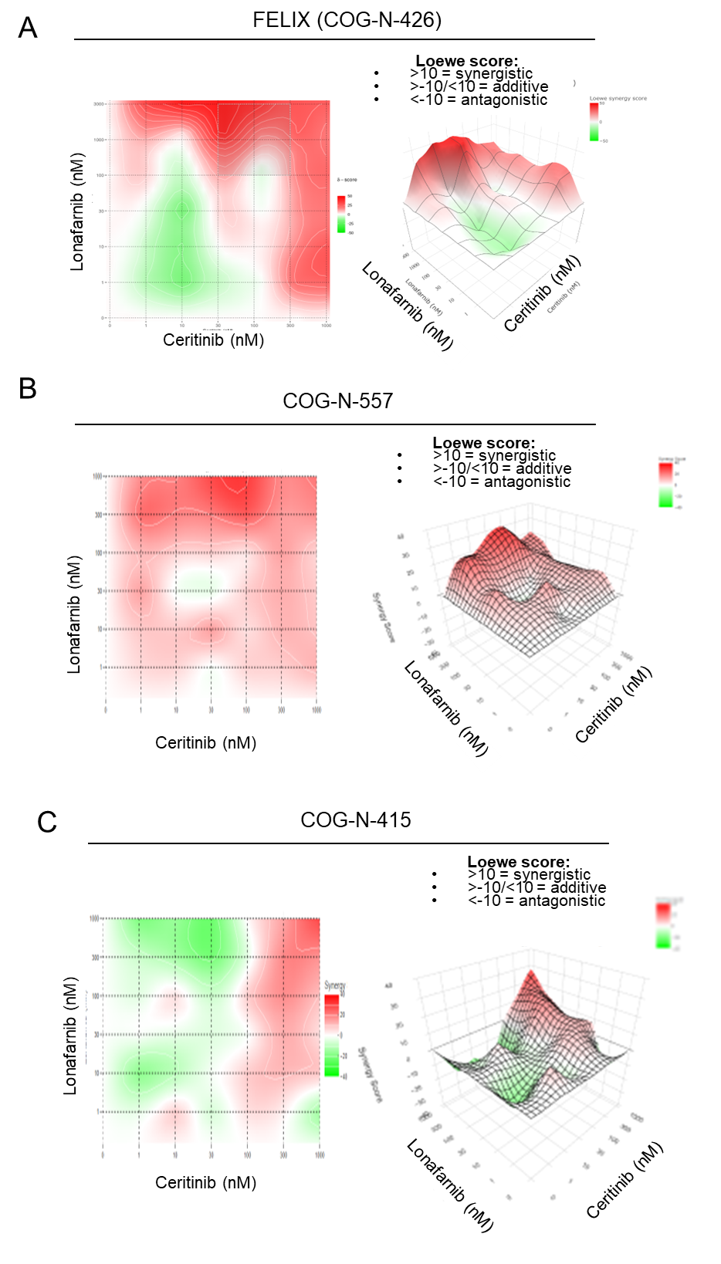
Extended Data Figure 7 Two-dimensional and three-dimensional representation of ALK TKI and lonafarnib synergism in NB PDX cells
Loewe synergy scores calculated with the Synergy Finder tool ⁸⁴ for FELIX (COG-N-426) (A), COG-N-557 (B) and for COG-N-415 (C) cells treated with lonafarnib and ceritinib for 72 h. Data are shown as both 2D and 3D models and are represented as color gradients from antagonistic (darker green, loewe score <-10) to synergistic (darker red, loewe score >10). Synergy scores >- 10 and <10 are considered additive.

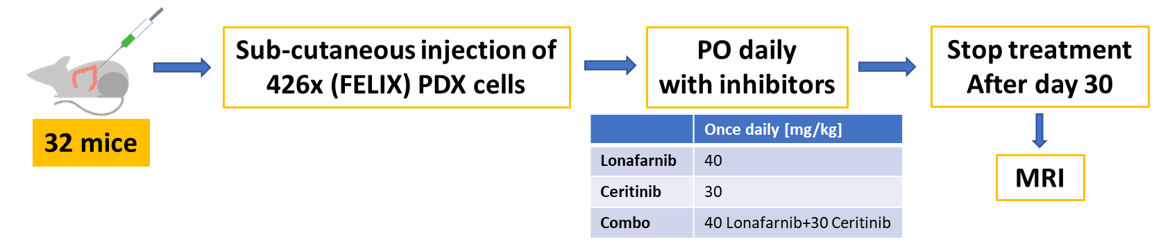
Extended Data Figure 8. Flowchart of the in vivo study
Flowchart of the in vivo study of ceritinib and lonafarnib treatment of FELIX (COG-N-426x) PDX models. PO = oral gavage administration. MRI = magnetic resonance imaging.

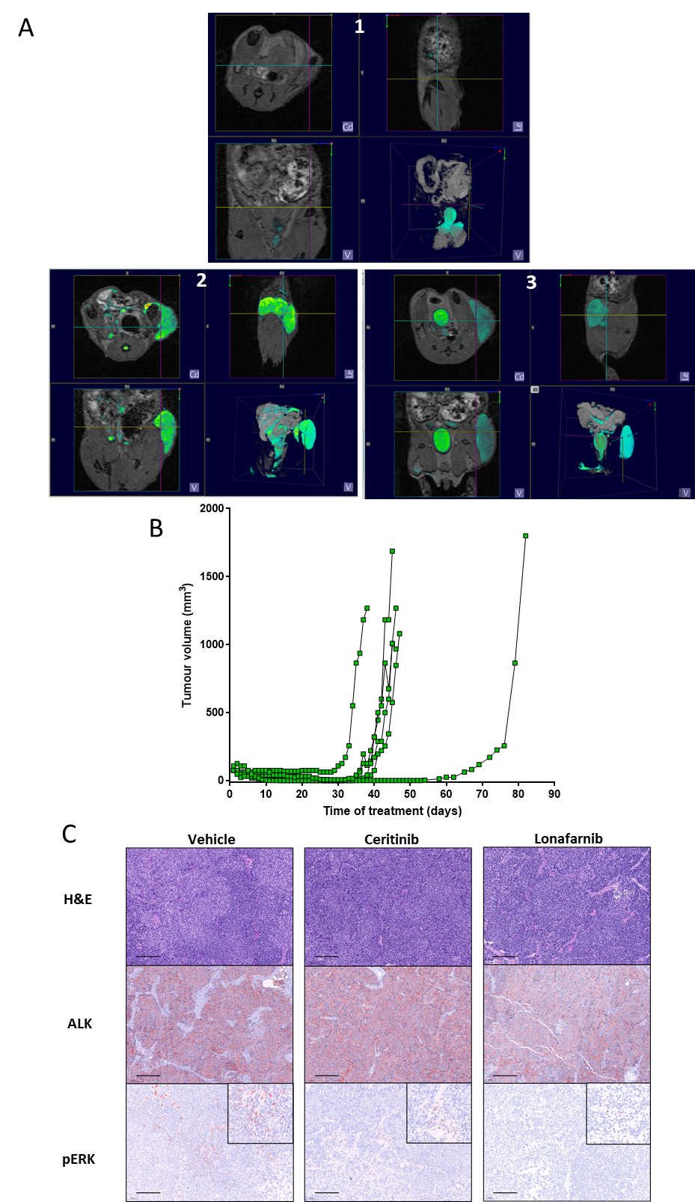
Extended Data Figure 9. Combining the ALK inhibitor (ceritinib) with the farnesyltransferase inhibitor (lonafarnib) significantly reduces tumour growth in vivo and lonafarnib effectively inhibits ALK and pERK expression
(A) MRI scan from axial (top-left) coronal (bottom-left) sagittal (top-right) and 3D (bottom-right) sections of animals treated with a combination of lonafarnib and ceritinib at the end of treatment (day 30) (1) compared to relapses after 9 (2) and 10 (3) days following the end of treatment (days 30+9 and 30+10 respectively). The green shading identifies bladder, testes (mouse 1 is male), vasculature and tumours. (B) Tumour volume over time of NSG mice injected sub-cutaneously with COG-N-426x primary NB cells which reached 75mm³ before daily administration of ceritinib and lonafarnib (combo), where the new study endpoint is defined as the time taken for tumours to reach 15 mm diameter. Each data point represents one animal. (C) Immunohistochemistry of H&E, ALK and pERK protein of vehicle (20% hydroxypropyl beta cyclodextrin), ceritinib (30 mg/kg) and lonafarnib (40 mg/kg) treated COG-N-426 (FELIX) PDX tumours at the study endpoint (day 30). Magnification bar = 100µm, inserts = 200x magnification.

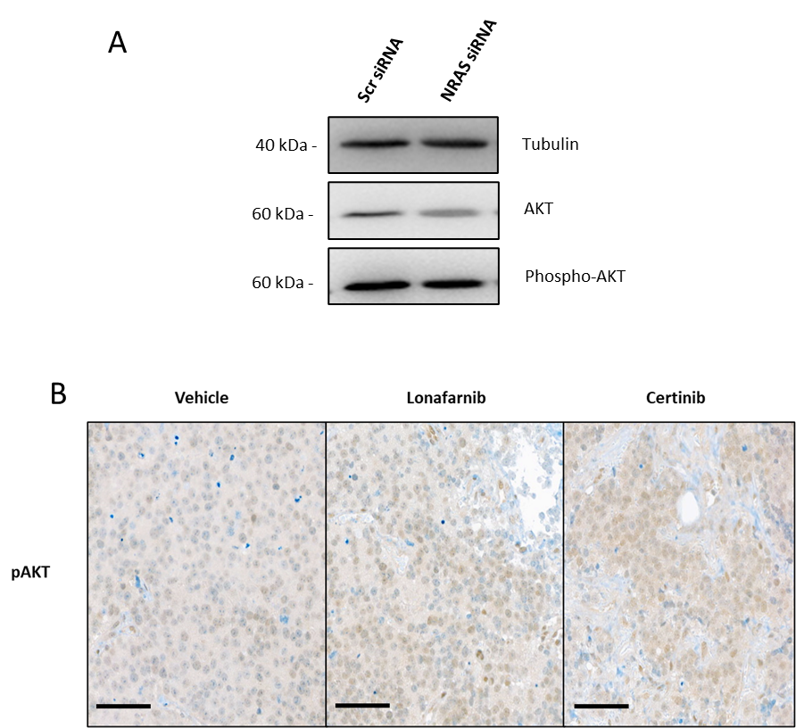
Extended Data Figure 10. NRAS targeting via knockdown of pharmacological inhibition does not affect pAKT expression.
(A) Western blot of the indicated proteins in SHSY5Y cells upon NRAS knockdown. (B) Immunohistochemistry of H&E, ALK and pAKT protein of vehicle (20% hydroxypropyl beta cyclodextrin), ceritinib (30 mg/kg) and lonafarnib (40 mg/kg) treated COG-N-426 (FELIX) PDX tumours at the study endpoint (day 30). Magnification bar = 50µm, inserts = 200x magnification.
Cell line | Source | ALK |  | MYCN  copy number | p53
Cell line | Source | Nucleotide substitution | Amino acid change | MYCN  copy number | p53
CHLA-15 | COG | 3824G>A | 1275R>Q | Non-amplified | Functional
CHLA-20 | COG | 3824G>A | 1275R>Q | Non-amplified | Functional
CHLA-90 | COG | 3733T>G (het) | 1245F>V | Non-amplified | Non-functional
CHLA-95 | COG | 3375C>A (het; syn);  3824G>A (het) | 1275R>Q | Amplified | Unknown
CHLA-171 | COG | 3375C>A (het; syn) |  | Non-amplified | Non-functional
CHP-134 | ECACC |  |  | Amplified | Functional
GIMEN | DSMZ |  |  | Non-amplified | Functional
KELLY | ECACC | 3522C>A | 1174F>L | Amplified | Non-functional
LAN-1 | ECACC | 3375C>A (het; syn);  3522C>A | 1174F>L | Amplified | Non-functional
LAN-6 | COG |  |  | Non-amplified | Functional
NB1643 | COG | 3824G>A | 1275R>Q | Amplified | Functional
NBEBC1 | COG | 3375C>A (het; syn) |  | Amplified | Unknown
NBL-S | DSMZ |  |  | Non-amplified | Functional
NGP | DSMZ |  |  | Amplified | Functional
SH-SY5Y | ECACC | 3522C:A (het) | 1174F>L | Non-amplified | Functional
SK-N-FI | COG | 3375C>A (het; syn);  3408C>T (het; syn) |  | Non-amplified | Non-functional
SMS-LHN | COG | 3375C>A (het; syn) |  | Non-amplified | Functional
Extended Data Table 1: Attributes of the NB cell line panel

Sequence ID | Cat N#
hsa-miR-136-5p inhibitor | IH-300629-05-0002
hsa-miR-1304-5p inhibitor | IH-301363-01-0002
hsa-miR-7975 inhibitor | IH-302860-01-0002
hsa-miR-4746-5p inhibitor | IH-302338-01-0002
Negative control 1 inhibitor | IN-001005-01-05
hsa-miR-1304-5p mimics | C-301363-00-0002
Negative control 1 mimics | CN-001000-01-05
Extended Data Table 2: miR INH-mimic sequences

Extended Data methods
CRISPR GeCKO
A CRISPR KO screen was conducted by exposing SH-SY5Y Cas9-expressing NB cells transduced with the GeCKO library to the ED₅₀ or ED₇₅ concentrations of brigatinib or ceritinib for 14 days (Fig. 1A) ⁵. Control analyses were performed with MaGECK-VISPR to ensure that the screens were adequately executed to allow for the acquisition of interpretable data. Quality control (QC) analysis of all raw fastq files derived from the screen samples were conducted at the sequence, read count and sample levels. The sequence level QC was designed to identify potential technical issues associated with the sequencing process itself and was conducted with the FastQC script (Babraham Bioinformatics) that was embedded in MaGECK-VISPR. Sequence level analysis of GeCKO screen samples satisfied the general QC guidelines (Fig. 1B). Sample level QC was conducted to analyze the level of consistency between samples. Sample level QC determined the distributions of normalized sgRNA read counts, represented by a box plot and a cumulative distribution function (CDF) plot. It also involved plotting the samples on the first 3 components of a principle component analysis (PCA) (Fig. 1C). The PCA plots matched brigatinib and ceritinib treated samples, potentially suggesting that these ALK TKI may induce similar resistance mechanisms. In addition, pairwise Pearson correlation analysis was performed using log-transformed sgRNA read counts of every sample in the GeCKO screen. The pairwise correlation analysis also matched samples from the brigatinib and ceritinib treated samples with values very close to 1 (Fig. 1 D). MaGECK, a turn-key bioinformatics script designed specifically for CRISPR screens, was used as a maximum likelihood estimation approach ⁸⁵. More specifically, MaGECK-MLE does not rely on a rank-based analysis, allowing for more accurate and detailed comparisons of gene selections. This allows MaGECK-MLE to establish more refined clusters of genes that could not be revealed by previous methods.

Amplification of the GeCKO CRISPR screen library
The CRISPR screen library was a gift from Dr. Feng Zhang (MIT): Human CRISPR Knockout Pooled Library (GeCKO v2) (#1000000049; Addgene) ²⁷. Each library (100ng at a concentration of 50 ng/ul) was transformed into ElectroMAX Stbl4 Competent Cells (ThermoFisher) via electroporation with the Gene Pulser II Electroporation System (BioRad) according to the manufacturer’s protocol, with 4 replicate reactions. Cells were recovered in SOC media (NEB) and cultured for 1.5 h at 32°C before plating onto ampicillin Lysogeny broth (LB) agarose bioassay dishes (Nunc), which were incubated overnight at 32°C. The bacterial colonies were then harvested and the CRISPR plasmid libraries were isolated using an EndoFree Plasmid Maxi Kit (Qiagen).

Preparation of HiSeq libraries
Frozen cell pellets were lysed and their gDNA was extracted using a QIAamp DNA Blood Maxi Kit as per the manufacturer’s instructions (Qiagen, Cat#51194). PCR was conducted on the gDNA samples to amplify the sgRNA guide sequence region and to append the Illumina (HiSeq) compatible adapters and barcodes. A two-step PCR was performed: First, the amount of input gDNA for each sample was calculated in order to achieve 500X library coverage, which was calculated to be approximately 220 µg DNA per replicate. For each replicate sample, 22 separate 100 µl PCR reactions with 10 µg of input genomic DNA in each reaction with Herculase II Fusion DNA Polymerase (Agilent, Cat#600677) were completed in an ABI Veriti Thermal Cycler (Applied Biosystems). The resulting amplicons from the first PCRs were then pooled together and mixed thoroughly to be used as the template for the second PCR reaction. Oligonucleotides (Sigma-Aldrich) used for the first PCR were:
Genomic PCR Forward 5’- AATGGACTATCATATGCTTACCGTAACTTGAAAGTATTTCG -3’
Genomic PCR Reverse - 5’CTTTAGTTTGTATGTCTGTTGCTATTATGTCTACTATTCTTTCC – 3’.
The second PCR was designed to attach standard Illumina adaptors and unique barcodes to the amplicons from the first PCR to allow for HiSeq reactions and demultiplexing of the reads, respectively. The second PCR was conducted on 5 µl of the first PCR amplicon as the template, in 100 µl reactions with a total of 22 reactions. Primers for the second PCR (Table S2) were synthesized as IDT DNA Ultramer Oligonucleotides (Integrated DNA Technologies) and also included a staggered region with variable lengths of sequence to enhance the library complexity.

NGS gene enrichment analysis
NGS analysis was performed as described previously study ⁵.

Gene set enrichment analysis (GSEA)
GSEA was performed as described previously ⁵.

Synergy experiments
For dose–response matrices, cells were treated with log-scale concentrations of ALK TKIs as described above in addition to log-scale concentrations of lonafarnib, as indicated in 7x7 grids and the DMSO concentration was maintained at 0.02%. Potential synergy between ALK TKIs and lonafarnib was evaluated by calculating the synergy score based on the Loewe model ⁸⁶ using synergy finder ⁸⁴. The synergy score is calculated for each combination of drug concentrations and also as an overall value, and is defined as:
- >10 = synergistic
- Between -10 and 10 = additive
- <-10 = antagonistic.

