In vivo evaluation of a novel ¹⁸F-labeled PET radioligand for translocator protein 18kDa (TSPO) in monkey brain

Xuefeng Yan, Fabrice G. Siméon, Jeih-San Liow, Cheryl L. Morse, Jose A. Montero Santamaria, Madeline Jenkins, Lester S. Manly, Maia Van Buskirk, Sami S. Zoghbi,
Victor W. Pike, Robert B. Innis, and Paolo Zanotti-Fregonara

Submitted to EJNMMI as an Original Article, October 2022

Corresponding author: Xuefeng Yan, MD, PhD, xuefeng.yan@nih.gov

Supplementary Information

Supplementary Table S1. Summary of experimental protocols for baseline and pre-blocked scans of ¹⁸F-SF51.
Parameter |  | Monkey 1 |  | Monkey 2 |  |  |  | Monkey 3
Parameter |  | Baseline | Blocked |  | Baseline | Blocked |  |  | Baseline | Blocked
Body weight  (kg) |  | 11.0 | 11.0 |  | 9.6 | 9.9 |  |  | 10.8 | 10.9
Injected activity (MBq) |  | 168 | 195 |  | 167 | 257 |  |  | 199 | 202
Molar activity (µCi/nmol) |  | 2494 | 3423 |  | 3158 | 3328 |  |  | 2393 | 2498
Injected mass (nmol/kg) |  | 0.25 | 0.14 |  | 0.15 | 0.14 |  |  | 0.21 | 0.2

Supplementary Table S2. Summary of imaging parameters for the whole brain of rhesus monkeys derived from three baseline scans and three scans blocked with PK11195 (5 mg/kg administered 10 minutes before the radioligand). Occupancy and nondisplaceable uptake (V_{ND}) were determined from distribution volume (V_{T})-based Lassen plot.

Parameter | AVG | SD | COV
V_{T} baseline (mL· cm⁻³) | 12.9 | 0.8 | 0.06
f_{Pbase} (%) | 6.4 | 0.7 | 0.11
V_{T} blocked (mL· cm⁻³) | 4.4 | 0.3 | 0.07
f_{Pblock} (%) | 18.8 | 3.6 | 0.19
Occupancy (%) | 104 | 0.9 | 0.09
V_{ND} (mL· cm⁻³) | 4.6 | 0.9 | 0.20
BP_{ND} | 1.9 | 0.7 | 0.38
f_{P}, plasma protein binding; BP_{ND}, binding potential ratio of specific to nondisplaceable uptake, calculated as (V_{T} baseline - V_{ND}) / V_{ND}; COV: coefficient of variation.

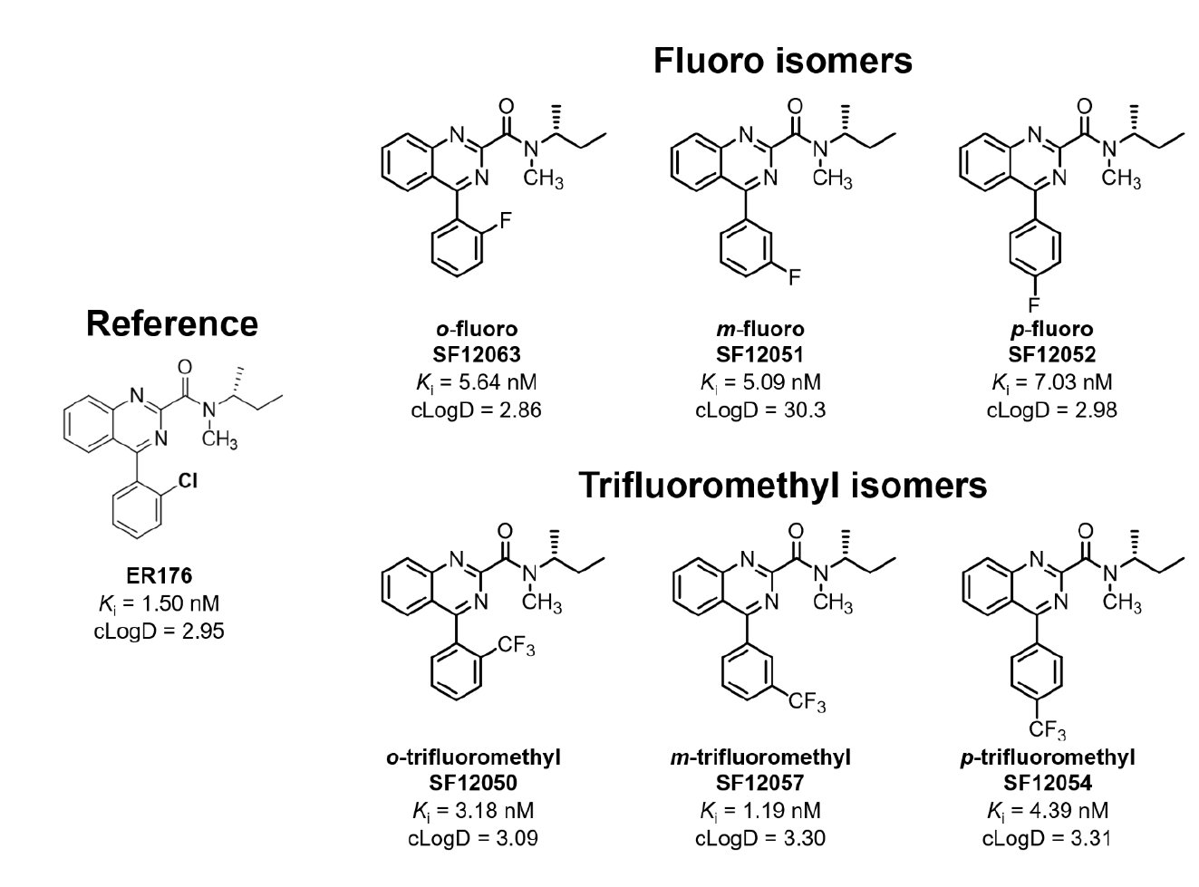
Supplementary Figure S1. Chemical structures of ¹¹C-ER176 and six fluorine-containing analogs. This figure was originally published in: Lee JH, Siméon FG, Liow JS, Morse CL, Gladding RL, Santamaria JAM, Henter ID, Zoghbi SS, Pike VW, Innis RB. In Vivo Evaluation of 6 Analogs of ¹¹C-ER176 as Candidate ¹⁸F-Labeled Radioligands for 18-kDa Translocator Protein. J Nucl Med. 2022 Aug;63(8):1252-1258. © SNMMI

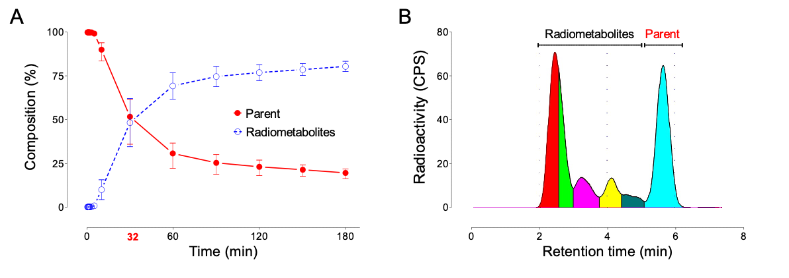

Supplementary Figure S2. (A) The percentage of blood components for baseline scans changed over time. Point and error bars, respectively, represent the mean and range of three scans. (B) Representative radiochromatogram showing the arterial plasma composition profile after i.v. injection of ¹⁸F-SF51 into a monkey. During the baseline study, at 30 minutes the parent was 36% while the total radiometabolites were 64%. There were more than five radiometabolites in plasma, although they were not well separated. The parent was well separated from the radiometabolites.

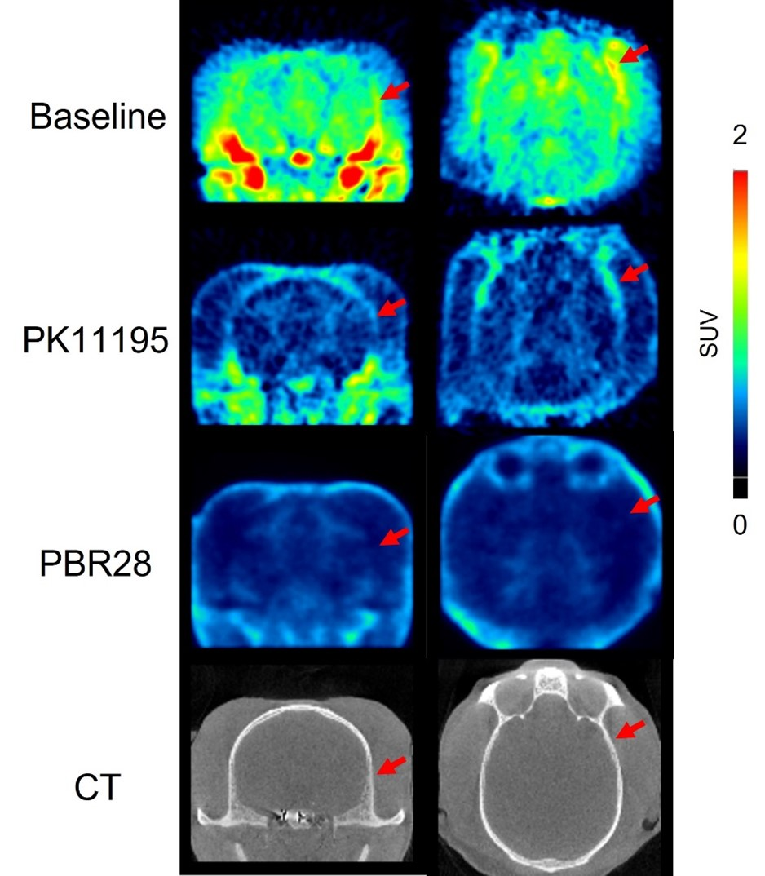

Supplementary Figure S3. The SUV PET images were generated from a 90-120-minute scan. ¹⁸F-SF51 in monkey brain at baseline (top row), after PK11195 (5 mg/kg, middle top row) and PBR28 blockade (5 mg/kg, middle bottom row). The individual monkey’s CT is shown in the bottom row. Skull is indicated with red arrows.

