Supplementary

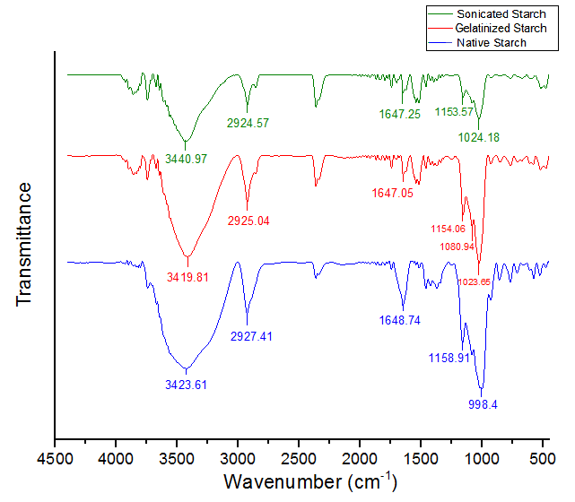
FTIR spectrum from top to bottom: sonicated, gelatinized and native starches

