Title
Data and assumptions for power system flexibility modelling in Vietnam

Authors
Naomi Tan^{1,2}

Affiliations
- Centre for Sustainable Transitions: Energy, Environment and Resilience, Loughborough University
- Centre for Environmental Policy, Imperial College London

Abstract
As Vietnam increases the amount of variable renewable energy such as solar and wind in the electricity system, technical challenges regarding balancing the load and generation at all times arises. Thus, strong modelling analysis should be made to provide key stakeholders with necessary information on energy policy decision making regarding supply and demand. Nonetheless, large volume of data is required to accurately model the power system flexibility of various energy pathways in the nation. This data note therefore provides key information on input data and assumptions, with the aim of representing the power system of Vietnam in a separate research article. Data regarding electricity demand, electricity imports and exports, hourly capacity factors, fuel assumptions, power plants, and electric vehicle charging can be found in this article.

Keywords
U4RIA
Variable renewable energy
Vietnam
Energy policy
Energy modelling

Specifications Table
Subject | Energy
Specific subject area | Energy System Modelling
Type of data | Tables  Graphs  Charts  Description of main modelling assumptions
How data were acquired | Literature survey (databases and reports from international organisations; journal articles)
Data format | Raw and Analysed
Parameters for data collection | Data collected based on inputs required to create an energy system model for Vietnam
Description of data collection | Data were collected from the websites, annual reports and databases of international organisations, as well as from academic articles and existing modelling databases.
Data source location | Not applicable
Data accessibility | With the article

Value of the Data
- These data can be used to develop national energy system models to inform national energy investment outlooks, policy plans and provide insights on the evolution of the electricity supply system under different trajectories.
- The data are useful for country analysts, policy makers and the broader scientific community, as a base for model development.
- These data could be used to examine a range of possible energy system pathways except the ones analysed in this study to provide further insights on the evolution of the country's power system.
- They are open-source and country specific which is not easily accessible current literature. The data can be used both for conducting an analysis of the power system but also for capacity building activities.

Data Description
The data provided in this paper can be used as input data to develop a power system model for Vietnam. As an illustration, these data were used to develop six energy system models using the linear optimisation tool FlexTool for the years 2025, 2030, 2040, and 2050 (Table 1). The data provided were collected from publicly available sources, including the reports of international organisations, journal articles, and existing model databases. It includes data such as electricity demand, hourly capacity factors, fuel assumptions, the techno-economic parameters of supply-side technologies, and electric vehicle (EV) charging.

Table 1: List of scenarios and their descriptions.
Abbreviation | Name | Description
PDP 7 (rev) | Power Development Plan VII (revised) for the period of 2011 – 2020 with the vision to 2030 | Follows the planned electricity generation mix from Vietnam’s PDP7 (rev)
PDP 8 (draft) | Power Development Plan VIII draft for the period of 2021-2030 with a vision to 2045 | Follows the planned capacity mix from Vietnam’s PDP8 (draft)
REDS | Renewable Energy Development Strategy | Follows the planned electricity generation mix from Vietnam’s Renewable Energy Development Strategy
RLP | Renewables-Led Pathway | Based on the planned generation mix from McKinsey & Company’s report on “Exploring an alternative pathway for Vietnam’s energy future”
NZ | Net Zero | Follows Vietnam’s COP26 commitment on a coal phase-out by 2040 and net zero by 2050.
CET | Clean Energy Transition | Assumes an ambitious target of a coal phase-out by 2030, net zero by 2040, and a gradual uptake of sustainable biomass

Electricity demand
Electricity demand was gathered from the APEC Energy Supply and Demand Outlook 7th Edition’s Business-as-Usual scenario (Asia-Pacific Economic Cooperation 2019). Figure 1 shows the projection. For the study, the years 2025, 2030, 2040, and 2050 were taken. The electricity demand assumes no influence from unforeseen circumstances such as pandemics or natural disasters. This was paired with Vietnam’s electricity load profile from the year 2015 (Brinkerink and Deane 2020). Due to lack of recent data, this load profile was used for the analysis of 2025, 2030, 2040, and 2050.

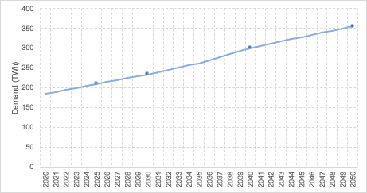
Figure 1: Projection of electricity demand in Vietnam (Asia-Pacific Economic Cooperation 2019).

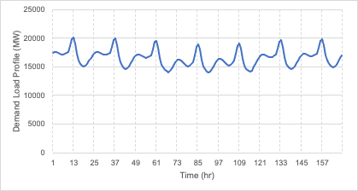
Figure 2: Electricity demand profile of Vietnam in a sample week (Brinkerink and Deane 2020).

Net imports
The net imports used for each of the scenarios for the years 2025, 2030, 2040, and 2050 in the main modelling study are shown in Figure 3, taken from Tan, Harrison, and Howells (2022). Negative values represent electricity exports. The load profile of net imports used for the study is of Denmark (Hartz and Hein 2022), due to lack of available data. This profile is shown in Figure 4. Denmark was chosen due to its similar level of net energy imports to Vietnam (TWB 2014). To represent the warm temperatures and daylight hours in Vietnam, the load profile of a summer’s week (1st – 7th July 2022) was used and replicated throughout the whole year.

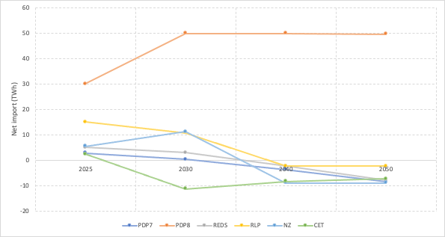
Figure 3: Net imports of the six scenarios

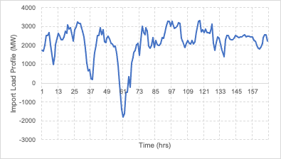
Figure 4: Net import load profile of Denmark (1-7 July 2022).

Hourly capacity factors
Hourly capacity factors used in the study was taken from the PLEXOS database (Brinkerink and Deane 2020), shown in Figure 5. These values are country-specific, however, is from 2015. Due to lack of recent data, the capacity factor profile for 2015 has been populated for future years. Note the value for offshore wind from the PLEXOS database is constant throughout the year. The capacity factor of hydropower is also dependent on the seasons in Vietnam, noted in Table 2. Due to lack of hourly data, the four values are populated for each season.

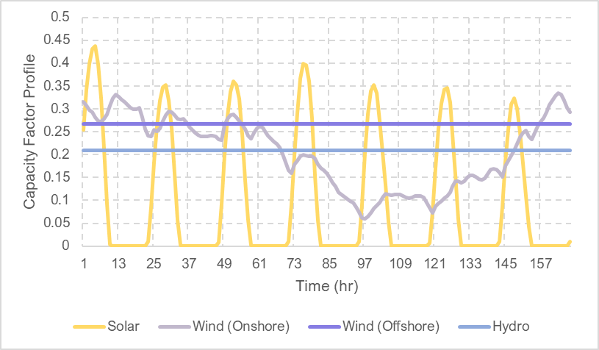
Figure 5: Hourly capacity profiles of solar, wind, and hydropower in Vietnam, in a sample week (Brinkerink and Deane 2020).

Table 2: Capacity factor of hydropower in Vietnam, based on seasons (Brinkerink and Deane 2020).
 | Hydro Capacity Factor
Winter (Jan – Mar) | 0.209548
Spring (Apr – Jun) | 0.336179
Summer (Jul – Sep) | 0.750621
Autumn (Oct – Dec) | 0.658002

Fuel assumptions
Data on fuel, including prices and carbon content are noted in this section.

Fuel prices
Projected fuel prices used in the study are noted in Table 3. These values are from the CCG Vietnam Starter Data Kit (Allington et al. 2021).

Table 3: Projected fuel prices in Vietnam.
 | 2025 | 2030 | 2040 | 2050
Oil | 51.96 | 55.98 | 68.16 | 73.31
Biomass | 12.40 | 12.40 | 12.40 | 12.40
Coal | 10.55 | 10.75 | 12.08 | 12.34
Light Fuel Oil | 59.37 | 63.97 | 77.90 | 83.75
Heavy Fuel Oil | 51.93 | 55.98 | 68.19 | 73.26
Natural Gas | 34.80 | 35.47 | 36.67 | 36.76
Uranium | 0.265 | 0.279 | 0.308 | 0.340

Carbon content
Carbon content for each fuel source is taken from the CCG Vietnam Starter Data Kit (Allington et al. 2021). The data used is shown in Table 4. Due to lack of data, the carbon content is assumed to be of carbon dioxide only and constant throughout the modelling period. To model the uptake of sustainable biomass in the CET scenario, the carbon emissions from the burning of biomass decreases to 0 by 2040.

Table 4: Carbon content of various fuel.
 | Carbon content (t/MWh)
Oil | 0.26388
Biomass | 0.36
Coal | 0.34056
Light Fuel Oil | 0.24948
Heavy Fuel Oil | 0.27864
Natural Gas | 0.20196

Table 5: Carbon content of biomass in the CET scenario.
 | 2025 | 2030 | 2040 | 2050
Biomass | 0.3 | 0.2 | 0 | 0

Power plant assumptions
Technoeconomic data on power plants, including costs and flexibility performance are noted in this section.

Fixed costs
Fixed costs for each power plant technology modelled in the study is taken from the CCG Vietnam Starter Data Kit (Allington et al. 2021). The data used is shown in Table 6.

Table 6: Fixed costs of power plant technologies.
 | 2025 | 2030 | 2040 | 2050
Biomass | 69 | 69 | 69 | 69
Coal | 52 | 52 | 52 | 52
Geothermal | 100 | 100 | 100 | 100
Light Fuel Oil | 18 | 18 | 18 | 18
Oil Fired Gas | 18 | 18 | 18 | 18
Gas (CCGT) | 40 | 40 | 40 | 40
Gas (SCGT) | 23 | 23 | 23 | 23
Solar PV (Utility) | 10.8 | 9.70 | 7.91 | 7.91
CSP with Storage | 120 | 120 | 120 | 120
Large Hydropower (Dam) (>100MW) | 46.17 | 46.17 | 46.17 | 46.17
Medium Hydropower (10-100MW) | 47.79 | 47.79 | 47.79 | 47.79
Small Hydropower (<10MW) | 64.86 | 64.86 | 64.86 | 64.86
Onshore Wind | 71.03 | 64.83 | 55.64 | 55.64
Offshore Wind | 87.50 | 70.96 | 65.89 | 60.82
Nuclear | 138 | 138 | 138 | 138
Utility-scale PV with 2 hour storage | 12.87 | 10.80 | 8.78 | 8.13
Onshore Wind power plant with storage | 77.41 | 69.46 | 59.39 | 58.50
Light Fuel Oil Standalone Generator (1kW) | 38 | 38 | 38 | 38
Solar PV (Distributed with Storage) | 37.62 | 35.12 | 33.82 | 32.52
Off-grid Hydropower | 64.86 | 64.86 | 64.86 | 64.86

Investment costs
Investment costs for each power plant technology modelled in the study is taken from the CCG Vietnam Starter Data Kit (Allington et al. 2021). The data used is shown in Table 7.

Table 7: Investment costs of power plant technologies.
 | 2025 | 2030 | 2040 | 2050
Biomass | 2750 | 2750 | 2750 | 2750
Coal | 1300 | 1300 | 1300 | 1300
Geothermal | 2500 | 2500 | 2500 | 2500
Light Fuel Oil | 1200 | 1200 | 1200 | 1200
Oil Fired Gas | 1344 | 1344 | 1344 | 1344
Gas (CCGT) | 1000 | 1000 | 1000 | 1000
Gas (SCGT) | 784 | 784 | 784 | 784
Solar PV (Utility) | 828.33 | 745.84 | 608.62 | 608.62
CSP with Storage | 4000 | 3223.13 | 3134.9 | 3134.9
Large Hydropower (Dam) (>100MW) | 1539 | 1539 | 1539 | 1539
Medium Hydropower (10-100MW) | 1592.87 | 1592.87 | 1592.87 | 1592.87
Small Hydropower (<10MW) | 2162 | 2162 | 2162 | 2162
Onshore Wind | 1775.78 | 1620.71 | 1391.1 | 1391.1
Offshore Wind | 2187.28 | 1773.92 | 1647.21 | 1520.5
Nuclear | 5500 | 5500 | 5500 | 5500
Utility-scale PV with 2 hour storage | 1287.331 | 1079.83 | 877.62 | 812.62
Onshore Wind power plant with storage | 1935.13 | 1736.61 | 1484.71 | 1462.43
Light Fuel Oil Standalone Generator (1kW) | 1500 | 1500 | 1500 | 1500
Solar PV (Distributed with Storage) | 1880.8 | 1755.8 | 1690.8 | 1625.8
Off-grid Hydropower | 2162 | 2162 | 2162 | 2162

Start-up costs
Start-up costs for various power plants are noted in Table 8. Due to lack of available country-specific data, values are taken and averaged from a Deloitte report on the flexibility of renewable energy integration in Germany (Muizon and Trüby 2019). For example, coal of vintage class 1, 2, and 3 were averaged to gain an overall average value for a coal power plant.

Table 8: Start-up costs of power plant technologies.
 | Start-up Cost ($/MW)
Biomass Power Plant | 24.48
Coal Power Plant | 39.1
Natural Gas (CCGT) Power Plant | 54.06
Natural Gas (SCGT) Power Plant | 35.7
Nuclear Power Plant | 51

Operation and maintenance costs
Operation and maintenance costs are assumed to be minimal in this research. Therefore, values close to $0/MWh are used in modelling the costs of the energy systems.

Flexibility performance
Flexibility performance of power plants including minimum load, ramp up, ramp down, inertia constants, minimum uptime and minimum downtime are noted in Table 9. Data on minimum load for biomass, geothermal, CSP, and hydropower technologies were gathered from Ramirez-Meyers et al. (2021), whilst minimum load for coal, oil, natural gas, and nuclear were collected from Lens (2014), Gonzalez-Salazar, Kirsten, and Prchlik (2018), and G. de Muizon and Trüby (2019). Ramp up and down rates were assumed to be the same, and gathered from G. de Muizon and Trüby (2019), Ramirez-Meyers et al. (2021); Gonzalez-Salazar, Kirsten, and Prchlik 2018). Ramp up and down rates for renewable technologies are modelled to be 1. The inertia constant for the technologies were taken from Ramirez-Meyers et al. (2021), Johnson et al. (2019), and Jathunga, Wijethunga, and Ekanayake (2021). Note that the inertia constant for medium hydropower was based of Johnson et al. (2019), and large and small hydropower were assumed to be ± 0.5 of medium hydropower. Off-grid hydropower is assumed to be 0.5 less than small hydropower, due to its miniscule size. Minimum uptime and downtime is assumed to be the same, taken from Ramirez-Meyers et al. (2021), G. de Muizon and Trüby (2019) and Gonzalez-Salazar, Kirsten, and Prchlik (2018). Large and medium hydropower is assumed to be at the top end of the range, whilst small and off-grid hydropower is assumed to be at the bottom end of the range, due to their sizes. Non-synchronous technologies are also represented with ‘1’, otherwise ‘0’. All the data used were from various countries and not country specific, due to lack of available data.

Table 9: Flexibility performance of power plant technologies.
 | Min Load | Ramp Up & Ramp Down | Inertia Constant | Min Uptime & Min Downtime | Non synchronous
Biomass | 0.25 | 0.0054 | 3 | 0 | 0
Coal | 0.3 | 0.07 | 2.63 | 3 | 0
Geothermal | 0.15 | 0.05 |  | 1 | 0
Light Fuel Oil | 0.3 | 0.07 |  | 3 | 0
Oil Fired Gas | 0.3 | 0.07 |  | 3 | 0
Gas (CCGT) | 0.2 | 0.08 | 4.69 | 2 | 0
Gas (SCGT) | 0.15 | 0.2 | 4.98 | 0.16 | 0
Solar PV (Utility) |  | 1 | 0 |  | 1
CSP with Storage | 0.25 | 0.06 | 0 | 1 | 1
Large Hydropower (Dam) (>100MW) | 0.05 | 0.15 | 2.9 | 1 | 0
Medium Hydropower (10-100MW) | 0.05 | 0.15 | 2.4 | 1 | 0
Small Hydropower (<10MW) | 0.05 | 0.15 | 1.9 | 0 | 0
Onshore Wind |  | 1 | 0 |  | 1
Offshore Wind |  | 1 | 0 |  | 1
Nuclear | 0.5 | 0.005 | 4.07 | 10 | 0
Utility-scale PV with 2 hour storage |  | 1 | 0 |  | 1
Onshore Wind power plant with storage |  | 1 | 0 |  | 1
Light Fuel Oil Standalone Generator (1kW) | 0.3 | 0.07 |  | 3 | 0
Solar PV (Distributed with Storage) |  | 1 | 0 |  | 1
Off-grid Hydropower | 0.05 | 0.15 | 1.4 | 0 | 0

Operational performance
Data on the power plants’ operational performance such as efficiency, availability, max reserve, lifetime, and interest used in the modelling can be found in Table 10. All data for operational performance were taken from the CCG Vietnam Starter Data Kit (Allington et al. 2021). Efficiency of each technology was obtained through dividing the output activity ratio by the input activity ratio.

Table 10: Operational performance of power plant technologies.
 | Efficiency | Availability | Max Reserve | Lifetime | Interest
Biomass | 0.38 | 1 | 1 | 25 | 0.1
Coal | 0.30 | 1 | 1 | 60 | 0.1
Geothermal | 0.1 | 1 | 1 | 50 | 0.1
Light Fuel Oil | 0.4 | 1 | 1 | 50 | 0.1
Oil Fired Gas | 0.4 | 1 | 1 | 50 | 0.1
Gas (CCGT) | 0.55 | 1 | 1 | 30 | 0.1
Gas (SCGT) | 0.35 | 1 | 1 | 30 | 0.1
Solar PV (Utility) | 1 | 1 | 0 | 30 | 0.1
CSP with Storage | 1 | 1 | 0 | 35 | 0.1
Large Hydropower (Dam) (>100MW) | 1 | 1 | 1 | 40 | 0.1
Medium Hydropower (10-100MW) | 1 | 1 | 0 | 40 | 0.1
Small Hydropower (<10MW) | 1 | 1 | 0 | 40 | 0.1
Onshore Wind | 1 | 1 | 0 | 30 | 0.1
Offshore Wind | 1 | 1 | 0 | 30 | 0.1
Nuclear | 0.33 | 1 | 0 | 60 | 0.1
Utility-scale PV with 2 hour storage | 1 | 1 | 0 | 30 | 0.1
Onshore Wind power plant with storage | 1 | 1 | 0 | 30 | 0.1
Light Fuel Oil Standalone Generator (1kW) | 0.42 | 1 | 0 | 20 | 0.1
Solar PV (Distributed with Storage) | 1 | 1 | 0 | 24 | 0.1
Off-grid Hydropower | 1 | 1 | 0 | 40 | 0.1

Electric vehicle charging
In the modelling study, unidirectional electric vehicle charging with a flexible schedule (i.e., with a battery) was incorporated to assess the importance of sector coupling in the power system. Data regarding electric vehicle charging is noted in this subsection. The study aims to present results based on the integration and expansion of private, workspace, and public EV charging stations, thus, data on the installation of charging ports were used instead of data regarding ownership of specific vehicles.

Load profile
The load profile of electric vehicle charging (Figure 6) was taken from a public report on the United Kingdom’s charging behaviour (Dodson and Slater 2019). Due to lack of available data, the average charging load profile for a week was used and populated for the remaining year in the study.

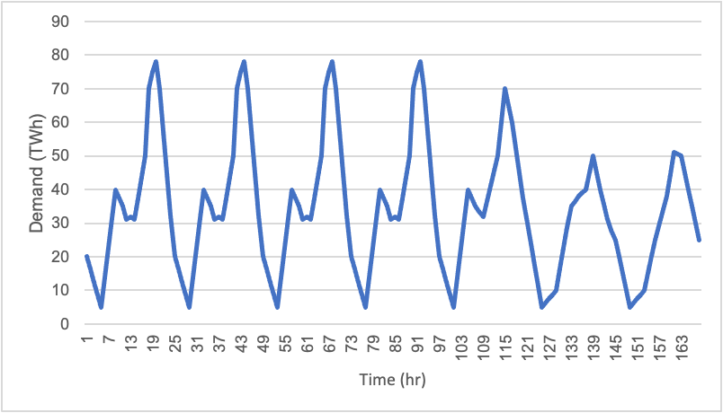
Figure 6: Average weekly load profile of electric vehicle charging in the United Kingdom.

Fixed cost
According to Nelder and Rogers (2019), "make-ready costs are typically a large percentage of the capital costs of an installation, at about 30%–40%. However, they are largely quite fixed”. Therefore, fixed costs in the modelling study are assumed to be 35% of capital costs (Table 11). Capital costs can be found in the next subsubsection. Furthermore, it is expected that the number of chargers per port increases over time. To model a flexible charging schedule, a 4-hour lithium battery was also incorporated. Cole and Frazier (2019) suggest that fixed costs is “2.5% of the $/kW capacity cost for a 4-hour battery”, thus, values are based on the capital costs shown in Table 14.

Table 11: Fixed cost of electric vehicle charging stations.
 | 2025 | 2030 | 2040 | 2050
 | 1 charger | 2 chargers | 3-5 chargers | 6+ chargers
Residential charging | 96.98 | 79.84 | 69.35 | 66.98
Workspace charging | 174.69 | 143.80 | 124.92 | 120.65
Public charging | 22.33 | 18.39 | 15.97 | 15.43
Charging battery | 25 | 20.7 | 18 | 15.6

Investment cost
To obtain the investment cost of each charger type, the average hardware cost per charger type was first calculated (Table 12). Data on the hardware cost was taken from Nelder and Rogers (2019). Secondly, the total installation cost per kW for a workspace (i.e., commercial) charger was calculated by dividing total installation costs taken from Nelder and Rogers (2019) with the average capacity of a workspace charger (11.14 kW), and this can be seen in Table 13. Due to lack of data for the installation cost of residential and public chargers, it is assumed that the capital cost for residential is the same ratio as what hardware cost was for residential and commercial chargers. This is the same for public chargers, and the results can be found in Table 14. It is also expected that number of chargers per port will increase over time. To represent a flexible charging station, a 4-hour lithium battery was modelled in the study. Mid costs from Cole and Frazier (2019) were used, and can be found in Table 14.

Table 12: Hardware cost of electric vehicle chargers.
Charger type | kW | Min hardware cost | Max hardware cost | Average hardware cost per kW | Average hardware cost per charger type
Residential | 2.9 | 131 | 131 | 45.17 | 23.45
Residential | 5.8 | 87 | 98 | 15.95 | 23.45
Residential | 7.7 | 52 | 90 | 9.22 | 23.45
Workspace | 7.2 | 444 | 542 | 68.47 | 42.23
Workspace | 7.7 | 326 | 391 | 46.56 | 42.23
Workspace | 9.6 | 396 | 448 | 43.96 | 42.23
Workspace | 14.4 | 501 | 501 | 34.79 | 42.23
Workspace | 16.8 | 292 | 292 | 17.38 | 42.23
Public | 50 | 400 | 716 | 11.16 | 5.40
Public | 150 | 504 | 667 | 3.90 | 5.40
Public | 350 | 366 | 429 | 1.14 | 5.40

Table 13: Total installation cost of workspace chargers.
Workspace | 1 charger | 2 chargers | 3-5 chargers | 6+ chargers
Total installation cost | 5560 | 4577 | 3976 | 3840
Total installation cost per kW | 499.10 | 410.86 | 356.91 | 344.70

Table 14: Investment cost of electric vehicle charging stations.
 | 2025 | 2030 | 2040 | 2050
 | 1 charger | 2 chargers | 3-5 chargers | 6+ chargers
Residential charging | 277.10 | 228.11 | 198.16 | 191.38
Workspace charging | 499.10 | 410.86 | 356.91 | 344.70
Public charging | 63.81 | 52.53 | 45.63 | 44.07
Charging battery | 1000 | 828 | 720 | 624

Flexibility and operational performance
The flexibility and operational performance of charging ports and a 4-hr lithium battery is presented in Table 15. Due to lack of data, ramp up, ramp down, and availability values are assumed to be 1. Maximum reserve is also assumed to be 0. The interest rate was from the CCG Vietnam Starter Data Kit (Allington et al. 2021) .The conversion efficiency of the residential and workspace chargers were gathered from Sears, Roberts, and Glitman (2014), whilst the conversion efficiency for public chargers was from Rajendran et al. (2021)The fixed kW/kWh ratio of the charging battery is calculated through dividing 4 (i.e., 4-hour lithium battery) by 24 (i.e., 24 hours in a day). Lifetime for the chargers were from Hosseini and Sarder (2019), using the “most likely” value. Cole and Frazier (2019) noted the efficiency of a 4-hour lithium charging battery, and the fixed kW/kWh ratio was calculated by dividing 4 (i.e., 4-hour lithium battery) by 24 (i.e., 24 hours in a day). The efficiency charge was taken from a range of sources (Battery University 2021b; Electronics Notes n.d.; Power Tech 2022), whilst the self discharge loss was from Battery University (2021a). (Cole and Frazier 2019) noted the lifetime of a 4-hour lithium battery is 15 years. All technologies were modelled as synchronous, hence ‘0’.

Table 15: Flexibility and operational performance of electric vehicle charging stations.
 | Residential charging | Workspace charging | Public charging | Charging battery
Efficiency |  |  |  | 0.85
Ramp up & ramp down | 1 | 1 | 1 | 1
Availability | 1 | 1 | 1 | 1
Max reserve | 0 | 0 | 0 | 0
Fixed kW/kWh ratio |  |  |  | 0.167
Conversion efficiency | 0.838 | 0.894 | 0.914
Efficiency charge |  |  |  | 0.99
Self discharge loss |  |  |  | 0.00208
Lifetime | 10 | 10 | 10 | 15
Interest | 0.1 | 0.1 | 0.1 | 0.1
Non synchronous | 0 | 0 | 0 | 0

Penalty costs
Penalty costs is introduced in the modelling study. Here, it is assumed that the price of carbon increases each year, as listed in Table 16. This is to represent the increasing global interest in capping carbon dioxide (CO₂) emissions. The price for the first modelling year (2025) was taken from Do and Burke (2021), which is the average CO₂ price for all countries in 2019. The penalty costs for other parameters are noted down in Table 17. Loss of load penalty was taken from a 2011 Great Britain report on loss of load due to lack of available data (London Economics 2013). Similarly, the cost of curtailment is taken from a case study on China from 2010 to 2016 (Qi, Lu, and Zhu 2018). Loss of reserves, lack of inertia, and lack of capacity penalties are assumed to be 2000, 3000, and 500, respectively, due to lack of available data.

Table 16: Proposed carbon pricing in the modelling study.
 | 2025 | 2030 | 2040 | 2050
$/ton of CO2 | 2 | 4 | 10 | 20

Table 17: Proposed penalty costs in the modelling study.
Loss of load penalty ($/MWh) | 1985
Loss of reserves penalty ($/MWh) | 2000
Lack of inertia penalty ($/MWs) | 3000
Curtailment penalty ($/MWh) | 8
Lack of capacity penalty ($/MWh) | 500

Experimental Design, Material, and Methods
All data in this article were collected via a literature review of open and available sources. This included material from international organization, journal articles, open database, and media reports. The data was compiled, presented, and discussed with local stakeholders to reach consensus on the main data and assumptions to be used in the analysis.

Acknowledgements
The research in this paper was funded by the Climate Compatible Growth (CCG) programme of the United Kingdom Foreign, Commonwealth and Development Office (FCDO), in a project carried out for the British Embassy in Hanoi. The authors would like to thank all the partners for their continued support, involvement, and guidance during this study. The views expressed in this paper do not necessarily reflect the United kingdom government’s official policies.

References
Allington, Lucy, Carla Cannone, Ioannis Pappis, Karla Cervantes Barron, Will Usher, Steve Pye, Edward Brown, et al. 2021. “Selected ‘Starter Kit’ Energy System Modelling Data for Vietnam (#CCG).” Research Square, July.
Asia-Pacific Economic Cooperation. 2019. “APEC Energy Demand and Supply Outlook (7th Edition) - Volume II.” Tokyo. https://www.apec.org/publications/2019/05/apec-energy-demand-and-supply-outlook-7th-edition---volume-ii.
Battery University. 2021a. “BU-802b: What Does Elevated Self-Discharge Do?” Battery University. 2021. https://batteryuniversity.com/article/bu-802b-what-does-elevated-self-discharge-do.
———. 2021b. “BU-409: Charging Lithium-Ion.” Battery University. October 25, 2021. https://batteryuniversity.com/article/bu-409-charging-lithium-ion.
Brinkerink, Maarten, and Paul Deane. 2020. “PLEXOS-World 2015.” Harvard Database. https://doi.org/https://doi.org/10.7910/DVN/CBYXBY.
Cole, Wesley, and A. Will Frazier. 2019. “Cost Projections for Utility-Scale Battery Storage.” Golden, Colorado. https://www.nrel.gov/docs/fy19osti/73222.pdf.
Do, Thang Nam, and Paul J. Burke. 2021. “Carbon Pricing in Vietnam: Options for Adoption.” Energy and Climate Change 2 (December): 100058. https://doi.org/10.1016/j.egycc.2021.100058.
Dodson, Tristan, and Shane Slater. 2019. “Electric Vehicle Charging Behaviour Study.” Cambridge.
Electronics Notes. n.d. “Li-Ion Lithium Ion Battery Charging.” Electronics Notes. Accessed September 12, 2022. https://www.electronics-notes.com/articles/electronic_components/battery-technology/li-ion-lithium-ion-charging.php.
Gonzalez-Salazar, Miguel Angel, Trevor Kirsten, and Lubos Prchlik. 2018. “Review of the Operational Flexibility and Emissions of Gas- and Coal-Fired Power Plants in a Future with Growing Renewables.” Renewable and Sustainable Energy Reviews 82 (February): 1497–1513. https://doi.org/10.1016/j.rser.2017.05.278.
Hartz, Katharina, and Fabian Hein. 2022. “Electricity Data - Power Imports/Exports.” Agora Energiewende. 2022. https://www.agora-energiewende.de/en/service/recent-electricity-data/chart/power_import_export/01.07.2022/07.07.2022/today/.
Hosseini, Seyedmohsen, and MD Sarder. 2019. “Development of a Bayesian Network Model for Optimal Site Selection of Electric Vehicle Charging Station.” International Journal of Electrical Power & Energy Systems 105 (February): 110–22. https://doi.org/10.1016/j.ijepes.2018.08.011.
Jathunga, T. G., A. H. Wijethunga, and J. B. Ekanayake. 2021. “Impact of Inertia Constant on Frequency Dynamics of a Power System.” Ceylon Journal of Science 50 (1): 3. https://doi.org/10.4038/cjs.v50i1.7841.
Johnson, Samuel C., Dimitri J. Papageorgiou, Dharik S. Mallapragada, Thomas A. Deetjen, Joshua D. Rhodes, and Michael E. Webber. 2019. “Evaluating Rotational Inertia as a Component of Grid Reliability with High Penetrations of Variable Renewable Energy.” Energy 180 (August): 258–71. https://doi.org/10.1016/j.energy.2019.04.216.
Lens, Hendrik. 2014. “Mid-Load Operation of Large Coal-Fired Power Plants.” Köln.
London Economics. 2013. “The Value of Lost Load (VoLL) for Electricity in Great Britain.” London.
Muizon, Gildas de, and Johannes Trüby. 2019. “Assessing the Flexibility of Coal-Fired Power Plants for the Integration of Renewable Energy in Germany.” https://www2.deloitte.com/content/dam/Deloitte/fr/Documents/financial-advisory/economicadvisory/deloitte_assessing-flexibility-coal-fired-power-plants.pdf.
Nelder, Chris, and Emily Rogers. 2019. “Reducing EV Charging Infrastructure Costs.” https://rmi.org/wp-content/uploads/2020/01/RMI-EV-Charging-Infrastructure-Costs.pdf.
Power Tech. 2022. “The Lithium Difference.” Power Tech. 2022. https://www.powertechsystems.eu/home/tech-corner/lithium-ion-battery-advantages/#:~:text=Lithium%20batteries%20charge%20at%20nearly,of%20most%20lead%20acid%20batteries.
Qi, Ye, Jiaqi Lu, and Mengye Zhu. 2018. “Wind Curtailment in China and Lessons from the United States.” Tsinghua.
Rajendran, Gowthamraj, Chockalingam Aravind Vaithilingam, Norhisam Misron, Kanendra Naidu, and Md Rishad Ahmed. 2021. “A Comprehensive Review on System Architecture and International Standards for Electric Vehicle Charging Stations.” Journal of Energy Storage 42 (October): 103099. https://doi.org/10.1016/j.est.2021.103099.
Ramirez-Meyers, K, W Neal Mann, T A Deetjen, S C Johnson, J D Rhodes, and M E Webber. 2021. “How Different Power Plant Types Contribute to Electric Grid Reliability, Resilience, and Vulnerability: A Comparative Analytical Framework.” Progress in Energy 3 (3): 033001. https://doi.org/10.1088/2516-1083/abf636.
Sears, Justine, David Roberts, and Karen Glitman. 2014. “A Comparison of Electric Vehicle Level 1 and Level 2 Charging Efficiency.” In 2014 IEEE Conference on Technologies for Sustainability (SusTech), 255–58. IEEE. https://doi.org/10.1109/SusTech.2014.7046253.
Tan, Naomi, John Harrison, and Mark Howells. 2022. “Comparing Long-Term Energy Pathways in Vietnam: A Cost-Optimization Approach with OSeMOSYS.” Research Square, no. Preprint (October). https://doi.org/10.21203/rs.3.rs-2159519/v1.
TWB. 2014. “Energy Imports, Net (% of Energy Use).” The World Bank. 2014. https://data.worldbank.org/indicator/EG.IMP.CONS.ZS?end=2015&most_recent_value_desc=false&start=2015.

