Supplementary information

Supplementary methods
Plasmids, shRNAs, and siRNAs
The pcDNA3.1-PRMT6-FLAG, pcDNA3.1-CDC20-HA, pcDNA3.1-CDC20(N1-171)-HA, pcDNA3.1-CDC20(N172-499, WD40)-HA, pcDNA3.1-CDKN1B-FLAG, pcDNA3.1-Ubiquitin-His, pLenti-CBH-CDC20-HA overexpression plasmids were constructed from YouBio Biotechnology (Changsha, China). hU6-MCS-Ubiquitin-shPRMT6 lentiviral shRNA plasmids and CDC20 siRNAs were generated by GenePharma (Suzhou, China). The sequences of shPRMT6 and siCDC20 are listed in Table S1. The plasmids or siRNAs were transfected into cells using Lipofectamine 3000 (Invitrogen, USA) according to the manufacturer's instructions.
Lentivirus packaging and generation of stable cells
Lentivirus packaging was performed in accordance with the method previously described [1]. HEK293T cells were co-transfected with an shPRMT6 plasmid or pLenti-CBH-CDC20-HA overexpression plasmid, Pcmvdr8.91 plasmid, and pMD.G-VSV-G plasmid. The cell supernatants were collected and filtered with a 0.45 µm nitrocellulose filter 48 h post-transfection. Finally, the glioma cells were incubated with the supernatants for 48 h and screened with 5 µg/ml puromycin for 1-2 weeks to obtain stable cells.
Cell viability assay
The Cell Counting Kit-8 (CCK-8) test was performed to assess cell viability using a CCK-8 kit (Dojindo, Japan). Stably transfected cells (2 x10³ cells/well) were grown in 96-well plates for 0-5 days, respectively. 10% CCK-8 solution was added to the cells and incubated at 37°C for 1 h. The plates were read on a microplate reader (TECAN, Switzerland) at 450 nm wavelength. The colony formation assay was also used to evaluate cell proliferation. The cells (1 x 10³ cells/well) were cultured in 6-well plates for 10 days. The colonies were fixed with 4% paraformaldehyde, stained with 0.1% crystal violet, pictured with ChemiDoc™ XRS+ system (Bio-Rad, USA), and counted with Image J software.
Cell cycle analysis
A cell cycle assay was performed to analyze cell cycle phase distribution with a kit (Beyotime, Shanghai, China). The cells were harvested and fixed with pre-cold 70% ethanol at 4 °C overnight. Then, the cells were incubated in a 500 µL staining buffer containing 25 µL Propidium Iodide (PI) and 10 µL RNase A at RT for 30 min in the dark. The stained cells were then immediately analyzed with a CytExpert flow cytometer (Beckman Coulter, USA).
Quantitative Real-Time PCR assay (qRT-PCR)
Total RNA was isolated from cells by TRIZOL reagent (Invitrogen, USA). RNA was reverse transcribed into cDNA by a cDNA synthesis kit (Invitrogen, USA). qRT-PCR was performed using SYBR Green (Takara, Beijing, China) in an ABI 7000 thermal cycler. The 2^{−ΔΔCT} method was used to analyze RNA expression. β-actin was utilized as an internal control for normalization purposes. The primer sequences were synthesized by Sangon Biotechnology (Shanghai, China) and are listed in Table S2.
Immunoblot
RIPA lysis buffer supplemented with protease inhibitors (Beyotime, Shanghai, China) was used to separate total protein from cells and tissues. The concentration of total protein was determined with a BCA kit (Invitrogen, CA, USA). An equal amount of total protein (30 µg) was electrophoresed on 10% -12% SDS-PAGE, and then electro-transferred to a nitrocellulose filter (NC) membrane (Millipore, MA, USA). Then, the membranes were blocked with 5% non-fat dry milk in TBST at RT for 1 h. After washing with TBST, the membranes were incubated with subsequent primary antibodies at 4 °C overnight. On the second day, the membranes were incubated with HRP-labeled secondary antibodies (Jackson, Lancaster, USA) at RT for 1 h. An enhanced chemiluminescence system (Millipore, MA, USA) was used to measure protein expression value. The relative quantity of proteins was analyzed by Image J software. Primary antibodies used for immunoblot were: anti-PRMT6 (CST, #14641, 1:1000), anti-CDC20 (CST, #14866, 1:1000), anti-CDKN1B (CST, #3686, 1:1000), anti-H3R2me2a (Abcam, ab176845, 1:500), anti-Histone H3 (Abcam, ab1791, 1:2000), anti-FLAG (CST, #14793, 1:1000), anti-HA (CST, #3724, 1:1000), anti-CDK6 (CST, #13331, 1:1000), anti-Cyclin D1 (CST, #55506, 1:1000), anti-CDKN1A (CST, #2947, 1:1000), and anti-β-Actin (ABclonal, #AC026, 1:50000).
Immunohistochemistry (IHC)
The clinical glioma tissues and brains of xenograft mice were fixed with 4% PFA and embedded in paraffin. Then, 5 µm slices were cut by a microtome (Leica, Germany) and deparaffinized, dehydrated, and incubated in heat-mediated antigen retrieval. Subsequently, the endogenous catalase was eliminated with 3% H₂O₂‐methanol, and tissue slices were incubated with indicated primary antibodies at 4 °C overnight. On the next day, sections were washed with PBS and incubated with biotinylated secondary antibodies at RT for 1 h. They were then incubated with peroxidase solution for 30 min and then the sections were stained with DAB reagent and counterstained with hematoxylin. The images of each section were taken and analyzed under an optical microscope. IHC staining images were quantified by ImageJ software. Primary antibodies used for IHC were: anti-PRMT6 (Proteintech, 15395-1-AP, 1:200), anti-CDC20 (Proteintech, 10252-1-AP, 1:150), anti-CDKN1B (Santa Cruz, sc-1641, 1:100), and anti-Ki67 (Abcam, ab15580, 1:500).
Xenograft tumor assay
All mouse experiments were approved by the Institutional Animal Care and Use Committee of Guangzhou Medical University. U87 cells (5×10⁵ in 10 µL PBS) were injected intracranially into female 6-week-old BALB/c nude mice (Guangdong Medical Laboratory Animal Center, Guangzhou, China) (5 mice for each group). Mice were observed daily for death or neurological symptoms and then sacrificed if they developed neurological symptoms. The entire brain was then collected, fixed with 4% PFA, embedded in paraffin, and sectioned coronally from anterior to posterior. To measure the size of the tumor, the largest cross-section area of the tumor was selected. The formula for calculating the tumor volume is V = (a × b²) / 2, where a is the longest diameter and b is the shortest diameter. a and b are measured with Image J. For survival analysis assays, mice (6 mice for each group) were injected intracranially with the above procedure. The dying mice were sacrificed under deep anesthesia and the remaining mice were sacrificed 90 days after injection of U87 cells.
Chromatin immunoprecipitation (ChIP) qPCR
ChIP-qPCR was performed as described previously with minor modification [2]. Briefly, the cells were crosslinked with 1% PFA for 10 min at RT, and then 0.125 M glycine was added to stop the crosslinking reaction. After washing with pre-cold PBS, the cells were centrifuged, lysed with buffer containing Protease Inhibitor Cocktail, and centrifuged again to obtain cell nuclear. The cell nuclear was ultra-sonicated for 6 min with 4 s ultra-sonication at 8 s intervals, added elution buffer containing RNase A, and incubated with Proteinase K at 62 °C for 2 h. The fragmented chromatin extract was incubated with antibodies (H3R2me2a or IgG) overnight and then incubated with Protein A/G magnetic beads at 4 °C for 2 h. After thorough washing, elution, and reverse cross-linking, the DNA is purified for qPCR analysis. Production of qPCR reaction was subjected to gel electrophoresis. The primers used for ChIP-qPCR analysis in the promoter are listed in Table S2.
Bioinformatics analysis
PRMT6 or CDC20 expression and survival time data of patients with glioma/GBM from the TCGA, CGGA, and Gravendeel databases were analyzed in this study by the GlioVis website (http://gliovis.bioinfo.cnio.es/). The samples of survival analysis were divided into high and low groups followed by PRMT6 or CDC20 expression values. Gene functional enrichment analysis was performed by the Metascape website (https://metascape.org). Graphic production and statistical analysis were performed by GraphPad Prism 8.0 (GraphPad Software, La Jolla, CA, USA).
REFERENCES
- Yu S, Yu X, Sun L, Zheng Y, Chen L, Xu H, et al. GBP2 enhances glioblastoma invasion through Stat3/fibronectin pathway. Oncogene. 2020;39:5042-5055.
- Wang J, Chen Y, Wang Q, Xu H, Wu C, Jiang Q, et al. MEOX2-mediated regulation of Cathepsin S promotes cell proliferation and motility in glioma. Cell Death Dis. 2022;13:360.

Supplementary figures
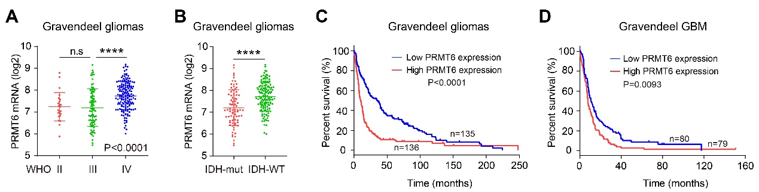
Fig. S1 PRMT6 is overexpressed in glioma. A, B PRMT6 mRNA expression in gliomas with different WHO grades and different IDH statuses from the Gravendeel database. C, D KM survival curves of patients with glioma and GBM from the Gravendeel database stratified by PRMT6 expression. n.s: no significant, ****p < 0.0001.

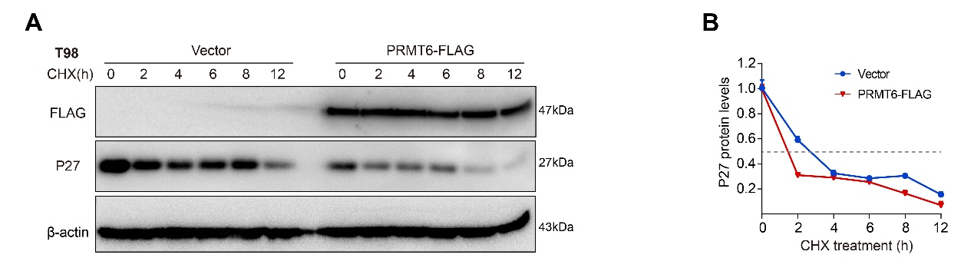
Fig. S2 PRMT6 attenuates the protein stability of CDKN1B in T98 cells. A Immunoblotting analysis of T98 cells with or without PRMT6 overexpression to determine the protein half-life of CDKN1B. B Quantifications of the protein half-life result.
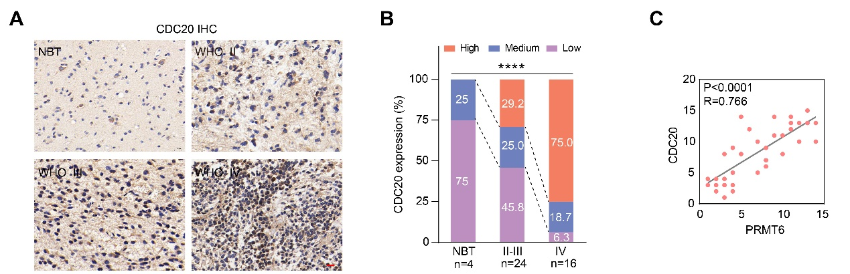
Fig. S3 CDC20 is overexpressed in glioma. A Representative IHC images of CDC20 in gliomas with different histological grades and NBT. Bar: 20 µm. B The semi‑quantitative for the IHC results of PRMT6 and CDC20. C Pearson correlation analysis of IHC score statistics for PRMT6 and CDC20. ****p < 0.0001.

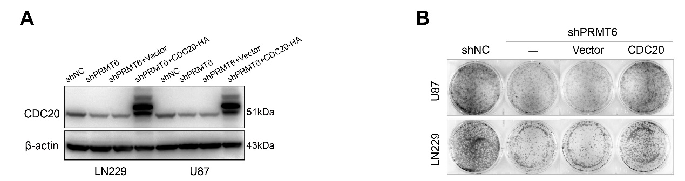
Fig. S4 PRMT6 promotes GBM cell colony formation via CDC20 in vitro. A Immunoblot analysis of CDC20 expression in U87 and LN229 cells treated with NC shRNA, shPRMT6, shPRMT6 + CDC20 Vector or shPRMT6 + CDC20. B Colony formation capability for U87 and LN229 cells infected with NC shRNA, shPRMT6, shPRMT6 + CDC20 Vector or shPRMT6 + CDC20.

Supplementary tables
Table S1. Sequences of siRNAs and shRNAs.
shRNA/siRNA | Sequence (5'-3')
shRNA_NC | CCGGCAACAAGAT GAAGAGCACAACTCGAGTTGGTGCTCTTCATCTTGTTGTTTTT
shPRMT6 #1 | CCGGGCCCAGTTTGAGATGCCTTATCTCGAGATAAGGCATCTCAAACTGGGCTTTTTG
shPRMT6 #2 | CCGGCACCGGCATTCTGAGCATCTTCTCGAGAAGATGCTCAGAATGCCGGTGTTTTTG
shPRMT6 #3 | CCGGCACGGACGTTTCAGGAGAGATCTCGAGATCTCTCCTGAAACGTCCGTGTTTTTG
siRNA_NC | UUCUCCGAACGUGUCACGUTT
siCDC20 #1 | CGAAAUGACUAUUACCUGAAC
siCDC20 #2 | GGAUGUGCAGCAGCAGAAACG

Table S2. Primer sequences for RT-qPCR and ChIP-qPCR.
Genes | Sequence (5'-3')
CDK6 | F: TCTTCATTCACACCGAGTAGTGC
CDK6 | R: TGAGGTTAGAGCCATCTGGAAA
Cyclin D1 | F: TGGAGCCCGTGAAAAAGAGC
Cyclin D1 | R: TCTCCTTCATCTTAGAGGCCAC
P21 | F: CGATGGAACTTCGACTTTGTCA
P21 | R: GCACAAGGGTACAAGACAGTG
P27 | F: ATCACAAACCCCTAGAGGGCA
P27 | R: GGGTCTGTAGTAGAACTCGGG
CDC20 | F: GCACAGTTCGCGTTCGAGA
CDC20 | R: CTGGATTTGCCAGGAGTTCGG
β-actin | F: TCCTGTGGCATCCACGAAACT
β-actin | R: GAAGCATTTGCGGTGGACGAT
CDC20 F1 | F: TGATTGCTGCTCCACCTCTG
CDC20 F1 | R: GGATGTGCCCGAGGTCATAC
CDC20 F2 | F: TGGATTTGTTGTCGGGGTGG
CDC20 F2 | R: GCACTGTGGCTTATCCCCTT
CDC20 F3 | F: AGCAAACGAGACAAACACACG
CDC20 F3 | R: GAGCAGGAAGAAGGCCAGAG
CDC20 F4 | F: TTCTGCACCGAGTTCTGCAT
CDC20 F4 | R: TCCTGGAGTCGTCTCGGTTC
CDC20 F5 | F: GGCCGGCTTTCCAGTACTAG
CDC20 F5 | R: TCCGGGGAAAGTCTCAGCTA
CDC20 F6 | F: GCGGAGAGTTTAAGAGGCGT
CDC20 F6 | R: GCCACAAAATCAGGGCCAC

