Supplementary Information

Equivalent temperature and the temperature-dependent heat fluxes
In the main text we indicate that equivalent temperature ($Te$) should be expected, on physical grounds, to correspond more closely with variations in the temperature-dependent heat fluxes (Ѱ):

$${ψ=Q}_{LW}+Q_{SHF}+Q_{LHF}$$
Eq. 1
To illustrate this point, we consider first the expressions to calculate the turbulent fluxes of sensible ($Q_{SHF}$) and latent ($Q_{LHF}$) heat:
$$Q_{SHF}=\left({Ta}_{a}-{Ta}_{s}\right)Cp CH \overline{U} pa$$
Eq. 2
in which the subscripts on (dry bulb) temperature ($Ta$) refer to the atmosphere (a) and surface (s); $Cp$ is the specific heat capacity of air; $pa$is the air density; $\overline{U}$ is the wind speed; and the exchange coefficient ($CH$) is a function of the surface roughness and boundary layer stability¹. Similarly:
$$Q_{LHF}=\left(q_{a}-q_{s}\right)Lv CE \overline{U} pa$$
Eq. 3
where $CE$ is the exchange coefficient for latent heat, and the atmospheric specific humidity ($q_{a}$) depends on ${Ta}_{a}$ through the Clausius Clapeyron relation for saturation specific humidity ($e\left({Ta}_{a}\right),$in Pa) and the relative humidity ($RH)$:
$$q_{a}=\frac{e\left(T_{a}\right)}{P} 0.622 RH$$
Eq. 4
The closer co-variation to expect between $Te$ and the turbulent heat fluxes becomes clearer if we write:
$$Q_{SHF}+Q_{LHF}=\left({Ta}_{a}-{Ta}_{s}\right)Cp CH \overline{U} pa+\left(q_{a}-q_{s}\right) Lv CE \overline{U} pa$$
Eq. 5
such that:
$$\frac{Q_{SHF}+Q_{LHF}}{Cp}=\left({Ta}_{a} +\frac{Lvq_{a}}{Cp}-{Ta}_{s} -\frac{Lvq_{s}}{Cp}\right)C \overline{U} pa$$
Eq. 6
in which we have made the assumption $C=CH=CE$(cf. ref. 2). Recalling the definition of the equivalent temperature (equation 1 in the main text), we can then write:
$$\frac{Q_{SHF}+Q_{LHF}}{Cp}=\left({Te}_{a}-{Te}_{s}\right)C \overline{U} pa$$
Eq. 7
The turbulent heat fluxes can thus be written as a simple function of the difference in equivalent temperatures. It is therefore reasonable to expect atmospheric equivalent temperature (${Te}_{a}$) to correspond more closely with the turbulent heat fluxes than ${Ta}_{a}$. Intuitively, this follows from the fact that the former includes the latent heat content of the atmosphere. Note also that the sensitivity of the turbulent heat fluxes to changes in the equivalent temperature gradient $\left({Te}_{a}-{Te}_{s}\right)$ is also now just a function of the wind speed and the atmospheric density. The former should be expected to be much more variable across glacier sites because (from the ideal gas law), air density is physically constrained to a narrow range in a way that wind speed is not.
The net longwave heat flux also depends on ${Ta}_{a}$ (in Kelvin):
$$Q_{LW}=ε_{a}σ{{Ta}_{a}}^{4}-ε_{s}σ{{Ta}_{s}}^{4}$$
Eq. 8
where $ε$ is the emissivity of the atmosphere and surface; and $σ$ is the Stefan Boltzmann constant.
The net longwave heat flux may also be expected to scale more closely with ${Te}_{a}$ than ${Ta}_{a}$, because the emissivity ($ε_{a}$) varies not only with cloud cover, but also with vapour pressure, which is closely related to the latent heat content of the atmosphere ($\frac{q_{a}}{Lv}=\frac{e}{P} 0.622$) (see the review in ref. 3). From a physical perspective, then, we suggest that functions which parameterize $Q_{LW}$ and $Q_{SHF}+Q_{LHF}$ as a function of $Te$ will capture more variability in these temperature-dependent heat fluxes than $Ta$-based approaches.

Scales of variability
In the main text, we assert that for the GO model the temperature-dependent heat fluxes ($Ѱ$) should be more sensitive to a 1°C change in $Ta$ than in $Te$. That is, we assume that the parameter $c$ in the equation (valid above the threshold temperature, ${Tx}_{tip}$ – see Methods):

$$Ѱ=ψ_{min}+c(Tx)$$
Eq. 9

is larger when $Tx$ = $Ta$. This follows from recognizing that:

$$c=\frac{dѰ}{dTx}$$
Eq. 10

And under the assumption that relative humidity remains constant, a 1°C increment in $Ta$ should increase $Te$ by a factor of k:

$$k=\frac{dTe}{dTa}=1+ϵ\frac{Lv q}{Cp}$$
Eq. 11

in which, $ϵ$ is the temperature sensitivity of the Clausius Clapeyron equation (~6.5 % °C⁻¹). Hence, for everything else equal, the value of $c$ should be expected to be k-times smaller when $Ѱ$ is expressed in terms of $Te$ – because the denominator in Eq. 9 is k-times larger. Equivalently, $c$ should be k-times larger in the $Ta$ version of the model. In Table S2 we provide $k$ for all sites using the mean observed $q$ at each site.

Agreement with reanalysis data
We observed that the correlation between daily mean (NCEP and ERA5) reanalysis and glacier observations is generally higher for $Te$than $Ta$, and note that this follows from errors in $Ta$ being compensated for by opposing errors in relative humidity (RH). To explain this, we first recall that $Te$ can be written:
$$Te=Ta+\frac{Lv f(Ta)}{Cp}RH$$
Eq. 12
in which RH is expressed as a proportion (0-1), and $f(Ta)$ denotes that saturation specific humidity can be written as a monotonic function of $Ta$ using the Clausius Clapeyron equation. Hence, if errors ($Δ$) in $RH$ are of opposite sign, they will offset those in $Ta$ to some extent. We explored this compensation by first defining errors in $Ta$ ($Δ_{Ta}$) $RH$ ($Δ_{RH}$) as the difference between the daily mean observed and reanalysis variables, and then computed the Pearson correlation coefficients between errors. Table S3 indicates that, in nearly all cases, $Δ_{Ta}$ and $Δ_{RH}$ have a statistically significant negative correlation. Hence, the more that daily-mean $Ta$ is overestimated by the reanalysis datasets, the more $RH$ is underestimated, and vice-versa.

Estimating the rain/snow transition temperature for glaciers
As described in the main text (Methods), logistic regressions were used to identify the threshold temperatures to differentiate between rain and snow ($Tx_{50}$) at the sample of 5509 weather stations. We then regressed $Tx_{50}$ against the elevation of each station, obtaining the following parameter values to define the relationship:

$Ta_{50}=1.04 (0.01)+0.0003 (1.7 × {10}^{-5}) z$
Eq. 13
$Te_{50}=10.13 (0.02)+0.0016 (2.7 × {10}^{-5}) z$
Eq. 14

In which the numbers in parentheses are the standard errors of the respective intercept and slope parameters. All parameters are significantly different from zero (p < 0.001).

We applied the regression equations to estimate $Tx_{50}$ for the different Randolph Glacier Inventory regions⁴, taking the arithmetic mean of all median glacier elevations to prescribe a single $z$ for each location. The results from inserting this elevation into the expression above for each glacier region are provided in Table S5.

Table S1. Mean meteorology for the full period of record at the different glacier automatic weather stations. See Table 1 (Main text) for the locations of these stations.

Glacier | Ta (℃) | RH (%) | Wind speed (m s⁻¹) | Insolation (W m⁻²) | Albedo (-) | Incident longwave radiation (W m⁻²)
Kersten | -6.84 | 60.7 | 5.01 | 343 | 0.55 | 179
Artesonraju | 1.14 | 75.3 | 2.84 | 225 | 0.38 | 277
Shallap | 1.27 | 70.9 | 3.08 | 212 | 0.46 | 273
Quisoquipina | -0.62 | 74.9 | 2.20 | 187 | 0.58 | 279
Zongo | -0.37 | 67.1 | 2.19 | 208 | 0.57 | 248
Naulek | -5.05 | 61.7 | 2.68 | 234 | 0.61 | 242
Morteratsch | 0.97 | 63.0 | 2.90 | 157 | 0.59 | 249
Langjӧkull | 4.97 | 83.2 | 5.46 | 169 | 0.13 | 313
Kan-L | -7.50 | 75.7 | 4.46 | 125 | 0.68 | 237
Storglaciären | 4.51 | 84.9 | 2.96 | 137 | 0.44 | 310

Table S2. Ratio between observed and theoretical temperature sensitivities (parameter c in the GO model). Column “c_{Ta}/c_{Te}” provides the calibrated temperature sensitivity with subscripts denoting the respective $Ta$ and $Te$ model variants. Column k shows the theoretical ratio arising from the different scales of variability between $Ta$ and $Te$.

Glacier | c_{Ta}/c_{Te} | k
Kersten | 1.61 | 1.42
Artesonraju | 0.65 | 1.84
Shallap | -0.05 | 1.80
Quisoquipina | 1.39 | 1.77
Zongo | 0.74 | 1.70
Naulek | 3.16 | 1.55
Morteratsch | 1.13 | 1.58
Langjӧkull | 1.70 | 1.76
Kan-L | 1.20 | 1.34
Storglaciären | 2.41 | 1.84
Mean | 1.40 | 1.66

Table S3. Pearson product moment correlations between daily mean air temperature (Ta) and the daily mean wind speed, relative humidity (RH), specific humidity (qa) and the thermal emissivity of the atmosphere ($ε_{a}$). Right-hand side of the table is the same, but for correlations between equivalent air temperature (Te) and the respective measures. Correlations with p >0.05 are shown in grey.

 | Ta |  |  |  | Te
Glacier | Wind speed | RH | qa | $$ε_{a}$$ | Wind speed | RH | qa | $$ε_{a}$$
Kersten | -0.5 | -0.09 | 0.11 | 0.16 | -0.27 | 0.86 | 0.95 | 0.86
Artesonraju | 0.02 | -0.06 | 0.22 | 0.05 | -0.29 | 0.84 | 0.96 | 0.76
Shallap | 0.1 | -0.26 | -0.02 | -0.22 | -0.34 | 0.85 | 0.96 | 0.63
Quisoquipina | -0.19 | 0.2 | 0.53 | 0.26 | -0.33 | 0.79 | 0.96 | 0.74
Zongo | -0.07 | 0.07 | 0.35 | 0.08 | -0.51 | 0.82 | 0.95 | 0.77
Naulek | -0.56 | 0.63 | 0.86 | 0.65 | -0.7 | 0.81 | 0.97 | 0.81
Morteratsch | 0.22 | -0.06 | 0.84 | 0.04 | 0.13 | 0.12 | 0.94 | 0.21
Langjӧkull | 0.07 | -0.07 | 0.67 | 0.1 | -0.04 | 0.36 | 0.92 | 0.38
Kan-L | 0.14 | -0.24 | 0.94 | 0.22 | 0.1 | -0.18 | 0.96 | 0.25
Storglaciären | 0.07 | -0.4 | 0.65 | -0.33 | -0.04 | 0.00 | 0.9 | 0.03

​​

Table S4. Pearson correlation coefficients between errors in $Ta$ and $RH$ from NCEP and ERA5 reanalysis data. Correlations with p > 0.05 are shown in grey. Note that errors are defined as the difference between daily-mean observed values, and daily means computed from the respective reanalysis products.
 | NCEP | ERA5
Kersten | -0.21 | -0.41
Artesonraju | -0.17 | -0.29
Shallap | -0.04 | -0.43
Quisoquipina | 0.13 | -0.20
Zongo | -0.55 | -0.48
Naulek | -0.27 | -0.29
Morteratsch | -0.37 | -0.46
Langjökull | -0.04 | -0.31
Kan-L | -0.40 | -0.40
Storglaciären | -0.63 | -0.58

Table S5. Temperature thresholds ($Tx_{50}$) to differentiate snow from rain for the mean median elevation of glaciers within each Randolph Glacier Inventory region. Note that $ΔTx_{50}$is the standard error of the mean response.
Region | Median Elevation (m. a.s.l) | Ta₅₀ (°C) | ΔTa₅₀ (°C) | Te₅₀ (°C) | ΔTe₅₀ (°C)
Scandinavia | 1418 | 1.53 | 0.02 | 12.43 | 0.03
New Zealand | 1916 | 1.70 | 0.03 | 13.24 | 0.04
South Asia West | 5269 | 2.84 | 0.09 | 18.68 | 0.13
Caucasus Middle East | 3411 | 2.20 | 0.05 | 15.66 | 0.08
Alaska | 1566 | 1.58 | 0.02 | 12.67 | 0.04
NorthAsia | 2430 | 1.87 | 0.04 | 14.07 | 0.06
Arctic Canada North | 1033 | 1.40 | 0.01 | 11.81 | 0.02
Svalbard | 484 | 1.21 | 0.01 | 10.92 | 0.01
Greenland Periphery | 1164 | 1.44 | 0.02 | 12.02 | 0.03
South Asia East | 5388 | 2.88 | 0.09 | 18.87 | 0.14
Southern Andes | 1540 | 1.57 | 0.02 | 12.63 | 0.03
Arctic Canada South | 1021 | 1.39 | 0.01 | 11.79 | 0.02
Low Latitude | 5209 | 2.82 | 0.09 | 18.58 | 0.13
Iceland | 1264 | 1.47 | 0.02 | 12.18 | 0.03
Antarctic/Sub-Antarctica | 0 | 1.04 | 0.01 | 10.13 | 0.02
Central Asia | 5059 | 2.76 | 0.08 | 18.34 | 0.13
Central Europe | 3041 | 2.08 | 0.05 | 15.06 | 0.07
Western Canada and USA | 2144 | 1.77 | 0.03 | 13.61 | 0.05
Russian Arctic | 468 | 1.20 | 0.01 | 10.89 | 0.01

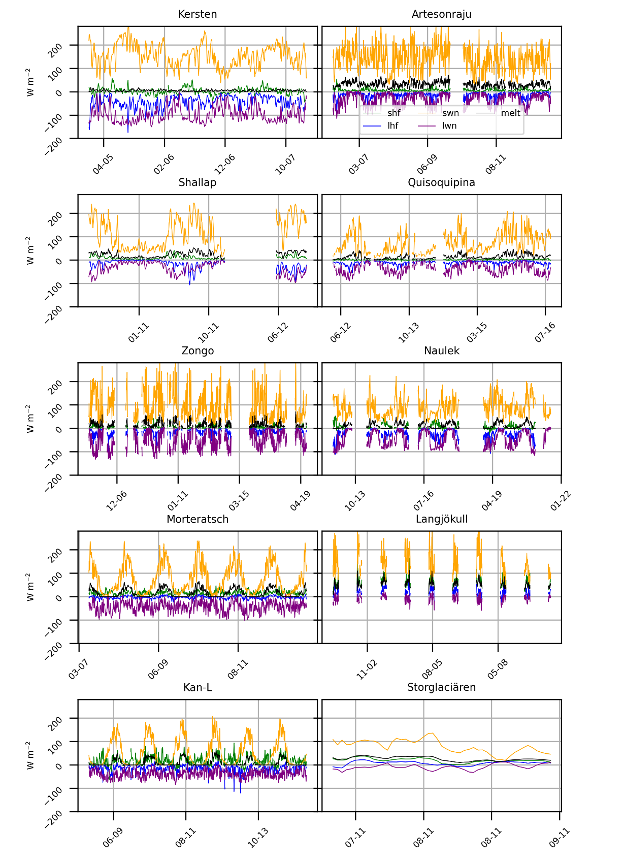
Figure S1. Surface energy balance terms at the different glacier Automatic Weather Stations (AWSs). Note that shf is the sensible heat flux; lhf is the latent heat flux; swn is the net shortwave radiation; lwn is the net longwave radiation; and melt is the energy available for melting.

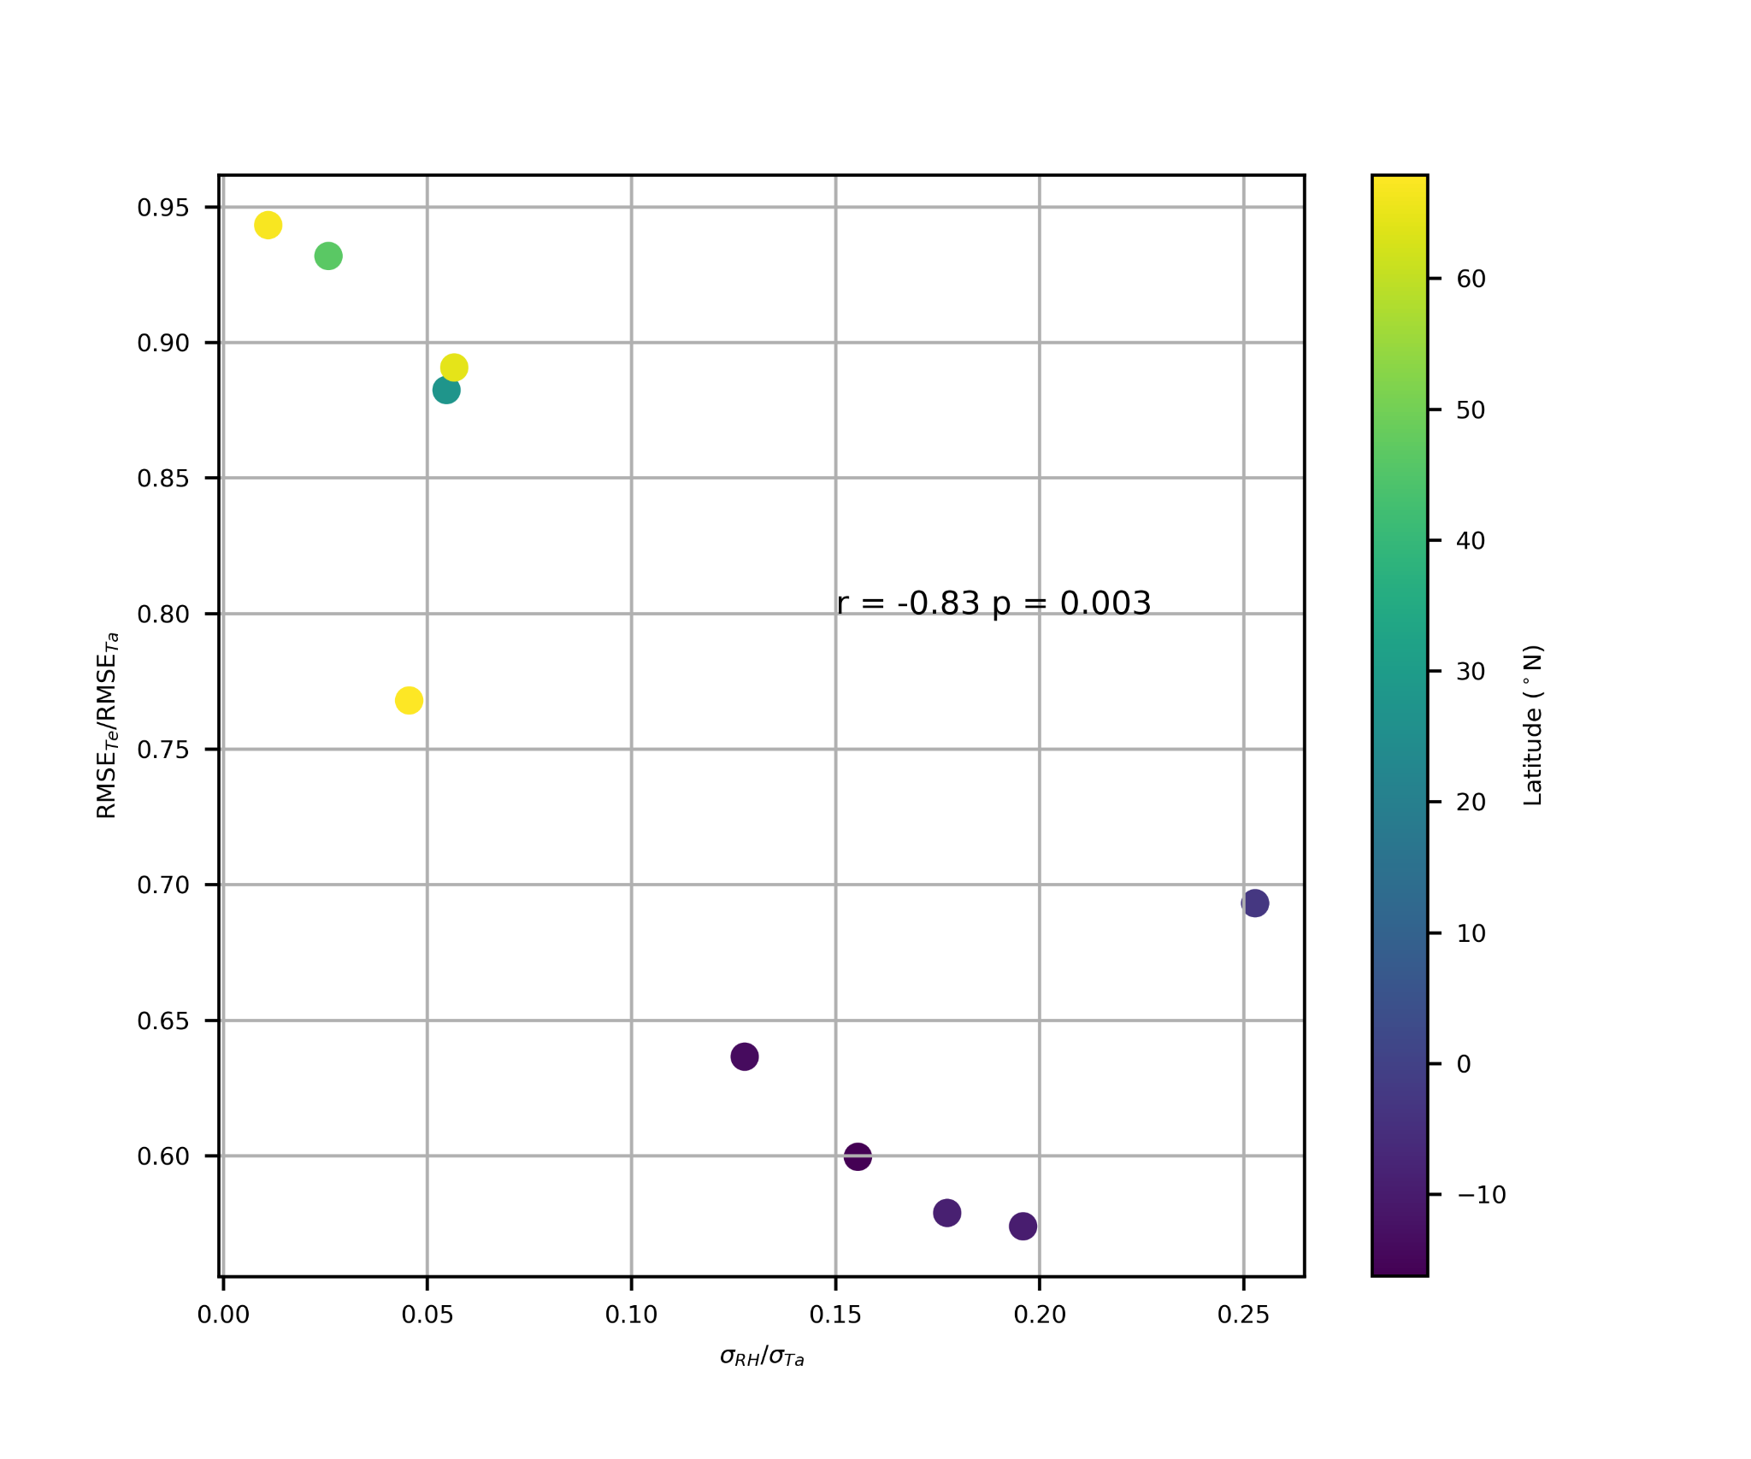
Figure S2. The ratio of the standard deviation in daily mean relative humidity ($RH$) to the standard deviation of $Ta$ (abscissa) versus the ratio of errors in modelling the temperature dependent heat flux ($ψ$), using $Te$ compared to $Ta$ (ordinate). Smaller error ratios indicate larger improvements in model performance. Note that scatter points are colored according to their latitude (°N); and the Pearson correlation (r) between the ratios is annotated, along with its p value.

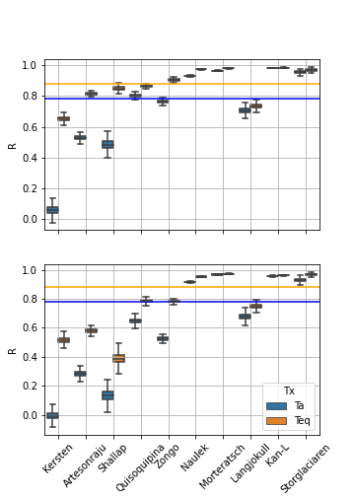
Figure S3. Pearson correlations between daily mean ERA5 (top) and NCEP (bottom) reanalysis $Ta$ and $Te$ with observations from the glacier AWSs. Note that these box and whisker plots were computed by performing a 10,000 iteration bootstrap to generate an ensemble of correlation coefficients for each site. Horizontal lines indicate the median correlation for $Ta$ (blue) and $Te$ (orange) across locations. Locations are plotted (left to right) in the order of increasing distance from the equator. Kersten-Naulek are in the tropics/subtropics.

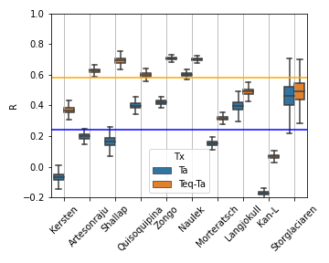
Figure S4. Pearson correlations between daily mean ERA5 ‘latent temperature’ ($Te-Ta$: proportional to the specific humidity) and sublimation (orange); and between air temperature ($Ta$) and sublimation (blue).

References
1. Hock, R. Glacier melt: a review of processes and their modelling. Prog. Phys. Geogr. Earth Environ. 29, 362–391 (2005).
2. Klok, E. J. (Lisette) & Oerlemans, J. Model study of the spatial distribution of the energy and mass balance of Morteratschgletscher, Switzerland. J. Glaciol. 48, 505–518 (2002).
3. de Kok, R. J. et al. Measurements, models and drivers of incoming longwave radiation in the Himalaya. Int. J. Climatol. 0, (2019).
4. Pfeffer, W. T. et al. The Randolph Glacier Inventory: a globally complete inventory of glaciers. J. Glaciol. 60, 537–552 (2014).

