SUPPLEMENTARY INFORMATION
Supplementary Tables:
Supplementary Table S1: Kendall’s rank correlation per TE type. Correlation and partial (in brackets) correlations were performed per TE type. Significant values are highlighted in bold.
 | GC (partial) | CpG.cov (partial) | Gene.cov (partial) | Rec.rate (partial)
LTR | -0.08****  (0.01) | -0.07****  (-0.01) | -0.12****  (-0.10****) | -0.16****  (-0.14****)
LINE | 0.09****  (0.08****) | 0.02*  (-0.01) | 0.01  (-0.01) | 0.02*  (-0.01)
SINE | -0.13****  (-0.10****) | -0.04****  (-0.002) | -0.02  (0.02) | -0.10****  (-0.06****)
DNA | -0.03**  (0.01) | -0.02  (0.01) | -0.04***  (-0.03***) | -0.11****  (-0.10****)

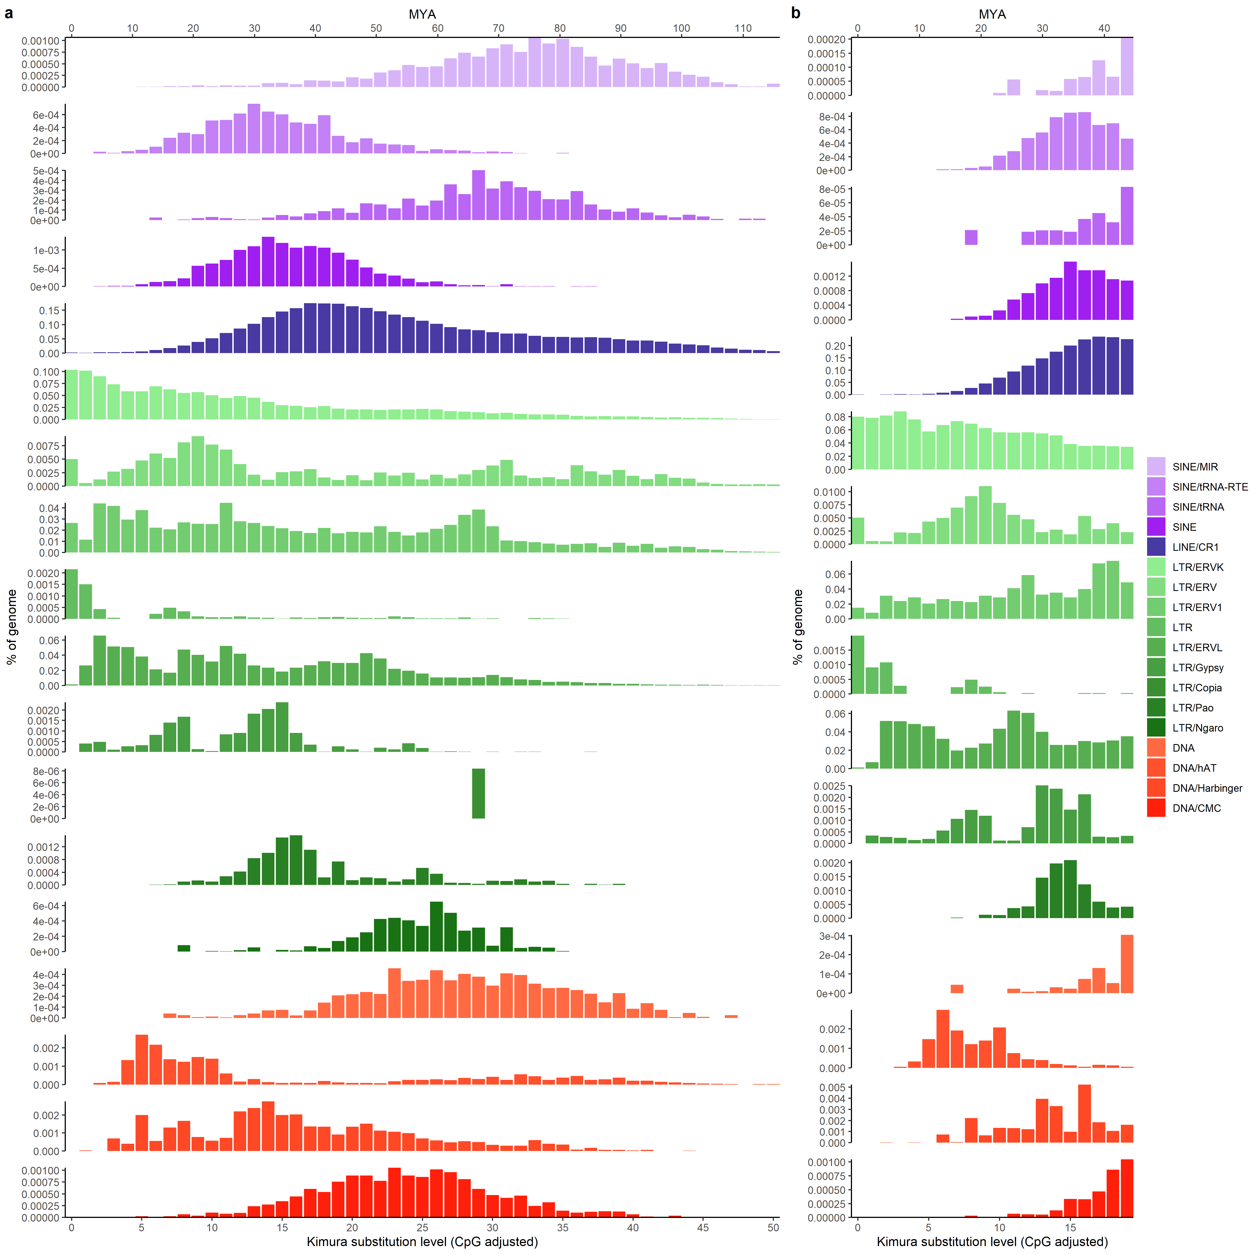
Supplementary figures:
Supplementary Figure S1: interspersed repeat landscape of the blackcap genome separately plotted per family. Plots not to scale on the Y axis to visualise distribution patterns of repeat families with generally lower % coverage. a) Repeat landscape calculated by RepeatMasker on the raw output. b) Repeat landscape calculated on the final TE annotation. The bottom x-axis is the kimura-2 substitution level, the top x-axis is the timescale in million years ago (MYA), and the y-axis is the percentage of the genome occupied.

