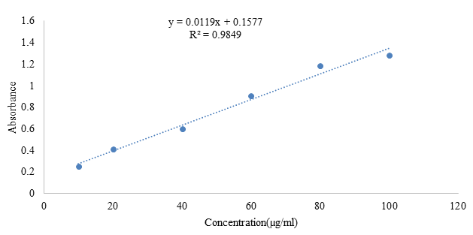
Figure 1. Calibration curve of Standard Gallic acid

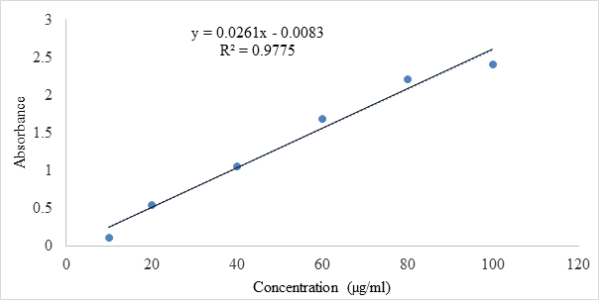
Figure 2. Calibration curve of Standard Quercetin

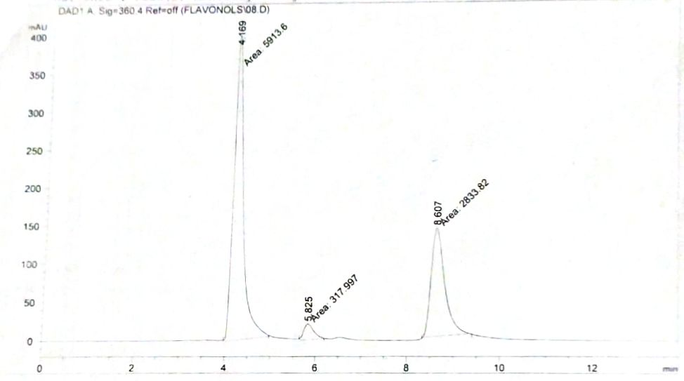

Figure 3. Standard spectra of flavonolic compounds

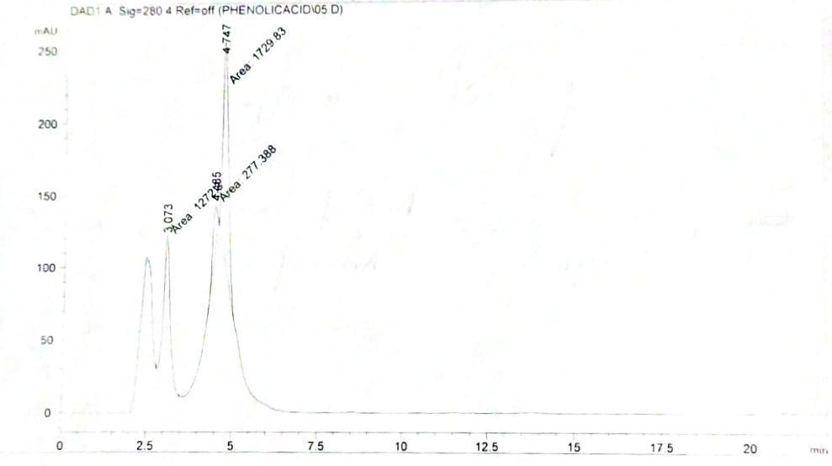

Figure 4. Standard spectra of phenolic compounds

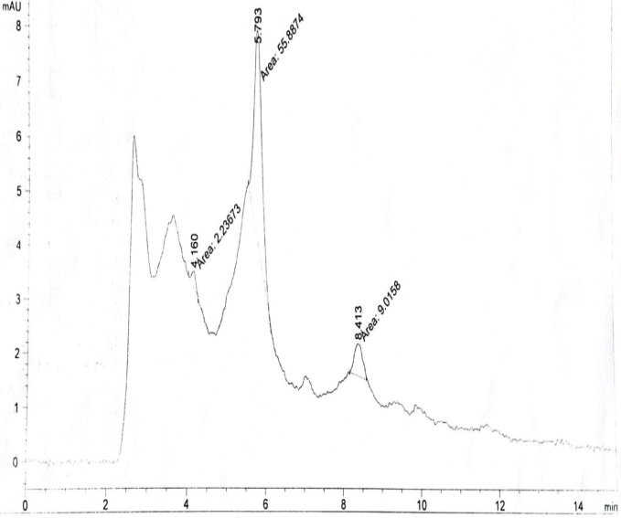

Figure 5. Spectra of flavonolic compounds detected in Cyperus iria aqueous-ethanol extract

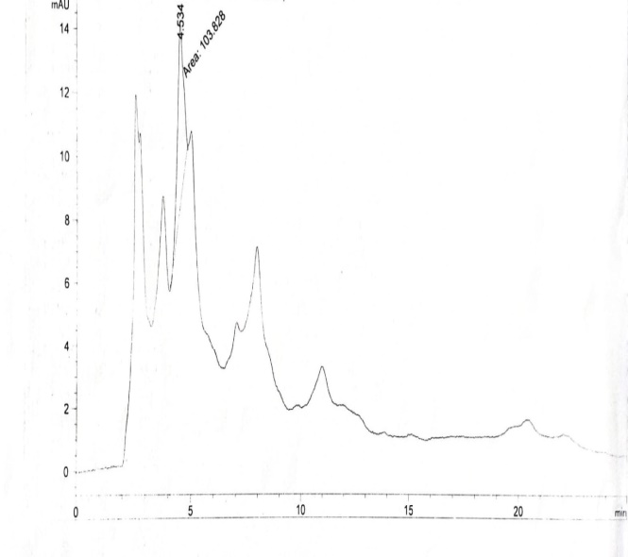
Figure 6. Spectra of phenolic compound detected in Cyperus iria aqueous-ethanol extract

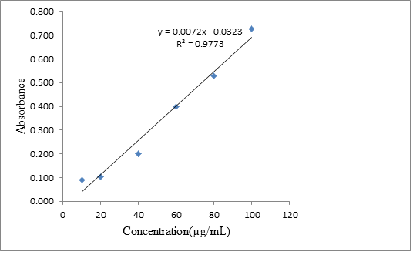
Figure 7. Standard curve of Ascorbic acid

Table 1. Phytochemical analysis of aqueous ethanolic extract of Cyperus iria
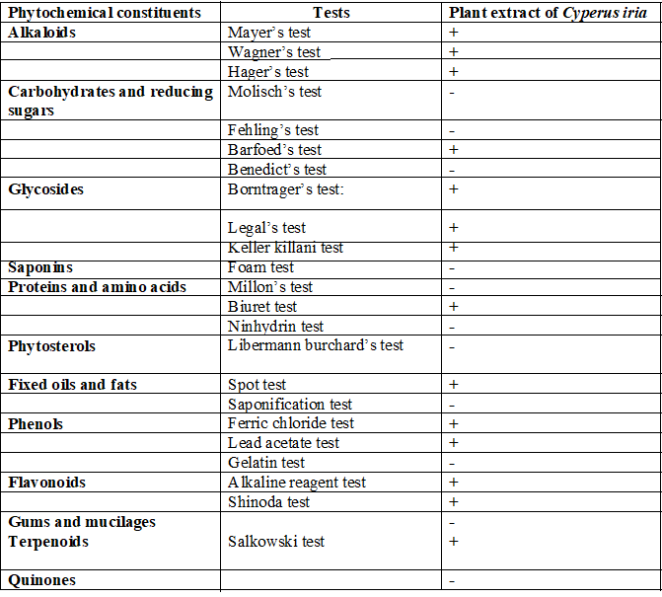
+ indicates presence and ₋ represents absence

Table 2. Effect of Cyperus iria aqueous-ethanol extract on ALP levels in STZ induced diabetic rats (n=5)

PCG | NCG | DCG | E125 | E250 | E500
118. | 90. | 184. | 167. | 150. | 132.
117. | 94. | 191. | 172. | 151. | 129.
123. | 91. | 189. | 174. | 149. | 120.
124. | 89. | 184. | 169. | 156. | 130.
117. | 92. | 186. | 170. | 143. | 128.

Table 3. Effect of Cyperus iria aqueous-ethanol extract on ALT levels in STZ induced diabetic rats (n=5)

PCG | NCG | DCG | E125 | E250 | E500
65. | 46. | 131. | 117. | 103. | 82.
67. | 48. | 137. | 119. | 99. | 82.
64. | 47. | 129. | 120. | 103. | 79.
69. | 46. | 144. | 112. | 107. | 81.
61. | 52. | 151. | 126. | 98. | 81.

Table 4. Effect of Cyperus iria aqueous-ethanol extract on AST levels in STZ induced diabetic rats (n=5)
PCG | NCG | DCG | E125 | E250 | E500
165. | 147. | 223. | 215. | 201. | 185.
169. | 144. | 220. | 210. | 202. | 188.
160. | 144. | 207. | 208. | 207. | 192.
171. | 142. | 211. | 210. | 200. | 187.
168. | 145. | 217. | 212. | 209. | 187.

Table 5. Effect of Cyperus iria aqueous-ethanol extract on total cholesterol levels in STZ induced diabetic rats (n=5)

PCG | NCG | DCG | E125 | E250 | E500
81. | 75. | 198. | 134. | 120. | 98.
85. | 69. | 200. | 134. | 124. | 101.
87. | 67. | 207. | 136. | 122. | 97.
89. | 72. | 207. | 131. | 126. | 100.
89. | 74. | 211. | 130. | 124. | 98.

Table 6. Effect of Cyperus iria aqueous-ethanol extract on creatinine levels in STZ induced diabetic rats (n=5)

PCG | NCG | DCG | E125 | E250 | E500
0.70 | 0.45 | 0.97 | 0.90 | 0.80 | 0.70
0.70 | 0.40 | 0.99 | 0.91 | 0.84 | 0.60
0.61 | 0.49 | 0.97 | 0.89 | 0.85 | 0.72
0.69 | 0.46 | 0.98 | 0.89 | 0.83 | 0.68
0.68 | 0.47 | 0.93 | 0.90 | 0.80 | 0.70

Table 7. Effect of Cyperus iria aqueous-ethanol extract on C reactive protein levels in STZ induced diabetic rats (n=5)
PCG | NCG | DCG | E125 | E250 | E500
2.99 | 2.21 | 4.38 | 4.01 | 3.75 | 3.43
2.94 | 2.20 | 4.39 | 4.11 | 3.69 | 3.38
2.97 | 2.24 | 4.44 | 3.99 | 3.71 | 3.39
2.97 | 2.22 | 4.39 | 4.22 | 3.70 | 3.42
2.93 | 2.23 | 4.42 | 4.37 | 3.71 | 3.10

Table 8. Effect of Cyperus iria aqueous-ethanol extract on HDL levels in STZ induced diabetic rats (n=5)
PCG | NCG | DCG | E125 | E250 | E500
24. | 28. | 17. | 17. | 19. | 22.
23. | 28. | 16. | 18. | 18. | 21.
24. | 29. | 15. | 20. | 20. | 21.
20. | 30. | 17. | 17. | 17. | 19.
23. | 29. | 15. | 16. | 20. | 22.

Table 9. Effect of Cyperus iria aqueous-ethanol extract on insulin levels in STZ induced diabetic rats (n=5)
PCG | NCG | DCG | E125 | E250 | E500
0.60 | 0.69 | 0.44 | 0.50 | 0.54 | 0.59
0.61 | 0.68 | 0.42 | 0.48 | 0.53 | 0.58
0.60 | 0.67 | 0.40 | 0.49 | 0.54 | 0.57
0.62 | 0.68 | 0.44 | 0.49 | 0.53 | 0.58
0.63 | 0.69 | 0.41 | 0.48 | 0.52 | 0.59

Table 10. Effect of Cyperus iria aqueous-ethanol extract on LDL levels in STZ induced diabetic rats (n=5)
PCG | NCG | DCG | E125 | E250 | E500
56. | 33. | 168. | 127. | 90. | 65.
52. | 35. | 177. | 134. | 95. | 69.
55. | 38. | 178. | 129. | 101. | 67.
50. | 33. | 164. | 120. | 89. | 65.
57. | 31. | 170. | 131. | 92. | 69.

Table 11. Effect of Cyperus iria aqueous-ethanol extract on total lipids in STZ induced diabetic rats (n=5)
PCG | NCG | DCG | E125 | E250 | E500
377. | 345. | 447. | 422. | 401. | 393.
372. | 347. | 445. | 421. | 398. | 388.
369. | 345. | 449. | 420. | 401. | 390.
375. | 351. | 451. | 421. | 407. | 381.
376. | 349. | 447. | 425. | 394. | 389.

Table 12. Effect of Cyperus iria aqueous-ethanol extract on triglyceride levels in STZ induced diabetic rats (n=5)
PCG | NCG | DCG | E125 | E250 | E500
85. | 74. | 127. | 120. | 117. | 101.
87. | 81. | 136. | 122. | 114. | 106.
86. | 74. | 131. | 121. | 115. | 99.
88. | 76. | 132. | 120. | 115. | 98.
85. | 76. | 134. | 121. | 112. | 101.

Table 13. Effect of Cyperus iria aqueous-ethanol extract on urea levels in STZ induced diabetic rats (n=5)
PCG | NCG | DCG | E125 | E250 | E500
38. | 35. | 49. | 48. | 44. | 40.
39. | 30. | 49. | 53. | 47. | 42.
37. | 32. | 51. | 49. | 45. | 40.
37. | 30. | 48. | 50. | 45. | 40.
39. | 31. | 48. | 51. | 43. | 43.

Table 14. Effect of Cyperus iria aqueous-ethanol extract on vLDL levels in STZ induced diabetic rats (n=5)
PCG | NCG | DCG | E125 | E250 | E500
29. | 18. | 34. | 37. | 35. | 32.
31. | 16. | 32. | 35. | 34. | 31.
31. | 17. | 34. | 36. | 36. | 32.
29. | 19. | 33. | 37. | 35. | 32.
28. | 18. | 31. | 38. | 32. | 33.

Table 15. Effect of Cyperus iria aqueous-ethanol extract on COX-2 levels in STZ induced diabetic rats (n=5)

PCG | NCG | DCG | E125 | E250 | E500
347.43 | 158.30 | 459.60 | 408.73 | 368.30 | 356.00
352.65 | 147.00 | 452.21 | 403.95 | 371.34 | 357.89
344.39 | 152.65 | 470.91 | 379.17 | 374.82 | 357.43
349.60 | 154.82 | 443.08 | 407.00 | 370.00 | 358.30
366.13 | 143.08 | 463.08 | 409.17 | 367.89 | 357.00

Table 16. Effect of Cyperus iria aqueous-ethanol extract on TNF-α levels in STZ induced diabetic rats (n=5)
DCG | PCG | NCG | E125 | E250 | E500
22.16 | 11.17 | 6.69 | 21.96 | 17.81 | 15.82
22.26 | 11.09 | 6.51 | 20.15 | 18.42 | 15.82
22.29 | 11.12 | 6.44 | 14.63 | 19.08 | 15.54
22.69 | 10.89 | 6.56 | 21.14 | 17.66 | 15.80
22.95 | 12.34 | 6.46 | 19.82 | 19.51 | 14.78

Table 17. Effect of Cyperus iria aqueous-ethanol extract on IL-6 levels in STZ induced diabetic rats (n=5)
PCG | NCG | DCG | E125 | E250 | E500
477.23 | 334.15 | 1214.90 | 736.46 | 666.46 | 574.15
456.46 | 336.46 | 1234.92 | 833.38 | 642.61 | 571.84
480.30 | 458.00 | 1209.53 | 720.30 | 650.30 | 572.61
487.23 | 436.46 | 1168.76 | 767.23 | 666.46 | 574.15
491.07 | 319.53 | 1144.92 | 745.69 | 664.90 | 568.76

Table 18. Effect of Cyperus iria aqueous-ethanol extract on SOD activity in STZ induced diabetic rats (n=5)
PCG | NCG | DCG | E125 | E250 | E500
164.20 | 182.40 | 144.57 | 152.04 | 157.170 | 162.30
163.23 | 182.82 | 143.64 | 151.10 | 157.170 | 161.83
165.10 | 181.42 | 139.44 | 150.17 | 159.030 | 161.30
163.70 | 183.20 | 141.78 | 151.10 | 160.430 | 163.70
165.56 | 182.82 | 140.38 | 149.71 | 160.900 | 164.63

Table 19. Effect of Cyperus iria aqueous-ethanol extract on GSH-ST activity in STZ induced diabetic rats (n=5)
PCG | NCG | DCG | E125 | E250 | E500
108.61 | 130.73 | 50.40 | 76.422 | 92.68 | 95.93
106.99 | 131.70 | 37.39 | 73.170 | 89.43 | 96.91
109.26 | 130.08 | 60.16 | 89.430 | 79.67 | 94.95
107.64 | 129.10 | 34.10 | 66.660 | 86.17 | 96.58
108.94 | 131.38 | 56.91 | 73.170 | 86.17 | 94.63

Table 20. Effect of Cyperus iria aqueous-ethanol extract on glucoce tolerance in normal rats (n=5)
Time (min) | PCG | DCG | E125 | E250 | E500
0. | 134.2 | 149.0 | 112.8 | 132.0 | 142.0
30. | 136.6 | 288.6 | 123.4 | 163.2 | 176.6
60. | 238.0 | 240.6 | 200.8 | 220.0 | 244.0
90. | 160.0 | 195.2 | 139.2 | 119.2 | 122.4
120. | 115.2 | 176.4 | 122.0 | 114.4 | 109.4
180. | 110.2 | 160.0 | 110.8 | 113.6 | 107.2
210. | 96.8 | 142.4 | 104.4 | 102.6 | 98.6

