Spectroscape: Real-time Query and Visualization of a Spectral Archive of Millions of Tandem Mass Spectra

Long Wu^{1,2}, Ayman Hoque¹, Henry Lam^{1,*}

¹ Department of Chemical and Biological Engineering, The Hong Kong University of Science and Technology

² Department of Electrical and Computer Engineering, The Hong Kong University of Science and Technology

Supplementary Information

* Corresponding author

Henry Lam

Department of Chemical and Biological Engineering

The Hong Kong University of Science and Technology

Clear Water Bay

Hong Kong Special Administrative Region

China

Email: kehlam@ust.hk

Supplementary Methods

The FAISS IVF-PQ algorithm
The Facebook AI Similarity Search (FAISS) library, published in 2019, has implemented a number of indexing algorithms that enable fast retrieval of similar digital objects (e.g. images, texts) among a huge pool of candidates. We adapted one of them, named inverted file index product quantization (IVF-PQ) for tandem mass spectra. The first step, called the “inverted file index” step, is to divide a high-dimensional space where a vector representation of a spectrum resides into regions (called “buckets”). This is done in a “training” step by k-means clustering of a randomly selected sample of 100,000 spectra. In brief, the algorithm searches for the partition of the data points into $k$ buckets $\{C_{1}, C_{2}, C_{3}, …, C_{k}\}$ with corresponding centroids $\{c_{1}, c_{2}, c_{3}, …, c_{k}\}$ that minimizes the function:
$$D=\sum_{j=1}^{k}{\sum_{x∈C_{j}}{{\left\|x-c_{j}\right\|}^{2}}}$$In the variant that we used in this study (short-handed “IVF256,PQ16”), 256 buckets were used. Next, for each vector $x$ representing a spectrum, its nearest bucket centroid is found:
$$c\left(x\right)=\underset{c_{j}∈\left\{c_{1},…,c_{256}\right\}}{arg min}\left\|x-c_{j}\right\|$$
Here $c\left(.\right)$ is the function that maps a vector to its nearest centroid. The residual vector is computed:
$$r=x-c\left(x\right)$$
Then the spaces of the residual vectors are divided into 16 subspaces in the “product quantization” step, such that $r$ is represented by a direct sum of 16 256-dimensional vectors:
$$r=r^{1}⊕r^{2}⊕r^{3}⊕⋯⊕r^{16}$$
In our case, the decomposition into subspaces is achieved by randomly partitioning the 4096 bins along the m/z axis of the spectrum into 16 sets of 256 bins. Next, the 256-dimensional vectors in each of the subspace are further sorted into 256 “sub-buckets” by k-means clustering, similar to the IVF step. Finally, the residual vector is approximated by a direct sum of the centroids of the sub-buckets, $\hat{r}$:
$$r≈\hat{r}=c\left(r^{1}\right)⊕c\left(r^{2}\right)⊕c\left(r^{3}\right)⊕⋯⊕c\left(r^{16}\right)$$
The spectrum vector is finally approximated by:
$$x= c\left(x\right)+r≈c\left(x\right)+\hat{r}=c\left(x\right)+\left[c\left(r^{1}\right)⊕c\left(r^{2}\right)⊕c\left(r^{3}\right)⊕⋯⊕c\left(r^{16}\right)\right]$$
The “address” of the spectrum vector is simply a concatenation of the bucket number and the 16 sub-bucket numbers. Both the bucket number and the sub-bucket number have 256 possible values, so each can be specified in 1 byte. Hence, the address is 17-byte long.
At query time, the query spectrum undergoes the same spectrum preprocessing steps, and its vector representation $y$ is computed. The address is found by the same algorithm, as follows:
$$s=y-c\left(y\right)$$
$$y=c\left(y\right)+s≈c\left(y\right)+\hat{s}=c\left(y\right)+\left[c\left(s^{1}\right)⊕c\left(s^{2}\right)⊕c\left(s^{3}\right)⊕⋯⊕c\left(s^{16}\right)\right]$$
where $s$ is the residual vector of $y$, and $\hat{s}$ is the approximation of $s$ based on the direct sum of centroids. To retrieve approximate nearest neighbors, the algorithm first finds the $M$ nearest bucket centroids ($M$ can be set by the query-time parameter nprobes), and collects all the existing addresses (each corresponding to a spectrum in the spectral archive) in those buckets. These are the candidates of the approximate nearest neighbors. However, instead of returning all these candidates, the algorithm performs efficient approximate dot product calculations between the query’s address and the candidates’ addresses:
$$x∙y=\left(c\left(x\right)+r\right)∙\left(c\left(y\right)+s\right)=c\left(x\right)∙c\left(y\right)+c\left(x\right)∙s+r∙c\left(y\right)+r∙s \\ ≈c\left(x\right)∙c\left(y\right)+c\left(x\right)∙\hat{s}+\hat{r}∙c\left(y\right)+\hat{r}∙\hat{s}$$
Note that the dot product of two direct sums is distributive (provided the subspaces are the same), and can be written as a direct sum of dot products, e.g.:

$$\hat{r}∙\hat{s}=\left[c\left(r^{1}\right)⊕c\left(r^{2}\right)⊕c\left(r^{3}\right)⊕⋯⊕c\left(r^{16}\right)\right]∙\left[c\left(s^{1}\right)⊕c\left(s^{2}\right)⊕c\left(s^{3}\right)⊕⋯⊕c\left(s^{16}\right)\right]$$
$$=\left[c\left(r^{1}\right)∙c\left(s^{1}\right)\right]⊕\left[c\left(r^{2}\right)∙c\left(s^{2}\right)\right]⊕\left[c\left(r^{3}\right)∙c\left(s^{3}\right)\right]⊕⋯⊕\left[c\left(r^{16}\right)∙c\left(s^{16}\right)\right]$$
Thus, the approximate dot product is calculated by summing inter-centroid dot products. Since the centroids are known at training, all inter-centroid dot products can be computed beforehand and stored in a lookup table. Therefore, no multiplication is necessary and only about 50 additions are required for each approximate dot product calculation. This is further accelerated by parallel computing in GPUs. The algorithm then returns the most similar 1,024 approximate nearest neighbors (ANNs) among the candidates, as ranked by this approximate dot product.
To improve the recall, multiple distinct indices can be generated for the same spectral archive. To produce a different index, a different random sample of spectra is used in the training, and a different random partitioning of bins is used during the decomposition into subspaces in the product quantization step. At query time, each index will return its own set of 1,024 ANNs, many, but not all, of which will be common between indices. The union of the ANNs returned by all indices are passed to the next step for true dot product calculations and clustering.
In summary, the IVF-PQ algorithm approximates each spectrum vector as a sum of centroids for efficient dot product calculations. The address is 17-byte long, which means the addresses of 1 billion spectra can fit in 17 GB in principle, small enough to be loaded into memory for most modern computers for fast processing. In terms of time complexity, retrieval of ANNs is expected to scale linearly with the archive size. This is because the number of spectra in each bucket, and hence the number of candidates for approximate dot product calculations, is expected to grow linearly with archive size. The efficient and parallelizable nature of the algorithm, however, helps to keep the running time manageable, especially with continuous hardware improvement (e.g., addition of more GPUs). Moreover, as more and more spectra are accumulated in spectral repositories, an increasing fraction of them (at least in their preprocessed and vectorized forms) will be identical or nearly identical, as they should ultimately originate from a finite set of observable peptide ions. Future development of the algorithm should aim to reduce this redundancy.

Optimization of the FAISS IVF-PQ algorithm for spectral archives
There are two hyper-parameters in the IVF-PQ algorithm to be optimized, nprobes and nindices. The former controls the number of nearby buckets to look into for each query, and the latter is the number of indices used in the spectral archive. Increasing nprobes and nindices will lead to higher recall, at the expense of computational time. We tested the retrieval performance of Spectroscape on settings of nindices ranging from 1 to 6, and nprobes ranging from 1 to 64 (Supplementary Figure 1). The overall recall of 10,000 randomly chosen queries was used as the metric. Although perfect per query recall (100%) is possible for higher values of nprobes and nindices, there is a diminishing improvement in recall as one increases nindices beyond 2 and nprobes beyond 8. Therefore the optimal hyper-parameter setting was chosen to be nprobes = 8 and nindices = 2, resulting in an overall recall over 97.5%. It should also be noted that perfect recall is not necessary for our application, as in a vast majority of cases, the identity of a query spectrum can be clearly determined provided we have a substantial fraction TNNs retrieved, since most spectra occur repeatedly in many replicates. Losing a few of them in the retrieval process will not materially affect the final outcome.

True Dot Product Calculations
As described in the main text, the query spectrum is represented as 50 mz values, sorted by intensity in decreasing order and stored in the MZ file:
$$q=\left\{mz_{0}, mz_{1}, …, mz_{49}\right\}, mz_{i}∈\{0,1,…,65535\}$$
Here, 65535 is the largest integer that can be stored in 2 bytes, so we took maximum advantage of it to store the real m/z values ${mz}_{i, real}$as accurately as possible:
$${mz}_{i}=\left\lfloor \frac{{mz}_{i, real}}{2000}×65535\right\rfloor$$
where $\left\lfloor ∙\right\rfloor$ is the floor function. (We consider 2000 to be the maximum m/z value of a typical peptide tandem mass spectrum, and the rare m/z values beyond 2000 will be recorded as 65535.) This enables us to maintain higher m/z compared to the 4096-dimension vector used for index building. Thus, the spectrum q is vectorized by binning the m/z axis into 65536 bins (with bin width 2000/65536 = 0.0305 m/z), resulting in a 65536-dimension vector $V(q)$:
$$V\left(q\right)=(v_{0},v_{2},v_{3},v_{4},…,v_{65535})$$
$$v_{k}=\left\{\begin{matrix}\begin{matrix}50-i & if k=mz_{i}\end{matrix} \\ \begin{matrix}0 & otherwise\end{matrix}\end{matrix}\right.$$
For calculating the accurate dot product, the query spectrum and the ANNs are retrieved from the MZ files. Then only the query spectrum is vectorized as described above. To mimic a wider m/z tolerance than the bin width, the same rank-transformed intensity ($50 – i$) is placed into neighboring bins for the query spectrum. For example, by default, a fragment ion m/z tolerance of approximately $±0.045$Da is used for HCD spectra in Spectroscape, which is accomplished by filling the bins between $mz_{i}-1$ and $mz_{i}+1$ with the same rank-transformed intensity for each occupied bin at $mz_{i}$. Finally, the dot product between $V(q)$ and one of its ANNs, $s$, is calculated as:
$$dp\left(s,q\right)=\sum_{mz_{i}∈s}{\left(50-i\right)v_{mz_{i}}}, v_{mz_{i}}∈V(q)$$
This efficient dot product calculation avoids any comparison of m/z values, and the vectorization of the spectra of the ANNs. The only steps required is to generate $V\left(q\right)$ from the query spectrum q, and the dot product calculation which requires 50 multiplications and 49 additions.
For determining the whole cluster structures among the retained TNNs, pairwise accurate dot product calculations are necessary. To do so, each of the TNNs take the place of the query spectrum q in the above algorithm.

Visualization and Force-directed Graph Drawing
Spectroscape displays the queried spectrum as a node in a graph, together with the top N true nearest neighbors (where N is 20 by default but can be adjusted at query time) in its “neighborhood.” The true nearest neighbors (TNNs) were obtained by calculating accurate dot products between the query and the retrieved ANNs. For the displayed nodes of TNNs, pairwise dot product calculations were performed to determine if they should be joined by an edge. The length of the edge is initialized to a function of the Euclidean distances between the vectorized spectra, as computed by:
$$d=\sqrt{x^{2}+y^{2}-2x⋅y}$$
If we assume vector $x, y$ are normalized, that is $x^{2}=y^{2}=1$, then
$$d=\sqrt{1+1-2x⋅y}=\sqrt{2\left(1-x⋅y\right)}$$
where $x⋅y$ is the dot product, and $0<d<\sqrt{2}$. Only edges corresponding to distances below a certain threshold, which defaults to 0.8 but can be user-specified.
However, instead of keeping the edge lengths as the calculated Euclidean distances between the spectra, the graph of nodes (representing spectra) is plotted using a force-directed graph algorithm, implemented in D3.js (https://d3js.org/), which is a free JavaScript library focused on interactive data visualization. The idea is to run a physical simulation in which nodes are spheres of mass $m=1$ unit, and charge $c=1$ unit and edges are massless springs with desired link distance $l$ and spring constant $k=1$ unit. The elastic force between two joined nodes can be calculated by Hooke’s law:
$$F=-kΔl$$
and the repulsion between two charged spheres can be calculated by Coulomb’s law.
$$F=-k_{e}\frac{q_{1}q_{2}}{l^{2}}$$
In addition, a gravity force pointing to the center of the drawing canvas is included to balance the repulsive force. The node corresponding to the query spectrum is fixed at the center and displayed as a larger circle than the neighbors. Starting from any initial state, the whole system will evolve with Newton’s law of motion, where the acceleration is used to update the velocity, and velocity is used to update the position of the node. This simulation will reach an equilibrium where every node’s net force added up to zero. After some testing to optimize for simulation speed, the length of the edge (the massless spring) is initialized to be a logistic transformation of the Euclidean distance:
$$l=30+\frac{80}{1+e^{20d-12}}$$
Force-directed graph drawing can minimize crossing edges and overlapping nodes in graph drawing. More importantly, it has the effect of clearly displaying clusters of densely-connected nodes, while sending loosely-connected nodes farther away, facilitating the detection of sub-clusters, outliers and bridges.
The user can also choose to disconnect the edges between neighbors regardless of their similarities, so the resulting graph is star-shaped with the query spectrum in the middle. The cluster structure will not come into play. Concentric circles marking a scale of Euclidean distances from the center (query) node can be overlaid on the graph for easy visualization (second screenshot of Supplementary Figure 3).
Mousing over any node will display information about the node, including its identification (if any), precursor m/z, confidence of identification (shown as PeptideProphet and iProphet probabilities), source file and scan number, etc. Single-clicking any node will display its corresponding full spectrum in a spectrum viewer, with peak annotation if the identification is known. The user can also further explore the displayed “neighborhood” by double clicking on any node, which will initiate a new query with the clicked node as the query spectrum, replacing the old one. Alternatively (in an option available in a menu opened by right-clicking), one can expand the neighborhood by adding neighbors of any clicked node, without replacing the old graph.
An option also exists for the user to enter a peak list into the web interface in a text box (in which each line is a peak represented by the m/z and the intensity, separated by space), and search it against the archive. This query spectrum is not added into the archive, but Spectroscape will retrieve its nearest neighbors among all spectra in the archive and display them as nodes in clusters (third screenshot in Supplementary Figure 3).

Supplementary Figures
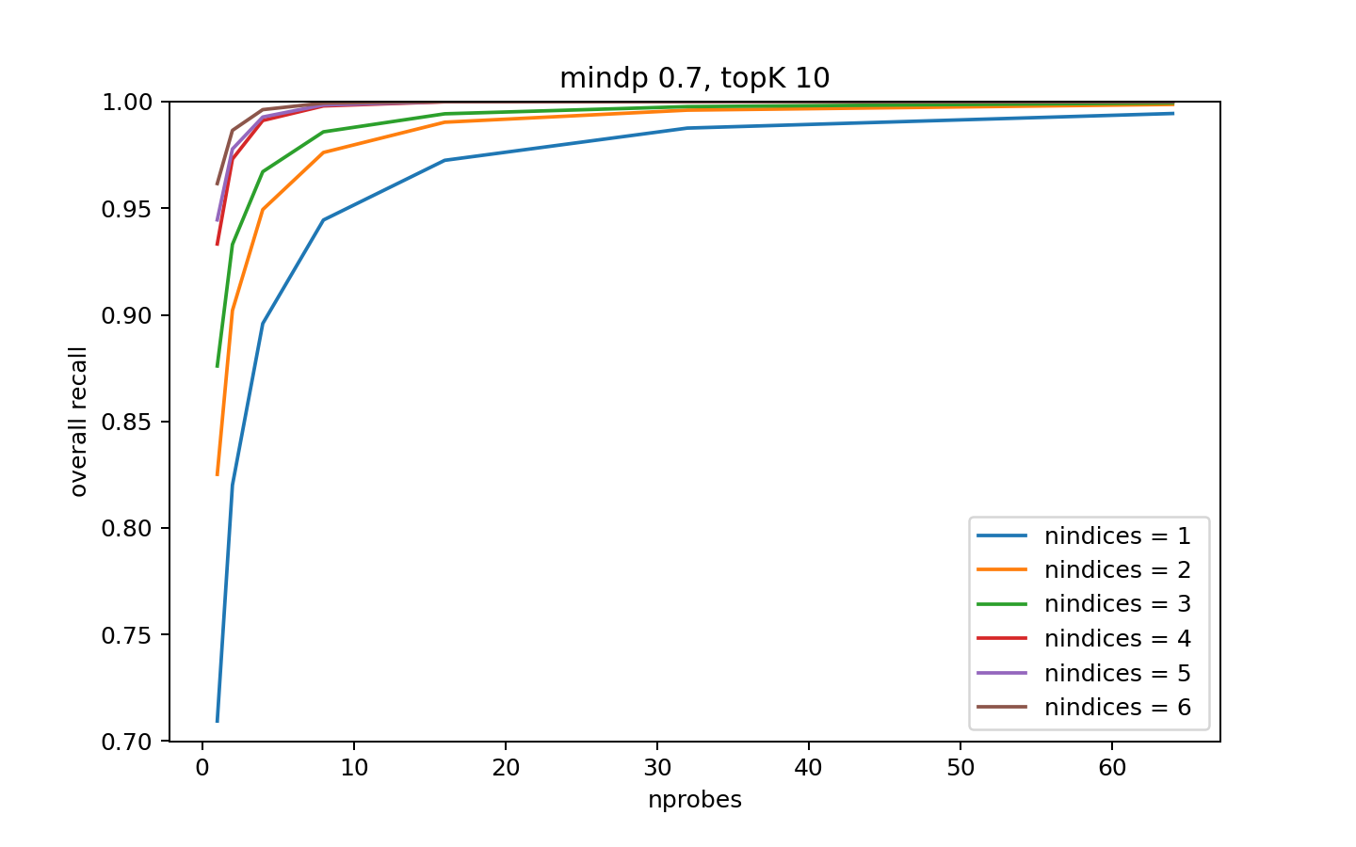
Supplementary Figure 1 | Optimization of the hyper-parameters nprobes and nindices. The overall recall of a randomly selected set of 10,000 queries was determined for each parameter setting. As shown, the overall recall improves when nprobes and nindices increase, but the improvement diminishes quickly beyond nprobes = 8 and nindices = 2. To strike a balance between recall and efficiency, the hyper-parameter setting of nprobes = 8 and nindices = 2 was chosen for this study. The overall recall is defined as:
$$R_{overall}=\frac{\sum_{i=1}^{10000}{|A\left(q_{i}\right)∩T(q_{i},N,t)|}}{\sum_{i=1}^{10000}{|T(q_{i}, N, t)|}}$$
where $A\left(q_{i}\right)$ is the set of retrieved ANNs of the i-th query, and $T(q_{i},N,t)$ is the set of retained TNNs of the i-th query. The minimum dot product threshold to be retained as TNN, $t$, is set to be 0.7, and the maximum number of TNNs retained for each query, $N$, is set to be 10.

a
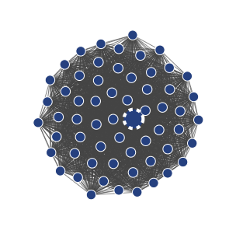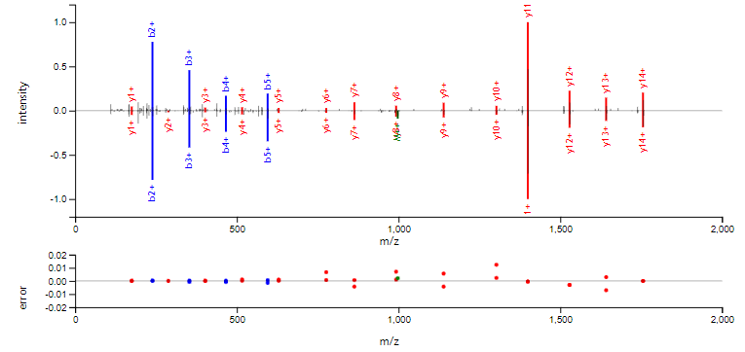
b
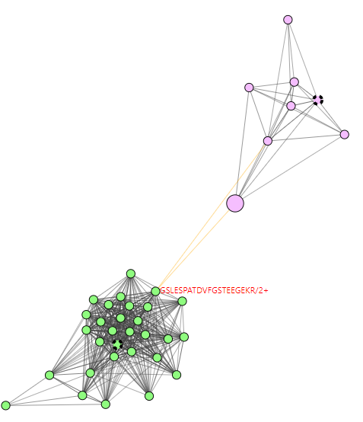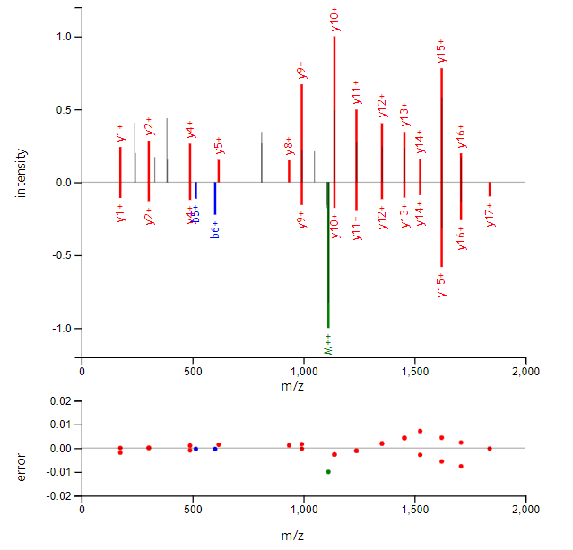
Supplementary Figure 2. More examples of visualized spectrum clusters by Spectroscape. (a) The consensus library spectrum is near the center of a cluster, shown as the node with dashed outline. This represents the ideal scenario where the replicate spectra are all highly similar to each other, and the averaging scheme to produce the consensus spectrum works as intended. On the right, a butterfly plot showing the spectrum-spectrum match between the library spectrum (down) and one of the replicates (up, its node indicated by red arrow). As shown, even for a neighbor at the edge of the cluster, the spectra are extremely similar. (b) Two clusters colored by pink and green are connected with orange edges, which indicate a precursor mass difference. The spectra in pink and green are identified to peptide KGSLESPATDVFGSTEEGEKR/2, and GSLESPATDVFGSTEEGEKR/2, respectively, the leading K being the only difference and accounting for the precursor mass difference. The butterfly plot on the right shows that the two spectra share many y ions but no b-ions due to the difference at the N-terminus.
Supplementary Figure 3 | Screenshots showing the features of Spectroscape. Detailed descriptions are below each screenshot.
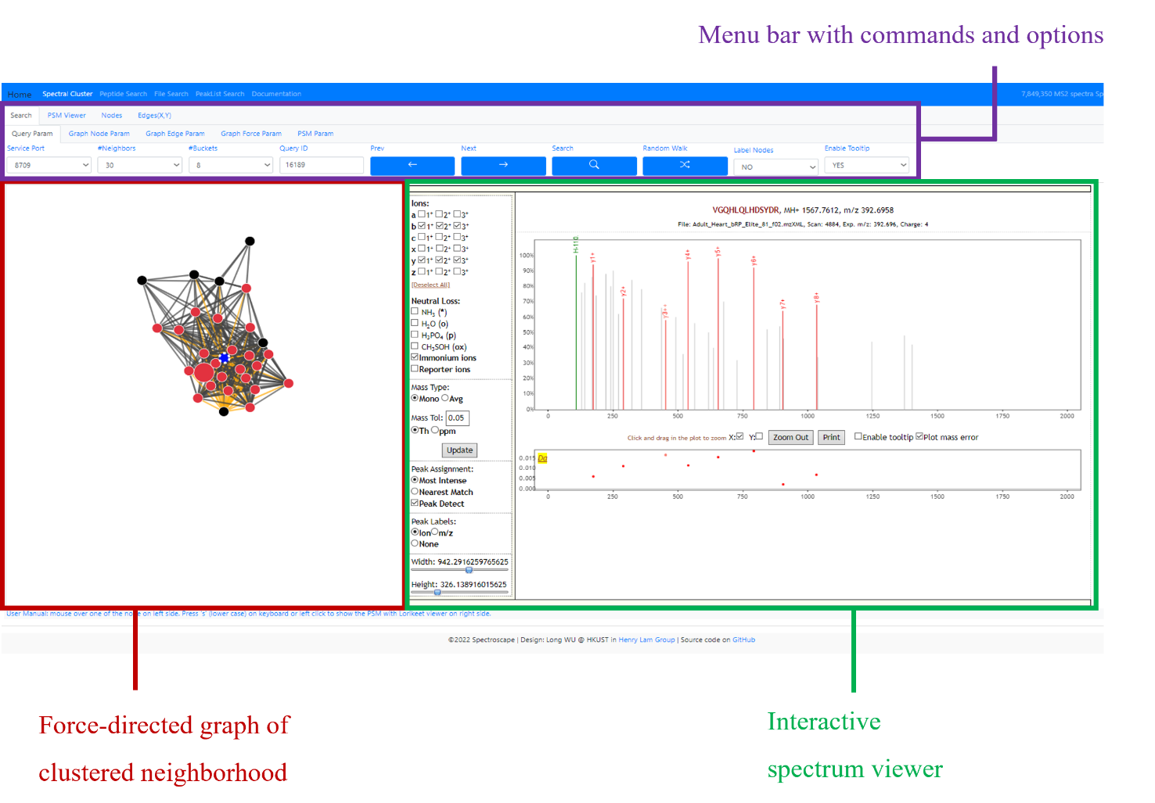
The default interface. The left pane (red box) shows a force-directed graph depicting the clustered "neighborhood" of the query spectrum. The default setting shows the 20 "true" nearest neighbors (small circles).. The interactive Lorikeet viewer (green box) on the right shows the 50-peak rank-transformed spectrum of the query (annotated with its putative identification loaded into the archive). A menu bar with many commands and options for the user to execute new queries, explore the archive and customize Spectroscape is on top (purple box).
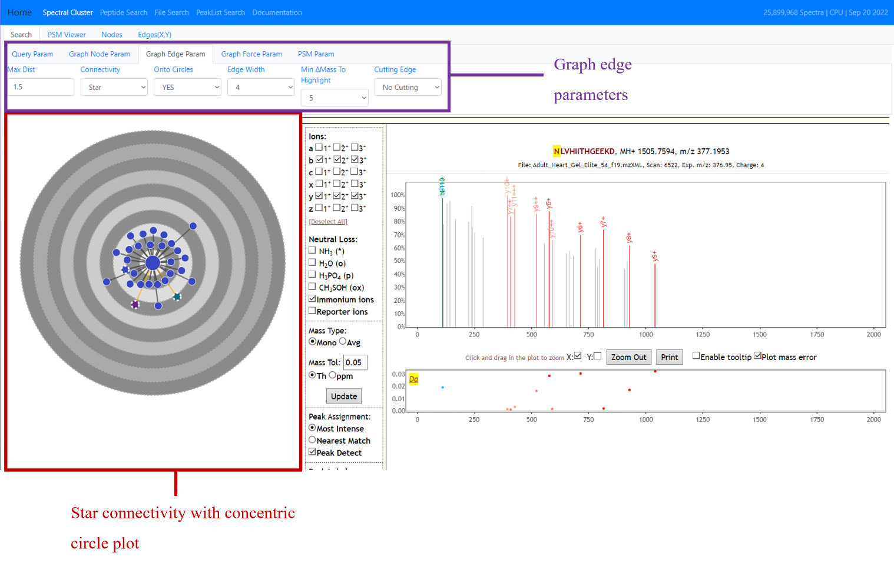
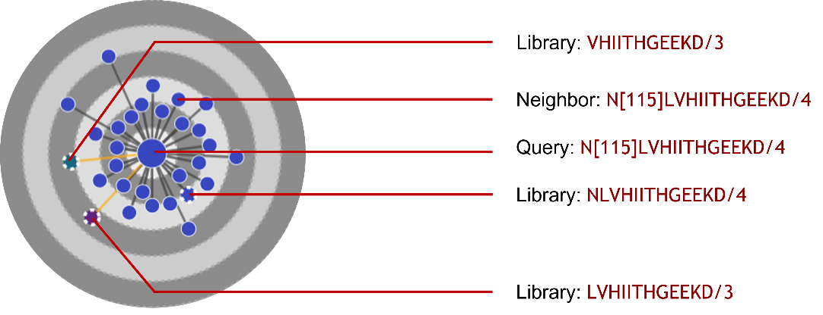
The star connectivity with concentric circle plot. The user can use this visualization feature by selecting “Star” in the “Connectivity” menu in the graph edge parameters (purple box). The star visualization shows only nodes connected to the query node as opposed to all edges between "neighbor" nodes. The concentric circle visualization places each neighboring node into an "orbit" divided according to a dot-product threshold. The star connectivity plot is better for showing the neighbors in the order of similarity. The zoomed-in picture below shows that the query (identified to N[115]LVHIITHGEEKD/4 where N[115] is deamidated asparagine) has neighbors of slightly different sequences, including the library spectrum of unmodified NLVHIITHGEEKD/4 and the library spectra of the N-terminal truncated peptides LVHIITHGEEKD/3 and VHIITHGEEKD/3 of different charge states further away. The orange edges indicate a difference in precursor mass between nodes. The mass difference of deamidation (+1 Da), on the other hand, is within the user-defined tolerance for precursor mass difference (5 Da as shown above as parameter “minimum $Δ$mass to highlight”), is therefore shown as black.
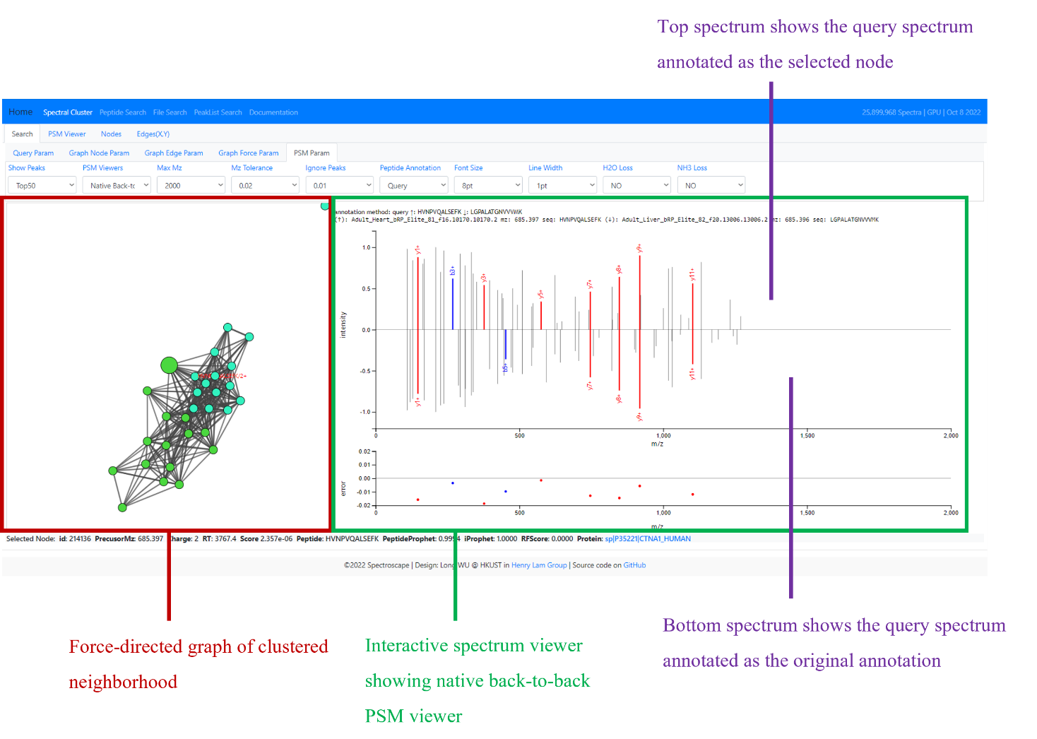
The “butterfly” spectrum-to-spectrum match viewer. Two spectra can be shown “head-to-tail” for easier comparison, and each can be re-annotated with respect to the identification of the other node. The bottom spectrum is of the query node, which is identified by the search engine as LGPALATGNVVVMK/2. The top spectrum is that of the query spectrum annotated as the selected query node which was identified as HVNPVQALSEFK/2. This feature is helpful for correcting the identification of a query node based on its neighbors.
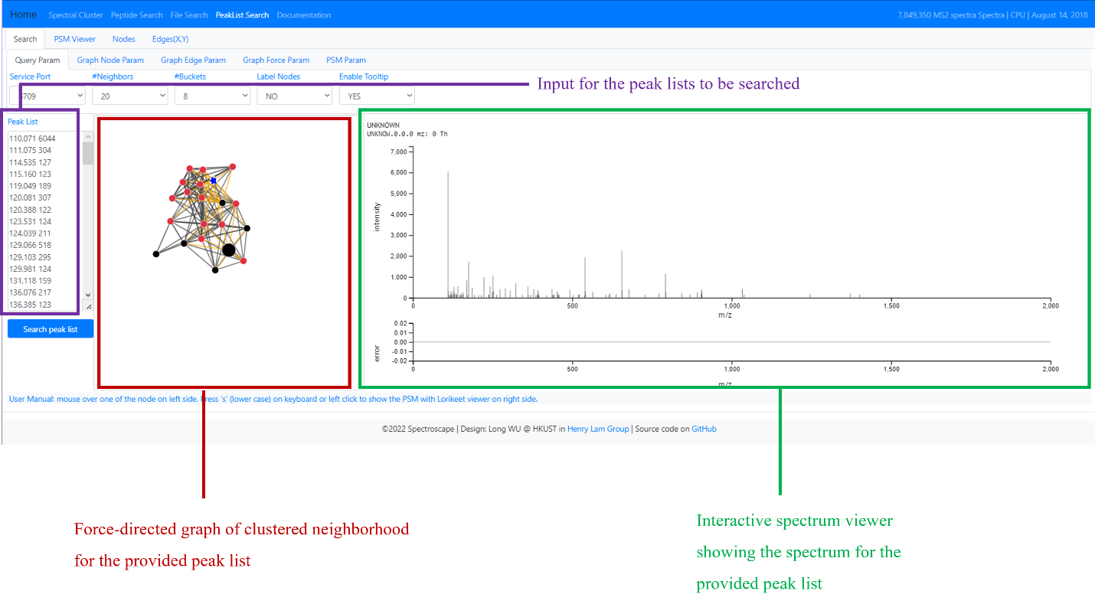
The peak list search function. The left pane (purple box) is an input box for the user to provide a list of peaks to be searched against the archive. Nearest neighbors closest to this provided peak list are retrieved and clustered by Spectroscape (red box). On the right, the provided peak list can be visualized as a spectrum (green box).

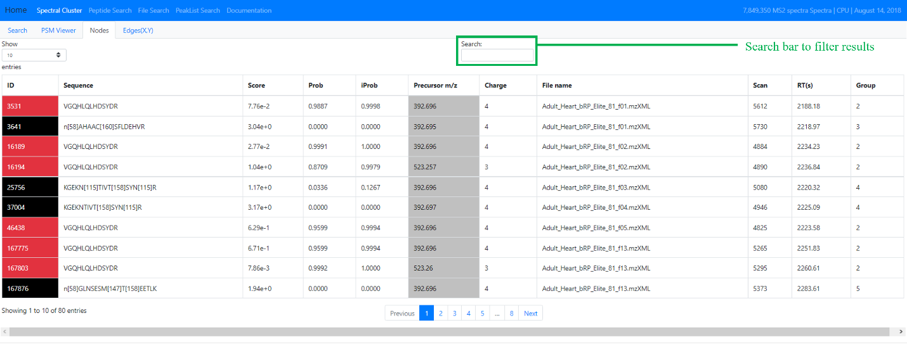
The node table. This feature shows all the neighbors within a certain proximity. The number of neighbors parameter in the Search tab determines the number of nodes shown in the table. By double clicking a column, the table can be sorted according to that column, allowing us to quickly group nodes according to attributes such as Sequence, Probability, and File name. The search bar can also be used to filter the table (green box). Clicking on a cell in the “ID” column will initiate a search using that spectrum as a query.

