Supplementary information
Supplementary figure S1
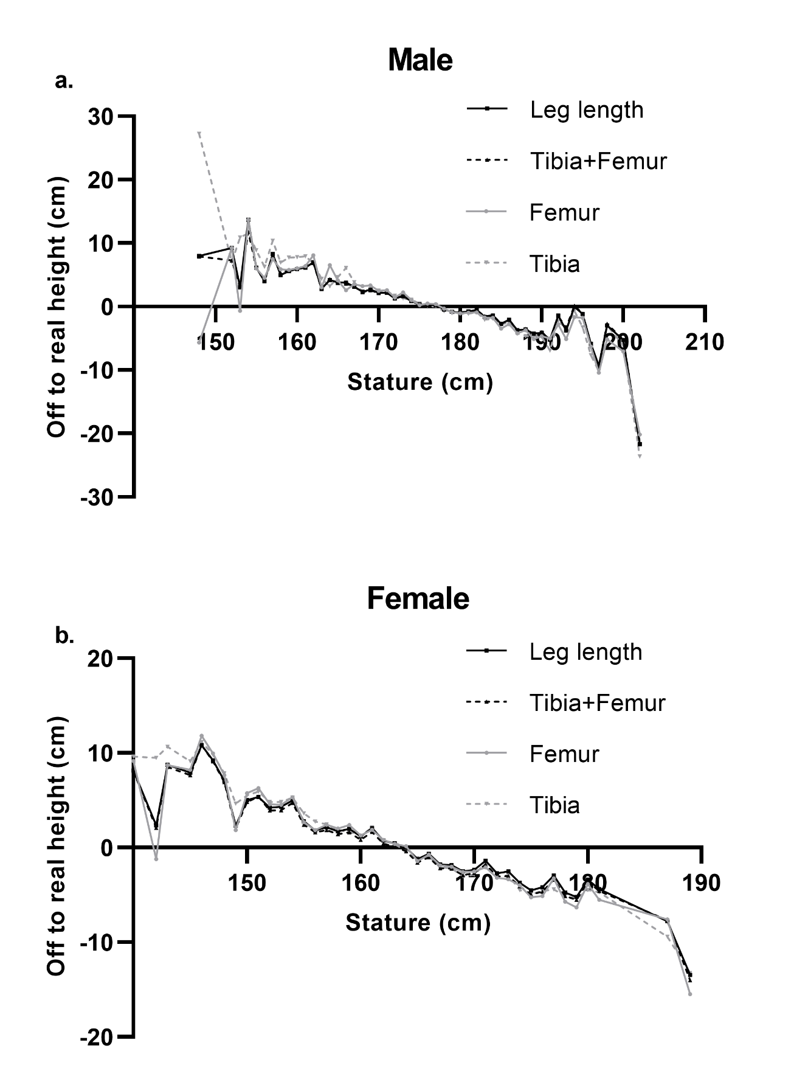
Mean difference to real height

Figure legend:
Suppl. Fig. S1. Differences between mean stature and predicted stature, based on our regression equations, for males (a.) and females (b.) in our sample. The vertical axes depict the difference between predicted and actual mean stature value for the four regression formulae derived here (means per stature category, i.e. each cm). For very short persons, predicted stature was larger than the actual stature and for tall persons predicted stature was smaller than the actual stature values for all four regression formulae.

