Supplementary information

a)
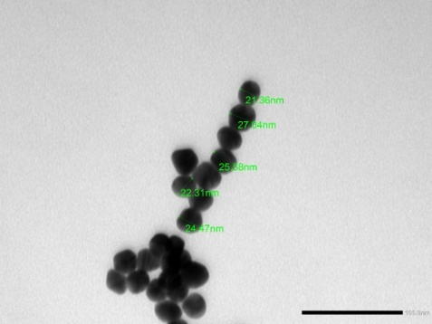
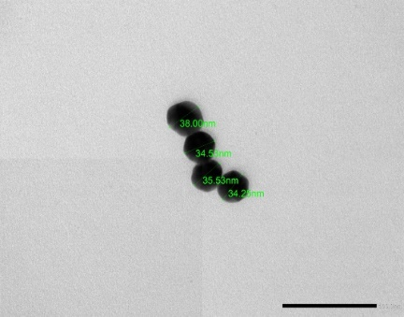
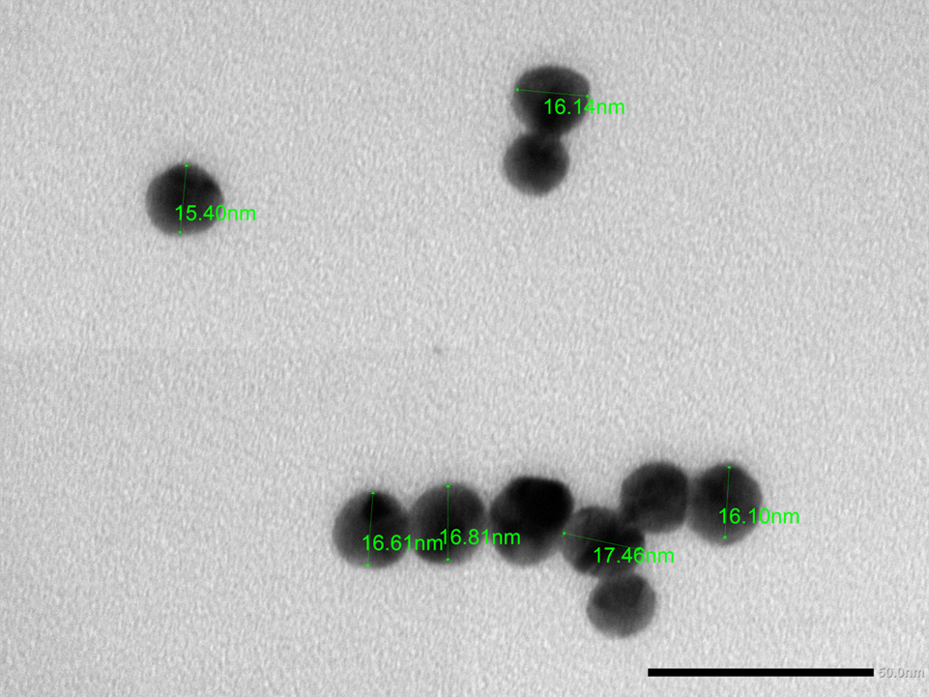
3° Step
4° Step
7° Step
1° Step

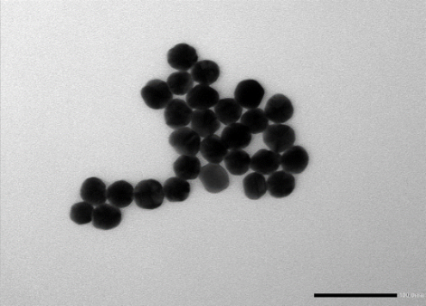
50 nm

50 nm

50 nm

b)

Fig.1 Extinction spectra of gold nanospheres from 5 nm to 70 nm in diameter (a) TEM images of the representative samples (b)

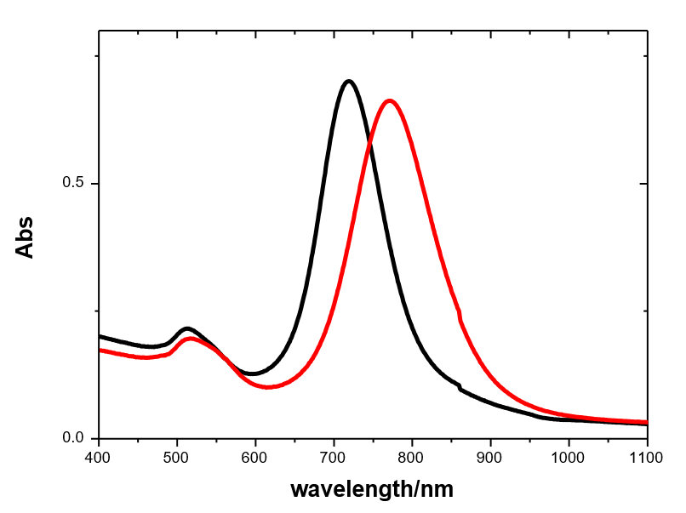

a)
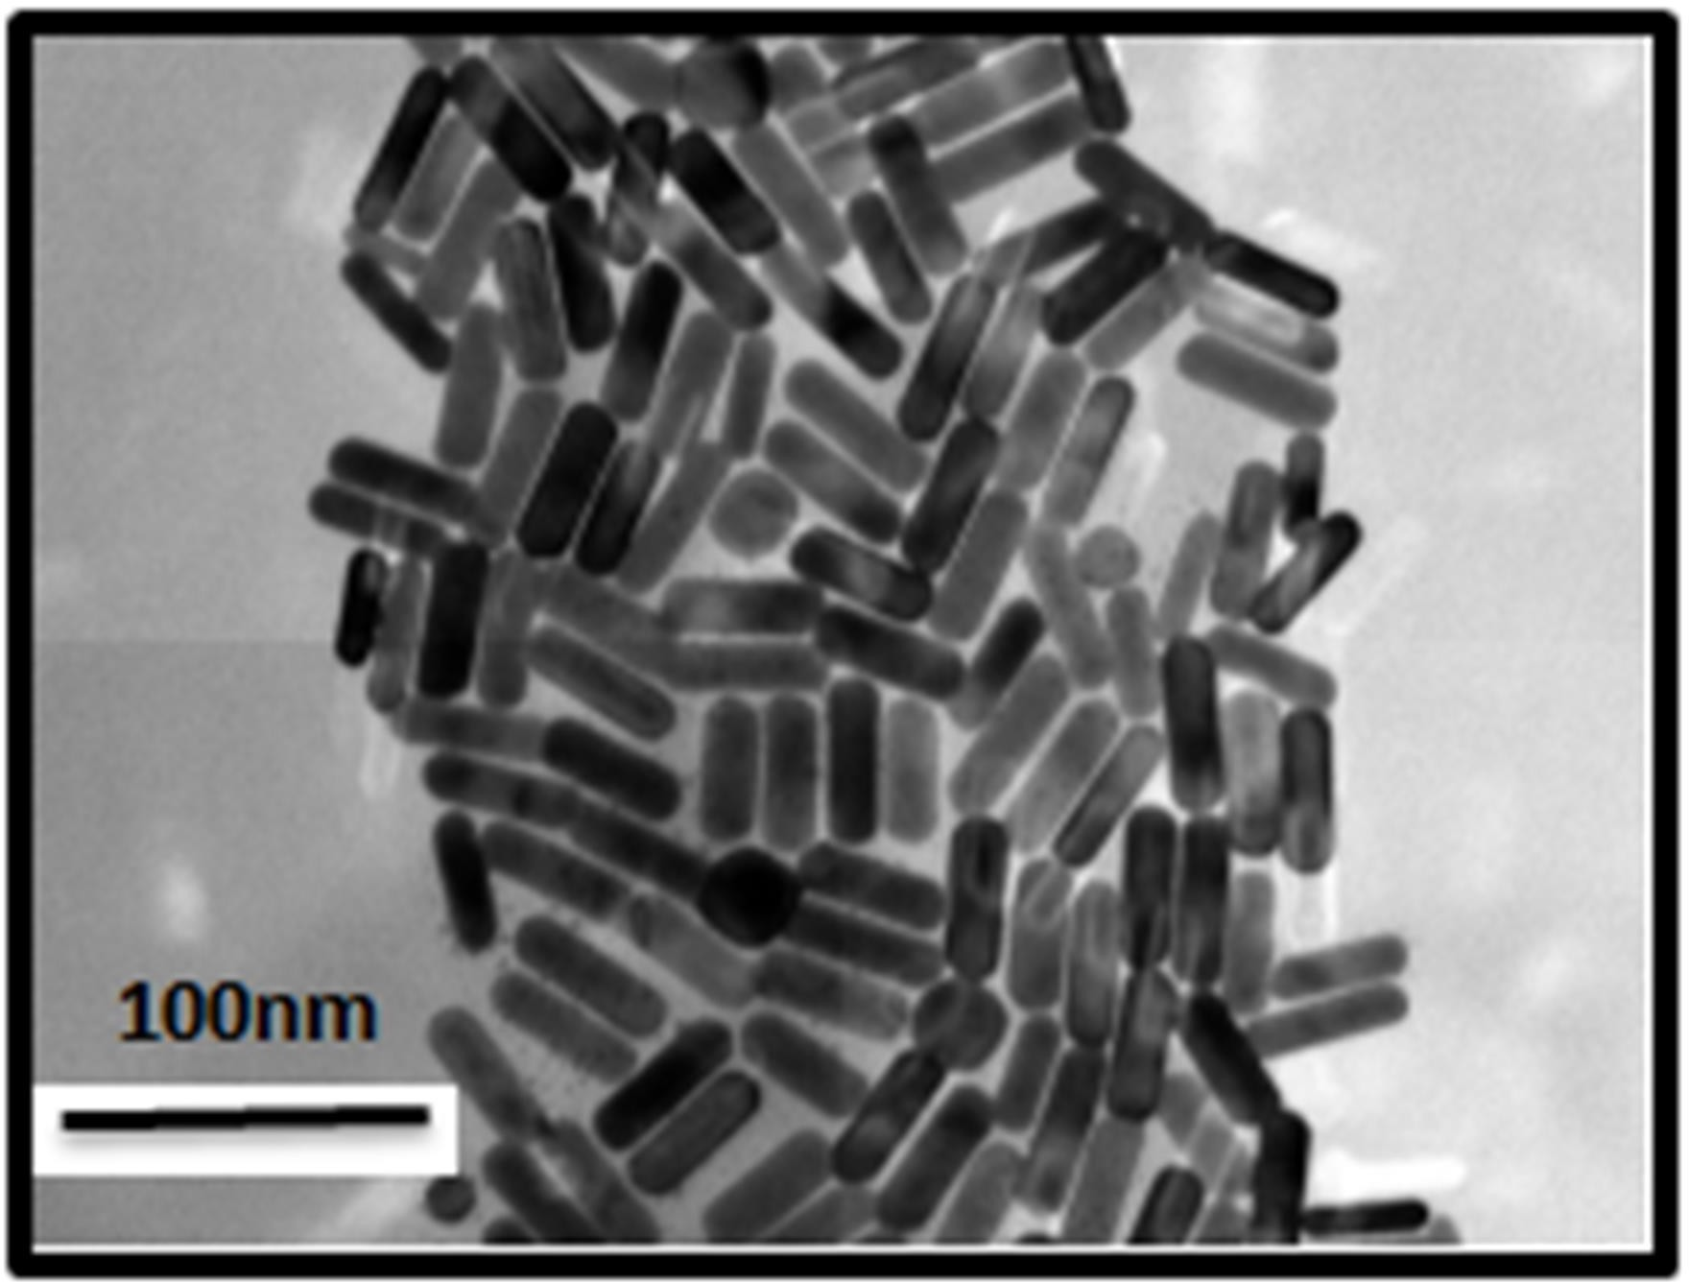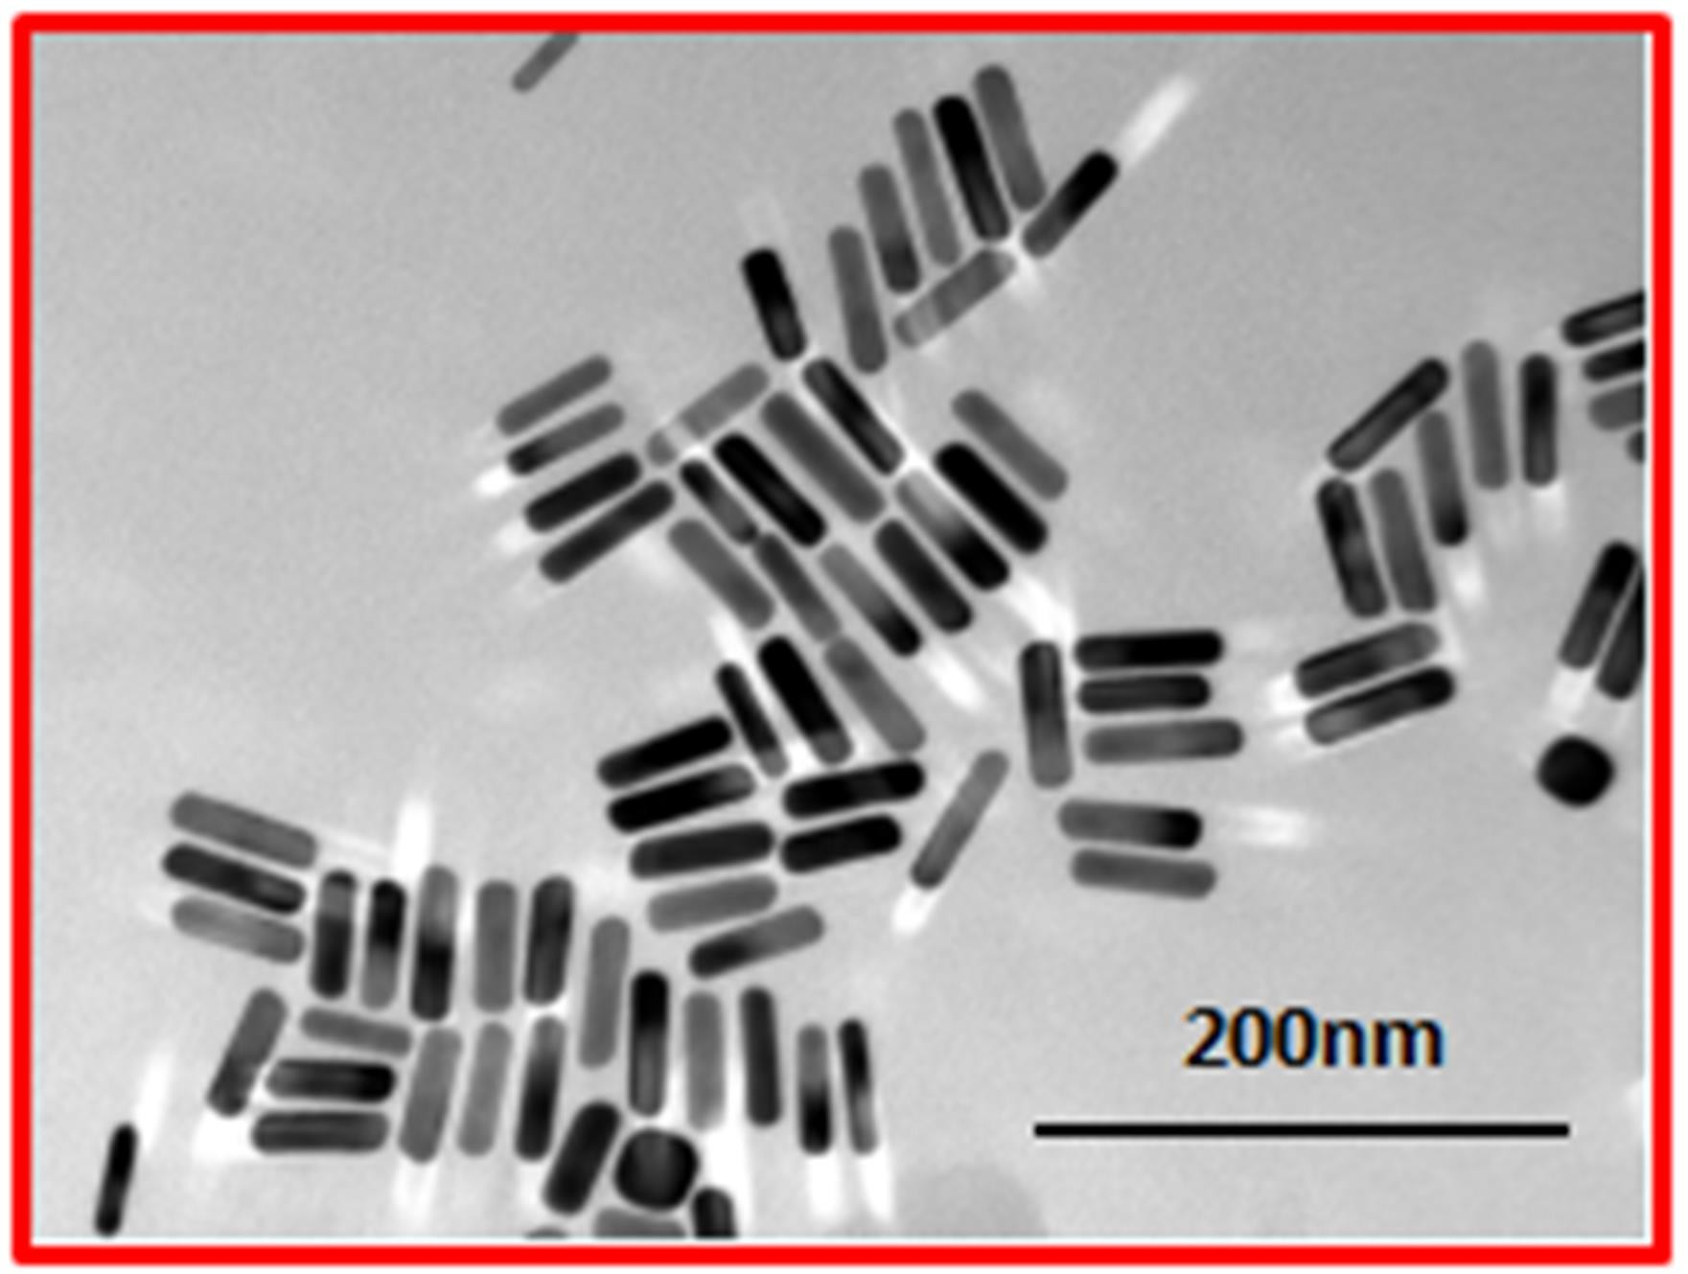

b)

Fig.2 Extinction spectra (a) and TEM images (b) of gold nanorods with A.R. 3.3 black line, A.R. 4 red line

