Evaluation the effect of Gum Arabic as prophylactic agent against chemotherapy-induced oral mucositis in cancer patients: A clinical trial

Abdulrazzaq Yahya Al khazzan^{1*}, Abdel-Wahab Hasan Mohamed², Ali Elbagir Eltayib³ & Waheeb Saleem Suliman⁴
¹University of Science and Technology, Clinical Pharmacy & Pharmacy Practice, Sana’a, 11111. Yemen.
²Omdurman Islamic University, Clinical pharmacology, Sudan
³Khartoum Oncology Hospital, Clinical oncology, Khartoum, 11111, Sudan
⁴Agricultural Research Corporation, Wad Madani, Sudan

*Corresponding author: abdulrazzagy@gmail.com

Table 1 Chi-Square tests results for Cancer type * Presence or absence of oral mucositis during six weeks for all patients.
 | GA-treated group |  |  | Control group
Week | df | Value (χ²) | Sig. (P. value) | df | Value (χ²) | Sig. (P. value)
First | 9 | 5.087 | .827 | 9 | 16.926 | .050
Second | 9 | 8.400 | .494 | 9 | 14.577 | .103
Third | 9 | 8.018 | .532 | 9 | 4.414 | .882
Fourth | 9 | 5.498 | .789 | 9 | 2.539 | .980
Fifth | 9 | 5.579 | .781 | 9 | 12.003 | .213
Sixth | 9 | 3.173 | .957 | 9 | 10.606 | .304

Table 2 Chi-Square tests results for Chemotherapy type * Presence or absence of oral mucositis during six weeks for all patients.
 | GA-treated group |  |  | Control group
Week | df | Value (χ²) | Sig. (P. value) | df | Value (χ²) | Sig. (P. value)
First | 64 | 50.607 | .888 | 47 | 49.113 | .388
Second | 65 | 83.026 | .065 | 46 | 45.771 | .482
Third | 66 | 70.265 | .337 | 46 | 50.370 | .305
Fourth | 65 | 48.214 | .941 | 45 | 46.889 | .395
Fifth | 59 | 65.857 | .252 | 44 | 42.426 | .539
Sixth | 63 | 83.475 | .043 | 45 | 38.889 | .727

Table 3 Cancer locations within 392 of participants in this study.
No. | Tumor type location | Frequency | Percent (%)
1. | Abdominal Lymph Node | 2 | .5
2. | Adrecort | 1 | .3
3. | Anal | 2 | .5
4. | Backbone | 1 | .3
5. | Bowel | 1 | .3
6. | Breast | 14 | 3.6
7. | Bronchus | 1 | .3
8. | Buccal mucosa | 1 | .3
9. | Carcinoid | 1 | .3
10. | Cervical | 1 | .3
11. | Cervix | 10 | 2.6
12. | Cholangiocarcinoma | 2 | .5
13. | CLL | 3 | .8
14. | Colon | 4 | 1.0
15. | Colorectal | 1 | .3
16. | CysticTeratoma | 1 | .3
17. | DSL | 1 | .3
18. | Endometrium | 5 | 1.3
19. | Esophagus | 21 | 5.4
20. | Ethmoid Sinus | 1 | .3
21. | Fibromatosis | 1 | .3
22. | FibroSarcoma | 1 | .3
23. | GITcardi | 1 | .3
24. | GOJ | 1 | .3
25. | HCC | 5 | 1.3
26. | Hydatidiform mole | 2 | .5
27. | Kaposi sarcoma | 1 | .3
28. | Larynx | 6 | 1.5
29. | Liver metastasis | 1 | .3
30. | Lower Lip | 2 | .5
31. | Lt bladder | 1 | .3
32. | Lt breast | 60 | 15.3
33. | Lt neck | 1 | .3
34. | Lung | 9 | 2.3
35. | Lymphoma | 2 | .5
36. | Melanoma | 2 | .5
37. | Mesothelioma | 1 | .3
38. | Molar Pregnancy | 5 | 1.3
39. | Mycosis Fungoides | 1 | .3
40. | NHL | 17 | 4.3
41. | NPH | 24 | 6.1
42. | NSCLC | 2 | .5
43. | Oesteosarcoma | 10 | 2.6
44. | Oropharnx | 2 | .5
45. | Ovary | 36 | 9.2
46. | Pancreas | 11 | 2.8
47. | Perineal Skin SCC | 1 | .3
48. | Postcricoid | 1 | .3
49. | Prostate | 1 | .3
50. | Pseudmyxoma | 1 | .3
51. | Pyriform | 1 | .3
52. | Rectum with Liver mets | 2 | .5
53. | Rt breast | 68 | 17.3
54. | Sarcoma | 3 | .8
55. | SCLC | 2 | .5
56. | Skin | 1 | .3
57. | Spinal | 1 | .3
58. | Stomach | 13 | 3.3
59. | STS Rt glutal | 1 | .3
60. | STSarcoma | 1 | .3
61. | Submandible Salivery | 1 | .3
62. | Testis | 2 | .5
63. | Tongue | 2 | .5
64. | Tonsil | 3 | .8
65. | Uterus | 7 | 1.8

Table 4 Chemotherapy treatment regimens described for the patients in this study.
No. | Chemotherapy regimen | Frequency | Percent (%)
1. | 5 Fluorouracil (5FU) | 14 | 3.6
2. | 5FU/Carboplatin | 8 | 2.0
3. | 5FU/Cisplatin (CISP) | 41 | 10.5
4. | 5FU/ Cyclophosphamide (Cyclo) | 2 | .5
5. | 5FU/Gemcitabine (GEM) | 1 | .3
6. | 5FU/Methotrexate (MTX)/Cyclo | 2 | .5
7. | Bleomycin (BLM)/Etoposide/Carboplatin | 2 | .5
8. | Carboplatin / Etoposide | 1 | .3
9. | Carboplatin /GEM | 1 | .3
10. | CISP | 3 | .8
11. | Docetaxel/5FU | 2 | .5
12. | Docetaxel/5FU/ CISP | 6 | 1.5
13. | Docetaxel/ CISP | 1 | .3
14. | Docetaxel /Cyclo | 11 | 2.8
15. | Docetaxel | 4 | 1.0
16. | Doxorubicin (DOXO) | 1 | .3
17. | DOXO /5FU | 1 | .3
18. | DOXO /5FU/Cyclo | 14 | 3.6
19. | DOXO /Capecitabine | 1 | .3
20. | DOXO / CISP | 16 | 4.1
21. | DOXO /Cyclo | 45 | 11.5
22. | DOXO / Docetaxel/Cyclo | 6 | 1.5
23. | DOXO /Ifosphamide | 4 | 1.0
24. | Epirubicin (EPI)/5FU | 2 | .5
25. | EPI /5FU/ CISP | 6 | 1.5
26. | EPI /5FU/Cyclo | 34 | 8.7
27. | EPI / CISP | 1 | .3
28. | Epi/Cyclo | 6 | 1.5
29. | EPI / Docetaxel | 6 | 1.5
30. | EPI / Docetaxel /Cyclo | 8 | 2.0
31. | Etoposide/ CISP | 3 | .8
32. | Etoposide / CISP /BLM | 7 | 1.8
33. | Etoposide /Ifosphamide | 1 | .3
34. | Etoposide /MTX | 5 | 1.3
35. | Folic Acid (FA)/5FU | 1 | .3
36. | GEM/Carboplatin | 1 | .3
37. | GEM / CISP | 2 | .5
38. | GEM / Docetaxel | 1 | .3
39. | Gemcitabine | 12 | 3.1
40. | MTX | 1 | .3
41. | MTX/Cyclo/FA | 1 | .3
42. | MTX/FA | 1 | .3
43. | Oxaliplatin / Capecitabine | 5 | 1.3
44. | Oxaliplatin/ GEM | 3 | .8
45. | Paclitaxel / GEM | 2 | .5
46. | Paclitaxel /Carboplatin/Etoposide | 1 | .3
47. | Paclitaxel | 5 | 1.3
48. | Paclitaxel/Carboplatin | 42 | 10.7
49. | Paclitaxel/ CISP | 2 | .5
50. | Paclitaxel/Cyclo | 2 | .5
51. | Vincristine (VCR) | 1 | .3
52. | VCR/BLM | 1 | .3
53. | VCR/BLM/ CISP | 1 | .3
54. | VCR/BLM/Cyclo | 4 | 1.0
55. | VCR/BLM/Dacarbazine | 1 | .3
56. | VCR/ CISP | 1 | .3
57. | VCR/Cyclo | 6 | 1.5
58. | VCR/ Dacarbazine / CISP | 1 | .3
59. | VCR/ DOXO | 1 | .3
60. | VCR/ DOXO /BLM/ Dacarbazine | 1 | .3
61. | VCR/ DOXO /Cyclo | 16 | 4.1
62. | VCR/Etoposide/ CISP | 1 | .3
63. | Venorelbine/Carboplatin | 1 | .3
64. | Venorelbine/ CISP | 3 | .8

Table 5 Timing and duration for the chemotherapy regimens that induced most oral mucositis in the cancer patients in the current study.
No. | Regimen type | Timing | Duration (NO. of cycles)
1 | 5 Fluorouracil (5FU) | Every 3 weeks | 4 - 6
2 | 5FU/ Cisplatin (CISP) | Every 3 weeks | 4
3 | Docetaxel/ Cyclophosphamide (Cyclo) | Every 3 weeks | 4
4 | Doxorubicin (DOXO)/5FU/Cyclo | Every 3 weeks | 6
5 | DOXO /Cyclo | Every 3 weeks | 4 - 8
6 | DOXO / Docetaxel /Cyclo | Every 3 weeks | 4 - 6
7 | DOXO /Ifosphamide | Every 3 weeks | 3
8 | Epirubicin (EPI) /5FU/ CISP | Every 3 weeks | 4 - 6
9 | EPI/5FU | Every 3 weeks | 6
10 | EPI /5FU/Cyclo | Every 3 weeks | 4 - 6
11 | EPI / Docetaxel /Cyclo | Every 3 weeks | 6
12 | Etoposide / CISP | Every 3 weeks | 6
13 | Etoposide / Methotrexate (MTX) | Every 3 weeks | 6
14 | Gemcitabine (GEM) | 1 – 3 | 8
15 | Oxaliplatin / Capecitabine | Every 2weeks | 2
16 | Paclitaxel/Carboplatin | Every 3 weeks | 6
17 | VCR/Cyclo | Every 3 weeks | 6
18 | VCR/ DOXO /Cyclo | Every 3 weeks | 6
Table 6 Age frequencies for the participants.
Statistics
Age
N | Valid |  | 386
N | Missing |  | 6
Age
 |  |  |  | Frequency |  | Percent | Valid Percent | Cumulative Percent
Valid |  | 14 |  | 1 |  | .3 | .3 | .3
 |  | 15 |  | 1 |  | .3 | .3 | .5
 |  | 16 |  | 3 |  | .8 | .8 | 1.3
 |  | 17 |  | 3 |  | .8 | .8 | 2.1
 |  | 18 |  | 1 |  | .3 | .3 | 2.3
 |  | 19 |  | 1 |  | .3 | .3 | 2.6
 |  | 20 |  | 3 |  | .8 | .8 | 3.4
 |  | 22 |  | 6 |  | 1.5 | 1.6 | 4.9
 |  | 23 |  | 3 |  | .8 | .8 | 5.7
 |  | 24 |  | 2 |  | .5 | .5 | 6.2
 |  | 25 |  | 2 |  | .5 | .5 | 6.7
 |  | 26 |  | 1 |  | .3 | .3 | 7.0
 |  | 27 |  | 7 |  | 1.8 | 1.8 | 8.8
 |  | 28 |  | 4 |  | 1.0 | 1.0 | 9.8
 |  | 29 |  | 3 |  | .8 | .8 | 10.6
 |  | 30 |  | 4 |  | 1.0 | 1.0 | 11.7
 |  | 31 |  | 3 |  | .8 | .8 | 12.4
 |  | 32 |  | 3 |  | .8 | .8 | 13.2
 |  | 33 |  | 1 |  | .3 | .3 | 13.5
 |  | 34 |  | 1 |  | .3 | .3 | 13.7
 |  | 35 |  | 18 |  | 4.6 | 4.7 | 18.4
 |  | 36 |  | 6 |  | 1.5 | 1.6 | 19.9
 |  | 37 |  | 12 |  | 3.1 | 3.1 | 23.1
 |  | 38 |  | 8 |  | 2.0 | 2.1 | 25.1
 |  | 39 |  | 3 |  | .8 | .8 | 25.9
 |  | 40 |  | 22 |  | 5.6 | 5.7 | 31.6
 |  | 41 |  | 3 |  | .8 | .8 | 32.4
 |  | 42 |  | 13 |  | 3.3 | 3.4 | 35.8
 |  | 43 |  | 4 |  | 1.0 | 1.0 | 36.8
 |  | 44 |  | 2 |  | .5 | .5 | 37.3
 |  | 45 |  | 41 |  | 10.5 | 10.6 | 47.9
 |  | 46 |  | 6 |  | 1.5 | 1.6 | 49.5
 |  | 47 |  | 13 |  | 3.3 | 3.4 | 52.8
 |  | 48 |  | 6 |  | 1.5 | 1.6 | 54.4
 |  | 49 |  | 5 |  | 1.3 | 1.3 | 55.7
 |  | 50 |  | 26 |  | 6.6 | 6.7 | 62.4
 |  | 51 |  | 4 |  | 1.0 | 1.0 | 63.5
 |  | 52 |  | 7 |  | 1.8 | 1.8 | 65.3
 |  | 53 |  | 6 |  | 1.5 | 1.6 | 66.8
 |  | 54 |  | 7 |  | 1.8 | 1.8 | 68.7
 |  | 55 |  | 21 |  | 5.4 | 5.4 | 74.1
 |  | 56 |  | 5 |  | 1.3 | 1.3 | 75.4
 |  | 57 |  | 2 |  | .5 | .5 | 75.9
 |  | 58 |  | 9 |  | 2.3 | 2.3 | 78.2
 |  | 59 |  | 3 |  | .8 | .8 | 79.0
 |  | 60 |  | 19 |  | 4.8 | 4.9 | 83.9
 |  | 61 |  | 2 |  | .5 | .5 | 84.5
 |  | 62 |  | 4 |  | 1.0 | 1.0 | 85.5
 |  | 63 |  | 8 |  | 2.0 | 2.1 | 87.6
 |  | 64 |  | 1 |  | .3 | .3 | 87.8
 |  | 65 |  | 22 |  | 5.6 | 5.7 | 93.5
 |  | 66 |  | 1 |  | .3 | .3 | 93.8
 |  | 67 |  | 2 |  | .5 | .5 | 94.3
 |  | 68 |  | 3 |  | .8 | .8 | 95.1
 |  | 69 |  | 2 |  | .5 | .5 | 95.6
 |  | 70 |  | 6 |  | 1.5 | 1.6 | 97.2
 |  | 72 |  | 1 |  | .3 | .3 | 97.4
 |  | 73 |  | 2 |  | .5 | .5 | 97.9
 |  | 74 |  | 1 |  | .3 | .3 | 98.2
 |  | 75 |  | 2 |  | .5 | .5 | 98.7
 |  | 76 |  | 1 |  | .3 | .3 | 99.0
 |  | 80 |  | 4 |  | 1.0 | 1.0 | 100.0
 |  | Total |  | 386 |  | 98.5 | 100.0
Missing |  | System |  | 6 |  | 1.5
Total |  |  |  | 392 |  | 100.0

Table 7 World Health Organization Oral Mucositis Scale, Patient Assessment and Characteristics
Grade | WHO Scale | Week 1 | Week 2 | Week 3 | Week 4 | Week 5 | Week 6
0 | No oral mucositis
1 | Soreness +/- erythema
2 | Ulcers; able to eat solids
3 | Ulcers, extensive erythema; patient cannot swallow solid diet
4 | Ulcers; alimentation not possible (due to mucositis)

Pt.’s name: …………………………………….. Diagnosis: ……………………………………………………………………………
Type of treatment: Radiotherapy Chemotherapy Supportive only Supportive + Gum Arabic
Chemotherapy type: ………………………………….……………, Cycles: C1 …………...….; C2 ………..…; C3 ………; C4 …...…
Total Radiotherapy dose: ………………………………………, Number of fractions: ……………………………..……………………
Duration of treatment: …………………………………; Educational level: ………………………., Occupation: ……………...............
Sex: ………….; Age:………….……; Weight: …………….; Height: ………….; BSA: ……..….. Drug history: ………...…………… Presence any other systemic diseases …………………………………………………………………………...….…………….............
Table 8 Follow up form for a period of six weeks for each patient (for Gum Arabic treated group).
No | Patient’s name & Tel. number | Starting date & Quantity issued of Gum Arabic | Date of the next quantity of Gum Arabic | Day & date of weekly follow up by telephone call
 |  |  |  | W1 | W2 | W3 | W4 | W5 | W6
1.
2.
3.
4.
5.
6.
7.
8.
9.
10.
11.
12.
13.
14.
15.
16.
17.
18.
19.
20.

Table 9 Follow up form for a period of six weeks for each patient (for control group patients).
No | Patient’s name & Tel. number | Starting date | Day & Date of weekly follow up by telephone call
No | Patient’s name & Tel. number | Starting date | W1 | W2 | W3 | W4 | W5 | W6
1.
2.
3.
4.
5.
6.
7.
8.
9.
10.
11.
12.
13.
14.
15.
16.
17.
18.
19.
20.

Rawaa consent to participate in the study (her age was 14 years):
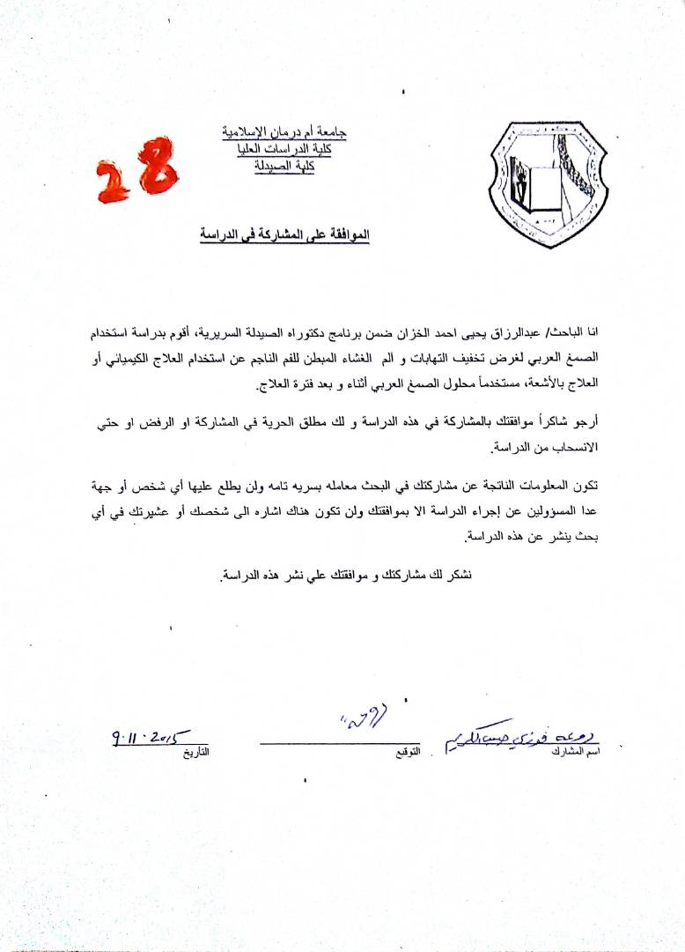

Manahil consent to participate in the study (her age was 15 years):
