Appendix 1. Receiver operating curves for determining cut-off values

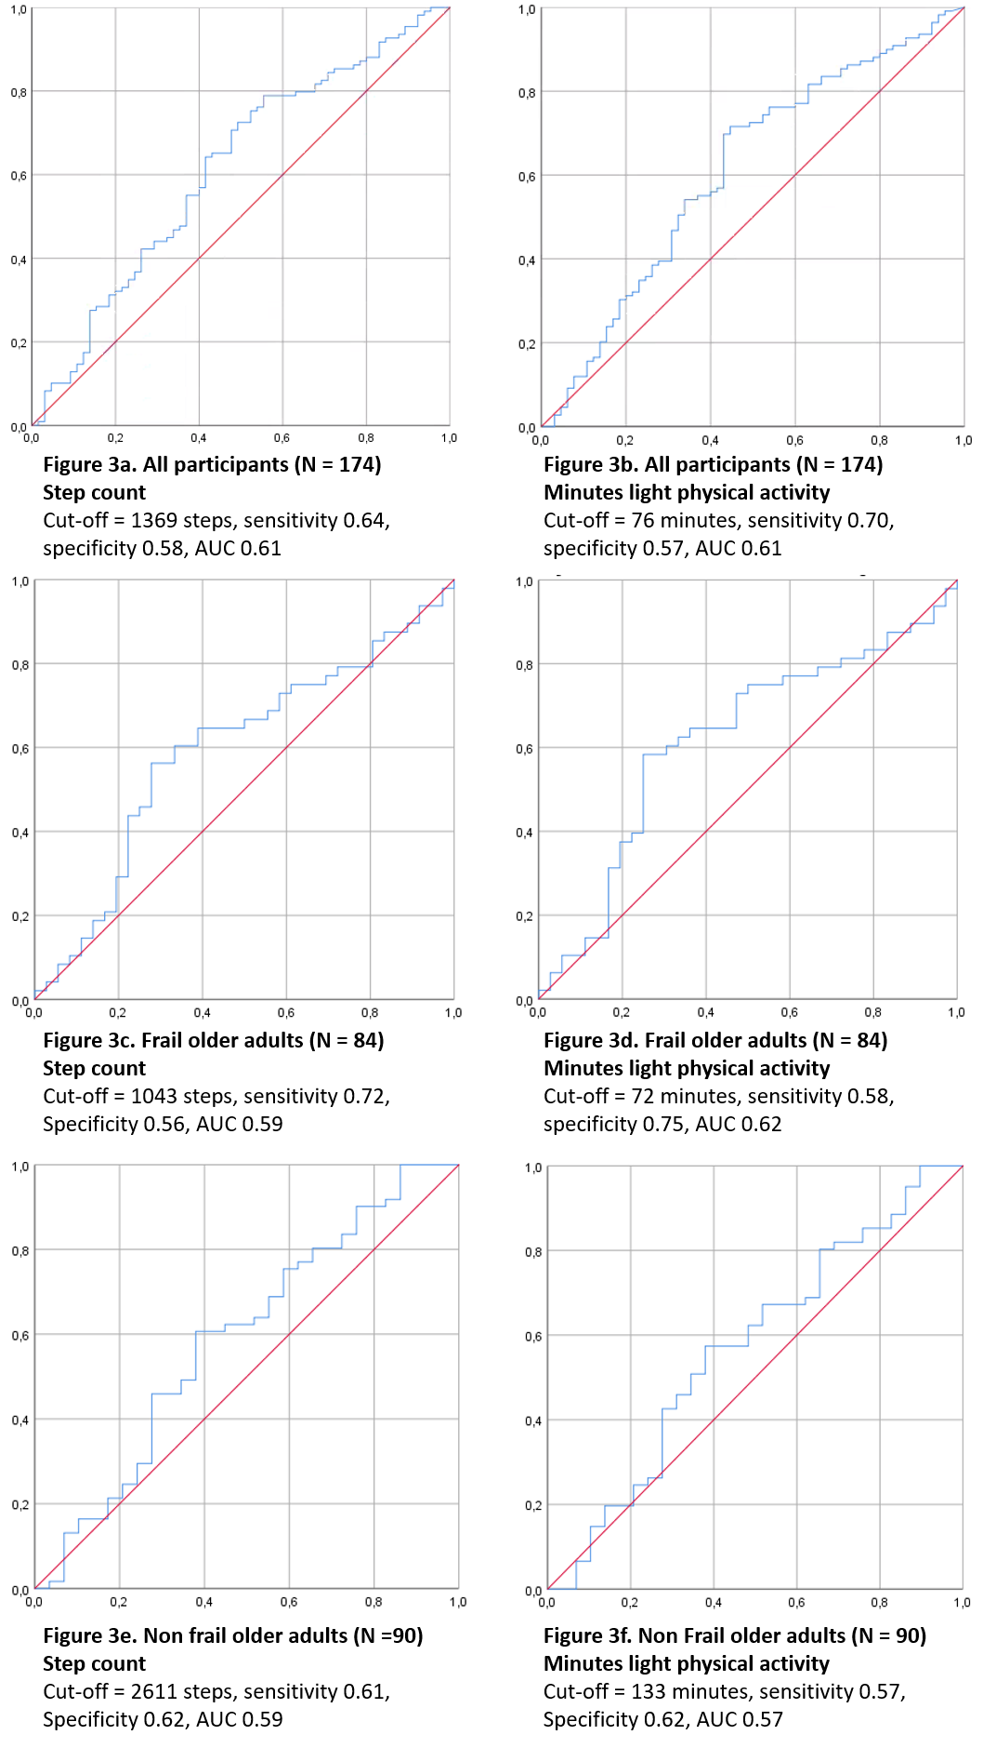
Appendix 1. Receiver operating curves of older adults recovery 3 months
post discharge based on levels of physical activity measured in steps
or minutes of light activity. The x-axis displays 1 – specificity (false
positive rate), the y-axis displays the sensitivity (true positive rate),
AUC = area under the curve.

