Ni-P based Alloy Coatings Prepared by Direct and Pulsed Electrodeposition for Hydrogen Evolution Reaction in Alkaline Media

A. P. Gaikwadª, Atindra Mohan Banerjee^{a, c, *}, M. R. Pai^{a, c}, Rajat Dheeman^{a#}, Sanjay Kumar^{b}, A. K. Tripathi^{a, c}

a - Chemistry Division, b - Materials Science Division, Bhabha Atomic Research Centre, Mumbai-400085

c - Homi Bhabha National Institute, Anushaktinagar, Mumbai-400094

Spectrum No. | Ni | P | Ni/p
1 | 5.9 | 0 | -
2 | 4.9 | 0 | -
3 | 5.8 | 0 | -
4 | 5.9 | 0 | -
5 | 6.2 | 0 | -
6 | 5.5 | 0.4 | 13.75
7 | 5.2 | 0.4 | 13

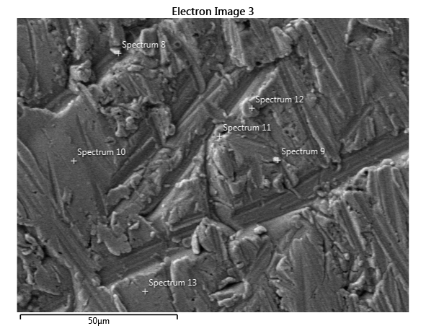
Spectrum No. | Ni | P | Ni/P
8 | 2.7 | 0.2 | 13.5
9 | 4 | 0.3 | 13.33
10 | 3.2 | 0.5 | 6.4
11 | 3.7 | 0.6 | 6.17
12 | 3.5 | 0.5 | 7
13 | 3.7 | 0.5 | 7.4

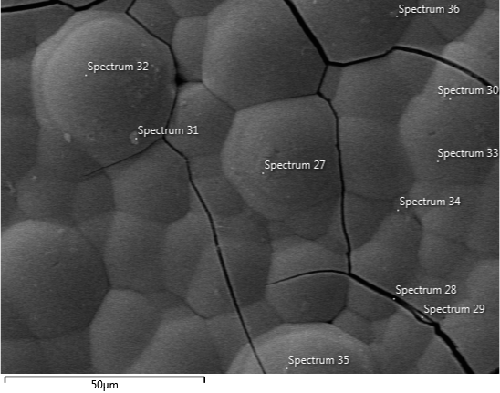
No. | Ni | P | Ni/P
27 | 85.9 | 11.5 | 7.47
28 | 93.8 | 0.7 | 134
29 | 89.4 | 9.4 | 9.50
30 | 87.8 | 12.2 | 7.20
31 | 93.4 | 4.6 | 20.30
32 | 88 | 11.1 | 7.30
33 | 90.1 | 9.9 | 9.10
34 | 88.5 | 9.4 | 9.41
35 | 86.7 | 12.4 | 7
36 | 95.4 | 4.3 | 22.19

