Additional file 2: figure
Development and Characterization of Simple Sequence Repeat (SSR) Markers from the Genomic Sequence of Sweet potato [Ipomoea batatas L. (Lam) cv. Taizhong6]
Hanna Amoanimaa-Dede¹, Jiacheng Zhang¹, Chuntao Su¹, Hongbo Zhu^{1*}.

Figure A1: Characteristics of SSRs in the sweet potato genome.
a. Distribution of different repeat types
b. Frequency distribution of major repeat motifs
c. Frequency distribution of main motif sequence in I. Dinucleotide, II. Trinucleotide and III. Tetranucleotide repeats.
a.

c.

Figure A2: Original uncropped gel of the amplification results generated by IBM 241 in the 24 sweetpotato varieties. The numbers 1–24 represent sweetpotato materials and M represents the DNA marker.

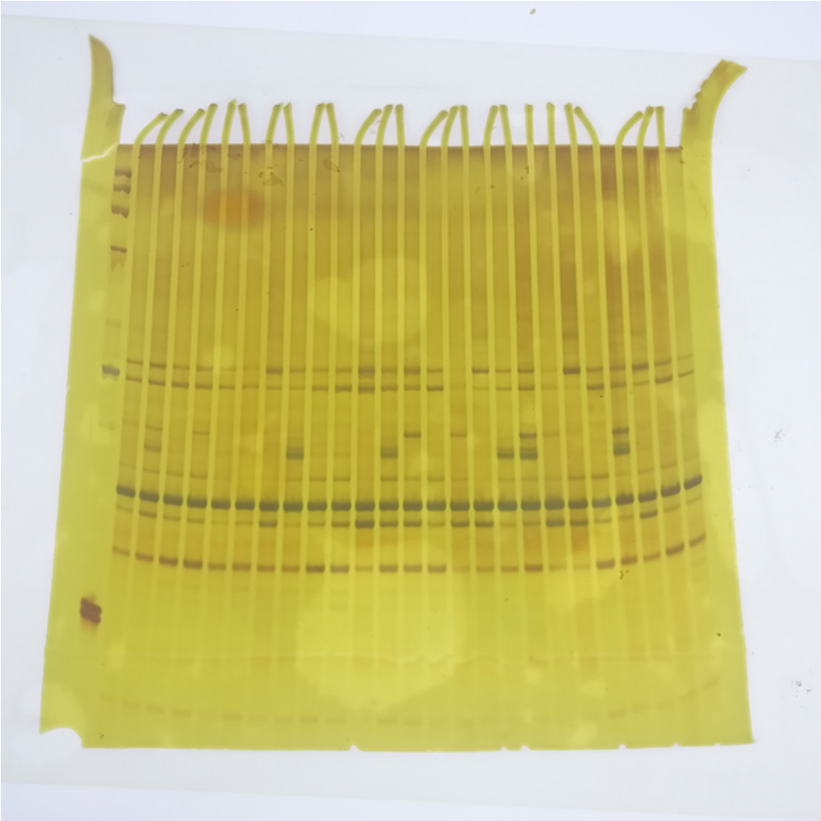
M 1 2 3 4 5 6 7 8 9 10 11 12 13 14 15 16 17 18 19 20 21 22 23 24 24

