Additional files
Additional file 1: Figure S1. The result for selecting power value.
Additional file 2: Figure S2. Module feature vector clustering diagram.
Additional file 3: Table S1. The result of T-test of General Characteristics between the two groups at H1.
Additional file 4: Table S2. The result of T-test of Clinical Data between the two groups at H1.
Additional file 5: Table S3. The result of Function Enrichment of key genes.
Additional file 6: Table S4. The result of KEGG Pathway Enrichment of key genes.
Additional file 6: Table S5. The details of ROC Curves of candidate genes.

Figure S1 The result for selecting power value.
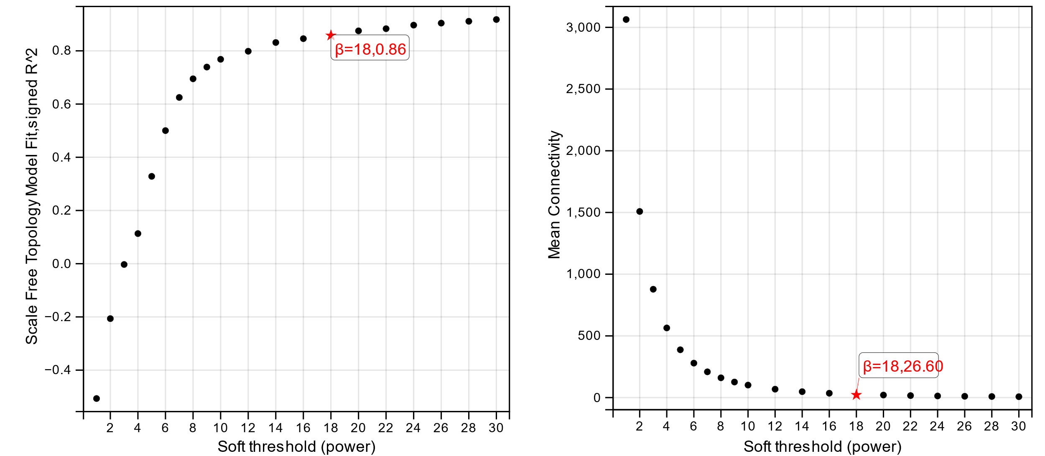
Figure S2 Module feature vector clustering diagram.
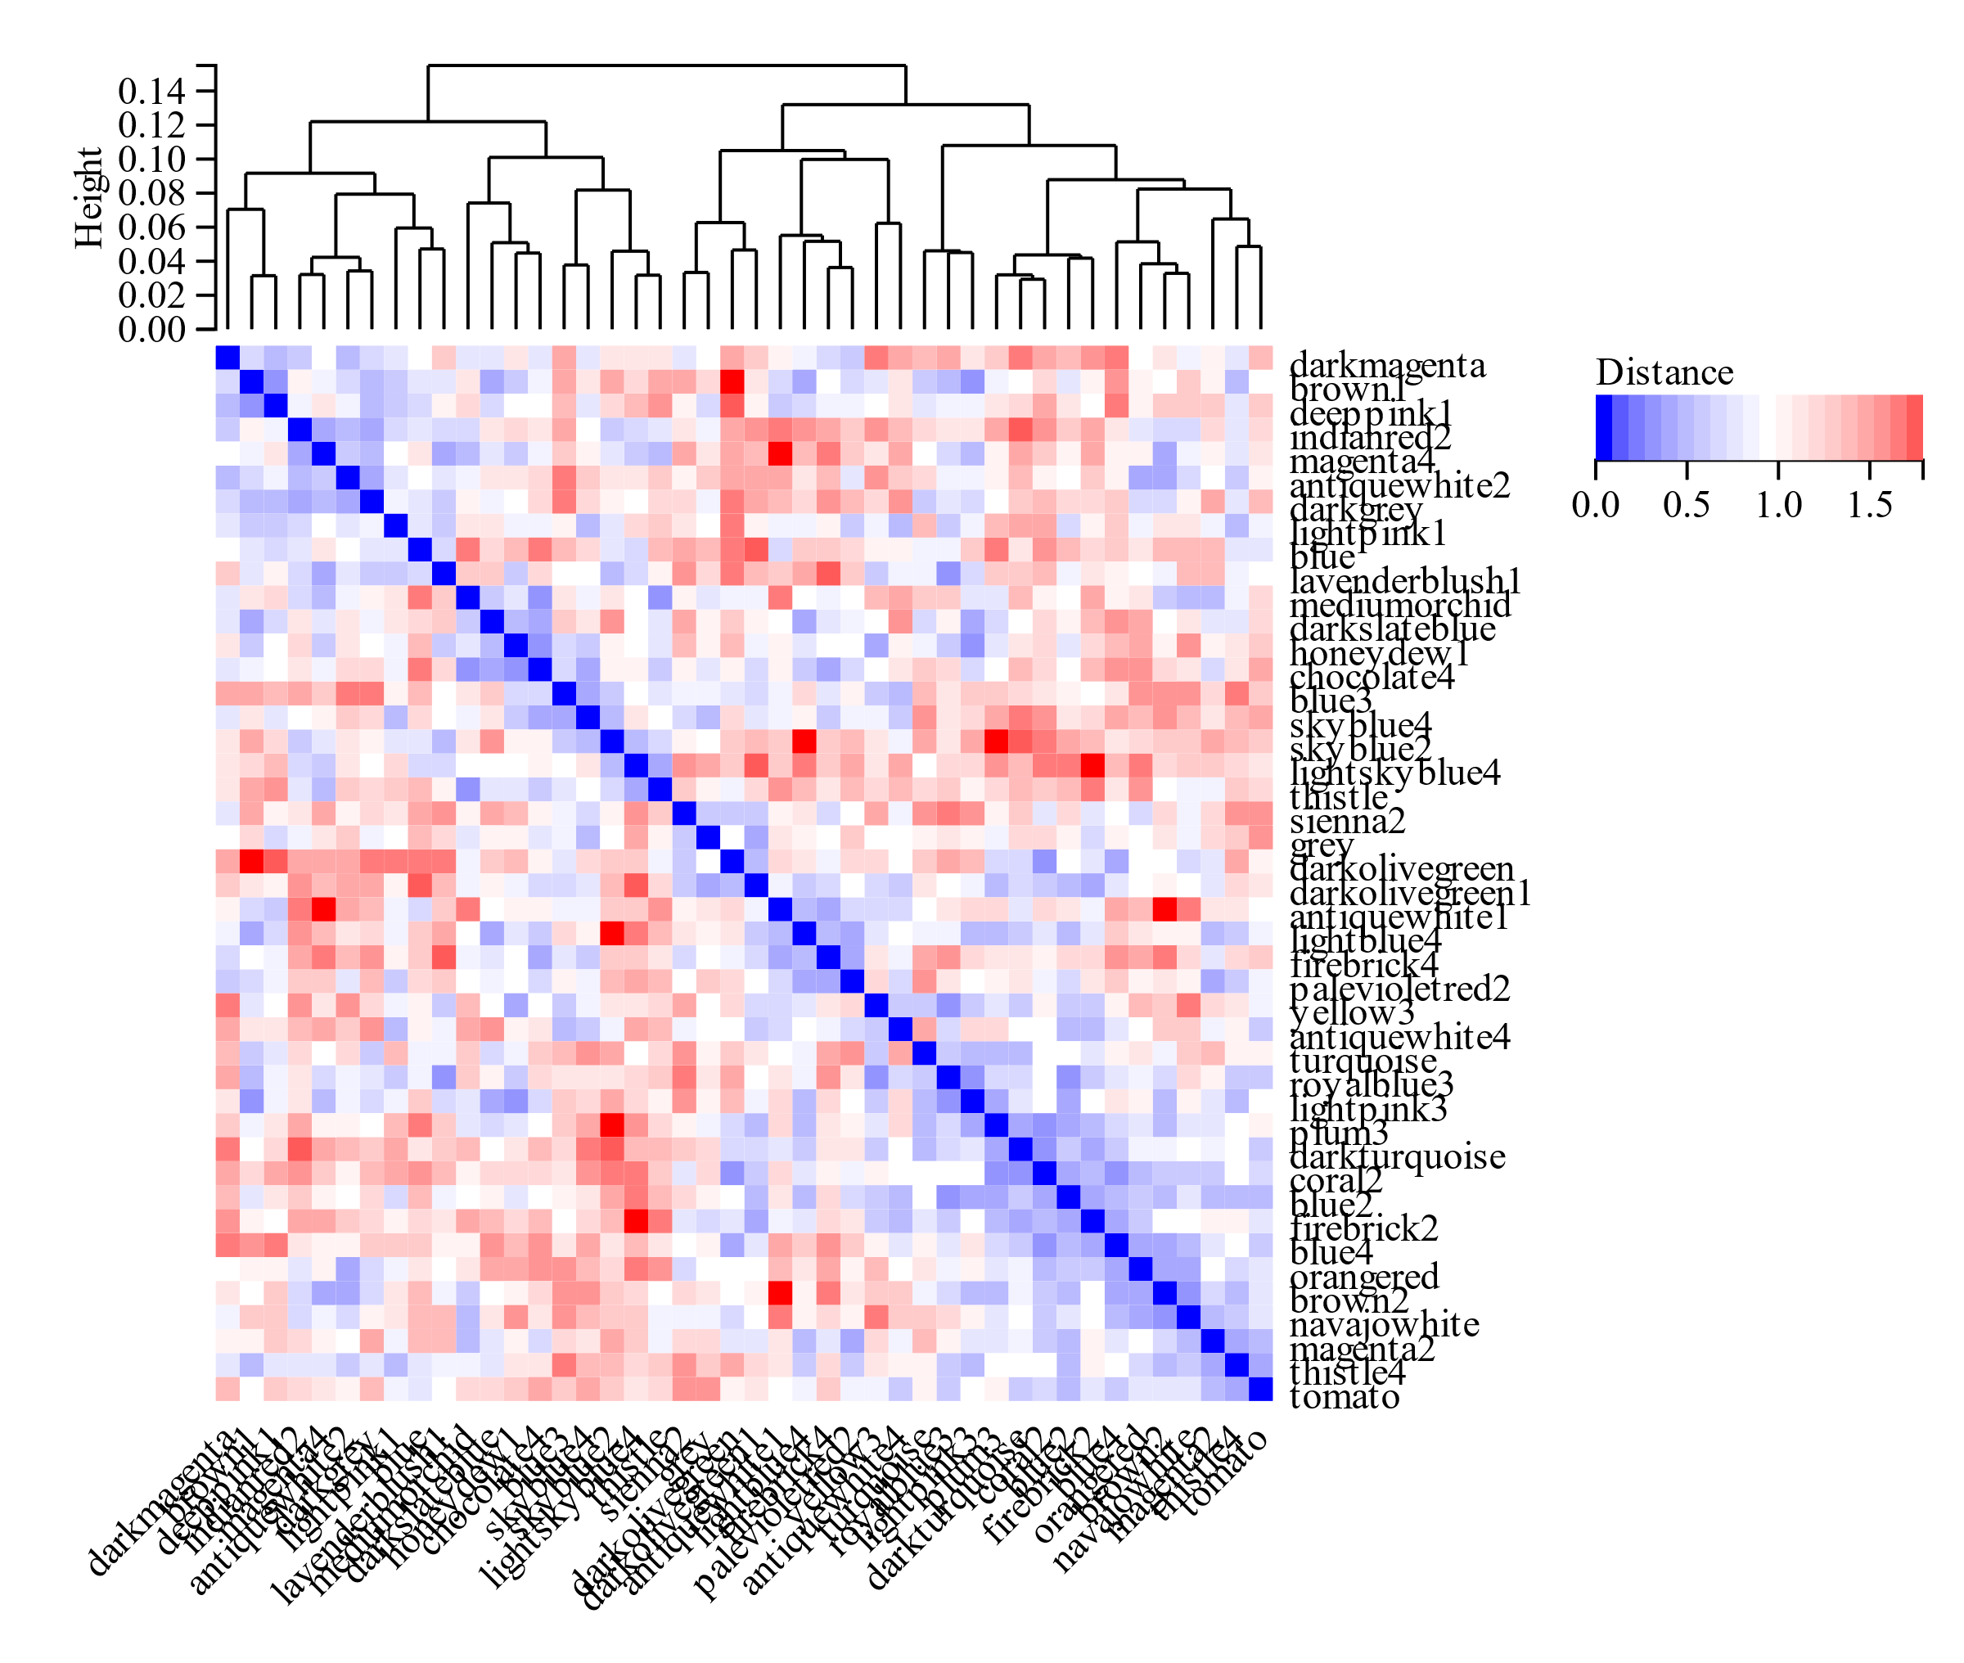

Table S1 The result of T-test of General Characteristics between the two groups at H1.
Variable(s) | Group | Mean | Std. Deviation | Std. Error Mean | t | P
Age | NM-AMS | 20.400 | 0.966 | 0.306
 | MS-AMS | 21.220 | 1.787 | 0.596 | -1.228 | 0.243
HT | NM-AMS | 177.420 | 8.675 | 2.743
 | MS-AMS | 174.411 | 7.061 | 2.354 | 0.823 | 0.422
WT | NM-AMS | 71.258 | 10.351 | 3.273
 | MS-AMS | 70.622 | 6.962 | 2.321 | 0.155 | 0.879
BMI | NM-AMS | 22.535 | 21.930 | 0.610
 | MS-AMS | 23.178 | 1.235 | 0.412 | -0.874 | 0.396
Bodyfat | NM-AMS | 11.710 | 4.963 | 1.570
 | MS-AMS | 14.467 | 5.985 | 1.995 | -1.097 | 0.288

Table S2 The result of T-test of Clinical Data between the two groups at H1.
Variable(s) | Group | Mean | Std. Deviation | t | P
PaO2 (mmHg) | NM-AMS | 36.082 | 2.865
 | MS-AMS | 36.011 | 2.764 | 0.055 | 0.957
PaCO2 (mmHg) | NM-AMS | 26.456 | 2.299
 | MS-AMS | 26.856 | 3.865 | -0.277 | 0.785
SaO2 (%) | NM-AMS | 75.740 | 4.423
 | MS-AMS | 76.778 | 7.918 | -0.358 | 0.725
CaO2 (ml/dL) | NM-AMS | 15.720 | 1.351
 | MS-AMS | 14.589 | 2.533 | 1.233 | 0.234
P50 (mmHg) | NM-AMS | 26.594 | 1.648
 | MS-AMS | 25.556 | 2.828 | 0.991 | 0.336
Hemoglobin (g/dL) | NM-AMS | 14.814 | 1.081
 | MS-AMS | 13.556 | 1.530 | 2.050 | 0.059

Table S3 The result of Function Enrichment of key genes.
GO | Category | Description | Count | % | P | q
GO:0042981 | GO Biological Processes | regulation of apoptotic process | 5 | 71.43 | <0.001 | 0.013
GO:0043067 | GO Biological Processes | regulation of programmed cell death | 5 | 71.43 | <0.001 | 0.013
GO:0010941 | GO Biological Processes | regulation of cell death | 5 | 71.43 | <0.001 | 0.013
GO:0043066 | GO Biological Processes | negative regulation of apoptotic process | 4 | 57.14 | <0.001 | 0.013
GO:0043069 | GO Biological Processes | negative regulation of programmed cell death | 4 | 57.14 | <0.001 | 0.013
GO:0006915 | GO Biological Processes | apoptotic process | 5 | 71.43 | <0.001 | 0.013
GO:0060548 | GO Biological Processes | negative regulation of cell death | 4 | 57.14 | <0.001 | 0.014
GO:0012501 | GO Biological Processes | programmed cell death | 5 | 71.43 | <0.001 | 0.014
GO:0008219 | GO Biological Processes | cell death | 5 | 71.43 | <0.001 | 0.017
GO:0050764 | GO Biological Processes | regulation of phagocytosis | 2 | 28.57 | 0.001 | 0.018
GO:0099523 | GO Cell Component | presynaptic cytosol | 1 | 0.17 | 0.004 | 0.134
GO:0099524 | GO Cell Component | postsynaptic cytosol | 1 | 0.17 | 0.005 | 0.134
GO:0044305 | GO Cell Component | calyx of Held | 1 | 0.17 | 0.007 | 0.134
GO:0099522 | GO Cell Component | region of cytosol | 1 | 0.17 | 0.008 | 0.134
GO:0035577 | GO Cell Component | azurophil granule membrane | 1 | 0.17 | 0.018 | 0.257
GO:0035578 | GO Cell Component | azurophil granule lumen | 1 | 0.17 | 0.029 | 0.279
GO:0043679 | GO Cell Component | axon terminus | 1 | 0.17 | 0.032 | 0.279
GO:0005793 | GO Cell Component | endoplasmic reticulum-Golgi intermediate compartment | 1 | 0.17 | 0.036 | 0.279
GO:0044306 | GO Cell Component | neuron projection terminus | 1 | 0.17 | 0.038 | 0.279
GO:0005766 | GO Cell Component | primary lysosome | 1 | 0.17 | 0.049 | 0.279
GO:0009931 | GO Molecular Function | calcium-dependent protein serine/threonine kinase activity | 1 | 0.20 | 0.001 | 0.024
GO:0010857 | GO Molecular Function | calcium-dependent protein kinase activity | 1 | 0.20 | 0.001 | 0.024
GO:0015643 | GO Molecular Function | toxic substance binding | 1 | 0.20 | 0.003 | 0.033
GO:0004697 | GO Molecular Function | protein kinase C activity | 1 | 0.20 | 0.005 | 0.033
GO | Category | Description | Count | % | P | q
GO:0043395 | GO Molecular Function | heparan sulfate proteoglycan binding | 1 | 0.20 | 0.005 | 0.033
GO:0010314 | GO Molecular Function | phosphatidylinositol-5-phosphate binding | 1 | 0.20 | 0.005 | 0.033
GO:0080025 | GO Molecular Function | phosphatidylinositol-3,5-bisphosphate binding | 1 | 0.20 | 0.007 | 0.039
GO:0043325 | GO Molecular Function | phosphatidylinositol-3,4-bisphosphate binding | 1 | 0.20 | 0.008 | 0.039
GO:0043394 | GO Molecular Function | proteoglycan binding | 1 | 0.20 | 0.011 | 0.039
GO:0005547 | GO Molecular Function | phosphatidylinositol-3,4,5-trisphosphate binding | 1 | 0.20 | 0.011 | 0.039

Table S4 The result of KEGG Pathway Enrichment of key genes.
KEGG | Category | Description | Count | % | P | q
hsa04925 | KEGG Pathway | Aldosterone synthesis and secretion | 7 | 3.78 | 0.008 | 0.714

Table S5 The details of ROC Curves of candidate genes.
Test Result Variable(s) | Area | Std. Errora | Asymptotic Sig.b | Asymptotic 95% Confidence Interval
FAM86B3P | 0.867 | 0.082 | 0.007 | [0.706,1.000]
AZU1 | 0.8 | 0.102 | 0.027 | [0.601,0.999]
PHLDA3 | 0.767 | 0.112 | 0.05 | [0.548,0.999]
MYDGF | 0.744 | 0.12 | 0.072 | [0.508,0.980]
ZNF45 | 0.267 | 0.124 | 0.086 | [0.024,0.509]
RIPPLY3 | 0.744 | 0.134 | 0.072 | [0.482,1.000]
PRKCG | 0.822 | 0.098 | 0.018 | [0.631,1.000]
CAAP1 | 0.244 | 0.116 | 0.06 | [0.017,0.472]
AZU1&PRKCG | 0.833 | 0.096 | 0.014 | [0.646,1.000]

