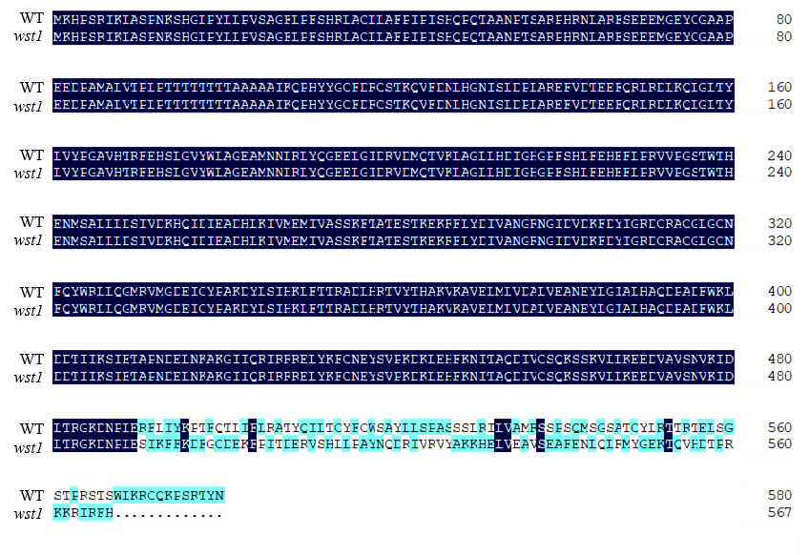
Fig S1. Comparison of the amino acid sequence of WST1 between WT and wst1. The numbers on the right side indicate the position of the residues in the proteins.

Table S1. List of primers used for fine mapping and real-time PCR
Name | Forward sequence（5'→3'） | Reverse sequence（5'→3'） | Purpose
RM3252 | ATGCAAGCATCTGCTTATGG | GTTGGTAACTTTGTTCCCATGC | Mapping
RM10048 | CAAGCAGTGATCATACAGCCTTCC | GCCATGGCTGAGAACAGAGAGC | Mapping
RM8068 | GTGTCATATGCAAGCAACAACTCC | AGTATGTACGTCTCCTCCGTTGC | Mapping
M3 | TCGTTACCCAAGTTTTGAGAGC | TCAAACCATGTACCTTTCAGGA | Mapping
M6 | TGCAACGACGGGCATTTTG | GAGCTTCTTGATGTAGGCCG | Mapping
M10 | CAACAATGCCAAGGGAACAT | TGCCGTTTCTCCTCTGAACT | Mapping
M11 | GGGGCTCAACATGGACCAAA | GGCATGTTGAAGCTGAGCAC | Mapping
M12 | CAAAGCTGTGGGATGTCAAA | TCTACCCAGGACGAACAAATC | Mapping
WST-D | TAACCGCACAAGACATAG | GCCCAGGCTCAGAGTAAA | PCR (genome and cDNA)
WST1 | TCCACCAAGCAGGTCTTCG | CCTCTGAAACTCCTCCGTATC | RT-PCR
CAO1 | GATCCATACCCGATCGACAT | CGAGAGACATCCGGTAGAGC | RT-PCR
CHLD | GGAAAGAGAGGGCATTAG | CAATACGATCAAGTAAGTGTT | RT-PCR
CHLH | CTATACATTCGCCACACT | TATCACACAACTCCCAAG | RT-PCR
CHLI | AGTAACCTTGGTGCTGTG | AATCCATCAACATTCAACTCTG | RT-PCR
DVR | CGAGCCCAGGTTCATCAAGGTGC | CCTCCCGATCTTGCCGAACTCC | RT-PCR
YGL1 | CCGTCCTATTCCTTCAGGCG | AAAGCAAGGACCCACCAACA | RT-PCR
PORA | ATCACCAAGGGCTACGTCTC | GAGTTGTTGTTCCAGCTCCA | RT-PCR
PORB | CCGCAAGGAGGGAGCGGTG | CCCTCTTGGTGCTAAGGCCG | RT-PCR
Cab1R | AGATGGGTTTAGTGCGACGAG | TTTGGGATCGAGGGAGTATTT | RT-PCR
Cab2R | TGTTCTCCATGTTCGGCTTCT | GCTACGGTCCCCACTTCACT | RT-PCR
PsaA | GCGAGCAAATAAAACACCTTTC | GTACCAGCTTAACGTGGGGAG | RT-PCR
PsbA | CCCTCATTAGCAGATTCGTTTT | ATGATTGTATTCCAGGCAGAGC | RT-PCR
AtpA | TCAAAAAGGGCAAGATGT | TTGTAATGTAGCAGGGGAAT | RT-PCR
AtpB | ATGAATGTTATTGGTGAGCCA | CTGTTCTGTGGCTTGCTCAA | RT-PCR
RbcL | CTTGGCAGCATTCCGAGTAA | ACAACGGGCTCGATGTGATA | RT-PCR
RbcS | TCCGCTGAGTTTTGGCTATTT | GGACTTGAGCCCTGGAAGG | RT-PCR
RpoC1 | TCGCGAAACTCTGCTTGGGA | CACATTGATGTAATGAAAGT | RT-PCR
Actin | TGGCATCTCTCAGCACATTCC | TGCACAATGGATGGGTCAGA | RT-PCR

Table S2 Candidate gene prediction in the mapped region
Gene | Predicted function
LOC_Os01g01850 | transposon protein
LOC_Os01g01860 | transposon protein
LOC_Os01g01870 | helix-loop-helix DNA-binding domain containing protein
LOC_Os01g01880 | expressed protein
LOC_Os01g01890 | expressed protein
LOC_Os01g01900 | retrotransposon protein
LOC_Os01g01910 | expressed protein
LOC_Os01g01920 | HD domain containing protein 2
LOC_Os01g01925 | expressed protein
LOC_Os01g01930 | expressed protein
LOC_Os01g01940 | expressed protein
LOC_Os01g01950 | expressed protein
LOC_Os01g01960 | transcriptional repressor
LOC_Os01g01970 | expressed protein

