Supplementary data for the article:

Understanding Chlorella vulgaris acclimation strategies on textile supports can improve the operation of biofilm-based systems

Su Fang Li¹, Andrea Fanesi¹, Thierry Martin¹, Filipa Lopes^{1*}
¹Laboratoire Génie des Procédés et Matériaux (LGPM), CentraleSupélec, Université Paris-Saclay, 91190 Gif-sur-Yvette, France
* Corresponding author.
Tel: +33 0617607634
E-mail address: filipa.lopes@centralesupelec.fr

Fig. S1 Micro-texture of textile materials observed at 30× magnification (the scale bar is 1000 µm) using a stereomicroscopy

Table S1 Micro-texture and physical-chemical properties of textile materials, all data are shown in mean value ± SD (n ≥3)
Textile materials | Composition | Relative opening surface area (mm² cm⁻²) | Roughness  (μm) | Contact angle  (°)
Terrazzo | Polyamide | N.D. | 16.48 ± 6.55 | 126.88 ± 1.93
Nordkap | Cotton | 0.97 ± 0.80 | 55.52 ± 4.91 | 112.57 ± 2.23
Cotton | Cotton | 9.96 ± 1.70 | 37.02 ± 10.86 | 130.30 ± 3.25
Mariella | Polyester | 4.57 ± 0.73 | 27.55 ± 3.97 | -
Sun silk | Polyester | 6.44 ± 1.63 | 49.00 ± 8.02 | 41.50 ± 5.96

N.D. (Not detected) represents parameters which cannot be detected at 63× magnification.
- No contact angle could be measured on Mariella, demonstrating its high hydrophilicity.

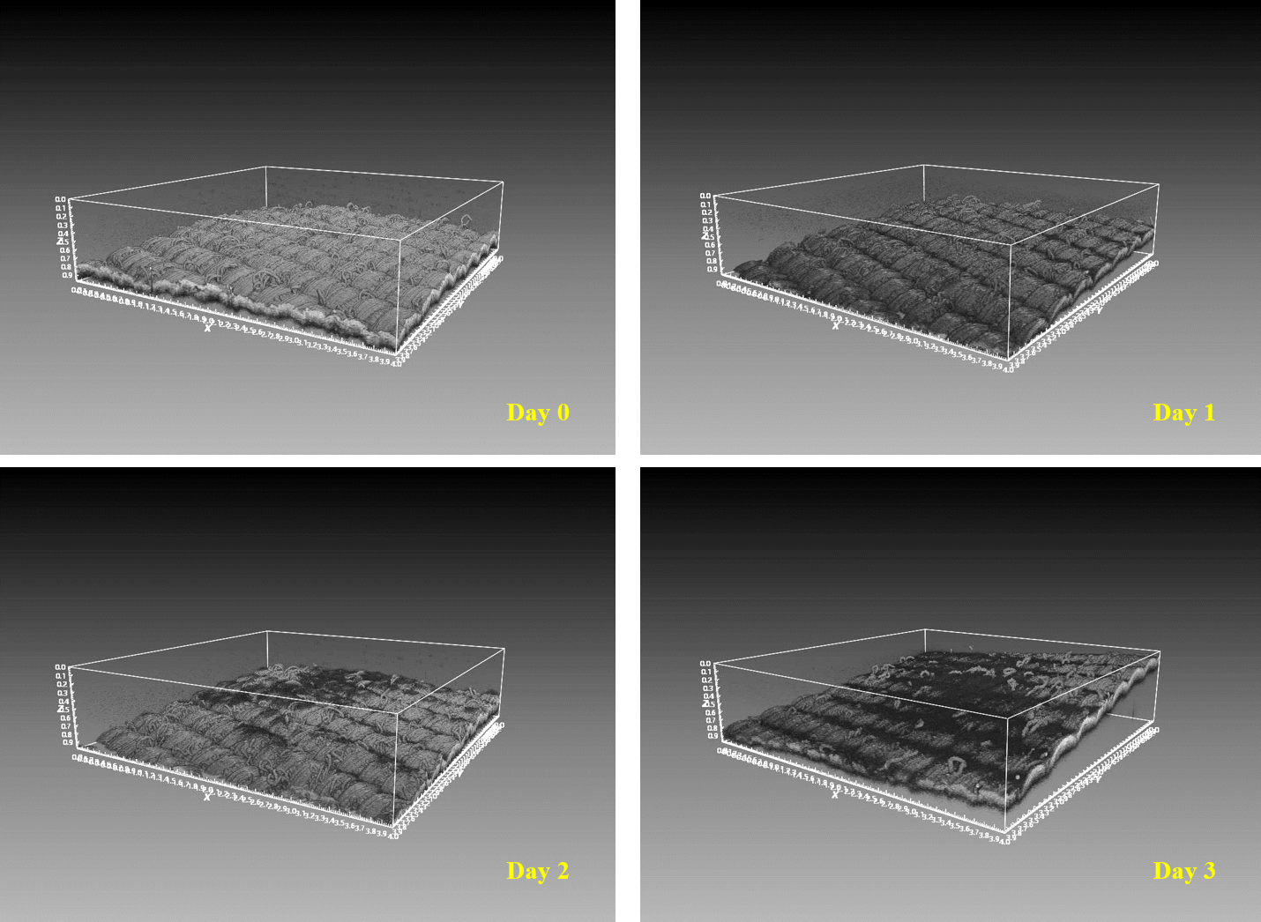
Fig. S2 OCT images of C. vulgaris biofilm on Terrazzo during 3-day cultivation
Due to the highest cells retention capability on Terrazzo (Fig. 2), biofilm structural dynamics on fabrics was for the first time investigated at mesoscale by OCT imaging (Fig. S2). Cells/biofilm accumulation seems to occur mainly at the crevices between the fabric clusters at the first day, further thriving on the surface from day 1 onwards. In addition, spatial biofilm heterogeneity on the support was also observed.

Table S2 Average cell volume, photosynthetic parameters (F_{v}/F_{m}, α, E_{k}) and cellular composition of immobilized C. vulgaris (pre-acclimated to 50 μmol m⁻² s⁻¹) under low inoculum density condition after 3-days cultivation
Supports | Cell volume  (μm³) | F_{v}/F_{m} | α | E_{k}  (µmol m⁻² s⁻¹) | Lipids to proteins ratio
Cotton | 47.3 ± 2.7 | 0.68 ± 0.02 | 0.36 ± 0.03 | 349 ± 15 | 0.16 ± 0.00
Terrazzo | 49.7 ± 5.4 | 0.71 ± 0.00 | 0.39 ± 0.03 | 433 ± 89 | 0.17 ± 0.00

