Supplementary Materials
Supplementary Table1: List of soybean genotypes used for seed longevity and associated traits
Species/Group | No. of accessions | Genotypes
Glycine tomentella | 1 | G. tomentella accession
Glycine soja | 19 | PI 464925 B, PI 464925 A, PI 464925 A, PI 561355, PI 464869 A, PI 522183 B, PI 464889 A, PI 407294, PI 407292, PI 406684, PI 366120, PI 507805, PI 423991, PI 522229, PI 507830 B, PI 326582 B, PI 424051 B, PI 424079, PI 424032, DC-2008-1
Glycine max | 105 | DS 9712, DS 76-1-2-1, G 2215, G 2132, G 2144, PK 1243, PK 1135, Bragg, TGX 1855-530, TGX 1864-15F, TAMS 38, UGM 34, UPSL 117-B, UPSL 291, EC 456615, EC 457442, EC 457472, EC 471635, EC 457189, DS 9909, MAUS 164, PK 1347, TS 148-22, MACS 869, DS 9814, DS 9817, DS 9819, His 01, JS 94-67, KB 222, MACS 450, PK 1024, PK 1041, VLS 61, SL 679, SL 710, E 20, SL 688, PKS 34, NRC 71 ,NRC 78, DS 2614, JS 20-05, Dsb 15, PS 1477, PS 1480, MACS 1336, SL 900, DSB 19, PS 1503, DSB 21, PS 1505, NRC 89, AMS 56, DS 2708, PS 1518, DS 61, DS 178, DS 76-37-2, DS 93-3, EC13969, EC343361 A, EC1021, EC 36961, EC 39873, EC 97351, EC105790, G 2265, G 2344, G 2608, JS 335, G 2651, G 3023, GUJ SOY-1, IC 144409, IC 141446, JAVA 16, J 231, JS 76-257, M 253, MACS 565, MAUS 2, NRC 21, PK 1225A, UPSL 19, UPSL 29, UPSL 34, UPSL 736, EC 458342, EC 1023, DS MM 64, G 2603, G 2253, G 2601, MACS 694, EC 471919, EC 472134, G 395, UPSL 163, UPSL 332, DS 74, AMSS 34, NRC 7, PK 416, PK 472
Recombinant Inbred Lines (G soja × G max) | 25 | 2-6-1, 2-6-2, 2-34-1, 2-34-4, 2-34-5, 4-11-4, 7-28-2, 8-26-3, 9-14-2, 13-2-2,13-8-2, 19-3-1, 19-5-2, 19-33-3, 19-35-3, 20-3A-3, 20-3A-4, 25-58-1, 25-58-2, 26-2-3, 26-3-1, 27-2-4, 34-30-1, 14-3-5, 20-11-1

Supplementary Table 2: Electrical conductance from seed leachates on 40 soybean genotypes during storage
S.No. | Genotypes | Control | 6 month stored seeds
Good storers
1 | G-2215 | 19.22 | 39.46
2 | UPSL-117-B | 23.36 | 38.43
3 | UPSL-291 | 26.55 | 48.19
4 | DS 61 | 22.23 | 60.81
5 | EC13969 | 23.25 | 41.55
6 | EC105790 | 30.67 | 61.28
7 | G2265 | 22.33 | 37.55
8 | G2651 | 15.69 | 30.31
9 | IC-141446 | 26.65 | 49.19
10 | JAVA-16 | 22.23 | 43.27
11 | M253 | 21.40 | 37.28
12 | UPSL-34 | 20.32 | 37.77
13 | UPSL-736 | 19.34 | 37.52
14 | EC 1023 | 26.36 | 41.21
15 | DS MM 64 | 22.69 | 34.81
16 | G 2603 | 18.25 | 36.11
17 | G 2253 | 15.25 | 40.22
18 | G 2601 | 19.34 | 43.14
19 | UPSL 163 | 16.36 | 31.23
20 | UPSL 332 | 15.66 | 36.76
21 | DS 74 | 15.20 | 30.35
22 | AMSS 34 | 15.88 | 31.85
 | Mean (good storer) | 20.78 | 40.38
Poor storers
23 | PK-1243 | 33.85 | 68.23
24 | EC-471635 | 22.23 | 43.25
25 | EC-457189 | 26.34 | 59.28
26 | MAUS-164 | 28.31 | 55.22
27 | VLS-61 | 39.32 | 88.69
28 | E-20 | 25.23 | 60.67
29 | PS-1480 | 28.15 | 58.33
30 | MACS-1336 | 23.39 | 44.23
31 | DSB-19 | 34.57 | 73.67
32 | PS-1503 | 29.39 | 61.68
33 | DSB-21 | 31.98 | 57.23
34 | AMS-56 | 36.37 | 81.22
35 | DS-2708 | 38.45 | 74.91
36 | MACS565 | 31.29 | 82.38
37 | MAUS-2 | 25.28 | 55.39
38 | EC 472134 | 24.46 | 58.28
39 | NRC 7 | 29.52 | 47.28
40 | PK 472 | 33.46 | 54.22
 | Mean (poor storer) | 30.09 | 62.45
 | Grand mean | 25.14 | 51.00
 | MSD genotypes at 5% |  | 7.12
MSD: minimum significant difference; Control: at the start of seed storage

Supplementary Table 3: Genotypes used in imbibition kinetics
S.No. | Genotypes | S.No. | Genotypes | S.No. | Genotypes
*1 | G. tomentola | #11 | DS 61 | @21 | PK1243
2 | PI407294 | 12 | EC13969 | 22 | EC457189
3 | PI407292 | 13 | G2265 | 23 | VLS61
4 | PI406684 | 14 | G2651 | 24 | E20
5 | PI366120 | 15 | M253 | 25 | MACS1336
6 | PI507805 | 16 | UPSL34 | 26 | DSB19
7 | PI507830-B | 17 | UPSL736 | 27 | PS1503
8 | PI424051 B | 18 | EC 1023 | 28 | DS2708
9 | PI424079 | 19 | G 2253 | 29 | MACS565
10 | DC2008-1 | 20 | UPSL 163 | 30 | MAUS2
[*S. Nos. 1-10: Good storing and hard-seeded; #S. Nos. 11-20: Good storing and soft seeded; @S.Nos. 21-30: Poor storing and soft seeded genotypes]

Supplementary Table 4: ANOVA for seed germination (%) in soybean genotypes
Source | DF | Type III SS | MS | F
Genotypes | 149 | 360147.70 | 2417.099** | 254.23
Storage periods | 3 | 1122199.43 | 374066.48** | 39344.2
Replications | 2 | 647.29 | 323.65** | 34.04
Genotype × Storage periods | 447 | 197645.49 | 442.16** | 46.51
Model | 601 | 1680639.91 | 2796.40 | 294.12
Error | 1198 | 11390.04 | 9.51
Corrected Total | 1799 | 1692029.96
** Significance at 1%, DF: degree of freedom, SS: Sum of squares, MS: mean squares, F: F values (calculated)

Supplementary Table 5: Eigen values, variance contribution (%), variables coordinates and percent contribution of each variable on individual principle component of 150 soybean germplasm
 | Eigen vectors |  |  | Variation explanation
 | HSW | SCP | G | Eigen value | % of variance | cumulative %
PC1 | 0.60 | 0.54 | -0.59 | 2.25 | 74.90 | 74.90
PC2 | -0.30 | 0.84 | 0.45 | 0.50 | 16.57 | 91.47
PC3 | 0.74 | -0.10 | 0.67 | 0.26 | 8.53 | 100.00
HSW: 100 seed weight, SCP: Seed coat permeability, G: Germination

Supplementary Table 6: Pearson correlation coefficients among the seed quality parameters in soybean genotypes
 | SCP | HSW | G0 | G1 | G2 | G3
SCP | 1.00 | 0.58** | -0.19** | -0.36** | -0.46** | -0.60**
HSW |  | 1.00 | -0.33** | -0.62 | -0.71** | -0.72**
G0 |  |  | 1.00 | 0.57** | 0.56** | 0.51**
G1 |  |  |  | 1.00 | 0.78** | 0.71**
G2 |  |  |  |  | 1.00 | 0.90**
G3 |  |  |  |  |  | 1.00
**Correlation is significant at the 0.01 level; HSW: 100 seed weight, SCP: Seed coat permeability, G0, G1, G2, G3: Germination (%) after 0, 1, 2, and 3 years of storage respectively

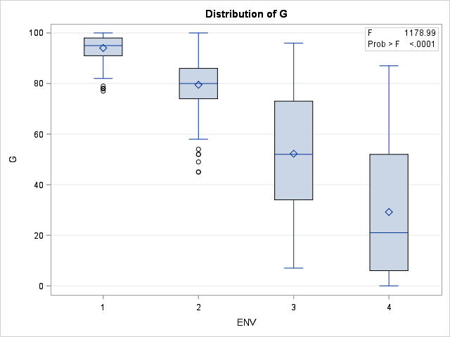
Supplementary Fig. 1: Distribution pattern of seed viability of soybean accessions over the years [ENV: Storage years, G: germination (%)]

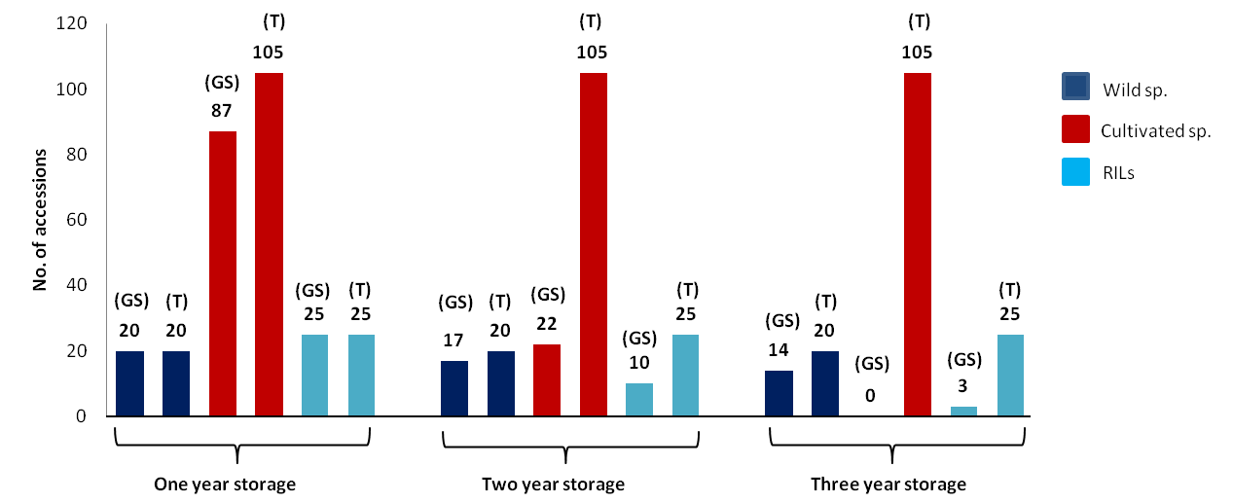
Supplementary Fig. 2: Diagram depicting no. of good storers after one, two and three years of storage (T: total no. of genotypes used in each group, GS: good storers identified in each group)
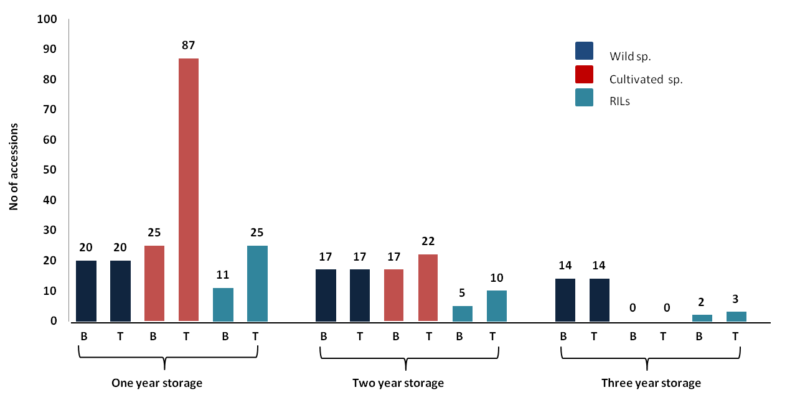
Supplementary Fig. 3: Diagram depicting no. of good storers and black seeded good storers after one, two and three years of storage (T: total no. of good storers in each group, B: Black seeded good storers in each group)

