Supplementary Information

Superionic effect and anisotropic texture in Earth’s inner core driven by geomagnetic field

Shichuan Sun^{1,2}, Yu He^{1,2,3,*}, Junyi Yang^{1,2}, Yufeng Lin⁴, Jinfeng Li⁴, Duck Young Kim³, Heping Li^{1,2}, Ho-kwang Mao³

¹Key Laboratory of High-Temperature and High-Pressure Study of the Earth’s Interior, Institute of Geochemistry, Chinese Academy of Sciences, Guiyang 550081, Guizhou, China
²University of Chinese Academy of Sciences, Beijing 100049, China
³Center for High Pressure Science and Technology Advanced Research, Shanghai 201203, China
⁴Department of Earth and Space Sciences, Southern University of Science and Technology, Shenzhen 518055, China

*E-mail: heyu@mail.gyig.ac.cn

S1. Seismic velocities in superionic Fe-H alloys under inner core conditions
S2. Reversal of the fast velocity axis and change in the c/a ratio in superionic Fe-H alloys
S3. Elastic anisotropy in Fe-H and other Fe alloys
S4. Comparison of Fe-H seismic anisotropy with seismological observations
S5. H-ion anisotropic diffusion in Fe-H alloys
S6. H-ion transportation in external electric field
S7. Bader charge analysis on Fe alloys
S8. References

S1. Seismic velocities in superionic Fe-H alloys under inner core conditions.
The elastic properties of Fe-H alloys are calculated under various temperatures (2000-6000 K), pressures (330-360 GPa) and H contents (0.0625, 0.125 and 0.25 atomic percent) using the AIMD method. This method has been used for elastic property calculations in our previous studies¹⁻³. The calculated elastic constants show good consistency with the experimental results of the superionic material Li₂O at high temperatures³. The elastic properties of crystals are expressed as the relationship between stress and strain:
$σ_{ij}=C_{ijkl}ε_{kl}$, (1)
where $σ_{ij}$ refers to a stress tensor, $ε_{kl}$ refers to a strain tensor, and $C_{ijkl}$ represents a fourth-order elastic modulus. The elastic constant C_{ij} was calculated by distorting the equilibrium structure and solving the stress–strain relations (see method for details; Table S1).
The statistical errors of the calculated temperature and stress were evaluated using the blocking method⁴ (1). The standard deviation is defined as follows⁵:
$$\begin{aligned}δ≈\sqrt{\frac{C_{0}^{'}}{n^{'}-1}\left(1+\frac{1}{\sqrt{2\left(n^{'}-1\right)}}\right)}\#\left(2\right)\end{aligned}$$
$$\begin{aligned}n^{'}=\frac{n}{2}\#\left(3\right)\end{aligned}$$
$$\begin{aligned}x_{i}^{'}=\frac{1}{2}\left(x_{2i-1}-x_{2i}\right)\#\left(4\right)\end{aligned}$$
$$\begin{aligned}c_{o}^{'}=\frac{1}{n^{'}}\sum_{k=1}^{n^{'}}{{\left(x_{k}-\overline{x}\right)}^{2}}\#\left(5\right)\end{aligned}$$

where n is the number of data points. The standard deviations of time-averaged properties in NVT simulations are counted, and the errors are 3-9 K in temperature and 0.02-0.15 GPa in stress. The errors are ~2% in C_{ij}.

The adiabatic elastic constants ($C_{ij}^{S}$) were estimated from isothermal elastic constants ($C_{12}^{T}$) using the following equations (Table S2)^{5,6}:
$$\begin{aligned}C_{11}^{S}=C_{11}^{T}+αγTK_{T}\#\left(6\right)\end{aligned}$$
$$\begin{aligned}C_{12}^{S}=C_{12}^{T}+αγTK_{T}\#\left(7\right)\end{aligned}$$
$$\begin{aligned}C_{13}^{S}=C_{13}^{T}+αγTK_{T}\#\left(8\right)\end{aligned}$$
$$\begin{aligned}C_{33}^{S}=C_{33}^{T}+αγTK_{T}\#\left(9\right)\end{aligned}$$
$$\begin{aligned}C_{44}^{S}=C_{44}^{T}\#\left(10\right)\end{aligned}$$
$$\begin{aligned}C_{66}^{S}=C_{66}^{T}\#\left(11\right)\end{aligned}$$
$K_{S}=K_{T}(1+αγT)$ (12)
where $α$ and $γ$ denote the thermal expansion coefficient and Grüneisen parameter ($α=1×{10}^{-5}/K$, $γ$=1.5)^{7,8}, respectively. T is the temperature, and $K_{T}$ is the isothermal bulk modulus. It is worth noting that the thermodynamic property for superionic Fe alloys is not well constrained; thus, the estimated adiabatic elastic constants may present some deviation. In addition, as the thermal conductivity is high in the inner core, the presence of thermal convection, and possible Joule heating due to the penetration of the outer core magnetic field, it is still not clear if the seismic wave velocities in the inner core are isothermal, intermediate or adiabatic. In this case, we still use the isothermal data for discussion. The adiabatic compressional velocity is higher than the isothermal velocity, but the difference in compressional velocity anisotropy is negligible (Fig. S1 & Table S2).

We calculated the bulk modulus B and shear modulus G using the Voigt average scheme, which is proven to be more appropriate and accurate in calculating the seismic wave properties⁹.
The compressional wave velocity $V_{P}$, shear wave velocity $V_{S}$, and bulk sound velocity $V_{Φ}$ are calculated by:
$V_{P}=\sqrt{\frac{B+\frac{4G}{3}}{ρ}}$， $V_{S}=\sqrt{\frac{G}{ρ}}$，$V_{Φ}=\sqrt{\frac{B}{ρ}}$. (13)
The results are provided in Table S1. We also compared the compressional velocities in superionic FeH alloys with the PREM data¹⁰, and the temperature, pressure and H content effects on velocities and densities are evaluated in Fig. S2. Both the densities and velocities of Fe-H alloys decrease with temperature and H content. Increasing the temperature leads to a significant decrease in velocity, while increasing the H content causes a significant reduction in density. Moreover, both the densities and velocities decrease with increasing pressure. The V_{P} in Fe-H alloys is able to fit the PREM data¹⁰ considering the variation in temperature, pressure and H content in the IC. A higher H content is needed to fit the V_{P} of the outer inner core (OIC) due to the density deficiency. This may suggest a variation in H content with depth in the IC. The shear wave velocities in Fe-H alloys are still faster than the PREM data (Fig. S2b). This suggests the possible existence of other light elements in the IC. In particular, light elements that are more stable at substitutional sites should be considered.

Fig. S1. | Adiabatic and isothermal compressional velocity anisotropy in FeH_{0.25} as a function of angle ξ between the ray path and Earth’s rotation axis.
Fig. S2 | Calculated seismic velocities in Fe-H alloys in comparison with the PREM data. a. Compressional wave velocities and b. shear wave velocities in Fe-H alloys at temperatures from 0 to 6000 K (green symbols), pressures from 330 to 360 GPa (blue symbols), and H content increasing from 0.0625 to 0.25 atomic percent.

Table S1 | The isothermal elastic properties of Fe alloys under inner core conditions
 | P ($GPa$) | T ($K$) | $ρ$(g/cm³) | $$C_{11}$$ | $$C_{12}$$ | $$C_{33}$$ | $$C_{13}$$ | $$C_{44}$$ | AV_{P} (%) | AV_{S} (%)
FeH_{0.25} | 360 | 0 | 13.751 | 2390 | 1202 | 2529 | 1107 | 508 | 5.1 | 10.4
FeH_{0.25} | 360 | 2000 | 13.654 | 2273 | 1178 | 2373 | 1085 | 458 | 4.7 | 10.6
FeH_{0.25} | 360 | 3000 | 13.552 | 2195 | 1184 | 2195 | 1070 | 394 | 4.0 | 12.3
FeH_{0.25} | 360 | 4000 | 13.423 | 2050 | 1158 | 2059 | 1073 | 340 | 3.9 | 13.6
FeH_{0.25} | 360 | 5000 | 13.277 | 1869 | 1214 | 1830 | 1111 | 248 | 4.0 | 13.9
FeH_{0.25} | 330 | 5500 | 12.898 | 1648 | 1165 | 1613 | 968 | 198 | 4.8 | 20.7
FeH_{0.25} | 360 | 6000 | 13.118 | 1733 | 1178 | 1684 | 1054 | 178 | 5.3 | 22.1
FeH_{0.0625} | 360 | 6000 | 13.973 | 1894 | 1270 | 1925 | 1115 | 260 | 4.1 | 16.6
FeH_{0.125} | 360 | 6000 | 13.800 | 1860 | 1295 | 1863 | 1102 | 245 | 3.7 | 18.3
FeH_{0.375} | 360 | 6000 | 13.166 | 1699 | 1278 | 1510 | 1113 | 120 | 7.5 | 28.1
Feª | 360 | 7250 | 13.495 | 1424 | 1182 | 1822 | 1051 | 162 | 12.4 | 34.6
Fe₆₀Si₄^{b} | 360 | 6400 | 13.164 | 1707 | 1353 | 1971 | 1112 | 191 | 9.1 | 33.4
 | 360 | 7350 | 13.090 | 1620 | 1403 | 1901 | 1082 | 168 | 9.8 | 45.1
Fe₅₆Si₈^{b} | 360 | 6500 | 12.626 | 1742 | 1397 | 1857 | 1031 | 172 | 7.9 | 39.5
Fe₆₀Si₂C₂^{c} | 360 | 6500 | 13.12 | 1597 | 1403 | 1804 | 1085 | 164 | 7.9 | 44.0
 | 360 | 6700 | 13.06 | 1562 | 1382 | 1767 | 1085 | 157 | 7.7 | 44.0
Fe₆₂C₂^{c} | 360 | 6400 | 13.36 | 1700 | 1344 | 1741 | 1057 | 172 | 5.4 | 31.6
Fe₆₀C₄^{c} | 360 | 5000 | 13.34 | 1689 | 1370 | 1913 | 1148 | 170 | 8.1 | 33.6
Fe₆₂S₂^{c} | 360 | 6600 | 13.34 | 1724 | 1293 | 1889 | 1074 | 199 | 7.6 | 28.4
Fe₆₀S₄^{c} | 360 | 6000 | 13.22 | 1706 | 1291 | 1864 | 1081 | 216 | 6.4 | 25.1
 | 360 | 6500 | 13.15 | 1635 | 1315 | 1823 | 1063 | 191 | 7.4 | 31.8
Fe₆₄H₄^{d} | 360 | 6500 | 13.491 | 1638 | 1323 | 1735 | 1106 | 168 | 5.3 | 28.7
Fe₆₀Si₄H₄^{d} | 360 | 6500 | 13.063 | 1616 | 1326 | 1755 | 1104 | 151 | 6.6 | 33.3
The errors are 3-9 K in temperature, 0.02-0.15 GPa in stress, and ~2% in C_{ij}.
ªMartorell et al. (2013)⁵; ^{b}Martorell et al. (2016)¹¹; ^{c}Li et al. (2018)¹²; ^{d}Wang et al. (2021)⁶.

Table S2 | The adiabatic elastic properties of Fe-H alloys under inner core conditions
 | P ($GPa$) | T ($K$) | $ρ$(g/cm³) | $$C_{11}$$ | $$C_{12}$$ | $$C_{33}$$ | $$C_{13}$$ | $$C_{44}$$ | AV_{P} (%) | AV_{S} (%)
FeH_{0.25} | 360 | 0 | 13.751 | 2390 | 1202 | 2529 | 1107 | 508 | 5.1 | 10.4
FeH_{0.25} | 360 | 2000 | 13.654 | 2303 | 1208 | 2403 | 1116 | 458 | 4.7 | 10.6
FeH_{0.25} | 360 | 3000 | 13.552 | 2239 | 1228 | 2239 | 1114 | 395 | 3.9 | 12.3
FeH_{0.25} | 360 | 4000 | 13.423 | 2107 | 1215 | 2116 | 1130 | 340 | 3.8 | 13.6
FeH_{0.25} | 360 | 5000 | 13.277 | 1938 | 1283 | 1899 | 1180 | 248 | 3.8 | 14.0
FeH_{0.25} | 330 | 5500 | 12.898 | 1716 | 1233 | 1681 | 1036 | 198 | 4.6 | 20.8
FeH_{0.25} | 360 | 6000 | 13.118 | 1811 | 1256 | 1762 | 1132 | 178 | 5.1 | 22.2
FeH_{0.0625} | 360 | 6000 | 13.973 | 1979 | 1355 | 2010 | 1200 | 260 | 4.0 | 16.6
FeH_{0.125} | 360 | 6000 | 13.800 | 1944 | 1379 | 1947 | 1186 | 245 | 3.6 | 18.3
FeH_{0.375} | 360 | 6000 | 13.166 | 1779 | 1357 | 1590 | 1193 | 120 | 7.2 | 28.2

S2. Reversal of the fast velocity axis and change in the c/a ratio in superionic Fe-H alloys
To further investigate the elastic anisotropy, we calculated the azimuthal angle-dependent velocity of superionic Fe-H alloys by solving the following Christoffel equation^{13,14}.
$ρV^{2}=C_{ijkl}n_{i}w_{j}w_{k}n_{l}, (i,j,k,l=1,2,3)$, (14)
where $n$ is the propagation direction and $w$ is the polarization direction. Here, we investigated velocity anisotropy by analyzing the velocity change as a function of ray angle with Earth’s rotation axis. For a hexagonal system with cylindrical symmetry, we have:
$ρV_{P}^{2}=C_{11}+(4C_{44}+2C_{13}-2C_{11})\cos^{2}ξ$+$(C_{33}+C_{11}-{4C}_{44}{-2C_{13})cos}^{4}ξ$, (15)
where $ρ$ is the density, V_{P} is the compressional velocity, and $ξ$ is the angle between the ray path in the IC and Earth’s rotation axis. The velocity anisotropies of V_{P} and V_{S} in Fe alloys (Table S1) are calculated by:
$AV_{P}=\frac{(V_{P}^{MAX}-V_{P}^{MIN})×200}{V_{P}^{MAX}+V_{P}^{MIN}}$, (16)
$AV_{S}={\left[\frac{(V_{S1}-V_{S2})×200}{V_{S1}+V_{S2}}\right]}^{MAX}$. (17)
The velocity anisotropies are also calculated by solving the Christoffel equation employing MTEX¹⁵, as shown in Fig. S3.
Interstitial H impurities have a significant influence on the seismic velocity anisotropy in hcp-Fe. The reversal of the fast velocity direction from the c-axis to the basal plane is observed in the Fe-H alloy with increasing temperature and H content (Fig. 1). The c/a ratio is an important parameter governing the elastic anisotropy of the hcp structure¹⁶⁻¹⁹. The c/a ratio of hcp-Fe increases with temperature and approaches the ideal value (1.633) at the temperature condition of the IC^{20,21}. As a result, the elastic anisotropy of hcp-Fe under IC conditions is supposed to be weak. However, a recent experimental study suggests that the c/a ratio of hcp-Fe is substantially lower than the ideal value, indicating significant anisotropy in hcp-Fe under IC conditions¹⁹ (Fig. S4). We calculated the cell parameters using AIMD simulations at different temperatures and pressures under hydrostatic conditions. Our calculated c/a ratio of pure Fe at 360 GPa and 6000 K is approximately 1.61, which is consistent with previous experimental measurements, and the c/a ratio of the Fe-H alloy is larger than that of pure Fe. The c/a ratio grows further with temperature and H content, but it is still lower than the ideal value. Unlike pure Fe, the seismic anisotropy shows a trend of initially decreasing and then increasing with the c/a ratio. This effect is mainly caused by the significant decrease in C₃₃ with increasing temperature. It is likely that the highly diffusive H-ions taking more unstable interstitial sites at high temperature within the basal plane is responsible for the elastic softening in C₃₃ (Fig. S5).
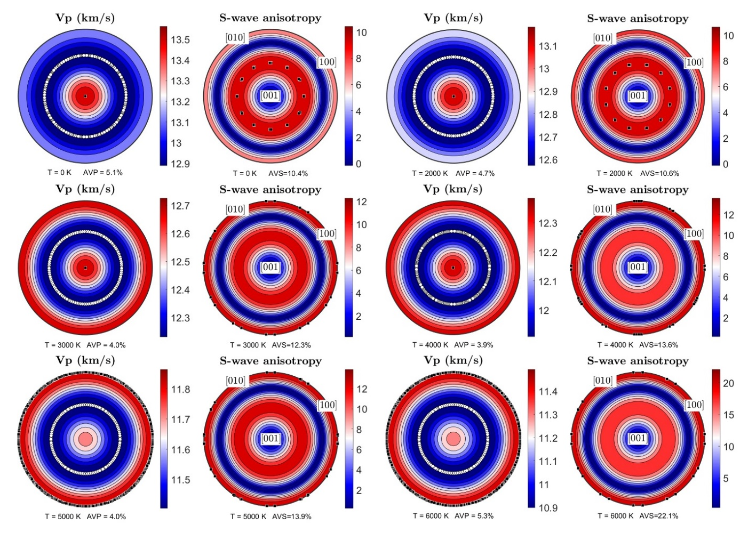
Fig. S3 | Seismic velocity anisotropy in FeH_{0.25} at 360 GPa and 0-6000 K. Black squares mark the maximum, and white circles mark the minimum. AV_{P} denotes the anisotropy of the P-wave velocity, while AV_{S} denotes the anisotropy of the S-wave velocity anisotropy (Eq. 16 and 17), which were directly obtained by solving the Christoffel equation employing MTEX¹⁵.
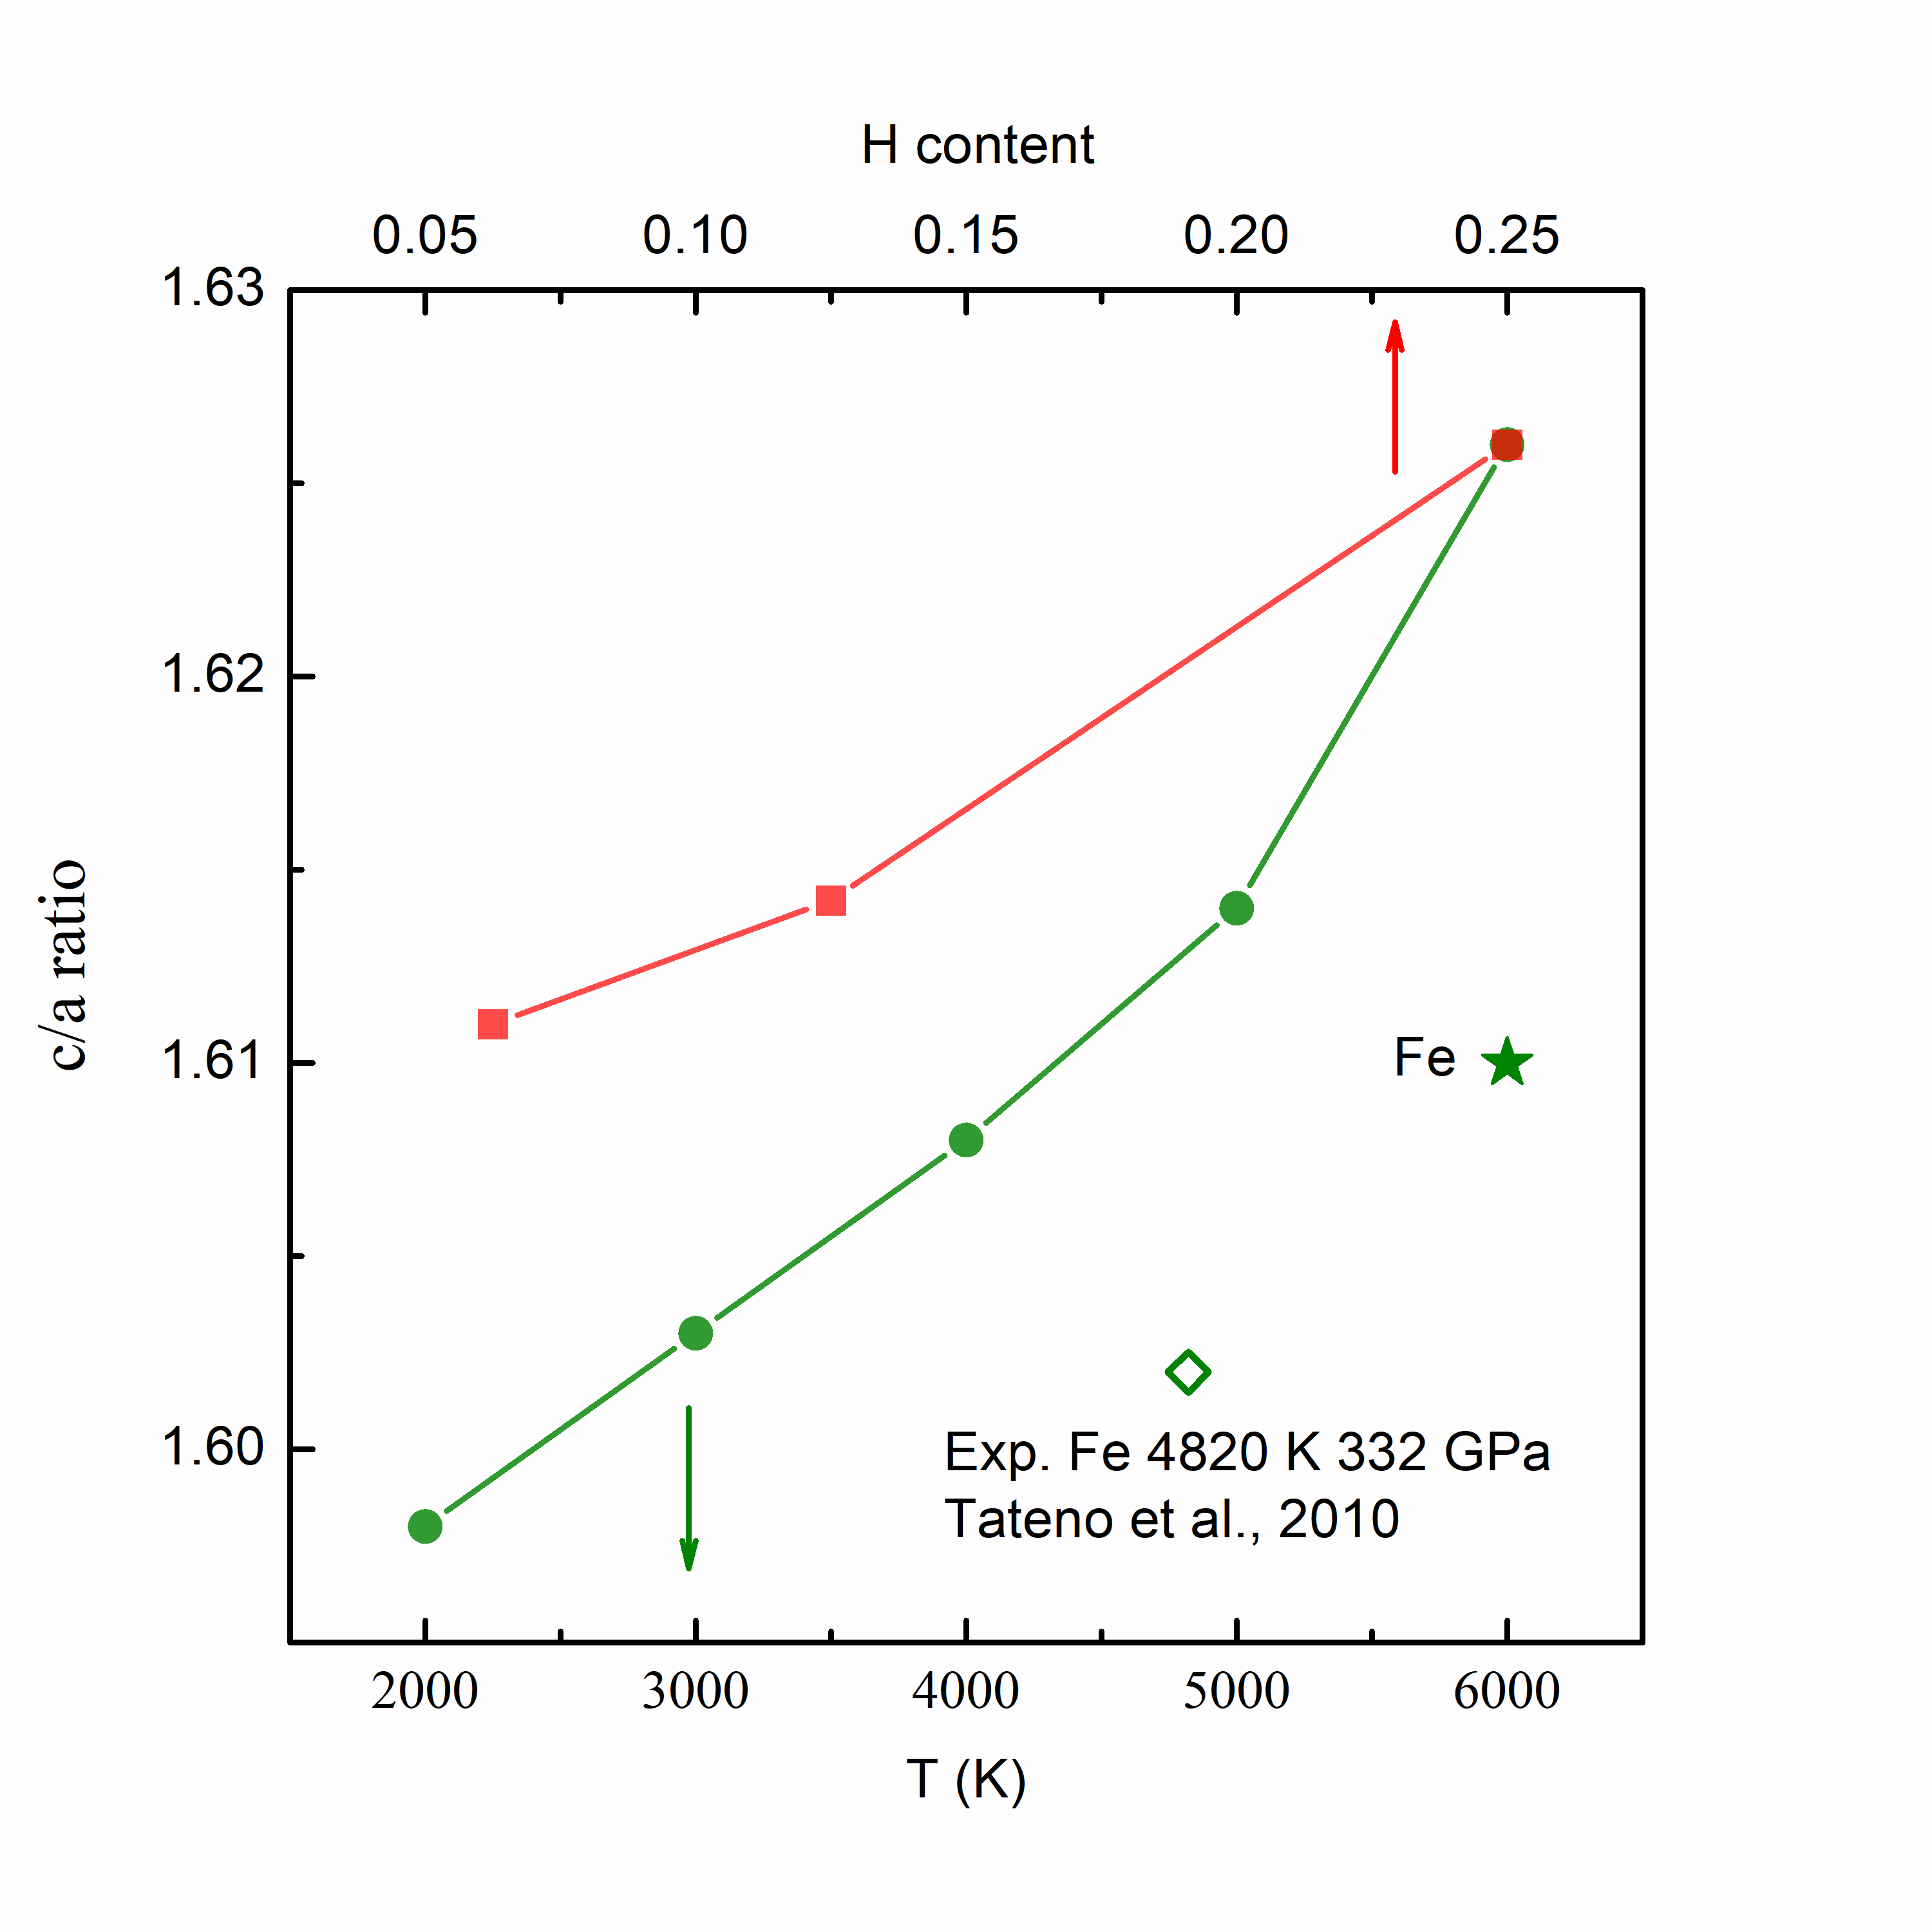
Fig. S4 | The change in the c/a ratio as a function of temperature (green circles) and H content (red squares) in hcp-FeH_{x} (x < 0.25) collected at 360 GPa. The calculated c/a ratio of hcp-Fe at 360 GPa and 6000 K is shown with a green start in comparison with the experimental data at 332 GPa and 4820 K (green empty diamond)¹⁹.

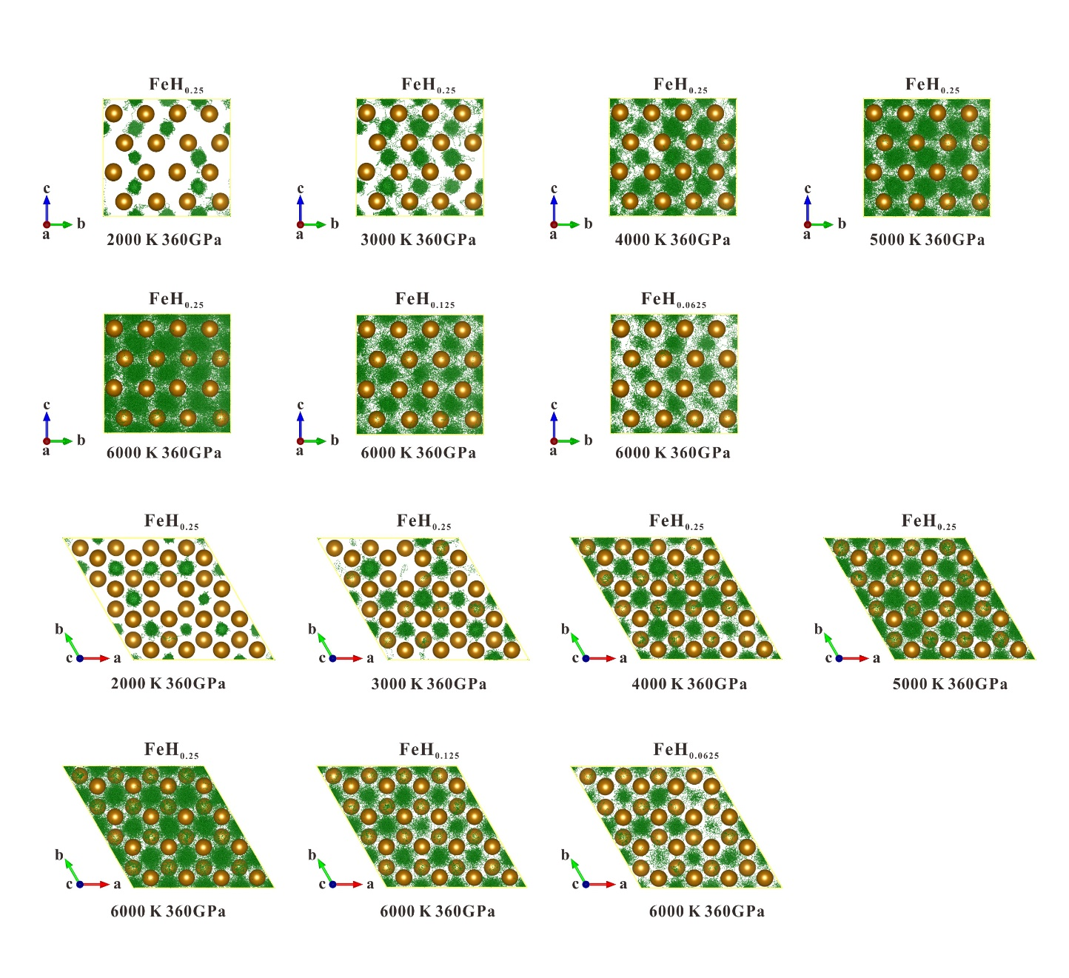
Fig. S5 | The trajectories of H-ions in hcp-FeH_{x} (x < 0.25) alloys at 360 GPa for over 10000 steps. H-ions are represented with small green spheres, and the brown spheres display the lattice positions of Fe. The lattice is viewed along the a-axis and c-axis in the upper and lower panels, respectively.

S3. Elastic anisotropy in Fe-H and other Fe alloys
Using the calculated elastic constants of previous computational studies, the compressional wave velocity anisotropies in pure Fe⁵ and other Fe alloys (Fe-C, Fe-S, Fe-Si, Fe-Si-H, and Fe-Si-C)^{6,11,12} are calculated and presented in Fig. S6. In the hcp structure, the velocity anisotropies of the Fe alloy are weaker than those of pure Fe. The velocity is faster along the c-axis, which is consistent with pure Fe. This suggests that the reduction in velocity anisotropy is due to the relatively strong softening along the c-axis in the presence of light element impurities. On the other hand, superionic FeH_{0.25} presents different velocity anisotropy with the fastest velocity in the basal plane.

Fig. S6 | Variation in compressional velocities (V_{P}) with propagation direction in superionic FeH_{0.25} at 6000 K and 360 GPa in the (010) plane. a Velocities of FeH_{0.25} calculated in this study compared with previously reported velocities in Fe, Fe₆₀Si₂C₂, Fe₆₀Si₄, Fe₅₆Si₈, Fe₆₄H₄, and Fe₆₀Si₄H₄. b Velocities of FeH_{0.25} calculated in this study compared with previously reported velocities in Fe₆₂C₂, Fe₆₂S₂ and Fe₆₀S₄.

S4. Comparison of Fe-H seismic anisotropy with seismological observations
The IC anisotropy has been observed by body waves²²⁻³¹ and normal modes³²⁻³⁴. Based on these observations, seismic waves travelling along Earth’s rotation axis are generally 2-3% faster than waves travelling along the east–west direction. With additional ultra-polar data, the anisotropy calculated by body wave residuals is better constrained to be ~2%, which is consistent with the value obtained using normal modes³¹. In considering the velocity change in FeH_{0.25} with azimuthal angle, we need to posit its basal plane parallel to Earth’s rotation axis, as shown in Fig. S7. Here, we considered two models for the configuration of FeH_{0.25} orientations in the equatorial plane. The first model is the anisotropic equatorial plane (AEP) model, in which the lattice of FeH_{0.25} is anisotropically oriented in the IC equatorial plane. The AEP model is an ideal model assuming that the velocity variation with ξ is consistent with the variation from the a-axis to the c-axis (Fig. S7 AEP). This model is almost impossible in adequate sampling of all the seismic ray paths in the IC. However, the sampling should be insufficient and biased due to the inhomogeneous distribution of seismic stations. In particular, the sampling of ultra-polar paths is quite limited. In this case, constructing this model is valuable in comparison with insufficient seismic data. The second model is an isotropic equatorial plane (IEP) model with a random distribution of the FeH_{0.25} lattice in the equatorial plane (Fig. S7 IEP). In this model, the change in the velocity as a function of angle ξ between the ray path and Earth’s rotation axis is calculated by averaging the velocities of all the possible paths from the fast axis to the a-c plane in the hcp structure. It can be viewed as a cylindrically averaged aggregate with a basal plane parallel to Earth’s rotation axis. These two models are compared with the seismic travel time data, as discussed in the main text (Fig. 4). Here, PKIKP refers to the compressional wave path transmitted through the inner core. PKPab and PKPbc are used as reference phases traversing only the mantle and outer core. Generally, the AEP model presents the slowest angle of which fits the IMIC absolute PKIKP data better²⁵. This may be due to insufficient ray path sampling of the IMIC. Alternatively, the IMIC may present a highly anisotropic equatorial plane, which is also suggested by recent observations of the coda-correlation wavefield. The equatorial anisotropy was proposed based on earthquake coda correlation, which is able to sample the deepest part of the IC^{35,36}. As suggested by recent studies^{37,38}, earthquake coda correlation can be an efficient approach to provide additional constraints on Earth’s interior structure if the real reconstructed ray paths from the coda correlation wavefield are carefully interpreted. Understanding the discrepancy between coda interferometry and ballistic observations^{39,40} may further provide critical clues for understanding the IC anisotropy structure. In addition, with the increase in seismological observations and the application of the coda correlation method, more information from the deepest part of Earth will be collected, and the mystery of the IMIC may be revealed. In particular, if the proposed equatorial anisotropy of the IMIC is confirmed with additional data, it should be critical evidence of the presence of a superionic Fe-H alloy in the IC.
We also compared the velocity anisotropy of other Fe alloys (360 GPa)^{5,11,12} with the IMIC observation data²⁵. In the case of other Fe alloys, the fastest direction is along the c-axis. To compare with the seismological observations, we need to place the c-axes of these Fe alloys along Earth’s rotation axis, and the orientation of their lattice in the equatorial plane does not affect the velocity change with ξ. The velocity anisotropies in other Fe alloys, which roughly fit with the IMIC data, present the slowest angles from ~45-60º and significant velocity fluctuations (Fig. S8).
The calculated velocities are also compared with the travel time residuals of PKPbc-PKIKP and PKPab-PKIKP, which are sensitive to the upper 350 km and 1100 km of the IC, respectively. However, the ray paths for these waves are different in the mantle; thus, the residuals are also affected by mantle heterogeneity. In Fig. S9, we compared our results with the dataset after mantle and ray path corrections were reported most recently³¹. The data travelling from the South Sandwich Islands (SSI) to Alaska are shown with red circles, as the anomalous positive travel time may be caused by the presence of subducted slabs in the SSI path in the mantle^{41,42}. Excluding the SSI data, the anisotropy for the bulk IC is approximately 2%, which is close to the normal model observations. The travel-time residual for FeH_{0.25} was estimated by
$\frac{δt}{t}=\frac{V_{P}-V_{P0}}{V_{P0}}$, (18)
where $V_{P0}$ is the Voigt average velocity. As the velocity anisotropy does not show an obvious change with pressure from 330 to 360 GPa, the data calculated at 360 GPa and 6000 K were used for comparison. The calculated travel-time residual of FeH_{0.25} is able to account for the IC anisotropy with faster velocity along the polar direction. We also calculated velocity anisotropies in the situation of 25%, 50%, and 75% aligned crystals with basal planes parallel to the rotation axis (Fig. S10). In comparison with the recent dataset of seismological observations, approximately 55-70% of LPO is needed to meet the observed residuals of PKPbc-PKIKP, and ~70-80% of LPO is needed to fit the PKPab-PKIKP data. In particular, the IEP model presents milder fluctuations in the average velocity at the equatorial side, which fits the observation data better. In contrast, the other Fe alloys all present significant negative residuals.

Fig. S7 | Models for the LPO of hcp-FeH_{0.25} with the basal plane along Earth’s rotation axis in the equatorial plane (dashed blue ellipse). Both the anisotropic and isotropic equatorial plane models (AEP/IEP) are presented. The basal plane of the lattice is shown by a light blue ellipse.

Fig. S8 | Compressional velocity in FeH_{0.25} as a function of angle $ξ$ between the ray path and Earth’s rotation axis. a. The IMIC data fit and PREM model and previously reported Fe-Si alloys and Fe-Si-C alloys were added for comparison. b. IMIC data fit and PREM model and previously reported Fe-C alloys and Fe-S alloys were plotted for comparison.

Fig. S9 | Calculated compressional velocity anisotropy in comparison with differential travel-time residuals as a function of angle $ξ$ between the ray path and Earth’s rotation axis. The δt/t of FeH_{0.25} and other Fe alloys are estimated by Eq. 14. The PKPab-PKIKP and PKPbc-PKIKP data are reported in a recent study with mantle and ray path corrections³¹. The data travelling from the South Sandwich Islands (SSI) to Alaska are shown with red circles.

Fig. S10 | Calculated seismic anisotropies with 25, 50, 75, and 100% LPO of hcp-FeH_{0.25} with basal planes aligned with the rotation axis.

S5. H-ion anisotropic diffusion in Fe-H alloys
The migration barrier energies along different migration paths are calculated using the climbing-image nudged elastic band (CINEB) method⁴³. This CINEB method duplicated a series of images (7 images in our calculations) between the starting point and the end point of migrating ions to simulate the intermediate states, with the positions of the starting point and the end point fixed. The actual diffusion pathway and migration barrier energy between the starting and end points are obtained by searching for the saddle point. Only the Γ point was adopted for k-point sampling to reduce the computational cost. The convergence check indicates that a denser k-mesh does not qualitatively affect our conclusion. The cut-off energy is 600 eV. To investigate the barrier energies of H-ion migration from one site to another, larger 8 × 4 × 2 and 4 × 4 × 4 supercells containing 160 atoms were used to calculate the barrier energies along the a-axis and c-axis, respectively. The cell parameters and volumes of hcp-FeH_{0.25} at 2000-6000 K and 360 GPa are adopted from AIMD simulations (Fig. 2 and Fig. S11), and both the volumes and c/a ratios increase with temperature (Fig. S4).
The stable interstitial site is the octahedral site (O), and the tetrahedral site (T) is metastable. We considered three diffusion paths for H-ion. As shown in Fig. 2a, path 1 and path 2 are in the basal plane, and the direct migration from O-O in the basal plane is much less stable than the indirect migration path O-T-O. In the direction along the c-axis, the direct migration from O-O (path 3) presents the lowest barrier energy. The saddle points (S) for these migration paths are at the center of the octahedral planes, where the H-ion has the strongest interaction with the Fe lattice. The barrier energies along the c-axis and in the basal plane are different due to the nonideal c/a ratio. In FeH_{0.25} at 360 GPa and 6000 K, the c/a ratio is 1.626, which is smaller than the ideal value of 1.633. As the distance of nearby Fe atoms along the c-axis is shorter than the distance in the basal plane, H-ion migration in the basal plane has a stronger interaction with the Fe sublattice. Thus, the c/a ratio is a critical parameter governing the anisotropic diffusion behavior of interstitial impurities in hcp-Fe alloys, and diffusion in the basal plane can be favorable when the c/a ratio is larger than the ideal value. In the case of hcp-FeH_{0.25}, the c/a ratios are lower than the ideal value under IC conditions, and H-ion diffusion along the c-axis is more favorable. From 2000 to 6000 K, the barrier energies for the three paths mostly decrease with temperature, and the barrier energy along the c-axis is the lowest (Fig. S11).
We also used AIMD simulations to study the diffusion anisotropy in hcp-Fe-H alloys. In the AIMD simulations, the diffusion coefficient is defined as:
$D=\lim_{0→∞}\left[\frac{1}{2dt}〈{\left[\vec{r}\left(t\right)\right]}^{2}〉\right]$, (19)
where d is the dimension of the lattice on which ion hopping takes place. Mean square displacement (MSD)
$〈{\left[\vec{r}\left(t\right)\right]}^{2}〉=\frac{1}{N}\sum_{i=1}^{N}{〈{\left[\vec{r_{i}}\left(t+t_{0}\right)-\vec{r_{i}}\left(t_{0}\right)\right]}^{2}〉}$, (20)
is averaged over all H-ions, $\vec{r_{i}}\left(t\right)$ is the displacement of the ith H-ion at time t, and N is the total number of H-ions in the system.
The H-ion diffusion coefficients along different directions in FeH_{0.25} at 2000-6000 K and 360 GPa are calculated and plotted as a function of reciprocal temperature (Fig. S12). The values are fitted with an Arrhenius equation:
$$\begin{aligned} D=Aexp\left(-\frac{∆H}{kT}\right),\#\left(21\right)\end{aligned}$$
where $∆H$ is the activation enthalpy, A is a pre-exponential factor, k is the Boltzmann constant, and T is the temperature. Based on Eq. 21, $∆H$ along different paths were calculated, and the activation enthalpy along the c-axis was the lowest (Fig. S12). This result is consistent with the migration barrier energy calculated using the CINEB method, suggesting that H-ion diffusion along the c-axis is the energetically most favorable path in FeH_{0.25}. The diffusion coefficient of defects in the lattice can be described by the following equation:
$$\begin{aligned}D=\frac{Z}{6}Fl^{2}υe^{-\frac{∆H-T∆S}{kT}},\#\left(22\right)\end{aligned}$$
where Z is the number of equivalent migration paths, F is the correlation factor, $l$ is the migration distance, $υ$ is the attempt frequency, $∆H$ and ∆S are the migration enthalpy and entropy, $k$ is Boltzmann’s constant, and T is the temperature. As shown in Supplementary Fig. S13, there are two equivalent migration paths for H ions along the a-axis of hcp-Fe lattice, while there is only one migration path along the c-axis. Therefore, the H-ion diffusion coefficients along the a-axis and c-axis are almost identical at high temperatures (Supplementary Fig S12) although the migration barrier energy along the c-axis is higher.

Fig. S11 | Calculated migration paths and barrier energies for H-ions in hcp-FeH_{0.25} at 360 GPa and 2000-6000 K. Paths 1, 2, and 3 represent the O-O direct path, O-T-O indirect path in the basal plane, and O-O path along the c axis. The calculated barrier energies at 2000-6000 K for different H-ion migration paths are shown with pink, blue and green spheres.

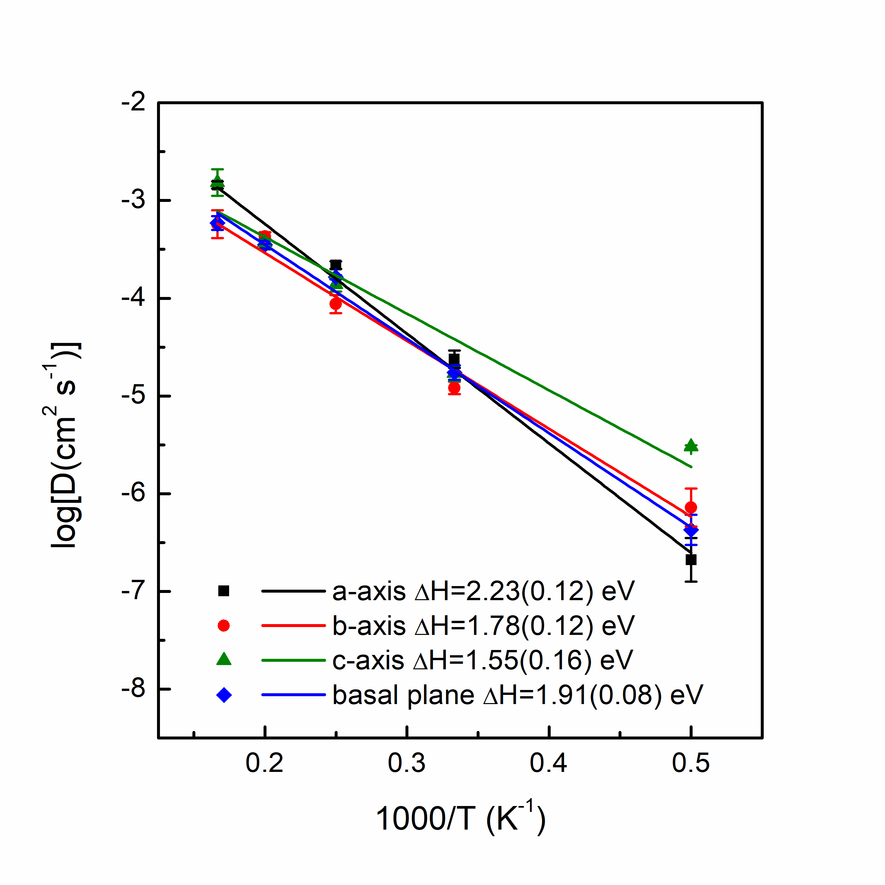 Fig. S12 | Calculated H-ion diffusion coefficients in hcp-FeH_{0.25} as a function of reciprocal temperature. The diffusion coefficients along the a-axis, b-axis, c-axis and basal plane at 360 GPa and different temperatures (2000-6000 K) are shown with black squares, red circles, green triangles, and blue diamonds. The data are linearly fitted, and the calculated activation enthalpies are noted.

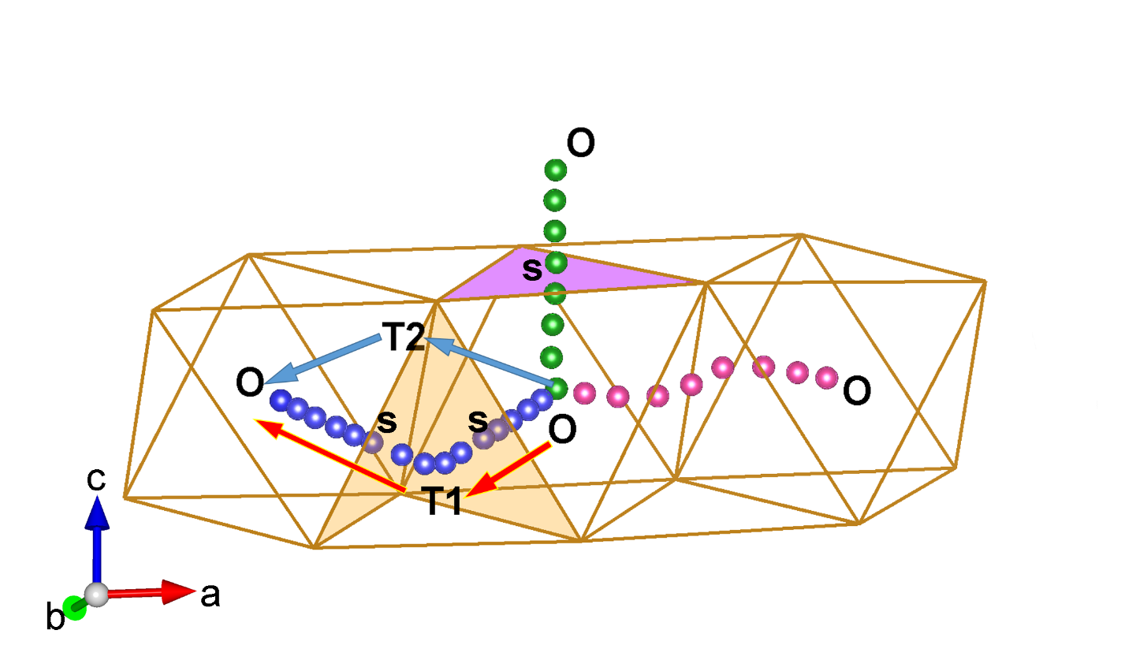
Fig. S13 | The equivalent migration paths along the a-axis. The equivalent migration paths, O-T1-O and O-T2-O, are shown with blue and red arrows. O, T, and S represent the octahedral site, tetrahedral site, and saddle point of the migration path, respectively.

S6. H-ion transportation in external electric field

External electric fields alter ionic transportation behavior in superionic ice⁴⁴. Considering the presence of electric field in Earth’s inner core, it is worth to study the effect of external electric field on H-ion diffusion in superionic Fe-H alloys. MD simulations based on neural network potential (NNP) with large supercell and long simulation time are used to enhance computational efficiency and accuracy. Thus, an NNP of FeH_{0.25} at 360 GPa and 6000 K is developed based on our AIMD dataset using the DeePMD-kit package⁴⁵. The NNP and DFT computed energies and forces are compared in Fig. S14, and the root mean square errors are 4 meV/atom for the energies, 256 meV/Å for the forces, and 24 meV/atom for the virial stresses on the testing set at 360 GPa and 6000 K. Comparisons between the pair distribution function computed by the NNP-based MD simulation and AIMD show good consistency (Fig. S15).

We conducted nonequilibrium molecular dynamics simulations using the LAMMPS software package^{46,47} with the well-trained NNP. A larger supercell containing 640 atoms was used for the simulation, and the temperature was controlled by the Nosé‒Hoover thermostat. External static electric fields with strengths of 0.1 and 1.0 V/Å were set along the directions of a-axis and c-axis of the hcp-FeH_{0.25} lattice and run for 1000 ps in a canonical ensemble at 360 GPa and 6000 K.

The incorporation of an electric field into MD simulations can be achieved by adding a force F=qE⁴⁸ with a charge of q. The atomic charges of Fe and H were set to +0.075 e and -0.3 e according to the Bader charge calculation results (Table S3). The total energy in MD simulations was calculated by counting the contributions from potential energy, kinetic energy and electric-field-induced energy change.

The MSDs of the H-ion along the a-axis and c-axis were calculated and are shown in Fig. S16. The MSDs change with the applied electric field, and diffusion along the c-axis is more favorable when the electric field points to the c-axis. However, the electric field along the a-axis does not significantly increase H-ion diffusion along this direction. In particular, when the field intensity is 0.1 V/Å, H-ion diffusion along the c-axis is still preferred (Fig. S16). The calculated diffusion coefficients under different external electric fields are shown in Fig. 3a. In addition, we compared the internal energies under the electric field along the a-axis and c-axis. The energy differences (∆E = E_{c-axis}-E_{a-axis}) increase with simulation time under electric fields of 0.1 and 1.0 V/Å, indicating that the alignment of the c-axis parallel to the external electric field direction is energetically more favorable. This provides robust evidence of the anisotropic H-ion transportation property in the hcp-FeH alloy, especially in the presence of external electric fields.

Fig. S14 | Scatter plot of the NNP energies and forces. Comparison of the calculated energies and forces using DFT (a) and NNP (b) for a dataset of 20000 configurations.

Fig. S15 | The comparison partial radial distribution functions (RDFs). The RDFs of Fe-H, Fe-Fe, and H-H are calculated using AIMD (black) and NNP-based MD (red) methods at 360 GPa and 6000 K.

Fig. S16 | The MSDs along the a-axis and c-axis in superionic FeH_{0.25} at 360 GPa and 6000 K in the presence of external static electric fields (F_{e}). The field directions and intensities are labelled.

S7. Bader charge analysis on Fe alloys
To estimate the charge of interstitial impurities (C, H, and O) in Fe alloys, we performed Bader charge analysis⁴⁹ on the electronic charge densities of FeH_{0.25}, FeC_{0.0625}, and FeO_{0.0625}. The structures were obtained from our previous study¹. The results are shown in Table S2, and the net charges for the H, C, and O ions are -0.306, -0.803, and -0.951 e, respectively. The negative charge suggests electron transfer from Fe to interstitial H, C, and O atoms in these alloys at 360 GPa. The calculated charge was adopted for the MD simulations under electric fields.

Table S2. Bader net charge of the atoms for FeH_{0.25}, FeC_{0.0625}, and FeO_{0.0625} at 360 GPa
FeH_{0.25} |  |  | FeC_{0.0625} |  |  | FeO_{0.0625}
Atoms | charge (e) |  | Atoms | charge (e) |  | Atoms | charge (e)
H1 | -0.306 |  | C1 | -0.803 |  | O1 | -0.951
H2 | -0.306 |  | Fe1 | 0.013 |  | Fe1 | 0.009
Fe1 | 0.094 |  | Fe2 | 0.011 |  | Fe2 | 0.007
Fe2 | 0.059 |  | Fe3 | -0.004 |  | Fe3 | 0.0004
Fe3 | 0.059 |  | Fe4 | 0.011 |  | Fe4 | 0.009
Fe4 | 0.094 |  | Fe5 | 0.117 |  | Fe5 | 0.168
Fe5 | 0.094 |  | Fe6 | 0.113 |  | Fe6 | 0.161
Fe6 | 0.059 |  | Fe7 | 0.029 |  | Fe7 | -0.035
Fe7 | 0.059 |  | Fe8 | 0.111 |  | Fe8 | 0.157
Fe8 | 0.094 |  | Fe9 | 0.119 |  | Fe9 | 0.165
 |  |  | Fe10 | 0.029 |  | Fe10 | -0.035
 |  |  | Fe12 | 0.113 |  | Fe12 | 0.161
 |  |  | Fe11 | 0.108 |  | Fe11 | 0.159
 |  |  | Fe13 | 0.012 |  | Fe13 | 0.009
 |  |  | Fe14 | -0.004 |  | Fe14 | 0.0004
 |  |  | Fe15 | 0.011 |  | Fe15 | 0.00699
 |  |  | Fe16 | 0.013 |  | Fe16 | 0.009

S8. References
- He, Y., Sun, S., Kim, D. Y., Li, H., Mao, H.-k. Superionic hcp-Fe alloys and their seismic velocities in Earth’s inner core. Nature 602, 258-262 (2022).
- Sun, S., He, Y., Kim, D. Y. & Li, H. Anomalous elastic properties of superionic ice. Phy. Rev. B 102, 104108 (2020).
- He, Y., Sun, S. & Li, H. Ab initio molecular dynamics investigation of the elastic properties of superionic Li₂O under high temperature and pressure. Phy. Rev. B 103, 174105 (2021).
- Flyvbjerg, H. & Petersen, H. G. Error estimates on averages of correlated data. J. Chem. Phys. 91, 461-466 (1989).
- Martorell, B., Vocadlo, L., Brodholt, J. & Wood, I. G. Strong premelting effect in the elastic properties of hcp-Fe under inner-core conditions. Science 342, 466-468 (2013).
- Wang, W. et al. Strong shear softening induced by superionic hydrogen in Earth's inner core. Earth and Planetary Sci. Lett. 568, 117014 (2021).
- Vočadlo, L. Ab initio calculations of the elasticity of iron and iron alloys at inner core conditions: Evidence for a partially molten inner core? Earth and Planetary Sci. Lett. 254, 227-232 (2007).
- Vočadlo, L., Alfè, D., Gillan, M. J. & Price, G. D. The properties of iron under core conditions from first principles calculations. Phys. Earth Planet. Inter. 140, 101-125 (2003).
- Simmons, G. & Wang, H. Single Crystal Elastic Constants and Calculated Aggregate Properties: A Handbook (MIT Press, Cambridge, MA, 1971).
- Dziewonski, A. M. & Anderson, D. L. Preliminary Reference Earth Model. Physics of the Earth and Planetary Interiors 25, 297-356 (1981).
- Martorell, B., Wood, I. G., Brodholt, J. & Vočadlo, L. The elastic properties of hcp-Fe_{1−x}Si_{x} at Earth's inner-core conditions. Earth and Planetary Sci. Lett. 451, 89-96 (2016).
- Li, Y., Vočadlo, L. & Brodholt, J. P. The elastic properties of hcp-Fe alloys under the conditions of the Earth's inner core. Earth and Planetary Sci. Lett. 493, 118-127 (2018).
- Anderson, D. Theory of the Earth (Blackwell Scientific, Boston, (1989)
- Karki, B., Stixrude, L., Clark, S., Warren, M., Ackland, G. & Crain, J. Structure and elasticity of MgO at high pressure. Am. Mineral. 82, 51 (1997).
- Mainprice, D., Hielscher, R. & Schaeben, H. Calculating anisotropic physical properties from texture data using the MTEX open-source package. Geological Society, London, Special Publications 360, 175-192 (2011).
- Sha, X. & Cohen, R. E. Elastic isotropy of ɛ-Fe under Earth's core conditions. Geophys. Res. Lett. 37, L10302 (2010).
- Vočadlo, L., Dobson, D. P. & Wood, I. G. Ab initio calculations of the elasticity of hcp-Fe as a function of temperature at inner-core pressure. Earth Planet. Sci. Lett. 288, 534–38 (2009).
- Mattesini, M. et al., Hemispherical anisotropic patterns of the Earth’s inner core. Proc. Natl. Acad. Sci. USA 107, 9507-9512 (2010).
- Tateno, S., Hirose, K., Ohishi, Y. & Tatsumi, Y. The Structure of Iron in Earth’s Inner Core. Science 330, 359-361 (2010).
- Belonoshko, A. B., Ahuja, R. & Johansson, B. Stability of the body-centred-cubic phase of iron in the Earth’s inner core. Nature 424, 1032-1034 (2003).
- Gannarelli, C. M. S., Alfe, D. & Gillan, M. J. The axial ratio of hcp iron at the conditions of the Earth’s inner core. Phys. Earth Planet. Inter. 152, 67-77 (2005).
- Poupinet, G., Pillet, R. & Souriau, A. Possible heterogeneity of the Earth’s core deduced from PKIKP travel times. Nature 305, 204-206 (1983).
- Morelli, A., Dziewonski, A.M. & Woodhouse, J.H. Anisotropy of the inner core inferred from PKIKP travel times, Geophys. Res. Lett. 13, 1545–1548 (1986).
- Creager, K.C. Anisotropy of the inner core from differential travel times of the phases PKP and PKIKP. Nature 356, 309-314 (1992).
- Ishii, M. & Dziewonski, A.M. The innermost inner core of the Earth: evidence for a change in anisotropic behavior at the radius of about 300 km, Proc. Natl. Acad. Sci. USA 99, 14026–14030 (2002).
- Niu, F. & Chen, Q.F. Seismic evidence for distinct anisotropy in the innermost inner core. Nat. Geosci. 1, 692–696.
- Niu, F. & Wen, L. Hemispherical variations in seismic velocity at the top of Earth’s inner core. Nature 410, 1081–1084 (2001).
- Song, X., Helmberger, D. V. Depth dependence of anisotropy of Earth’s inner core. J. Geophys. Res. 100, 9805–9816 (1995).
- Irving, J. C. E. & Deuss, A. Hemispherical structure in inner core velocity anisotropy. J. Geophys. Res. 116, B04307 (2011).
- Lythgoe, K. H., Deuss, A., Rudge, J. F. & Neufeld, J. A. Earth’s inner core: Innermost inner core or hemispherical variations? Earth Planet. Sci. Lett. 385, 181–189 (2014).
- Brett, H. & Deuss, A. Inner core anisotropy measured using new ultra-polar PKIKP paths. Geophys. J. Int. 223, 1230-1246 (2020).
- Woodhouse, J.H., Giardini, D. & Li, X.-D. Evidence for inner core anisotropy from free oscillations. Geophys. Res. Lett. 13, 1549–1552 (1986).
- Deuss, A., Irving, J.C.E. & Woodhouse, J.H. Regional variation of inner core anisotropy from seismic normal mode observations. Science 328, 1018–1020 (2010).
- Irving, J. C. E., Deuss, A. & Woodhouse, J. H. Normal mode coupling due to hemispherical anisotropic structure in Earth’s inner core. Geophys. J. Int. 178, 962–75 (2009).
- Wang, T., Song, X. & Xia, H. H. Equatorial anisotropy in the inner part of Earth’s inner core from autocorrelation of earthquake coda. Nat. Geosci. 8, 224-227 (2015).
- Wang, T. & Song, X. Support for equatorial anisotropy of Earth’s inner-inner core from sesmic interferometry at low latitudes. Phys. Earth Planet. Inter. 276, 247-257 (2018).
- Tkalčić, H., Phạm, T.-S. & Wang, S. The Earth's coda correlation wavefeld: Rise of the new paradigm and recent advances. Earth-Sci. Rev. 208, 103285 (2020).
- Wang, S., & Tkalčić, H. Seismic event coda-correlation: Toward global coda-correlation tomography. J. Geophys. Res.: Solid Earth 125, e2019JB018848 (2020).
- Romanowicz, B., Cao, A., Godwal, B., Wenk, R., Ventosa, S. & Jeanloz, R. Seismic anisotropy in the Earth's innermost inner core: testing structural models against mineral physics predictions. Geophys. Res. Lett. 43, 93–100. (2016).
- Frost, D.A. & Romanowicz, B. On the orientation of the fast and slow directions of anisotropy in the deep inner core. Phys. Earth Planet. Inter. 286, 101–110 (2019).
- Tkalčić, H. Large variations in travel times of mantle-sensitive seis-mic waves from the South Sandwich Islands: is the Earth’s inner core a conglomerate of anisotropic domains? Geophys. Res. Lett. 37, L14312 (2010).
- Frost, D.A., Romanowicz, B. & Roecker, S., 2020. Upper mantle slab under Alaska: contribution to anomalous core-phase observations on south-Sandwich to Alaska paths. Phys. Earth planet. Inter. 299, 106427 (2020).
- Henkelman, G., Uberuaga, B. P. & Jonsson, H. A climbing image nudged elastic band method for finding saddle points and minimum energy paths. J. Chem. Phys. 113, 9901–9904 (2000).
- Futera, Z., Tse, J. S. & English, N. J. Possibility of realizing superionic ice VII in external electric fields of planetary bodies. Sci. Adv. 6, eaaz2915 (2020).
- Wang, H., Zhang, L., Han, J. & E, W. DeePMD-kit: A deep learning package for many-body potential energy representation and molecular dynamics. Comput. Phys. Commun. 228, 178–184 (2018).
- Plimpton, S. Fast Parallel Algorithms for Short-Range Molecular Dynamics. J. Comput. Phys. 117, 1-19 (1995).
- English, N.J. Molecular Simulation of External Electric Fields on the Crystal State: A Perspective. Crystals 11, 1405 (2021).
- Plimpton, S. LAMMPS-large-scale atomic/molecular massively parallel simulator. Sandia Natl. Lab. (2007).
- Bader, R. F. W. Atoms in Molecules: A Quantum Theory. Oxford University Press, Oxford, UK, (1990).

