Supplementary materials
Supplementary Table S1 Daily meteorological and air quality data of 122 districts/counties in 2019 Hunan
Variables | X_{min} | P₂₅ | P₅₀ | P₇₅ | X_{max} | QR
Average temperature(℃) | -5.5 | 11.3 | 19.6 | 26.7 | 33.4 | 15.4
Min temperature(℃) | -7.6 | 7.8 | 15.3 | 22.8 | 30.1 | 15.0
Max temperature（℃） | -4.6 | 14.4 | 24.1 | 30.6 | 38.6 | 16.2
Relative humidity（%） | 39.7 | 76.0 | 81.2 | 86.3 | 99.6 | 10.3
DTR(℃) | 0.004 | 4.8 | 7.7 | 10.1 | 22.3 | 5.3
PM_{2.5}(μg/m³) | 1.8 | 21.4 | 31.2 | 46.5 | 288.0 | 25.1
PM₁₀(μg/m³） | 6.9 | 38.2 | 52.2 | 75.2 | 363.0 | 37.0
SO₂(μg/m³） | 1.4 | 6.7 | 9.1 | 11.9 | 48.5 | 5.2
NO₂(μg/m³) | 1.6 | 13.1 | 17.8 | 25.1 | 100.3 | 12.0
O₃(μg/m³） | 4.0 | 64.8 | 94.7 | 123.1 | 250.4 | 58.3
CO(mg/m³） | 0.1 | 0.7 | 0.9 | 1.0 | 2.8 | 0.3
DTR indicates diurnal temperature range; PM_{2.5} indicates fine particulate matter; PM₁₀ indicates inhalable particulate matter; SO₂ indicates sulfur dioxide; NO₂ indicates nitrogen dioxide; O₃ indicates ozone; CO indicates carbon monoxide; QR, indicates interquartile range.

Supplementary Table S2 Spearman correlation coefficients of daily exposure variables
Variables | Average temperature | Relative humidity | DTR | PM_{2.5} | PM₁₀ | SO₂ | NO₂ | O₃ | CO
Average temperature (℃) | — | — | — | — | — | — | — | — | —
Relative humidity (%) | 0.22* | — | — | — | — | — | — | — | —
DTR(℃) | 0.34* | 0.01* | — | — | — | — | — | — | —
PM_{2.5}(μg/m³) | -0.15* | -0.06* | -0.08* | — | — | — | — | — | —
PM₁₀(μg/m³） | -0.19* | -0.24* | -0.10* | 0.83* | — | — | — | — | —
SO₂(μg/m³） | -0.13* | -0.31* | -0.07* | 0.29* | 0.37* | — | — | — | —
NO₂(μg/m³) | 0.01 | -0.10* | -0.05* | 0.57* | 0.55* | 0.48* | — | — | —
O₃(μg/m³） | -0.07 | 0.01 | 0.03 | -0.19* | -0.08* | -0.06* | -0.20* | — | —
CO(mg/m³） | -0.05* | -0.22* | -0.05* | 0.35* | 0.35* | 0.38* | 0.29* | -0.18* | —
* P<0.05
DTR indicates diurnal temperature range; PM_{2.5} indicates fine particulate matter; PM₁₀ indicates inhalable particulate matter; SO₂ indicates sulfur dioxide; NO₂ indicates nitrogen dioxide; O₃ indicates ozone; CO indicates carbon monoxide.

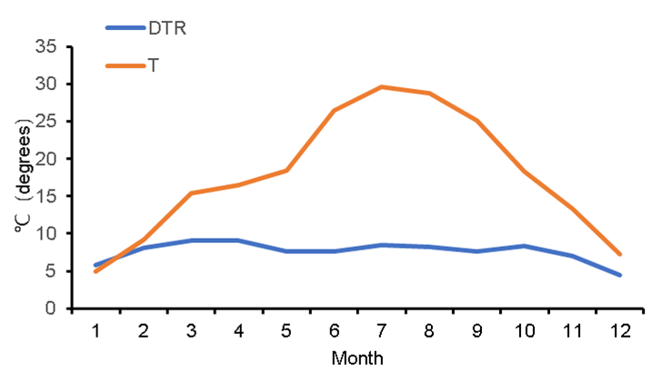
Supplementary Fig.S1 Distribution of monthly mean temperature and diurnal temperature range in 2019 Hunan

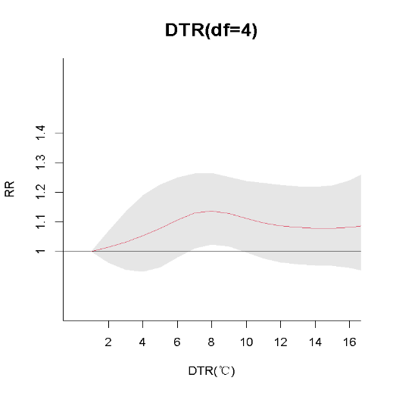
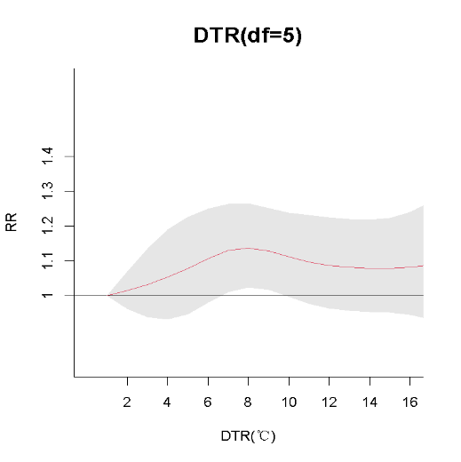
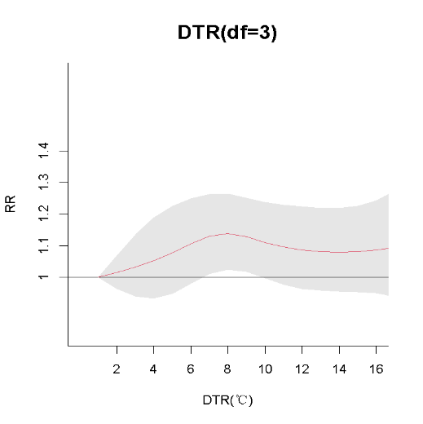
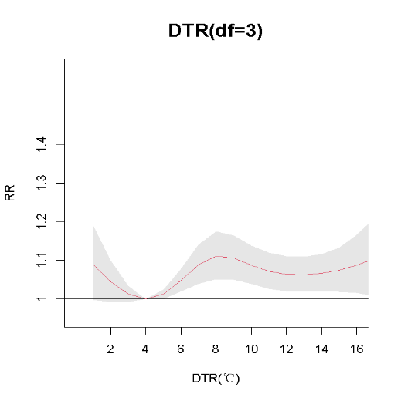
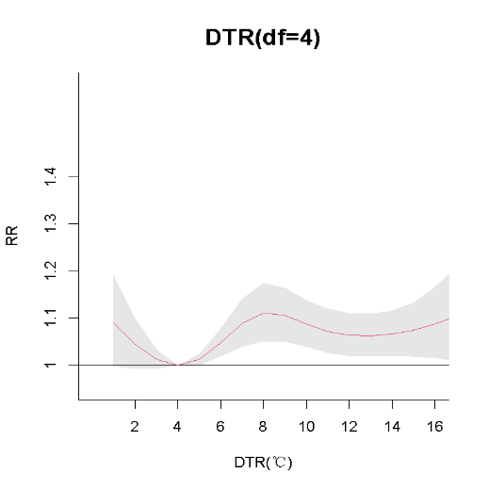
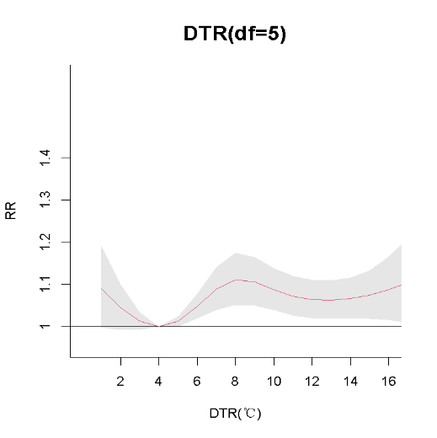
B
A

Supplementary Fig. S2 Sensitivity analyses of the effects of diurnal temperature range effects on Intracerebral hemorrhage admissions of A (middle-aged group) andB (elderly group), changing df for diurnal temperature range

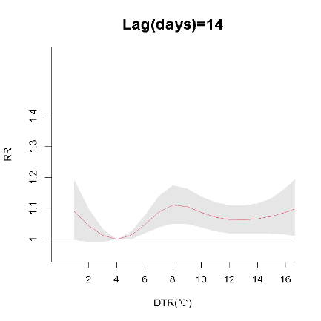
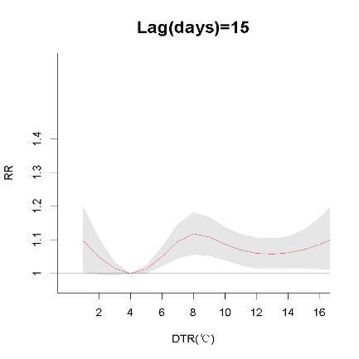
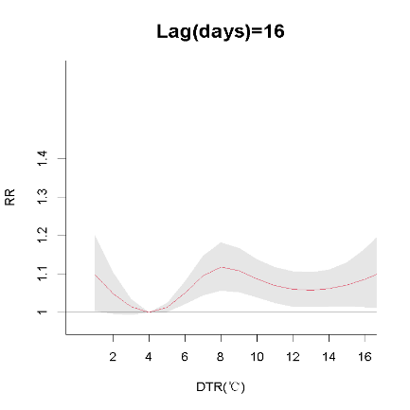
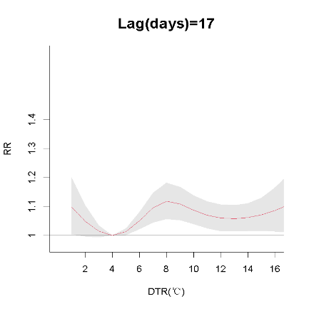
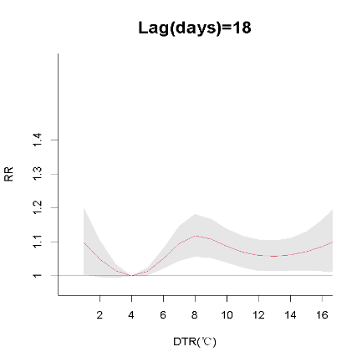
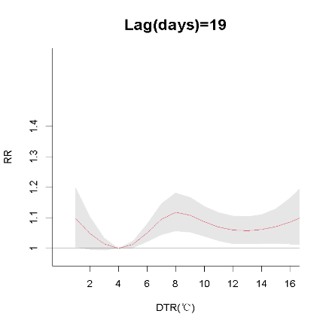
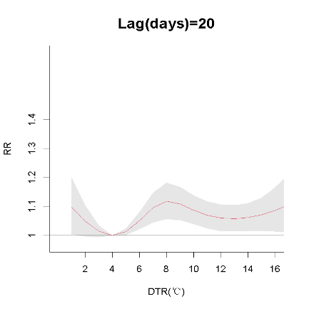
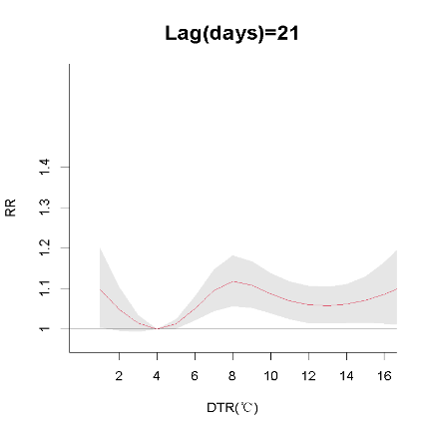
B
A
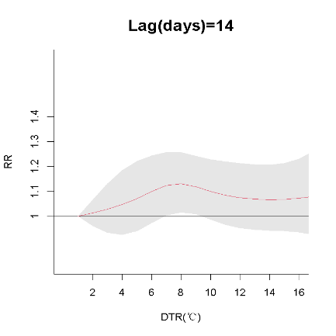
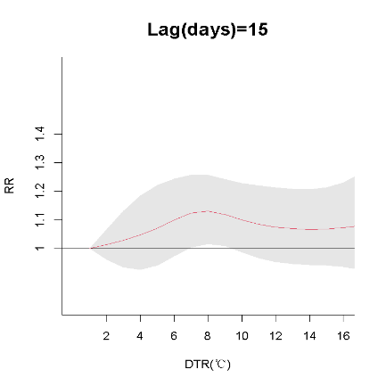
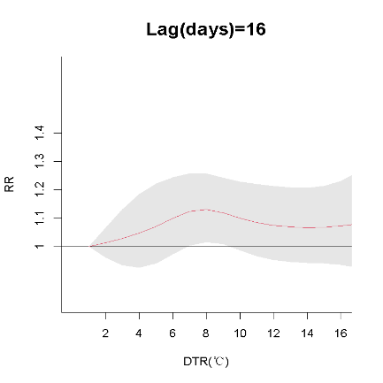
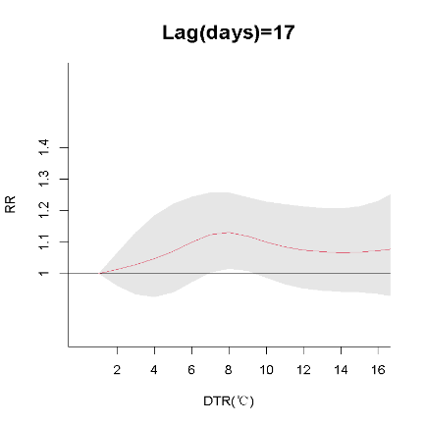
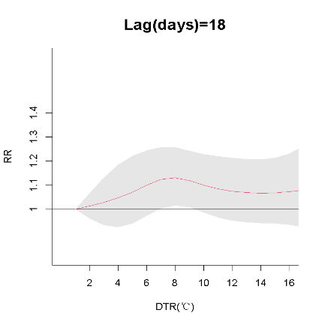
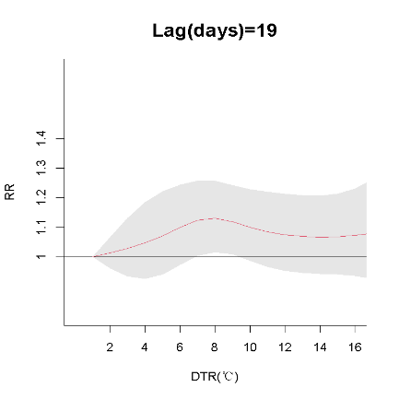
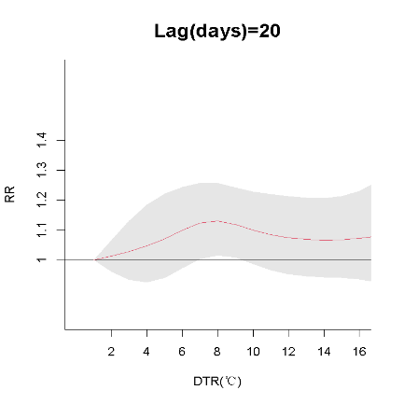
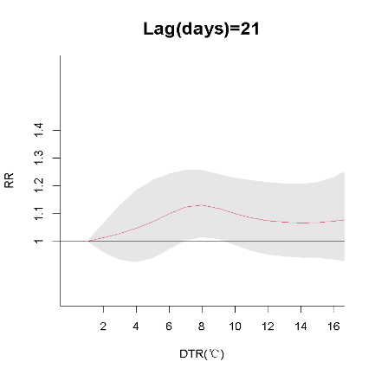
Supplementary Fig. S3 Sensitivity analyses of the effects of diurnal temperature range on Intracerebral hemorrhage admission of A (middle-aged group) and B (elderly group), changing maximum lag days for diurnal temperature range

