Supplementary information
Lipo-MGN Nanoparticle Hypoxia Attenuation-Mediated Single-dose Radiotherapy- and pH/ROS-Responsive T1 Contrast Magnetic Resonance Imaging in Hepatocellular Carcinoma
Reju George Thomas ^{1*}, Subin Kim ^{1*}, Raveena Nagareddy¹, Veena Vjayan², Ansuja Mathew Pullickal², Mee Sun Yoon³, In Kyu Park², Yong Yeon Jeong^{1†}
¹Department of Radiology, Chonnam National University Medical School and Hwasun Hospital, Hwasun, Korea
²Department of Biomedical Sciences, Chonnam National University Medical School and Hospital, Gwangju, Korea
³ Department of Radiation Oncology, Chonnam National University Hwasun Hospital, Chonnam National University Medical School, Gwangju, South Korea

*These authors contributed equally to the manuscript.

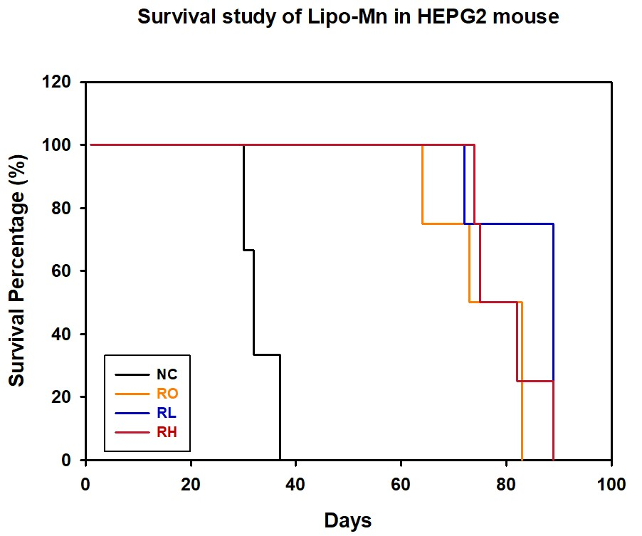
S1: Survival of mice after radiotherapy.
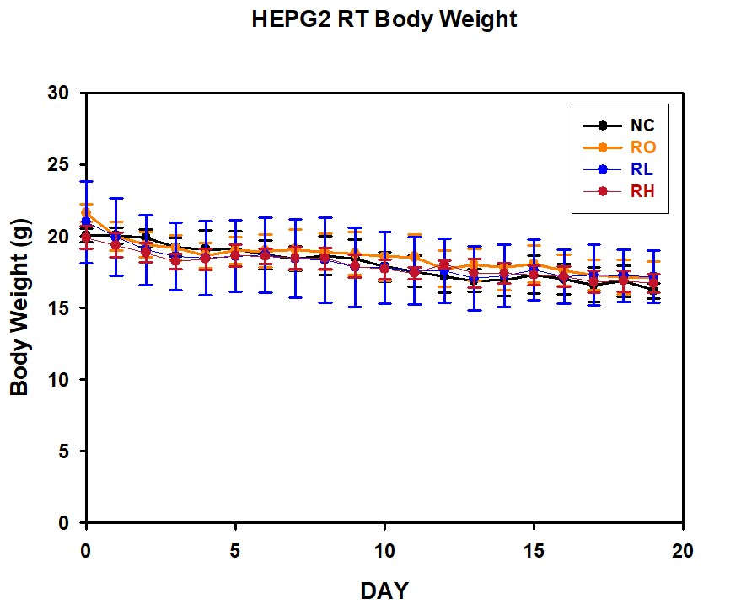
Figure 9: In vivo mice weight after radiotherapy.

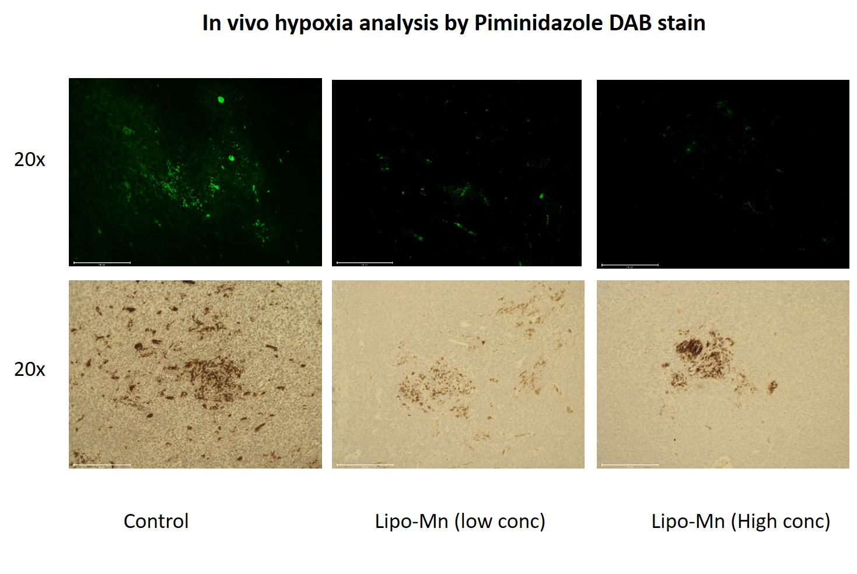
S3: Ex vivo piminadazole assay tissue staining of hypoxic HepG2 tumor

