DeephageTP: A Convolutional Neural Network Framework for Identifying Phage-specific Proteins from metagenomic sequencing data
Running title: an alignment-free deep learning framework for identifying phage-specific proteins
Yunmeng Chu^{1,2#}, ym.chu@siat.ac.cn
Shun Guo^{1#}, shun.guo@siat.ac.cn
Dachao Cui^{1#}, dc.cui@siat.ac.cn
Xiongfei Fu^{1#}, xf.fu@siat.ac.cn
Yingfei Ma^{1*}, yingfei.ma@siat.ac.cn
1 Shenzhen Key Laboratory of Synthetic Genomics, Guangdong Provincial Key Laboratory of Synthetic Genomics, CAS Key Laboratory of Quantitative Engineering Biology, Shenzhen Institute of Synthetic Biology, Shenzhen Institutes of Advanced Technology, Chinese Academy of Sciences, Shenzhen 518055, China
²Department of Bioengineering and Biotechnology, Huaqiao University, Xiamen, Fujian, 361021, PR China.
#These authors contributed equally.
*Corresponding to Yingfei Ma, yingfei.ma@siat.ac.cn

Supplementary material

Supplementary Materials
Fig. S1. The length distribution of the three protein sequences.
Fig. S2. The prediction performance of the CNN model on the seven groups of the mimic metagenomic dataset. A~C: the prediction performance of the model without using the cutoff values; D~F: the prediction performance of the model with the cutoff values.
Fig. S3. The Venn diagrams of the prediction results of three methods (i.e., DeephageTP, Diamond, and HMMER) on the metagenomic datasets. ERR2868024: A(TerL), B(Portal), C(TerS); SRR7892426: D(TerL), E(Portal), F(TerS).
Table S1. The average loss value and the average accuracy of 5-fold cross-validation on the training dataset with different sequence length sizes.
Table S2. The average loss value and the average accuracy of 5-fold cross-validation on the training dataset with the different number of filters.
Table S3. The average loss value and the average accuracy of 5-fold cross-validation on the training dataset with the different number of neurons in the fully connected layer.
Table S4. The prediction performance of DeephageTP on the seven testing datasets and the mock dataset (group 8).
Table S5. The prediction performance of DeephageTP with cutoff values on the seven testing datasets and the mock dataset (group 8).
Table S6. The manual-check result of the protein sequences identified by DeephageTP.

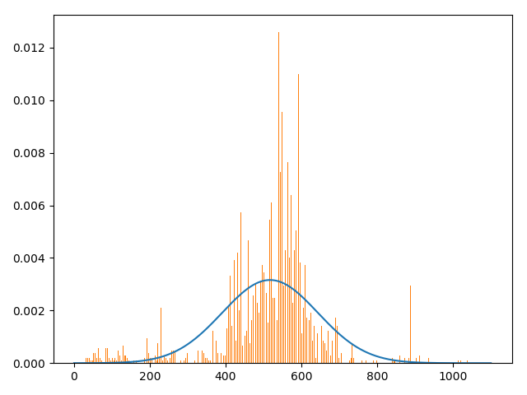
A
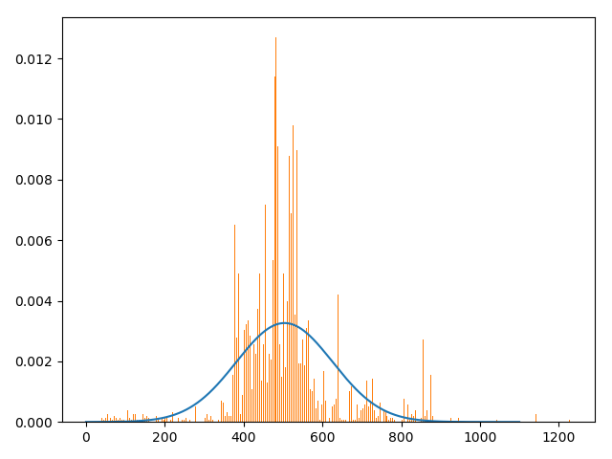
B
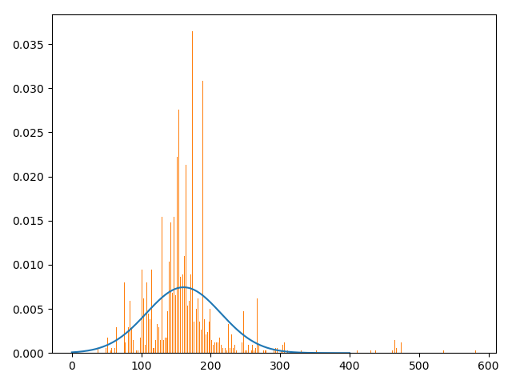
C
Figure S1. The length distributions of the three proteins. X-axis is the length of protein sequences. A: TerL; B: Portal; C: TerS.

Figure S2. The prediction performance of the CNN model on the seven groups of the mimic metagenomic dataset. A~C: the prediction performance of the model without using the cutoff values; D~F: the prediction performance of the model with the cutoff values.

Fig S3. The Venn diagrams of the prediction results of three methods (i.e., DeephageTP, Diamond and HMMER) on the metagenomic datasets. ERR2868024: A(TerL), B(Portal), C(TerS); SRR7892426: D(TerL), E(Portal), F(TerS).

