Supplemental Figures
Sulfated endospermic nanocellulose crystals prevent the transmission of SARS-CoV-2 and HIV-1; Enrique Javier Carvajal Barriga, et al.

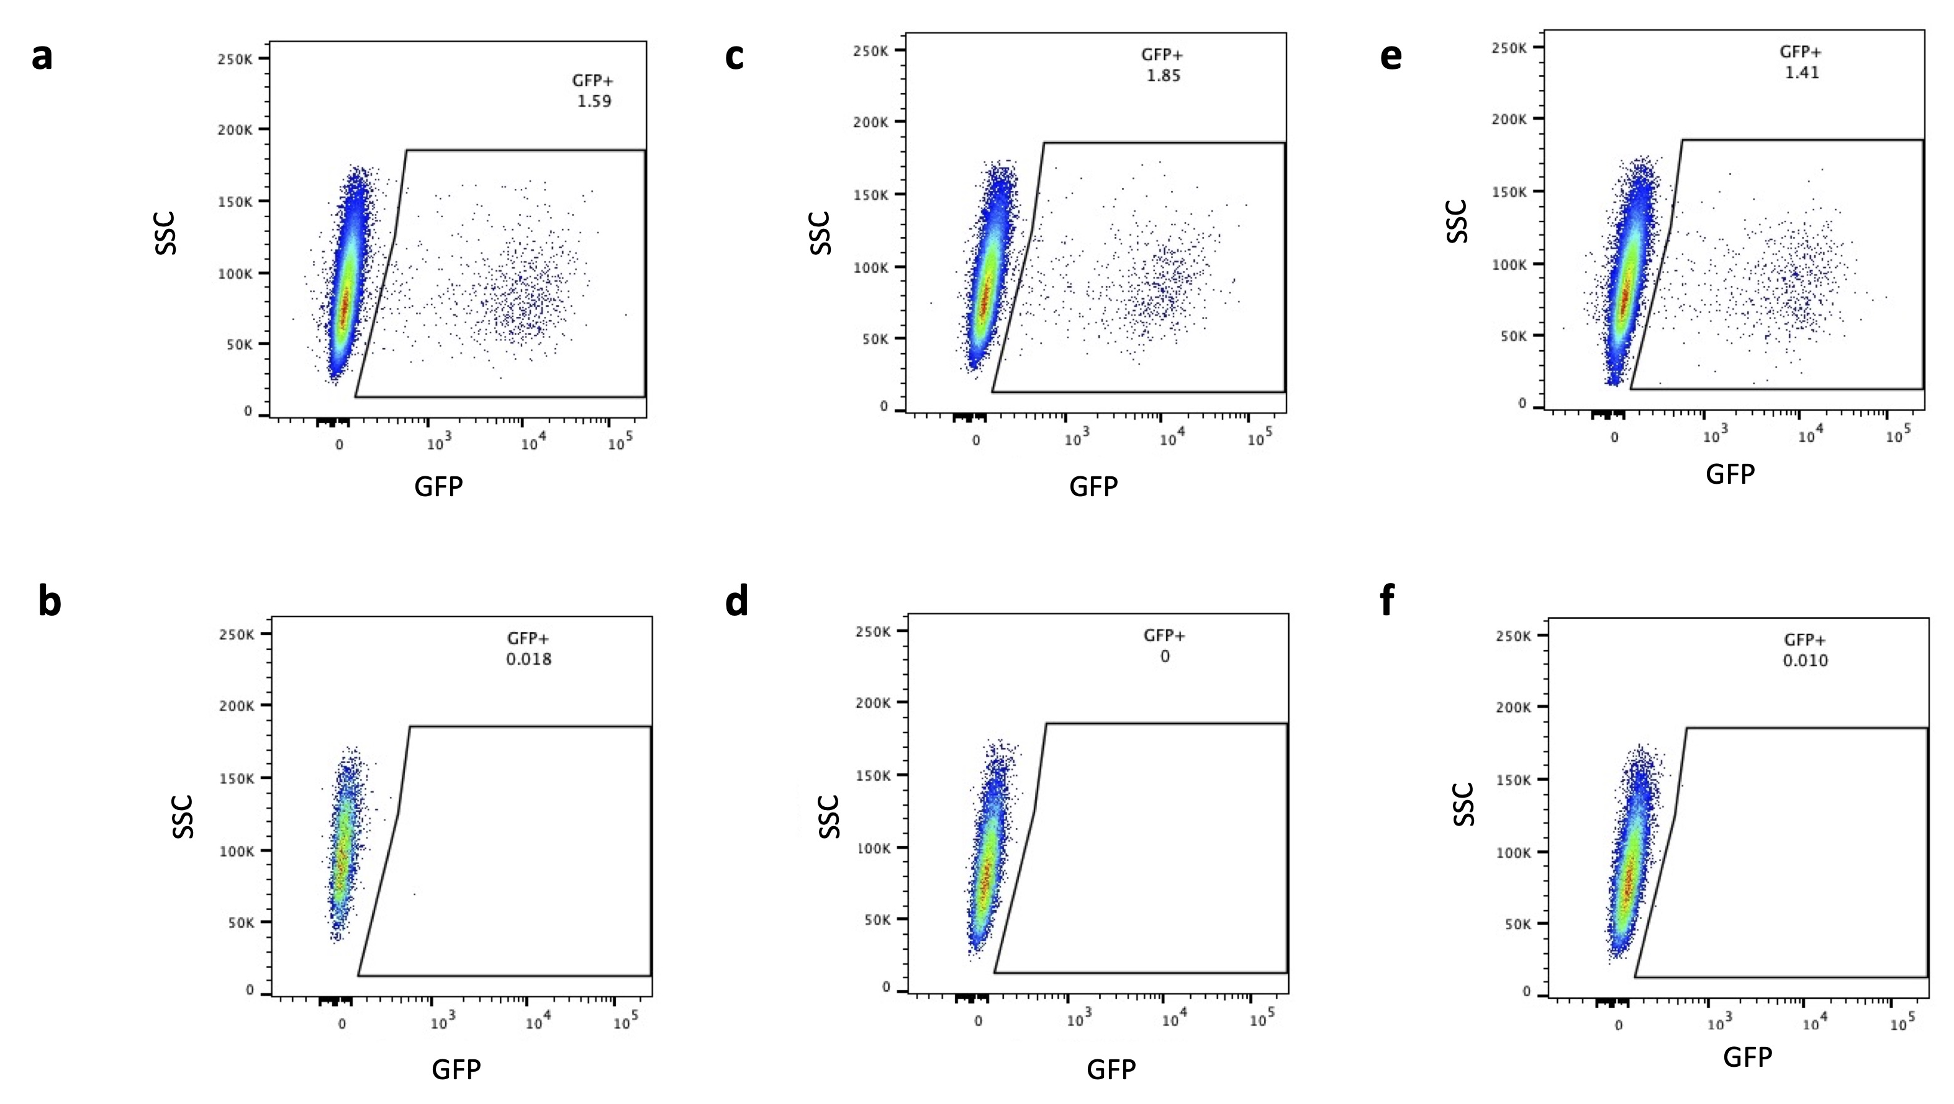

Supplemental Figure 1. ENC prevented SAR-CoV-2 pseudovirus infection of 293T-ACE2 cells as measured by flow cytometry.
293T-ACE2 cells were inoculated with SARS-CoV-2 pseudovirus (pv) with a GFP reporter in conditions with and without endospermic nanocellulose (ENC) and molecular lures (ACE2 or anti-SARS-CoV-2 S IgG (IgG)) and incubated for 3 days. Cells were harvested for flow cytometry analysis and % of GFP infected cells was determined for each condition (n=16, one representative experiment is shown). a. cells+pv (positive control) b. cells+(ENC+pv), c. cells+(ACE2+pv), d. cells+(ENC+ACE2+pv), e. cells+(IgG+pv), f. cells+(ENC+IgG+pv).
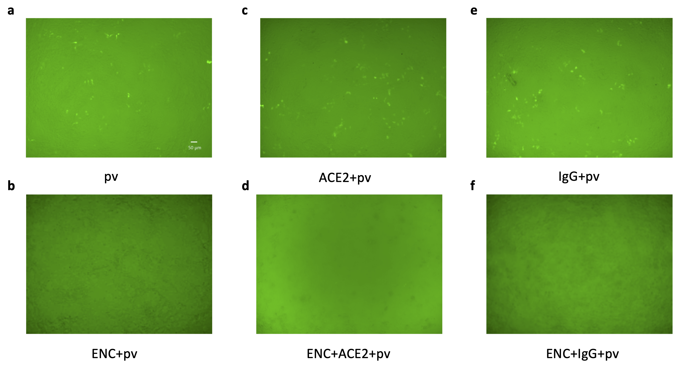

Supplemental Figure 2. ENC prevented SAR-CoV-2 pseudovirus infection of 293T-ACE2 cells visualized by fluorescent microscopy.
293T-ACE2 cells were inoculated with SARS-CoV-2 pseudovirus (pv) with a GFP reporter in conditions with and without ENC and molecular lures (ACE2 or anti-SARS-CoV-2 S IgG (IgG)) and incubated for 3 days. Cells were imaged on a fluorescent microscope and GFP+ infected cells were visualized for each condition (n=4, one representative experiment is shown). a. cells+pv (positive control) b. cells+(ENC+pv), c. cells+(ACE2+pv), d. cells+(ENC+ACE2+pv), e. cells+(IgG+pv), f. cells+(ENC+IgG+pv).

