Supplementary Material For:
Fluoride levels in deep aquifers of Makurdi, North-central, Nigeria: An Appraisal based on multivariate statistics and human health risk analysis.
In: Environmental Monitoring and Assessment Journal
*Raphael T. Iwar¹, Kola’ Ogedengbe², Kamil Kayode Katibi³, Josiah Nuhu Jabbo⁴
¹Department of Agricultural and Environmental Engineering, Federal University of Agriculture, Makurdi - Nigeria.
²Department of Agricultural and Environmental Engineering, University of Ibadan, Ibadan - Nigeria.
³Department of Food, Agricultural and Biological Engineering, Kwara State University, Malete - Nigeria.
⁴Department of Environmental Science Faculty of Forestry and Environment, Universiti Putra Malaysia.
*Corresponding Author: E-mail iwar.raphael@uam.edu.ng; raphaeliwar@gmail.com, Tel: +2347030920174; +2349032229816
ORCID: https://orcid.org/0000-0003-4676-6602

Table S1: Coordinates of Borehole Locations in Makurdi Metropolis, Benue State- Nigeria
S/No | Location | Latitude | Longitude | Groundwater Source
1 | Achusa | 7º N 42’ 73’’ | 8º E 31’ 49’’ | Borehole
2 | Ichwa | 7º N 45’ 36’’ | 8º E 33’ 52’’ | Borehole
3 | B.Division | 7º N 43’ 88’’ | 8º E 32’ 35’’ | Borehole
4 | Barracks Road | 7º N 45’ 17’’ | 8º E 32’ 39’’ | Borehole
5 | Logo I | 7º N 42’ 53’’ | 8º E 32’ 20’’ | Borehole
6 | Wurukum | 7º N 43’ 14’’ | 8º E 32’ 48’’ | Borehole
7 | Nyiman | 7º N 42’ 36’’ | 8º E 31’ 35’’ | Borehole
8 | Gyado Villa | 7º N 43’ 28’’ | 8º E 34’ 78’’ | Borehole
9 | Welfare Quarters | 7º N 40’ 27’’ | 8º E 32’ 26’’ | Borehole
10 | Akpehe | 7º N 42’ 39’’ | 8º E 33’ 11’’ | Borehole
11 | Coca Cola | 7º N43’ 03’’ | 8º E 35’ 36’’ | Borehole
12 | Nyor Gyungu | 7º N 43’ 78’’ | 8º E 38’ 33’’ | Borehole
13 | Mbakyaa | 7º N 43’ 27’’ | 8º E 69’ 47’’ | Borehole
14 | Modern market | 7º N 43’ 33’’ | 8º E 30’ 56’’ | Borehole
15 | Tse Abu | 7º N 42’ 20’’ | 8º E 34’ 53’’ | Borehole
16 | Owner Occupier | 7º N 41’ 49’’ | 8º E 33’ 19’’ | Borehole
17 | Abua | 7º N 43’ 42’’ | 8º E 36’ 57’’ | Borehole
18 | High Level | 7º N 43’ 12’’ | 8º E 31’ 45’’ | Borehole
19 | Naka Road | 7º N 42’ 33’’ | 8º E 29’ 54’’ | Borehole
20 | Agan | 7º N 45’ 26’’ | 8º E 33’ 33’’ | Borehole
21 | Apir | 7º N 39’ 36’’ | 8º E 33’ 14’’ | Borehole

Table S2: Relative Weights of Water Quality Parameters (WHO, 2011)
S/No | Chemical parameter | WHO Standard | Weight (w_{i}) | Relative Weight (W_{i})
1 | pH | 6.5 - 8.5 | 5 | 0.1
2 | TDS (mg/L) | 1000 | 5 | 0.1
3 | EC (µs/cm) | 1500 | 5 | 0.1
4 | Chloride (mg/L) | 200 | 5 | 0.1
5 | Fluoride (mg/L) | 1.5 | 5 | 0.1
6 | Nitrate (mg/L) | 50 | 5 | 0.1
7 | Sulphate (mg/L) | 250 | 4 | 0.08
8 | Potassium (mg/L) | 50 | 4 | 0.08
9 | Bicarbonate (mg/L) | 500 | 3 | 0.06
10 | Sodium (mg/L) | 200 | 3 | 0.06
11 | Calcium (mg/L) | 75 | 3 | 0.06
12 | Magnesium (mg/L) | 150 | 3 | 0.06

Table S3: Water Quality Classification Based on WQI Value
WQI Range | Class | Type of Water
≤ 50 | I | Excellent Water
50.1 – 100 | II | Good Water
100.1 – 200 | III | Poor Water
200.1 – 300 | IV | Very Poor Water
≥ 300 | V | Water unsuitable for drinking
Source: Al – Omran et al., 2015

Table S4: Computation of WQI for All Locations
Sample Location | S/No | Parameter | C_{i} | W_{i} | S_{i} | q_{i} = C_{i}/S_{i} × 100 | Sl_{i} = W_{i} × q_{i}
P1 (Achusa)
 | 1 | pH | 6.79 | 0.1 | 8.50 | 79.88 | 7.99
 | 2 | TDS | 1244.57 | 0.1 | 1000 | 124.46 | 12.45
 | 3 | EC | 2305.50 | 0.1 | 1500 | 153.7 | 15.37
 | 4 | Chloride | 167.97 | 0.1 | 200 | 83.99 | 8.40
 | 5 | Fluoride | 1.45 | 0.1 | 1.5 | 96.67 | 9.67
 | 6 | Nitrate | 6.96 | 0.1 | 50 | 13.92 | 1.39
 | 7 | Sulphate | 399.90 | 0.08 | 250 | 159.96 | 12.80
 | 8 | Potassium | 6.03 | 0.08 | 50 | 12.06 | 0.96
 | 9 | Bicarbonate | 401.00 | 0.06 | 500 | 80.2 | 4.81
 | 10 | Sodium | 248.30 | 0.06 | 200 | 124.15 | 7.45
 | 11 | Calcium | 73.40 | 0.06 | 75 | 97.87 | 5.87
 | 12 | Magnesium | 200.73 | 0.06 | 150 | 133.82 | 8.03
 |  | $$WQI= \sum_{i=1}^{n}{{SI}_{i}}$$ |  |  |  |  | 95.19
Sample Location | S/No | Parameter | C_{i} | W_{i} | S_{i} | q_{i} = C_{i}/S_{i} × 100 | Sl_{i} = W_{i} × q_{i}
P2 (Ichwa) | 1 | pH | 6.72 | 0.1 | 8.50 | 79.06 | 7.91
 | 2 | TDS | 980.00 | 0.1 | 1000 | 98.00 | 9.80
 | 3 | EC | 1832.87 | 0.1 | 1500 | 122.19 | 12.22
 | 4 | Chloride | 211.87 | 0.1 | 200 | 105.94 | 10.59
 | 5 | Fluoride | 1.48 | 0.1 | 1.5 | 98.67 | 9.87
 | 6 | Nitrate | 10.08 | 0.1 | 50 | 20.16 | 2.02
 | 7 | Sulphate | 472.87 | 0.08 | 250 | 189.15 | 15.13
 | 8 | Potassium | 6.38 | 0.08 | 50 | 12.76 | 1.02
 | 9 | Bicarbonate | 329.90 | 0.06 | 500 | 65.98 | 3.96
 | 10 | Sodium | 387.73 | 0.06 | 200 | 193.87 | 11.63
 | 11 | Calcium | 141.30 | 0.06 | 75 | 188.40 | 11.30
 | 12 | Magnesium | 85.53 | 0.06 | 150 | 57.02 | 3.42
 |  | $$WQI= \sum_{i=1}^{n}{{SI}_{i}}$$ |  |  |  |  | 98.87
Sample Location | S/No | Parameter | C_{i} | W_{i} | S_{i} | q_{i} = C_{i}/S_{i} × 100 | Sl_{i} = W_{i} × q_{i}
P3 (B. Div.)
 | 1 | pH | 6.46 | 0.1 | 8.50 | 76.00 | 7.60
 | 2 | TDS | 923.47 | 0.1 | 1000 | 92.35 | 9.24
 | 3 | EC | 1685.23 | 0.1 | 1500 | 112.35 | 11.24
 | 4 | Chloride | 178.63 | 0.1 | 200 | 89.32 | 8.93
 | 5 | Fluoride | 1.47 | 0.1 | 1.5 | 98.00 | 9.80
 | 6 | Nitrate | 6.18 | 0.1 | 50 | 12.36 | 1.24
 | 7 | Sulphate | 310.30 | 0.08 | 250 | 124.12 | 9.93
 | 8 | Potassium | 8.15 | 0.08 | 50 | 16.30 | 1.30
 | 9 | Bicarbonate | 258.47 | 0.06 | 500 | 51.69 | 3.10
 | 10 | Sodium | 255.30 | 0.06 | 200 | 127.65 | 7.66
 | 11 | Calcium | 170.97 | 0.06 | 75 | 227.96 | 13.68
 | 12 | Magnesium | 54.77 | 0.06 | 150 | 36.51 | 2.19
 |  | $$WQI= \sum_{i=1}^{n}{{SI}_{i}}$$ |  |  |  |  | 85.91
Sample Location | S/No | Parameter | C_{i} | W_{i} | S_{i} | q_{i} = C_{i}/S_{i} × 100 | Sl_{i} = W_{i} × q_{i}
P4 (Barr. Rd.)
 | 1 | pH | 6.34 | 0.1 | 8.50 | 74.59 | 7.46
 | 2 | TDS | 946.67 | 0.1 | 1000 | 94.67 | 9.47
 | 3 | EC | 1631.13 | 0.1 | 1500 | 108.74 | 10.87
 | 4 | Chloride | 457.87 | 0.1 | 200 | 228.93 | 22.89
 | 5 | Fluoride | 1.53 | 0.1 | 1.5 | 102.00 | 10.2
 | 6 | Nitrate | 2.91 | 0.1 | 50 | 5.82 | 0.58
 | 7 | Sulphate | 278.90 | 0.08 | 250 | 111.56 | 8.92
 | 8 | Potassium | 4.46 | 0.08 | 50 | 8.92 | 0.71
 | 9 | Bicarbonate | 481.30 | 0.06 | 500 | 96.26 | 5.78
 | 10 | Sodium | 163.57 | 0.06 | 200 | 81.79 | 4.91
 | 11 | Calcium | 74.93 | 0.06 | 75 | 99.91 | 5.99
 | 12 | Magnesium | 176.33 | 0.06 | 150 | 117.55 | 7.05
 |  | $$WQI= \sum_{i=1}^{n}{{SI}_{i}}$$ |  |  |  |  | 94.83
Sample Location | S/No | Parameter | C_{i} | W_{i} | S_{i} | q_{i} = C_{i}/S_{i} × 100 | Sl_{i} = W_{i} × q_{i}
P5 (Logo I)
 | 1 | pH | 6.75 | 0.1 | 8.50 | 79.41 | 7.94
 | 2 | TDS | 1132.00 | 0.1 | 1000 | 113.20 | 11.32
 | 3 | EC | 2138.77 | 0.1 | 1500 | 142.58 | 14.26
 | 4 | Chloride | 105.73 | 0.1 | 200 | 52.87 | 5.29
 | 5 | Fluoride | 1.25 | 0.1 | 1.5 | 83.33 | 8.33
 | 6 | Nitrate | 8.38 | 0.1 | 50 | 16.76 | 1.68
 | 7 | Sulphate | 271.53 | 0.08 | 250 | 108.61 | 8.69
 | 8 | Potassium | 5.90 | 0.08 | 50 | 11.80 | 0.94
 | 9 | Bicarbonate | 471.53 | 0.06 | 500 | 94.31 | 5.66
 | 10 | Sodium | 255.37 | 0.06 | 200 | 127.68 | 7.66
 | 11 | Calcium | 76.77 | 0.06 | 75 | 102.36 | 6.14
 | 12 | Magnesium | 136.23 | 0.06 | 150 | 90.82 | 5.45
 |  | $$WQI= \sum_{i=1}^{n}{{SI}_{i}}$$ |  |  |  |  | 83.36
Sample Location | S/No | Parameter | C_{i} | W_{i} | S_{i} | q_{i} = C_{i}/S_{i} × 100 | Sl_{i} = W_{i} × q_{i}
P6 (Wurukum)
 | 1 | pH | 6.75 | 0.1 | 8.50 | 79.41 | 7.94
 | 2 | TDS | 1404.23 | 0.1 | 1000 | 140.42 | 14.04
 | 3 | EC | 2118.43 | 0.1 | 1500 | 141.23 | 14.12
 | 4 | Chloride | 179.40 | 0.1 | 200 | 89.70 | 8.97
 | 5 | Fluoride | 1.56 | 0.1 | 1.5 | 104.00 | 10.4
 | 6 | Nitrate | 4.27 | 0.1 | 50 | 8.54 | 0.85
 | 7 | Sulphate | 360.60 | 0.08 | 250 | 144.24 | 11.54
 | 8 | Potassium | 7.53 | 0.08 | 50 | 15.06 | 1.20
 | 9 | Bicarbonate | 193.10 | 0.06 | 500 | 38.62 | 2.32
 | 10 | Sodium | 291.33 | 0.06 | 200 | 145.67 | 8.74
 | 11 | Calcium | 133.50 | 0.06 | 75 | 178.00 | 10.68
 | 12 | Magnesium | 39.20 | 0.06 | 150 | 26.13 | 1.57
 |  | $$WQI= \sum_{i=1}^{n}{{SI}_{i}}$$ |  |  |  |  | 92.37
Sample Location | S/No | Parameter | C_{i} | W_{i} | S_{i} | q_{i} = C_{i}/S_{i} × 100 | Sl_{i} = W_{i} × q_{i}
P7 (Nyiman)
 | 1 | pH | 6.54 | 0.1 | 8.50 | 76.94 | 7.69
 | 2 | TDS | 238.90 | 0.1 | 1000 | 23.89 | 2.39
 | 3 | EC | 427.73 | 0.1 | 1500 | 28.52 | 2.85
 | 4 | Chloride | 239.47 | 0.1 | 200 | 119.74 | 11.97
 | 5 | Fluoride | 1.30 | 0.1 | 1.5 | 86.67 | 8.67
 | 6 | Nitrate | 8.98 | 0.1 | 50 | 17.96 | 1.80
 | 7 | Sulphate | 234.93 | 0.08 | 250 | 93.97 | 7.52
 | 8 | Potassium | 3.71 | 0.08 | 50 | 7.42 | 0.59
 | 9 | Bicarbonate | 188.03 | 0.06 | 500 | 37.61 | 2.26
 | 10 | Sodium | 198.47 | 0.06 | 200 | 99.23 | 5.95
 | 11 | Calcium | 66.87 | 0.06 | 75 | 89.16 | 5.35
 | 12 | Magnesium | 56.20 | 0.06 | 150 | 37.47 | 2.25
 |  | $$WQI= \sum_{i=1}^{n}{{SI}_{i}}$$ |  |  |  |  | 59.29
Sample Location | S/No | Parameter | C_{i} | W_{i} | S_{i} | q_{i} = C_{i}/S_{i} × 100 | Sl_{i} = W_{i} × q_{i}
P8 (Gyado-Villa)
 | 1 | pH | 6.49 | 0.1 | 8.50 | 76.35 | 7.64
 | 2 | TDS | 1025.87 | 0.1 | 1000 | 102.58 | 10.26
 | 3 | EC | 1860.53 | 0.1 | 1500 | 124.04 | 12.40
 | 4 | Chloride | 40.43 | 0.1 | 200 | 20.22 | 2.02
 | 5 | Fluoride | 1.53 | 0.1 | 1.5 | 102.00 | 10.20
 | 6 | Nitrate | 2.56 | 0.1 | 50 | 5.12 | 0.51
 | 7 | Sulphate | 462.73 | 0.08 | 250 | 185.09 | 14.81
 | 8 | Potassium | 10.03 | 0.08 | 50 | 20.06 | 1.60
 | 9 | Bicarbonate | 534.10 | 0.06 | 500 | 106.82 | 6.41
 | 10 | Sodium | 353.93 | 0.06 | 200 | 176.97 | 10.62
 | 11 | Calcium | 135.07 | 0.06 | 75 | 180.09 | 10.81
 | 12 | Magnesium | 93.80 | 0.06 | 150 | 62.53 | 3.75
 |  | $$WQI= \sum_{i=1}^{n}{{SI}_{i}}$$ |  |  |  |  | 91.03
Sample Location | S/No | Parameter | C_{i} | W_{i} | S_{i} | q_{i} = C_{i}/S_{i} × 100 | Sl_{i} = W_{i} × q_{i}
P9 (Welfare Qtrs.)
 | 1 | pH | 6.42 | 0.1 | 8.50 | 75.53 | 7.55
 | 2 | TDS | 575.00 | 0.1 | 1000 | 57.50 | 5.75
 | 3 | EC | 921.01 | 0.1 | 1500 | 61.40 | 6.14
 | 4 | Chloride | 214.30 | 0.1 | 200 | 107.15 | 10.72
 | 5 | Fluoride | 0.63 | 0.1 | 1.5 | 42.00 | 4.20
 | 6 | Nitrate | 1.07 | 0.1 | 50 | 2.14 | 0.21
 | 7 | Sulphate | 406.53 | 0.08 | 250 | 162.61 | 13.01
 | 8 | Potassium | 7.48 | 0.08 | 50 | 14.96 | 1.20
 | 9 | Bicarbonate | 342.60 | 0.06 | 500 | 68.52 | 4.11
 | 10 | Sodium | 303.47 | 0.06 | 200 | 151.74 | 9.10
 | 11 | Calcium | 146.43 | 0.06 | 75 | 195.24 | 11.71
 | 12 | Magnesium | 182.07 | 0.06 | 150 | 121.38 | 7.28
 |  | $$WQI= \sum_{i=1}^{n}{{SI}_{i}}$$ |  |  |  |  | 73.71
Sample Location | S/No | Parameter | C_{i} | W_{i} | S_{i} | q_{i} = C_{i}/S_{i} × 100 | Sl_{i} = W_{i} × q_{i}
P10 (Akpehe)
 | 1 | pH | 6.57 | 0.1 | 8.50 | 77.29 | 7.23
 | 2 | TDS | 1176.97 | 0.1 | 1000 | 117.70 | 11.77
 | 3 | EC | 1984.50 | 0.1 | 1500 | 132.30 | 13.23
 | 4 | Chloride | 58.37 | 0.1 | 200 | 29.19 | 2.92
 | 5 | Fluoride | 1.26 | 0.1 | 1.5 | 84.00 | 8.40
 | 6 | Nitrate | 5.30 | 0.1 | 50 | 10.60 | 1.06
 | 7 | Sulphate | 93.73 | 0.08 | 250 | 37.49 | 3.00
 | 8 | Potassium | 2.18 | 0.08 | 50 | 4.36 | 0.35
 | 9 | Bicarbonate | 229.73 | 0.06 | 500 | 45.95 | 2.76
 | 10 | Sodium | 106.23 | 0.06 | 200 | 53.12 | 3.19
 | 11 | Calcium | 73.40 | 0.06 | 75 | 97.87 | 5.87
 | 12 | Magnesium | 58.87 | 0.06 | 150 | 39.25 | 2.35
 |  | $$WQI= \sum_{i=1}^{n}{{SI}_{i}}$$ |  |  |  |  | 62.13
Sample Location | S/No | Parameter | C_{i} | W_{i} | S_{i} | q_{i} = C_{i}/S_{i} × 100 | Sl_{i} = W_{i} × q_{i}
P11 (Coca-Cola)
 | 1 | pH | 6.61 | 0.1 | 8.50 | 77.76 | 7.78
 | 2 | TDS | 405.57 | 0.1 | 1000 | 40.56 | 4.06
 | 3 | EC | 747.83 | 0.1 | 1500 | 49.86 | 4.99
 | 4 | Chloride | 160.70 | 0.1 | 200 | 80.35 | 8.04
 | 5 | Fluoride | 0.51 | 0.1 | 1.5 | 34.00 | 3.40
 | 6 | Nitrate | 5.43 | 0.1 | 50 | 10.86 | 1.09
 | 7 | Sulphate | 129.43 | 0.08 | 250 | 51.77 | 4.14
 | 8 | Potassium | 2.86 | 0.08 | 50 | 5.72 | 0.46
 | 9 | Bicarbonate | 361.50 | 0.06 | 500 | 72.30 | 4.34
 | 10 | Sodium | 76.73 | 0.06 | 200 | 38.37 | 2.30
 | 11 | Calcium | 116.97 | 0.06 | 75 | 155.96 | 9.36
 | 12 | Magnesium | 60.23 | 0.06 | 150 | 40.15 | 2.41
 |  | $$WQI= \sum_{i=1}^{n}{{SI}_{i}}$$ |  |  |  |  | 52.37
Sample Location | S/No | Parameter | C_{i} | W_{i} | S_{i} | q_{i} = C_{i}/S_{i} × 100 | Sl_{i} = W_{i} × q_{i}
P12 (Nyor Gyungu)
 | 1 | pH | 6.42 | 0.1 | 8.50 | 75.53 | 7.55
 | 2 | TDS | 739.87 | 0.1 | 1000 | 73.99 | 7.40
 | 3 | EC | 1161.40 | 0.1 | 1500 | 77.43 | 7.74
 | 4 | Chloride | 111.60 | 0.1 | 200 | 55.80 | 5.58
 | 5 | Fluoride | 1.47 | 0.1 | 1.5 | 98.00 | 9.8
 | 6 | Nitrate | 4.68 | 0.1 | 50 | 9.36 | 0.94
 | 7 | Sulphate | 47.27 | 0.08 | 250 | 18.91 | 1.51
 | 8 | Potassium | 1.88 | 0.08 | 50 | 3.76 | 0.30
 | 9 | Bicarbonate | 108.87 | 0.06 | 500 | 21.77 | 1.31
 | 10 | Sodium | 49.83 | 0.06 | 200 | 24.92 | 1.49
 | 11 | Calcium | 74.70 | 0.06 | 75 | 99.60 | 5.98
 | 12 | Magnesium | 74.43 | 0.06 | 150 | 49.62 | 2.98
 |  | $$WQI= \sum_{i=1}^{n}{{SI}_{i}}$$ |  |  |  |  | 52.58
Sample Location | S/No | Parameter | C_{i} | W_{i} | S_{i} | q_{i} = C_{i}/S_{i} × 100 | Sl_{i} = W_{i} × q_{i}
P13 (Mbakyaa)
 | 1 | pH | 6.35 | 0.1 | 8.50 | 74.71 | 7.47
 | 2 | TDS | 642.93 | 0.1 | 1000 | 64.29 | 6.43
 | 3 | EC | 1184.33 | 0.1 | 1500 | 78.96 | 7.90
 | 4 | Chloride | 372.83 | 0.1 | 200 | 186.42 | 18.64
 | 5 | Fluoride | 1.99 | 0.1 | 1.5 | 132.67 | 13.27
 | 6 | Nitrate | 15.38 | 0.1 | 50 | 30.76 | 3.08
 | 7 | Sulphate | 316.47 | 0.08 | 250 | 126.40 | 10.11
 | 8 | Potassium | 6.89 | 0.08 | 50 | 13.78 | 1.10
 | 9 | Bicarbonate | 237.97 | 0.06 | 500 | 47.59 | 2.86
 | 10 | Sodium | 229.77 | 0.06 | 200 | 114.89 | 6.89
 | 11 | Calcium | 106.03 | 0.06 | 75 | 141.37 | 8.48
 | 12 | Magnesium | 113.07 | 0.06 | 150 | 75.38 | 4.52
 |  | $$WQI= \sum_{i=1}^{n}{{SI}_{i}}$$ |  |  |  |  | 90.75
Sample Location | S/No | Parameter | C_{i} | W_{i} | S_{i} | q_{i} = C_{i}/S_{i} × 100 | Sl_{i} = W_{i} × q_{i}
P14 (Modern Mkt)
 | 1 | pH | 6.45 | 0.1 | 8.50 | 75.88 | 7.59
 | 2 | TDS | 306.23 | 0.1 | 1000 | 30.62 | 3.06
 | 3 | EC | 506.57 | 0.1 | 1500 | 33.77 | 3.38
 | 4 | Chloride | 53.53 | 0.1 | 200 | 26.77 | 2.68
 | 5 | Fluoride | 0.45 | 0.1 | 1.5 | 30.00 | 3.00
 | 6 | Nitrate | 3.60 | 0.1 | 50 | 7.20 | 0.72
 | 7 | Sulphate | 166.23 | 0.08 | 250 | 66.49 | 5.32
 | 8 | Potassium | 2.01 | 0.08 | 50 | 4.02 | 0.32
 | 9 | Bicarbonate | 390.17 | 0.06 | 500 | 78.03 | 4.68
 | 10 | Sodium | 89.87 | 0.06 | 200 | 44.94 | 2.70
 | 11 | Calcium | 62.13 | 0.06 | 75 | 82.84 | 4.97
 | 12 | Magnesium | 66.10 | 0.06 | 150 | 44.07 | 2.64
 |  | $$WQI= \sum_{i=1}^{n}{{SI}_{i}}$$ |  |  |  |  | 41.11
Sample Location | S/No | Parameter | C_{i} | W_{i} | S_{i} | q_{i} = C_{i}/S_{i} × 100 | Sl_{i} = W_{i} × q_{i}
P15 (Tse-Abu)
 | 1 | pH | 6.74 | 0.1 | 8.50 | 79.29 | 7.93
 | 2 | TDS | 160.13 | 0.1 | 1000 | 16.01 | 1.60
 | 3 | EC | 305.33 | 0.1 | 1500 | 20.36 | 2.04
 | 4 | Chloride | 199.33 | 0.1 | 200 | 99.67 | 9.97
 | 5 | Fluoride | 1.51 | 0.1 | 1.5 | 100.67 | 10.07
 | 6 | Nitrate | 3.09 | 0.1 | 50 | 6.18 | 0.62
 | 7 | Sulphate | 303.17 | 0.08 | 250 | 121.27 | 9.70
 | 8 | Potassium | 2.82 | 0.08 | 50 | 5.64 | 0.45
 | 9 | Bicarbonate | 134.53 | 0.06 | 500 | 26.91 | 1.61
 | 10 | Sodium | 140.37 | 0.06 | 200 | 70.18 | 4.21
 | 11 | Calcium | 72.37 | 0.06 | 75 | 96.49 | 5.79
 | 12 | Magnesium | 70.23 | 0.06 | 150 | 46.82 | 2.81
 |  | $$WQI= \sum_{i=1}^{n}{{SI}_{i}}$$ |  |  |  |  | 56.8
Sample Location | S/No | Parameter | C_{i} | W_{i} | S_{i} | q_{i} = C_{i}/S_{i} × 100 | Sl_{i} = W_{i} × q_{i}
P16 (Owner Occupier)
 | 1 | pH | 6.26 | 0.1 | 8.50 | 73.65 | 7.36
 | 2 | TDS | 525.50 | 0.1 | 1000 | 52.55 | 5.26
 | 3 | EC | 914.47 | 0.1 | 1500 | 60.96 | 6.10
 | 4 | Chloride | 46.07 | 0.1 | 200 | 23.04 | 2.30
 | 5 | Fluoride | 0.82 | 0.1 | 1.5 | 54.67 | 5.47
 | 6 | Nitrate | 2.95 | 0.1 | 50 | 5.90 | 0.59
 | 7 | Sulphate | 307.13 | 0.08 | 250 | 122.85 | 9.82
 | 8 | Potassium | 4.86 | 0.08 | 50 | 9.72 | 0.78
 | 9 | Bicarbonate | 488.80 | 0.06 | 500 | 97.76 | 5.87
 | 10 | Sodium | 318.20 | 0.06 | 200 | 159.00 | 9.54
 | 11 | Calcium | 60.57 | 0.06 | 75 | 80.76 | 4.84
 | 12 | Magnesium | 70.93 | 0.06 | 150 | 47.29 | 2.84
 |  | $$WQI= \sum_{i=1}^{n}{{SI}_{i}}$$ |  |  |  |  | 60.77
Sample Location | S/No | Parameter | C_{i} | W_{i} | S_{i} | q_{i} = C_{i}/S_{i} × 100 | Sl_{i} = W_{i} × q_{i}
P17 (Abua)
 | 1 | pH | 6.72 | 0.1 | 8.50 | 79.06 | 7.91
 | 2 | TDS | 98.17 | 0.1 | 1000 | 9.82 | 0.98
 | 3 | EC | 172.97 | 0.1 | 1500 | 11.53 | 1.15
 | 4 | Chloride | 77.83 | 0.1 | 200 | 38.92 | 3.89
 | 5 | Fluoride | 0.74 | 0.1 | 1.5 | 49.33 | 4.93
 | 6 | Nitrate | 9.02 | 0.1 | 50 | 18.04 | 1.80
 | 7 | Sulphate | 417.60 | 0.08 | 250 | 167.04 | 13.36
 | 8 | Potassium | 4.35 | 0.08 | 50 | 8.70 | 0.70
 | 9 | Bicarbonate | 205.83 | 0.06 | 500 | 41.11 | 2.47
 | 10 | Sodium | 249.53 | 0.06 | 200 | 124.77 | 7.49
 | 11 | Calcium | 176.13 | 0.06 | 75 | 234.84 | 14.09
 | 12 | Magnesium | 74.40 | 0.06 | 150 | 49.60 | 2.98
 |  | $$WQI= \sum_{i=1}^{n}{{SI}_{i}}$$ |  |  |  |  | 61.75
Sample Location | S/No | Parameter | C_{i} | W_{i} | S_{i} | q_{i} = C_{i}/S_{i} × 100 | Sl_{i} = W_{i} × q_{i}
P18 (High Level)
 | 1 | pH | 6.40 | 0.1 | 8.50 | 75.29 | 7.53
 | 2 | TDS | 1143.87 | 0.1 | 1000 | 114.39 | 11.44
 | 3 | EC | 1939.63 | 0.1 | 1500 | 129.31 | 12.93
 | 4 | Chloride | 288.77 | 0.1 | 200 | 144.39 | 14.44
 | 5 | Fluoride | 1.62 | 0.1 | 1.5 | 108.00 | 10.80
 | 6 | Nitrate | 1.59 | 0.1 | 50 | 3.18 | 0.32
 | 7 | Sulphate | 258.50 | 0.08 | 250 | 103.40 | 8.27
 | 8 | Potassium | 3.79 | 0.08 | 50 | 7.58 | 0.61
 | 9 | Bicarbonate | 557.43 | 0.06 | 500 | 111.49 | 6.69
 | 10 | Sodium | 140.70 | 0.06 | 200 | 70.35 | 4.22
 | 11 | Calcium | 70.67 | 0.06 | 75 | 94.23 | 5.65
 | 12 | Magnesium | 70.03 | 0.06 | 150 | 46.69 | 2.80
 |  | $$WQI= \sum_{i=1}^{n}{{SI}_{i}}$$ |  |  |  |  | 85.70
Sample Location | S/No | Parameter | C_{i} | W_{i} | S_{i} | q_{i} = C_{i}/S_{i} × 100 | Sl_{i} = W_{i} × q_{i}
P19 (Naka Road)
 | 1 | pH | 6.50 | 0.1 | 8.50 | 76.47 | 7.65
 | 2 | TDS | 805.43 | 0.1 | 1000 | 80.54 | 8.05
 | 3 | EC | 987.60 | 0.1 | 1500 | 65.84 | 6.58
 | 4 | Chloride | 129.80 | 0.1 | 200 | 64.90 | 6.49
 | 5 | Fluoride | 1.53 | 0.1 | 1.5 | 102.00 | 10.20
 | 6 | Nitrate | 5.76 | 0.1 | 50 | 11.52 | 1.15
 | 7 | Sulphate | 86.33 | 0.08 | 250 | 34.53 | 2.76
 | 8 | Potassium | 2.19 | 0.08 | 50 | 4.38 | 0.35
 | 9 | Bicarbonate | 428.27 | 0.06 | 500 | 85.65 | 5.14
 | 10 | Sodium | 80.13 | 0.06 | 200 | 40.07 | 2.40
 | 11 | Calcium | 72.33 | 0.06 | 75 | 96.44 | 5.79
 | 12 | Magnesium | 73.30 | 0.06 | 150 | 48.87 | 2.93
 |  | $$WQI= \sum_{i=1}^{n}{{SI}_{i}}$$ |  |  |  |  | 59.49
Sample Location | S/No | Parameter | C_{i} | W_{i} | S_{i} | q_{i} = C_{i}/S_{i} × 100 | Sl_{i} = W_{i} × q_{i}
P20 (Agan)
 | 1 | pH | 6.44 | 0.1 | 8.50 | 75.76 | 7.58
 | 2 | TDS | 253.83 | 0.1 | 1000 | 25.38 | 2.54
 | 3 | EC | 435.70 | 0.1 | 1500 | 29.05 | 2.90
 | 4 | Chloride | 69.53 | 0.1 | 200 | 34.77 | 3.48
 | 5 | Fluoride | 1.02 | 0.1 | 1.5 | 68.00 | 6.80
 | 6 | Nitrate | 7.48 | 0.1 | 50 | 14.96 | 1.50
 | 7 | Sulphate | 338.20 | 0.08 | 250 | 135.28 | 10.82
 | 8 | Potassium | 6.50 | 0.08 | 50 | 13.00 | 1.04
 | 9 | Bicarbonate | 315.73 | 0.06 | 500 | 63.15 | 3.79
 | 10 | Sodium | 304.03 | 0.06 | 200 | 152.00 | 9.12
 | 11 | Calcium | 198.03 | 0.06 | 75 | 264.04 | 15.84
 | 12 | Magnesium | 111.87 | 0.06 | 150 | 74.58 | 4.47
 |  | $$WQI= \sum_{i=1}^{n}{{SI}_{i}}$$ |  |  |  |  | 66.88
Sample Location | S/No | Parameter | C_{i} | W_{i} | S_{i} | q_{i} = C_{i}/S_{i} × 100 | Sl_{i} = W_{i} × q_{i}
P21 (Apir)
 | 1 | pH | 6.30 | 0.1 | 8.50 | 74.12 | 7.14
 | 2 | TDS | 340.07 | 0.1 | 1000 | 34.01 | 3.40
 | 3 | EC | 641.50 | 0.1 | 1500 | 42.77 | 4.28
 | 4 | Chloride | 103.07 | 0.1 | 200 | 51.54 | 5.15
 | 5 | Fluoride | 1.27 | 0.1 | 1.5 | 84.67 | 8.47
 | 6 | Nitrate | 7.91 | 0.1 | 50 | 15.82 | 1.58
 | 7 | Sulphate | 299.03 | 0.08 | 250 | 119.61 | 9.57
 | 8 | Potassium | 5.05 | 0.08 | 50 | 10.10 | 0.81
 | 9 | Bicarbonate | 321.93 | 0.06 | 500 | 64.39 | 3.86
 | 10 | Sodium | 207.87 | 0.06 | 200 | 103.94 | 6.24
 | 11 | Calcium | 55.90 | 0.06 | 75 | 74.53 | 4.47
 | 12 | Magnesium | 52.10 | 0.06 | 150 | 34.73 | 2.08
 |  | $$WQI= \sum_{i=1}^{n}{{SI}_{i}}$$ |  |  |  |  | 57.05

Table S5: Raw Water Quality Data with Replications
Sample | Replications | pH | TDS (mg/l) | EC (µS/cm) | Cl– (mg/l) | CO₃^{2–} (mg/l) | HCO₃– (mg/l) | SO₄^{2–} (mg/l) | NO₃– (mg/l) | F– (mg/l) | Na⁺ (mg/l) | K⁺ (mg/l) | Ca²⁺ (mg/l) | Mg²⁺ (mg/l)
AchusaP1 | 1 | 6.82 | 1187.4 | 2139.5 | 136.3 | 8.7 | 431.4 | 383.2 | 6.91 | 1.44 | 289.3 | 5.72 | 78.9 | 183.2
AchusaP1 | 2 | 6.74 | 1268.1 | 2383.4 | 188.9 | 8,1 | 389.2 | 432.0 | 7.14 | 1.39 | 217.7 | 6.06 | 69.0 | 202.3
AchusaP1 | 3 | 6.81 | 1278.2 | 2393.6 | 178.7 | 7.6 | 382.4 | 384.5 | 6.83 | 1.53 | 237.9 | 6.32 | 72.3 | 216.7
Ichwa P2 | 1 | 6.73 | 1136.0 | 2218.9 | 231.2 | 12.6 | 317.2 | 469.0 | 10.51 | 1.56 | 372.5 | 6.91 | 134.8 | 82.4
Ichwa P2 | 2 | 6.70 | 905.1 | 1893.7 | 218.0 | 12.3 | 368.0 | 462.3 | 10.43 | 1.51 | 403.1 | 4.83 | 156.7 | 93.8
Ichwa P2 | 3 | 6.75 | 899.6 | 1384.5 | 186.4 | 11.0 | 304.5 | 487.3 | 9.29 | 1.37 | 387.6 | 7.39 | 132.4 | 80.4
B Div.  P3 | 1 | 6.48 | 921.2 | 1812.7 | 167.3 | 14.0 | 293.7 | 326.7 | 5.80 | 1.35 | 229.1 | 7.31 | 174.6 | 65.6
B Div.  P3 | 2 | 6.43 | 856.5 | 1520.4 | 209.5 | 15.3 | 236.8 | 290.0 | 6.32 | 1.62 | 234.5 | 9.02 | 149.0 | 43.9
B Div.  P3 | 3 | 6.47 | 992.7 | 1722.6 | 159.1 | 14.8 | 244.9 | 314.2 | 6.41 | 1.44 | 302.3 | 8.11 | 189.3 | 54.8
Barr. Rd.  P4 | 1 | 6.43 | 998.3 | 1749.5 | 358.6 | 27.1 | 521.9 | 249.1 | 2.93 | 1.56 | 158.2 | 4.82 | 72.3 | 162.7
Barr. Rd.  P4 | 2 | 6.21 | 1048.0 | 1836.0 | 482.4 | 19,6 | 408.3 | 286.0 | 2.91 | 1.55 | 179.3 | 4.80 | 68.3 | 128.6
Barr. Rd.  P4 | 3 | 6.39 | 793.7 | 1307.9 | 532.6 | 25.1 | 513.7 | 301.6 | 2.88 | 1.48 | 153.2 | 3.76 | 84.2 | 237.7
Logo I  P5 | 1 | 6.80 | 1232.4 | 2487.4 | 93.7 | 17.9 | 448.7 | 283.4 | 8.32 | 1.23 | 244.9 | 5.44 | 83.6 | 113.4
Logo I  P5 | 2 | 6.68 | 1056.2 | 1896.3 | 127.4 | 18.3 | 482.3 | 232.8 | 7.90 | 1.30 | 246.8 | 6.34 | 76.5 | 146.3
Logo I  P5 | 3 | 6.77 | 1107.4 | 2032.6 | 96.1 | 13.5 | 483.6 | 298.4 | 8,92 | 1.22 | 274.4 | 5.92 | 70.2 | 149.0
Wurukum  P6 | 1 | 6.74 | 1358.7 | 2019.1 | 174.9 | 33.6 | 216.0 | 369.2 | 4.75 | 1.52 | 262.8 | 8.19 | 125.7 | 36.9
Wurukum  P6 | 2 | 6.80 | 1382.5 | 2086.7 | 177.3 | 29.9 | 164.9 | 372.2 | 3.75 | 1.58 | 289.0 | 6.39 | 146.6 | 52.1
Wurukum  P6 | 3 | 6.71 | 1471.5 | 2249.5 | 186.0 | 21.6 | 198.4 | 340.4 | 4.31 | 1.57 | 322.2 | 8.00 | 128.2 | 28.6
Nyiman  P7 | 1 | 6.83 | 209.3 | 411.8 | 211.4 | 9.8 | 184.5 | 263.4 | 8.93 | 1.35 | 212.7 | 3.08 | 69.2 | 54.6
Nyiman  P7 | 2 | 6.45 | 306.9 | 474.0 | 307.8 | 4.5 | 206.2 | 198.3 | 9.00 | 1.21 | 189.3 | 4.19 | 57.3 | 65.7
Nyiman  P7 | 3 | 6.34 | 200.5 | 397.4 | 199.2 | 6.7 | 173.4 | 243.1 | 9.02 | 1.33 | 193.4 | 3.85 | 74.1 | 48.3
Gyado Villa  P8 | 1 | 6.67 | 1136.1 | 1982.3 | 38.1 | 20.3 | 601.6 | 412.6 | 2.69 | 1.47 | 338.5 | 9.21 | 143.8 | 96.1
Gyado Villa  P8 | 2 | 6.28 | 811.8 | 1489.1 | 38.5 | 16.4 | 532.2 | 483.5 | 2.61 | 1.58 | 379.1 | 9.38 | 134.5 | 82.1
Gyado Villa  P8 | 3 | 6.53 | 1129.7 | 2110.2 | 44.7 | 24.7 | 468.5 | 492.1 | 2.39 | 1.53 | 344.2 | 11.49 | 126.9 | 103.2
Welfare Qtrs  P9 | 1 | 6.48 | 697.6 | 937.3 | 228.1 | 11.6 | 338.5 | 428.5 | 1.48 | 0.43 | 314.7 | 7.65 | 127.4 | 154.5
Welfare Qtrs  P9 | 2 | 6.36 | 424.5 | 733.5 | 206.7 | 9.1 | 300.8 | 387.4 | 0.58 | 0.81 | 275.4 | 7.83 | 163.2 | 209.1
Welfare Qtrs  P9 | 3 | 6.41 | 602.9 | 1092.4 | 208.1 | 12.5 | 334.5 | 403.7 | 1.14 | 0.65 | 320.3 | 6.95 | 148.7 | 182.6
AkpeheP10 | 1 | 6.69 | 1215.0 | 1974.8 | 47.4 | 19.7 | 273.8 | 89.5 | 4.67 | 1.18 | 79.4 | 2.64 | 72.1 | 58.3
AkpeheP10 | 2 | 6.52 | 1328.3 | 2134.8 | 69.5 | 21.6 | 179.0 | 108.3 | 6.39 | 1.29 | 115.6 | 2.04 | 69.5 | 43.5
AkpeheP10 | 3 | 6.49 | 984.6 | 1843.9 | 58.2 | 16.8 | 236.4 | 83.4 | 4.85 | 1.31 | 123.7 | 1.85 | 78.6 | 74.8
Coca Cola P11 | 1 | 6.71 | 447.5 | 732.9 | 190.3 | 28.4 | 373.4 | 134.7 | 3.72 | 0.49 | 86.8 | 2.30 | 112.7 | 66.0
Coca Cola P11 | 2 | 6.69 | 467.8 | 881.1 | 147.6 | 27.0 | 334.1 | 123.2 | 6.22 | 0.61 | 74.5 | 3.52 | 124.4 | 51.0
Coca Cola P11 | 3 | 6.44 | 301.4 | 629.5 | 144.2 | 28.1 | 377.0 | 130.4 | 6.36 | 0.44 | 68.9 | 2.76 | 113.8 | 63.7
Nyor Gyungu  P12 | 1 | 6.37 | 887.6 | 1321.2 | 126.5 | 12.7 | 119.3 | 39.6 | 5.30 | 1.33 | 34.3 | 2.15 | 65.9 | 69.8
Nyor Gyungu  P12 | 2 | 6.51 | 803.4 | 1235.6 | 89.1 | 14.9 | 95.0 | 48.3 | 4.71 | 1.62 | 69.0 | 1.47 | 78.3 | 81.4
Nyor Gyungu  P12 | 3 | 6.38 | 528.6 | 927.4 | 119.2 | 11.1 | 112.3 | 53.9 | 4.03 | 1.47 | 46.2 | 2.03 | 79.9 | 72.1
Mbakyaa  P13 | 1 | 6.30 | 704.5 | 1372.0 | 331.4 | 6.04 | 214.0 | 374.9 | 14.15 | 2.06 | 245.6 | 6.24 | 90.2 | 127.1
Mbakyaa  P13 | 2 | 6.33 | 458.1 | 748.5 | 402.3 | 5.06 | 226.7 | 232.1 | 16.39 | 1.92 | 184.5 | 7.40 | 106.4 | 95.7
Mbakyaa  P13 | 3 | 6.41 | 766.2 | 1432.5 | 384.8 | 8.29 | 273.2 | 342.4 | 15.60 | 2.00 | 259.2 | 7.03 | 121.5 | 116.4
Modern Mkt  P14 | 1 | 6.50 | 347.4 | 629.4 | 58.9 | 10.9 | 389.7 | 158.3 | 2.78 | 0.43 | 69.9 | 1.96 | 74.5 | 60.2
Modern Mkt  P14 | 2 | 6.37 | 177.3 | 368.9 | 52.7 | 7.3 | 402.2 | 177.4 | 3.99 | 0.32 | 112.3 | 1.74 | 53.6 | 62.3
Modern Mkt  P14 | 3 | 6.48 | 394.0 | 521.4 | 49.0 | 11.9 | 378.6 | 163.0 | 4.03 | 0.61 | 87.4 | 2.32 | 58.3 | 75.8
Tse Abu  P15 | 1 | 6.66 | 157.6 | 293.5 | 176.6 | 14.5 | 149.8 | 281.5 | 3.21 | 1.51 | 173.2 | 3.29 | 62.6 | 61.7
Tse Abu  P15 | 2 | 6.73 | 201.5 | 374.0 | 238.3 | 10.3 | 116.3 | 309.7 | 3.19 | 1.50 | 138.5 | 2.78 | 76.4 | 83.1
Tse Abu  P15 | 3 | 6.82 | 121.3 | 248.5 | 183.1 | 13.7 | 137.5 | 318.3 | 2.86 | 1.51 | 109.4 | 2.38 | 78.1 | 65.9
Owner Occ Qtrs  P16 | 1 | 6.20 | 571.5 | 896.7 | 49.5 | 18.9 | 460.2 | 314.7 | 2.83 | 0.83 | 285.6 | 4.85 | 65.3 | 70.3
Owner Occ Qtrs  P16 | 2 | 6.25 | 610.3 | 1025.3 | 41.5 | 18.7 | 502.0 | 299.0 | 3.02 | 0.88 | 327.6 | 5.09 | 59.0 | 68.3
Owner Occ Qtrs  P16 | 3 | 6.34 | 394.7 | 821.4 | 47.2 | 17.4 | 504.2 | 307.7 | 3.00 | 0.75 | 341.4 | 4.65 | 57.4 | 74.2
Abua P17 | 1 | 6.82 | 98.3 | 176.6 | 68.0 | 0.0 | 232.4 | 392.2 | 9.36 | 0.61 | 270.1 | 4.03 | 135.3 | 62.2
Abua P17 | 2 | 6.73 | 89.8 | 158.4 | 90.3 | 0.0 | 198.8 | 422.2 | 8.73 | 0.53 | 230.2 | 3.37 | 179.4 | 83.6
Abua P17 | 3 | 6.60 | 106.4 | 183.9 | 75.2 | 0.0 | 186.3 | 438.4 | 8.97 | 1.07 | 248.3 | 5.64 | 213.7 | 77.4
High Level  P18 | 1 | 6.38 | 1292.5 | 2154.2 | 268.2 | 25.6 | 570.5 | 274.6 | 0.89 | 1.59 | 116.5 | 3.14 | 81.4 | 83.9
High Level  P18 | 2 | 6.49 | 1182.0 | 1932.2 | 301.4 | 26.4 | 562.7 | 277.1 | 2.15 | 1.55 | 148.0 | 4.50 | 58.3 | 59.3
High Level  P18 | 3 | 6.33 | 957.1 | 1732.5 | 296.7 | 25.0 | 539.1 | 223.8 | 1.74 | 1.72 | 157.6 | 3.74 | 72.3 | 66.9
Naka Rd  P19 | 1 | 6.76 | 721.7 | 1098.1 | 139.3 | 21.8 | 419.6 | 87.4 | 6.40 | 1.53 | 83.8 | 2.53 | 77.6 | 34.5
Naka Rd  P19 | 2 | 6.42 | 574.2 | 972.1 | 111.5 | 19.8 | 438.9 | 88.0 | 5.20 | 1.57 | 80.2 | 1.90 | 68.5 | 47.3
Naka Rd  P19 | 3 | 6.31 | 520.4 | 892.6 | 138.6 | 14.6 | 426.3 | 83.6 | 5.68 | 1.50 | 76.4 | 2.15 | 70.9 | 48.1
Agan  P20 | 1 | 6.47 | 273.7 | 439.2 | 72.1 | 0.00 | 294.5 | 321.7 | 7.22 | 1.03 | 292.3 | 6.09 | 169.3 | 136.7
Agan  P20 | 2 | 6.49 | 202.3 | 388.7 | 62.1 | 0.00 | 345.6 | 344.7 | 7.05 | 0.92 | 305.6 | 7.11 | 203.8 | 89.3
Agan  P20 | 3 | 6.35 | 285.5 | 479.2 | 74.4 | 0.00 | 307.1 | 348.2 | 8.18 | 1.10 | 314.2 | 6.29 | 221.0 | 109.6
Apir  P21 | 1 | 6.32 | 433.4 | 785.7 | 103.6 | 13.2 | 324.7 | 291.1 | 8.17 | 1.27 | 225.7 | 5.30 | 58.7 | 65.1
Apir  P21 | 2 | 6.20 | 379.2 | 643.0 | 89.8 | 15.1 | 326.9 | 306.6 | 8.06 | 1.22 | 198.6 | 5.00 | 45.8 | 53.0
Apir  P21 | 3 | 6.38 | 207.6 | 495.8 | 115.8 | 17.3 | 314.2 | 299.4 | 7.49 | 1.31 | 199.3 | 4.86 | 63.2 | 38.2

Table S6: Raw Water Quality Data showing Means and Standard Deviations
Sample | Stat | pH | TDS (mg/l) | EC (µS/cm) | Cl– (mg/l) | CO₃^{2–} (mg/l) | HCO₃– (mg/l) | SO₄^{2–} (mg/l) | NO₃– (mg/l) | F– (mg/l) | Na⁺ (mg/l) | K⁺ (mg/l) | Ca²⁺ (mg/l) | Mg²⁺ (mg/l)
AchusaP1 | Mean | 6.79 | 1244.57 | 2305.50 | 167.97 | 32.43 | 401.00 | 399.90 | 6.96 | 1.45 | 248.30 | 6.03 | 73.40 | 200.73
AchusaP1 | SD | ±0.04 | ±49.76 | ±143.85 | ±27.89 | ±42.43 | ±26.55 | ±27.81 | ±0.16 | ±0.07 | ±36.92 | ±0.30 | ±5.04 | ±16.80
Ichwa P2 | Mean | 6.72 | 980.00 | 1832.37 | 211.87 | 11.97 | 329.90 | 472.87 | 10.08 | 1.48 | 387.73 | 6.38 | 141.30 | 85.53
Ichwa P2 | SD | ±0.02 | ±134.93 | ±420.57 | ±23.02 | ±0.85 | ±33.60 | ±12.94 | ±0.68 | ±0.10 | ±15.30 | ±1.36 | ±13.39 | ±7.23
B Div.  P3 | Mean | 6.46 | 923.47 | 1685.23 | 178.63 | 14.70 | 258.47 | 310.30 | 6.18 | 1.47 | 255.30 | 8.15 | 170.97 | 54.77
B Div.  P3 | SD | ±0.03 | ±68.13 | ±149.69 | ±27.04 | ±0.66 | ±30.78 | ±18.66 | ±0.33 | ±0.14 | ±40.79 | ±0.86 | ±20.39 | ±10.85
Barr. Rd.  P4 | Mean | 6.34 | 946.67 | 1631.13 | 457.87 | 82.73 | 481.30 | 278.90 | 2.91 | 1.53 | 163.57 | 4.46 | 74.93 | 176.33
Barr. Rd.  P4 | SD | ±0.11 | ±134.78 | ±283.23 | ±89.56 | ±98.09 | ±63.35 | ±26.96 | ±0.02 | ±0.04 | ±13.85 | ±0.61 | ±8.27 | ±55.81
Logo I  P5 | Mean | 6.75 | 1132.00 | 2138.77 | 105.73 | 16.57 | 471.53 | 271.53 | 8.38 | 1.25 | 255.37 | 5.90 | 76.77 | 136.23
Logo I  P5 | SD | ±0.06 | ±90.64 | ±309.52 | ±18.80 | ±2.67 | ±19.78 | ±34.37 | ±0.51 | ±0.04 | ±16.51 | ±0.45 | ±6.70 | ±19.82
Wurukum  P6 | Mean | 6.75 | 1404.23 | 2118.43 | 179.40 | 28.37 | 193.10 | 360.60 | 4.27 | 1.56 | 291.33 | 7.53 | 133.50 | 39.20
Wurukum  P6 | SD | ±0.05 | ±59.46 | ±118.43 | ±5.84 | ±6.15 | ±25.96 | ±17.56 | ±0.50 | ±0.03 | ±29.77 | ±0.99 | ±11.41 | ±11.92
Nyiman  P7 | Mean | 6.54 | 238.90 | 427.73 | 239.47 | 7.00 | 188.03 | 234.93 | 8.98 | 1.30 | 198.47 | 3.71 | 66.87 | 56.20
Nyiman  P7 | SD | ±0.26 | ±59.05 | ±40.71 | ±59.49 | ±2.66 | ±16.68 | ±33.31 | ±0.05 | ±0.08 | ±12.50 | ±0.57 | ±8.64 | ±8.81
Gyado Villa  P8 | Mean | 6.49 | 1025.87 | 1860.53 | 40.43 | 20.47 | 534.10 | 462.73 | 2.56 | 1.53 | 353.93 | 10.03 | 135.07 | 93.80
Gyado Villa  P8 | SD | ±0.20 | ±185.41 | ±327.97 | ±3.70 | ±4.15 | ±66.57 | ±43.63 | ±0.16 | ±0.06 | ±21.98 | ±1.27 | ±8.46 | ±10.73
Welfare Qtrs P9 | Mean | 6.42 | 575.00 | 921.07 | 214.30 | 11.07 | 342.60 | 406.53 | 1.07 | 0.63 | 303.47 | 7.48 | 146.43 | 182.07
Welfare Qtrs P9 | SD | ±0.06 | ±138.67 | ±180.00 | ±11.97 | ±1.76 | ±20.71 | ±20.70 | ±0.45 | ±0.19 | ±24.47 | ±0.46 | ±18.01 | ±27.30
Akpahe P10 | Mean | 6.57 | 1175.97 | 1984.50 | 58.37 | 19.37 | 229.73 | 93.73 | 5.30 | 1.26 | 106.23 | 2.18 | 73.40 | 58.87
Akpahe P10 | SD | ±0.11 | ±175.14 | ±145.69 | ±11.05 | ±2.41 | ±47.75 | ±12.98 | ±0.95 | ±0.07 | ±23.59 | ±0.41 | ±4.69 | ±15.66
Coca-Cola P11 | Mean | 6.61 | 405.57 | 747.83 | 160.70 | 27.83 | 361.50 | 129.43 | 5.43 | 0.51 | 76.73 | 2.86 | 116.97 | 60.23
Coca-Cola P11 | SD | ±0.15 | ±90.78 | ±126.46 | ±25.69 | ±0.74 | ±23.80 | ±5.81 | ±1.49 | ±0.09 | ±9.16 | ±0.62 | ±6.46 | ±8.08
Nyor Gyungu P12 | Mean | 6.42 | 739.87 | 1161.40 | 111.60 | 12.90 | 108.87 | 47.27 | 4.68 | 1.47 | 49.83 | 1.88 | 74.70 | 74.43
Nyor Gyungu P12 | SD | ±0.08 | ±187.74 | ±207.12 | ±19.82 | ±1.91 | ±12.51 | ±7.21 | ±0.64 | ±0.14 | ±17.63 | ±0.36 | ±7.66 | ±6.14
Mbakyaa P13 | Mean | 6.35 | 642.93 | 1184.33 | 372.83 | 6.46 | 237.97 | 316.47 | 15.38 | 1.99 | 229.77 | 6.89 | 106.03 | 113.07
Mbakyaa P13 | SD | ±0.06 | ±163.02 | ±378.65 | ±36.93 | ±1.66 | ±31.17 | ±74.85 | 1.14 | ±0.07 | ±39.79 | ±0.59 | ±15.65 | ±15.96
Modern Mkt P14 | Mean | 6.45 | 306.23 | 506.57 | 53.53 | 10.03 | 390.17 | 166.23 | 3.60 | 0.45 | 89.87 | 2.01 | 62.13 | 66.10
Modern Mkt P14 | SD | ±0.07 | ±114.06 | ±130.88 | ±5.00 | ±2.42 | ±11.81 | ±9.95 | ±0.71 | ±0.15 | ±21.31 | ±0.29 | ±10.96 | ±8.47
Tse-Abu P15 | Mean | 6.74 | 160.13 | 305.33 | 199.33 | 12.83 | 134.53 | 303.17 | 3.09 | 1.51 | 140.37 | 2.82 | 72.37 | 70.23
Tse-Abu P15 | SD | ±0.08 | ±40.16 | ±63.58 | ±33.90 | ±2.23 | ±16.95 | ±19.25 | ±0.20 | ±0.01 | ±31.94 | ±0.46 | ±8.50 | ±11.34
Owner Occupier P16 | Mean | 6.26 | 525.50 | 914.47 | 46.07 | 18.33 | 488.80 | 307.13 | 2.95 | 0.82 | 318.20 | 4.86 | 60.57 | 70.93
Owner Occupier P16 | SD | ±0.07 | ±114.93 | ±103.10 | ±4.12 | ±0.81 | ±24.79 | ±7.87 | ±0.10 | ±0.07 | ±29.06 | ±0.22 | ±4.18 | ±3.00
 | Stat | pH | TDS (mg/l) | EC (µS/cm) | Cl– (mg/l) | CO₃^{2–} (mg/l) | HCO₃– (mg/l) | SO₄^{2–} (mg/l) | NO₃– (mg/l) | F– (mg/l) | Na⁺ (mg/l) | K⁺ (mg/l) | Ca²⁺ (mg/l) | Mg²⁺ (mg/l)
Abua P17 | Mean | 6.72 | 98.17 | 172.97 | 77.83 | 0.00 | 205.83 | 417.60 | 9.02 | 0.74 | 249.53 | 4.35 | 176.13 | 74.40
Abua P17 | SD | ±0.11 | ±8.31 | ±13.13 | ±11.38 | ±0.00 | ±23.84 | ±23.44 | ±0.32 | ±0.29 | ±19.98 | ±1.17 | ±39.30 | ±11.01
High Level P18 | Mean | 6.40 | 1143.87 | 1939.63 | 288.77 | 25.67 | 557.43 | 258.50 | 1.59 | 1.62 | 140.70 | 3.79 | 70.67 | 70.03
High Level P18 | SD | ±0.08 | ±170.92 | ±210.93 | ±17.97 | ±0.70 | ±16.35 | ±30.07 | ±0.64 | ±0.09 | ±21.50 | ±0.68 | ±11.64 | ±12.60
Naka Road P19 | Mean | 6.50 | 805.43 | 987.60 | 129.80 | 18.73 | 428.27 | 86.33 | 5.76 | 1.53 | 80.13 | 2.19 | 72.33 | 43.30
Naka Road P19 | SD | ±0.23 | ±104.22 | ±103.62 | ±15.85 | ±3.72 | ±9.80 | ±2.39 | ±0.60 | ±0.04 | ±3.70 | ±0.32 | ±4.72 | ±7.63
Agan P20 | Mean | 6.44 | 253.83 | 435.70 | 69.53 | 0.00 | 315.73 | 338.20 | 7.48 | 1.02 | 304.03 | 6.50 | 198.03 | 111.87
Agan P20 | SD | ±0.08 | ±45.02 | ±45.35 | ±6.54 | ±0.00 | ±26.62 | ±14.40 | ±0.61 | ±0.09 | ±11.03 | ±0.54 | ±26.33 | ±23.78
Apir P21 | Mean | 6.30 | 340.07 | 641.50 | 103.07 | 15.20 | 321.93 | 299.03 | 7.91 | 1.27 | 207.87 | 5.05 | 55.90 | 52.10
Apir P21 | SD | ±0.09 | ±117.88 | ±144.96 | ±13.01 | ±2.05 | ±6.79 | ±7.76 | ±0.37 | ±0.04 | ±15.45 | ±0.22 | ±9.03 | ±13.47

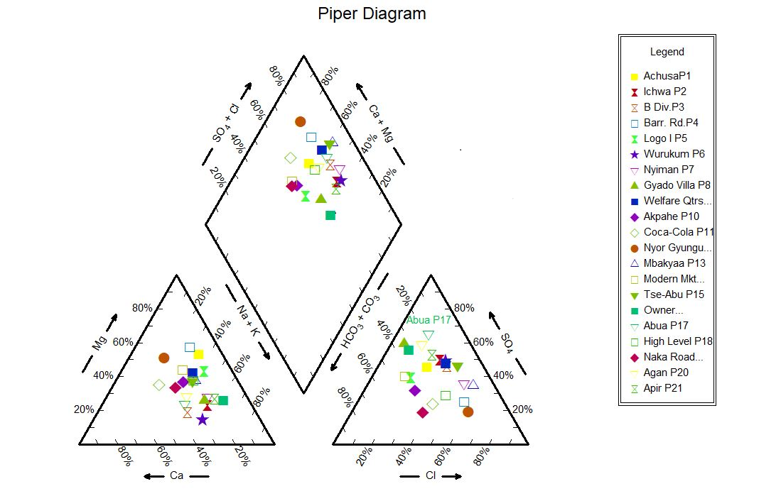
Figure S1: Piper Diagram for Hydrogeochemical Description of the Water Samples

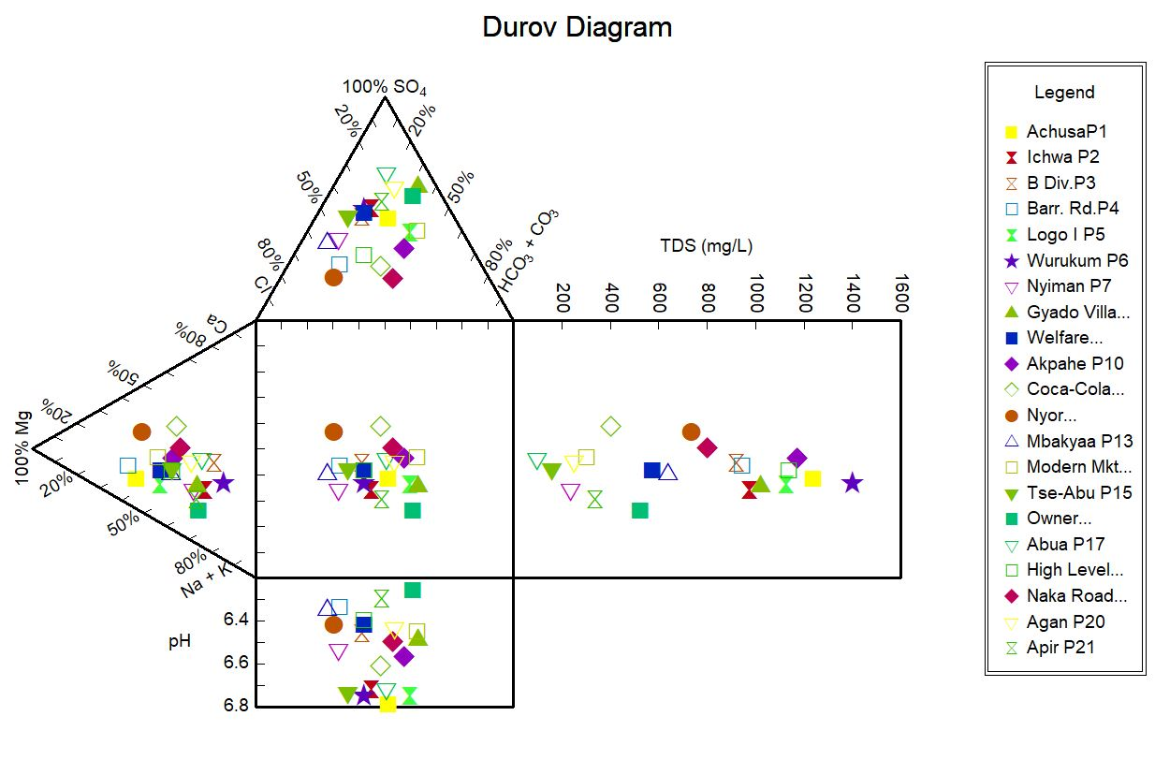
Figure S2: Durov Diagram showing the interactions between major ions
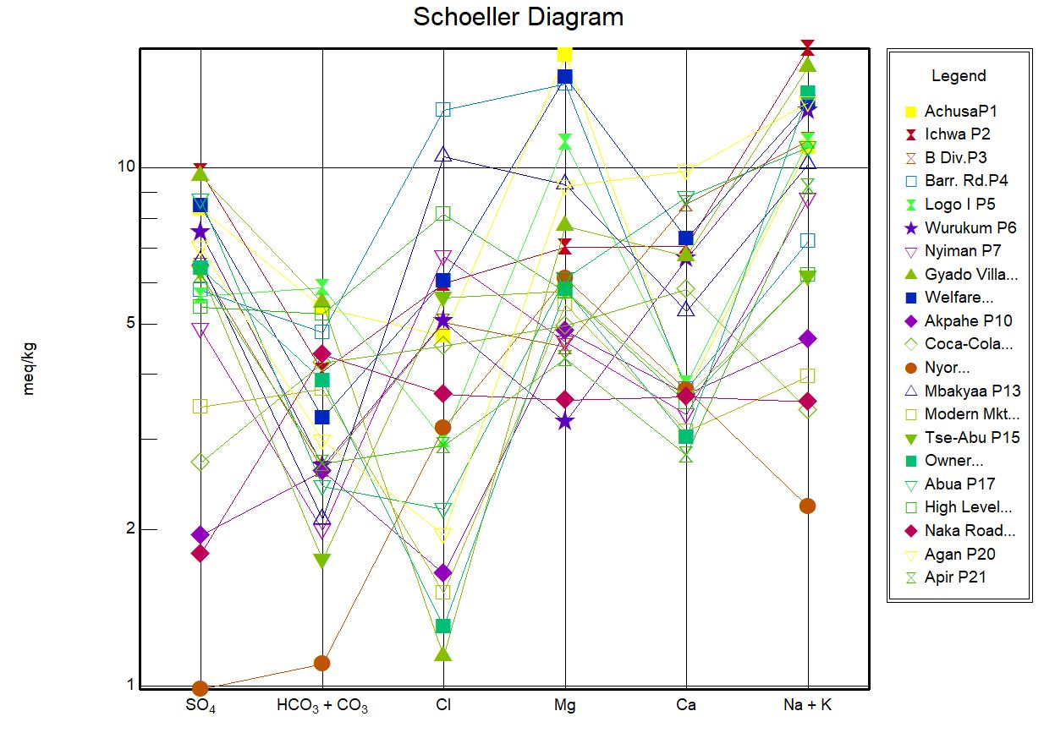
Figure S3: Schoeller Diagram showing the interactions between major ions

Table S7: Computation of Fluoride Risk Parameters
Location | F⁻ Conc.  (C_{j} in mg/L) | Rfd (mg/kg/d) | Mean Water intake (C_{y} in L/d) |  |  |  | Average Body Weight (B_{x} in kg) |  |  |  | Estimated Daily Intake (EDI in mg/kgB_{x}/d) |  |  |  | Hazard Quotient (HQ = EDI/RfD)
Location | F⁻ Conc.  (C_{j} in mg/L) | Rfd (mg/kg/d) | Infants | Children | Teenagers | Adults | Infants | Children | Teenagers | Adults | Infants | Children | Teenagers | Adults | Infants | Children | Teenagers | Adults
P1 | 1.45 | 0.06 | 0.50 | 1.00 | 2.00 | 2.5 | 10.0 | 18.0 | 45.00 | 70.0 | 0.073 | 0.081 | 0.064 | 0.052 | 1.217 | 1.350 | 1.067 | 0.867
P2 | 1.48 | 0.06 | 0.50 | 1.00 | 2.00 | 2.5 | 10.0 | 18.0 | 45.00 | 70.0 | 0.074 | 0.082 | 0.066 | 0.053 | 1.233 | 1.367 | 1.367 | 0.883
P3 | 1.47 | 0.06 | 0.50 | 1.00 | 2.00 | 2.5 | 10.0 | 18.0 | 45.00 | 70.0 | 0.074 | 0.082 | 0.065 | 0.053 | 1.233 | 1.367 | 1.083 | 0.883
P4 | 1.53 | 0.06 | 0.50 | 1.00 | 2.00 | 2.5 | 10.0 | 18.0 | 45.00 | 70.0 | 0.077 | 0.085 | 0.068 | 0.055 | 1.283 | 1.417 | 1.133 | 0.917
P5 | 1.25 | 0.06 | 0.50 | 1.00 | 2.00 | 2.5 | 10.0 | 18.0 | 45.00 | 70.0 | 0.062 | 0.069 | 0.056 | 0.045 | 1.033 | 1.15 | 0.933 | 0.75
P6 | 1.56 | 0.06 | 0.50 | 1.00 | 2.00 | 2.5 | 10.0 | 18.0 | 45.00 | 70.0 | 0.075 | 0.083 | 0.067 | 0.056 | 1.250 | 1.383 | 1.117 | 0.933
P7 | 1.30 | 0.06 | 0.50 | 1.00 | 2.00 | 2.5 | 10.0 | 18.0 | 45.00 | 70.0 | 0.065 | 0.072 | 0.058 | 0.046 | 1.083 | 1.200 | 0.967 | 0.767
P8 | 1.53 | 0.06 | 0.50 | 1.00 | 2.00 | 2.5 | 10.0 | 18.0 | 45.00 | 70.0 | 0.075 | 0.085 | 0.068 | 0.055 | 1.250 | 1.417 | 1.133 | 0.917
P9 | 0.63 | 0.06 | 0.50 | 1.00 | 2.00 | 2.5 | 10.0 | 18.0 | 45.00 | 70.0 | 0.030 | 0.035 | 0.028 | 0.023 | 0.500 | 0.583 | 0.467 | 0.383
P10 | 1.26 | 0.06 | 0.50 | 1.00 | 2.00 | 2.5 | 10.0 | 18.0 | 45.00 | 70.0 | 0.060 | 0.070 | 0.056 | 0.045 | 1.000 | 1.167 | 0.933 | 0.750
P11 | 0.51 | 0.06 | 0.50 | 1.00 | 2.00 | 2.5 | 10.0 | 18.0 | 45.00 | 70.0 | 0.025 | 0.028 | 0.023 | 0.018 | 0.417 | 0.047 | 0.383 | 0.300
P12 | 1.47 | 0.06 | 0.50 | 1.00 | 2.00 | 2.5 | 10.0 | 18.0 | 45.00 | 70.0 | 0.074 | 0.082 | 0.065 | 0.053 | 1.233 | 1.367 | 1.083 | 0.883
P13 | 1.99 | 0.06 | 0.50 | 1.00 | 2.00 | 2.5 | 10.0 | 18.0 | 45.00 | 70.0 | 0.100 | 0.110 | 0.088 | 0.071 | 1.667 | 1.833 | 1.467 | 1.183
P14 | 0.45 | 0.06 | 0.50 | 1.00 | 2.00 | 2.5 | 10.0 | 18.0 | 45.00 | 70.0 | 0.023 | 0.025 | 0.020 | 0.016 | 0.383 | 0.417 | 0.333 | 0.267
P15 | 1.51 | 0.06 | 0.50 | 1.00 | 2.00 | 2.5 | 10.0 | 18.0 | 45.00 | 70.0 | 0.075 | 0.083 | 0.067 | 0.054 | 1.250 | 1.383 | 1.117 | 0.900
P16 | 0.82 | 0.06 | 0.50 | 1.00 | 2.00 | 2.5 | 10.0 | 18.0 | 45.00 | 70.0 | 0.041 | 0.046 | 0.036 | 0.029 | 0.683 | 0.767 | 0.600 | 0.483
P17 | 0.74 | 0.06 | 0.50 | 1.00 | 2.00 | 2.5 | 10.0 | 18.0 | 45.00 | 70.0 | 0.037 | 0.041 | 0.033 | 0.026 | 0.617 | 0.683 | 0.550 | 0.433
P18 | 1.62 | 0.06 | 0.50 | 1.00 | 2.00 | 2.5 | 10.0 | 18.0 | 45.00 | 70.0 | 0.081 | 0.090 | 0.072 | 0.057 | 1.360 | 1.500 | 1.200 | 0.950
P19 | 1.53 | 0.06 | 0.50 | 1.00 | 2.00 | 2.5 | 10.0 | 18.0 | 45.00 | 70.0 | 0.077 | 0.085 | 0.068 | 0.055 | 1.283 | 1.417 | 1.133 | 1.133
P20 | 1.02 | 0.06 | 0.50 | 1.00 | 2.00 | 2.5 | 10.0 | 18.0 | 45.00 | 70.0 | 0.051 | 0.057 | 0.045 | 0.036 | 0.850 | 0.95 | 0.750 | 0.600
P21 | 1.27 | 0.06 | 0.50 | 1.00 | 2.00 | 2.5 | 10.0 | 18.0 | 45.00 | 70.0 | 0.064 | 0.071 | 0.056 | 0.045 | 1.067 | 1.183 | 0.933 | 0.750

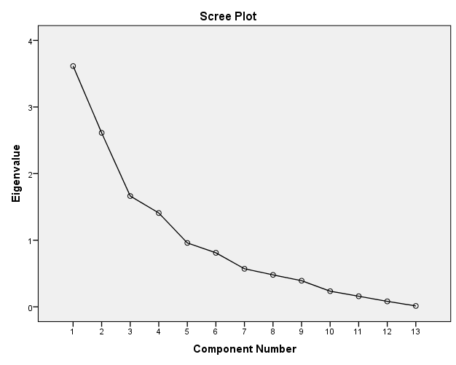
Figure S4: Scree plot showing Extracted Components (Factors) and Eigen Values

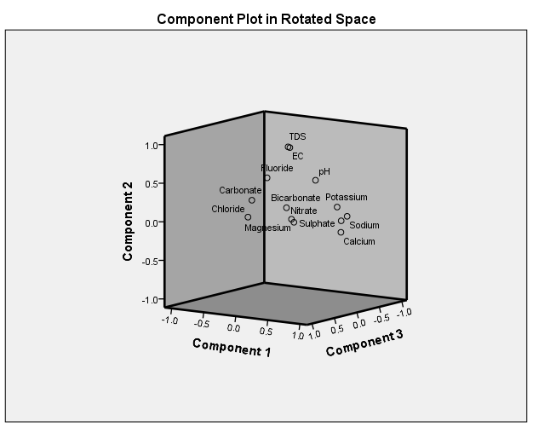

Figure S5: Significant Principal Components with Factor Loadings

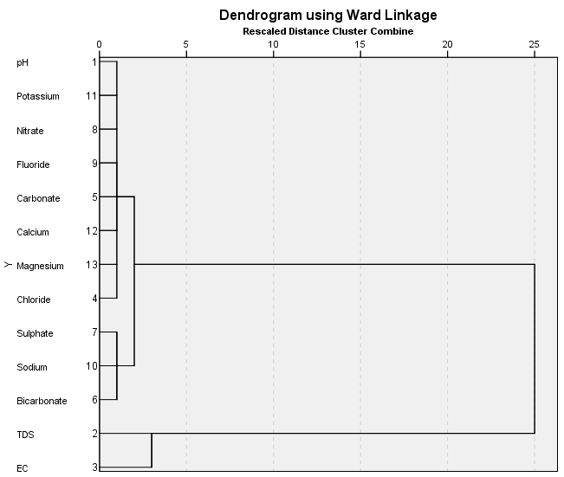

Figure S6: Variable-Mode Dendrogram for HCA of 13 Water Quality Parameters

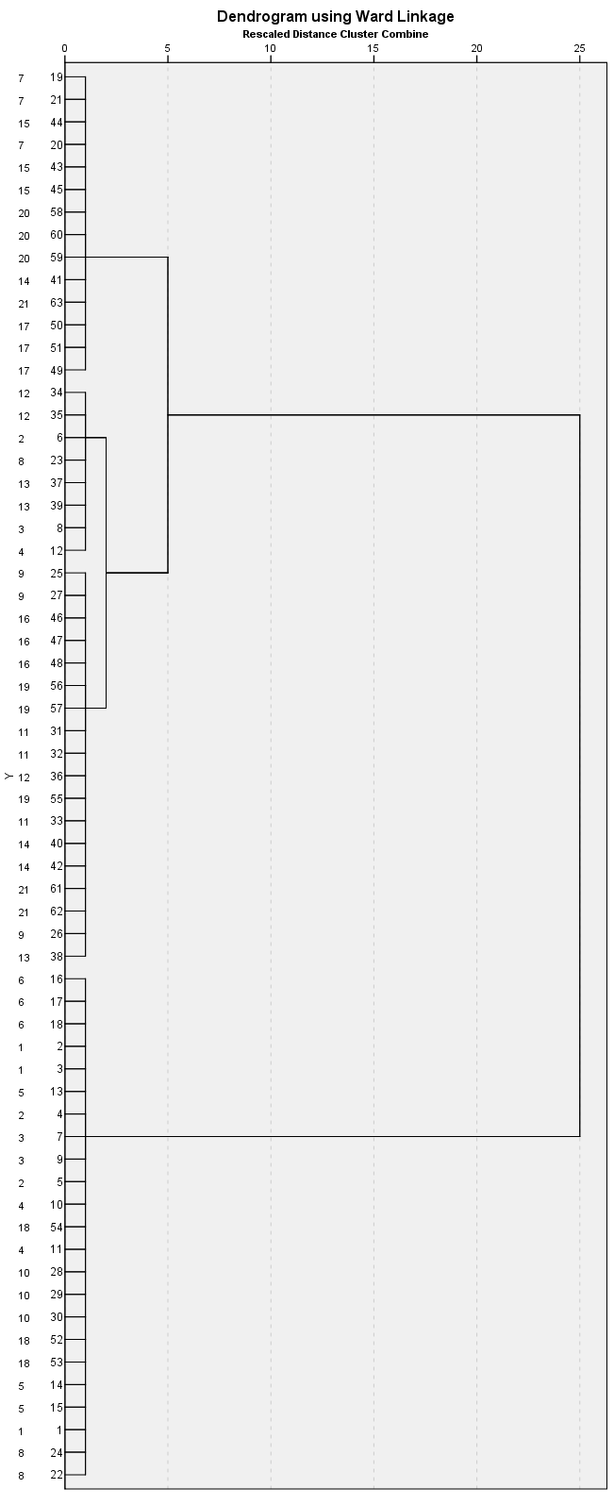

Figure S7: Case-Mode Dendrogram for HCA of 63 Samples from 21 Locations

Figure S8: Estimated Daily Intake Values for Fluoride Risk in the studied Populations

