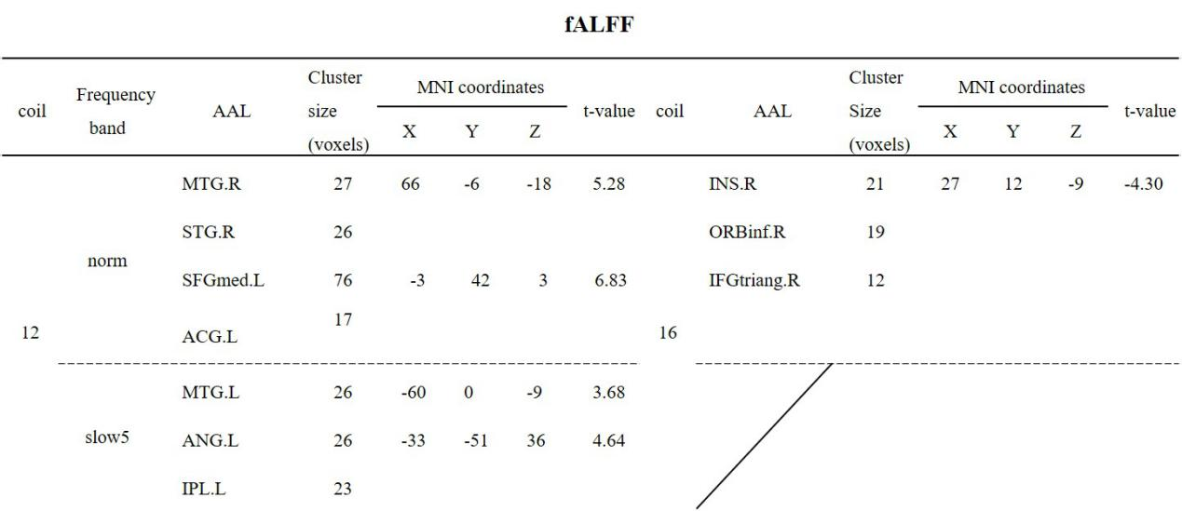
Supporting Table S1. Brain regions with fALFF changes using the two coils after electroacupuncture at ST36 (GRF, voxel-wise p<0.01, cluster-wise p<0.05, two-tailed, and cluster-voxel size >15).

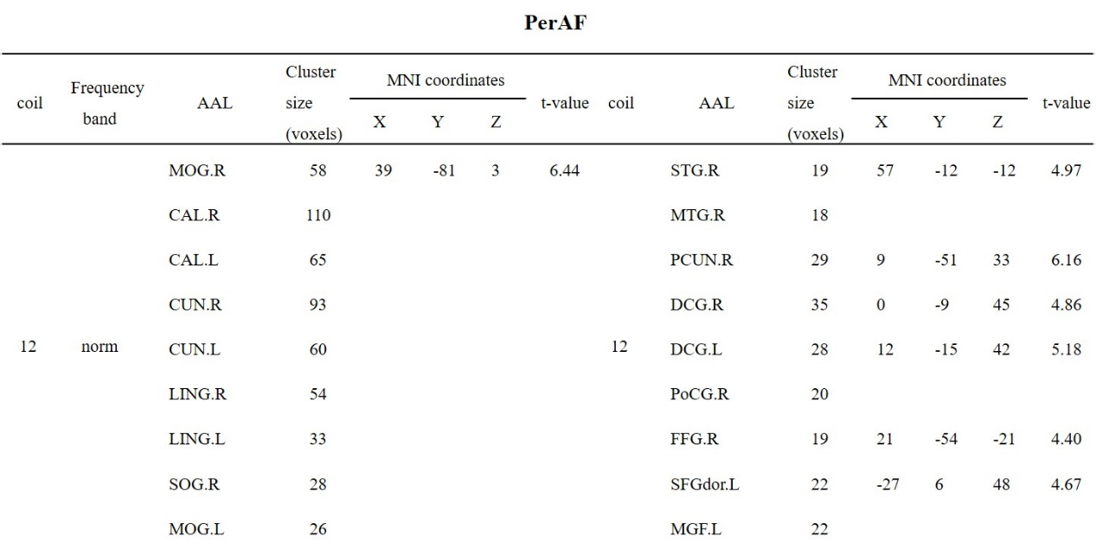

Supporting Table S2a. Brain regions with PerAF changes in the conventional frequency band using the 12-channel coil after electroacupuncture at ST36 (GRF, voxel-wise p<0.01, cluster-wise p<0.05, two-tailed, and cluster-voxel size >15)
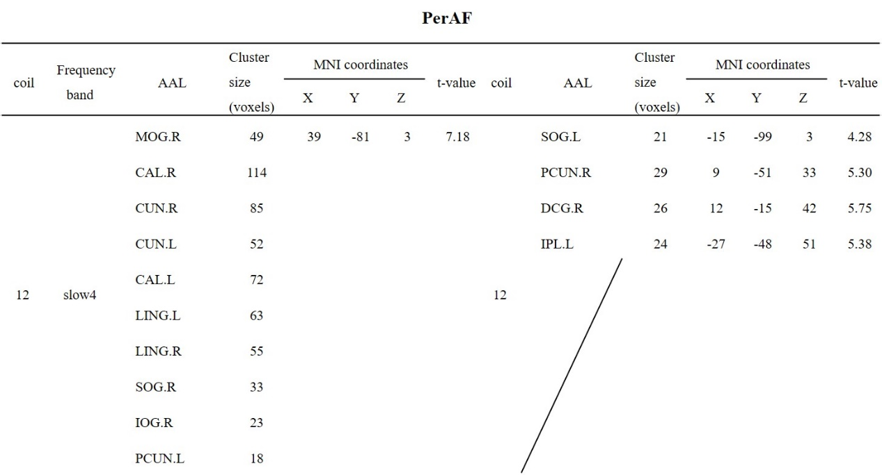

Supporting Table S2b. Brain regions with PerAF changes in the slow-4 frequency band using the 12-channel coil after electroacupuncture at ST36 (GRF, voxel-wise p<0.01, cluster-wise p<0.05, two-tailed, and cluster-voxel size >15)

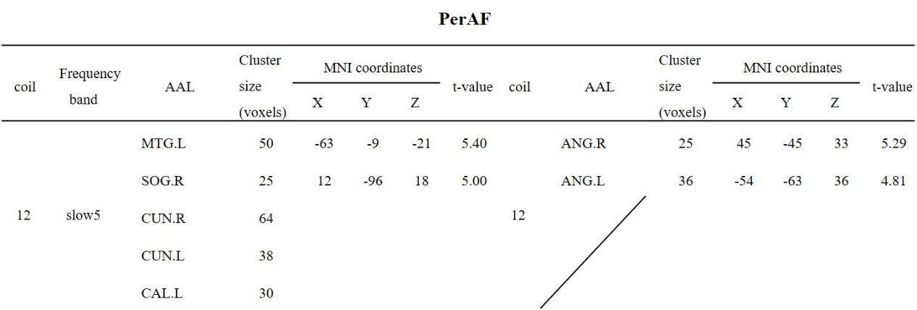
Supporting Table S2c. Brain regions with PerAF changes in the slow-5 frequency band using the 12-channel coil after electroacupuncture at ST36 (GRF, voxel-wise p<0.01, cluster-wise p<0.05, two-tailed, and cluster-voxel size >15)
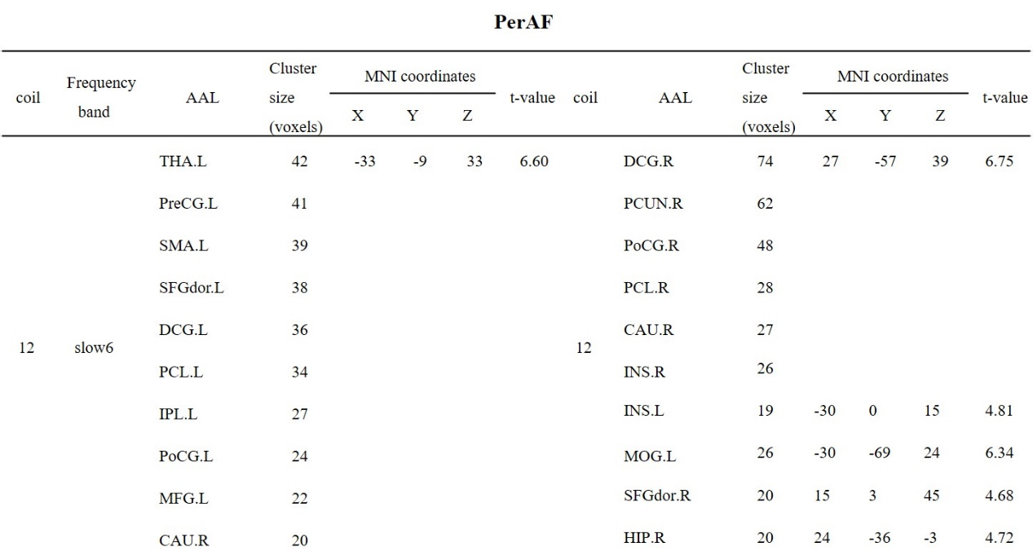

Supporting Table S2ad. Brain regions with PerAF changes in the slow-6 frequency band using the 12-channel coil after electroacupuncture at ST36 (GRF, voxel-wise p<0.01, cluster-wise p<0.05, two-tailed, and cluster-voxel size >15)

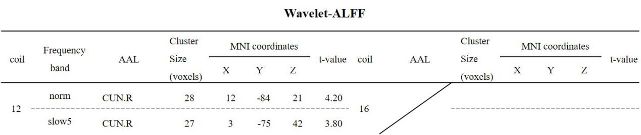

Supporting Table S3. Brain regions with PerAF changes in the conventional and slow-5 frequency bands using the 12-channel coil after electroacupuncture at ST36, respectively (GRF, voxel-wise p<0.01, cluster-wise p<0.05, two-tailed), and cluster-voxel size >15)

