Supplementary Materials

Hybrid graphene electrode for diagnosis and treatment of epilepsy in free-moving animal models

Jeongsik Lim¹, Sangwon Lee^{2,3}, Jejung Kim¹, Jeonghoon Hong⁴, Sooho Lim^{2,3}, Kyungtae Kim², Jeongwoo Kim⁴, Sungchil Yang⁵*, Sunggu Yang^{2,3}*, Jong-Hyun Ahn¹*

¹School of Electrical & Electronic Engineering, Yonsei University, Seoul, 03722, Republic of Korea
²Department of Nano-bioengineering, Incheon National University, Incheon, 22012, Republic of Korea
³Gbrain Inc., Incheon, Republic of Korea
⁴Department of Physics, Incheon National University, Incheon 22012, Republic of Korea
⁵Department of Neuroscience, City University of Hong Kong, Tat Chee Avenue, Kowloon, Hong Kong

These authors contributed equally: Jeongsik Lim, Sangwon Lee.
*Corresponding authors: sungchil.yang@cityu.edu.hk, sungguyang@inu.ac.kr and ahnj@yonsei.ac.kr

- Supplementary Figures 1-4
- Supplementary Table 1
- Caption for Supplementary Video 1

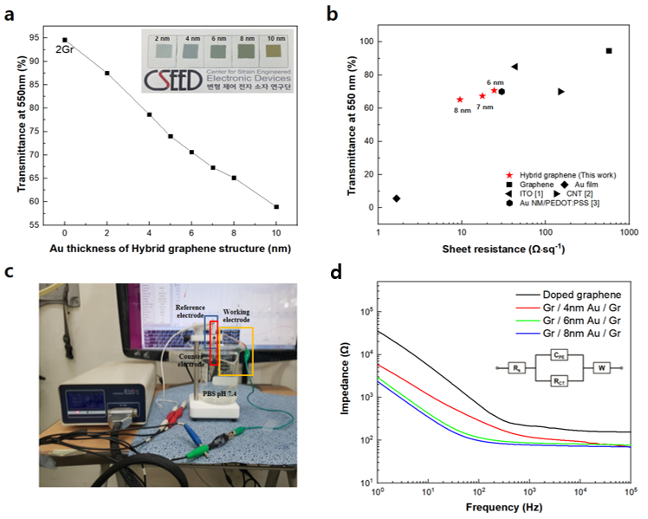

Supplementary Figure 1. The transmittance and impedance of hybrid graphene electrode by Au thickness. a, Optical transmittance at 550 nm as a function of the Au thickness. b, Comparison of sheet resistance and transmittance of the hybrid graphene electrode to that of previously reported works. c, The photography of the EIS testing setup (left) and (d) resulting impedance of hybrid graphene electrodes by 4, 6 and 8 nm Au thickness (right).

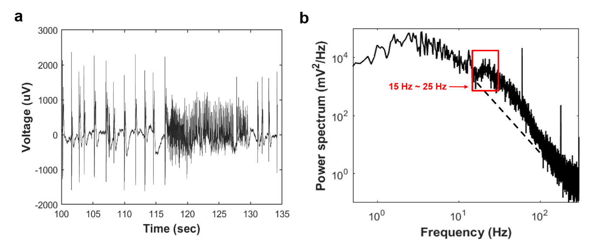

Supplementary Figure 2. Frequency distribution of the seizure signal. a, The seizure signal measured by hybrid graphene electrode array in-vivo measurements. b, Power spectra density of (a) for analyzing the signal in frequency domain.

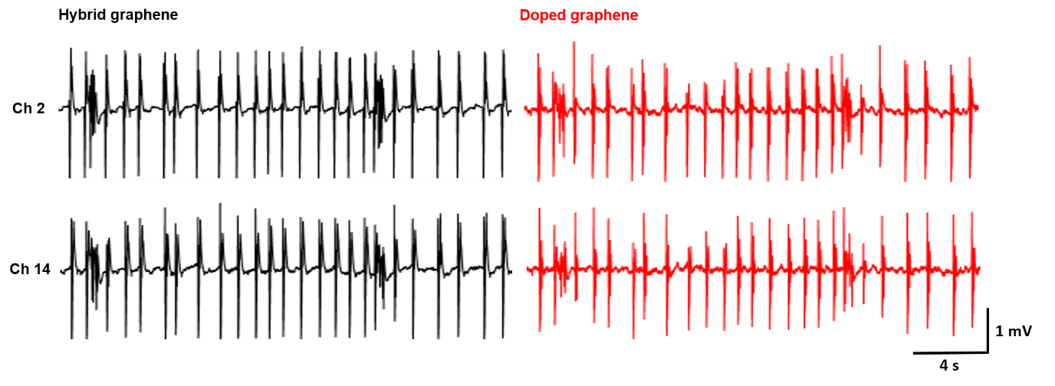

Supplementary Figure 3. Interictal-like activity recorded by hybrid graphene electrode array and doped graphene electrode array after application of bicuculline. Both recordings exhibit a signal-to-noise ratio of 53.03 for the hybrid graphene electrode array (left) and 35.36 for the doped graphene electrode array (right).

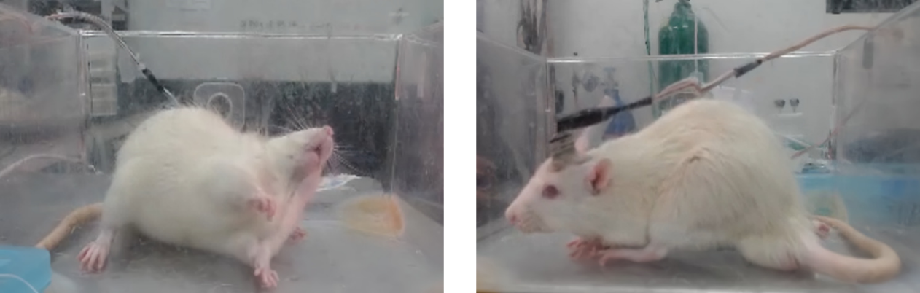

Supplementary Figure 4. A sinusoidal high-frequency stimulation (sHFS; 200uA, 100Hz) was delivered for 30 seconds to confirm the change in epileptic behavior through the same hybrid electrode array. The effect of sHFS on generalized seizures was analyzed to relieve epileptic behavior before (left) and after (right) electrical stimulation.

Supplementary Table 1. The results fitted with EIS equivalent circuit model of Au electrode and hybrid graphene electrode.

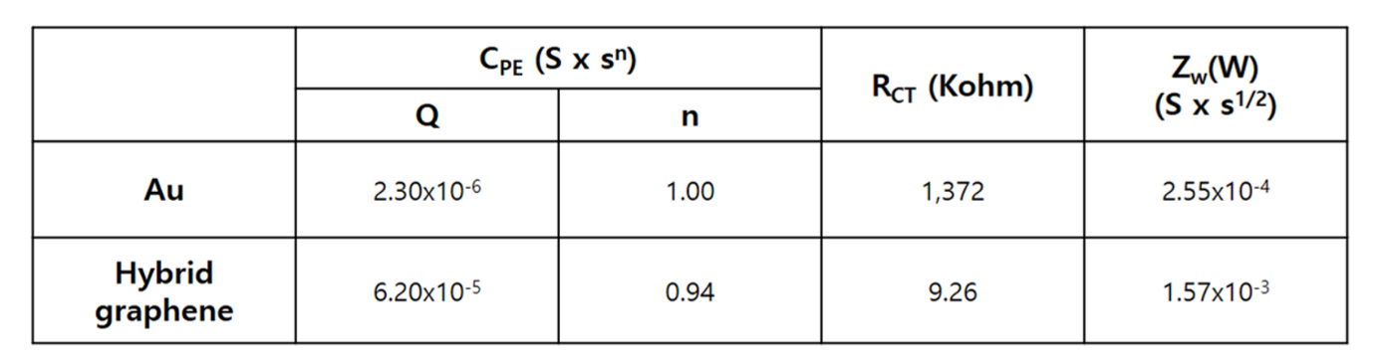

References
1. Ledochowitsch, P., Olivero, E., Blanche, T. & Maharbiz, M.M. A transparent μECoG array for simultaneous recording and optogenetic stimulation. Proc. IEEE Eng. Med. Biol. Soc. Conf. 2937 (2011).
2. Zhang, J. et al. Stretchable transparent electrode arrays for simultaneous electrical and optical interrogation of neural circuits in vivo. Nano Lett. 18, 2903 (2018).
3. Qiang, Y. et al. Transparent arrays of bilayer-nanomesh microelectrodes for simultaneous electrophysiology and two-photon imaging in the brain. Sci. Adv. 4, eaat0626 (2018).

Supplementary Movie

Supplementary Movie 1. Electrotherapy by cortical surface stimulation through hybrid graphene electrode array.

